
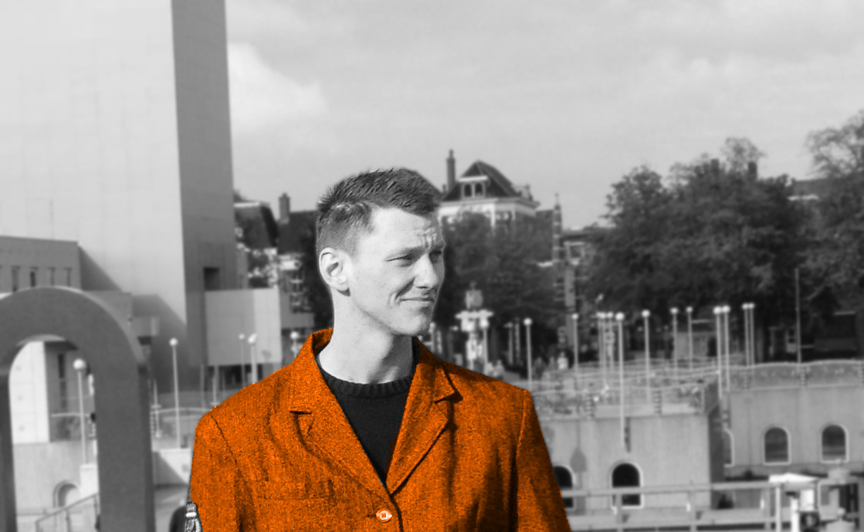
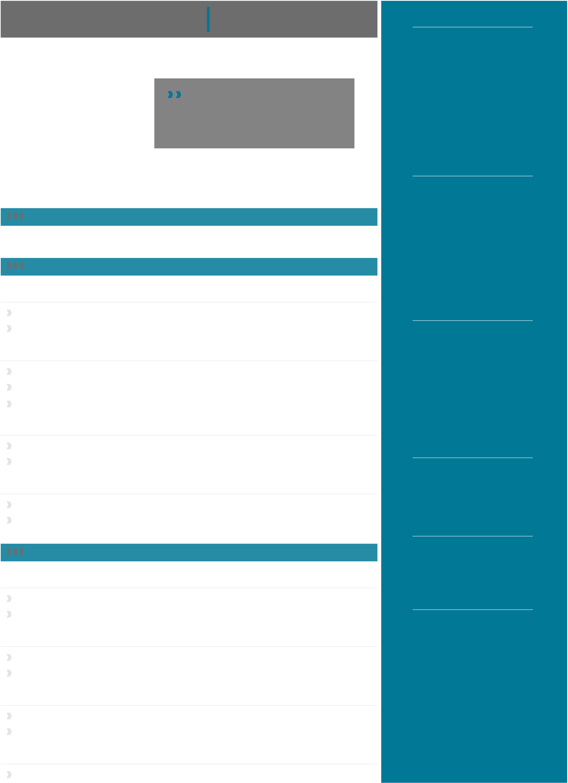
JANKÜSTER RESUME
CONTACT
½Bremen, Germany
Æ+49 176 313 *** **
>
Icreateawesome resume templates in http://jankuester.com/
LaTeXforeveryone.Besides that I am
workingattheUniversity of Bremen and
engineerfullstackJS applications with Meteor. 7
FIELDS
/Software Development
⋆⋆⋆⋆⋆⋆⋆⋆⋆⋆
STATUS :Consulting
⋆⋆⋆⋆⋆⋆⋆⋆⋆⋆
JavaScriptfullstack engineer,M.Sc.DigitalMedia,focuseson education and healthcare
0Project Management
EXPERIENCE ⋆⋆⋆⋆⋆⋆⋆⋆⋆⋆
FullstackJavascriptEngineer University of Bremen, 2016/09 - now
Inventa realtime classroommanagementusingMeteor and React TECHNOLOGIES
Designsoftware architectureandleadingdevelopment /JavaScript
ScientificEmployee/SoftwareDevelopment University of Bremen, 2012 - 2014 /Meteor
Invented a flexible assessmentframework,targetingindustrial trainees tBlaze
Supervised software developmentlifecycle MongoDB
Recruited team members 0Git
ProjectManagementSimulationTraining Getoq Consulting, 2011 / 11
Performed a two-day projectsimulationfrommanagement perspective TOOLS
Topicsincluded customercontracts,changemanagement, controlling, operational tasks
/Webstorm 0SourceTree
StudentAssistant/Programmer otulea.uni-bremen.de, 2010 - 2011 &Terminal `Inkscape"Blender
Realized an online diagnosisplatformforworkforceliteracy development (Flex)
Modeled software design,implementedvariousprototypes, conducted usability tests ACTIVITIES
EDUCATION e

GraduatedasM.Sc.DigitalMedia University of Bremen, 2015 / 07
MasterThesis:Semi AutomatedScoringinTechnology Based Assessment

OPERATING SYSTEMS

Developed and evaluatedanalgorithmforsemiautomated scoring of spreadsheet data
± q
MasterProject-PrIMA University of Bremen, 2012 - 2013
Co-Invented a touch tableapplicationformedicalsupport, co-developed software (Java)
Formed a scrum team, maintedprojectdevserver(Debian), surveyed target audience
MasterStudiesDigitalMedia University of Bremen, 2012 - 2015
Inter-cultural classes inEnglish,coveringspecialtopics in computer science and design
Professionalized in researchmethods,softwaredevelopment and e-assessment
SemesterAbroad University of Melbourne, 2009 - 2010
Mastered six months ofstudyandtrans-culturalexperience in Melbourne, Australia
Finished machine programming,informationvisualization, professional essay writing
Coypright2018jkuester@uni-bremen.de · licensed under MIT license

