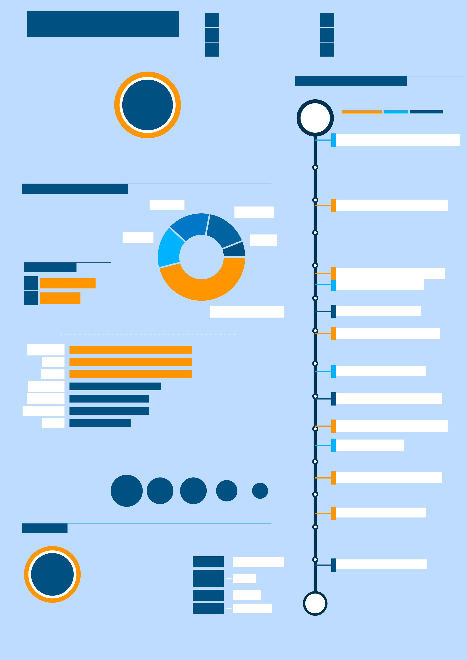
½Bremen, Germany www.jankuester.com JAN KÜSTER Æ+49 176 *** *** ** github.com/jankapunkt CONSULTANT/ SOFTWARE ENG. >info@jankuester.com 7@Kuester_Jan
EXPERIENCE AND EDUCATION
graduate with working M.Sc. And I am always look-Iamadigitalmedia
experience in research projectsaswellasin Digital Media ingfornewexciting and interdisciplinary 2021 ExperienceEventsEducation projects worldwide.
the private sector.
10/2020Meteor Impact Conference as latest degree from
University of Bremen
SKILLS AND TECHNOLOGIES
Research 10/2018Software Engineer @UB Consulting
ThebiggestpartIcon-
tribute to my work is in the
area of Software Engineer-ing. Projects Design
LANGUAGES
9/2016Software Engineer @UB
^ German (native) 5/2016Startup Weekend
^ English (c1)
Software Engineering 7/2015M.Sc. Graduation
11/2014IT Consultant @We4IT
Javascript
Blaze
Metor Currently, I develop re- 9/2013DELFI Conference
altimeappswithMe-Bootstrap
teor and Blaze.
MongoDB Formerly I worked with 11/2012Master Project - PrIMA
HTML/CSS Java and XPages.
LaTex 1/2012Scientific Employee @UB
6/2011PM Training
IregularlyuseMe- Webstorm Git Sourcetree Linux Office
teor,GitandWeb- 6/2010Student Assistant @UB
stormformydev
projects.
5/2009Semester Abroad
ACTVITIES
7 of news and help others on News
InmyfreetimeIreadlots Stackoverflow 10/2007Bachelor Studies
years Stackoverflow. Viabody-
weighttrainingIkeepmy
Fitness body and mind in balance.
2007
of participation at Game Dev
Global Game Jam @UB = University of Bremen

