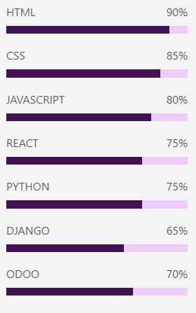

Romelia Maristany Hastie

My goal is to obtain a position as a junior computer engineer in a company where I can apply my knowledge and technical skills to contribute to the development of innovative projects and grow professionally. I am a highly motivated person, with the ability to learn quickly, teamwork and excellent communication; I am sure that I can add value to your company with my dedication and ability to learn.

Skills

**Email**: [romeliamaristany00@gmail.com](mailto:romeliamaristany00@gmail.com)

**Phone**:

+(53) 54977513

**LinkedIn**:

Romelia Maristany Hastie

Lenguage

* Spanish (Native)
* English (B1)
* University of Computer Sciences of Havana, Cuba.

Education

* Graduate in Computer Engineering (2023)

Contact