EXPLORING TINYBERT FOR CONTEXTUAL ANALYSIS

IN SARCASM DETECTION

THESIS

ELEINA RIA YBETH L. BUMANGLAG
ZEAN KYRON U. CLEMENTE
JENNICA R. LUCERO
ROMEO D. OBSANIA IV



Department of Computer Science
COLLEGE OF COMPUTING AND INFORMATION SCIENCES
Mariano Marcos State University
City of Batac 2906 Ilocos Nortejws

2025

EXPLORING TINYBERT FOR CONTEXTUAL ANALYSIS

IN SARCASM DETECTION

A Thesis Presented to the Faculty of College
of Computing and Information Sciences - Department of
Computer Science

In Partial Fulfilment of the Requirements for the Degree
of Bachelor of Science in Computer Science

By
ELEINA RIA YBETH L. BUMANGLAG
ZEAN KYRON U. CLEMENTE
JENNICA R. LUCERO
ROMEO D. OBSANIA IV

June 2025

APPROVAL SHEET
This thesis project titled, “EXPLORING TINYBERT FOR CONTEXTUAL ANALYSIS IN SARCASM DETECTION”, prepared and submitted by Eleina Ria Ybeth L. Bumanglag, Zean Kyron U. Clemente, Jennica R. Lucero, Romeo D. Obsania IV in partial fulfillment of the requirements for the degree Bachelor of Science in Computer Science, has been examined and recommended for acceptance and approval for the oral examination.

Mr. Ralph C. Perdido
Adviser

PANEL OF EXAMINERS
Approved by the Committee on Oral Examination in partial fulfillment of the requirements for the degree Bachelor of Science in Computer with a grade of grade
on date.

ACKNOWLEDGMENT
The researchers would like to extend their utmost gratitude to the following, who helped in the completion of this paper:
First and foremost, thank you to their parents, who have continuously supported them financially and emotionally. Their unwavering love and support have been the source of motivation in overcoming the challenges of accomplishing this research. Their sacrifices are deeply appreciated.
To their family and friends, who stood by them throughout the making of this study. Their constant understanding and encouragement made the difficulties more bearable and the accomplishment more fulfilling.
Lastly, to their thesis adviser, Mr. Ralph C. Perdido, who has patiently guided and supported them from the beginning to the completion of this study. His insightful advice and feedback have been greatly instrumental in the completion of this paper.
To everyone who has helped the researchers in one way or another, their efforts are sincerely treasured and appreciated. This research would not have been possible without each of their contributions. Thank you.

ABSTRACT

CLEMENTE, ZEAN KYRON U., BUMANGLAG, ELEINA RIA YBETH L., LUCERO, JENNICA R., OBSANIA, ROMEO D. IV, College of Computing and Information Sciences, June 2025, “EXPLORING TINYBERT FOR CONTEXTUAL ANALYSIS IN SARCASM DETECTION.” Contribution Number: 2025-05-0005 Adviser. MR. RALPH C. PERDIDO
This study explored TinyBERT, a smaller and more efficient variant of BERT, to see how well it performed for contextual analysis in sarcasm detection. While transformer-based models like BERT have demonstrated great results in detecting sarcasm, they often come with high computational demand. To address this, the study evaluated two versions of TinyBERT, the 4-layer and 6-layer TinyBERT models, by fine-tuning them on the Self-Annotated Reddit Corpus (SARC), a sarcasm-labeled dataset compiled by Mikhail Khodak, Nikunj Saunshi, and Kiran Vodrahalli.
The results showed that the 6-layer TinyBERT model consistently outperformed the 4-layer TinyBERT model, by achieving the highest result using approximately 1,000,000 samples and having these hyperparameters: learning rate of 3e-5, 4 epochs, a batch size of 16, 0.2 warm-up steps, and a weight decay rate of 0.05. This combination of hyperparameters had an accuracy of 77.94% and an F1 score of 78.46%, significantly improving the performance of the pre-trained model.

Keywords: TinyBERT, Sarcasm Detection, Contextual Analysis, Transformer-based models, 6-Layer TinyBERT, 4-Layer TinyBERT, Fine-Tuning, Hyperparameters

TABLE OF CONTENTS
Title Page i
Title Page i
APPROVAL SHEET ii
ACKNOWLEDGMENT iii
ABSTRACT iv
TABLE OF CONTENTS v
LIST OF TABLES vi
LIST OF FIGURES vii
LIST OF APPENDICES viii
CHAPTER
- THE PROBLEM AND ITS BACKGROUND
Background of the Study 1
Statement of the Problem 3
Objectives of the Study 3
Scope and Limitations 4
Definition of Terms 5
- REVIEW OF RELATED LITERATURE
Sarcasm and Sarcasm Detection 7
Methods and Approaches Used in Sarcasm Detection 8
Transformer Models in Sarcasm Detection 10
Uses and Advantages of TinyBERT 12
SARC Dataset 13
- METHODOLOGY
Dataset Description 16
Data Acquisition 16
Data Cleaning 16
Preprocessing 17
Fine-tuning 18
Evaluation 19
- RESULTS AND DISCUSSION
Data Acquisition and Cleaning 21
Preprocessing 23
Fine-Tuning 25
Evaluation 40
- CONCLUSIONS AND RECOMMENDATIONS
Conclusion 48
Recommendations 49
REFERENCES 50

LIST OF TABLES
Table
- Removed Dataset Overview 21
- Used Dataset Overview… 21
- Label Distribution… 22
- Data Split Ratio… 24
- Pre-trained 6-layer TinyBERT Performance Results… 40
- Fine-tuned 6-layer TinyBERT Performance Results… 43

LIST OF FIGURES
Figure
- Model Framework… 15
- Confusion Matrix… 20
- Data Size and F1 Score Heatmap… 27
- Data Size and Accuracy Trend Graph… 28
- Data Size and Accuracy Heatmap… 29
- Epoch and F1 Score Heatmap 30
- Epoch and Accuracy Heatmap… 31
- Batch Size and F1 Score Heatmap… 32
- Batch Size and Accuracy Heatmap… 33
- Learning Rate and F1 Score Heatmap… 34
- Learning Rate and Accuracy Heatmap… 35
- Warm Up and F1 Score Heatmap… 36
- Warm Up and Accuracy Heatmap… 37
- Weight Decay and F1 Score Heatmap… 38
- Weight Decay and Accuracy Heatmap… 39
- Pre-Trained 6-layer TinyBERT Confusion Matrix Heatmap… 42
- Fine-tuned 6-layer TinyBERT Confusion Matrix Heatmap… 45
- Comparison of Evaluation Metrics for Pre-Trained and Fine-tuned… 46
CHAPTER I
INTRODUCTION

Background of the Study
Sarcasm is a form of expression that uses words that contrast with the meaning of what the speaker really wants to say and is often used to hurt or criticize others [1]. It involves the intricacies of linguistic, pragmatic, and contextual factors [2], which can cause confusion, especially for people who have difficulty perceiving social cues. The absence of tone, facial expressions, and body language makes it even harder to recognize in writing. As more people communicate via text on social media, customer service platforms, and virtual assistants, there’s a growing need for automated sarcasm detectors. Detecting sarcasm remains a problem despite the continuous progress of AI and NLP. Sarcasm can make data noisy [3], which can negatively affect data analysis. As a solution, automatic sarcasm detection is needed in order to capture the true meaning behind words, enabling accurate sentiment and opinion analysis [4].
Researchers have approached the challenge of sarcasm detection using rule-based, statistical, and deep-learning methods. A rule-based approach generally relies on predefined sarcastic markers like hyperbole or contradiction, but fails to adapt to developing language. Statistical methods use probabilistic models like Support Vector Machines and Naive Bayes, which need large annotated datasets to be accurate, unlike the other models. In recent years, deep learning approaches have become more popular for allowing automatic representation learning from the data with little feature selection, as opposed to manual selection, also known as feature engineering. Recurrent Neural Networks (RNNs), Convolutional Neural Networks (CNNs), and transformer-based models like BERT are used for text data processing to a greater extent. These models capture complex patterns alongside contextual information, which is effective in sarcasm detection. Despite this, they often need considerable computational power or have large dataset requirements, and are less interpretable than rule-based or statistical methods [5]. Out of the three, the deep learning methods have the most potential to tackle the issues of detecting sarcasm embedded in texts. The benchmarks presented by Papers With Code, which track milestones in sarcasm detection, highlight deep learning models, particularly those based on transformers, as remarkable outperformers. Most importantly, BERT was shown to have great potential in sarcasm detection. One particular study reported that a fine-tuned BERT-based model achieved 73.1% accuracy [6], which is better than most machine-learning and BiLSTM models. The same study also points out, however, that the high computational cost of BERT remains a major drawback.
In response to these limitations, this research explored TinyBERT, which is a more efficient BERT-like model, assessing its 4-layer and 6-layer versions, which have 312 and 768 hidden dimensions, respectively, to determine their effectiveness in sarcasm detection. TinyBERT’s lower computational costs, combined with its capability to leverage BERT’s robust linguistic knowledge, make it ideal for tasks requiring precision and low resource demands. TinyBERT primarily learns the intermediate structures of BERT at the pre-training stage through a process called knowledge distillation. This allows TinyBERT to effectively mimic BERT’s internal representations, capturing key linguistic features and relationships while reducing the overall model size [7]. Given TinyBERT's ability to retain much of BERT’s language comprehension while being more efficient, it was remarkably suited for identifying linguistic subtleties like sarcasm, where understanding the intent is essential. This made it a suitable candidate for sarcasm detection in NLP. Furthermore, its fast inference time and smaller size gave TinyBERT an edge in deployment within resource-limited settings where BERT-based NLP models are dominantly used.
Thus, considering the previously stated challenges concerning sarcasm detection in text, this research sought to investigate the capacity of TinyBERT for identifying sarcastic expressions while maintaining computational efficiency. This research sought to fine-tune TinyBERT on a dataset labeled with sarcasm to see if it could grasp the intricacies of sarcastic language and to test how well it adapted to the task of sarcasm detection.

Statement of the Problem
Sarcasm can distort critical data [3] by changing the meaning of messages [8]. Sometimes, it can cause misunderstandings, most especially in customer service environments and social media interactions [9], which makes sarcasm detection incredibly important. Enhancing sarcasm detection systems can help facilitate a better understanding of contextual nuances, resulting in improved communication and interpretation of people’s insights and sentiments.
Although several approaches and models have been used for sarcasm detection systems, most of them require high computational resources. Because larger models usually provide good results, smaller models like TinyBERT remain unexplored for sarcasm detection.

Objectives of the Study
The aim of this research was to examine TinyBERT's capability for detecting sarcasm in text.
Specifically, the study aimed to achieve the following objectives:
- Acquire and preprocess a sarcasm-labeled dataset suitable for training TinyBERT.
- Fine-tune the pre-trained TinyBERT model on the training dataset.
- Validate the performance of the fine-tuned TinyBERT models using the validation dataset.
- Evaluate the pre-trained and fine-tuned models on the test dataset, comparing their accuracy, precision, recall, and F1 score.

Scope and Limitations
The scope of this study focused on assessing the effectiveness of TinyBERT, introduced by Jiao et al. [7], for sarcasm detection in text. The 4-layer and 6-layer versions were trained and evaluated using the Self-Annotated Reddit Corpus (SARC), compiled by Mikhail Khodak, Nikunj Saunshi, and Kiran Vodrahalli [10]. The pre-trained model was used as the baseline comparison for the fine-tuned model by evaluating both models using the same dataset and metrics, including accuracy, precision, recall, and F1.
The limitations of this study include detecting sarcasm in English-language text only. Other languages or modalities like images, audio, or video were not included in the scope of the study.
Significance of the Study
Researchers. The study will help future researchers that are going to study or interested in Natural Language Processing and sarcasm detection. They may find this study beneficial as it enhances understanding in feature extraction in text analysis and provides approaches to address the lack of computational resources associated with NLP tasks like detecting sarcasm. For the study used TinyBERT in sarcasm detection and demonstrating its capability in NLP tasks like detecting sarcasm, it allows other researchers to also build upon the findings of this research and improve TinyBERT’s performance by exploring other approaches and datasets, and even consider TinyBERT for other NLP tasks.
Developers. The results of this study provide developers with a less resource-intensive and potentially more effective approach for sarcasm detection. Developers who specialize in creating or enhancing sentiment analysis tools for any industry or platform may find this research beneficial by utilizing or integrating TinyBERT into systems that interpret people’s sentiments, such as customer feedback and reviews, social media comments, and other user-generated content.

Definition of Terms
To further understand this study, the following terms are defined operationally in the context of the present study.
Accuracy is the ratio of correct predictions to the total number of predictions.
Bidirectional Encoder Representations from Transformers, or BERT for short, is a model in deep learning developed for NLP pre-training and fine-tuning by Google.
Contextual Analysis is an application of natural language processing that looks at the words, sentences, or text that comes before or after a particular phrase or sentence to define its meaning. It means that when one gives meaning to words, they make sure that context is taken into account instead of just single words.
F1 score is the harmonic mean of precision and recall, providing a balanced metric.
Fine-tuning in machine learning customizes a model to particular tasks by modifying a previously trained model.
Knowledge distillation in machine learning refers to the process of transferring the information from a larger model to a smaller model.
Natural Language Processing (NLP) concerns itself with the examination of written text data, associated with documents and publications. It can emphasize syntax to describe the construction and order of a given set, or semantics to explain the interpretation of a text.
Precision is the proportion of sarcasm predictions that are actually sarcasm.
Recall is the proportion of sarcastic statements that are correctly predicted as sarcastic.
Sarcasm is a communicative act where a statement is made in such a way that its exact utterance contradicts the statement bearing a different meaning underlying the tone of voice or demeanor of the speaker.
Sarcasm Detection is a Natural Language Processing (NLP) task, specifically under text classification, that determines whether a sentence is sarcastic or non-sarcastic.
Transformer Models are a type of deep learning architecture designed to efficiently process sequential data, transforming one input sequence into an output sequence.
TinyBERT is a smaller version of the BERT model, optimized to deliver high performance in natural language processing tasks while using fewer computational resources.

CHAPTER II
REVIEW OF RELATED LITERATURE
This chapter presents related projects and literature that support the Researchers’ study.

Sarcasm and Sarcasm Detection
Sarcasm is a form of figurative language frequently used in spoken conversations to convey a meaning that contrasts with its literal interpretation. While it is often used to mock or offend, it may also serve various other purposes, such as humor, expressing dissatisfaction, or avoiding direct confrontation [11].
Sarcasm detection plays a crucial role in identifying people's true intentions behind their statements. Sarcasm can often be hostility disguised as humor, characterized by mockery and ridicule. In the absence of detecting sarcasm, sentiment analysis may misunderstand these statements, resulting in inaccurate analysis results regarding the speaker's true feelings and viewpoints.
In NLP, sentiment analysis is frequently used to comprehend people's subjective viewpoints. Nonetheless, if people use sarcasm in their statements, the analysis result might be biased. Effective sarcasm detection can significantly benefit numerous Natural Language Processing applications, including marketing research, opinion mining, and information categorization [12].
Being able to identify sarcasm ensures a more accurate reading of the statement’s underlying meaning. By differentiating the literal and intended meanings of statements, the sarcasm detection model improves the accuracy of sentiment analysis [13].

Methods and Approaches Used in Sarcasm Detection
CASCADE. Sarcasm detection has mainly focused on lexical, syntactic, and semantic-level text analysis. However, a sarcastic sentence can be expressed with contextual presumptions, background, and common-sense knowledge. To address these challenges, CASCADE was introduced as a novel hybrid sarcasm detector that utilizes both content and contextual information required for sarcasm detection. CASCADE uses Convolutional Neural Networks (CNNs) to generate the representation vector c_{i,j} for a comment. This captures both syntactic and semantic information used for analysing sarcastic comments. Also, the sarcastic nature and form vary from person to person. CASCADE utilizes user embeddings that encode the stylometric and personality of the features of the users. Both features are fused using CCA to create a single representation for final classification.
Compared to different models like Bag-of-Words, CNN, CNN-SVM, and CUE-CNN, CASCADE has the highest performance on the SARC main balanced dataset with an accuracy and F1 score of 77% [14].
CASCADE showed the significance of contextual features; its dependence on CNN with user embeddings, contextual discourse, and other features may lead to high computational cost. In contrast, TinyBERT transformer-based architectures are lightweight and more efficient for speed and scalability.
Convolutional Neural Networks. CNN is a type of deep learning model mainly used in computer vision, however, this showed promising results on specific kinds of sentiment analysis and classification problems compared to other neural network models. In the paper, the dataset contained 11,378 rows of comments collected from the subreddit “r/indonesia,” with 5,654 labeled as sarcastic and 5,724 labeled as not sarcastic. After pre-processing such as tokenization, stemming, and normalization, the CNN model achieved an F1 score of 90%, outperforming traditional machine learning methods like Naive Bayes with 82% and k-nearest 55%. This showed that CNN is effective in sarcasm detection tasks, even if it is limited to languages like Indonesian [15].
However, CNN focuses on local feature extraction and lacks the capacity to catch contextual nuances, which are often critical in detecting sarcasm. In contrast to TinyBERT transformer-based architecture highlights contextual understanding, making it more suitable for large-scale datasets.
Traditional Machine Learning Techniques. A variety of machine learning algorithms have been applied to the task of sarcasm detection, including Naive Bayes, support vector machines, random forests, recurrent neural networks, and convolutional neural networks. These algorithms work by learning to recognize patterns in text data that are associated with sarcasm. Several machine learning models, including logistic regression, ridge regression, linear support vector, and support vector machines. Among all traditional machine learning, ridge regression and linear SVM have the best results, achieving an accuracy of 70%, which shows how relatively simple machine learning algorithms can yield comparable results to more complex ones that may be sufficient for sarcasm detection in some cases[16]. Although traditional machine learning approaches require less computational cost, deep learning models provide better and more accurate results. For this study, the researchers used the TinyBERT model to balance both computational efficiency and performance.
Soft-Attention Bi-directional Long Short-Term Memory with Convolutional Networks. A deep learning approach that is developed by L. Hoang Son et al. [17]. It is a method in conjunction with the Convolution Network (ConvVet) for the exposure of sarcastic statements. This is an eight-layered model, and the attention layer is the softmax function, which is important for weighted vectors. Five features counted for this model are the presence of exclamatory marks, “or”, periods or dots, question marks, and capital letters. Various features are excerpted, such as lexical, hyperbole, pragmatic, syntactic, and pattern-based features. Also, the study used balanced datasets like SemEval 2015 Task 11 and achieved an accuracy of 92.89%. The F-scores exceed 93%, showing that it is effective in balanced datasets. While the accuracy drops to 85.92% on imbalance datasets like Random Tweets, the F-scores remain at 91%, showing that the model is still effective even with uneven class distributions[18].
This gives a useful comparison of how a smaller model like TinyBERT can understand context in sarcastic comments from a large SARC dataset.

Transformer Models in Sarcasm Detection
Transformer Models. It was introduced in the seminal paper “Attention Is All You Need” by Vaswani et. al [19], upgrading natural language processing by replacing the recurrent layers most commonly used in encoder-decoder architectures with multi-headed self-attention. Experiments on two machine translation tasks show these models to be superior in quality while being more parallelizable and requiring significantly less to train. One of the features is self-attention to compute relationships between different positions in a sequence, allowing the model to capture long-range dependencies without regard to their distance. Another is positional encoding, since the transformer contains no recurrence and no convolution, the model makes an order of the sequence, and it must inject some information about the relative or absolute position of the tokens in the sequence. There are many choices of positional encodings, and transformer models use sine and cosine functions of different frequencies. Lastly, this model architecture eschews recurrence and instead relies entirely on an attention mechanism to draw global dependencies between input and output, drastically reducing the training time and making the model more computationally efficient. On both WMT 2014 English to German and English to French translation tasks, transformation models achieve a revolutionary model that outperforms even all previously reported ensembles. Its capability of managing long-range dependencies, scale, as well as its efficiency, makes it a groundwork architecture for contemporary NLT, triggering later models such as BERT and GPT.
Hugging Face for sarcasm detection. Wolf et al. [20] researched how the pre-trained models have made it easy for future research, and the transformer library made it possible to collect all these huge pre-trained models in one place and accessible to the machine learning community. Transformers is indeed an ongoing project that Hugging Face’s team of technologists and researchers maintains with assistance from a thriving community of more than 400 outside contributors. At the end, the researchers conclude that, since its debut, Transformers has had substantial organic growth and is prepared to continue offering the essential infrastructure while easing the availability of new models.
BERT Models. Savini et al. [21] implemented strong baselines using BERT pre-trained language models. Moreover, BERT models improved by fine-tuning on sentiment classification and emotion detection tasks using the interplay of sarcasm and negative sentiment and emotions. Experimental results on three different datasets (Internet Argument Corpus (IAC), Reddit, and Twitter) support that BERT-based models improve sarcastic detection by 11.53% over prior methods.
Amirhossein Abaskohi et al. [22] did an extensive study on all possible models and data augmentation to find the best one for sarcasm detection. The research progressed from classical machine learning to modern transformer and attention-based models. The dataset iSarcasm, created in the course of the research, was used for the experiments. Out of all the tested models, which included SVM, LSTM-based, BERT-based, Attention-based, and Google's T5, the BERT-based model showed the best performance, gaining an F1 score of 41% for detecting sarcasm and an accuracy of 86%. This underscored the capability of transformer-based methods in understanding sarcasm within textual data.
Sharma et al. [23] did experiments on three datasets, which include “News Headlines”, “Self-Annotated Reddit Corpus” (SARC), and Twitter. Their work incorporated fuzzy logic and evolutionary techniques using ensemble embedding from multiple models, which included Word2Vec, Glove, and BERT. The model was able to achieve accuracy rates of 90.81%, 85.38%, and 86.80% on the three datasets, respectively. The study indicates the strength of hybrid approaches with transformer models like BERT. Its performance indicates that it can be used in sentiment analysis, social media mining, and fact-checking.
RoBERTA. Jayamaran et al. [24] explored sarcasm detection using the “News Headlines” dataset and applied a supervised learning paradigm. The study tested six models: Naive Bayes-Support Vector Machine, Logistic Regression, Bidirectional Gated Recurrent Units, BERT, Distil-BERT, and RoBERTa. The outcomes showed that in the case of accuracy, RoBERTa was the best among others, proving its utility for sarcasm detection. More specifically, the first version of the dataset had micro F1 scores of 93.26% and 93.11% for validation and test data, respectively, while the second version scored 93.36% and 93.82% for validation and testing accolades, respectively. Thus, it makes its claim the best model in the study.

Uses and Advantages of TinyBERT
Efficient and Lightweight. TinyBERT is significantly smaller than the original BERT model. It uses a similar architecture to BERT but with fewer layers. It typically has 4 or 6 layers compared to BERT base’s 12 layers. Despite its smaller size, it retains a high percentage of BERT’s performance for many natural language understanding tasks. It is particularly useful for tasks that require fast inference or deployment on devices with limited computing resources, such as mobile devices or edge computing scenarios. Moreover, with the reduction in size, the inference time is faster and has lower computational requirements [25].
Due to the limited resources available at the edge, there is a higher demand in the field of computing for models that are efficient and lightweight. TinyBERT addresses this requirement, which is a smaller version of BERT. Deployed natural language processing tasks using TinyBERT have faster inference times and lower memory requirements, thus preserving their efficacy. The size of TinyBERT makes it suitable for computation scenarios, particularly those where low latency is needed from local data processing. This makes it ideal for useful devices with limited computing resources like smartphones and IoT devices, therefore, real-time applications in resource-constrained environments [26].

SARC Dataset
SARC (Self-Annotated Reddit Corpus). The data was gathered by Mikhail Khodak, Nikunj Saunshi, and Kiran Vodrahalli [10] for their article “A Large Self-Annotated Corpus for Sarcasm”. SARC is one of the most extensive datasets for sarcasm detection, containing 1.3 million sarcastic comments collected from the online platform Reddit that include the ‘\s’ tag. The ‘\s’ tag, used by Redditors to denote sarcasm, is explicitly labeled as sarcastic. This method of annotation is considered a reliable indicator of sarcasm due to its organic usage. Moreover, SARC includes both balanced and imbalanced versions, providing flexibility for different experimental setups and making it a suitable choice for training deep learning models like TinyBERT, which requires extensive data to capture nuanced contextual relationships. Other datasets, such as the News Headline dataset [27], are very small in comparison to the SARC dataset. News Headline dataset is a tiny dataset with 28,619 headlines in total, out of which 13,635 are sarcastic and 14,984 are not. Likewise, iSarcasm dataset [28] has 4,484 tweets, 777 of which are sarcastic and 3,707 are not, and is challenging for models as they are likely to be biased towards the majority class. The MUStARD dataset [29] is unique because of its multimodal sarcasm detection, incorporating text, audio, and cues from videos, but it is less applicable for text-only sarcasm detection tasks. Lastly, the Sarcasm Corpus [30] dataset is used in natural language processing but is not sarcasm-focused, reducing its utility for this specific task. To conclude, SARC is suitable for contextual sarcasm detection with TinyBERT because, compared to other datasets, it has advantages that align well with the use of TinyBERT; it is large-scaled, has contextual labels, includes balanced and imbalanced versions, and solely focuses on sarcasm.

CHAPTER III
RESEARCH METHODOLOGY
This chapter presents and discusses the research methods used to explore TinyBERT for sarcasm detection in text.

Methodology
The following diagram, shown in Figure 1, illustrates the overall workflow of the study, which begins with data acquisition. In this step, the researchers found an existing dataset relevant and useful for fine-tuning the model. Next, data cleaning was performed to remove unnecessary elements from the dataset and reduce noise for more effective training. To ensure the data is in the correct and usable format, it was preprocessed for analysis and model training. Before fine-tuning the model, the pre-trained model was first evaluated using the validation and test sets. Once that is completed, the preprocessed data is used to fine-tune the model, allowing it to adapt to the specific task. Finally, the fine-tuned model was evaluated using the same validation and test sets used for the pre-trained model to ensure fairness in model comparison.
Since this study aimed to explore TinyBERT’s potential for contextual analysis in sarcasm detection, multiple experiments were conducted to observe the model’s performance under different hyperparameter configurations. Therefore, from preprocessing to fine-tuned model evaluation, the process is repeated for each configuration, allowing the researchers to adjust the number of data samples and hyperparameter values.

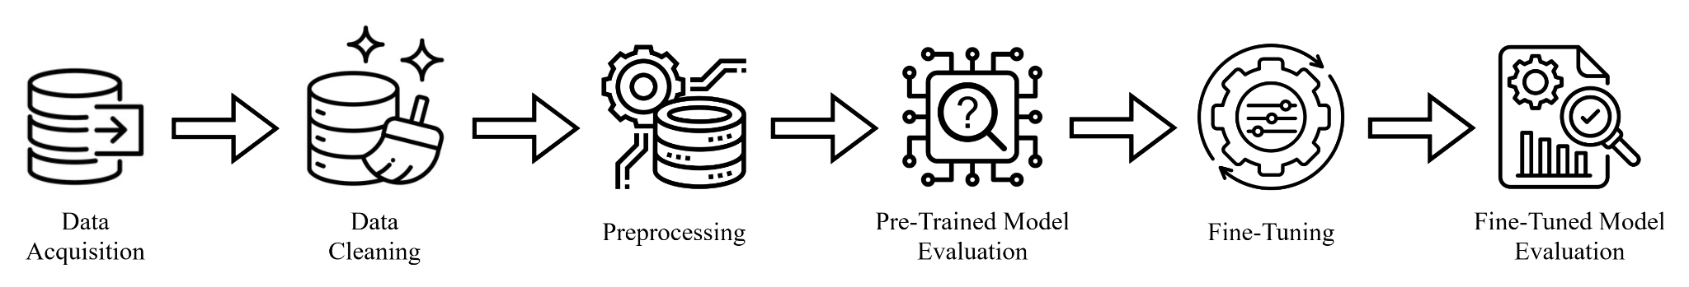

Figure 1. Model Framework

Dataset Description
The dataset used for this research is a large corpus for sarcasm research, training, and evaluating systems for sarcasm detection, containing sarcastic and non-sarcastic statements from Reddit. Each statement is self-annotated, which means sarcasm is labeled by the author, not an independent annotator, and provided with user, topic, and conversation context. Additionally, the dataset contains more than a million examples of sarcastic statements, exceeding all previous sarcasm corpora by an order of magnitude in size [30]. This section describes how the data was acquired and cleaned, and the characteristics of the data after it has been cleaned.

Data Acquisition
The dataset used in this study was imported from Kaggle. The Self-Annotated Reddit Corpus (SARC) is an existing dataset originally compiled by Mikhail Khodak, Nikunj Saunshi, and Kiran Vodrahall for their 2018 paper, "A Large Self-Annotated Corpus for Sarcasm". The sarcastic statements from the dataset were constructed from Reddit, a social media site wherein users communicate by commenting on submissions, resulting in a tree-like conversation structure such that each comment has a parent comment [31]. The dataset was chosen for this research because each statement has its corresponding topic and contextual information, which are significant to the study's objectives.

Data Cleaning
To furthermore improve the quality of data, a series of data cleaning steps were performed, such as removal of missing values, duplicates, and single characters. The comments were also converted into lowercase, and their lengths were filtered by setting a maximum length value. Comments that are more than 50 words and parent_comments that are more than 250 words were dropped from the dataset. This threshold was determined based on the distribution of text lengths, retaining the most frequent and representative entries. Length filtering was performed because, during tokenization, longer texts would be truncated and could affect label accuracy because the tokenization that was used only limits to 512 tokens.
For the purpose of this research, only the columns relevant to the objectives of the study were retained, specifically those containing comments, their equivalent labels, and the related context. Unnecessary columns were removed to focus simply on the contextual content. Then, the cleaned dataset is saved into a new file.

Preprocessing
Preprocessing involved data sampling, data tokenization, and data splitting. All these steps were performed repeatedly for each configuration to allow the researchers to assess the model on various numbers of data samples.
Data Sampling
Data sampling allowed the researchers to adjust the data size when conducting the experiments. Starting from a small subset of the dataset, the researchers gradually increased the data size to carefully observe the model’s performance while maintaining computational efficiency.
Tokenization
To prepare the text data to be fed to the model, a tokenizer was used to convert the format of the text so that the model can understand. Each comment was combined with its corresponding parent comment into a single text and was separated by a special token to help the model recognize the relationship between them.
The text data was processed into batches, converted into numerical representations, and shortened and padded if necessary. Attention masks were also created to help the model focus on important parts of the processed text data.
Data Splitting
Data splitting ensures the model is evaluated effectively by using different sets for training, validating, and testing. It reveals how the model performs on new and unseen data. For this research, an 80-10-10 split was used, which means 80% of the data was allocated for the training set, while the validation and testing sets each had 10% of the data. The size of the dataset allowed this approach as it is large enough to have a significant amount of data for training while leaving enough data for the validation and testing sets.

Fine-tuning
To improve the model’s performance, the pre-trained TinyBERT model was fine-tuned using different hyperparameters, which were selected based on the following:
- Batch size: is the number of samples used in one iteration before updating the model’s weights. This hyperparameter directly affects accuracy, computational efficiency, and speed. Choosing the optimal batch size number can help balance training time and generalization of the model [32].
- Learning rate: controls how much the model updates at each iteration. A higher learning rate can lead to faster convergence, but also instability. Adjusting this hyperparameter can help find the best balance between speed and stability [33].
- Epoch: is the number of complete passes through the entire training dataset. This hyperparameter was set to allow the model to learn underlying patterns in the data. By assigning the right value, epoch can help avoid the model from either underfitting or overfitting [34].
- Warm-up steps: gradually increase the learning rate from a small value to its initial value. This hyperparameter is useful for pretrained models as it stabilizes initial updates, which can help avoid abrupt weight changes [35].
- Weight decay rate: prevents the model from overfitting by penalizing large weights. By default, this hyperparameter is usually set to 0.01; however, increasing this value can improve the generalization of the model [33].
The model was fine-tuned by adjusting the settings of these hyperparameters and creating different combinations of configurations to balance model performance, resource usage, and training speed. This process was done repeatedly while tracking the model’s performance to identify the combination that produced the best results.

Evaluation
Both the pre-trained and the fine-tuned TinyBERT models were evaluated with the same validation and test sets to ensure a fair comparison. The pre-trained model was evaluated immediately without fine-tuning, serving as the baseline model, while the fine-tuned model was evaluated after its training and validation, assessing the final performance of the model.
After evaluation, the model made predictions on the test dataset. These predictions were used to generate a classification report by comparing them to the true labels. Then, the evaluation metrics were also computed using the model’s predictions. The evaluation metrics used for this research are defined as follows [31]:
Accuracy: The ratio of correct predictions to the total number of predictions.
Precision: The proportion of sarcasm predictions that are actually sarcasm.
Recall: The proportion of sarcastic statements that are correctly predicted as sarcastic.
F1 score: The harmonic mean of precision and recall, providing a balanced metric.
$Accuracy = \frac{Number of Correct Predictions}{Total Number of Predictions}$ OR $Accuracy =\frac{TP + TN}{TP + TN + FP + FN}$
$Precision = \frac{TP}{TP + FP}$
$Recall = \frac{TP}{TP + FN}$
$F1 score = 2⋅\frac{Precision ⋅ Recall}{Precision + Recall}$ OR $F1 score = 2⋅\frac{\frac{TP}{TP + FP} ⋅ \frac{TP}{TP + FN}}{\frac{TP}{TP + FP} + \frac{TP}{TP + FN}}$
To further analyze the model’s performance and results, a confusion matrix was generated from the model’s predictions. The confusion matrix categorizes predictions into four possible outcomes:
True Positive (TP): The text was predicted as sarcastic and was actually sarcastic.
False Positive (FP): The text was predicted as sarcastic but was actually not sarcastic.
True Negative (TN): The text was predicted as not sarcastic and was actually not sarcastic.
False Negative (FN): The text was predicted as not sarcastic but was actually sarcastic.
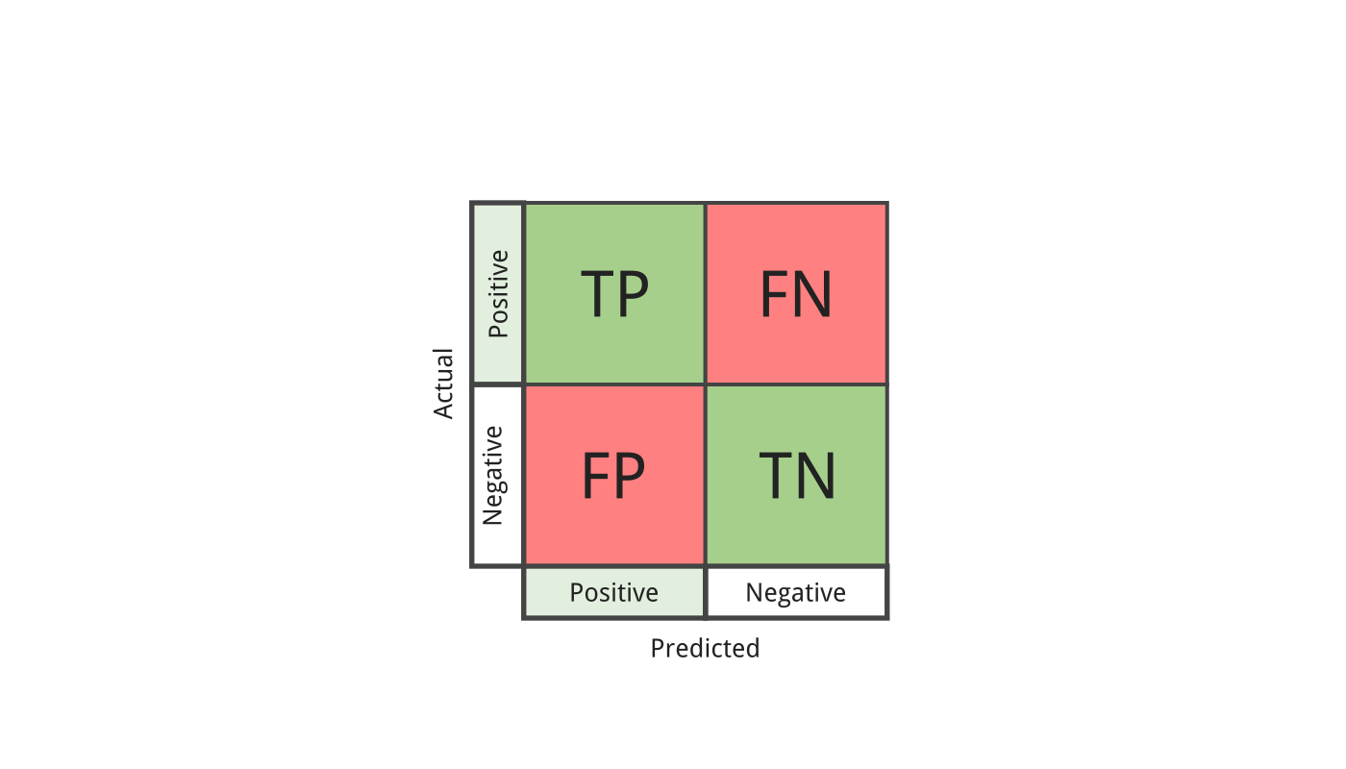

Figure 2. Confusion Matrix
CHAPTER IV
RESULTS AND DISCUSSIONS
This chapter presents the results of the sarcasm detection experiments using TinyBERT, followed by a discussion and interpretation of these findings.

Data Acquisition and Cleaning
The dataset initially contained 1,010,826 rows and ten columns, including label, comment, author, subreddit, score, ups, downs, date, created_utc, and parent_comment. For this research, the label, comment, and parent_comment were the only columns used. The rest of the columns that were not needed were removed from the dataset, leaving it with three columns.

Table 1. Removed Dataset Overview
Column Name | Description | Reason for Removal
author | The user who posted the comment | The research focuses on analyzing the context itself, not who posted it.
subreddit | A web forum of a particular topic where you can post links or create a self-post and discuss. | Sarcasm detection should be based on text, not on the topic or community bias.
score | Net upvotes | Upvotes/downvotes reflect popularity, not necessarily sarcasm.
ups | Total upvotes | It does not directly reflect sarcastic content.
downs | Total downvotes | It does not directly reflect sarcastic content.
date | Posting Date | Date information does not affect sarcasm expression.
created_utc | Created timestamp of posting | Time stamps do not affect sarcasm expression.

Table 2. Used Dataset Overview
Column Name | Description | Data Type | Example Value
label | Sarcastic (1) or Non-sarcastic (0) as indicated by the user who posted the comment. | Binary | 1
comment | The user’s comment being labeled as sarcastic or not. | Text | Oh, I never realized it was so easy, why had I, and every other lonely person on earth never thought...
parent_comment | The comment being replied to. | Text | A little self lovin can turn that 99 into a 100. Turn that frown upside down…
Missing Values: The remaining columns were checked for missing values, and the rows containing missing values were dropped from the dataset using the dropna() function.
Duplicates: Using the drop_duplicates() function, rows with the same comment and parent_comment were removed, keeping only the first instance. Additionally, duplicated comments with different labels were dropped from the dataset to reduce confusion for the model when training.
Lowercasing: Columns containing string values were converted to lowercase using the lower() function to ensure more consistent processing.
Single Characters: Comments and parent_comments consisting of only a single character were removed to further reduce noise, including words like “a” or “I”. These isolated characters often do not provide enough meaning or context to sarcasm detection.
Length Filtering: Comments exceeding 50 words and parent_comments exceeding 250 words were dropped from the dataset. This threshold was determined based on the distribution of text lengths, retaining the most frequent and representative entries.
Data Characteristics
After data cleaning, there were a total of 965,938 rows in the dataset. 488,930 (50.62%) of these were sarcastic, and 477,008(49.38%) were non-sarcastic.

Table 3. Label Distribution
Label | Count | Percentage
Sarcastic | 488, 930 | 50.62%
Non-sarcastic | 477, 008 | 49.38%

Preprocessing
Alongside the fine-tuning process, the whole preprocessing phase was repeated iteratively to prepare the dataset for each experiment. This ensured that the model was trained and evaluated consistently despite the varying configurations.
Data Sampling
The train_test_split() function was used to adjust the number of samples used in the experiments, specifying the exact proportions to be used while preserving the ratio of the two classes in the original dataset, sarcasm and non-sarcasm.
Tokenization
Using Hugging Face's AutoTokenizer from the transformers library, the corresponding BertTokenizer was automatically selected and used to tokenize and preprocess text for input into the TinyBERT model. A tokenization function was created to apply the tokenizer consistently across the whole dataset. The custom tokenize_data() function takes the comment and the parent_comment columns from the dataset and concatenates them into a single string using the format, “Parent Comment: <parent_comment> [SEP] Comment: <comment>”. The [SEP] token acts as a delimiter, helping the TinyBERT model distinguish between the two segments during processing. This structure allows the model to understand the contextual relationship between the comment and its parent comment. The combined strings were then tokenized in batches. During tokenization, each string underwent token splitting and vocabulary mapping, wherein each token was converted into its corresponding numeric ID based on the tokenizer’s vocabulary. The tokenizer then ensured all formats and max length defined were followed, and those sequences that exceeded the max length were truncated. Attention masks were also generated to differentiate actual tokens and padding tokens. These masks help the model focus only on the meaningful parts of the input while ignoring padded values. After processing all batches, the input_ids and attention_mask arrays were concatenated, forming the final tokenized dataset, which was then paired with the corresponding labels for model training and evaluation.
Data Splitting
The data was split into a training, validation, and testing set using the train_test_split() function. The dataset was initially divided into two: a training set and a temporary set. Then, the temporary set was split into validation and test sets. The training set consisted of 80% of the data, while the validation and test sets were both 10% of the data. An 80-10-10 split was decided on because of the dataset’s relatively large size, allowing a large training set while leaving enough data for validation and testing. The training set contains 772,750 statements, wherein 391,144 are sarcastic while 381,606 are non-sarcastic statements. Moreover, the validation set has 96,594 statements, wherein 48,893 are sarcastic while 47,701 are non-sarcastic. Lastly, the test set contains 96,594 statements, wherein 48,893 are sarcastic while 47,701 are non-sarcastic statements. All three datasets have 50.62% of sarcastic data and 49.38% of non-sarcastic data.

Table 4. Data Split Ratio
 | Sarcastic | Non-sarcastic | Overall Count | Percentage
Training set | 391,144  (50.62%) | 381,606 (49.38%) | 772,750 | 80%
Validation set | 48,893  (50.62%) | 47,701  (49.38%) | 96,594 | 10%
Testing set | 48,893  (50.62%) | 47,701  (49.38%) | 96,594 | 10%

Fine-tuning
The fine-tuning process began by assigning values to the hyperparameters, including batch size, learning rate, epoch, warm-up steps, and weight decay rate. These hyperparameters were adjusted using a random selection within a predefined scope to evaluate the model's performance. In total, 38 configurations were evaluated, which covered the range of learning rates, batch sizes, epoch counts, and weight decay values. During training, key metrics such as validation loss and accuracy were monitored to evaluate the efficacy of each configuration.
Class weights were also implemented to address the dataset's imbalance problem. Using the compute_class_weight() function, the weights for each class were calculated to ensure that the underrepresented class contributed equally to the loss function, preventing the model from being biased towards the more frequent label.
To control overfitting and optimize training time, the training procedure was stopped using EarlyStopping() when no further improvements were noted in the validation loss. Also, to ensure that the best model was retained, the ModelCheckpoint() function was added, which captures the model only at the point of the lowest validation loss during training.
Finally, the fit() method was used to train the TinyBERT model. While training the model, the learning process was accomplished by making predictions on each batch, and the predictions were compared to the actual labels through a cross-entropy loss function. The generated loss determines how the model’s weights are adjusted to improve efficacy. This cycle of prediction, evaluation, and weight updating was repeated across all batches and epochs, enabling the model to refine its understanding of the classification task over time.
This was done multiple times by the researchers while tracking each experiment’s performance results to find the combination of hyperparameters that gave the best results.

Hyperparameter Tuning
To analyze the impact of the hyperparameter settings on the performance of the TinyBERT model, a total of 38 experimental training and fine-tuning runs were conducted. These runs used different combinations of hyperparameters on varying dataset sizes to observe each of the hyperparameters’ influence on the model’s F1 Score and Accuracy. Heatmaps were then employed to visualize and identify trends and patterns across the different hyperparameter settings.
F1 Score and Accuracy are the primary metrics monitored in the experiments, as both provide key insights into the model’s prediction quality. The F1 Score balances precision and recall, demonstrating the model’s ability to correctly classify labels, while Accuracy measures the overall correctness of the model’s predictions. This makes the two metrics the most relevant and significant metrics in the study.
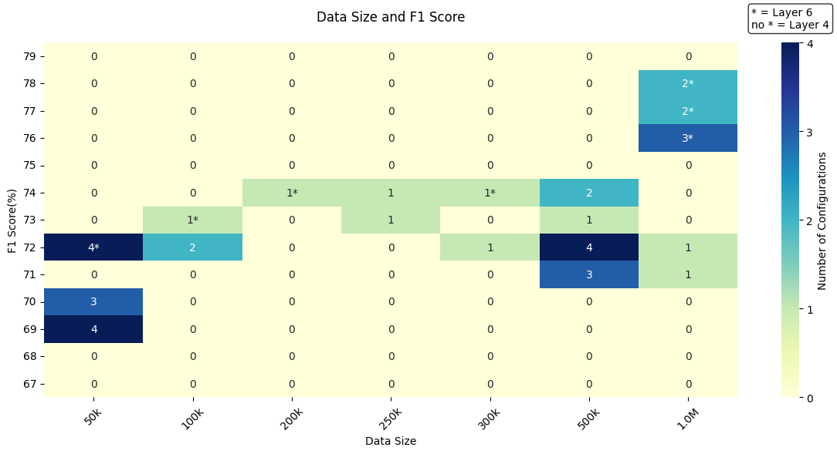

Figure 3. Data Size and F1 Score Heatmap
The heatmap shows how different dataset sizes affected F1 scores. Larger datasets inherently achieved higher F1 scores, especially 500,000 and 1,000,000, while smaller datasets like 50,000 obtained lower F1 scores. Additionally, the 6-layer TinyBERT models performed much better than the 4-layer models, achieving higher F1 scores even with smaller datasets. Overall, 6-layer TinyBERT with higher dataset sizes led to better F1 scores.
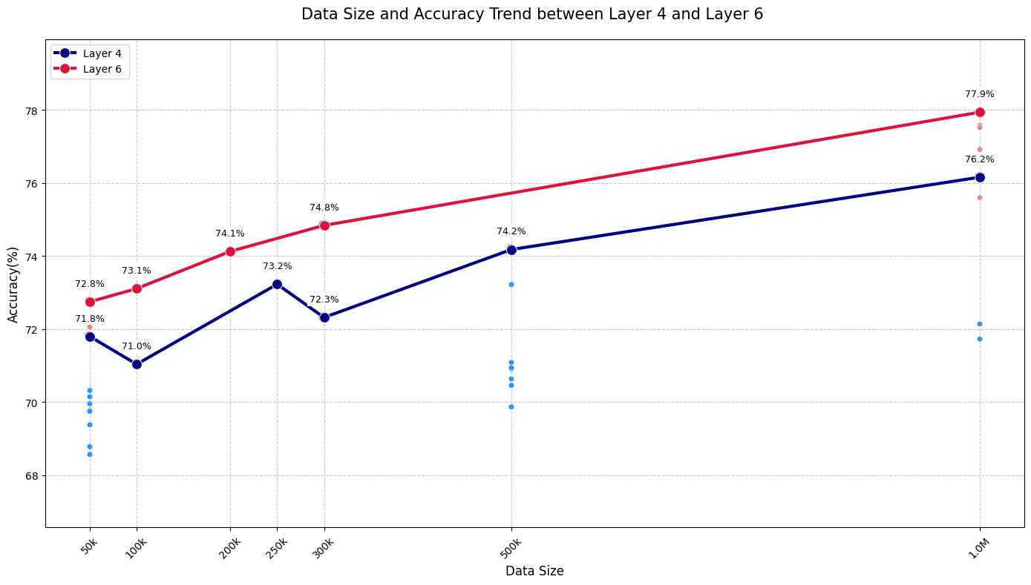

Figure 4. Data Size and Accuracy Trend Graph between 6-Layer and 4-Layer
The trend graph between the 4-layer model and the 6-layer model shows that the accuracy improves as the dataset increases from 50,000 to 1,000,000. Both layers have improved as the data size increases, however, the 6-layer model outperformed the 4-layer model. For example, at 50,000 data size, the highest accuracy for a 6-layer model reaches 72.8%, which is slightly higher than the 4-layer model’s 71.8%. This gap continues as the data size increases to 1,000,000, with the 6-layer model ending at 77.9% and the 4-layer model at 76.2%, showing more steady increments, while the 4-layer model has minor increments along the way. Overall, the 6-layer model with a larger data size is more reliable and accurate.
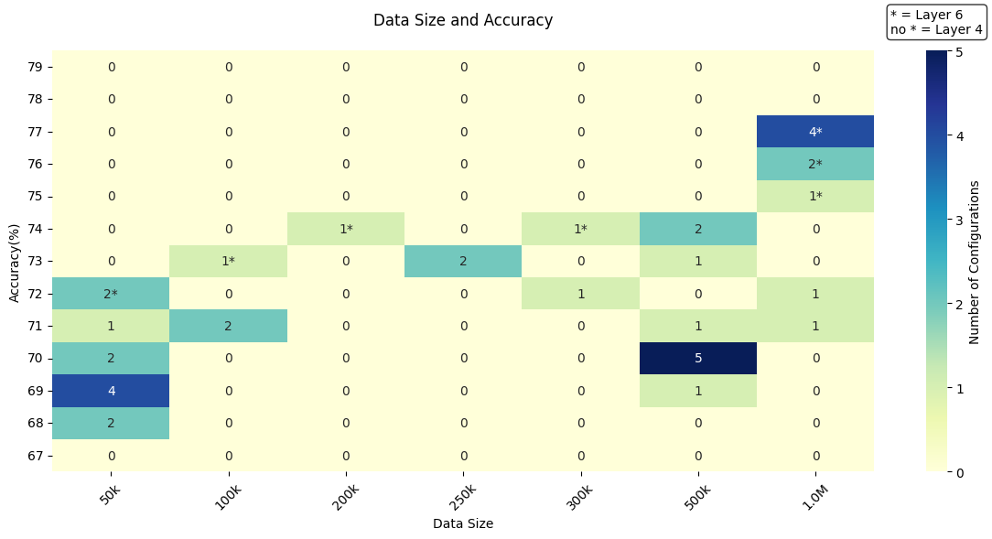

Figure 5. Data Size and Accuracy Heatmap
The heatmap shows how the dataset size affected accuracy. Similar to F1 Score, higher accuracy scores were generally reached with larger datasets, specifically 1,000,000, where the 6-layer model demonstrated higher performance compared to the 4-layer model. Smaller datasets like 50,000, paired with the 4-layer model, tended to result in lower accuracy. Overall, the 6-layer TinyBERT with a larger dataset led to better accuracy scores.
Epoch
Different numbers of epochs were used in the experiments to observe whether there is a direct relationship between the number of epochs and the model’s performance. In doing so, the researchers aimed to determine if additional training cycles contributed to improvements in the evaluation metrics.

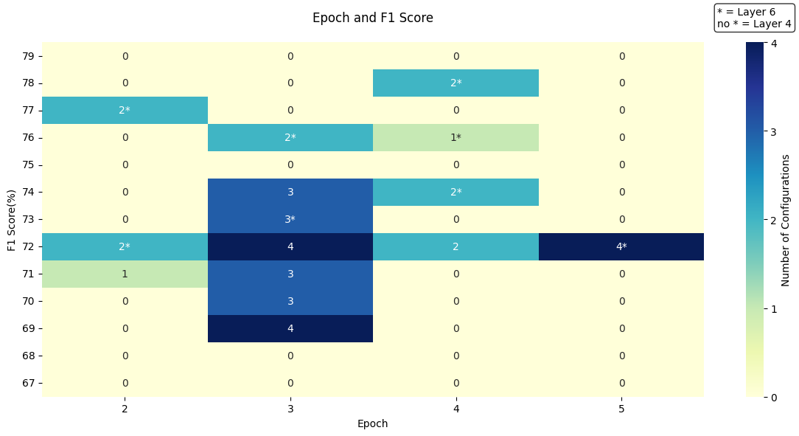

Figure 6. Epoch and F1 Score Heatmap
The heatmap shows how the number of epochs influenced F1 scores. F1 scores from 72% to 74% were the most common across epochs 3 to 5, with both 4-layer and 6-layer TinyBERT models. Epoch 3 has the highest frequency, as it was used to check if changes in other hyperparameter settings could lead to better results, since model improvement generally drops after epoch 2. Higher F1 scores were mostly achieved with the 6-layer model at epochs 2 and 4. Overall, 2 to 4 epochs tended to yield better F1 performance.
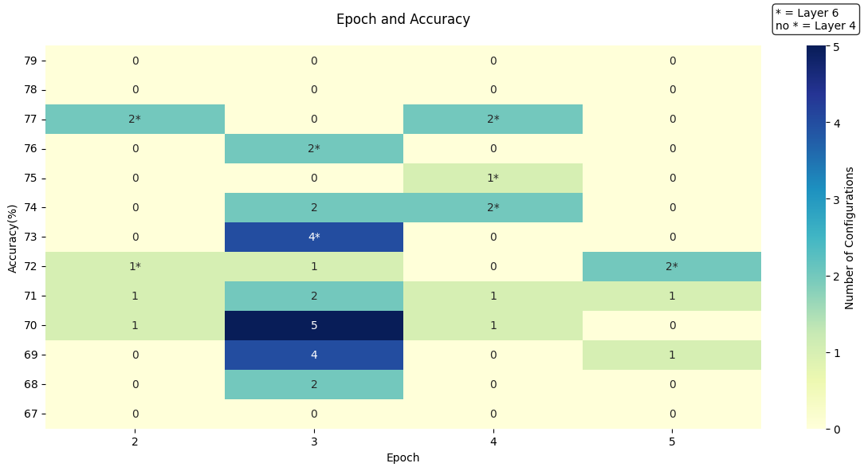

Figure 7. Epoch and Accuracy Heatmap
The heatmap shows how accuracy outcomes varied across different epoch values. As previously stated, epoch 3 appears most often due to its frequent use in experiments. While epoch 3 was frequently used, epoch 2 and epoch 4 have the highest accuracy, indicating that accuracy may not always correlate with the most commonly chosen configuration. Similar to the previous results, high accuracy scores were often achieved by the 6-layer TinyBERT.
Batch Size
Different batch sizes were explored in the experiments to observe their impact on the model’s training and overall performance. By adjusting the number of samples processed before each model update, the researchers aimed to determine how batch size influences the learning stability and the evaluation metrics.
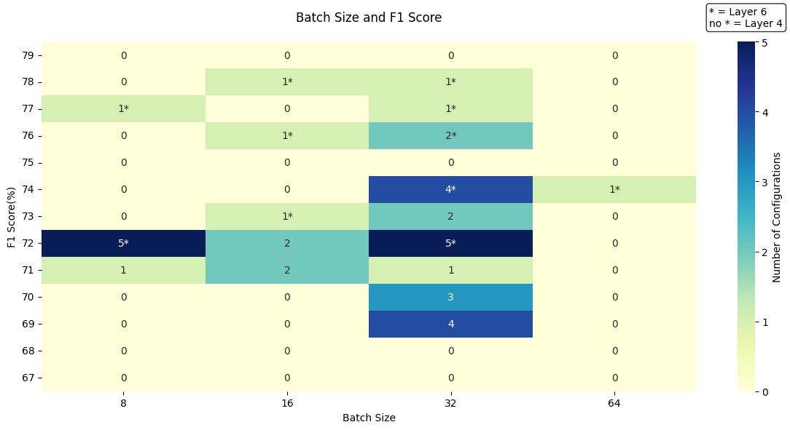

Figure 8. Batch Size and F1 Score Heatmap
The heatmap shows how the size of each batch influenced the F1 scores on different training runs. The most common scores were around 72% to 74% across various batch sizes for both 4-layer and 6-layer TinyBERT models. Batch sizes like 16 and 32 were the most effective choices during fine-tuning. In fact, batch 32 was the most frequent, as it was the preferred setting with steady results. Higher F1 scores, especially above 75%, were mainly achieved using the 6-layer model.
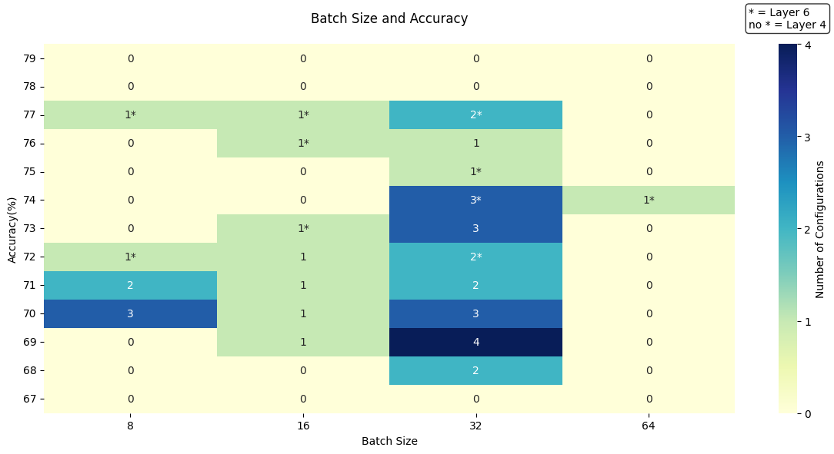

Figure 9. Batch Size and Accuracy Heatmap
The heatmap shows how different batch size determines the accuracy across the different training runs. Most accuracy scores were concentrated between 69% to 74% in both 4-layer and 6-layer TinyBERT models. All batch sizes, 8 to 32, were solid choices for achieving a consistent accuracy result. Among them, batch size 32 was the most frequent, implying that it was the most consistent and reliable for fine-tuning. High accuracy scores (above 75%) are commonly achieved by the 6-layer TinyBERT model.
Learning Rate
Various learning rates were tested to examine their effect on the model’s convergence and overall performance. The learning rate was adjusted to determine how different values influence the model’s ability to learn effectively and achieve higher evaluation metrics.

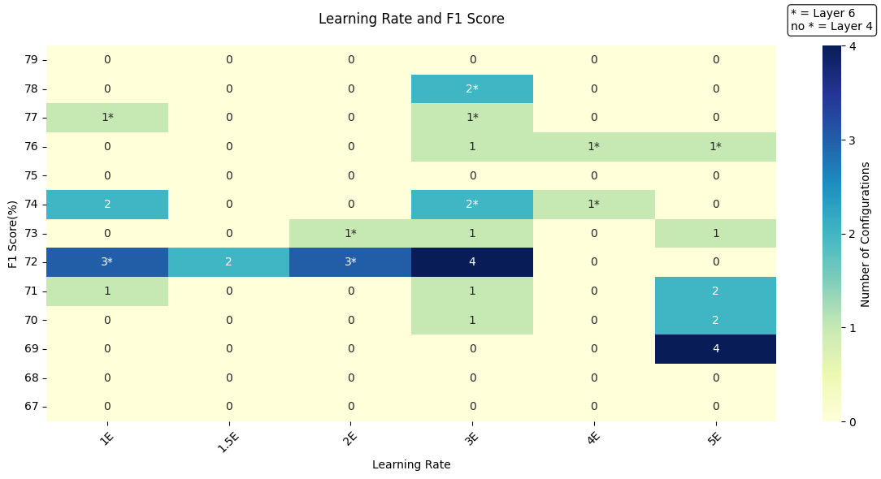

Figure 10. Learning Rate and F1 Score Heatmap
The heatmap shows the impact of learning rate on F1 scores during TinyBERT training runs. Moderate learning rates 3e-5 and 5e-5 led to the most consistent and reliable F1 scores. 3e-5 was the most frequent learning rate, implying that it is the most reliable learning rate for achieving a high F1 score. Higher F1 scores were mostly achieved with the 6-layer TinyBERT model, particularly at moderate learning rates. Overall, selecting a mid-range learning rate and combining it with the 6-layer model tended to produce higher F1 Score outcomes.

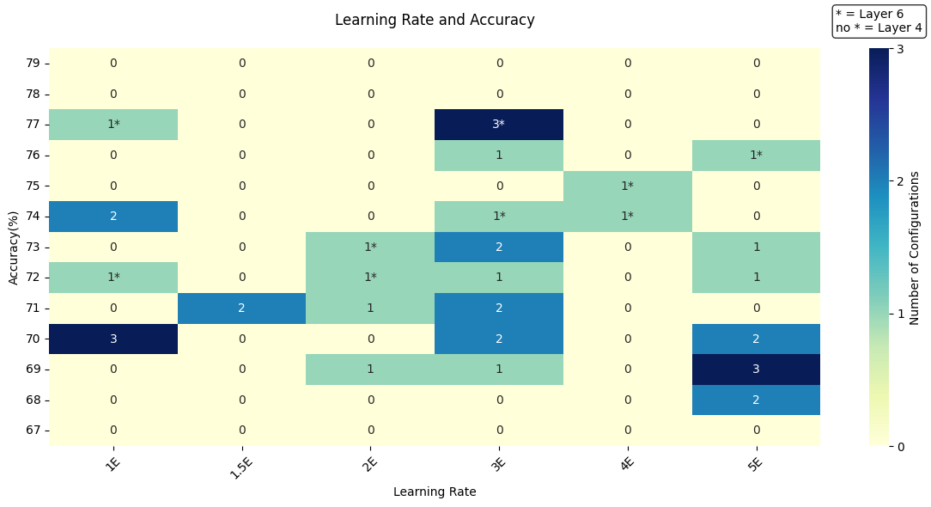

Figure 11. Learning Rate and Accuracy Heatmap
The heatmap reveals a strong pattern between learning rate choices and accuracy results. Moderate learning rate, particularly 3e-5, consistently concentrates high-performing outcomes around 74% to 77% accuracy. The 6-layer TinyBERT model often appears in the region with high accuracy scores, highlighting the advantage of deeper architectures.
Warm-up Steps
Warm-up steps were varied in the experiments to observe their influence on the model’s training stability and performance. To observe its effect on convergence and the overall evaluation metrics, the warm-up steps were adjusted accordingly to the other hyperparameter settings.
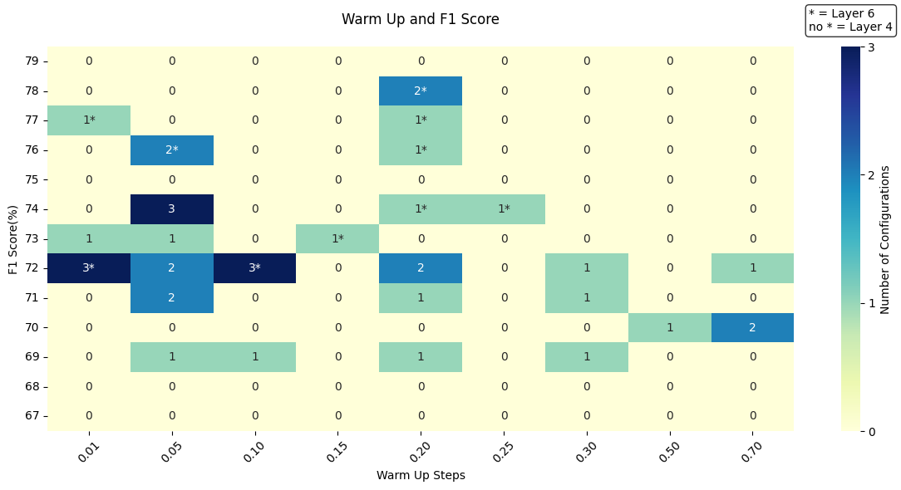

Figure 12. Warm Up and F1 Score Heatmap
The heatmap illustrates the relationship between Warm-up Steps and F1 Score in every training run. The most effective warm-up setting for reaching high F1 scores ranged from 0.05 to 0.20. This suggests that using an appropriate number of warm-up steps, not too low and not too high, helped the model to stabilize and train more effectively. Additionally, extreme warm-up step values (too low or too high) tended to result in fewer successful outcomes. High F1 Scores (76% to 78%) were more often associated with the 6-layer model.

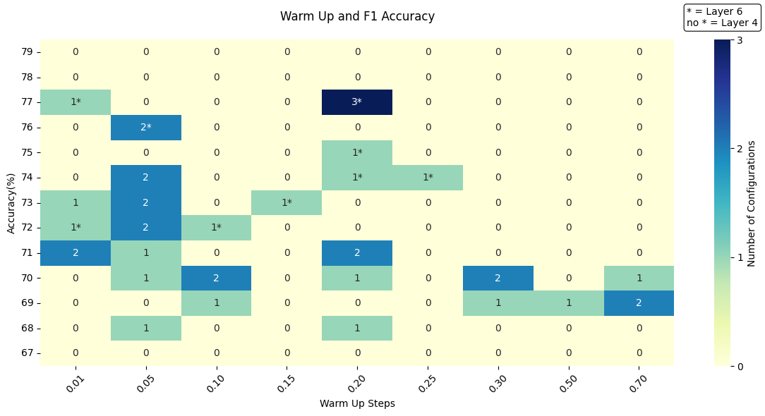

Figure 13. Warm Up and Accuracy Heatmap
The heatmap shows how different warm-up step counts affect model accuracy. Moderate warm-up counts, particularly around 0.01 and 0.20, achieved the highest accuracy, suggesting that it is the most reliable warm-up count for training the model. The highest accuracy scores, ranging from 74% to 77%, were mostly achieved by the 6-layer TinyBERT model, outperforming the 4-layer TinyBERT model.
Weight Decay
During the experiment, Weight Decay values were calibrated to observe their influence on the performance of the model’s architecture. Together with other hyperparameters, it was tuned to determine how various configurations affect the convergence behaviour and the evaluation metrics.

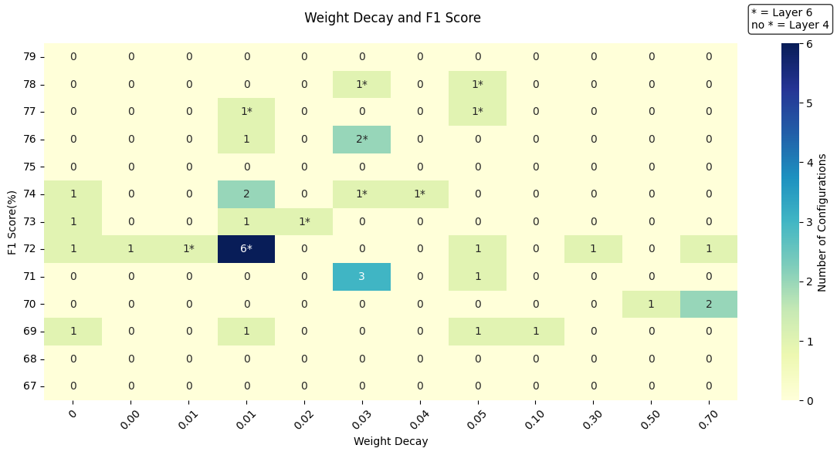

Figure 14. Weight Decay and F1 Score Heatmap
The heatmap shows how different weight decay value affects the model’s F1 scores. Weight decay, from 0.1 to 0.5 got the highest F1 score, achieving 76% to 78%. This indicates that having a moderate weight decay that is not too low or not too high is ideal in having a high F1 score. Additionally, the 6-Layer TinyBERT outperformed 4-Layer TinyBERT on achieving the highest F1 score. Proving to be a more dependable model for training.

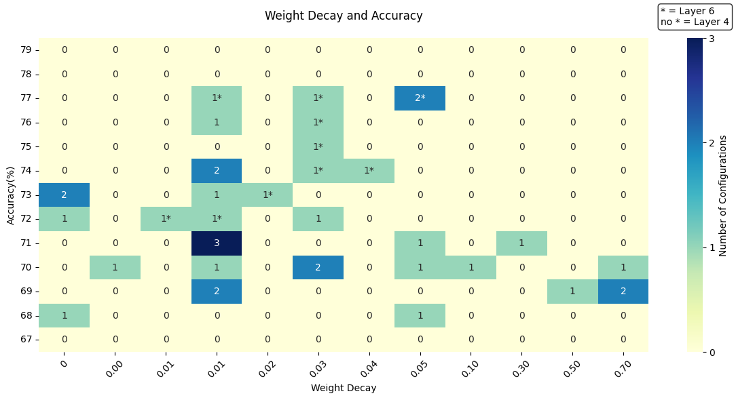

Figure 15. Weight Decay and Accuracy Heatmap
The heatmap shows how different weight decays influence the accuracy scores during training. The optimal accuracy value is between 0.01 and 0.05 by the 6-layer TinyBERT model in most training processes, outperforming the 4-layer TinyBERT model. This means that the 6-layer TinyBERT was more likely to have a consistently higher accuracy score than the TinyBERT 4-layer model. Additionally, selecting a medium weight decay was sure to achieve a higher accuracy measure than picking a weight decay value that's too high or too low.
Overall, the experiment provided a clear comprehension of how hyperparameters interact with evaluation metrics. It identified effective hyperparameter settings resulting in improved performance, primarily accuracy and F1 score. Results of the Experiment indicate that optimal configurations such as low epochs, warp-up values optimally tuned, and moderate weight decay enhanced the performance of TinyBERT. In addition, learning rate and number of epochs were the most influential factors on final evaluation scores. The 6-layer TinyBERT model performed better than the 4-layer TinyBERT model under all scenarios. Of special interest, by integrating these results, the researchers obtained the best evaluation result for sarcasm detection by fine-tuning the 6-layer TinyBERT with settings such as learning rate 3e-5, 4 epochs, batch size 16, 0.2 warm up steps, and weight decay rate 0.05 in an approximately 1,000,000 dataset samples. With this configuration, the model attained 77.94% accuracy and 78.46% F1 score.

Evaluation
The pre-trained and the fine-tuned TinyBERT models were evaluated using the evaluate() function. Then, using the predict() function, the model made predictions on the test dataset. These predictions were used to generate a classification report by comparing them to the true labels using the classification_report() function. Then, the evaluation metrics were also computed using the model’s predictions.

Pre-Trained TinyBERT Model Evaluation
The following table presents the evaluation results of the pre-trained 6-layer TinyBERT model, without fine-tuning, based on a test set containing approximately 100,000 samples. The results revealed that the pre-trained model’s predictions achieved a 50.84% accuracy, 50.85% precision, 86.61% recall, and 64.07% F1 score.

Table 5. Pre-trained 6-layer TinyBERT Performance Results
Accuracy | Precision | Recall | F1 score
50.8417 | 50.8459 | 86.6136 | 64.0763
The accuracy measures the overall correctness of the model’s predictions. In this case, an accuracy close to 50% with an almost balanced dataset between the two classes suggests that the model is making random predictions. Because the model has not been fine-tuned for sarcasm detection, the model fails to differentiate sarcastic and non-sarcastic statements.
The precision measures the correctness of positive predictions. Specifically, it tells how many were actually sarcastic out of all the comments the pre-trained model predicted as sarcastic. A 50% precision means that only half of the comments predicted as "sarcastic" were correct. This suggests that while the pre-trained model was capable of identifying sarcastic comments, it also over-predicted them.
The recall measures the model’s ability to identify all positive instances. Particularly, it shows how many sarcastic comments were correctly predicted by the pre-trained model. Since the recall is 86%, this means that the pre-trained model was able to identify many of the sarcastic comments. However, this does not necessarily imply that the model learned to identify sarcastic from non-sarcastic comments. Due to the model’s relatively low precision, this result only indicates that the model mostly predicted sarcasm even for non-sarcastic comments, which suggests that the pre-trained model had a bias towards predicting sarcasm.
The F1-score is a balanced measure of precision and recall. It is considered equally significant as accuracy, as it indicates that the model is good at identifying both positive and negative cases. Though 64% is not totally bad, having a higher F1 score is ideal, especially in this research, where false positives are more critical than false negatives. Thus, a higher precision score is needed to improve the model’s F1 score.
Overall, the pre-trained 6-layer TinyBERT model performed unreliably for the sarcasm detection task. Although TinyBERT had been trained on large and general text corpora, it had not been fine-tuned on a smaller task-specific dataset such as sarcasm detection. This limitation is evident in the results. While the model demonstrated a high recall (86.61%), its precision (50.85%) and accuracy (50.84%) indicated a tendency to over-predict sarcasm. To improve its correctness and precision, the model needed additional training and fine-tuning on a sarcasm detection dataset.
Pre-Trained TinyBERT Confusion Matrix
A confusion matrix was generated to visualize the distribution of predicted versus actual labels. This further evaluates the pre-trained 6-layer TinyBERT’s performance and its ability to differentiate sarcastic and non-sarcastic comments.
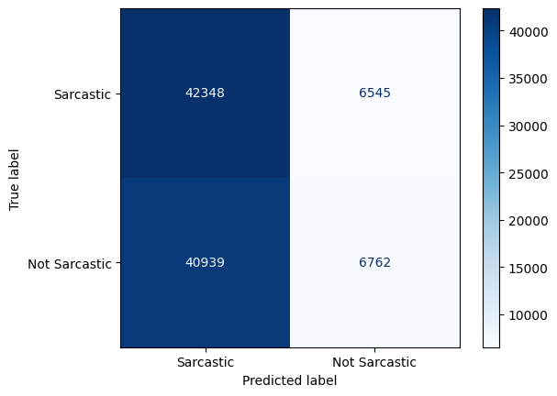

Figure 16. Pre-trained 6-layer TinyBERT Confusion Matrix Heatmap
The confusion matrix further supports the results presented in Table 4—the pre-trained 6-layer TinyBERT has a strong bias toward classifying comments as sarcastic. This can be seen from the high number of False Positives and the low number of True Negatives. Out of all the 47,701 non-sarcastic comments, only 6,762 were correctly predicted by the model, while the remaining 40,939 were incorrectly classified as sarcastic. Therefore, despite the high number of True Positives (42,348), the model is still considered unreliable, especially in identifying non-sarcastic comments. These results show that the pre-trained 6-layer TinyBERT model struggled to see the differences between sarcasm and non-sarcasm, misclassifying 86% of the non-sarcastic comments as sarcastic.

Fine-Tuned TinyBERT Model Evaluation
After training the 6-layer TinyBERT model on the training set of the Self-Annotated Reddit Corpus dataset, containing approximately 800,000 samples, and fine-tuning the model’s hyperparameters on multiple experiments, the table below reveals the model’s evaluation results, achieving a 77.94% accuracy, 77.57% precision, 79.37% recall, and 78.46% F1 score.

Table 6. Fine-tuned 6-layer TinyBERT Performance Results
Accuracy | Precision | Recall | F1 score
77.9417 | 77.5695 | 79.3733 | 78.4610
In comparison to the pre-trained model, the results of the fine-tuned 6-layer TinyBERT model showed significant improvement in all the evaluation metrics except for recall, where it decreased from 86.61% to 79.37%. However, this decrease is not an indication of a worse performance from the fine-tuned model, instead, it reflects a more balanced performance. In relevance to the other metrics, where all of them improved after fine-tuning, the decreased recall is simply due to the model’s reduced bias toward predicting sarcasm.
After fine-tuning, the model achieved an accuracy of 77.94%, a 27.10% rise from the 50.84% observed in the pre-trained model. This suggests that the model was able to learn significant features and patterns during fine-tuning, and is now better at detecting both sarcastic and non-sarcastic comments, in comparison to making blind predictions like the previous pre-trained model.
Precision improved from 50.85% to 77.57%, gaining a 26.72% increase. This means the fine-tuned model made more correct positive predictions than the pre-trained model, indicating that it became better at detecting sarcasm while reducing false positives.
Lastly, the F1-score increased from 64.08% to 78.46%, representing a better balance between precision and recall. As previously stated, even though the fine-tuned model experienced a decrease in recall, this trade-off resulted in a more reliable and accurate classifier overall, with improved ability to correctly identify both sarcastic and non-sarcastic comments. These improvements suggest that the fine-tuning process improved and corrected the bias toward detecting sarcasm.
Fine-Tuned TinyBERT Confusion Matrix
To further analyze the performance of the fine-tuned 6-layer TinyBERT model, a confusion matrix was generated, illustrating the model’s capability of identifying both sarcastic and non-sarcastic comments.
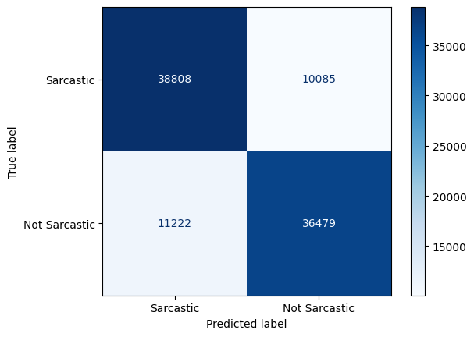

Figure 17. Fine-tuned 6-layer TinyBERT Confusion Matrix Heatmap
The confusion matrix of the fine-tuned 6-layer TinyBERT model demonstrates a significant improvement in performance compared to its pre-trained version, as reflected by the higher values along the diagonal corresponding to true positives and true negatives. The number of false positives dropped significantly from 40,939 to 11,222, only misclassifying 24% of the non-sarcastic comments in comparison to the pre-trained model’s 86% misclassification. This indicates that the fine-tuned model had learned to distinguish sarcasm from non-sarcasm better. Additionally, the number of true negatives increased from 6,762 to 36,482, showing substantial results by correctly identifying approximately 76% of the non-sarcastic content. Although the true positives decreased and the false negatives increased slightly, this trade-off is acceptable given the overall improvement in the model’s evaluation metrics.

Evaluation Metric Comparison
The following graph presents a comparison of accuracy, precision, recall, and F1 Score between the pre-trained and fine-tuned 6-layer TinyBERT models, further highlighting the performance improvements discussed earlier.
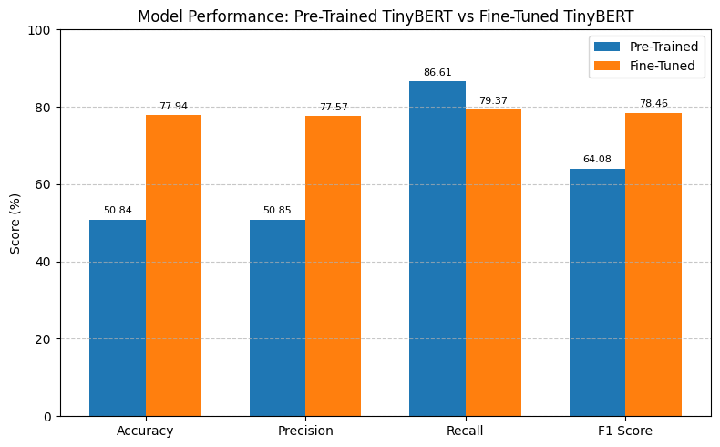

Figure 18. Comparison of Evaluation Metrics for Pre-trained and Fine-tuned TinyBERT
As shown in the graph, there is a clear improvement in performance after the model has been fine-tuned for sarcasm detection, with accuracy and precision showing the most substantial increase among the four metrics. This improvement suggests that the fine-tuned model has become better at making correct predictions overall and more reliable in detecting sarcastic comments, while reducing the number of incorrect positive predictions. Although the graph shows a slight decrease in recall, it did not negatively impact the model’s overall performance, as reflected by the small increase in F1 Score. Overall, the fine-tuned 6-layer TinyBERT model provided a more reliable and balanced performance than the pre-trained model, suggesting that the training and fine-tuning worked effectively for the sarcasm detection task.

CHAPTER V

CONCLUSION AND RECOMMENDATIONS

This chapter presents the conclusions derived from the study and provides recommendations based on the researchers’ findings.

Conclusion
The study explored the effectiveness of the TinyBERT model for contextual analysis in sarcasm detection. A pretrained 6-layer TinyBERT model was used and fine-tuned using the Self-annotated Reddit Corpus (SARC). Furthermore, evaluation metrics such as Accuracy, Precision, Recall, and F1 score were used for the Pre-trained and Fine-tuned TinyBERT model for evaluation. The goal was to assess the models' performance in classifying comments into sarcastic and non-sarcastic classes.
The dataset used in the study was imported from Kaggle, but originally compiled by Mikhail Khodak, Nikunj Saunshi, and Kiran Vodrahalli. Before training, the dataset was cleaned using multiple Python functions to address noise such as unnecessary columns, missing values, duplicates, single characters, long comments, and inconsistent character casing. Then, the training process involved tuning the hyperparameters, batch size, learning rate, epoch, warm-up steps, and weight decay rate. After testing 38 different hyperparameter configurations, the model achieved 77.94% in accuracy, 77.57% in precision, 79.37% in recall, and 78.46% in F1 score, an improvement over the pre-trained model, which produced 50.84% accuracy, 50.85% precision, 86.61% recall, and 64.07% F1 score without prior fine-tuning.
The results support the effectiveness of TinyBERT for sarcasm detection, highlighting the importance of domain-specific training, as the most substantial improvement in model performance occurred after fine-tuning TinyBERT on a sarcasm-labeled dataset. While further adjustments to hyperparameters led to incremental gains, the study demonstrates that aligning the training data with the task domain plays a critical role in enhancing model effectiveness. The consistent improvement from smaller to larger training samples also suggests that performance benefits are maintained as the model is exposed to more relevant examples.

Recommendations
Based on the findings of the study, the researchers recommend the following for future research and practical applications of TinyBERT in sarcasm detection:
- Real World Integration
Implement TinyBERT for sarcasm detection task in a real-world application by fine-tuning the model using domain-specific data, such as customer feedback or user-generated content. This will leverage TinyBERT’s ability to learn from domain-specific training and allow the model to adapt to the language, tone, and other linguistic patterns of the specific domain, enhancing its performance and contextual accuracy.
- Evaluation on Diverse Datasets
To assess TinyBERT’s generalizability, it is recommended to evaluate the model on datasets different from the training data. The purpose of this evaluation is to have a better understanding of the model’s ability to capture the nuances and complexity of sarcasm across different platforms and contexts and to ensure robustness in diverse real-world scenarios.
- Comparison With Larger Transformer Models
Compare TinyBERT to larger models, such as BERT and RoBERTa, to analyze how well it performs in terms of accuracy, model size, and data efficiency. This helps assess whether a lightweight model, like TinyBERT, has advantages in resource-constrained environments. Comparing TinyBERT with larger models helps to determine the suitable model depending on the task, such as contextual analysis in sarcasm detection, and the availability of computational resources.
- Inclusion of Emoji
Employ datasets with emojis, as emojis are likely to be a hint for sarcasm. Adding emojis will enhance model performance to detect sarcasm in social media and messaging apps. For instance, a smiley can reverse the literal meaning of the sentence. Adding emojis in TinyBERT can help the model enhance contextual knowledge and prediction.
- Train the model in different languages
As TinyBERT has been trained in the English language using the SARC dataset, it can be extended to different languages to understand how sarcasm is expressed in text-based context. Sarcasm in text often depends on context, wording, and cultural nuances, which differ from language to language. Training on different language text datasets would enable TinyBERT to detect sarcasm in a wide range, making it more useful for global text.

REFERENCES
[1] “sarcasm,” Merriam-Webster Dictionary. Apr. 29, 2025. [Online]. Available: https://www.merriam-webster.com/dictionary/sarcasm
[2] A. Reyes, P. Rosso, and D. Buscaldi, “From humor recognition to irony detection: The figurative language of social media,” Data & Knowledge Engineering, vol. 74, pp. 1–12, doi: 10.1016/j.datak.2012.02.005
[3] A.-C. Băroiu and Ș. Trăușan-Matu, “Automatic Sarcasm Detection: Systematic Literature Review,” Information, vol. 13, no. 8, 2022, doi: 10.3390/info13080399
[4] “New Approaches to Detecting Sarcasm in Text with AI,” Hivo.co, 2023. [Online]. Available: https://hivo.co/blog/detecting-sarcasm-in-text-with-ai-a-new-approach
[5] L. Kumar, A. Somani, and P. Bhattacharyya, “Approaches for Computational Sarcasm Detection: A Survey,” 2017. [Online]. Available: https://api.semanticscholar.org/CorpusID:9503193
[6] D. Šandor and M. Bagic Babac, “Sarcasm detection in online comments using machine learning,” Information Discovery and Delivery, vol. 52, no. 2, pp. 213-226, July 31, 2023, doi: 10.1108/IDD-01-2023-0002
[7] X. Jiao et al., “TinyBERT: Distilling BERT for Natural Language Understanding,” arXiv.org, Sep. 23, 2019. [Online]. Available: https://arxiv.org/abs/1909.10351
[8] G. Abercrombie and D. Hovy, “Putting Sarcasm Detection into Context: The Effects of Class Imbalance and Manual Labelling on Supervised Machine Classification of Twitter Conversations,” in Proceedings of the ACL 2016 Student Research Workshop, 2016, pp. 107–113, doi: 10.18653/v1/p16-3016
[9] W. Chen, F. Lin, G. Li, and B. Liu, “A survey of automatic sarcasm detection: Fundamental theories, formulation, datasets, detection methods, and opportunities,” Neurocomputing, vol. 578, p. 127428, Apr. 2024, doi: https://doi.org/10.1016/j.neucom.2024.127428
[10] M. Khodak, N. Saunshi, and K. Vodrahalli, “A large Self-Annotated Corpus for Sarcasm,” arXiv.org, Apr. 19, 2017. [Online]. Available: https://arxiv.org/abs/1704.05579
[11] T. M. A. Sarah Yasir Abd-Alsajad, “Purposes and Structures of Sarcasm: A Pragmatic Study,” Zenodo (CERN European Organization for Nuclear Research), Oct. 2021, doi: 10.5281/zenodo.5602029
[12] L. Xu and V. Xu, “Project Report: Sarcasm Detection,” [Online]. Available: https://web.stanford.edu/class/archive/cs/cs224n/cs224n.1194/reports/custom/15791781.pdf
[13] N. A. Helal, A. Hassan, N. L. Badr, and Y. M. Afify, “A contextual-based approach for sarcasm detection,” Scientific Reports, vol. 14, no. 1, p. 15415, Jul. 2024, doi: 10.1038/s41598-024-65217-8
‌[14] D. Hazarika, S. Poria, S. Gorantla, E. Cambria, R. Zimmermann, and R. Mihalcea, “CASCADE: Contextual Sarcasm Detection in Online Discussion Forums,” arXiv (Cornell University), pp. 1837–1848, May 2018, [Online]. Available: https://arxiv.org/pdf/1805.06413.pdf
[15] “Indonesian Sarcasm Detection Using Convolutional Neural Network,” International Journal of Emerging Trends in Engineering Research, vol. 8, no. 9, pp. 4952–4955, Sep. 2020, doi: 10.30534/ijeter/2020/10892020
[16] D. Šandor and M. Bagić Babac, “Sarcasm detection in online comments using machine learning,” Information Discovery and Delivery, vol. 52, no. 2, pp. 213–226, Jul. 2023, doi: 10.1108/idd-01-2023-0002
‌[17] L. H. Son, A. Kumar, S. R. Sangwan, A. Arora, A. Nayyar, and M. Abdel-Basset, “Sarcasm Detection Using Soft Attention-Based Bidirectional Long Short-Term Memory Model With Convolution Network,” IEEE Access, vol. 7, pp. 23319–23328, Jan. 2019, doi: 10.1109/access.2019.2899260
[18] P. Verma, N. Shukla, and A. P. Shukla, “Techniques of Sarcasm Detection: A review,” in 2021 International Conference on Advance Computing and Innovative Technologies in Engineering (ICACITE), pp. 968–972, Mar. 2021, doi: 10.1109/icacite51222.2021.9404585
[19] A. Vaswani et al., “Attention is all you need,” arXiv (Cornell University), Jan. 2017, doi: 10.48550/arxiv.1706.03762
[20] T. Wolf et al., “HuggingFace’s Transformers: State-of-the-art natural language processing,” arXiv (Cornell University), Jan. 2019, doi: 10.48550/arxiv.1910.03771
[21] E. Savini and C. Caragea, “Intermediate-Task Transfer Learning with BERT for Sarcasm Detection,” Mathematics, vol. 10, no. 5, p. 844, Mar. 2022, doi: 10.3390/math10050844
[22] A. Abaskohi, A. Rasouli, T. Zeraati, and B. Bahrak, “UTNLP at SemEval-2022 Task 6: A Comparative Analysis of Sarcasm Detection using generative-based and mutation-based data augmentation,” Proceedings of the 16th International Workshop on Semantic Evaluation (SemEval-2022), 2022, doi: 10.18653/v1/2022.semeval-1.135
[23] D. K. Sharma, B. Singh, S. Agarwal, N. Pachauri, A. A. Alhussan, and H. A. Abdallah, “Sarcasm Detection over Social Media Platforms Using Hybrid Ensemble Model with Fuzzy Logic,” Electronics, vol. 12, no. 4, p. 937, Feb. 2023, doi: 10.3390/electronics12040937
[24] A. K. Jayaraman, T. E. Trueman, G. Ananthakrishnan, S. Mitra, Q. Liu, and E. Cambria, “Sarcasm Detection in News Headlines using Supervised Learning,” in 2022 International Conference on Artificial Intelligence and Data Engineering (AIDE), pp. 288–294, Dec. 2022, doi: 10.1109/aide57180.2022.10060855
[25] Chiara, “Efficient Language Models with TinyBERT and Databricks,” Bitrock, Nov. 14, 2024. [Online]. Available: https://bitrock.it/blog/efficient-language-models-with-tinybert-and-databricks.html
[26] “TinyBERT Distilling BERT for NLU | Restackio.” [Online]. Available: https://www.restack.io/p/tinybert-answer-nlu-cat-ai
[27] R. Misra and P. Arora, “Sarcasm detection using news headlines dataset,” AI Open, vol. 4, pp. 13–18, Jan. 2023, doi: 10.1016/j.aiopen.2023.01.001
[28] “Papers with Code - iSarcasm: A Dataset of Intended Sarcasm,” Nov. 08, 2019. [Online]. Available: https://paperswithcode.com/paper/isarcasm-a-dataset-of-intended-sarcasm
[29] S. Castro, D. Hazarika, V. Pérez-Rosas, R. Zimmermann, R. Mihalcea, and S. Poria, “Towards Multimodal Sarcasm Detection (An Obviously Perfect Paper),” in Proceedings of the 57th Annual Meeting of the Association for Computational Linguistics, pp. 4619–4629, 2019, doi: 10.18653/v1/p19-1455
[30] “Papers with Code - Sarcasm Corpus V2 Dataset.” [Online]. Available: https://paperswithcode.com/dataset/sarcasm-corpus-v2
[31] O. Dorssers, "Sarcasm detection in structured text using DistilBERT: Evaluating the impact of text normalization on model performance," ARNO - Tilburg University Repository. June 6, 2024. [Online]. Available: https://arno.uvt.nl/show.cgi?fid=171929
[32] “Epochs, Batch Size, Iterations - How they are Important,” Sabrepc.com, 2024. [Online]. Available: https://www.sabrepc.com/blog/Deep-Learning-and-AI/Epochs-Batch-Size-Iterations
[33] “Glossary: LLM fine-tuning hyperparameters,” Modal, 2024. [Online]. Available: https://modal.com/blog/fine-tuning-llms-hyperparameters-glossary-article
[34] “What are Fine-tuning Hyperparameters and How to Set Them | Entry Point AI,” Entrypointai.com, 2023. [Online]. Available: https://www.entrypointai.com/blog/fine-tuning-hyperparameters
[35] “What parameters can be adjusted when fine-tuning a Sentence Transformer (e.g., learning rate, batch size, number of epochs) and how do they impact training?,” Milvus.io, 2025. [Online]. Available: https://milvus.io/ai-quick-reference/what-parameters-can-be-adjusted-when-finetuning-a-sentence-transformer-eg-learning-rate-batch-size-number-of-epochs-and-how-do-they-impact-training

‌

‌

Appendix A
Setup and Imports
import random
import os
import numpy as np
import tensorflow as tf
import zipfile
import pandas as pd
from transformers import AutoTokenizer, TFAutoModelForSequenceClassification, create_optimizer, Trainer, TrainingArguments, EarlyStoppingCallback
from sklearn.utils.class_weight import compute_class_weight
from sklearn.model_selection import train_test_split
from sklearn.metrics import confusion_matrix, ConfusionMatrixDisplay, accuracy_score, precision_score, recall_score, f1_score, classification_report

tokenizer = AutoTokenizer.from_pretrained("huawei-noah/TinyBERT_General_6L_768D")
model = TFAutoModelForSequenceClassification.from_pretrained("huawei-noah/TinyBERT_General_6L_768D", num_labels=2, from_pt=True)
Dataset Acquisition and Cleaning
df = pd.read_csv(
'/content/train-balanced-sarcasm.csv',
usecols=['comment', 'parent_comment', 'label'],
dtype={'label': 'int8'}
).dropna().drop_duplicates(subset=['comment', 'parent_comment'], keep='first')

df['comment'] = df['comment'].str.lower()
df['parent_comment'] = df['parent_comment'].str.lower()

repeated = df.groupby('comment')['label'].nunique()
diff_labels = repeated[repeated > 1].index
df = df[~df['comment'].isin(diff_labels)].copy()

df = df[df['comment'].str.len() > 1]
df = df[df['parent_comment'].str.len() > 1]

D df = df[['comment', 'parent_comment', 'label']]

df = pd.read_csv("/content/drive/MyDrive/Colab_Notebooks/cleaned-sarcasm.csv", )
Tokenization
def tokenize_data(comments, parent_comments, batch_size=1000, max_length=256):
input_ids, attention_mask = [], []

for i in range(0, len(comments), batch_size):
batch_comments = comments[i:i+batch_size]
batch_parents = parent_comments[i:i+batch_size]

combined_text = [
f"Parent Comment: {parent} [SEP] Comment: {comment}"
for parent, comment in zip(batch_parents, batch_comments)
]

batch_tokens = tokenizer(
combined_text,
max_length=max_length,
truncation=True,
padding='max_length',
return_tensors='np'
)

input_ids.append(batch_tokens['input_ids'])
attention_mask.append(batch_tokens['attention_mask'])

return {
'input_ids': np.concatenate(input_ids),
'attention_mask': np.concatenate(attention_mask),
}

tokenized_data = tokenize_data(df['comment'], df['parent_comment'])
tokenized_data

input_ids = tokenized_data['input_ids']
attention_mask = tokenized_data['attention_mask']
labels = df['label'].values
Dataset Splitting
X_train_ids, X_temp_ids, mask_train, mask_temp, y_train, y_temp = train_test_split(
input_ids,
attention_mask,
labels,
test_size=0.2,
random_state=42,
stratify=labels
)

X_val_ids, X_test_ids, mask_val, mask_test, y_val, y_test = train_test_split(
X_temp_ids,
mask_temp,
y_temp,
test_size=0.5,
random_state=42,
stratify=y_temp
)

def create_dataset(input_ids, attention_mask, labels, batch_size=16, shuffle=False):
dataset = tf.data.Dataset.from_tensor_slices((
{"input_ids": input_ids, "attention_mask": attention_mask},
labels

))
if shuffle:
dataset = dataset.shuffle(buffer_size=len(labels))
dataset = dataset.batch(batch_size).prefetch(tf.data.AUTOTUNE)
return dataset

train_dataset = create_dataset(X_train_ids, mask_train, y_train, shuffle=True)
val_dataset = create_dataset(X_val_ids, mask_val, y_val)
test_dataset = create_dataset(X_test_ids, mask_test, y_test)
Hyperparameter Configuration
batch_size = 16
epochs = 4
dataset_size = 1000000

num_training_steps = (dataset_size * epochs) // batch_size
num_warmup_steps = int(0.2 * num_training_steps)

optimizer, scheduler = create_optimizer(
num_train_steps=num_training_steps,
num_warmup_steps=num_warmup_steps,
init_lr=3e-5,
weight_decay_rate=0.05
)
Compile Model
model.compile(
optimizer=optimizer,
loss=tf.keras.losses.SparseCategoricalCrossentropy(from_logits=True),
metrics=['accuracy']
)
Pre-trained Model Evaluation
val_results = model.evaluate(val_dataset)
print(f"Validation loss: {val_results[0]}, Validation accuracy: {val_results[1]}")

test_results = model.evaluate(test_dataset)
print(f"Test loss: {test_results[0]}, Test accuracy: {test_results[1]}")
Pre-trained Model Predictions
predictions = model.predict(test_dataset)
predicted_labels = tf.argmax(predictions.logits, axis=-1).numpy()
print(classification_report(y_test, predicted_labels))
Pre-trained Model Result
pre_accuracy = accuracy_score(y_test, predicted_labels)*100
pre_precision = precision_score(y_test, predicted_labels)*100
pre_recall = recall_score(y_test, predicted_labels)*100
pre_f1 = f1_score(y_test, predicted_labels)*100

print(f"Accuracy: {pre_accuracy}")
print(f"Precision: {pre_precision}")
print(f"Recall: {pre_recall}")
print(f"F1 Score: {pre_f1}")
Pre-trained Model Confusion Matrix
cm_draft = confusion_matrix(y_test, predicted_labels)
print(cm_draft)

cm = cm_draft[[1, 0], :][:, [1, 0]]
print("\nConfusion Matrix:")
print(cm)

labels=["Sarcastic", "Not Sarcastic"]

disp = ConfusionMatrixDisplay(confusion_matrix=cm, display_labels=labels)
disp.plot(cmap="Blues")
Fine-tuning
class_weights = compute_class_weight(class_weight='balanced', classes=np.unique(df['label']), y=df['label'])

class_weight_dict = {i : class_weights[i] for i in range(len(class_weights))}
print(class_weight_dict)

early_stopping = tf.keras.callbacks.EarlyStopping(
monitor='val_loss',
patience=2,
verbose=1
)

checkpoint_path = "/content/drive/MyDrive/checkpoints/cp-6L-Ky-3e-2-{epoch:03d}.keras"
checkpoint_dir = os.path.dirname(checkpoint_path)
os.makedirs(checkpoint_dir, exist_ok=True)

model_checkpoint = tf.keras.callbacks.ModelCheckpoint(
filepath=checkpoint_path,
verbose=1,
monitor='val_loss',
save_best_only=True
)

history = model.fit(
train_dataset,
validation_data=val_dataset,
epochs=4,
batch_size=32,
class_weight=class_weight_dict,
callbacks=[early_stopping, model_checkpoint, tensorboard_callback, batch_logger],
verbose=1
)
Fine-tuned Model Evaluation
val_results = model.evaluate(val_dataset)
print(f"Validation loss: {val_results[0]}, Validation accuracy: {val_results[1]}")

test_results = model.evaluate(test_dataset)
print(f"Test loss: {test_results[0]}, Test accuracy: {test_results[1]}")
Fine-tuned Model Predictions
predictions = model.predict(test_dataset)
predicted_labels = tf.argmax(predictions.logits, axis=-1).numpy()
print(classification_report(y_test, predicted_labels))
Fine-tuned Model Result
trained_accuracy = accuracy_score(y_test, predicted_labels)*100
trained_precision = precision_score(y_test, predicted_labels)*100
trained_recall = recall_score(y_test, predicted_labels)*100
trained_f1 = f1_score(y_test, predicted_labels)*100

print(f"Accuracy: {trained_accuracy}")
print(f"Precision: {trained_precision}")
print(f"Recall: {trained_recall}")
print(f"F1 Score: {trained_f1}")
Fine-tuned Model Confusion Matrix
cm_draft = confusion_matrix(y_test, predicted_labels)
print(cm_draft)

cm = cm_draft[[1, 0], :][:, [1, 0]]
print("\nConfusion Matrix:")
print(cm)

labels=["Sarcastic", "Not Sarcastic"]

disp = ConfusionMatrixDisplay(confusion_matrix=cm, display_labels=labels)
disp.plot(cmap="Blues")
Pre-trained vs Fine-tuned Performance Comparison
metrics = ['Accuracy', 'Precision', 'Recall', 'F1 Score']

# Both in percentage
pre_metrics = [pre_accuracy, pre_precision, pre_recall, pre_f1]
trained_metrics = [trained_accuracy, trained_precision, trained_recall, trained_f1]

x = np.arange(len(metrics))
width = 0.35

plt.figure(figsize=(8, 5))
bars1 = plt.bar(x - width/2, pre_metrics, width, label='Pre-Trained')
bars2 = plt.bar(x + width/2, trained_metrics, width, label='Fine-Tuned')

plt.ylabel('Score (%)')
plt.title('Model Performance: Pre-Trained TinyBERT vs Fine-Tuned TinyBERT')
plt.xticks(x, metrics)
plt.ylim(0, 100)
plt.legend()
plt.grid(axis='y', linestyle='--', alpha=0.7)

for bar in bars1:
height = bar.get_height()
plt.text(bar.get_x() + bar.get_width()/2, height + 1, f'{height:.2f}', ha='center', va='bottom', fontsize=8)

for bar in bars2:
height = bar.get_height()
plt.text(bar.get_x() + bar.get_width()/2, height + 1, f'{height:.2f}', ha='center', va='bottom', fontsize=8)

plt.tight_layout()
plt.show()

CURRICULUM VITAE
Personal Information
Name : Eleina Ria Ybeth L. Bumanglag
Sex : Female
Address : Brgy. 49 A Darayday Laoag City
Birth Date : February 14, 2003
Birth Place : Laoag City
Email Address : bumanglag.eleinaria@gmail.com

Educational Attainment
Tertiary : Mariano Marcos State University
Bachelor of Science in Computer Science
2021-Present

Senior High School : STI College Laoag
TVL - Mobile in App and Web Development
With Honors
2019-2021

Junior High School : Ilocos Norte College of Arts and Trades
With Honors
2015-2019

Elementary : San Nicolas Elementary School
With Distinction
2009-2015


CURRICULUM VITAE
Personal Information
Name : Zean Kyron U. Clemente
Sex : Male
Address : Brgy. Saoit, Burgos, Ilocos Norte
Birth Date : April 17, 2002
Birth Place : Mandaluyong City
Email Address : zeankyronclemente@gmai.com

Educational Attainment
Tertiary : Mariano Marcos State University
Bachelor of Science in Computer Science
2021-Present

Senior High School : Divine Word College of Laoag
Science, Technology, Engineering and Mathematics
With Honors
2019-2021

Junior High School : Divine Word College of Laoag
With Honors
2015-2019

Elementary : Saoit Elementary School
With Honors
2009-2015


CURRICULUM VITAE
Personal Information
Name : Jennica R. Lucero
Sex : Female
Address : Brgy. 27, Laoag City, Ilocos Norte
Birth Date : July 27, 2003
Birth Place : Lipa City, Batangas
Email Address : jennicalucero11@gmail.com

Educational Attainment
Tertiary : Mariano Marcos State University
Bachelor of Science in Computer Science
2021-Present

Senior High School : Holy Spirit Academy of Laoag
Science, Technology, Engineering and Mathematics
With High Honors
2019-2021

Junior High School : Holy Spirit Academy of Laoag
With High Honors
2015-2019

Elementary : Holy Spirit Academy of Laoag
With Honors
2009-2015

CURRICULUM VITAE
Personal Information
Name : Romeo D. Obsania IV
Sex : Male
Address : Brgy. 22, Sarrat, Ilocos Norte
Birth Date : December 21, 2001
Birth Place : Parañaque City, Manila
Email Address : Obsana.romeo@gmail.com

Educational Attainment
Tertiary : Mariano Marcos State University
Bachelor of Science in Computer Science
2021-Present

Senior High School : Sarrat National High School
Science, Technology, Engineering and Mathematics
2019-2021

Junior High School : Sarrat National High School
2015-2019

Elementary : Sarrat North Central School
2009-2015

