CHICAGO TITLE INSURANCE COMPANY

ENDORSEMENT

Attached to and made a part of Policy Number:

Issued by: Chicago Title Insurance Company

Chicago Title Insurance Company, a Nebraska corporation, is the successor by merger to Ticor Title Insurance Company, a California corporation, effective July 1, 2010.

The above referenced policy, certificate of title or commitment is amended as follows: Chicago Title Insurance Company is hereby substituted for Ticor Title Insurance Company wherever the latter appears.

This endorsement is issued as part of the policy. Except as it expressly states, it does not
i) modify any of the terms and provisions of the policy, (ii) modify any prior endorsements,
iii) extend the Date of Policy, or (iv) increase the Amount of Insurance. To the extent a provision of the policy or a previous endorsement is inconsistent with an express provision of this endorsement, this endorsement controls. Otherwise, this endorsement is subject to all of the terms and provisions of the policy and of any prior endorsements.

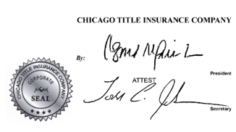
DATED:

____________________
Authorized Signatory

