Fidelity National Title
INSURANCE COMPANY

ATTACHED to and forming a part of POLICY NO.:

Issued by: Fidelity National Title Insurance Company

Fidelity National Title Insurance Company, a California corporation, is the successor by merger to Lawyers Title Insurance Corporation, a Nebraska corporation, effective July 1, 2010.

The above referenced policy, certificate of title or commitment is amended as follows: Fidelity National Title Insurance Company is hereby substituted for Lawyers Title Insurance Corporation wherever the latter appears.

This endorsement is issued as part of the policy. Except as it expressly states, it does not (i) modify any of the terms and provisions of the policy, (ii) modify any prior endorsements, (iii) extend the Date of Policy, or (iv) increase the Amount of Insurance. To the extent a provision of the policy or a previous endorsement is inconsistent with an express provision of this endorsement, this endorsement controls. Otherwise, this endorsement is subject to all of the terms and provisions of the policy and of any prior endorsements.

Dated:

Fidelity National Title Insurance Company

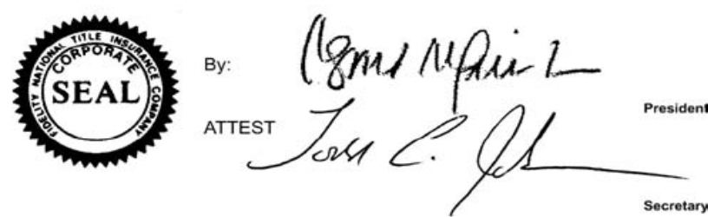
____________________
Authorized Signatory

