**DETAILS**

**ADDRESS**

1 Harborside Pl Apt 752 Jersey City, NJ, 07311

**PHONE**

(281) 857-9006

**EMAIL**

kgromero@gmail.com

**LINKS**

[kgromero.com](https://kgromero.com) [linkedin.com/in/kyleromero/](https://www.linkedin.com/in/kyleromero/)

**RECENT**

**TECHNOLOGIES**

Processes: DevOps, CICD, Agile Scrum, Kanban, GitFlow, Matrix Org

.NET: C#, VB.NET, ASP.NET API/MVC, Blazor, UWP

JavaScript: React, Node.js + NPM, Electron, Angular

Scripting: Python

Web: HTML, CSS

DB: SQL Server, Sqlite3, Oracle

Reporting: SSRS, PowerBI

Cloud: Azure, AWS

Servers: Windows Server, Linux (Ubuntu/Debian)

Tooling: Azure DevOps, GitHub, Visual Studio/VS Code, SSMS, DBeaver

Data: Boomi, SSIS

Other: Sharepoint Online, PowerApps, PowerAutomate, Twilio, Docker/MicroK8s (Novice)

**KYLE ROMERO**

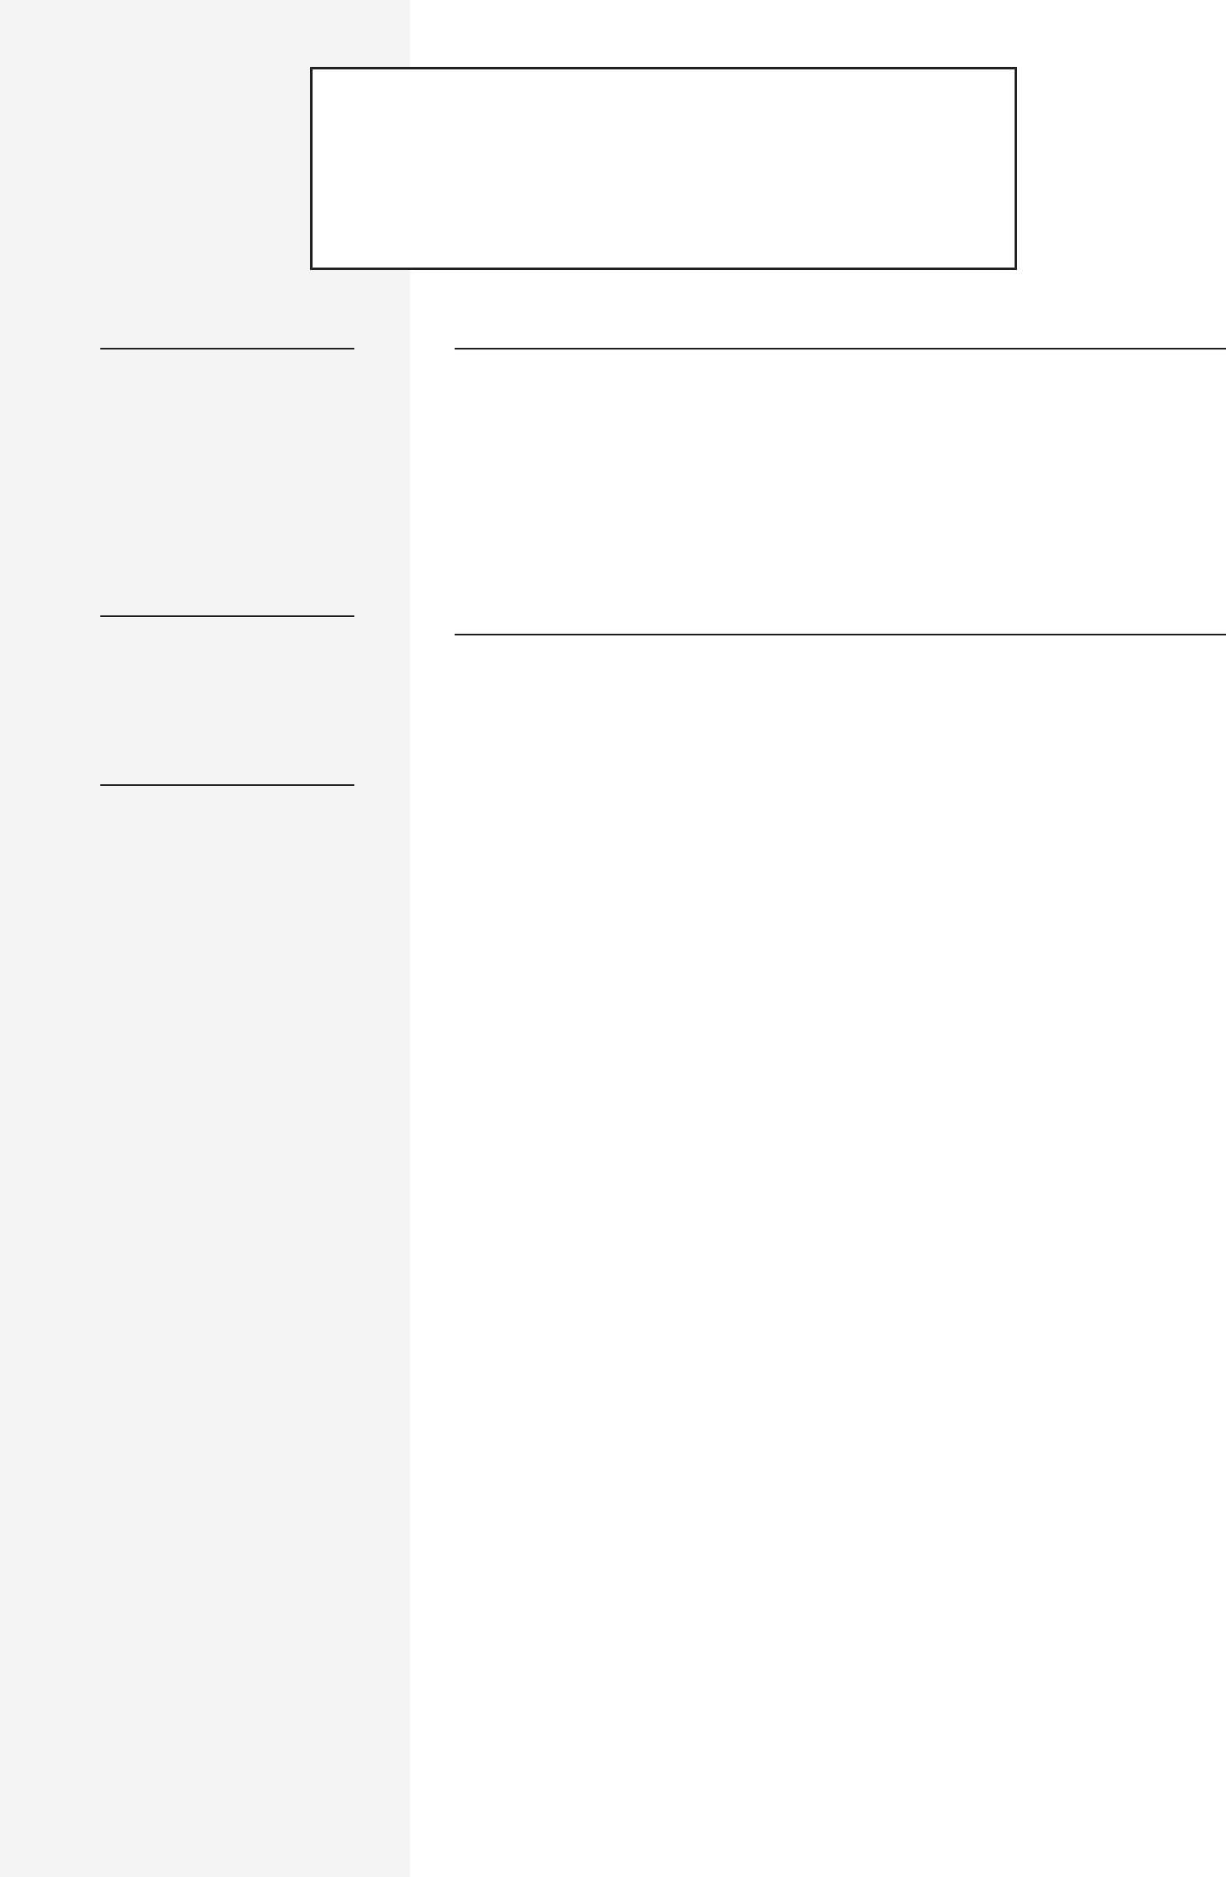

DIRECTOR OF SOFTWARE DEVELOPMENT

**PROFILE**

Highly experienced Director of Software Development with 16 years of experience in IT. Adept at building and managing a successful software development organization utilizing both internal onshore and development partner offshore resources. Skilled at bridging the communication gap between technical and non-technical personnel. Able to balance the leadership, technical, and financial management requirements of being a Director of Software Development. Proponent of servant leadership and continuous improvement. Have been in management since 2017 and was a developer from 2007 to 2017.

**EMPLOYMENT HISTORY**

**Director of Software Development, Raymour &** Jersey City, NJ (remote)

**Flanigan**

Mar 2023 — May 2024

Led the Application Development Organization of Raymour & Flanigan, which handled all internal software development company wide. This role was heavily focused on organizational transformation and modernization, both from a software and process perspective. Fully remote position but did travel occasionally (5%).

**Responsibilities:**

* **Leadership**
  + **Team Size:** 3 Managers (.NET Team, Oracle Team, Integrations Team), 4 Architects, 30 Developers (Primarily internal employees, with a few contractors from development partners).
  + Managed Internal Relationships within internal matrixed organization.
  + Defined and Executed Organizational Strategy, including 5 year vision.
  + Recruited and maintained skilled resources for organization.
  + Held weekly 1:1's and annual reviews with Direct Reports and Bi-Annual Skip-Level 1:1's with Indirect Reports.
  + Traveled to various Northeast U.S. locations as needed (5% of time)
* **Technical Management**
  + Acted as Technical Expert on Tech Stack and helped explore and implement new technologies
  + Directly Managed Change Control and Release Management Processes
  + Worked as SME alongside Architects (direct reports) to define and executive organizational architecture strategy.
  + Was On-Call alongside architects on a rotating basis.
  + **Largest Initiatives:** Order Management Tool Upgrade (UWP App), ERP Migration to NetSuite, WMS Migration to Körber, Omnichannel Sales Experience, 3rd Party Integrations (ChargeAfter, Bringg), Data Domain API and Boomi Standup.
* **Financial Management**
  + Forecasted and Managed Organizational Budget. Managed IT Organization Credit Card
  + Managed Invoice Review and Approval Process for Organization.
  + Negotiated, Reviewed, and Managed Development Partner (Near-Shore / On-Shore) and Vendor Contracts / Resources
  + Worked with Systems Team to monitor and control cloud and on-prem costs

**SKILLS**

Organizational Leadership People Management System Architecture Software Engineering Digital Transformation

**ACHIEVEMENTS**

2021: Promoted to Director of Operations Technology

2021: Nominated to MEARS Group Innovator Team (Company Think-Tank)

2021: Nominated to Quanta Services Leadership Academy

2020: Promoted to Senior Manager of Operations Technology

2013: Promoted to Technical Lead (IT Developer/Engineer III)

**Director of Operations Technologies, MEARS Group** Jersey City, NJ (remote)

Oct 2017 — Mar 2023

Managed the Operations Technology Organization of MEARS Group (part of Quanta Services), which delivered internally developed software solutions for field operations employees, with a special emphasis on digital transformation and field capture. Was hired as Manager of Operations Technology and promoted twice. This position was a direct report to the CIO.

**Responsibilities:**

* **Leadership**
  + **Team Size:** 4 Developers, 1 PM, 7 Offshore. All team members are remote.
  + Managed Executive and Customer Relationships
  + Defined and Executed Organizational Strategy
  + Recruited and maintained skilled resources for organization.
  + Managed yearly software development internship program
  + Traveled to various U.S. locations as needed (25% of time)
* **Technical Management**
  + Acted as Technical Expert on Tech Stack and helped explore and implement new technologies
  + Led Change Management process while rolling out Applications
  + Implemented DevOps/CICD, Agile Scrum, GitFlow, and QA Processes.
  + Defined and documented all architecture and SDLC for the organization
  + Administered various systems such as Azure DevOps, Sharepoint Online, Power Automate, PowerBI, and Azure.
  + **Largest Application:** Mission Critical SOX-compliant internally developed Field Capture solution, used by over 700 field construction crews across the U.S.
* **Financial Management**
  + Forecasted and Managed Organizational Budget
  + Onboarded and Managed Offshore Development Partner
  + Monitored and controlled cloud and on-prem infrastructure costs

**Team Lead / Senior Developer, Worldwide Machinery** Houston, TX

Apr 2016 — Oct 2017

This position reported to one of the co-owners of the company and was responsible for leading the internal software development team as well as acting as a senior developer. This team delivered mission-critical asset management software.

**Technical Lead (IT Developer / Engineer III), HP Inc.** Houston, TX

Dec 2011 — Feb 2016

This position acted as technical lead for the software development operations for HP's mission-critical third level support tool (10k+ users) and was part of the Analytics and Reporting organization. Worked on the entire technology stack for the third level support tool and received exposure to Big Data and BI/Analytics concepts.

**Software / Systems Engineer, X-Fab, Texas** Lubbock, TX

May 2007 — Dec 2011

Worked as an intern from May 2007 to July 2007 and then hired on as Software / Systems Engineer doing general software development, with an emphasis on 3-tier .NET development of internal tooling for semiconductor engineers.

**EDUCATION**



**Bachelor of Science in Computer Engineering, Texas** Lubbock, TX

**Tech University**

May 2005 — Dec 2009

**REFERENCES**



**References available upon request**