**Ex3 – Prob Modules**

1. Epsilon = 0.1

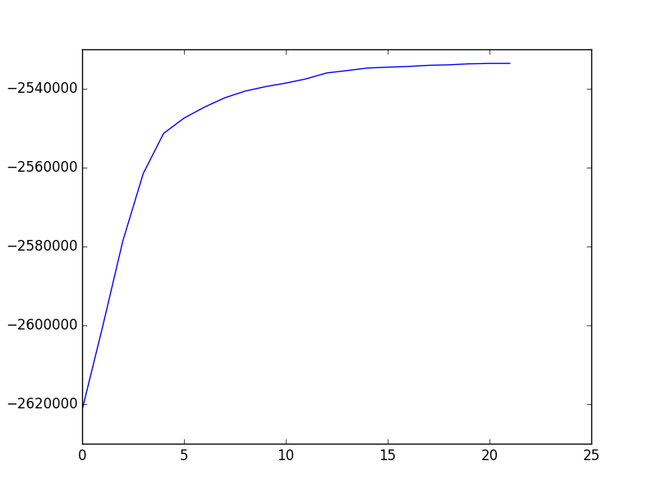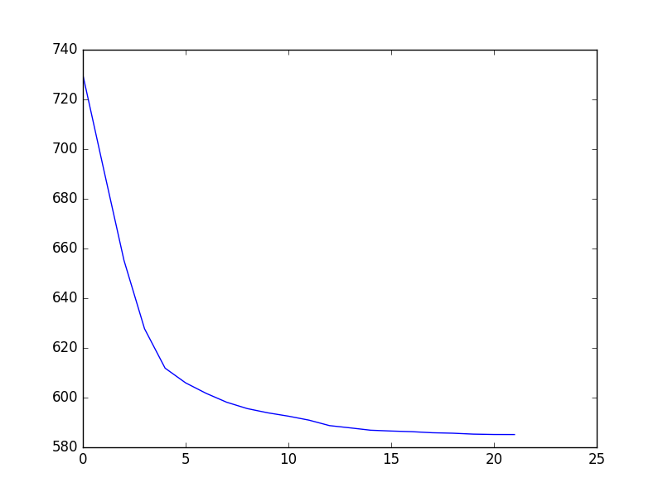 **perplexity** **loglikelihood**

|  |  |  |  |  |  |  |  |  |  |  |
| --- | --- | --- | --- | --- | --- | --- | --- | --- | --- | --- |
| sum | corn | wheat | ship | interest | trade | crude | grain | money-fx | acq | Clusters |
| 409 | 2 | 7 | 4 | 118 | 5 | 8 | 9 | 256 | 0 | 1 |
| 189 | 0 | 2 | 117 | 0 | 0 | 54 | 10 | 2 | 4 | 2 |
| 178 | 32 | 34 | 17 | 9 | 1 | 22 | 60 | 2 | 1 | 3 |
| 298 | 62 | 66 | 18 | 0 | 5 | 17 | 130 | 0 | 0 | 4 |
| 221 | 0 | 0 | 1 | 1 | 2 | 199 | 0 | 4 | 14 | 5 |
| 319 | 0 | 0 | 2 | 128 | 84 | 9 | 1 | 93 | 2 | 6 |
| 400 | 2 | 0 | 0 | 3 | 1 | 21 | 2 | 2 | 369 | 7 |
| 336 | 57 | 85 | 11 | 0 | 11 | 6 | 163 | 2 | 1 | 8 |
| 378 | 5 | 3 | 1 | 16 | 228 | 13 | 13 | 90 | 9 | 9 |

1. accuracy = 0.7768361581920904