Time Series Anlaysis
Practice 3. ARIMA models

- Read the IPC data as you did in the last homeworks. Then compute the Inflation as Inflation <- 100*diff(IPC,lag=12)/lag(IPC,k=-12) and the regularly and seasonally differentiated IPC time series as IPC.d1.d12 <- diff( diff(IPC,lag=12), lag=1).
path.data <- "./series temporales/"
path.data <- path.data.0
nm <- names(read.csv2(paste0(path.data,"INE_IPC.csv"), skip=6, header=TRUE, nrows=1))
end <- min(grep(".1",nm,fixed = TRUE))-1

IPC <- as.numeric(unlist(t(read.csv2(paste0(path.data,"INE_IPC.csv"), skip=6, sep = ";")[1:13,end:2])))
inflation <- 100*diff(IPC,lag=12)/lag(IPC,k=-12)
IPC.d1.d12 <- diff( diff(IPC,lag=12), lag=1)

- Joint the two previous time series with ts.union and plot the resulting bivariate series.
IPC.ts <- ts(IPC, frequency = 12, start=c(numYear[1],numMonth[1]), end=c(2018,3))
inflation.ts <- ts(inflation, frequency = 12, start=c(numYear[1],numMonth[1]), end=c(2018,3))
plot(ts.union(IPC.ts, inflation.ts))
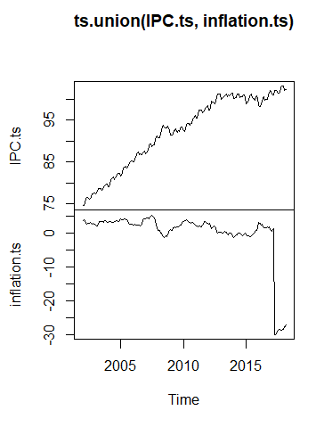
- Define Infl.d1 as the regular difference of Inflation. Check that this series is very similar to IPC.d1.d12.
infl.d1 <- diff(inflation, lag=12)
IPC.d1.d12 <- diff( diff(IPC,lag=12), lag=1)

- Using the function window, cut the time series IPC in two parts: a training part until December 2016, and a test part from January 2017. Call them IPC.tr and IPC.te, respectively. Then compute the regular and seasonal difference of IPC.tr and call the resulting series IPC.tr.d1.d12. Plot this series, as well as its ACF and its PACF.
IPC.tr <- window(IPC.ts,start=c(2002,1), end=c(2016,12))
IPC.te = window(IPC.ts,start=c(2017,1), end=c(2018,3))
IPC.tr.d1.d12<- diff( diff(IPC,lag=12), lag=1)
plot(IPC.tr.d1.d12)
acf(IPC.tr.d1.d12)
pacf(IPC.tr.d1.d12)

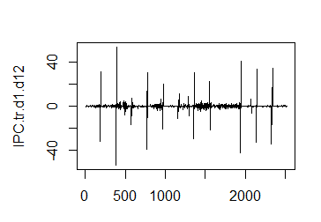
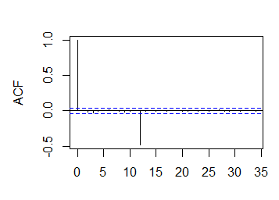
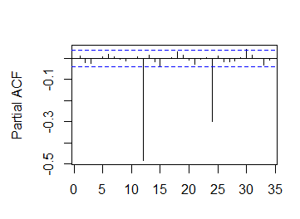

- Based on the ACF and the PACF, propose at least two different ARMA models for IPC.tr.d1.d12.
a. Estimate the ARMA models you propose. Plot the residuals of them and the residuals ACF and PACF.
library(forecast)
model1 <- Arima(IPC.tr.d1.d12,order=c(1,0,1))
model2 <- Arima(IPC.tr.d1.d12,order=c(0,1,1))
plot(model1$residuals,main=paste("Var=",round(var(model1$residuals),4)))
plot(model2$residuals,main=paste("Var=",round(var(model2$residuals),4)))
plot(acf(model1$residuals))
plot(acf(model2$residuals))
plot(pacf(model1$residuals))
plot(pacf(model2$residuals))

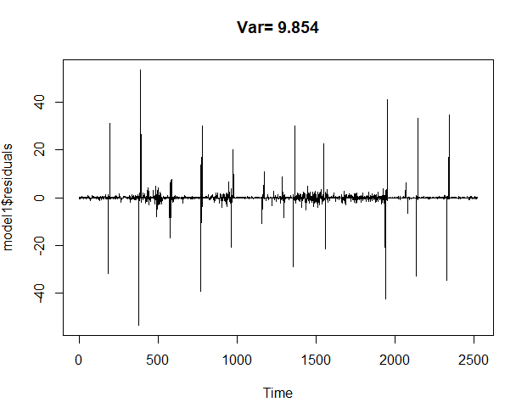
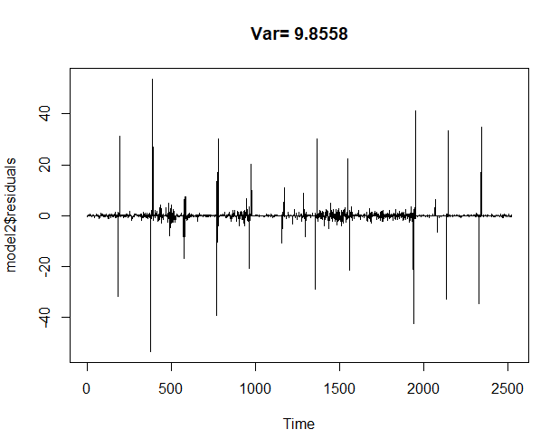
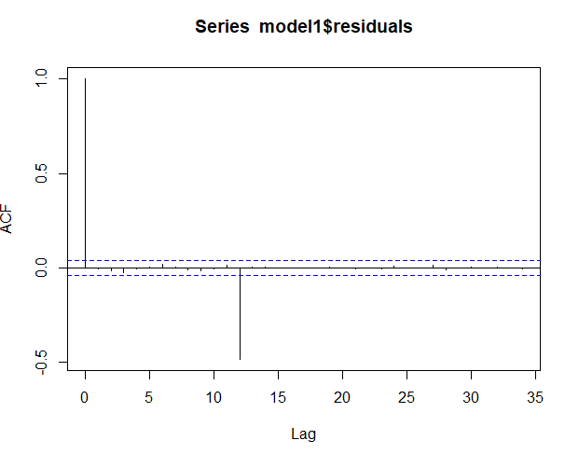
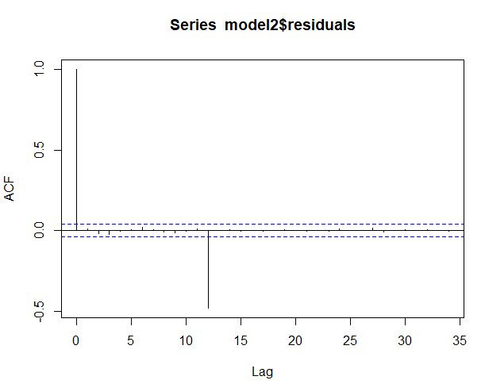
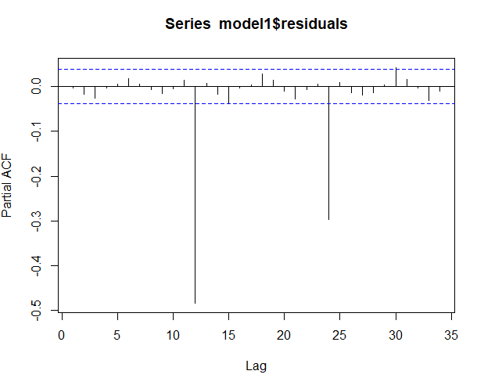
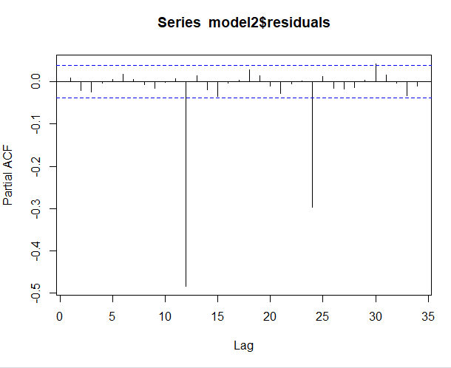

b. Which is the model suggested by auto.arima? Plot the residuals of this model and the residuals ACF and PACF.
IPC.tr.ts.d1.d12 <- ts(IPC.tr.d1.d12, frequency = 12, start=c(numYear[1],numMonth[1]), end=c(2018,3))
best.arima.model <- auto.arima(IPC.tr.ts.d1.d12)
plot(best.arima.model$residuals,main=paste("Var=",round(var(best.arima.model$residuals),4)))
plot(acf(best.arima.model$residuals))
plot(pacf(best.arima.model$residuals))
best.arima.model
Series: IPC.tr.ts.d1.d12
ARIMA(0,0,0)(0,0,2)[12] with zero mean

Coefficients:
sma1 sma2
-0.9242 0.3250
s.e. 0.0693 0.1207

sigma^2 = 5.353: log likelihood = -444.59
AIC=895.18 AICc=895.31 BIC=905

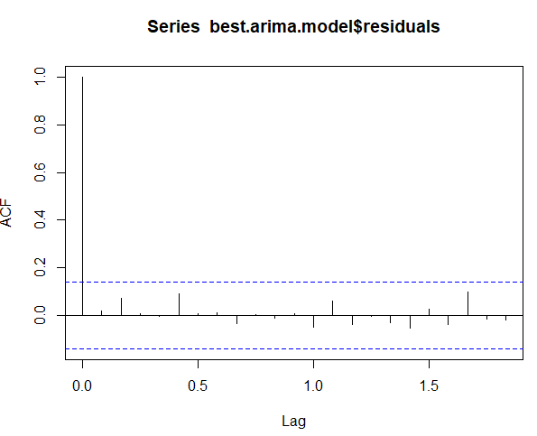
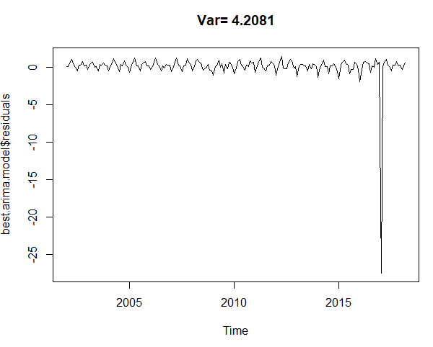

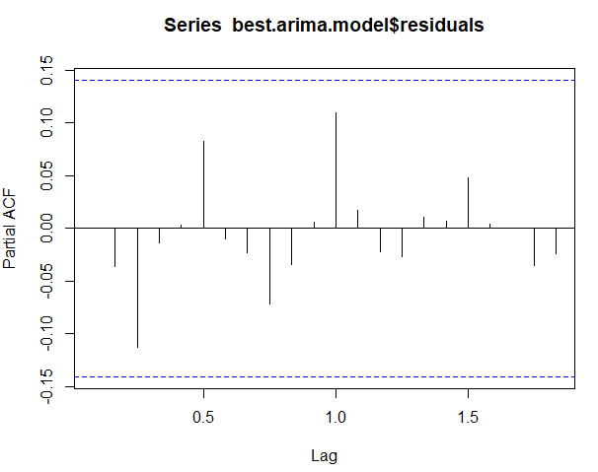

    - Which ARMA model do you chose finally for IPC.tr.d1.d12?
> final.aic <- Inf
> final.order <- c(0,0,0)
> for (i in 0:4) for (j in 0:4) {
+ current.aic <- AIC(arima(x, order=c(i, 0, j)))
+ if (current.aic < final.aic) {
+ final.aic <- current.aic
+ final.order <- c(i, 0, j)
+ final.arma <- arima(x, order=final.order)
+ }
+ }
There were 50 or more warnings (use warnings() to see the first 50)
> final.order
[1] 3 0 0
> final.arma

Call:
arima(x = x, order = final.order)

Coefficients:
ar1 ar2 ar3 intercept
-0.3699 -0.3699 -1 20.6604
s.e. 0.0004 0.0004 0 0.0152

sigma^2 estimated as 1.343e-12: log likelihood = 58.95, aic = -107.91

El mejor modelo ARMA para IPC.tr.d1.d12, seria el de orden 3,0,0.

- Which is the model suggested by auto.arima for the time series IPC.tr? Plot the residuals of this model and the residuals ACF and PACF.
IPC.tr.ts <- ts(IPC.tr, frequency = 12, start=c(numYear[1],numMonth[1]), end=c(2018,3))
best.arima.model <- auto.arima(IPC.tr.ts)
plot(best.arima.model$residuals,main=paste("Var=",round(var(best.arima.model$residuals),4)))
plot(acf(best.arima.model$residuals))
plot(pacf(best.arima.model$residuals))
best.arima.model
Series: IPC.tr.ts
ARIMA(0,1,0)

sigma^2 = 4.208: log likelihood = -414.67
AIC=831.34 AICc=831.36 BIC=834.61

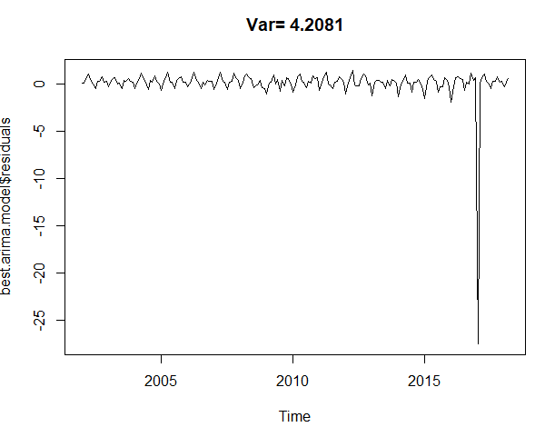

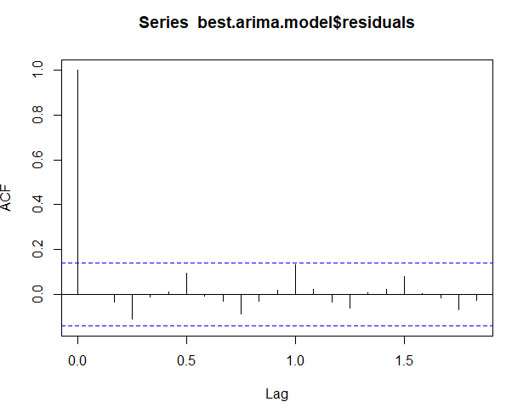

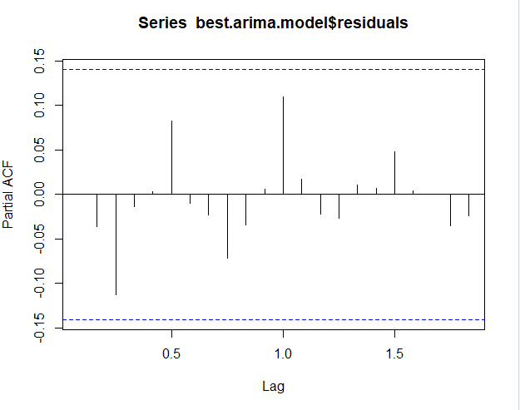
- Consider the ARMA model suggested and estimated by auto.arima for the time series IPC.tr.d1.d12. Use the function forecast from library forecast to predict the next 15 values of IPC.tr.d1.d12 (these are the forecasting of the values corresponding to the period from January 2017 to March 2018). Plot the forecasted object using plot and autoplot.
library(ggplot2)
plot(forecast(best.arima.model))
autoplot(forecast(best.arima.model))

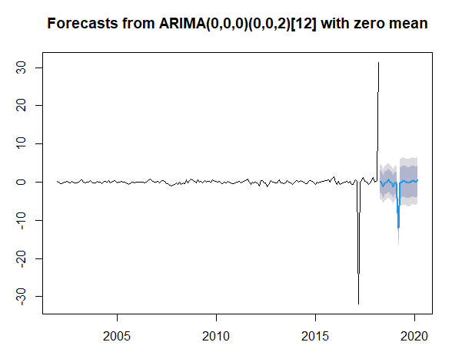
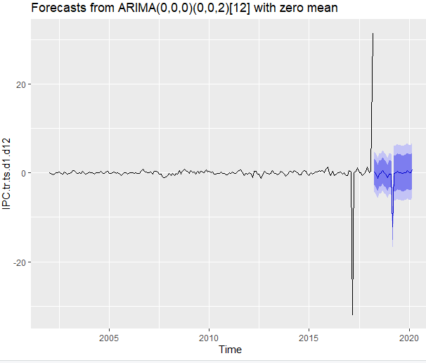

- Consider the ARIMA model suggested and estimated by auto.arima for the time series IPC.tr. Use the function forecast from library forecast to predict the next 15 values of IPC.tr (these are the forecasting of the values corresponding to the period from January 2017 to March 2018).
a. Plot the forecasted object using plot and autoplot.
library(ggplot2)
plot(forecast(best.arima.model))
autoplot(forecast(best.arima.model))
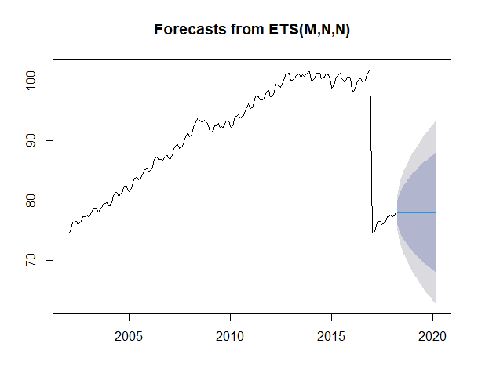
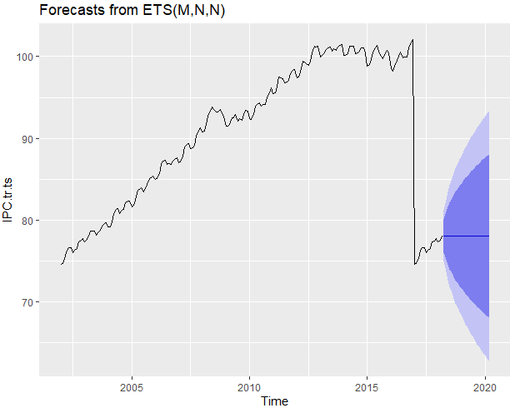
b. Compare these predictions with the values of of the test values in IPC.te.
El plot ofrecido por el Auto.Arima en relación a la predicción de los valores de IPC.te muestra mediante la parte azul, la probabilidad que sucedan aquellos valores es alta. Si nos vamos a la predicción, en esta se observan unos valores más altos que no lo sucedido en la muestra real. Aún así, el rango de confianza de color violeta abarcaría también los valores que acaban sucediendo de forma real.

- Compare the predictions obtained by Holt-Winters (last homework) and by the ARIMA model with the true values of IPC (IPC.te).
Con el modelo Arima tenemos un rango mayor de probabilidad, dejando la exactitud de los datos más abierta que frente a holt Winters, que prueba de aproximarse sin un rango ofreciendo valores exactos.
Auto Arima permite tener una mayor relevancia en cuanto a la confianza del modelo, puesto que la probabilidad de acierto en su rango es mayor.

