Practice 4. Discrete valued time series
Joan Puigdomenech i Joel Romia

- Plot the time series, its ACF and its PACF.
> load("./AccidSunday.Rdata")
> plot(deaths.Sunday.ts, type = 'l')
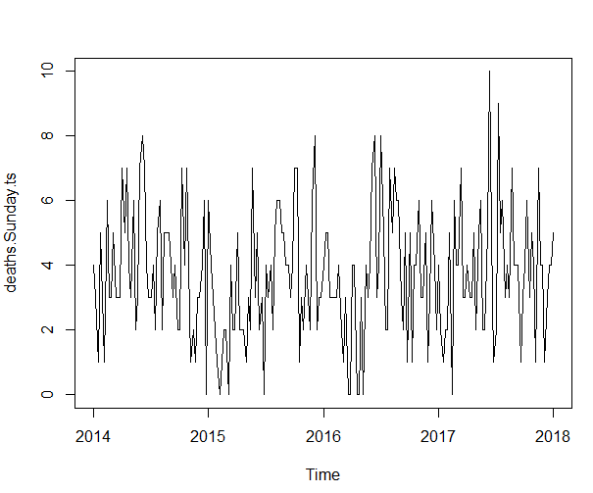
> acf(deaths.Sunday.ts)
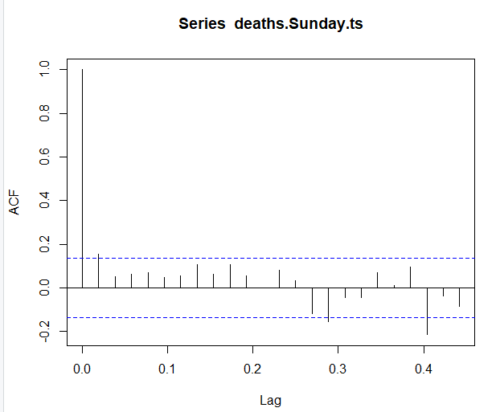
> pacf(deaths.Sunday.ts)

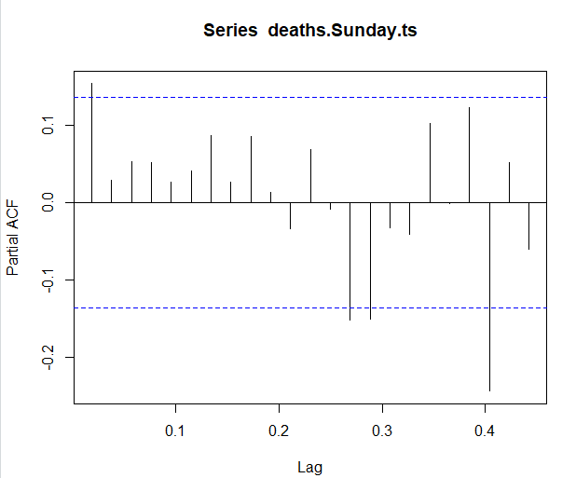

- Plot the relative frequencies of the marginal distribution of the time series.
> absfreq <- tabulate(deaths.Sunday.ts+1) #+1 to include 0
> Tlen <- length(deaths.Sunday.ts)
> maxval <- max(deaths.Sunday.ts)
> plot(0:maxval, absfreq/Tlen, type="h", xlab = "k", ylab = expression(paste("estimated P(X"[t],"=k)")), lwd=4, ylim=c(0,0.3))
> abline(h=0,col=8

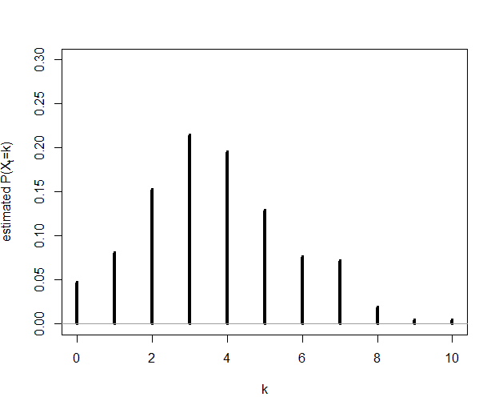
- Compute the observations’ mean μ^=x¯ and the observations’ variance: σ^2=γ^0. Assume now that the time series follows an INAR(1) model. Then estimate the mean and the variance of the innovations time series: μ^ε=μ^(1−α^), σ^2=(1−α^2)σ2^−α^μ^ε.
> mn <- mean(deaths.Sunday.ts)
> mn
[1] 3.669856
> varc <- var(deaths.Sunday.ts)
> varc
[1] 3.91452
>
> rho1 <- acf(deaths.Sunday.ts, plot=FALSE)[[1]][2]
> rho1
[1] 0.1532521
> mue <- mn*(1-rho1)
> mue
[1] 3.107443
>
> se <- (1-rho1^2)*varc-rho1*mue
> se
[1] 3.34636

- To test the equidispersion for the time series, compute the observed Index of Dispersion (ID), I^=γ^0/X¯, and the 95% confidence interval for the ID. Does 1 belong to this interval? Can we reject the null hypothesis of equidispersion?
> ID <- (Tlen-1)/Tlen*varc/mn
> ID
[1] 1.061565
>
> sdID <- sqrt(2/Tlen*(1+rho1^2)/(1-rho1^2))
> ID + -1/Tlen*(1+rho1)/(1-rho1) + c(-1,1)*qnorm(0.975)*sdID
[1] 0.8587609 1.2513351

El numero 1 si que pertenece a este rango y por lo tanto no podemos descartar la hipotesis nula de equidispersion.

- Fit the INAR(1) model to the time series:
- Maximum likelihood estimation of the Poisson INAR(1) model?
- Estimates: λ^,α^?
> estimate <- c(lambdaestml,alphaestml)
> estimate
[1] 3.1462443 0.1429882

- Observations’ Poisson parameter?
> muestml <- lambdaestml/(1-alphaestml)
> muestml
[1] 3.67118

- Compare the observed relative frequencies with the corresponding probabilities of a Poisson distribution with parameter equal to the estimated one.
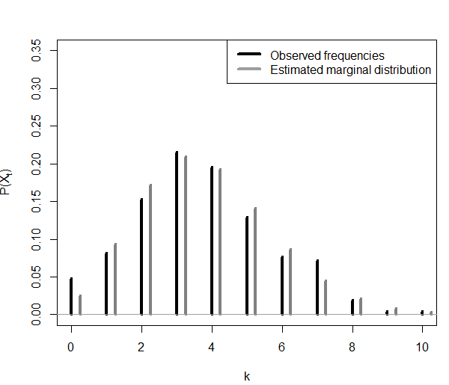
- Compute the Pearson residuals:
et=xt−E(Xt|Xt−1)
−−−−−−−−−−−, t=2,…,T.
√Var(Xt|Xt−1)

Plot the fitted values over the observed time series. In a different graphc, plot the Pearson residuals.
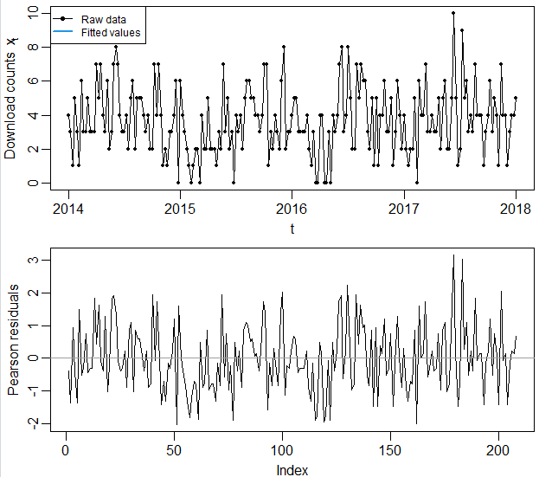
- Plot the ACF and the PACF of the Pearson residuals. Plot the Probability integral transform (PIT). Do you think the the INAR(1) model is appropriate for this time series?
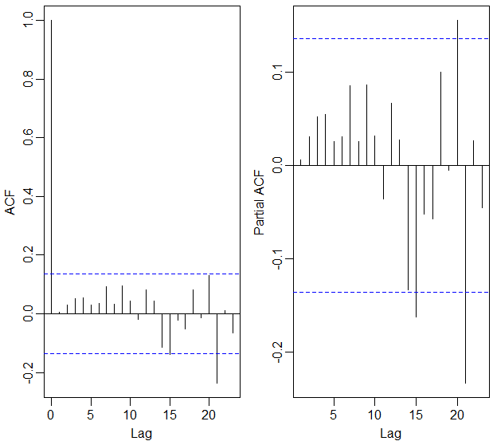
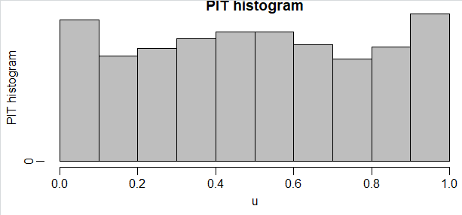
- Fit a Generalized Linear Models for the time series using the function tsglm. Use lags 1 and 52 for the observations and for the mean. Use the logarithm as the link function.
> library(tscount)
> campyfit_pois <- tsglm(campy, model=list(past_obs=c(1,52)), link="log", distr="poisson")
> summary(campyfit_pois)

Call:
tsglm(ts = campy, model = list(past_obs = c(1, 52)), link = "log",
distr = "poisson")

Coefficients:
Estimate Std.Error CI(lower) CI(upper)
(Intercept) 0.645635 0.1905 0.272 1.019
beta_1 0.721458 0.0487 0.626 0.817
beta_52 0.000425 0.0749 -0.146 0.147
Standard errors and confidence intervals (level = 95 %) obtained
by normal approximation.

Link function: log
Distribution family: poisson
Number of coefficients: 3
Log-likelihood: -438.8885
AIC: 883.7769
BIC: 892.6019
QIC: 883.7769

- Fit now the log-linear model until the middle of 2017 (end=c(2017,26)). Then predict the number of deaths by accidents in Sundays from the middle of 2017 to the end of 2017. Finally, compare the model predictions with the true observed values.
> campyfit_pois_17 <- tsglm(campy_until_2017,
+ model=list(past_obs=c(1,13)),
+ link="log", distr="poisson")
> summary(campyfit_pois_17)

Call:
tsglm(ts = campy_until_2017, model = list(past_obs = c(1, 13)),
link = "log", distr = "poisson")

Coefficients:
Estimate Std.Error CI(lower) CI(upper)
(Intercept) 0.377 0.1406 0.101 0.653
beta_1 0.597 0.0564 0.487 0.708
beta_13 0.237 0.0570 0.125 0.349
Standard errors and confidence intervals (level = 95 %) obtained
by normal approximation.

Link function: log
Distribution family: poisson
Number of coefficients: 3
Log-likelihood: -429.0057
AIC: 864.0115
BIC: 872.8364
QIC: 864.0115

