PRT582
Software Unit Testing Report
Intelligent Timetable Scheduler

Student | Romik Gurung
Student ID | S374535
Unit | PRT582
AI tools used | Claude (main development assistant)
Development approach: AI-assisted Test-Driven Development (AI-TDD)

1. Introduction
The main purpose to build this project is to develop a scheduler for a uni classes. This project consists of functions like checking room capacity, availability of lecturers to avoid the clashes between two classes, etc. This project also allocates teaching sessions to different time slots and rooms and also it uses the preferred time frames and selection of smallest room to improve the quality of the schedule.
This project was created with the help of Claude AI using Test-Driven Development methodology. The procedure was not perfect from the beginning; the first version was conceived too broad in one phase. Re-reading the criteria of the assignment, it was clear to me that this did not show the required iterative TDD process. So, I divided the project into seven small RED-GREEN phases. I tested each phase and recorded the results with screenshots.
Rather than presenting the initial prototype as if it had been designed test-first, this report truthfully documents the iterative rebuild.
In the end, depth-first backtracking is what's used. The present test suite for a simpler greedy first-fit scheduler was green, thus it seemed to be correct, hence it was intentionally tried first. A further regression analysis revealed an instance where the greedy algorithm preemptively decided against a viable schedule due to an early judicial decision. Subsequently, backtracking was implemented to enable the algorithm to undo decisions and explore alternate solutions.
There are 134 pytest automated tests in the finished product. The final version that is provided passes all 134 tests and achieves 100% statement coverage in the package.1.1 Assessment Evidence Overview
The report is organised to match the five assessment areas shown in the marking rubric. Each area is supported by concrete evidence from the requirements, automated tests, Claude development transcript, defect analysis, final execution results and submission artefacts.
Rubric area | Where addressed | Evidence in this report
Requirements Analysis & Test Design | Sections 2-3 | Functional/non-functional requirements, assumptions, constraints, 10+ expected behaviours, boundaries, invalid inputs, and justified test groups.
AI-Assisted Development Process | Section 4 | Seven RED-GREEN iterations, actual interaction summaries, AI response summaries, accept/modify/reject decisions, reasons, and executed-test evidence.
Critical Evaluation & Improvement of AI Output | Section 5 | Real defects found after initially green states, before/after fixes, regression tests, and evaluation of limitations in AI-generated tests.
Software Quality & Automated Testing | Sections 5.5-6 | Modular design, deterministic backtracking, error handling, 134 passing tests, regression coverage, and 100% statement coverage.
Report, Evidence & Professional Presentation | Sections 6-8 + Appendix | Captioned iteration evidence, final test/coverage evidence, repository/submission checklist, and a traceable evidence map.

2. Requirements Analysis

2.1 Functional Requirements
- Create and validate teaching time slots for Monday to Friday within supported teaching hours.
- Represent rooms with a unique identifier and positive seating capacity.
- Represent lecturers with identifiers, names and optional availability windows.
- Represent teaching sessions with unit code, lecturer, enrolment, duration, student group and optional preferred time windows.
- Assign every session to exactly one legal room and time slot when a feasible timetable exists.
- Ensure room capacity is at least the session enrolment.
- Ensure session duration matches the selected time-slot duration.
- Ensure the lecturer is available for the complete selected slot.
- Prevent lecturer clashes, room clashes and student-group clashes.
- Enforce prerequisite ordering so prerequisite units occur before dependent units.
- Prefer requested time windows where possible without breaking hard constraints.
- Prefer the smallest suitable room to reduce waste of large rooms.
- Raise a clear error when no feasible timetable exists or the search budget is exceeded.
- Produce a readable timetable and diagnostic explanation for candidate placements.

2.2 Non-Functional Requirements
- Correctness: every returned timetable must satisfy all hard constraints.
- Maintainability: domain models, constraint functions and the search algorithm are separated into modules.
- Testability: important scheduling rules can be tested independently.
- Determinism: identical valid input should produce the same timetable on repeated runs.
- Usability: invalid inputs and infeasible schedules should raise meaningful errors.
- Performance protection: a maximum search-step budget prevents unbounded backtracking.
- Portability: the application runs in Python and uses pytest/pytest-cov for development testing.

2.3 Assumptions
- Teaching occurs Monday to Friday.
- Time is represented in whole hours.
- The supported teaching day is 08:00 to 20:00.
- A lecturer with no stated availability is treated as unrestricted.
- A session must exactly fit one generated time slot.
- Back-to-back classes are allowed because touching time slots do not overlap.
- Prerequisite ordering is based on position in the teaching week.
- Soft preferences may be ignored when necessary to satisfy hard constraints.

2.4 Constraints
- Room capacity must be greater than or equal to enrolment.
- Lecturers can only teach within their availability and cannot teach overlapping sessions.
- A room cannot host overlapping sessions.
- A student group cannot attend overlapping sessions.
- Prerequisite units must begin strictly before the dependent unit.
- Circular and self-referential prerequisite definitions are invalid.
- Preferred times and room efficiency are soft constraints only.
- The scheduler stops if its configured search-step budget is exhausted.

2.5 Expected System Behaviours
- A lower-case day such as "mon" is normalised to "MON".
- Adjacent slots such as 09:00-11:00 and 11:00-13:00 do not overlap.
- A room with exactly the required number of seats is accepted.
- A room one seat too small is rejected.
- A lecturer may teach back-to-back sessions but not overlapping sessions.
- A room may be reused in a later non-overlapping slot.
- A student group cannot be scheduled into two simultaneous sessions.
- A lecturer with no availability restrictions can use any valid supplied slot.
- A preferred slot is chosen when it is legal and available.
- A preference is ignored if using it would break a hard constraint.
- A large class is assigned only to a room with enough capacity.
- A small class should use a smaller suitable room when possible.
- A dependent unit is scheduled after its prerequisite.
- A circular prerequisite relationship is rejected.
- The scheduler backtracks when an early legal choice blocks a later session.
- Repeated solve() calls reset internal search state and remain deterministic.

2.6 Boundary Conditions
- Earliest and latest legal teaching hours (08:00 and 20:00 boundaries).
- Room capacity exactly equal to enrolment and one seat below enrolment.
- Back-to-back slots that touch at the boundary but do not overlap.
- Prerequisite sessions that start at the same time, later on the same day, or on a later day.
- Empty availability meaning unrestricted availability.
- Repeated calls to solve() on the same Scheduler object.
- Search step count exactly at or beyond the configured maximum.

2.7 Invalid Input and Exceptional Scenarios
- Unknown day names, non-integer hours, zero-length slots and reversed start/end times.
- Empty or non-string identifiers for rooms, lecturers or sessions.
- Zero, negative or non-integer capacity, enrolment or duration.
- No sessions, no rooms or no time slots supplied.
- Duplicate session IDs or room IDs.
- A session referencing an unknown lecturer.
- Circular or self-referential prerequisites.
- A session too large for every available room.
- A lecturer whose availability cannot fit the session duration.
- More conflicting sessions than the available resources can support.
- A search problem exceeding the maximum step budget.

3. Test Design
It was now much simpler to determine if an error occurred due to input validation, a rule, or the search algorithm thanks to this division.

3.1 Major Test Groups and Purpose
Test group | Behaviour tested | Why necessary | Defect prevented
TimeSlot validation | Day/hour validation, containment and overlap boundaries | All scheduling rules depend on correct time behaviour | Invalid hours, unknown days, and treating touching slots as clashes
Room/Lecturer/Session models | Identifiers, capacities, enrolment, duration, availability and preferences | Reject malformed domain data before search | Invalid IDs, bool accepted as int, invalid capacities/durations
Hard constraints | Capacity, duration, availability, lecturer/room/group clashes | Each rule can be proven independently | A single combined scheduler hiding which rule is wrong
Scheduler integration | Every session is placed legally or a clear error is raised | Checks that rules still work when combined | Integration defects that isolated unit tests miss
Backtracking regression | Bad early room/time choice must be recoverable | A legal local choice may be globally wrong | Greedy first-fit falsely reporting no timetable
Prerequisites | Strict before-ordering, both directions, cycle detection | Search order is not chronological | Dependent unit placed before/same time as prerequisite
Soft constraints | Preferred slots and smallest-room-first ordering | Improve timetable quality without rejecting feasible solutions | Preferences accidentally behaving as hard constraints
Robustness/NFR tests | Determinism, max steps, repeated solve, explain() | Protect state and performance behaviour | Stale step counter, nondeterministic output, endless search

3.2 Final Test Suite Summary
The final suite contains 134 pytest tests across tests/test_models.py, tests/test_constraints.py and tests/test_scheduler.py. The suite includes normal behaviour, boundary conditions, invalid input, exceptions, characterisation tests and regression tests. Coverage of the final timetable package is 100% statement coverage.

4. AI-Assisted Development Process
Claude was the main AI development assistant. I first asked for help understanding and completing the assignment in simple language. After selecting the timetable scheduler, Claude generated an initial complete solution too quickly. I then noticed that the brief required an iterative development process and told Claude: “Just like it is mentioned in the document lets do everything step by step, as it says don’t finish everything in one go.” Claude agreed that the earlier approach was too broad and restarted the work as seven RED-GREEN iterations.
The transcript shows a useful change in how I used AI. Instead of asking for the whole application, I ran each provided RED state, sent the result back, reviewed the explanation, then moved to the GREEN implementation. In later iterations I also used tests to challenge AI-generated logic rather than assuming a green suite meant the design was correct.

4.1 AI Interaction Evidence Matrix
The table below makes the AI-TDD evidence explicit. It uses only interactions visible in the supplied Claude screenshots. Where the user response was a screenshot/result rather than a written prompt, it is described as a continuation interaction rather than inventing wording that was not shown.
Iteration | User interaction / prompt context | AI response summary | Decision | Reason | Executed-test evidence
1 - TimeSlot | Asked for step-by-step work after choosing the timetable scheduler; Claude then introduced Iteration 1 RED tests. | Generated TimeSlot tests and a deliberately incomplete skeleton. | Accepted with review | The tests covered validation, boundaries and overlap behaviour; implementation was added only after RED was observed. | 16 failed / 5 passed -> 21 passed
2 - Room/Lecturer/Session | Continued after reporting Iteration 1 GREEN; Claude moved to Room, Lecturer and Session RED tests. | Added model tests/skeletons and explained availability/preference design decisions. | Accepted + refactored | Shared identifier validation was refactored to avoid duplication; regression tests from Iteration 1 remained green. | 21 failed / 28 passed -> 49 passed
3 - Constraint rules | Continued after 49 passed; Claude introduced independent hard-constraint tests. | Generated constraint tests, a constraint module skeleton and Assignment model. | Accepted | Independent rule functions made failures easier to isolate before the scheduler existed. | 14 failed / 59 passed -> 73 passed
4 - Scheduler | After 73 passed, Claude introduced scheduler tests, then a greedy first-fit implementation and challenged it with a counterexample. | Produced a working greedy scheduler first, then a regression case and backtracking rewrite. | Initially accepted, then rejected/modified | The greedy version passed 100 tests but failed a valid timetable case; backtracking was required for correctness. | 22 failed / 78 passed -> 100 passed -> 1 failed / 102 passed -> 103 passed
5 - Prerequisites | Continued to prerequisite ordering and cycle detection. | Generated direct prerequisite tests and an initial one-direction implementation. | Modified | All direct rule tests passed, but end-to-end scheduler tests exposed a search-order integration defect. | 7 failed / 109 passed -> 2 failed / 114 passed -> 116 passed
6 - Soft constraints | Continued to preferred slots and room-efficiency tests. | Implemented preferences as candidate ordering rather than legality filters. | Accepted | This preserved feasibility because soft constraints could never override hard constraints. | 4 failed / 121 passed -> 125 passed
7 - Budget/determinism/coverage | Continued to deferred search-budget, determinism, explain() and coverage work; user selected deletion of unused Assignment.__str__. | Added budget/diagnostics; coverage exposed one unused statement; Claude offered delete-or-test options. | Modified | Dead code was removed instead of adding an artificial test only to increase the percentage. | 6 failed / 128 passed -> 134 passed -> 99% -> 100% coverage

4.2 Iteration 1 - TimeSlot validation and overlap detection
Prompt / interaction: Initial direction: “Help me with this, (simple language)” followed by selecting “Timetable scheduler” and asking for all required parts. After restarting iteratively, Claude prepared TimeSlot tests first and asked me to run them RED before receiving the implementation.
AI response summary: Claude created tests for valid/invalid days and hours, normalisation, containment and overlap behaviour, with a skeleton TimeSlot implementation that intentionally failed the new behaviours.
Decision and justification: Accepted with review. I ran the RED suite (16 failed, 5 passed), then replaced the skeleton with the GREEN implementation. The final result for this iteration was 21 passed.
What I learned / reviewed: A key edge case was that Python bool is a subclass of int. Numeric validation therefore had to reject bool explicitly. Another important boundary was using < rather than <= for overlap so 09:00-11:00 and 11:00-13:00 remain legal back-to-back slots.
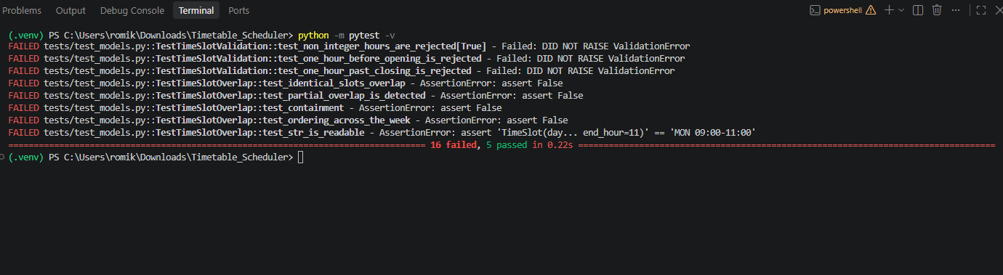
Iteration 1 RED: 16 failed, 5 passed.
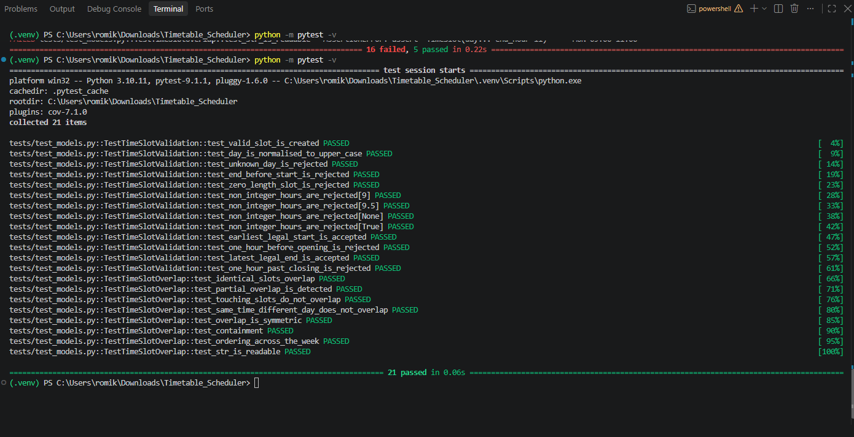
Iteration 1 GREEN: 21 passed.

4.3 Iteration 2 - Room, Lecturer and Session
Prompt / interaction: After Iteration 1 ran successfully, the topic shifted to "Iteration 2: Room, Lecturer, and Session." The red phase comes first; I ran the supplied RED tests before requesting the GREEN implementation.
AI response summary: Claude implemented tests and skeleton classes for room capacity, lecturer availability, session validation, and preference containment. It emphasized design decisions like assuming empty lecturer availability as unrestricted.
Decision and justification: Accepted and refactored. RED produced 21 failures and 28 passes. GREEN produced 49 passes. Shared identifier validation was refactored into a single helper rather than being duplicated across all three classes.
What I learned / reviewed: The iteration proved regression protection: all 21 TimeSlot tests from Iteration 1 passed, but new model tests failed. It also stated that a class must fit totally within a lecturer's availability window.

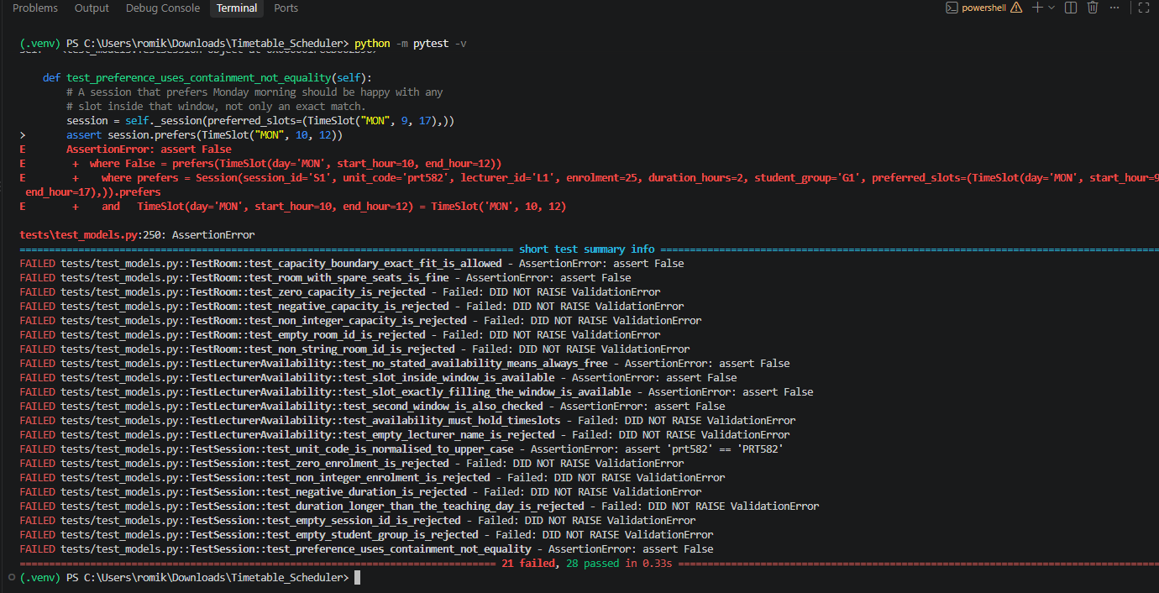
Iteration 2 RED: 21 failed, 28 passed.
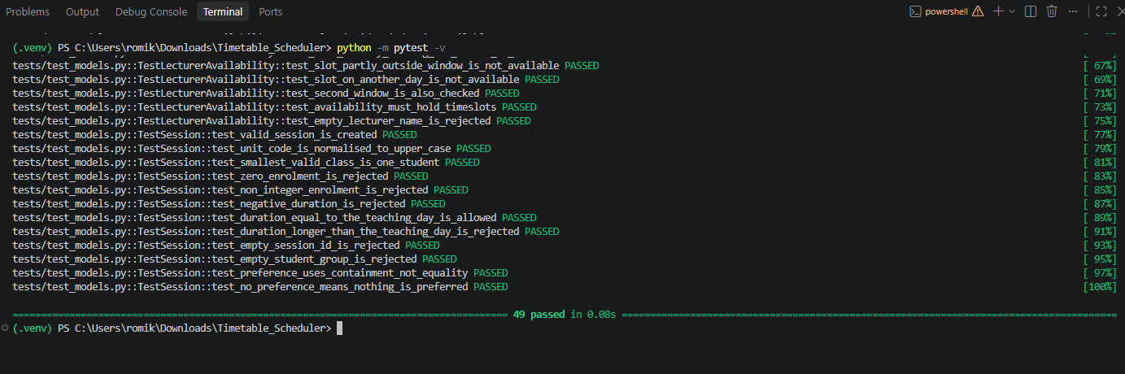
Iteration 2 GREEN: 49 passed.

4.4 Iteration 3 - Independent constraint rules
Prompt / interaction: After the model layer was green, Claude proceeded to "Iteration 3: the constraint rules" and provided tests for capacity, duration, lecturer availability, and three clash rules prior to deployment.
AI response summary: Claude developed tests/test_constraints.py, a foundational constraints.py, and the Assignment model. The rule functions were engineered to directly accommodate existing assignments instead than relying on the Scheduler.
Decision and justification: Accepted. In RED, 14 tests failed and 59 passed, and in GREEN, 73 passed. I kept the constraint rules separate so it would be easy to find failures and test the rules before there was a scheduling algorithm.
What I learned / reviewed: Some negative direction tests passed against stub functions that return false. This was a crucial testing lesson: a passing test is not necessarily good proof. Paired positive and negative tests were required to make the rule behavior meaningful.

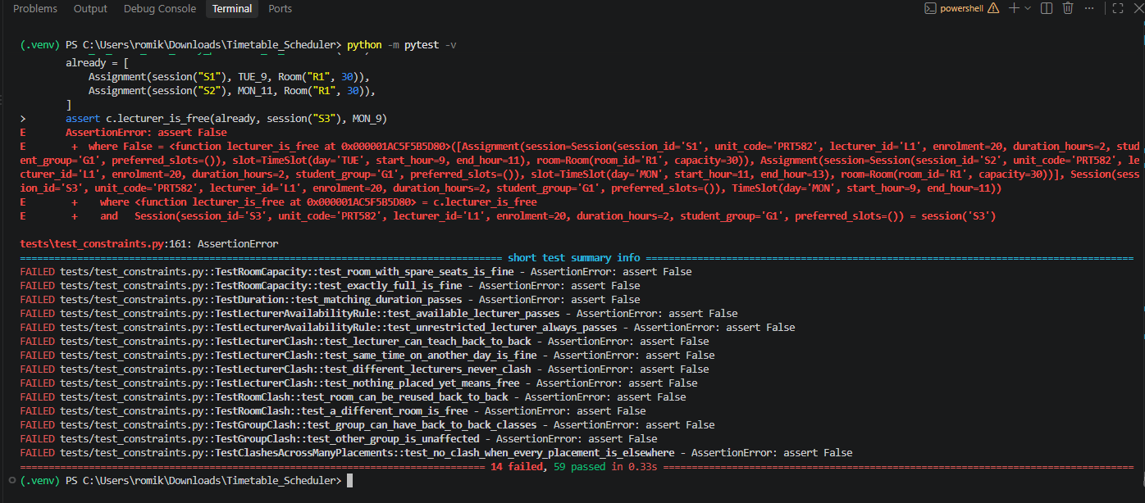
Iteration 3 RED: 14 failed, 59 passed.
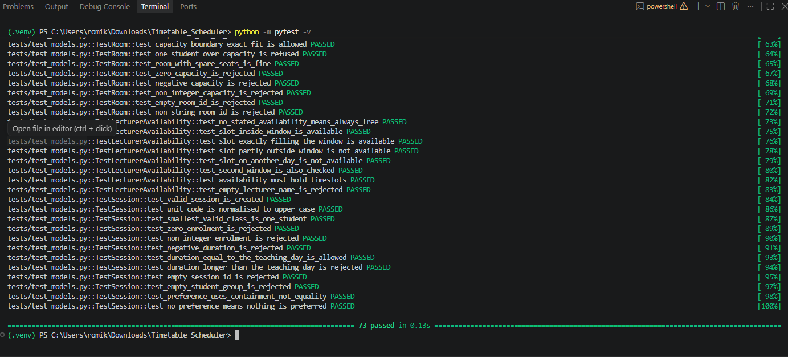
Iteration 3 GREEN: 73 passed.

4.5 Iteration 4 - Scheduler, greedy defect and backtracking fix
Prompt / interaction: Claude introduced the scheduler in three stages. First it supplied RED scheduler tests. After those failed, it supplied a simple greedy first-fit implementation. It then asked me to reason about whether an early legal room choice could make a later session impossible.
AI response summary: The initial scheduler skeleton produced 22 failed and 78 passed. The greedy implementation then produced 100 passed. Claude then described a two-room/two-class case in which SMALL_CLASS takes the only large room first and BIG_CLASS cannot be placed, even though a valid timetable exists.
Decision and justification: The greedy version was rejected after a new regression test exposed the defect. The new RED state was 1 failed and 102 passed. Claude then replaced first-fit with depth-first backtracking, producing 103 passed.
What I learned / reviewed: This was the most important defect in the project. The green suite at 100 tests did not prove the algorithm was generally correct; it only proved the tested behaviours. A new test was needed to expose the missing scenario. Backtracking fixed the problem by undoing a placement with placed.pop() and trying another candidate.
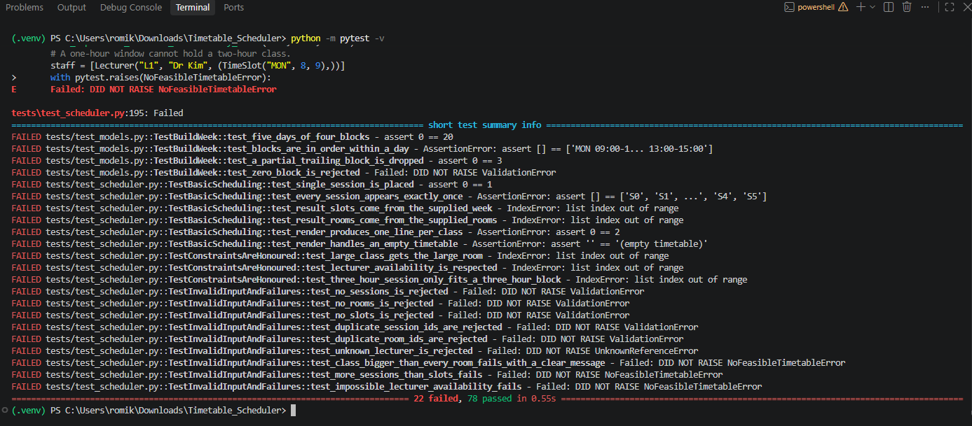
Iteration 4A RED: scheduler tests added - 22 failed, 78 passed.
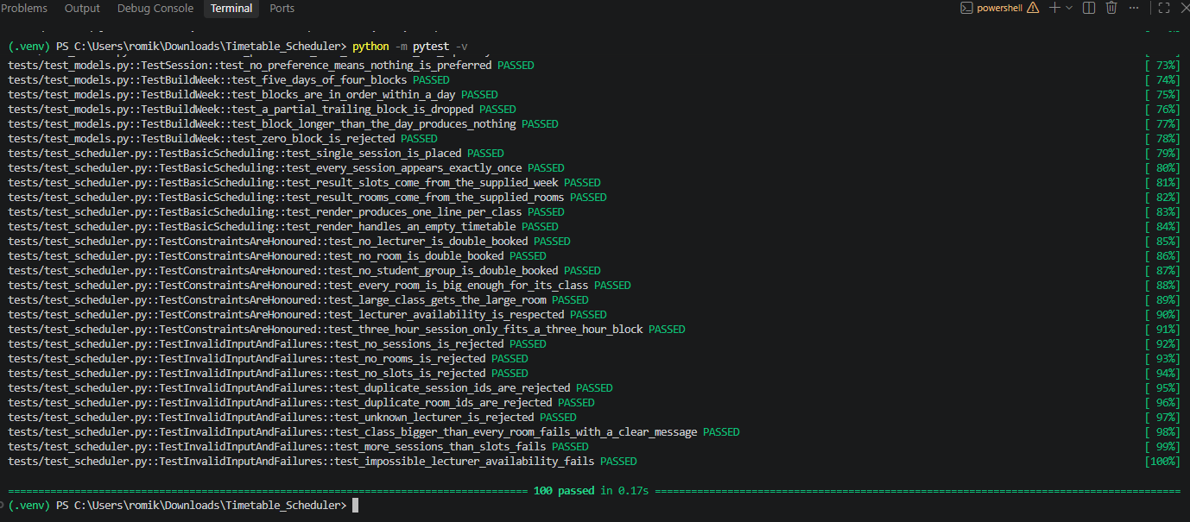
Iteration 4B GREEN: greedy first-fit - 100 passed.
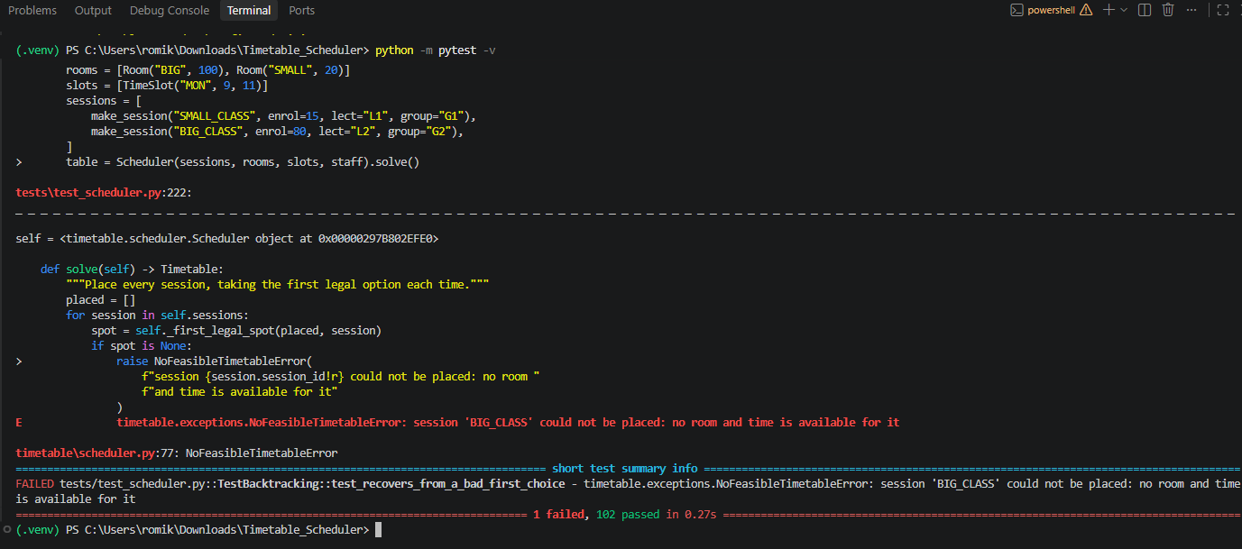
Iteration 4C RED again: regression test exposes greedy defect - 1 failed, 102 passed.
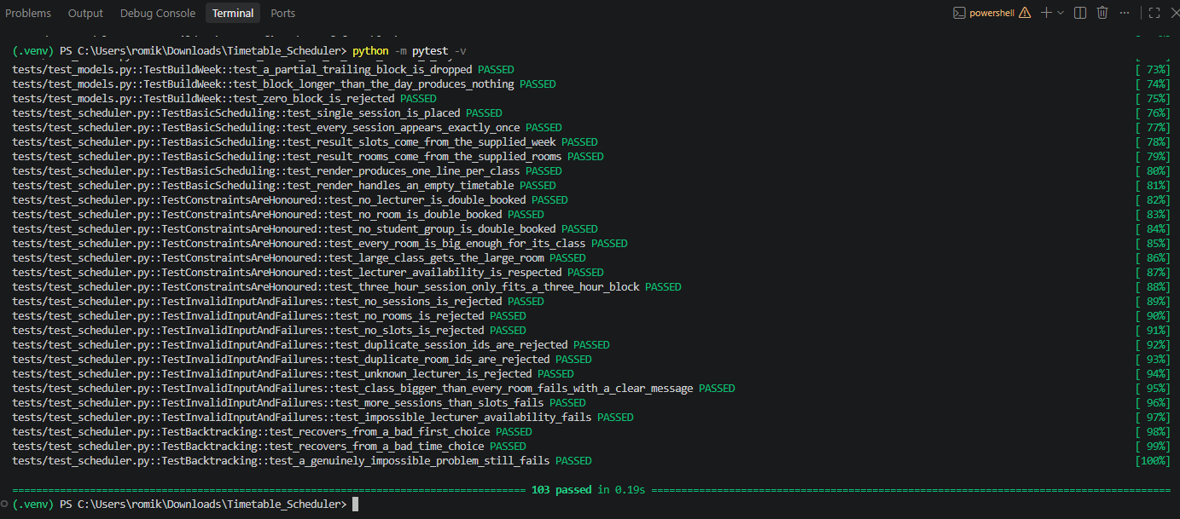
Iteration 4C GREEN: backtracking fix - 103 passed.

4.6 Iteration 5 - Prerequisite ordering
Prompt / interaction: Claude next added prerequisite-ordering and cycle-detection tests. The RED expectation was 7 failed and 109 passed. After the first implementation it specifically told me not to fix the remaining failures immediately, but to inspect why isolated constraint tests passed while scheduler tests failed.
AI response summary: The first prerequisite implementation checked only whether an already-placed session was a prerequisite of the current one. All seven direct rule tests passed, but two end-to-end scheduler tests still failed because the search places sessions in “hardest first” order rather than chronological order.
Decision and justification: Modified. I accepted the basic rule but the one-direction assumption was incomplete. The fix checked both directions: whether an already-placed session is my prerequisite, and whether I am a prerequisite of an already-placed session. Final result: 116 passed.
What I learned / reviewed: This defect showed why unit tests alone are not enough. A rule can pass in isolation and still fail when combined with a search algorithm that uses a different ordering. Integration-style scheduler tests caught the problem.
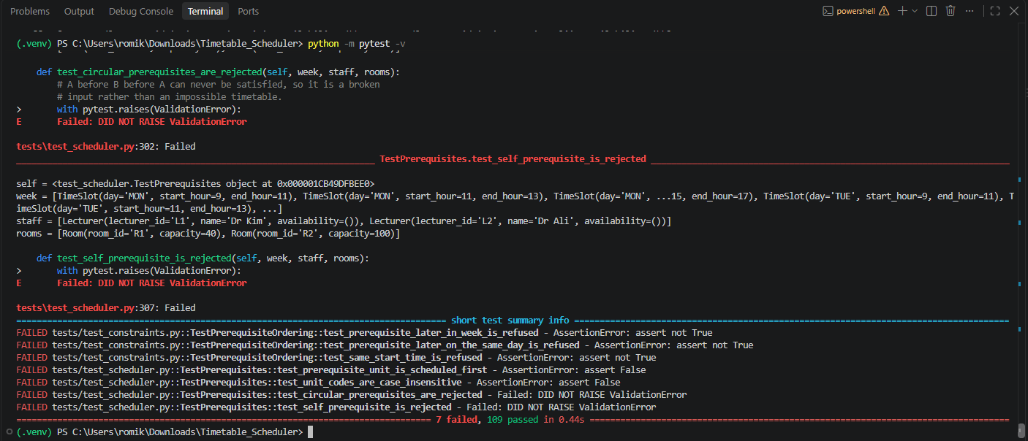
Iteration 5A RED: prerequisite tests added - 7 failed, 109 passed.
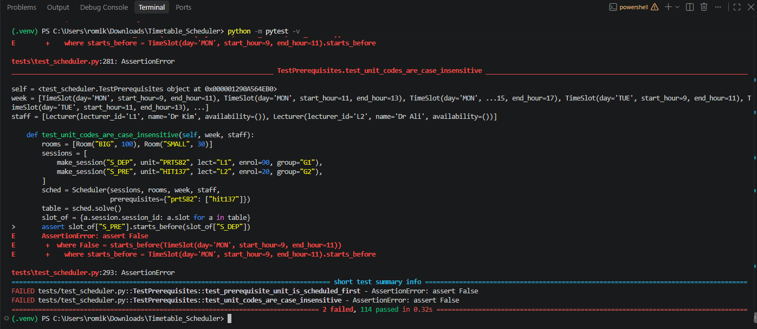
Iteration 5B partial GREEN: 2 failed, 114 passed; integration defect remains.
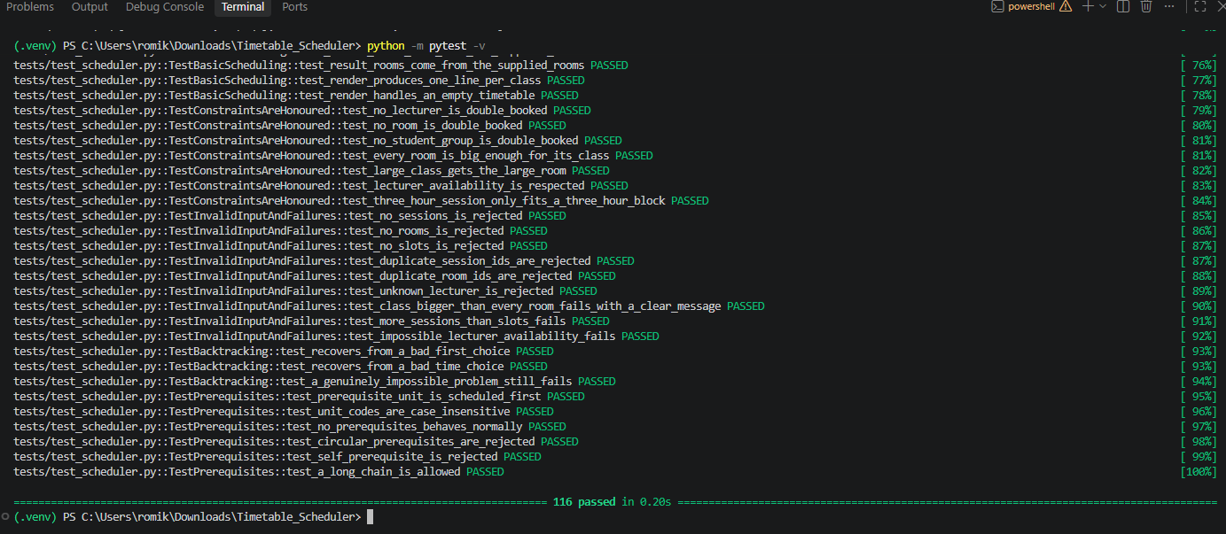
Iteration 5C GREEN: prerequisite check fixed in both directions - 116 passed.

4.7 Iteration 6 - Preferred time slots and room efficiency
Prompt / interaction: Claude introduced two soft constraints: preferred time windows and avoiding waste of large rooms. The RED state expected 4 failed and 121 passed.
AI response summary: Claude explained that soft constraints should change the order in which legal candidates are tried, not remove candidates. The implementation sorted candidates so preferred slots and smaller suitable rooms are attempted first while all hard constraints remain decisive.
Decision and justification: Accepted. RED produced 4 failed and 121 passed. GREEN produced 125 passed. No new defect was discovered in this iteration, and I recorded that honestly instead of inventing one.
What I learned / reviewed: A preference must never make a feasible timetable impossible. This is why candidate sorting is safer than filtering. The tests also showed again that some new tests can pass before implementation because they characterise behaviour already guaranteed by hard constraints.
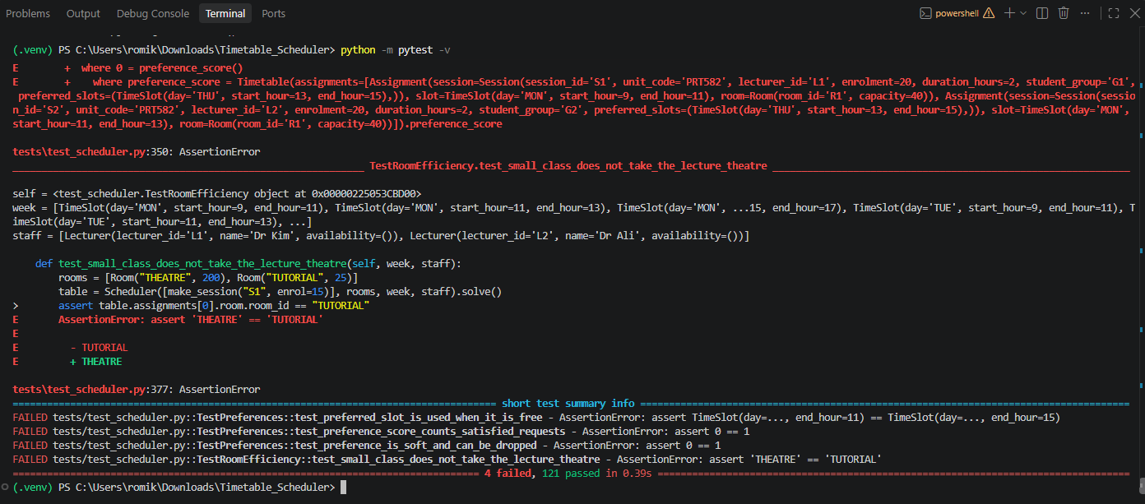
Iteration 6A RED: 4 failed, 121 passed.
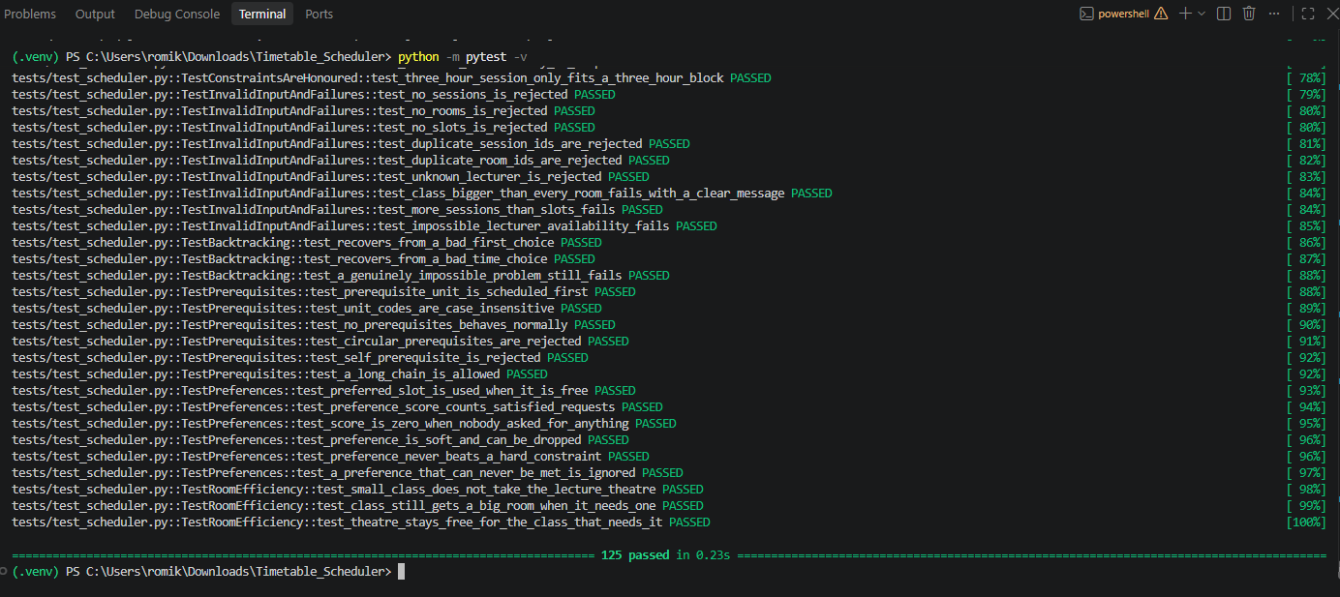
Iteration 6B GREEN: 125 passed.

4.8 Iteration 7 - Search budget, determinism, diagnostics and coverage cleanup
Prompt / interaction: The final iteration added the deferred search-step budget, determinism tests and explain() diagnostics. Claude stated that three determinism tests already passed because previous tie-break ordering had already made the implementation deterministic.
AI response summary: The RED state produced 6 failed and 128 passed. The GREEN implementation added the search budget and diagnostics, producing 134 passed. Running coverage then showed 99% with one unexecuted Assignment.__str__ line.
Decision and justification: Modified. When asked what to do with Assignment.__str__, I selected “Delete it as dead code.” Claude removed the unused method, added package exports, README and demo app. The final run produced 134 passed, 100% coverage, and the demo timetable in 11 search steps.
What I learned / reviewed: Coverage was used as a diagnostic, not just a target. The missing line was dead code, so removing it was cleaner than writing an artificial test only to make the percentage reach 100%.
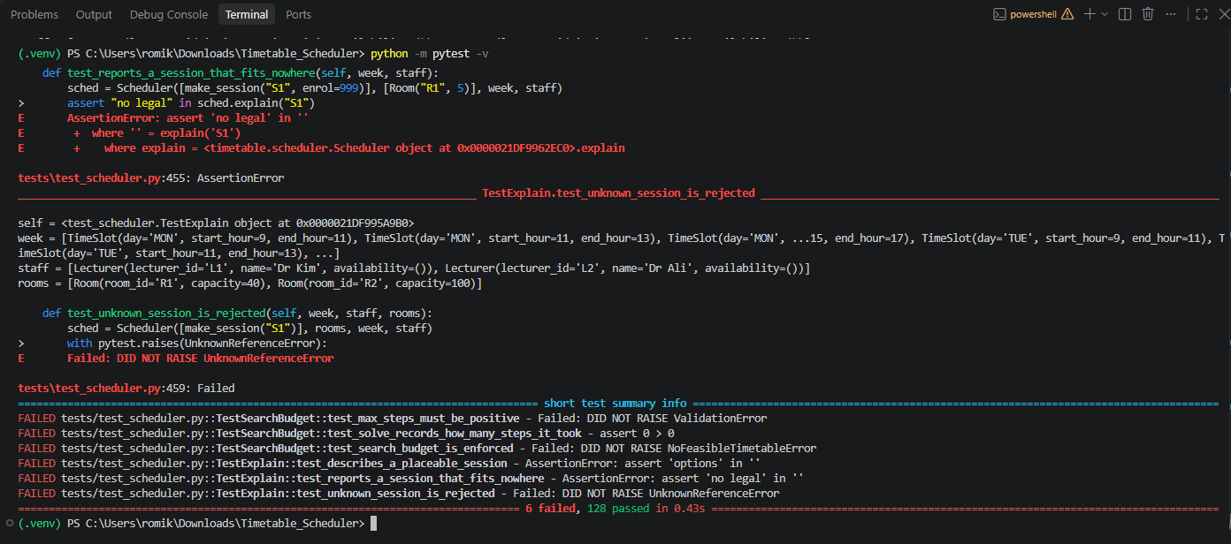
Iteration 7A RED: 6 failed, 128 passed.
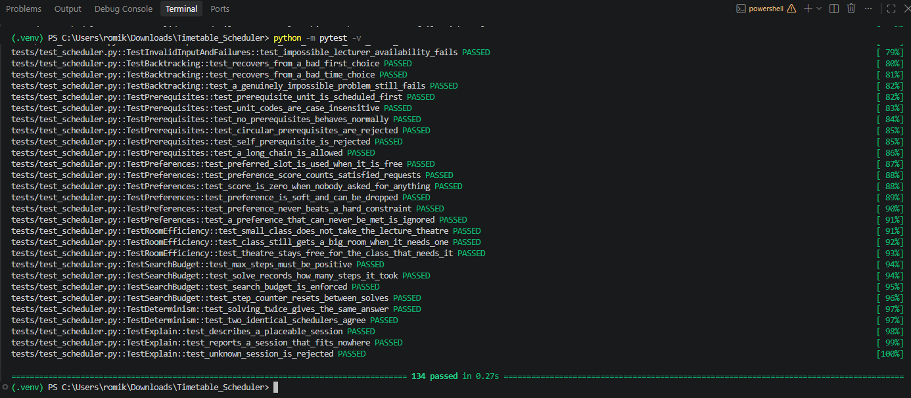
Iteration 7B GREEN: 134 passed before final coverage cleanup.

5. Evaluation and Improvement of AI Output
Both the AI-generated implementation and the AI-generated tests must be critically evaluated for the assignment. There are other instances in the development transcript where the AI output was helpful but lacking certain details. They didn't pop up after the fact; they were there when the test suite was getting increased.

5.1 Defect D1 - Greedy First-Fit Could Reject a Valid Timetable
What went wrong: the first scheduler to work on the project accepted the first legal room/time pair without asking for a second opinion. It was still possible to miss a valid schedule, even though all 100 tests that were available at the time passed.
Finding it involved subjecting the algorithm to an instance with a single time slot, a small class, a large class, and one huge room after the suite had been green-lit. Due to greedy first-fit, the large class had to make do with the little room.
The fix is to use recursive depth-first backtracking instead of greedy first-fit. At this point, the algorithm decides, tries to put the remaining sessions, and discards the decision if it fails.
placed.append(Assignment(session, slot, room))
if self._place(order, index + 1, placed):
return True
placed.pop() # undo and try another option
Regression evidence: following the backtracking fix, 103 passed the test, whereas 1 failed the greedy version.

5.2 Defect D2 - Prerequisite Rule Worked in Isolation but Failed in Search
What went wrong: One of the necessary functions could only go as far as previously placed sessions. The scheduler sorts of sessions according to difficulty, not chronological order, therefore this assumption was risky.
How it was found: 114 end-to-end scheduler tests succeeded, while 2 failed. All seven direct prerequisite constraint tests passed. This demonstrated that the rule seemed valid when considered independently but was lacking in the comprehensive search.
Fix: for each placement, double-check the prerequisite relationships. It needs to be earlier if I have an already-placed unit as a precondition. To be eligible for a precondition of a unit that has already been put, I need to be earlier than that unit.
dependants = {unit.upper() for unit in prerequisites.get(earlier.session.unit_code, ())}
if session.unit_code in dependants and not slot.starts_before(earlier.slot):
return False
Regression evidence: All 116 tests were successful following the two-way correction.

5.3 Before-and-After Improvement Summary
In response to a vulnerability discovered during testing, the following comparison demonstrates how AI-generated or AI-assisted implementations were modified. These do not represent hypothetical situations but rather match the development evidence-documented failures.
Improvement | Before | After | Why the change was necessary
Greedy scheduling | Just go with the first legal room/time pairing you see. | In depth-first backtracking, a choice is appended, and if it fails, the choice is popped after recursively trying the remaining sessions. | Prevents an early, lawful option from misleadingly making a realistic timeline seem unattainable.
Prerequisite checking | Just make sure to inquire if a previously placed unit is necessary for the session that is being put right now. | Search results are ordered by difficulty, not by date, so make sure to double-check each session's placement. | Avoids placing dependents before or at the same time as prerequisites if the dependent is searched for first.
Coverage gap | Any Assignment that is not in use should be retained.__str__ method and simply include a test to run it. | Code that isn't being used should be removed. | Enhances maintainability and ensures that 100% coverage accurately represents actual executable behavior, not just simulated testing.

5.4 Other AI Output Improvements
- To avoid implicit rejection of boolean values, numerical validation in Python returns True when called on an integer.
- Overlap uses severe inequality to ensure that consecutive classes are not seen as conflicts.
- Legal candidates are ranked based on subjective preferences rather than disqualifying those who are competent. Between solution() actions, the search step counter was reset to prevent state leakage from one run to the next.
- Kept the deterministic tie-break keys to make sure the outcome was consistent with the input. The only statement that was not performed was assignment.__str__; this was removed as dead code once coverage discovered it; no artificial test was added just to boost coverage.

5.5 Evaluation of the AI-Generated Tests
The test generated was strong as it includes constraints, incorrect inputs & positive and negative scenarios. But a big error was identified by the transcript as the test was declared as pass even when the implementation was wrong.
The integration and regression tests that were applied after the first successful states were the most thorough evaluations. Both the necessary scheduler assessments and the avaricious regression test found problems that the regular unit tests missed. Because of these examples, I was able to shift my testing focus from merely checking functions to actively trying to prove or disprove the algorithm.

5.6 Software Quality and Maintainability
The quantity and design of the test have impacted the software’s quality. The codes of different areas / functions like search algorithm, domain models & independent constraint functions are stored in separate section which makes it easier to examine individual behaviors and decreasing coupling. Dedicated exceptions differentiate between faulty specs and a truly unrealistic schedule, and validation rejects invalid input early. To improve repeatability and prevent uncontrolled search, the backtracking search employs an adjustable step budget and deterministic candidate ordering. Improving schedule quality without compromising correctness is possible with soft constraints since they only rank candidates that are already in the law. To make sure that the greedy first-fit failure and prerequisite integration flaw don't come back after further modifications, regression tests are still part of the suite.
Additionally, the final coverage pass underwent a thorough evaluation; the sole statement that was found to be useless code was eliminated instead of subjecting it to bogus testing.

6. Testing Results
The supplied final project was executed again while preparing this report. The result was 134 passed tests. Running pytest-cov reported 262 executable statements in the timetable package with 0 missed statements (100% statement coverage). This result is supported by multiple test levels: low-level model validation, independent constraint-unit tests, end-to-end scheduler tests, boundary/invalid-input cases, regression tests for discovered defects, determinism checks and search-budget behaviour. Coverage is therefore presented as supporting evidence rather than as proof of correctness by itself.
python -m pytest -q
# 134 passed
python -m pytest --cov=timetable --cov-report=term-missing -q
# TOTAL 262 statements, 0 missed, 100%
python main.py
# Timetable found in 11 search steps
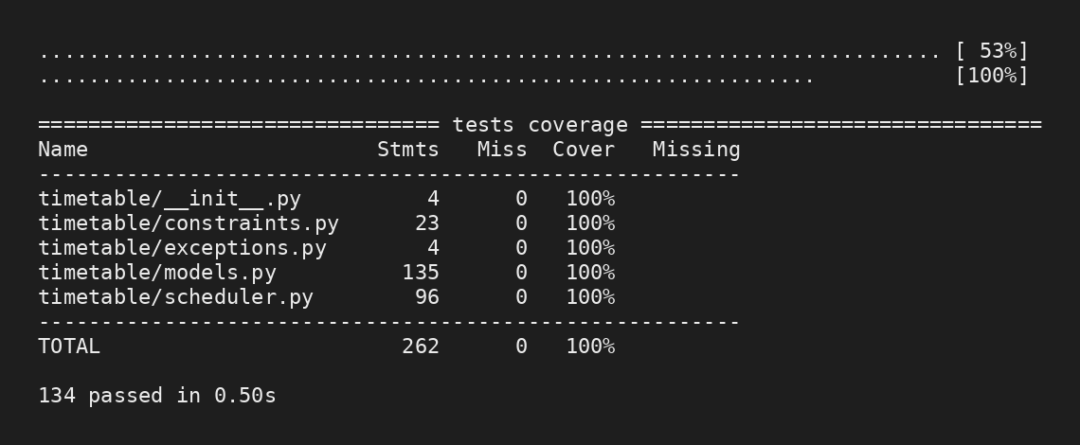
Final testing/coverage evidence supplied with the project: 134 tests passing and 100% coverage.
The demo application also produced a valid timetable in 11 search steps. Its output assigned HIT137 and PRT582 sessions to legal rooms and times and reported a preferred-slot score of 1/1. The final timetable output was checked against room capacity, prerequisite ordering and lecturer availability rules.

6.1 Progress Across TDD Iterations
Iteration | RED result | GREEN/result | Main outcome
1 | 16 failed / 5 passed | 21 passed | TimeSlot validation and overlaps
2 | 21 failed / 28 passed | 49 passed | Room, Lecturer, Session
3 | 14 failed / 59 passed | 73 passed | Independent hard constraints
4A | 22 failed / 78 passed | 100 passed | Initial greedy scheduler
4C | 1 failed / 102 passed | 103 passed | Greedy defect -> backtracking
5 | 7 failed / 109 passed; then 2 failed / 114 passed | 116 passed | Prerequisite integration fix
6 | 4 failed / 121 passed | 125 passed | Soft preferences and room efficiency
7 | 6 failed / 128 passed | 134 passed | Budget, determinism, diagnostics
Final coverage | 99% before cleanup | 100% | Removed unused Assignment.__str__

7. Reflection
I found that AI was most useful when tasks were divided into smaller behaviors. Claude did a great job at coming up with test cases, clarifying the importance of boundaries, and coming up with minor implementations after I observed the tests failing. The scheduler attempted to merge the constraint functions, but each rule could be understood and tested independently, making them an excellent example.
Additionally, the procedure revealed an issue with my initial application of AI. After I made a too general request, Claude came up with a full project to fulfilll it. The assignment required demonstration of iterative AI-TDD, and while that was convenient, it did not meet that requirement. I became aware of this and requested a step-by-step restart. The project's focus shifted from "AI provides a solution" to "AI recommends the next test/implementation, and I confirm the outcome before moving forward."
A green test suite is no guaranty of program correctness; this was the most important takeaway from TDD. A meticulously selected new scenario was still able to derail the greedy scheduler, even after it had passed 100 tests. While two end-to-end scheduler tests failed, all isolated prerequisite rule tests succeeded. The situation was reversed when it came to prerequisites. Based on these instances, I now know that test quantity is less important than test quality and variety.
Not every RED/GREEN cycle has to expose a bug, I discovered as well. After adding the tests, iteration 6 worked the first time. Accurately documenting that is preferable to fabricating issues. Similarly, in Iteration 7, instead of a functional problem, the coverage report discovered an unused __str__ method. Instead of writing a useless test to get 100% coverage, I decided to remove the dead code.
The program was enhanced by the implementation of a testing strategy that integrated unit tests, boundary tests, regression tests, and end-to-end scheduler tests. While unit tests made it easier to troubleshoot specific rules, scheduler tests verified how those rules interacted with the search order. The project is now safe from recurrence of the greedy failure or one-direction prerequisite bug thanks to the regression tests.
I would support half-hour slots and room-equipment needs, including weighted lecturer preferences, test substantially bigger randomly generated schedule problems, incorporate performance benchmarks, investigate constraint-propagation approaches prior to backtracking, and test considerably larger schedules if I had additional development time. Additionally, I would implement continuous integration to ensure that the complete test and coverage suite is executed automatically with each GitHub push.
The coding/TDD process relied heavily on Claude, an artificial intelligence tool. It is still my responsibility to ensure that the report is accurate and that the provided code and tests make sense in relation to the real project.

8. Repository and Submission Evidence
GitHub repository URL: https://github.com/romikgrg/Scheduler
The final repository should contain the same version of the application and tests that produced the 134-pass, 100%-coverage result. The assignment submission ZIP should contain the final report, source code and automated unit tests.
The Claude transcript contains suggested git commit commands for each RED/GREEN stage, but the supplied ZIP does not contain verified commit evidence. Therefore the report does not claim that the complete commit history already exists. Before submission, push the final project to GitHub and insert the repository URL above.

9. References
No external technical sources were supplied as evidence for this report. If Python, pytest, pytest-cov or other documentation was consulted during development, add those sources here in the referencing style required by the unit. The AI interactions are documented in the project development evidence rather than treated as authoritative technical references.

Appendix A - Evidence Map
The main report includes the complete sequence of 17 terminal screenshots from Iterations.docx. Their order corresponds to the RED/GREEN stages described in Section 4. The additional Claude conversation screenshots supplied during report preparation were used to reconstruct the actual interaction history, including the decision to restart the assignment iteratively, the greedy-scheduler defect discussion, the prerequisite integration defect, the soft-constraint design and the final coverage/dead-code decision.
Final verified commands executed while preparing this report:
python -m pytest -q -> 134 passed
python -m pytest --cov=timetable --cov-report=term-missing -q -> 100%
python main.py -> timetable found in 11 search steps

