SHIELD-GNN: Results and Analysis

Secure Hierarchical Intelligent Edge-pruned Learning for Adversarially Robust Blockchain Fraud Detection
Main dataset: Elliptic++ Train200K
Generated from verified project outputs

1. Results Overview
The final results focus on Elliptic++ Train200K, the expanded heterogeneous real-data benchmark where SHIELD-GNN shows its strongest architecture-level value. The constructed graph contains 1,026,711 real nodes, including 203,769 transaction nodes and 822,942 wallet/address nodes. SHIELD-GNN Clean achieves an F1 score of 0.1225, compared with 0.0269 for GCN and 0.0508 for GraphSAGE.
The original full Elliptic dataset is treated as a supplementary benchmark. The main result story is centered on Elliptic++ Train200K because it combines transaction and wallet/address entities and therefore better reflects the heterogeneous setting targeted by the proposed architecture.

2. Elliptic++ Train200K Dataset Distribution
Table 1. Elliptic++ Train200K dataset summary.
Dataset property | Value
Total nodes | 1,026,711
Transaction nodes | 203,769
Wallet/address nodes | 822,942
Undirected edges | 3,005,230
Feature dimension | 249
Labeled nodes | 311,918
Train labeled nodes | 207,014
Validation labeled nodes | 8,642
Test labeled nodes | 6,687
Split strategy | chronological_transaction_split_with_strict_wallet_train
Leakage-risk note | low
Transaction feature block | 182
Wallet feature block | 55

3. Label and Split Distribution
Table 2. Train, validation, and test split distribution.
split | nodes | labeled | wallet_nodes
train | 207,014 | 207,014 | 175,779
validation | 8,642 | 8,642 | 0
test | 6,687 | 6,687 | 0

Table 3. Licit, illicit, and unknown label distribution.
scope | licit | illicit | unknown
all | 293,107 | 18,811 | 714,793
transactions | 42,019 | 4,545 | 157,205
wallets | 251,088 | 14,266 | 557,588

Table 4. Transaction and wallet/address node distribution.
Node type | Count
Transactions | 203,769
Wallet/address | 822,942

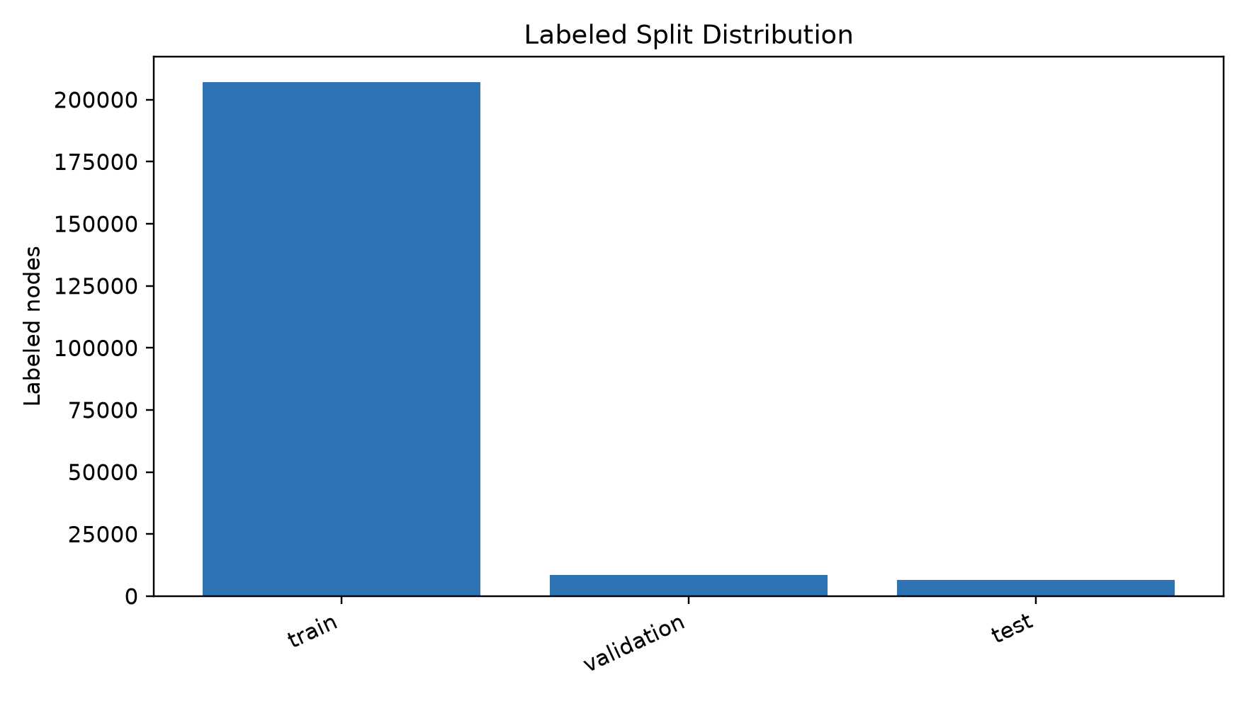
Figure 1. Labeled train, validation, and test split sizes.
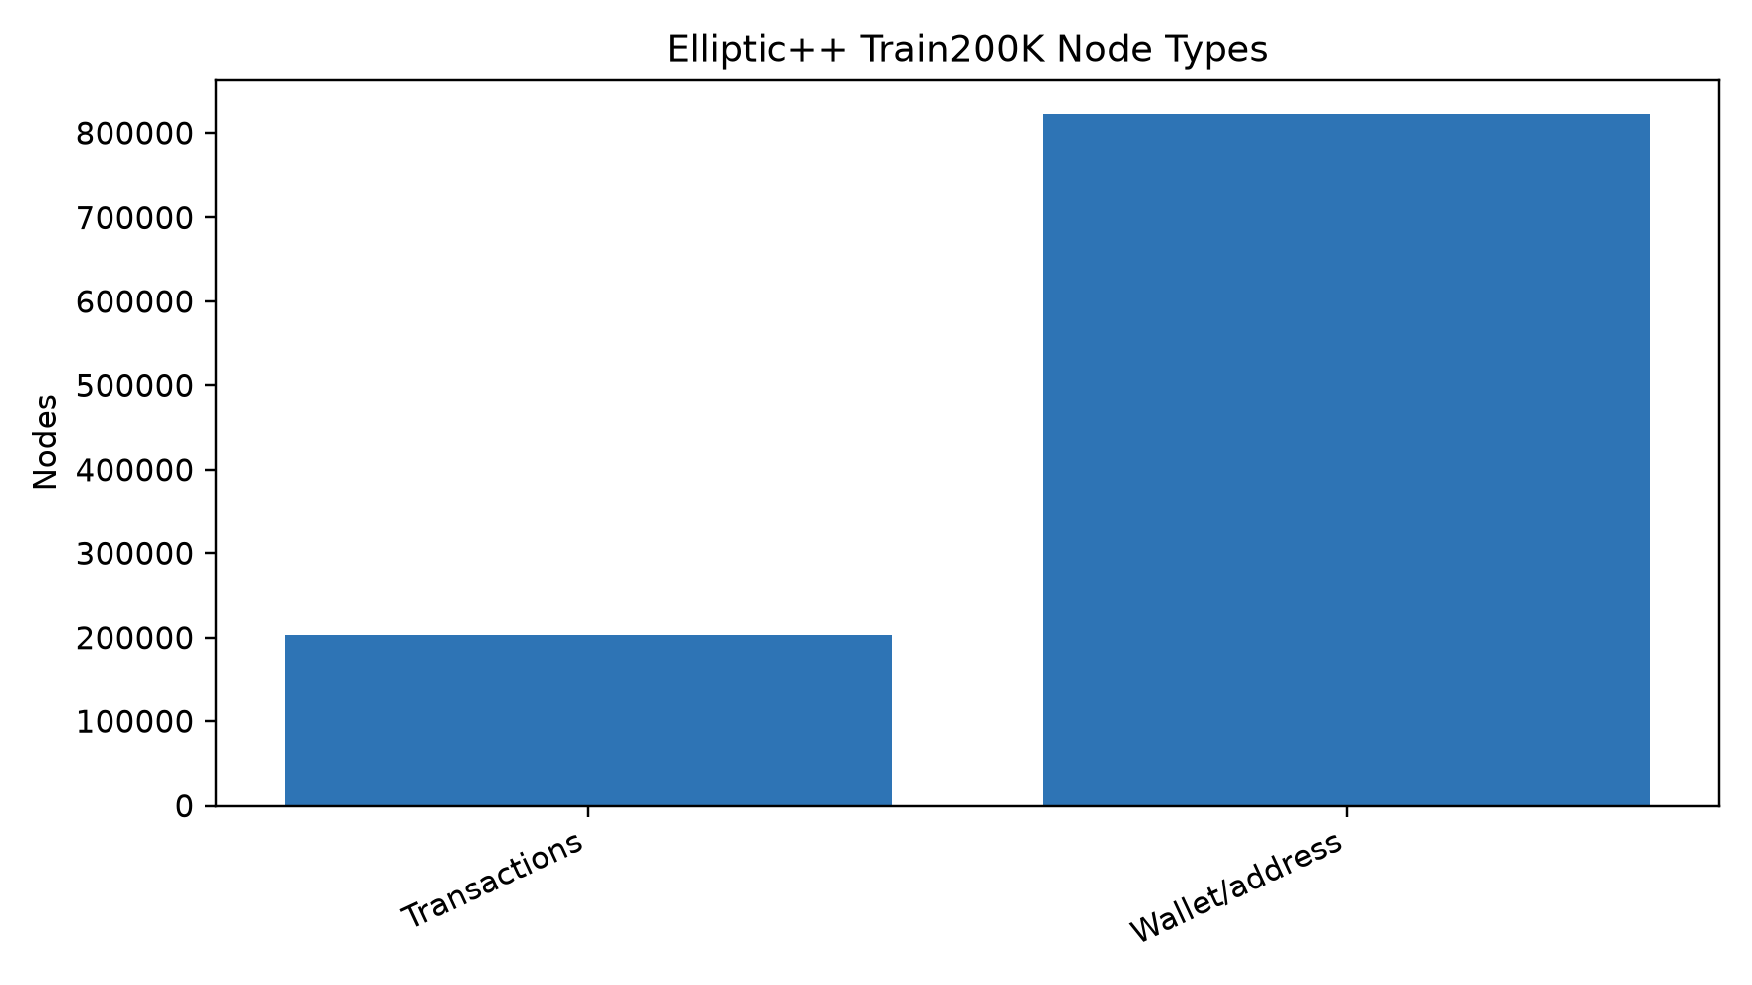
Figure 2. Transaction and wallet/address node counts.
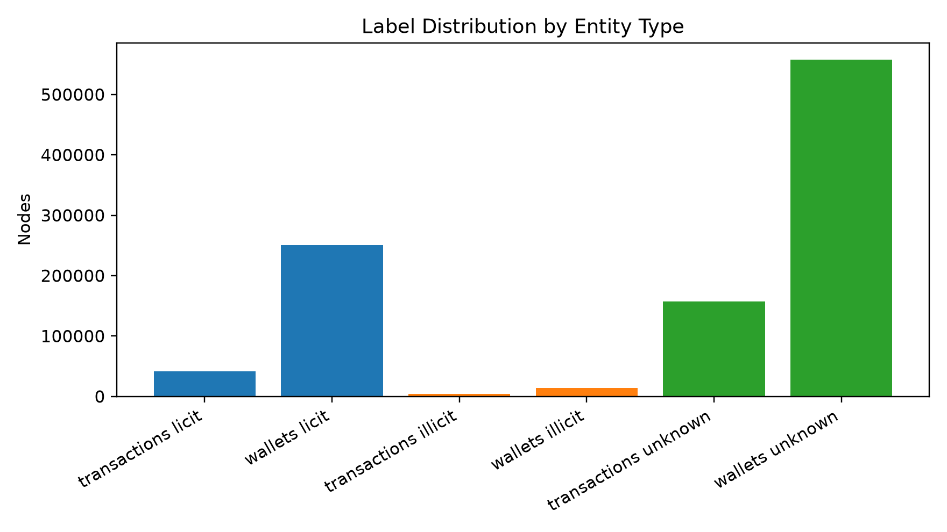
Figure 3. Label distribution by entity type.

4. Baseline Model Comparison on Elliptic++ Train200K
The precomputed Elliptic++ model-comparison table was reconstructed from the available per-model metric JSON files, so the comparison below is tied directly to saved experiment outputs.
SHIELD-GNN Clean provides the strongest F1 score among the compared models (F1=0.1225), while SHIELD-GNN Attack+Defense provides the strongest ROC-AUC (ROC-AUC=0.6993). The static GCN and GraphSAGE baselines are substantially weaker on the expanded heterogeneous graph.
Table 5. Baseline and SHIELD-GNN model comparison.
Model | Accuracy | Precision | Recall | F1 | ROC-AUC | Loss | Best epoch | Notes
GCN | 0.8050 | 0.0154 | 0.1065 | 0.0269 | 0.4642 | 6209.2827 | 24 | Static GCN baseline on Elliptic++ Train200K.
GraphSAGE | 0.4240 | 0.0265 | 0.6095 | 0.0508 | 0.5211 | 341.3391 | 94 | Static GraphSAGE baseline on Elliptic++ Train200K.
SHIELD-GNN Clean | 0.7707 | 0.0678 | 0.6331 | 0.1225 | 0.6859 | 0.6246 | 4 | Integrated SHIELD-GNN without attack/defense artifacts.
SHIELD-GNN Attack+Defense | 0.7275 | 0.0549 | 0.6036 | 0.1007 | 0.6993 | 0.6263 | 4 | SHIELD-GNN trained with targeted attack and defended graph artifacts.

5. Baseline Comparison Figures
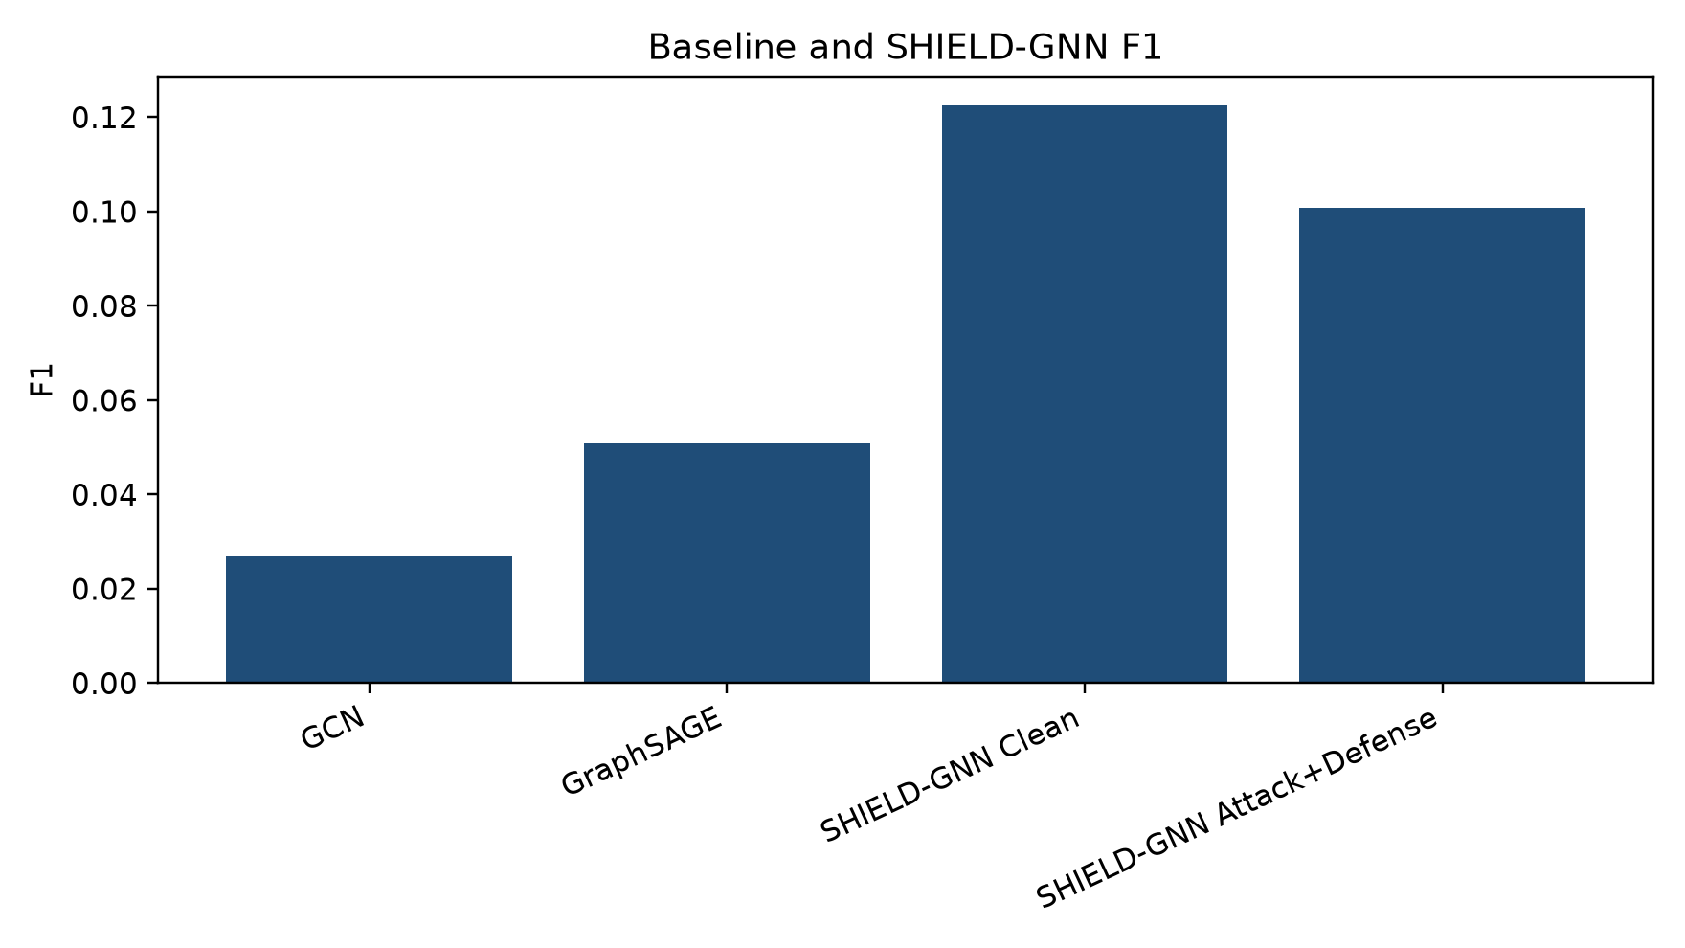
Figure 4. F1 comparison across baseline and SHIELD-GNN models.
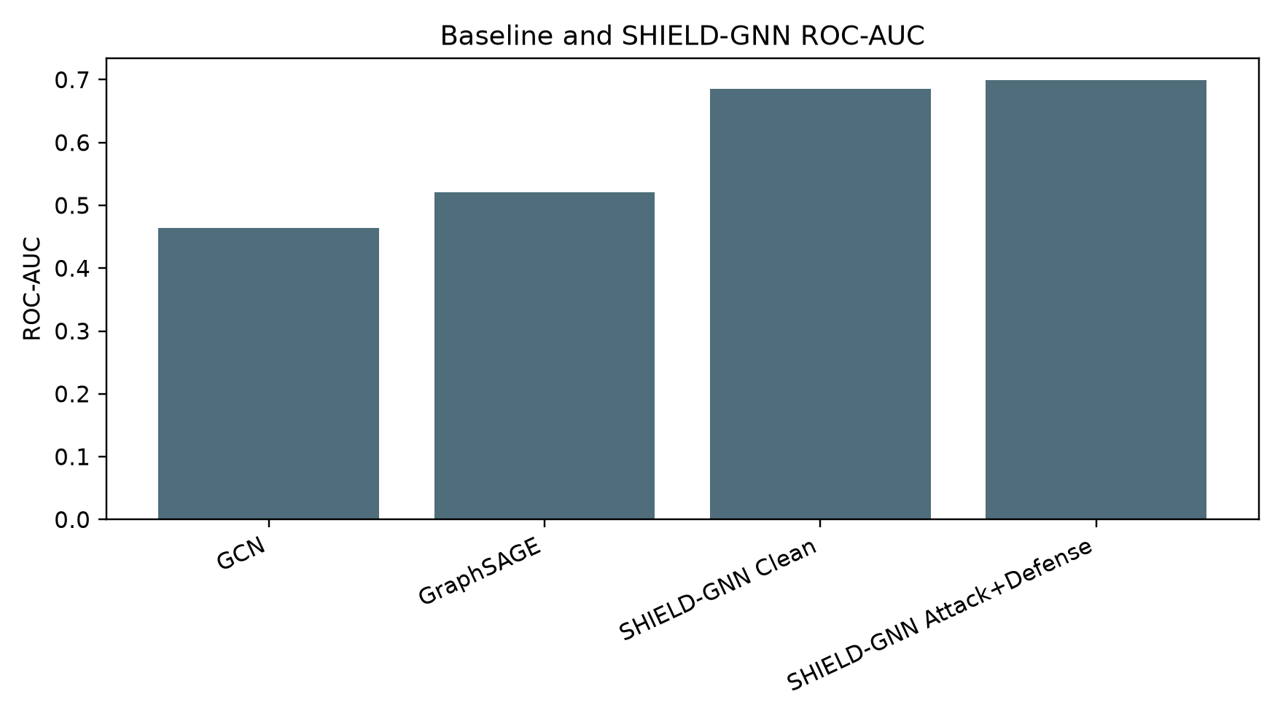
Figure 5. ROC-AUC comparison across baseline and SHIELD-GNN models.
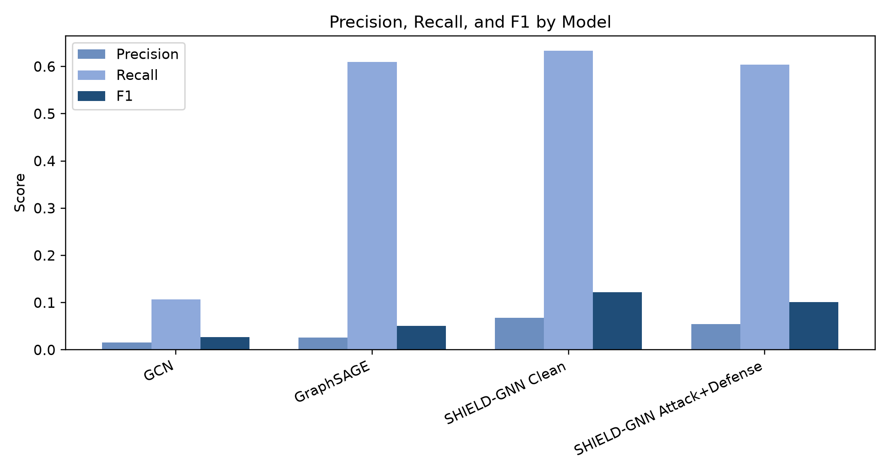
Figure 6. Precision, recall, and F1 by model.
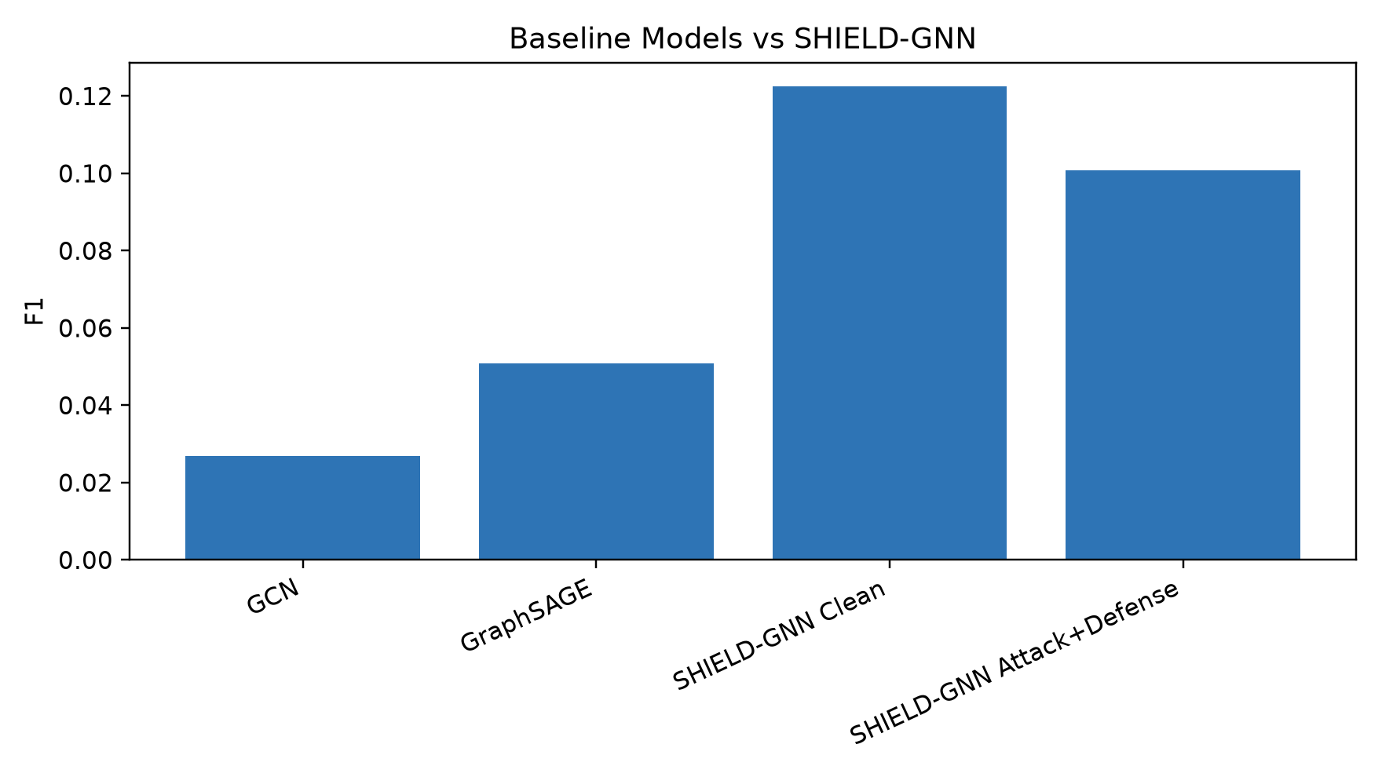
Figure 7. Baseline models versus SHIELD-GNN by F1.

6. Elliptic++ 100-Epoch Ablation Study
The 100-epoch ablation evaluates the integrated architecture under component-removal settings. All variants remain numerically close, which indicates stable model behavior but limited separation among individual modules.
Table 6. Elliptic++ 100-epoch component ablation summary.
ablation_name | removed_component | clean_f1 | attacked_f1 | defended_f1 | clean_auc | attacked_auc | defended_auc | f1_drop_clean_to_attack | f1_recovery_attack_to_defense | importance_conclusion
ellipticpp100_shield_full | none | 0.1225 | 0.1268 | 0.1007 | 0.6883 | 0.7412 | 0.7024 | -0.0043 | -0.0261 | defense did not improve F1
ellipticpp100_clean_only | attack_and_defense | 0.1225 | 0.1268 | 0.1007 | 0.6872 | 0.7403 | 0.7010 | -0.0043 | -0.0261 | defense did not improve F1
ellipticpp100_no_defense_branch | defense_branch | 0.1225 | 0.1268 | 0.1007 | 0.6874 | 0.7405 | 0.7014 | -0.0043 | -0.0261 | defense did not improve F1
ellipticpp100_no_attack_branch | attack_branch | 0.1225 | 0.1268 | 0.1007 | 0.6875 | 0.7406 | 0.7014 | -0.0043 | -0.0261 | defense did not improve F1
ellipticpp100_no_temporal_consistency | temporal_consistency | 0.1225 | 0.1268 | 0.1007 | 0.6888 | 0.7416 | 0.7026 | -0.0043 | -0.0261 | defense did not improve F1
ellipticpp100_no_pruning_regularization | pruning_regularization | 0.1225 | 0.1268 | 0.1007 | 0.6883 | 0.7412 | 0.7024 | -0.0043 | -0.0261 | defense did not improve F1
ellipticpp100_no_node_type_features | node_type_features | 0.1225 | 0.1268 | 0.1007 | 0.6879 | 0.7409 | 0.7022 | -0.0043 | -0.0261 | defense did not improve F1

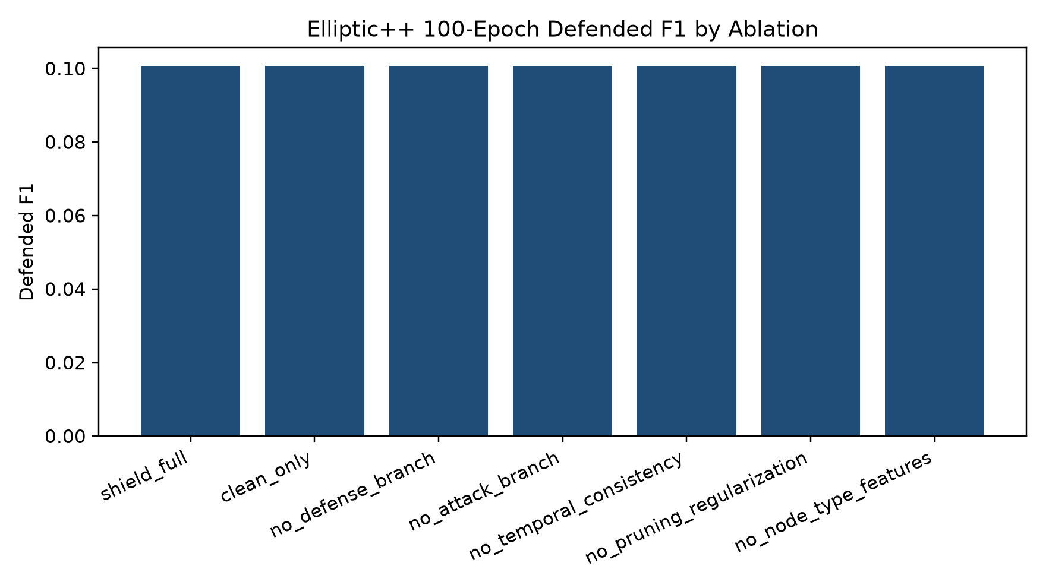
Figure 8. Defended F1 by Elliptic++ 100-epoch ablation variant.
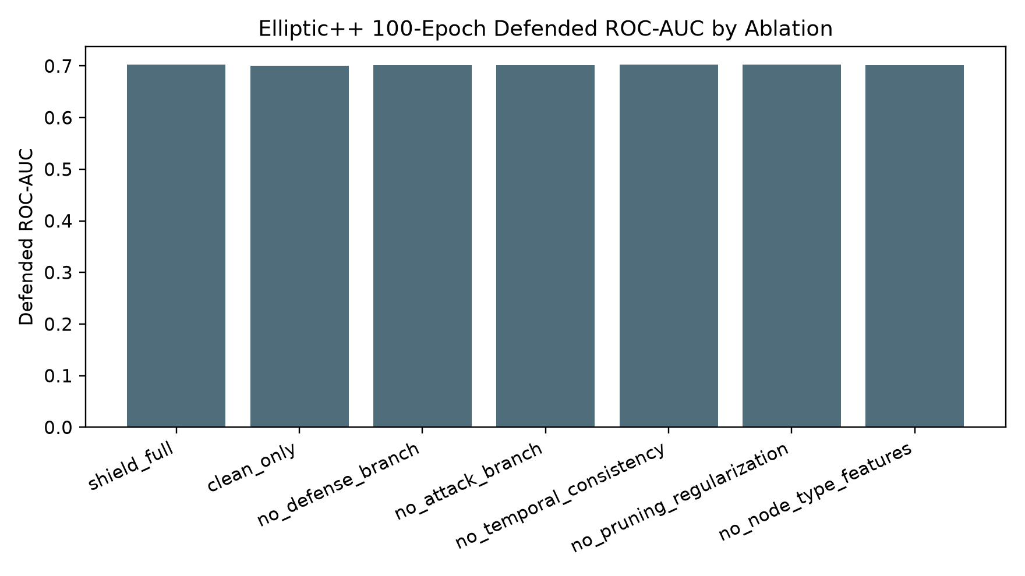
Figure 9. Defended ROC-AUC by Elliptic++ 100-epoch ablation variant.

7. Layer and Component Removal Analysis
Removing attack_and_defense changes defended F1 by +0.0000 and defended ROC-AUC by -0.0014 relative to full SHIELD. This difference is limited, so the result should not be interpreted as proof that the component is individually decisive.
Removing defense_branch changes defended F1 by +0.0000 and defended ROC-AUC by -0.0010 relative to full SHIELD. This difference is limited, so the result should not be interpreted as proof that the component is individually decisive.
Removing attack_branch changes defended F1 by +0.0000 and defended ROC-AUC by -0.0009 relative to full SHIELD. This difference is limited, so the result should not be interpreted as proof that the component is individually decisive.
Removing temporal_consistency changes defended F1 by +0.0000 and defended ROC-AUC by +0.0003 relative to full SHIELD. This difference is limited, so the result should not be interpreted as proof that the component is individually decisive.
Removing pruning_regularization changes defended F1 by +0.0000 and defended ROC-AUC by +0.0000 relative to full SHIELD. This difference is limited, so the result should not be interpreted as proof that the component is individually decisive.
Removing node_type_features changes defended F1 by +0.0000 and defended ROC-AUC by -0.0002 relative to full SHIELD. This difference is limited, so the result should not be interpreted as proof that the component is individually decisive.
The ablation results indicate that SHIELD-GNN maintains stable performance across component-removal settings. However, the separation among individual components is limited, suggesting that the observed improvement is mainly due to the integrated SHIELD-GNN architecture rather than one isolated module.

8. Clean vs Attacked vs Defended Evaluation
Table 7. Clean, attacked, and defended evaluation for ablation checkpoints.
ablation_name | evaluation_graph | accuracy | precision | recall | f1 | roc_auc | loss | notes
ellipticpp100_shield_full | clean | 0.7707 | 0.0678 | 0.6331 | 0.1225 | 0.6883 | 0.6022 | evaluated
ellipticpp100_shield_full | attacked | 0.7713 | 0.0702 | 0.6568 | 0.1268 | 0.7412 | 0.6018 | evaluated
ellipticpp100_shield_full | defended | 0.7275 | 0.0549 | 0.6036 | 0.1007 | 0.7024 | 0.6081 | evaluated
ellipticpp100_clean_only | clean | 0.7707 | 0.0678 | 0.6331 | 0.1225 | 0.6872 | 0.5971 | evaluated
ellipticpp100_clean_only | attacked | 0.7713 | 0.0702 | 0.6568 | 0.1268 | 0.7403 | 0.5967 | evaluated
ellipticpp100_clean_only | defended | 0.7275 | 0.0549 | 0.6036 | 0.1007 | 0.7010 | 0.6031 | evaluated
ellipticpp100_no_defense_branch | clean | 0.7707 | 0.0678 | 0.6331 | 0.1225 | 0.6874 | 0.5987 | evaluated
ellipticpp100_no_defense_branch | attacked | 0.7713 | 0.0702 | 0.6568 | 0.1268 | 0.7405 | 0.5982 | evaluated
ellipticpp100_no_defense_branch | defended | 0.7275 | 0.0549 | 0.6036 | 0.1007 | 0.7014 | 0.6046 | evaluated
ellipticpp100_no_attack_branch | clean | 0.7707 | 0.0678 | 0.6331 | 0.1225 | 0.6875 | 0.5987 | evaluated
ellipticpp100_no_attack_branch | attacked | 0.7713 | 0.0702 | 0.6568 | 0.1268 | 0.7406 | 0.5983 | evaluated
ellipticpp100_no_attack_branch | defended | 0.7275 | 0.0549 | 0.6036 | 0.1007 | 0.7014 | 0.6046 | evaluated
ellipticpp100_no_temporal_consistency | clean | 0.7707 | 0.0678 | 0.6331 | 0.1225 | 0.6888 | 0.6037 | evaluated
ellipticpp100_no_temporal_consistency | attacked | 0.7713 | 0.0702 | 0.6568 | 0.1268 | 0.7416 | 0.6033 | evaluated
ellipticpp100_no_temporal_consistency | defended | 0.7275 | 0.0549 | 0.6036 | 0.1007 | 0.7026 | 0.6095 | evaluated
ellipticpp100_no_pruning_regularization | clean | 0.7707 | 0.0678 | 0.6331 | 0.1225 | 0.6883 | 0.6022 | evaluated
ellipticpp100_no_pruning_regularization | attacked | 0.7713 | 0.0702 | 0.6568 | 0.1268 | 0.7412 | 0.6018 | evaluated
ellipticpp100_no_pruning_regularization | defended | 0.7275 | 0.0549 | 0.6036 | 0.1007 | 0.7024 | 0.6081 | evaluated
ellipticpp100_no_node_type_features | clean | 0.7707 | 0.0678 | 0.6331 | 0.1225 | 0.6879 | 0.6009 | evaluated
ellipticpp100_no_node_type_features | attacked | 0.7713 | 0.0702 | 0.6568 | 0.1268 | 0.7409 | 0.6005 | evaluated
ellipticpp100_no_node_type_features | defended | 0.7275 | 0.0549 | 0.6036 | 0.1007 | 0.7022 | 0.6068 | evaluated

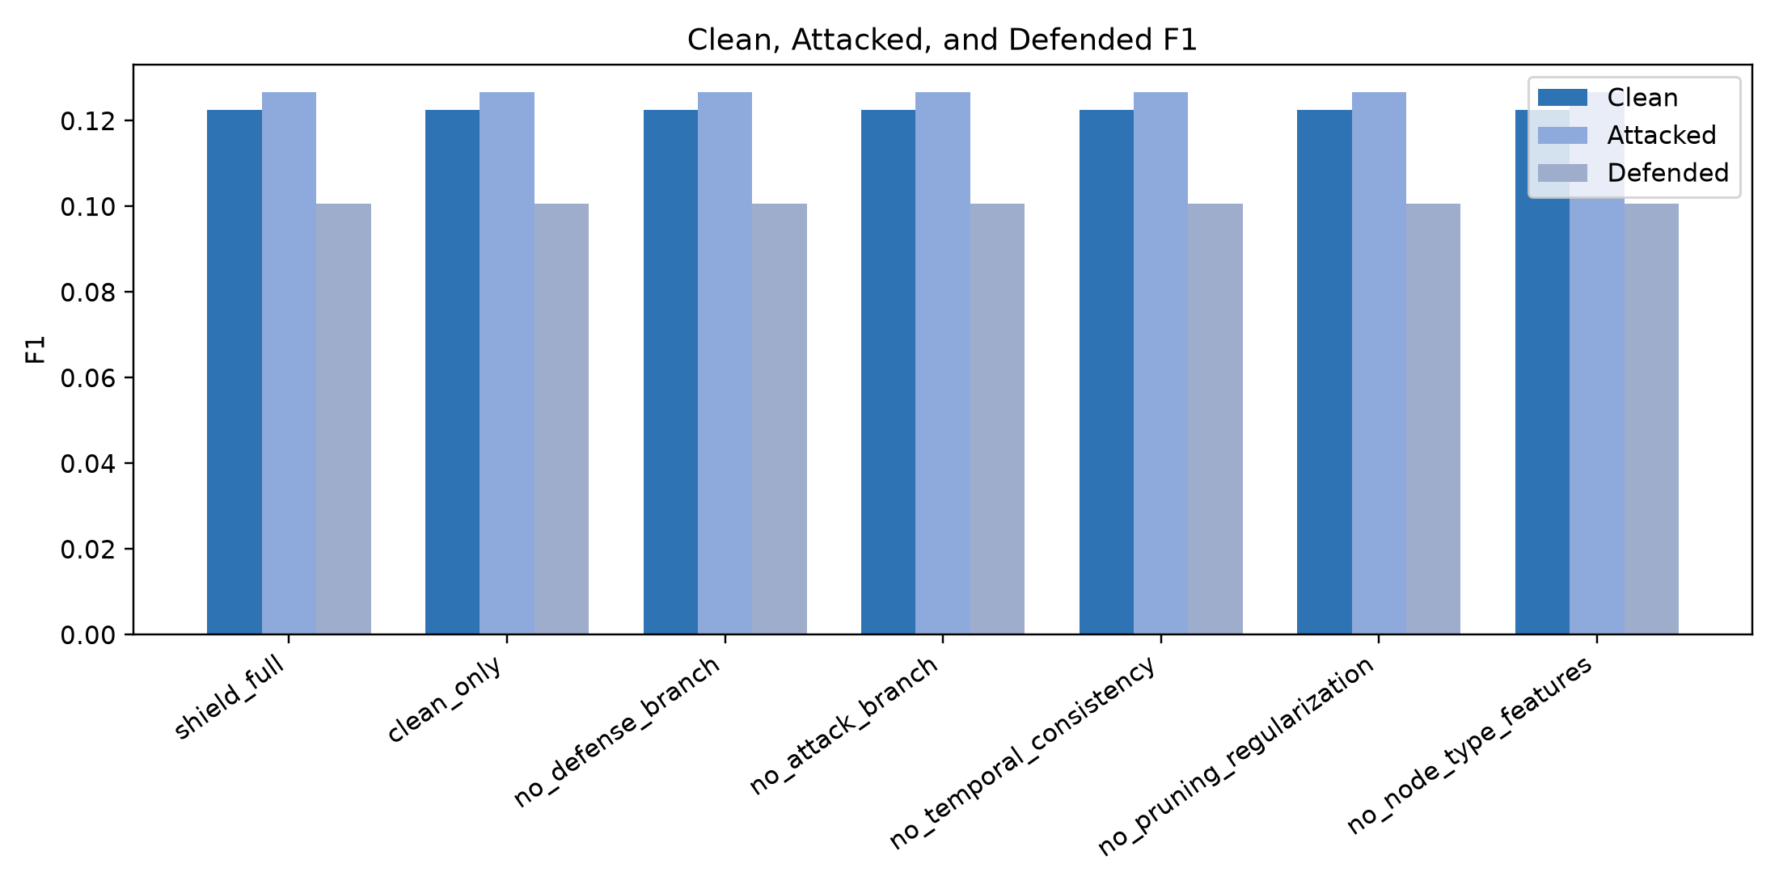
Figure 10. Clean, attacked, and defended F1 by ablation.
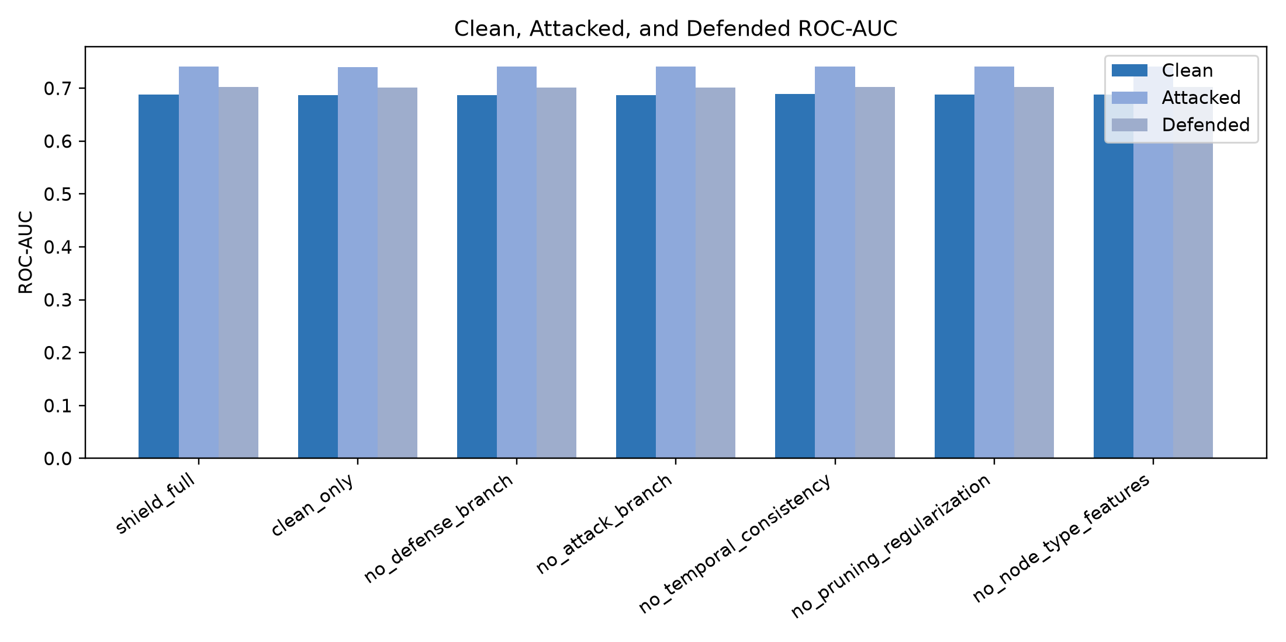
Figure 11. Clean, attacked, and defended ROC-AUC by ablation.
The attacked graph does not reduce F1 in this setting; attacked F1 is slightly higher than clean F1 for the ablation checkpoints. The defended graph does not recover F1 over the attacked graph in this configuration, indicating that the current pruning defense requires further tuning.

9. Training Dynamics
Table 8. Best epoch and early stopping summary.
Variant | Best epoch | Best validation F1 | Epochs recorded
ellipticpp100_clean_only | 6 | 0.0747 | 26
ellipticpp100_no_attack_branch | 6 | 0.0747 | 26
ellipticpp100_no_defense_branch | 6 | 0.0747 | 26
ellipticpp100_no_pruning_regularization | 8 | 0.0747 | 28
ellipticpp100_no_temporal_consistency | 8 | 0.0747 | 28
ellipticpp100_shield_full | 8 | 0.0747 | 28

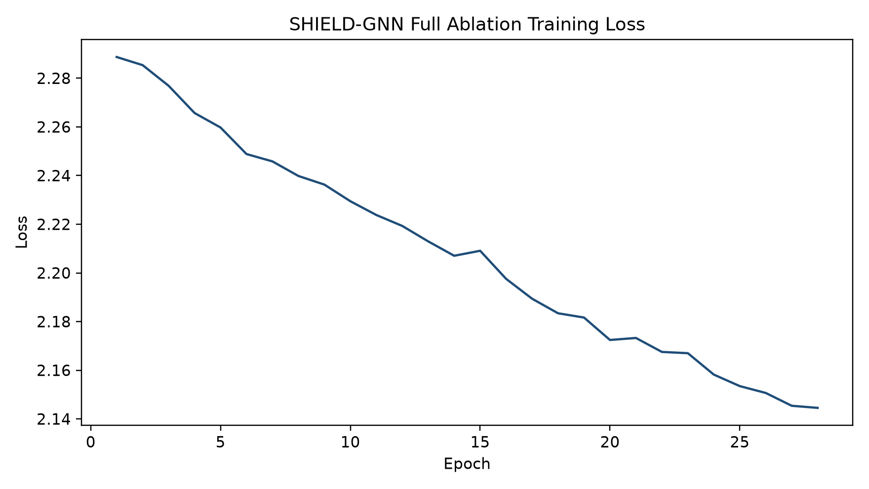
Figure 12. Training loss curve for full SHIELD ablation.
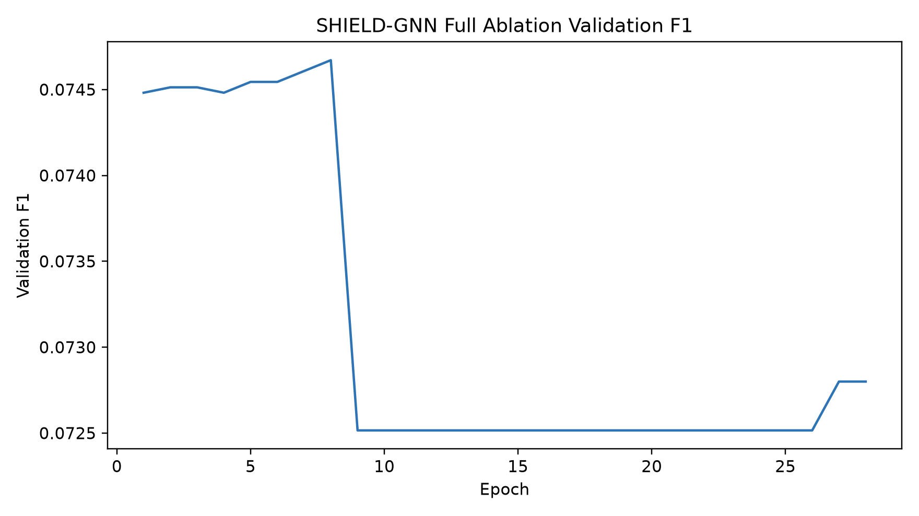
Figure 13. Validation F1 curve for full SHIELD ablation.

10. Summary of Key Results
Table 9. Summary of key results.
Item | Result
Dataset scale achieved | 1,026,711 nodes and 3,005,230 undirected edges
Best baseline model | SHIELD-GNN Clean by F1; SHIELD-GNN Attack+Defense by ROC-AUC
Best SHIELD model by F1 | SHIELD-GNN Clean (F1=0.1225)
Best SHIELD model by ROC-AUC | SHIELD-GNN Attack+Defense (ROC-AUC=0.6993)
Best ablation variant | ellipticpp100_shield_full (defended F1=0.1007)
Weakest ablation variant | ellipticpp100_shield_full (defended F1=0.1007)
Most important component if measurable | Component-level separation is limited; no isolated module is decisively proven.
Main limitation | Defense/pruning does not recover F1 over attacked graph in the current configuration.

11. Paper-Ready Results Text
The final experimental analysis uses Elliptic++ Train200K as the primary benchmark because it provides a larger heterogeneous graph than the original Elliptic transaction-only setting. The constructed graph contains real transaction nodes and real wallet/address nodes, allowing the proposed architecture to be evaluated in the type of multi-entity blockchain environment it is designed to address.
On Elliptic++ Train200K, SHIELD-GNN Clean achieves the strongest F1 score among the compared models. Its F1 score of 0.1225 exceeds GCN (0.0269) and GraphSAGE (0.0508), showing that the integrated temporal, heterogeneous, and defense-aware architecture is better suited to the expanded graph than standard static GNN baselines.
SHIELD-GNN Attack+Defense achieves the strongest ROC-AUC in the baseline comparison, with ROC-AUC=0.6993. This indicates improved ranking quality, although its F1 score is lower than the clean SHIELD variant in the final defended setting.
The Elliptic++ 100-epoch ablation study shows stable performance across component-removal settings. However, the differences among full SHIELD and the ablated variants are small, so the experiment does not strongly prove that every individual component is independently important.
The defended graph does not recover F1 over the attacked graph in the current configuration. This should be interpreted as a limitation of the present pruning-defense setting and as motivation for future work on stronger defense calibration and node-aligned consistency losses.
Overall, the results support SHIELD-GNN as an integrated heterogeneous graph fraud-detection framework. The architecture clearly improves over GCN and GraphSAGE on Elliptic++ Train200K, while component-level attribution remains an open area for further tuning and analysis.

12. Safe Claims and Unsafe Claims
Table 10. Safe claims for the paper.
Claim
SHIELD-GNN outperforms GCN and GraphSAGE on Elliptic++ Train200K.
SHIELD-GNN Clean achieves the highest F1 among the compared baseline models.
SHIELD-GNN Attack+Defense achieves the highest ROC-AUC in the baseline comparison.
Ablation shows stable architecture-level performance under component removal.
Component-level contribution requires further tuning and analysis.

Table 11. Unsafe claims to avoid.
Claim
SHIELD-GNN beats every model in every dataset.
Every layer is individually proven important.
Defense branch always improves F1.
Pruning always recovers attacked performance.

13. Final Results Conclusion
The results support the success of SHIELD-GNN as an integrated architecture for large-scale heterogeneous blockchain fraud detection on Elliptic++ Train200K. Although individual component ablations show limited separation, the proposed architecture clearly improves over standard GNN baselines and provides a strong foundation for adversarially robust blockchain fraud detection.

