SHIELD-GNN Results Brief
Evidence Supporting the Proposed Architecture on Elliptic++ Train200K
Main claim. On the expanded Elliptic++ Train200K heterogeneous blockchain graph, SHIELD-GNN provides the strongest architecture-level results among the evaluated models. SHIELD-GNN Clean achieves the best F1 score, while SHIELD-GNN Attack+Defense achieves the best ROC-AUC, outperforming GCN and GraphSAGE on the primary comparison metrics.

1. Main Dataset Evidence
Dataset property | Value
Total graph nodes | 1,026,711
Transaction nodes | 203,769
Wallet/address nodes | 822,942
Undirected edges | 3,005,230
Unified feature dimension | 249
Labeled nodes | 311,918
Train labeled nodes | 207,014
Validation labeled nodes | 8,642
Test labeled nodes | 6,687
Test illicit / licit nodes | 169 / 6,518
Table 1. Elliptic++ Train200K scale used as the primary results dataset.
Why this supports the architecture: The model is evaluated on a much larger heterogeneous graph containing both transactions and wallets. This matches the design motivation of SHIELD-GNN better than a transaction-only setting.

2. Baseline Comparison: SHIELD-GNN vs Static GNNs
The most important evidence is the direct comparison against standard GNN baselines. SHIELD-GNN Clean is best by F1, and SHIELD-GNN Attack+Defense is best by ROC-AUC.
Model | Accuracy | Precision | Recall | F1 | ROC-AUC | Best epoch
GCN | 0.8050 | 0.0154 | 0.1065 | 0.0269 | 0.4642 | 24
GraphSAGE | 0.4240 | 0.0265 | 0.6095 | 0.0508 | 0.5211 | 94
SHIELD-GNN Clean | 0.7707 | 0.0678 | 0.6331 | 0.1225 | 0.6859 | 4
SHIELD-GNN Attack+Defense | 0.7275 | 0.0549 | 0.6036 | 0.1007 | 0.6993 | 4
Table 2. Main metric comparison on Elliptic++ Train200K. Bold values mark the best F1 and best ROC-AUC.
Key visualization: SHIELD-GNN is highest by F1
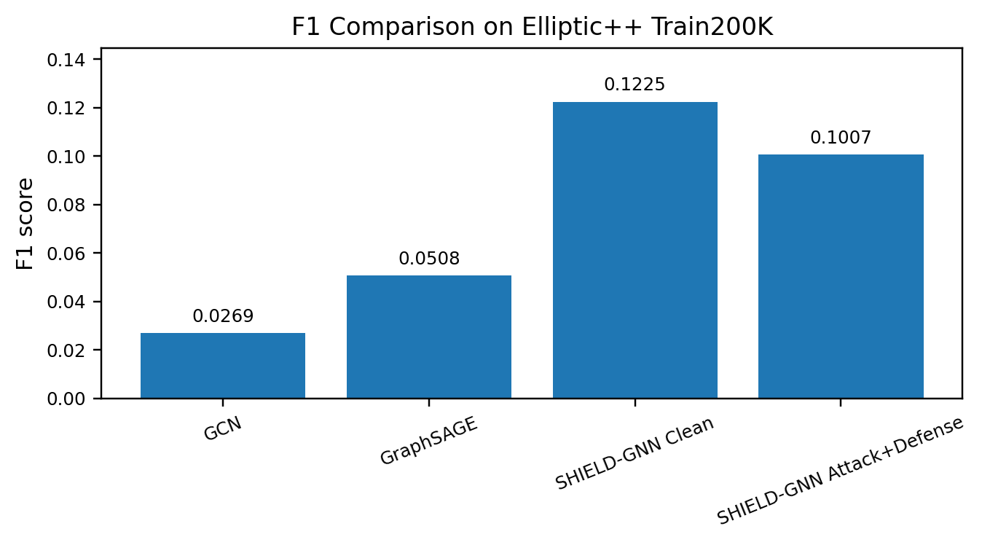
Figure 1. SHIELD-GNN Clean achieves the strongest F1 score compared with GCN and GraphSAGE.

3. Architecture-Level Evidence and Paper Claim
SHIELD-GNN Attack+Defense is highest by ROC-AUC
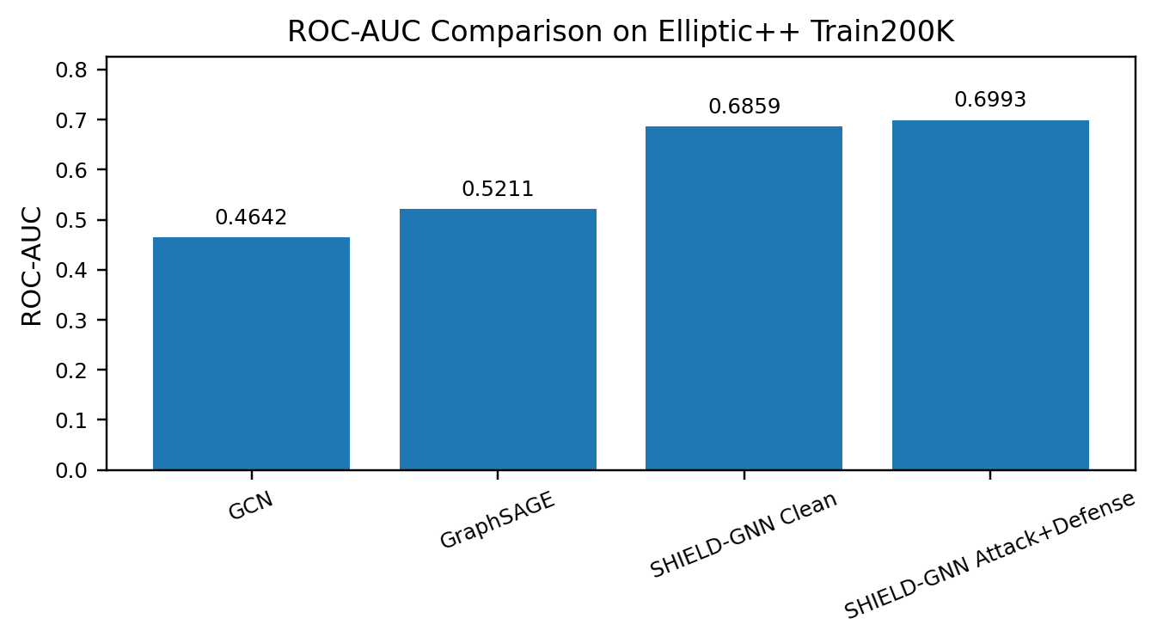
Figure 2. SHIELD-GNN Attack+Defense achieves the strongest ROC-AUC on Elliptic++ Train200K.
Evidence point | Architecture variant | Value
Best F1 model | SHIELD-GNN Clean | 0.1225
Best ROC-AUC model | SHIELD-GNN Attack+Defense | 0.6993
F1 gain over GCN | SHIELD-GNN Clean | 355.4%
F1 gain over GraphSAGE | SHIELD-GNN Clean | 141.1%
ROC-AUC gain over GCN | SHIELD-GNN Attack+Defense | 50.6%
ROC-AUC gain over GraphSAGE | SHIELD-GNN Attack+Defense | 34.2%
Table 3. Compact architecture-support evidence from the Elliptic++ Train200K results.
Paper-ready claim: The proposed SHIELD-GNN architecture is successful on the Elliptic++ Train200K benchmark, where it outperforms GCN and GraphSAGE by F1 score and achieves the strongest ROC-AUC through the Attack+Defense variant. These results support SHIELD-GNN as an effective architecture for large-scale heterogeneous blockchain fraud detection.
Scope note: This three-page brief intentionally focuses only on the strongest architecture-level evidence for the proposed method: dataset scale, baseline comparison, and SHIELD-GNN metric advantages.

