**DSSA ASSIGNMENT2**

Romil Aggarwal

201330112, C.S.E.

Question1

In this question we were supposed to perform convolution of the image with the given3X4 matrix. We can clearly see that it removes the noise but has a blurring effect.(Also we divided by 16 instead of 12 so it becomes darker).

Observed Images:

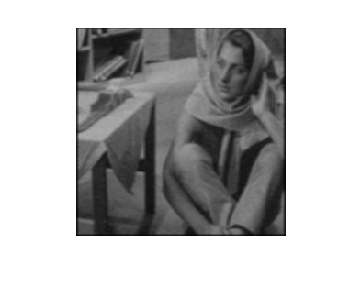

This is the result after doing convolution once on image 1.

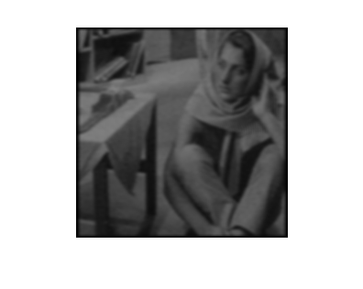

This is the result after doing convolution twice on image 1.

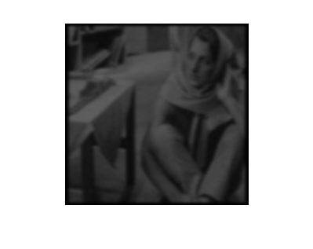

This is the result after doing convolution thrice for image 1.

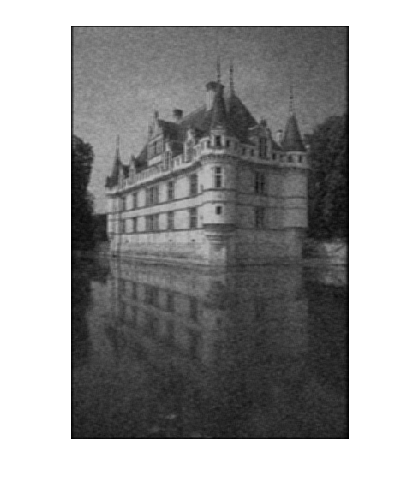

This is the result after doing convolution once on image 2.

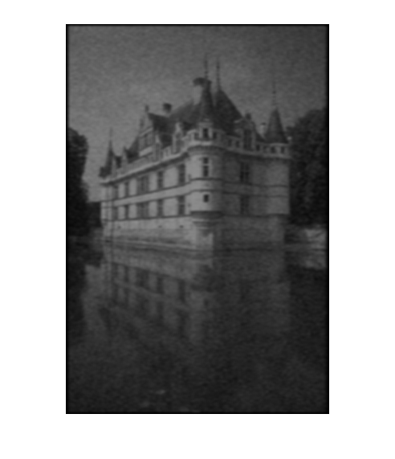

This is the result after doing convolution twice on image 2.

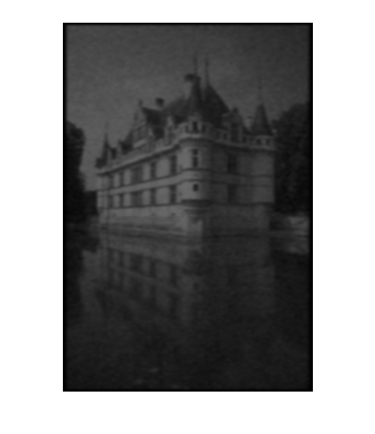

This is the result after doing convolution trice for image 3.

Question 2:

In this question we were supposed to generate a cosine signal and perform auto-correlation for every 10ms frame. To generate the signal use

“

*w=200*pi;*

*t=0.001;*

*n=0:1:1000;*

*x=cos (w*n*t);*

“

And we get the output as:

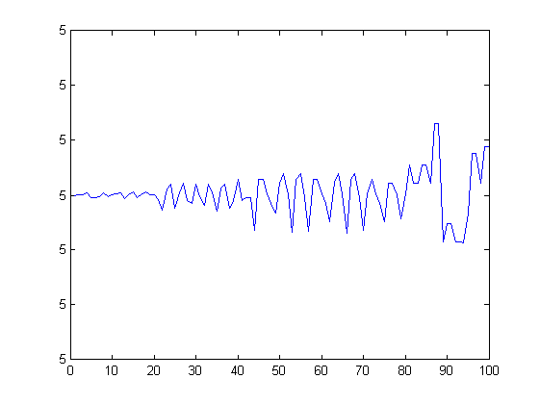

The autocorrelation value vs frame no. graph for every frame (there will be 100 frames).

The time instant (in seconds) where the maximum value occurs between 3ms to 12ms in auto-correlation of each frame is usually 10ms.

Question 3

In this question we were assigned the task of performing Image Steganography.

I applied Discrete Cosine Transform on the second image which will be used for hiding the first image (The DCT transforms a signal or image from the spatial domain to the frequency domain).

First I resized the 2 images and made them of the same size. Then I replace the 4 least significant bits of those pixels whose real value of DCT is lower than a fixed threshold (which I decided to keep as 40) with the 4 most significant bits of the image to be hidden.

Taking advantage of the limitations of human perception, these low DCT value pixels can be easily replaced as they don't contribute much to the original image.

The image can be extracted back by generating pixels with the help 4 least significant bits of the pixels which were modified.

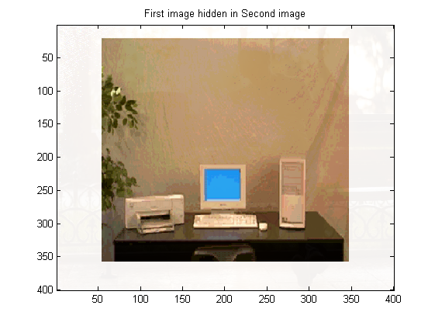

This image has the first image hidden in it.

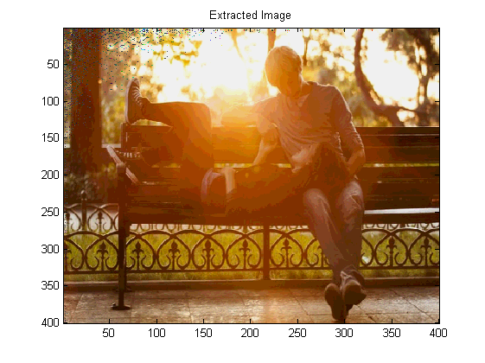

This is the extracted image.