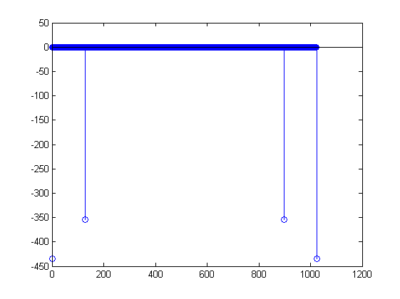Z3

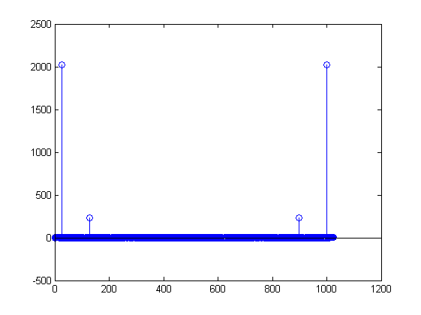Z2

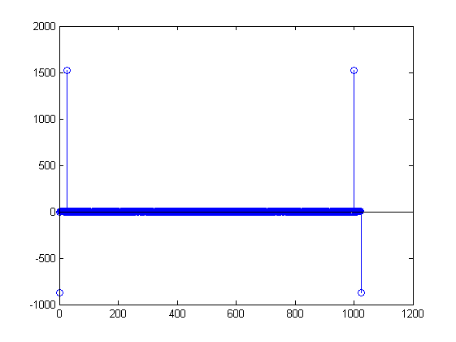Z1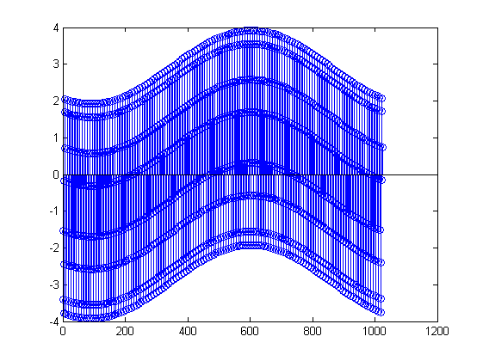Y3

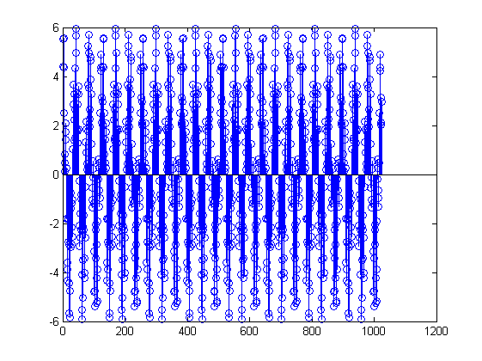Y2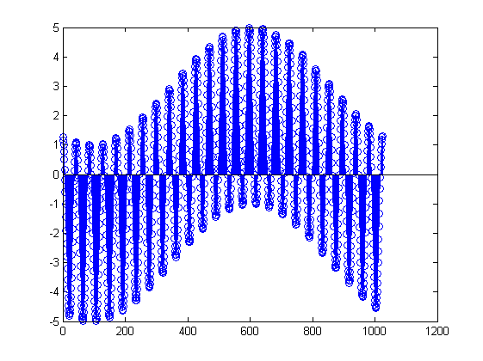Y1

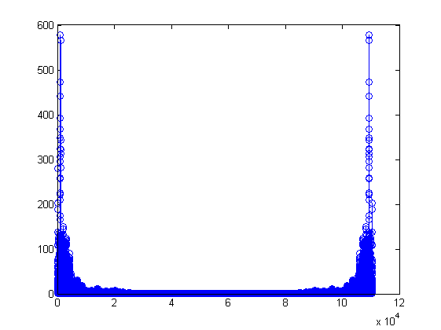guitar

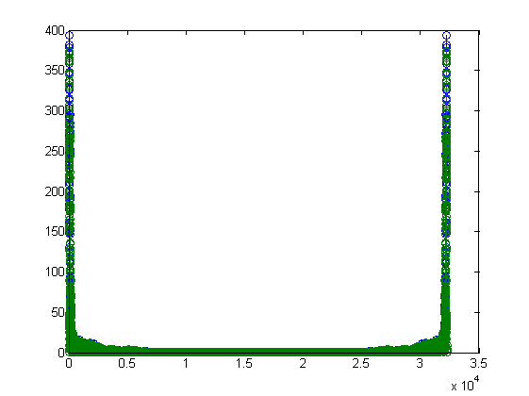drum

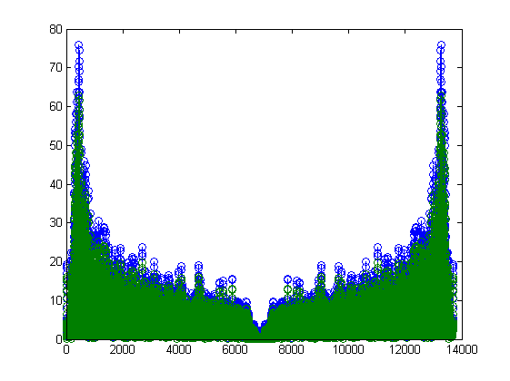clap

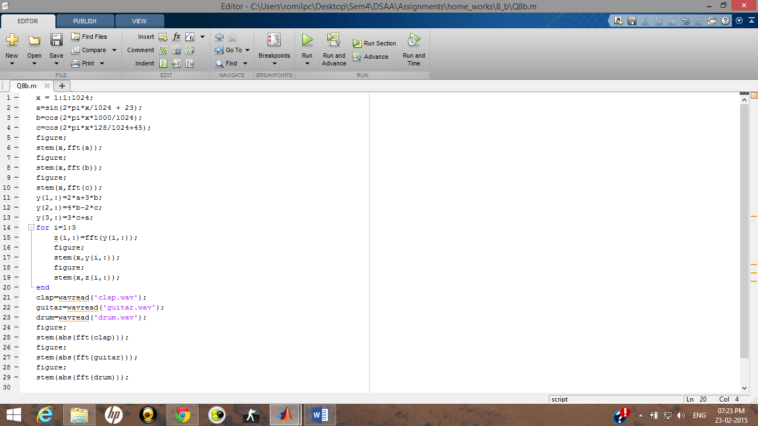

Code

a) Zi is the fft for the corresponding Yi.

[ a=sin(2\*pi\*x/1024 + 23);

b=cos(2\*pi\*x\*1000/1024);

c=cos(2\*pi\*x\*128/1024+45);

y(1,:)=2\*a+3\*b;

y(2,:)=4\*b-2\*c;

y(3,:)=3\*c+a;

]

The plots of the absolute values of the Fast Fourier Transform thus result in the various frequencies with the values of the coefficient being their multipliers.

b) The plots are thus explained by the fact there is an aggregation of simple frequencies which make up the sounds data.