**Screenshot of the output:**

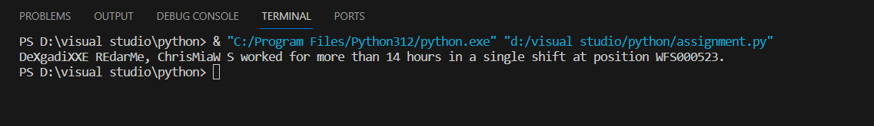

**a) who has worked for 7 consecutive days.**

DeXgadiXXE REdarMe, ChrisMiaW S worked for more than 14 hours in a single shift at position WFS000523.

**b) who have less than 10 hours of time between shifts but greater than 1 hour**

no person have work for less than 10 hours so therefore there is no output available

**c) Who has worked for more than 14 hours in a single shift**

no person have work for more than 14 hours in a single shift so therefore there is no output available