**Online Medication Platform**

**Distributed Systems**

***- Assignme–nt 4 –***

# **Student: Romina Băilă**

# **Group 30433**

# Assignment specification:

The platform used by the doctors to view the information gathered for a patient is based on SOA Web Services. The doctors can: i) view the activity history of a patient as charts containing each daily activity; ii) view if the patient took the medication according to the plan in a given day; iii) annotate if the patient behavior according to the sensor data was normal or not iv) if the patient behavior was not normal, add a recommendation that can be seen by the caregiver. Besides this, the caregiver can see the recommendations for their patients.

Design and implement two web services, in two different programming languages, one for the doctor and one for the caregiver. Each web service should have a layered architecture (API, services and data repository). The two web services have the following requirements:

* 1. ➢ The doctor, after logging in the doctor application, can: o view the activity history of a patient as charts containing each daily activity
  2. o view if the patient took the medication according to the plan in a given day
  3. o for the activities that do not meet the rules defined in Assignment 2, annotate if the patient behavior according to the sensor data is considered normal or not
  4. o if the patient behavior was not normal, add a recommendation that can be seen by the caregiver
  5. ➢ The caregiver, after logging in the caregiver application, can see the recommendations added by the doctors for their patients

# Conceptual Architecture Diagram

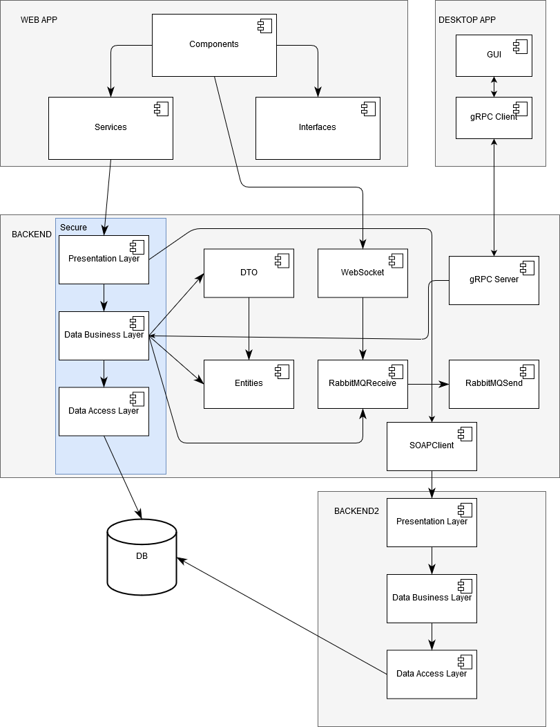

# Database Diagram

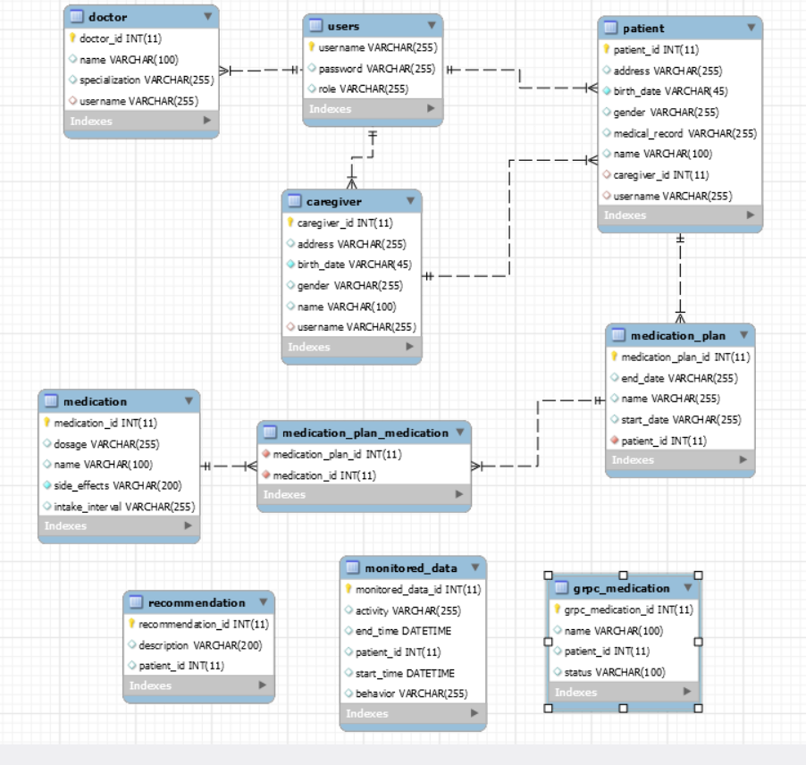

# Deployment diagram

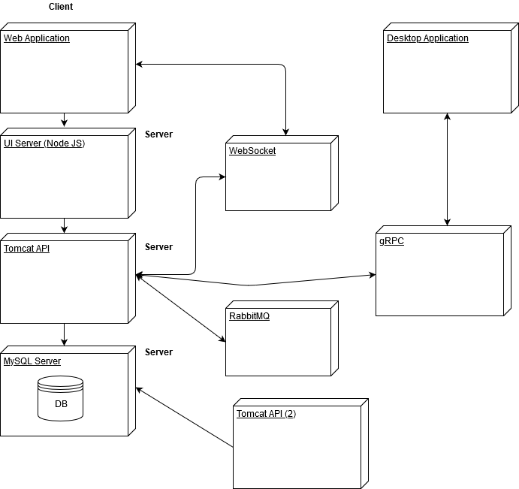



# Application demo

