2. The parametric approach. The LM test of isotropy.
El enfoque paramétrico que desarrollaremos en esta sección está basado en los Multiplicadores de Lagrange. To begin with, we are going to take as our reference an econometric model with substantive cross-sectional dependence:
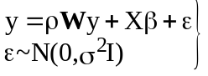
Where W is the habitual weight matrix and ρ a parameter associated with an overall
level of dependence.
Toda la información sobre la interconexiones entre las distintas unidades espaciales y su intensidad se recoge en el modelo mediante la matriz W. Es posible descomponer esta matriz en diferentes matrices que recojan direccionalidad.
W direccional
Un modelo anisotrópico podria especificarse como:
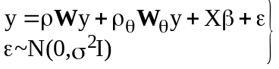
Donde 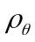es el parámetro mediante el cual se recoge la diferencia de intensidad en la dirección
Un modelo simple que recoja diferentes intensidades en diferentes direcciones pordria especificarse como:

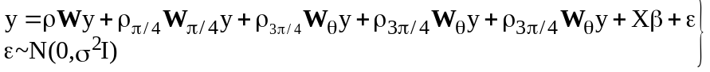

Isot | 0.9 * W1+W3 | 0.9 * W1+W2
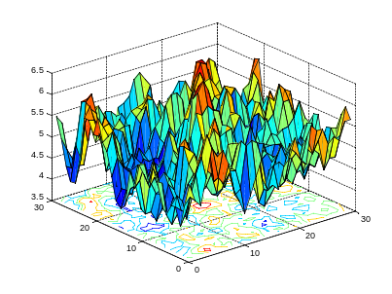 | 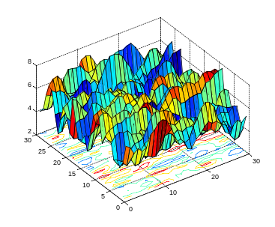 | 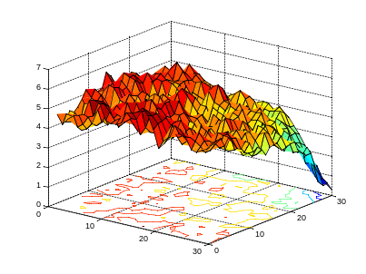

In general terms, the model of (10) coincides with that proposed by Huang (1984) although, in this case, using a very particular sequence of weighting matrices.
After solving the approximation of (9), it is possible to obtain the ML estimation of the resulting model. The log-likelihood function is standard:
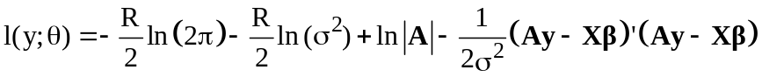 (11)
where θ is the vector of parameters of the model 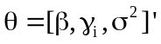 and A is a matrix 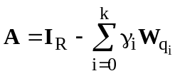. The score vector can be written as:
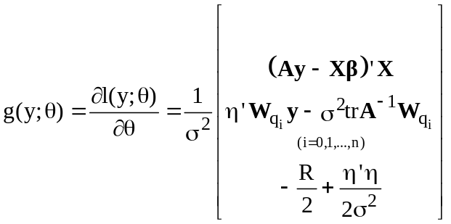 (12)
where 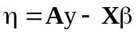. The Hessian matrix can easily be obtained:
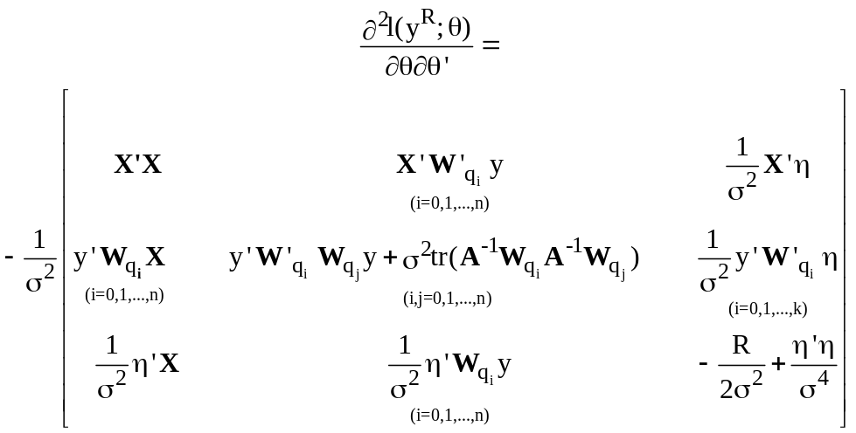 (13)
The information matrix corresponds to the negative expectation of the previous expression:
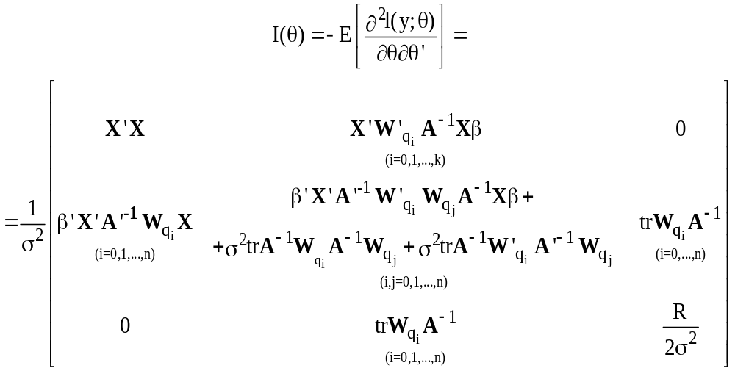 (14)
Finally, it is relatively simple to obtain a Lagrange Multiplier with which to test the isotropy hi´potesis. The null hypothesis that all the parameters associated with the expansion are zero:
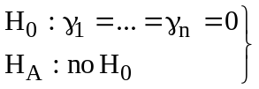 (15)
corresponds to the case where there is la misma intensidad de la dependencia especial en todas las direcciones. The resulting statistic is the so-called 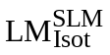, in its raw version (Mur et al, 2008), or 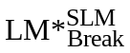 in its robust version (Angulo et al, 2008). We should equally point out that the rejection of the null hypothesis of (15) may be due to other factors such as, for example, a non adequate selection of the basic determining elements (variables z) or to a poor approximation to function h(-).

