**Tasks 3: Aggregate functions, Having, Order By, GroupBy and Joins:**

1. Write a SQL query to Find the average account balance for all customers

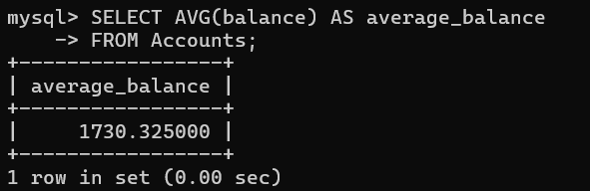

2. Write a SQL query to Retrieve the top 10 highest account balances.

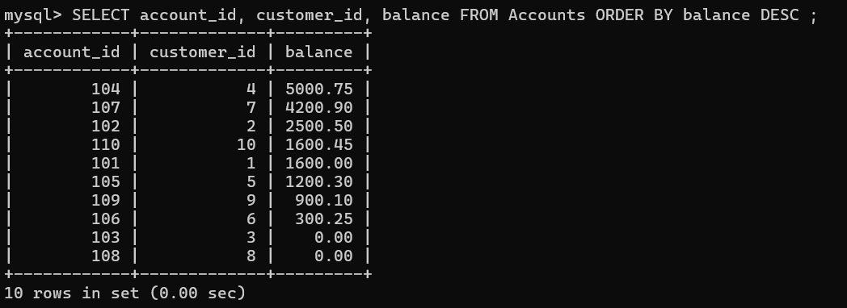

3. Write a SQL query to Calculate Total Deposits for All Customers in specific date



**(NOTE:- UPDATE THE VALUE OF TRANSACTION_DATE COL FROM NULL VALUE TO PERFORM THE OPERATION)**

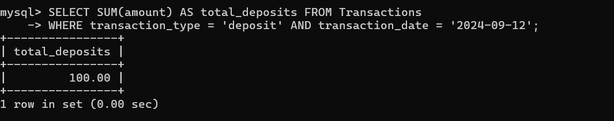

4. Write a SQL query to Find the Oldest and Newest Customers.

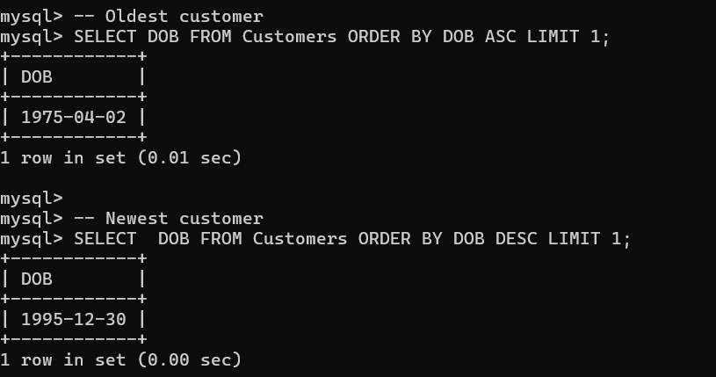

5. Write a SQL query to Retrieve transaction details along with the account type.

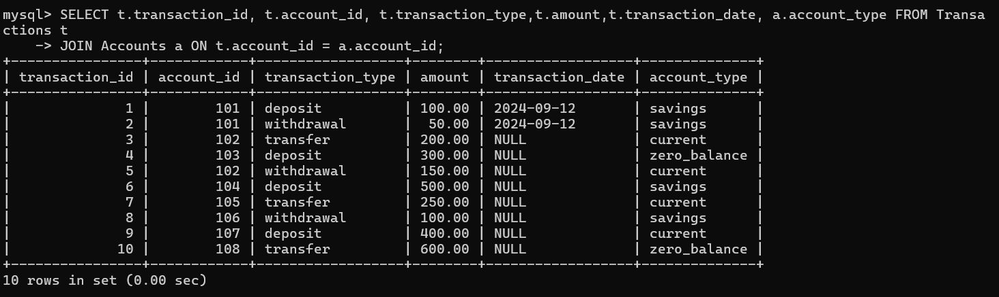

6. Write a SQL query to Get a list of customers along with their account details.

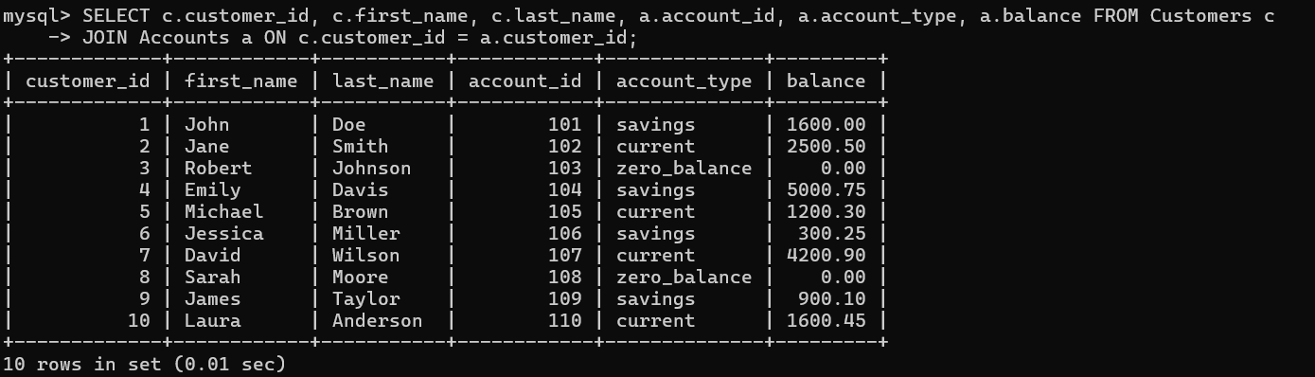

7. Write a SQL query to Retrieve transaction details along with customer information for a specific account.

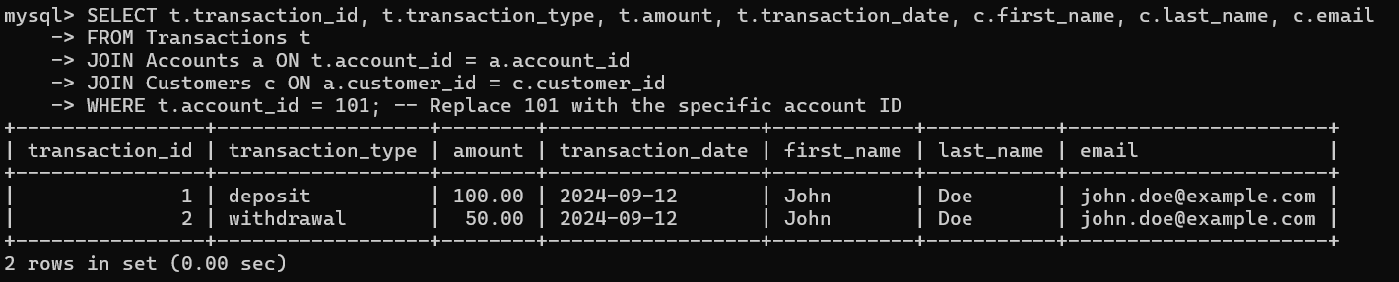

8. Write a SQL query to Identify customers who have more than one account.

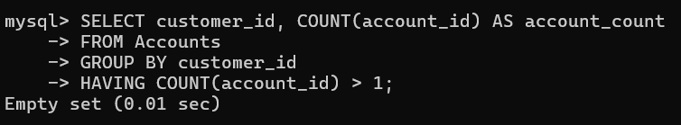

**Note :- THERE ARE NO CUSTOMERS HAVING MULTIPLE ACCOUMTS.**

9. Write a SQL query to Calculate the difference in transaction amounts between deposits and withdrawals.

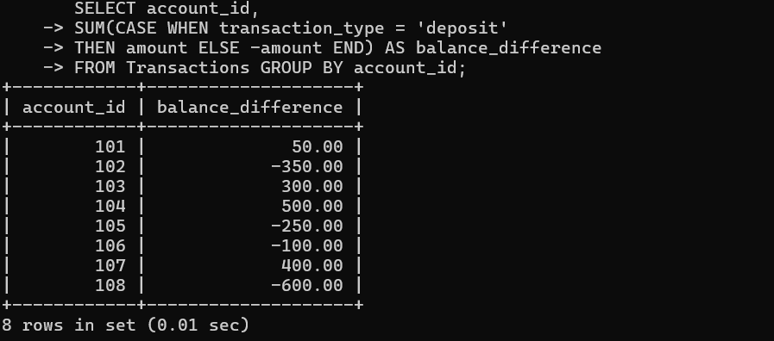

10. Write a SQL query to Calculate the average daily balance for each account over a specified period.

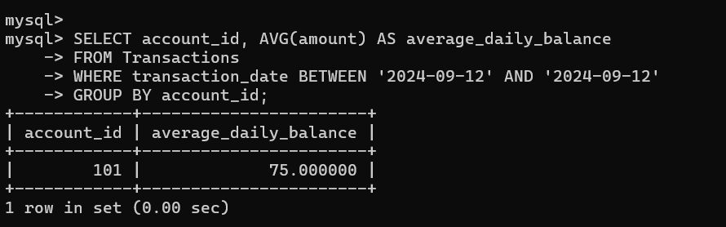

11. Calculate the total balance for each account type.

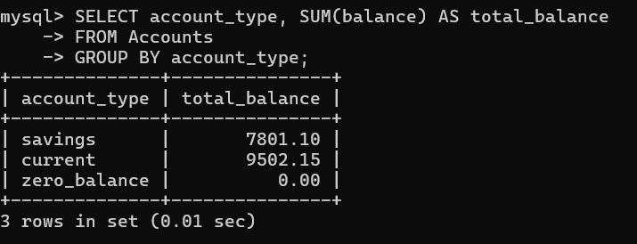

12. Identify accounts with the highest number of transactions order by descending order.

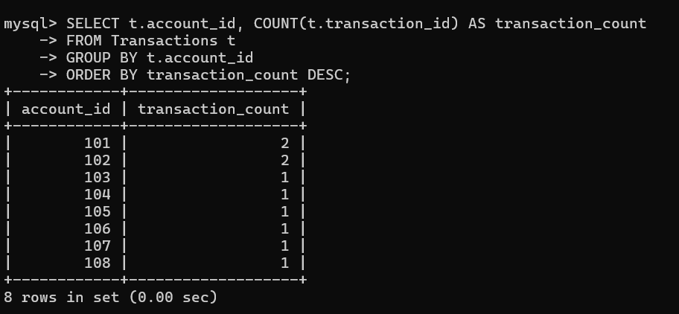

13. List customers with high aggregate account balances, along with their account types.

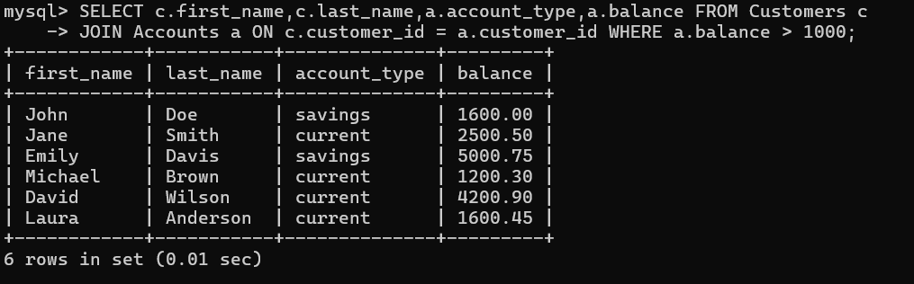

14. Identify and list duplicate transactions based on transaction amount, date, and account.

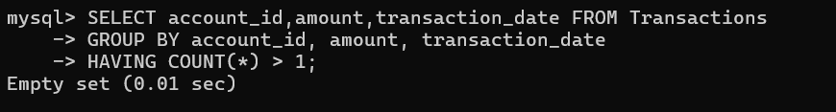

**(NOTE:- NO DUPLICATE TRANSACTIONS)**