1. Retrieve the customer(s) with the highest account balance: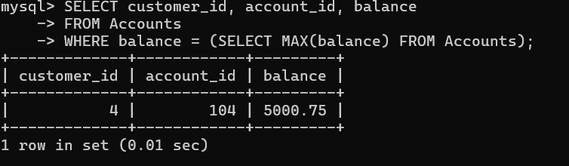
2. Calculate the average account balance for customers who have more than one account:

NOTE :- NONE OF THE CUSTOMERS HAVE MORE THAN ONE ACCOUNT.

1. Retrieve accounts with transactions whose amounts exceed the average transaction amount: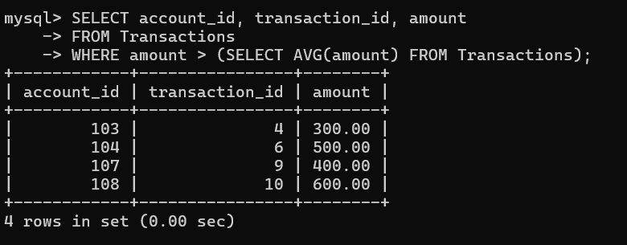
2. Identify customers who have no recorded transactions: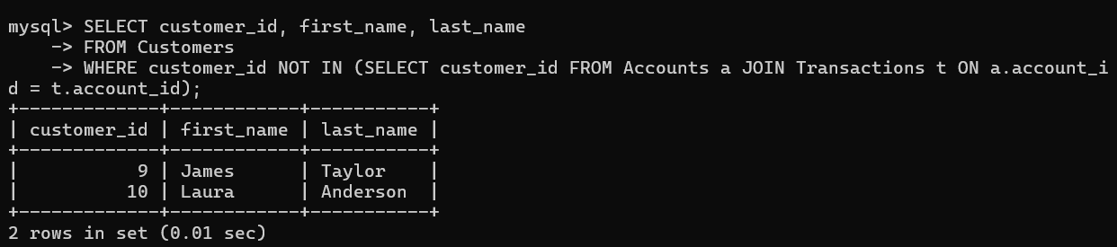
3. Calculate the total balance of accounts with no recorded transactions: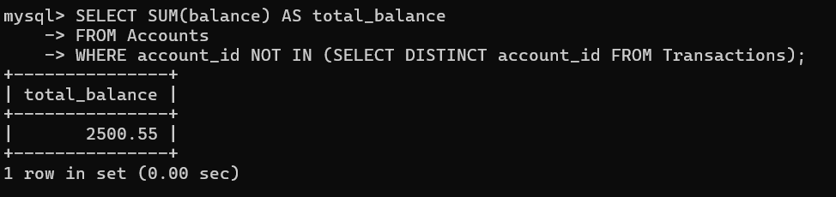

6. Retrieve transactions for accounts with the lowest balance.

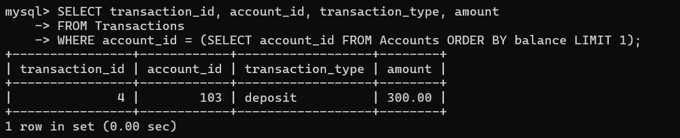

7. Identify customers who have accounts of multiple types.



8. Calculate the percentage of each account type out of the total number of accounts.

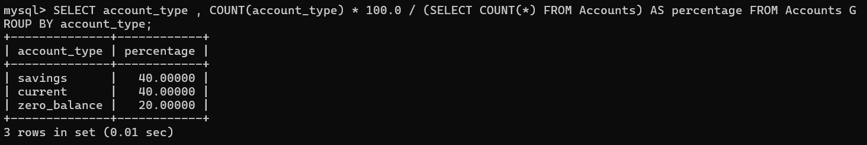

9. Retrieve all transactions for a customer with a given customer_id.

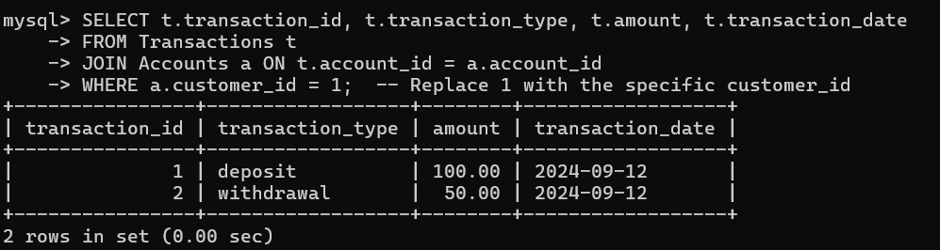

10. Calculate the total balance for each account type, including a subquery within the SELECT clause.

