**Concatenate**

**Sample Abstract**

**Team Information**

**Team Name: XYZ**

**Team Leader:**

**Number of members in the Team (maximum 6):**

|  |  |  |  |  |
| --- | --- | --- | --- | --- |
|  | |  | | |
| **Details of the Team members :** | | | | | |  | |
|  | |  | | |
| **S. No.** | **Name of Team Members**  **(Including Team leader)** | | **Email-id** | **Contact No.** | | |
| **1.** |  | |  |  | | |
| **2.** |  | |  |  | | |
| **3.** |  | |  |  | | |
| **4.** |  | |  |  | | |
| **5.** |  | |  |  | | |

**Aim:** **Vend a coke bottle out of the machine in a presentable manner.**

**Materials Required:** Strings, Pulley, Rod/Bar ,Balls, Flat strips of wood/ thermocol, Remote controlled toy car, Bottle with water, Bucket,   Wires, Aluminium foil, Thermocol, Fevicol, Tape, Soldering material ,Electronic components,5 rupees coin ,hammer, optical fibres, carton ,wall chart, cycle wheel, marble ,pipe, funnel, loads, bricks, etc.

**STEP:1** The coin stops the IR rays. It sets the logic of comparator 1.

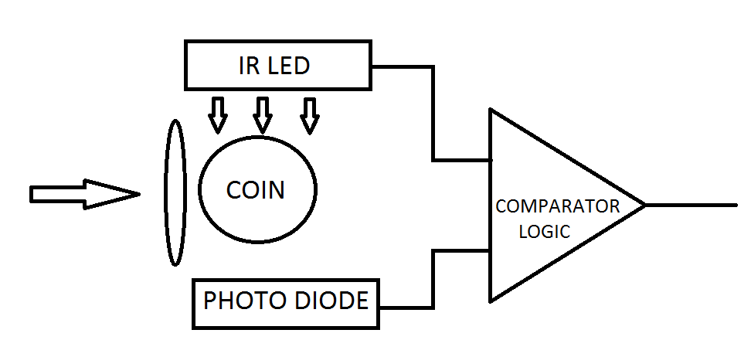z

**STEP:2 The comparator runs the motor, string through pulley becomes tight.**

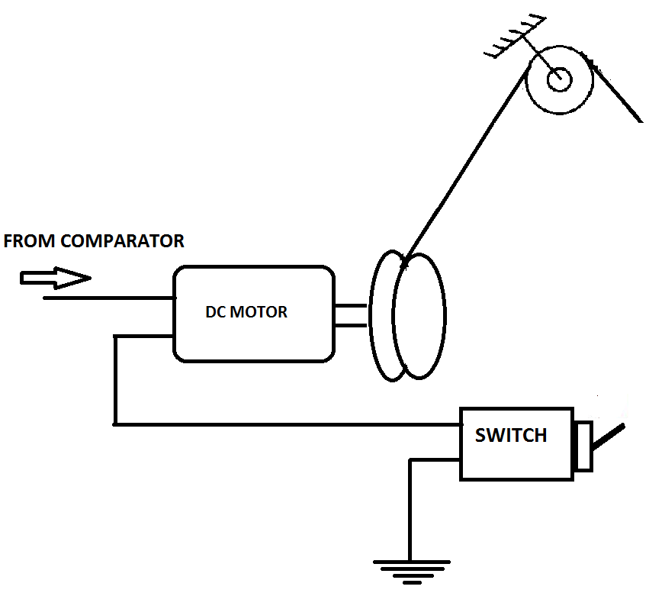

**STEP:3 The string disturbs the ball, ball goes through the arrangement, hits the switch, turns off motor.**

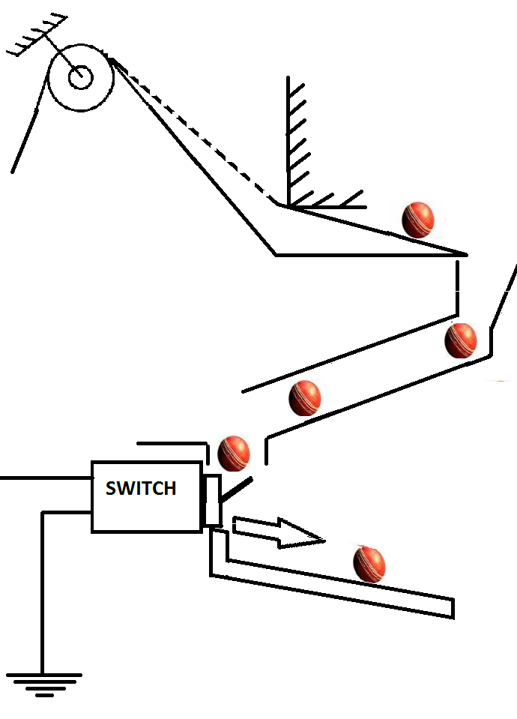

**STEP 4: Ball from previous step, drops into basket, which in turn moves the pulley and ball on the pulley comes in motion..**

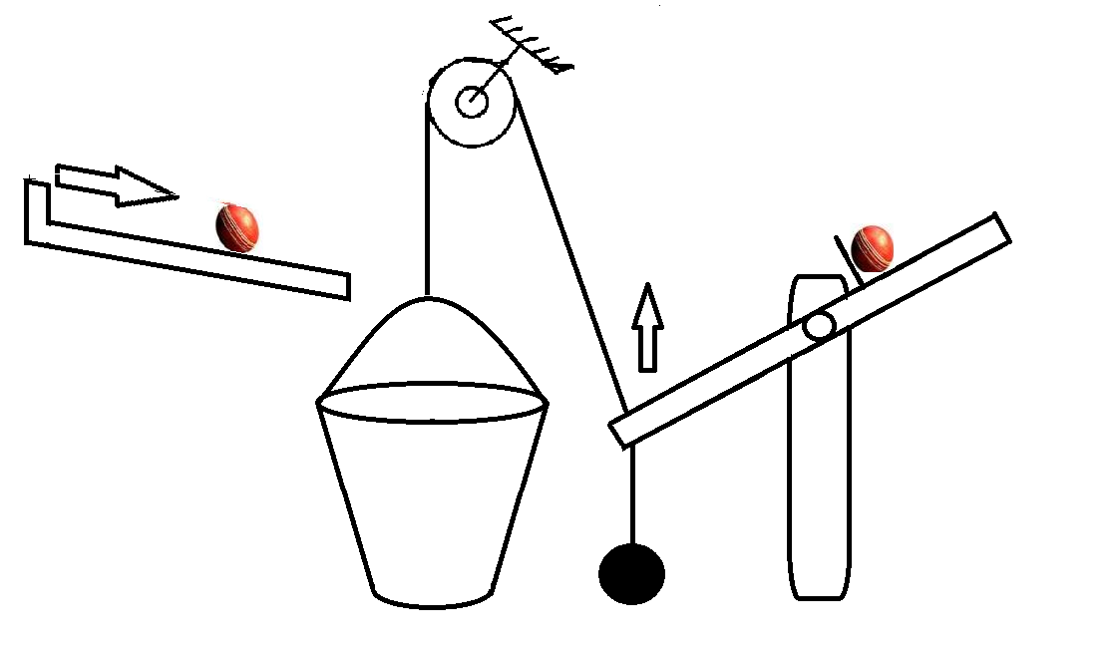

**STEP 5: Ball from previous goes into the setup as shown...the ball takes the base with itself downwards....**

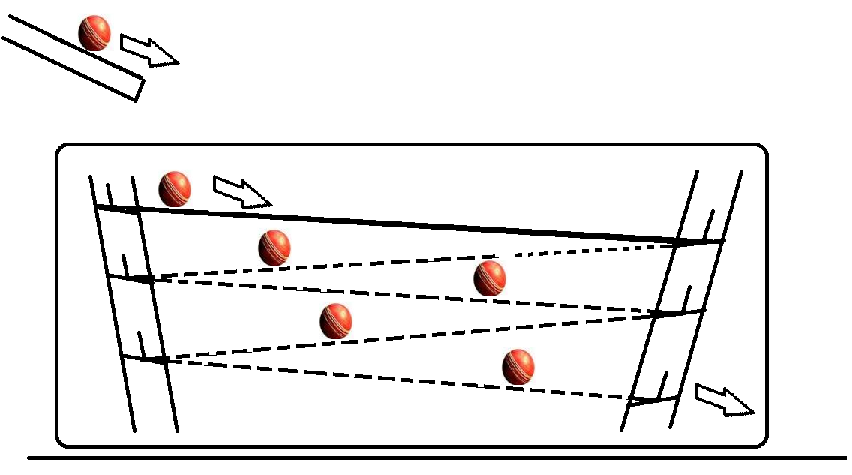

**STEP 6: Ball and the base arrangement hits the plates arrangement.**

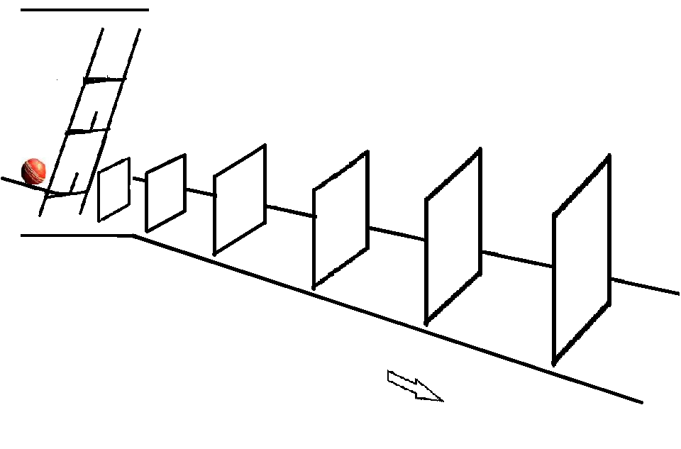

**STEP 7: One of the plates hits stick supporting the hammer, hammer pulls the string....**

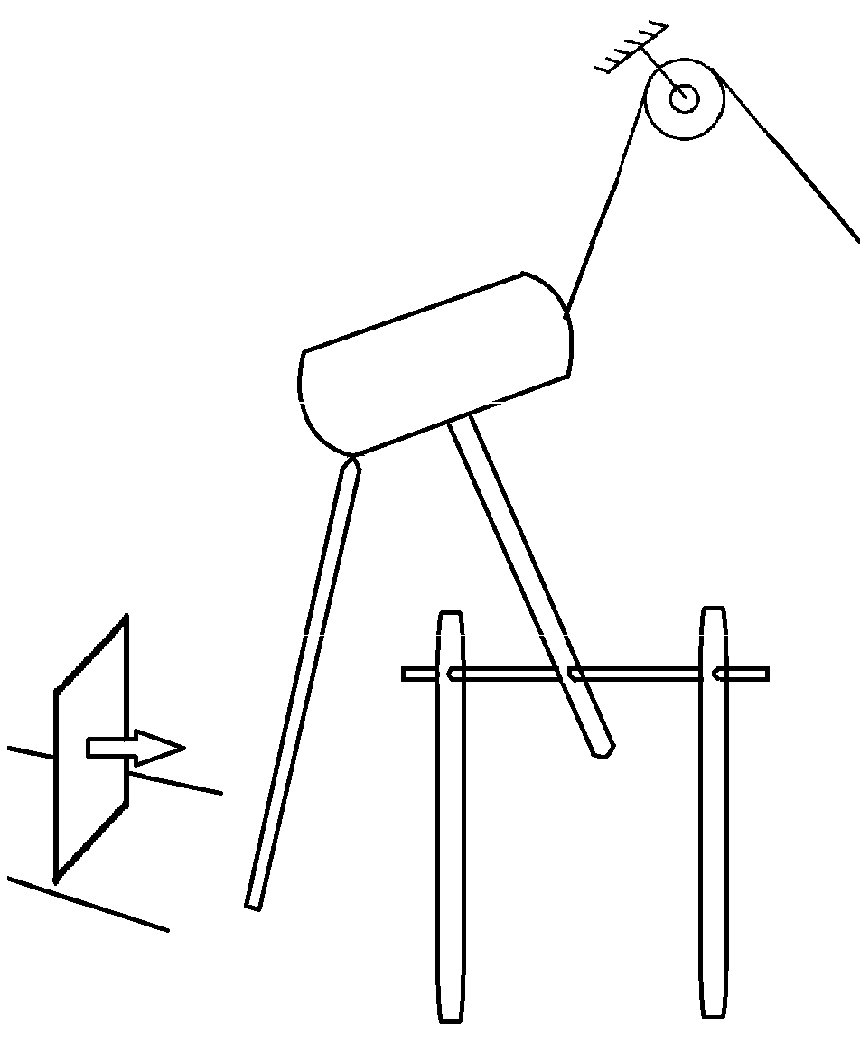

**STEP 8:The pulled string disturbs the arrangement, block falls to the left, ball pulls the string, turns the remote switch on...**

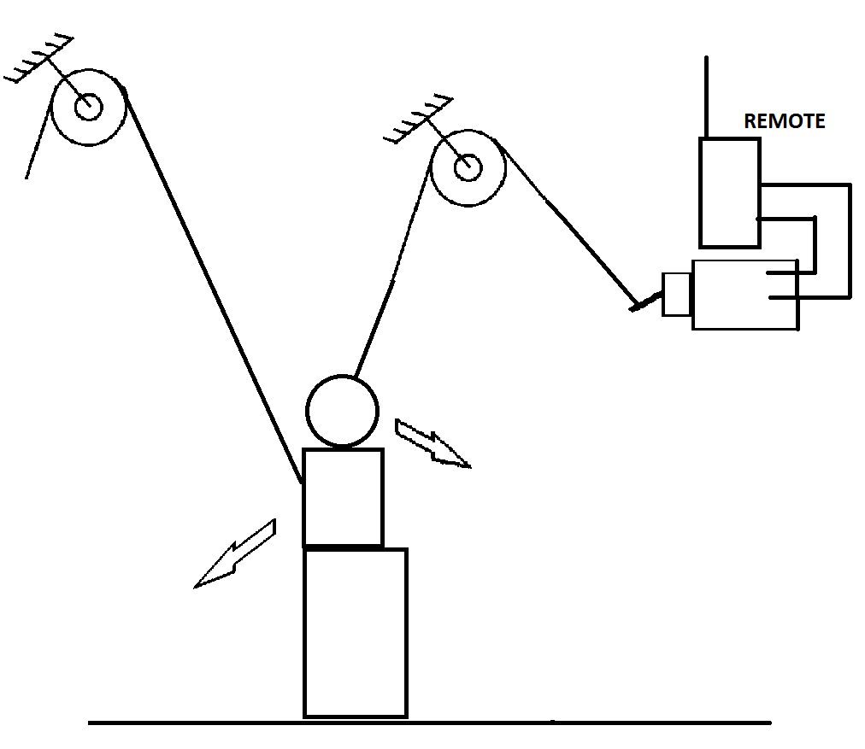

**STEP 9: It runs the toy remote car which again stops the IR radiation, sets logic 1, which lights the bulb...**

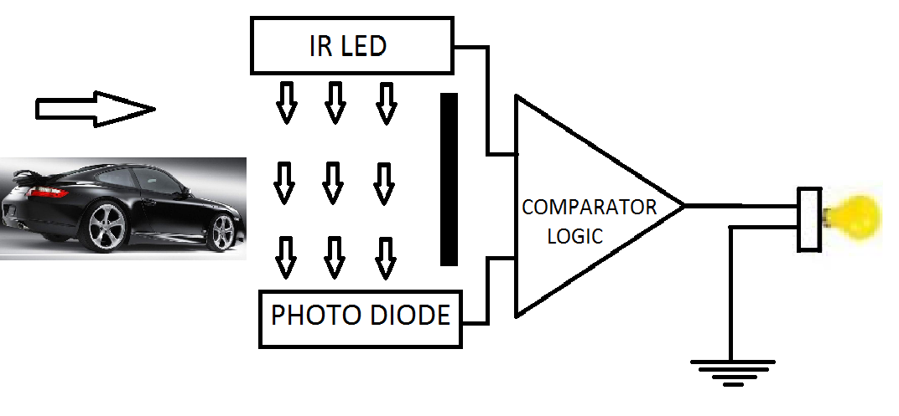

**STEP 10: The light travels through the optical fibre...**

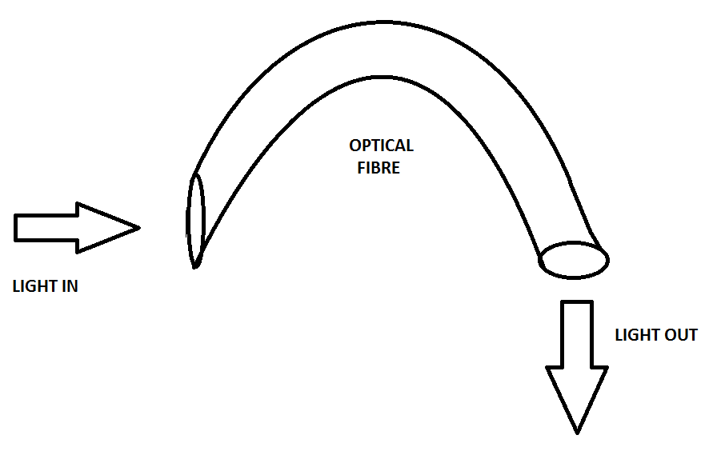

**STEP 11: Light is incident on LDR, sets the comparator logic 1....**

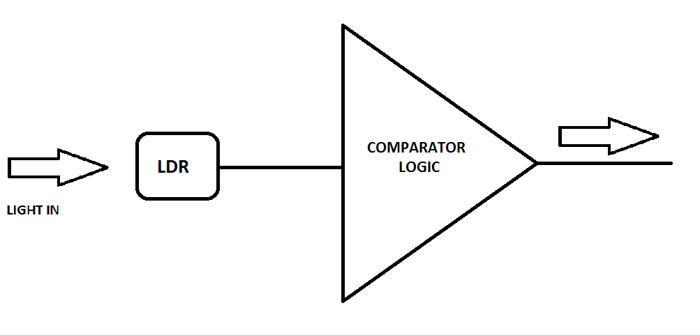

**STEP 12: It runs a motor which opens a message as shown....**

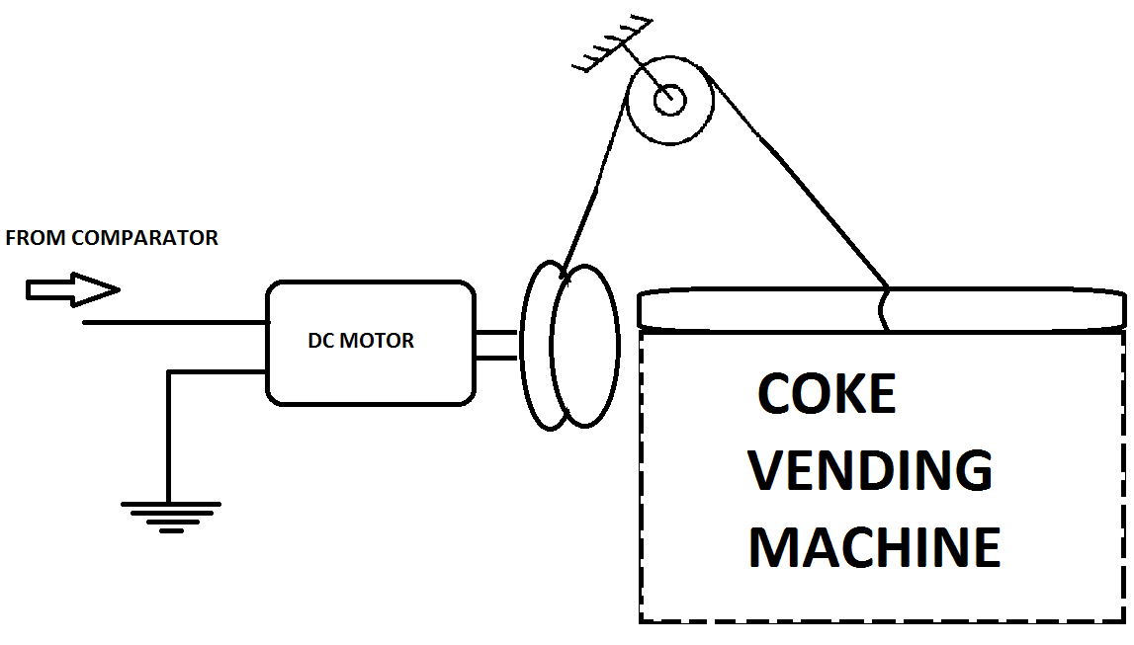

**STEP 13: The comparator output also runs an LCD...shows a message**

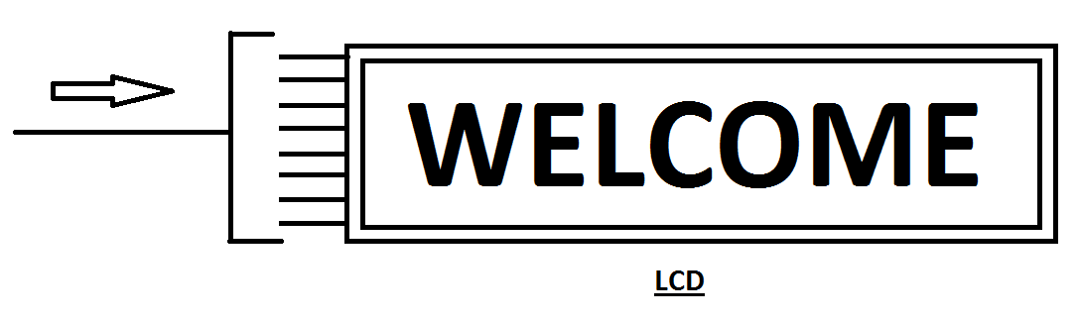

**STEP 14: Block from step 8, disturbs the arrangement and the wheel starts rotating on the direction out of the plane due to the weight of stick which pulls the string.**

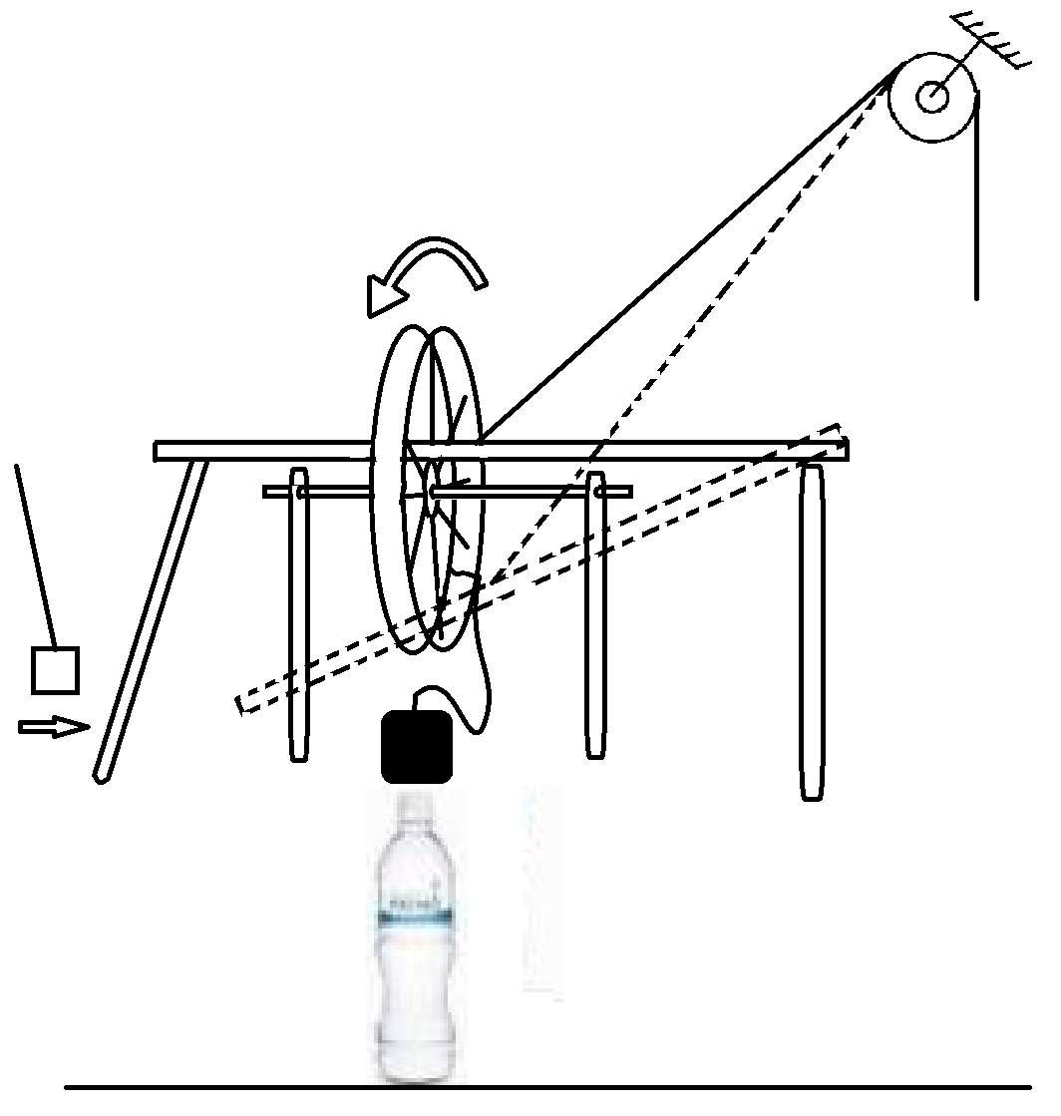

**STEP 15: When the string pulls the weight the see saw arrangement goes down on right hand side, ball comes into motion....**

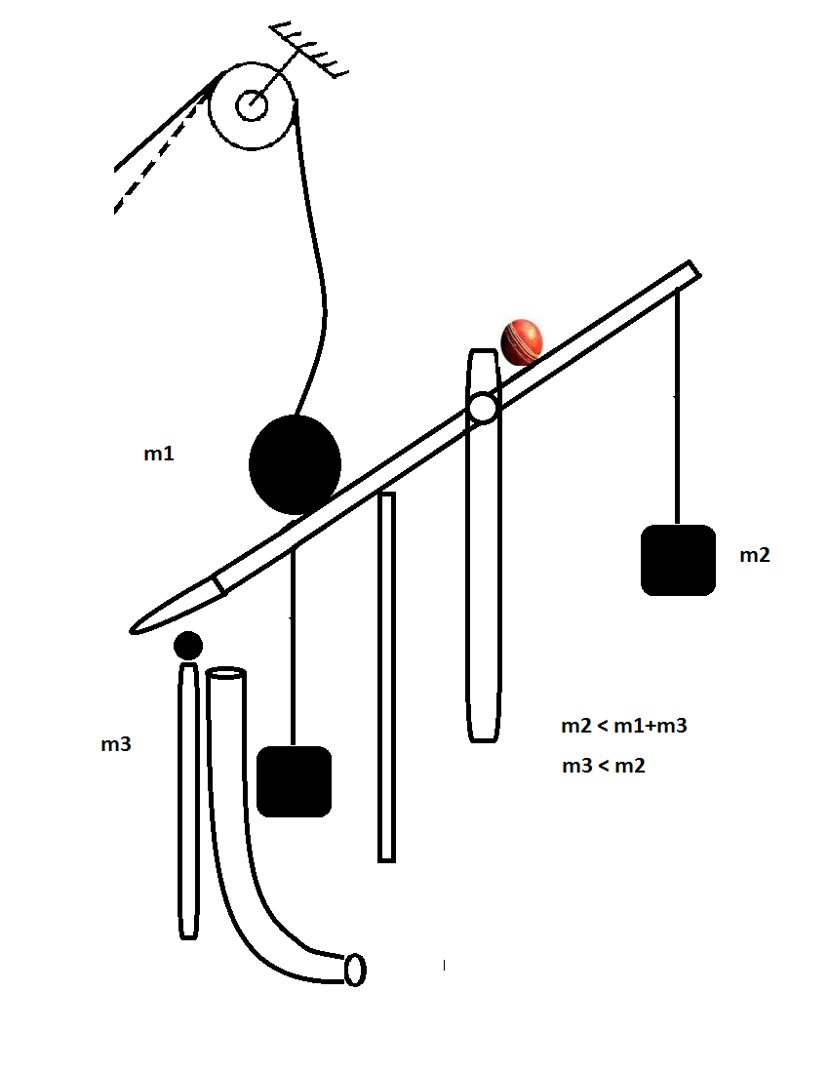

**STEP 16: Ball goes through the arrangement...**

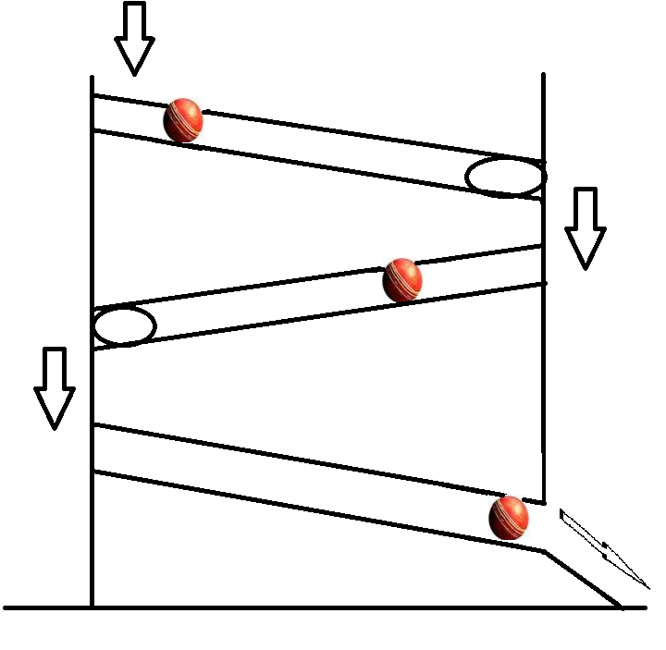

**STEP 16: Ball goes through the arrangement...**



**STEP 18: Block on the bottle falls, rotates the wheel inwards, which loosens the string...**

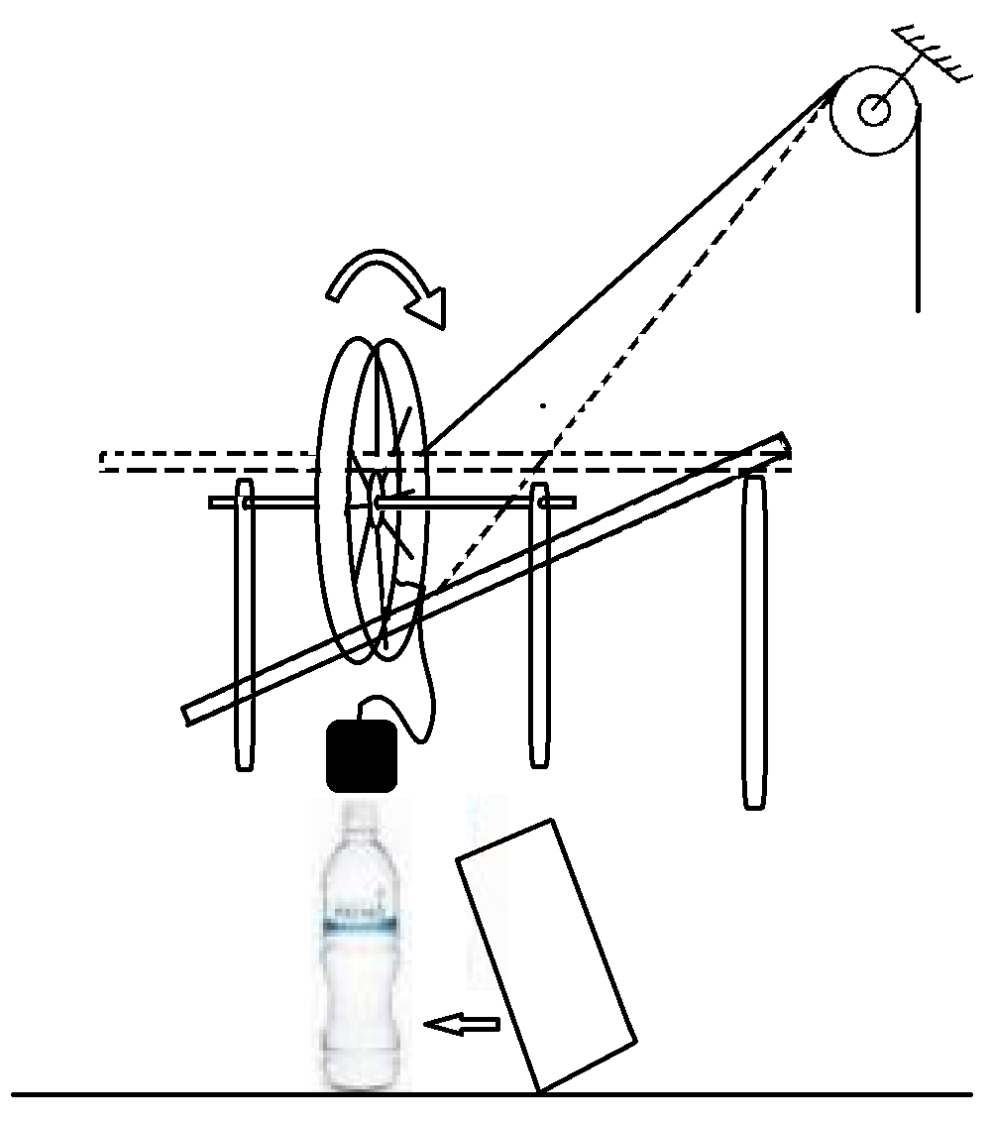

**STEP 19: The loose string allows the block m1 to go down, which disturbs the ball, ball goes through the pipe**

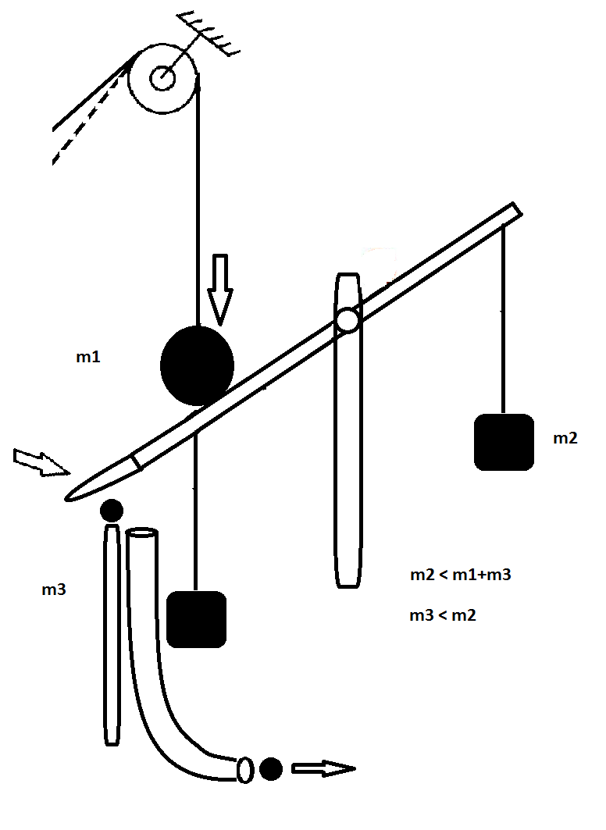

**STEP 20: The ball through the pipe hit the support under the see saw arrangement...ball on the see saw attached with string pulls the string when it falls.....**

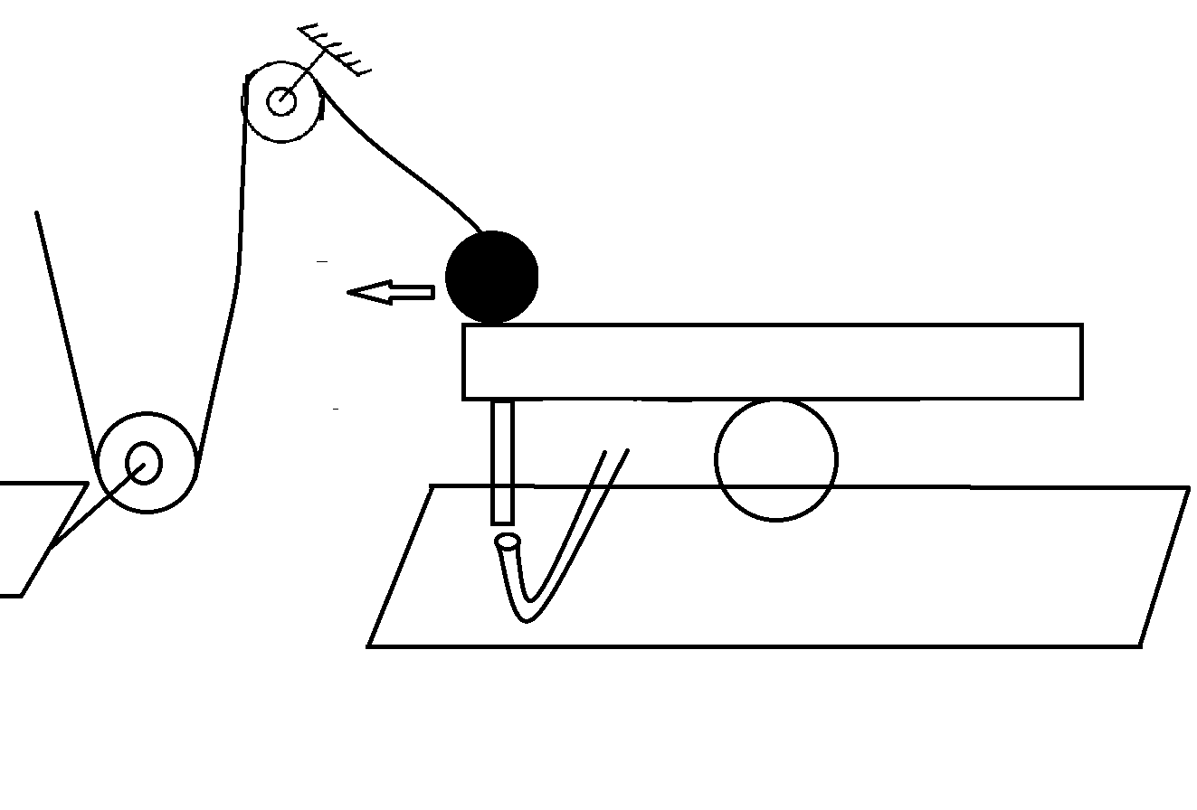

**STEP 21: The string is tied to bottle neck, bottle is filled with water. Bottle falls when string is pulled, water goes through the funnel into the beaker, where a circuit is completed.....**

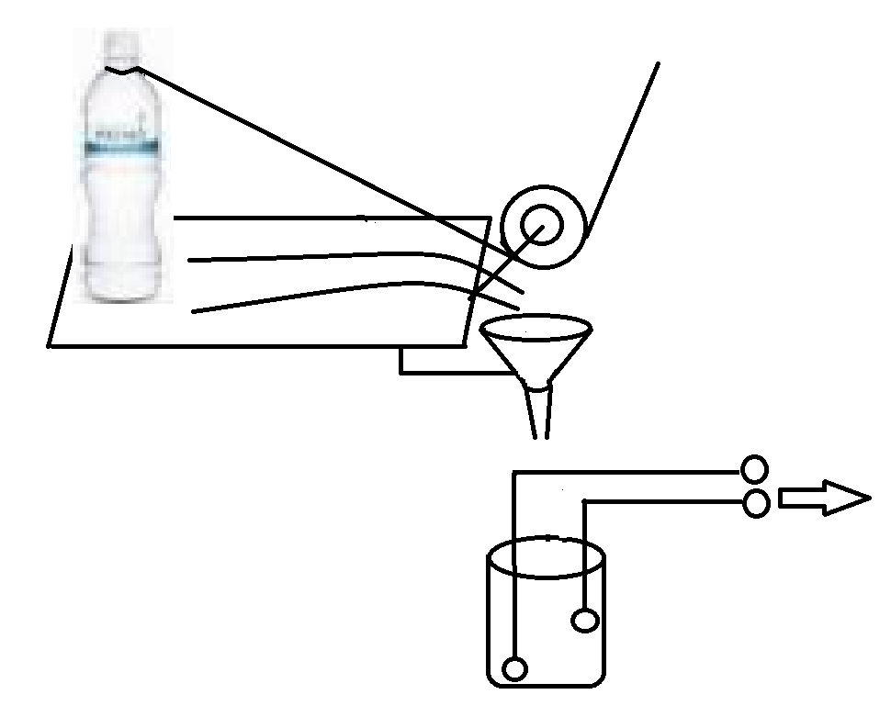

**STEP 21: The string is tied to bottle neck, bottle is filled with water. Bottle falls when string is pulled, water goes through the funnel into the beaker, where a circuit is completed.....**



**Extra step: We will be using this step whenever we need to provide height throughout the process....**

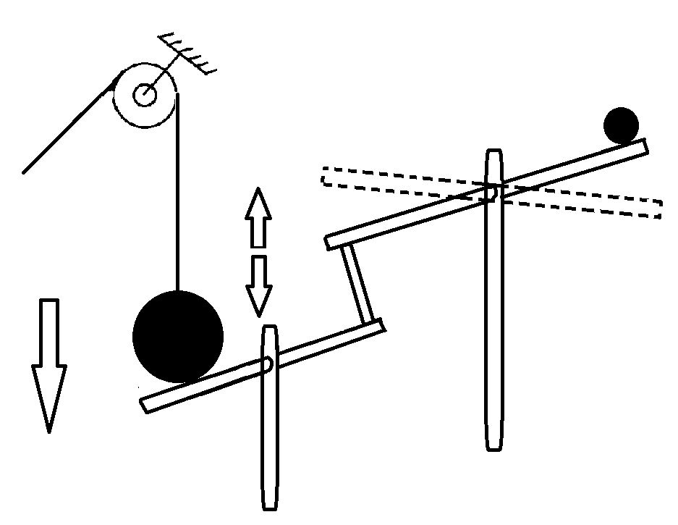

**SUMMARY**

**Summary of all steps can be seen in the next diagram**

