AF 52
Synopsis
SmartPharm
Submitted in partial fulfilment of the requirements of the degree of
Bachelor of Engineering
In
Artificial Intelligence and Machine Learning

by
Neev Borana [07] [EU1246063]
Romit Meher [32] [EU1226023]
Rohit Gorhekar [15] [EU1246019]

Under the Guidance of
__________________________
__________________________



DEPARTMENT OF ARTIFICIAL INTELLIGENCE AND MACHINE LEARNING
ST. JOHN COLLEGE OF ENGINEERING & MANAGEMENT
UNIVERSITY OF MUMBAI
2026-2027


Certificate of Approval

This is to certify that Neev Borana [EU1246063], Romit Meher [EU1226023] and Rohit Gorhekar [EU1246019] are bonafide students of the Department of Artificial Intelligence and Machine Learning, St. John College of Engineering and Management. They have submitted the project SmartPharm for evaluation during the academic year 2026-2027.

Signature :  Name : _______________________  Designation | Signature :  Name :_______________________  Designation

Signature:
Name : Dr. Kamal Shah Principal,
St. John College of Engineering and Management.

Declaration

I/we declare that this written submission represents my/our ideas in my/our own words and where others ideas or words have been included, I/we have adequately cited and referenced the original sources. I/we also declare that I/we have adhered to all principles of academic honesty and integrity and have not misrepresented or fabricated or falsified any idea/data/fact/source in my/our submission. I/we understand that any violation of the above will be cause for disciplinary action by the Institute and can also evoke penal action from the sources which have thus not been properly cited or from whom proper permission has not been taken when needed.

(Signature)

.

Date:

Acknowledgement
We express our sincere gratitude to all those who have directly and indirectly contributed to the successful preparation of this project synopsis.
We are deeply grateful to Dr. Kamal Shah, Principal, St. John College of Engineering and Management, for providing an excellent academic environment and the necessary facilities to undertake this project.
We extend our heartfelt thanks to the Mr. Ajay Sirsat, Head of the Department of AIML, for the constant encouragement, valuable suggestions, and continuous support throughout the preparation of this synopsis.
We would like to express our sincere appreciation to our project guide, __________________________, for guidance, constructive suggestions and support throughout the project.
We also acknowledge all the faculty members and laboratory staff of the Department of Artificial Intelligence and Machine Learning for their timely assistance, cooperation, and technical support.
Finally, we express our heartfelt gratitude to our parents, family members, friends, and classmates for their constant encouragement, moral support, and cooperation throughout this work.

Group Members
- Neev Borana
- Romit Meher
- Rohit Gorhekar

ABSTRACT
SmartPharm is a web-based pharmacy management project that connects medicine stocking, batch inventory, POS billing, procurement, prescription review and operational insight. The design separates a medicine identity from its manufactured batch and from the physical quantity stored at a location.
The implementation uses a Next.js / React / TypeScript frontend, Flask and SQLAlchemy APIs, Aiven MySQL for business records and Aiven PostgreSQL for AI/reference data. Barcode input, camera capture and packaging OCR provide working review-assisted identification. Prescription and invoice reading produce editable drafts for verification.
Billing validates stock and expiry, allocates eligible batches in FEFO order and commits stock, sale and payment records together. Dashboard views show recent invoices, stock and expiry alerts, purchase drafts and replenishment estimates. PWA support provides installation controls and a safe reconnect experience.
The classroom demonstration contains eight medicines and sixteen paired package photos, with labelled synthetic transactions. Verification includes focused automated tests and deployed browser checks. Recognition output remains subject to human review; no untested accuracy percentage or autonomous clinical capability is claimed.
C O N T E N T S

- List of Figures
- List of Tables
- Abbreviations and symbols

Chapter No. | Topic | Page No.
Chapter 1  Chapter 1 | Introduction
Chapter 2 | Literature Review
Chapter 3 | Proposed Methodology
Chapter 4 | Project Planning
Chapter 5  Chapter 5 | Resources & Feasibility
Chapter 6 | Expected Results
Chapter 7 | Sustainability & Impact
Chapter 8 | Conclusion
References | Numbered research references
Appendices | Diagrams, APIs, test cases and frontend screenshots

List of Figures

Figure No. | Figure Name | Page No.
1 | System Architecture
2 | Recognition Flowchart
3 | Activity Diagram
4 | DFD 0 Context Diagram
5 | DFD 1 Major Processes
6 | DFD 2 Billing Decomposition
7 | System Flow
8 | Functional Flow
9 | Core Data Model
10 | Test Case Verification Diagram
11 | Sign In
12 | Dashboard
13 | POS Billing Terminal
14 | Inventory and Batches
15 | Medicines Catalogue
16 | Purchases and Invoices
17 | Prescription Workspace
18 | Expiry Management

List of Tables

Table No. | Table Name | Page No.
1 | Literature Review
2 | Components and Materials
3 | Semester Planning
4 | Roles and Responsibilities
5 | Risk Assessment
6 | Budget Estimation
7 | Business APIs
8 | Recognition APIs
9 | Test Cases

Abbreviations and symbols

- ML: Machine Learning
- AI: Artificial Intelligence
- TF-IDF: Term Frequency-Inverse Document Frequency
- NLP: Natural Language Processing
- DFD: Data Flow Diagram
- UML: Unified Modeling Language
- CSV: Comma-Separated Values
- UI: User Interface
- PDF: Portable Document Format
- HR: Human Resources
- ETL: Extract, Transform, Load

CHAPTER 1: INTRODUCTION

1.1 Background
SmartPharm is a pharmacy management web application that connects medicine stocking, batch-level inventory, billing, procurement, prescription review and operational insight. A medicine identity is separated from its manufactured batches and from physical quantity at a storage location. This distinction supports changing batch prices and expiry dates.

1.2 Problem Statement
The project addresses repeated manual entry and disconnected medicine, inventory and billing records.
- Existing problem: staff must identify the intended medicine while tracking strength, batch, expiry and physical availability.
- Industrial issue: product-level stock totals do not explain differences between batch prices, expiry dates or shelf locations.
- Research gap: OCR output alone does not establish a saleable medicine identity or a valid stock transaction.
- Need for improvement: connect reviewed identification with catalogue matching, FEFO billing and traceable stock changes.

1.3 Need of the Project
The project supports consistent pharmacy records and reduces repeated typing through barcode input, camera capture and document reading. Human review and manual search keep uncertain recognition recoverable.

1.4 Objectives
Develop an integrated pharmacy workflow that remains usable when optional recognition or network services cannot provide a reliable result.
Maintain separate medicine, batch and location-stock records with store-scoped access.
Provide barcode lookup and working review-assisted photo recognition for medicine entry and billing.
- Apply FEFO allocation and validate stock and expiry before accepting a sale.
- Support reviewed procurement, eligible returns and audited stock adjustments.
- Present recent activity, expiry alerts and explainable replenishment estimates.
- Verify stock/payment invariants, offline replay behaviour and responsive user interfaces.

1.5 Scope
The project covers counter and back-office workflows for a pharmacy chain installation.
- Included: catalogue, inventory, POS, purchases, suppliers, prescriptions, returns, shelf locations, staff access, expenses and dashboard.
- Boundary: recognition assists review; it does not independently prescribe or make final dispensing decisions.
- Future expansion includes independently evaluated image recognition, physical-device testing, backup restoration exercises and longer-history forecast validation.

1.6 Expected Outcomes
The project provides a deployed web prototype with connected business records and a repeatable classroom demonstration.
- Working prototype: responsive browser interface and PWA installation support.
- Software: Next.js / React frontend, Flask APIs, Aiven MySQL business records and Aiven PostgreSQL AI references.
- Demonstration: eight medicines represented by sixteen paired package photos.
- Traceability: medicine, batch, location, sale and purchase records remain distinct.
- Operational output: recent invoice chart, low-stock and expiry alerts, purchase drafts and reorder estimates.
- Verification output: scoped automated tests and deployed browser checks.
- Academic contribution: integration of reviewed recognition with transactional pharmacy operations.

CHAPTER 2: LITERATURE REVIEW

2.1 Introduction
Seven primary research papers are surveyed on OCR, scene-text detection, handwriting, document layout and retrieval-augmented generation. Findings describe the cited research rather than measured SmartPharm recognition accuracy.

2.2 Literature Review Table

The literature comparison follows the prescribed paper, author, year, method, findings and research-gap structure.
Paper | Author | Year | Method | Findings | Research Gap
[1] CRNN | Shi, Bai and Yao | 2015 | CNN + recurrent sequence recognition | End-to-end image text sequence modelling | Text must still be linked to a valid medicine identity.
[2] Differentiable Binarization | Liao et al. | 2019 / 2020 | Learned text-region binarisation | Efficient scene text detection | Detection is not product identification.
[3] PP-OCR | Du et al. | 2020 | Lightweight detector, direction classifier, recogniser | Practical OCR pipeline | Foil, rotation and glare need application handling.
[4] TrOCR | Li et al. | 2021 | Pretrained image and text Transformers | Printed and handwritten transcription | Ambiguous names/directions require review.
[5] LayoutLMv3 | Huang et al. | 2022 | Unified text/image masking and alignment | Document layout and content representation | Project uses OCR layout parsing, not this whole model.
[6] PaddleOCR 3.0 | Cui et al. | 2025 | OCR, structured parsing and extraction | Maintained document processing toolkit | Toolkit benchmarks do not establish project accuracy.
[7] RAG | Lewis et al. | 2020 | Generator with retrieved external memory | Grounded knowledge-intensive generation | Retrieved content still needs validation and provenance.
The selected papers combine foundational recognition research with recent OCR and document-understanding work.

2.3 Research Gap
Previous research provides strong methods for recognising text and representing document content.
- CRNN and Transformer recognisers turn image regions into text; detection methods locate candidate text regions.
- Unresolved application concerns include reflective medicine foil, rotated labels, ambiguous handwriting and linking extracted text to verified store stock.
- SmartPharm addresses the integration gap with catalogue evidence, manual recovery, review before confirmation and batch-aware transactions.

2.4 Novelty / Innovation
The engineering contribution is a connected review workflow rather than a new OCR architecture.
- Medicine entry and billing share reviewed identity mappings and barcode aliases.
- Purchase drafts are separate from accepted physical intake; FEFO billing uses recorded batch expiry.
- A low-evidence scan leads to recapture or manual search rather than an invented medicine identity.

CHAPTER 3: PROPOSED METHODOLOGY

3.1 Proposed System
A Next.js and React frontend communicates with Flask APIs over HTTPS. SQLAlchemy services validate and persist business operations in Aiven MySQL. Aiven PostgreSQL supports AI reference/vector retrieval. Optional Google Gemini and Tavily integrations assist handwriting and reference search.

3.2 Working Principle
1. Sign in and retrieve the current store and role. 2. Enter a medicine manually or read a barcode/package. 3. Review identity and batch details before stock entry. 4. Select a stocked medicine and quantity in POS. 5. Validate saleable batches and allocate FEFO stock. 6. Commit sale, tender records and stock deduction together. 7. Review dashboard alerts, purchase drafts and eligible returns.

3.3 System Architecture / Block Diagram
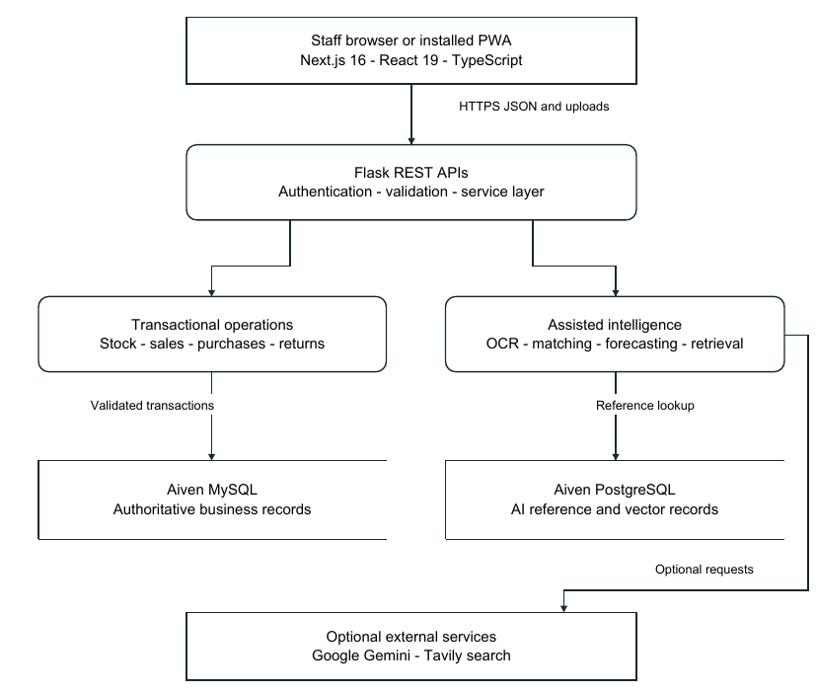
Figure 1 System Architecture

3.4 Flow Chart
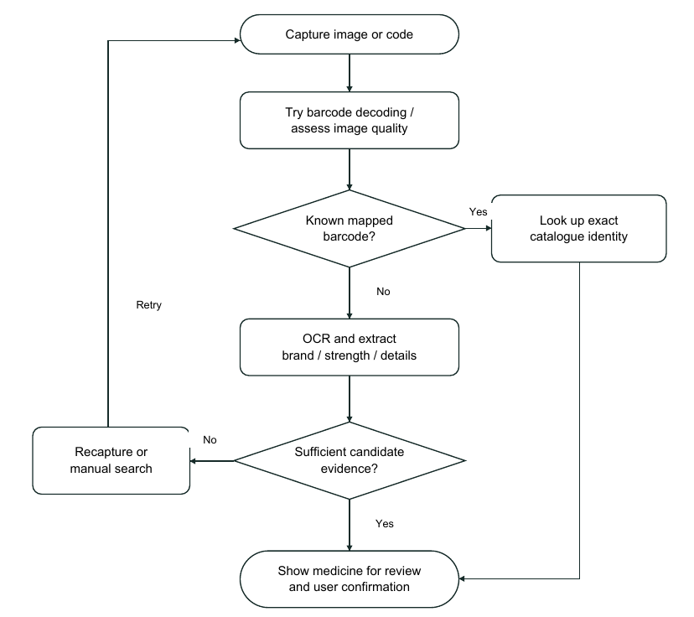
Figure 2 Recognition Flowchart

Implementation uses incremental service, API, UI and regression-test changes.
The design preserves authoritative business data and separates optional recognition results from confirmed stock.
- Design procedure: model medicine identity, batch pricing/expiry, location quantities and transaction links.
- Experimental procedure: prepare isolated fixtures, exercise deterministic operations, inspect deployed read-only paths and review scan outcomes.
- Algorithms: catalogue evidence matching, barcode alias lookup, FEFO allocation, adaptive moving-average demand estimation and Ridge regression when sufficient selling-day history exists.
- Physical workflow: compare actual delivered quantities with invoice drafts before accepting stock.
- Programming steps: implement validation and service transactions; expose authenticated routes; connect review forms; add focused tests; build and verify deployment.

3.6 Components / Materials
The principal implementation components are listed below.
Component | Inspected implementation or requirement
Frontend | Next.js 16.3.5, React 19.2.8, TypeScript 5 and responsive CSS.
Backend | Python Flask, SQLAlchemy, Alembic migrations and a production WSGI server.
Vision / ML | PaddleOCR, OpenCV, NumPy, scikit-learn; optional experimental PyTorch training.
Databases | Aiven MySQL for business data; Aiven PostgreSQL for AI references/vector data.
Hosting | Separate frontend/API containers on Google Cloud Run over HTTPS.
Capture / devices | Desktop or phone browser with camera permission; optional USB keyboard-style barcode scanner.
Development GPU | RTX 3070 available for local experiments; not a requirement for Cloud Run CPU inference.

CHAPTER 4: PROJECT PLANNING

4.1 Work Breakdown Structure
Work packages comprise requirements/schema, transactional services, responsive UI, camera/document input, billing and returns, planning views, deployment, tests and academic documentation.

4.2 Gantt Chart
Suggested semester milestones are shown below; this is a planning schedule, not a retrospectively measured development log.
Work package | W1-2 | W3-4 | W5-6 | W7-8 | W9-10 | W11-12
Requirements and data design | X | X
Core stock and APIs |  | X | X
Billing and procurement UI |  |  | X | X
OCR and review flows |  |  |  | X | X
Deployment and verification |  |  |  |  | X | X
Report and demonstration |  |  |  |  |  | X

4.3 Roles and Responsibilities
The group members participate in project review and demonstration. Individual development contributions should be confirmed with the project guide.
Student | PID | Responsibility
Neev Borana | EU1246063 | Group review and demonstration; individual allocation to be confirmed.
Romit Meher | EU1226023 | Group review and demonstration; individual allocation to be confirmed.
Rohit Gorhekar | EU1246019 | Group review and demonstration; individual allocation to be confirmed.

4.4 Risk Assessment
Risk | Impact | Mitigation
Ambiguous label or handwriting | Wrong candidate | Reject weak matches; retain original image and manual review.
Interrupted network / repeated request | Duplicate or pending bill | Persistent UUID queue and server replay receipt.
Thin sales history | Unstable estimate | Baseline fallback and user-reviewed draft orders.
Credential exposure | Unauthorised access | Keep secrets outside code; rotate exposed credentials.

CHAPTER 5: RESOURCES & FEASIBILITY

5.1 Technical Feasibility
Established web, database and OCR libraries make the prototype technically feasible. Manual search remains available when recognition is uncertain. MySQL is used for business persistence and PostgreSQL for AI/reference data. Production services are containerised on Google Cloud Run.

5.2 Economic Feasibility
Existing computers and a camera can be reused. Costs depend on hosting, database plans, image volume, API quotas, backups and printing. Free tiers can support a classroom demo but are not permanent cost guarantees.

5.3 Operational Feasibility
Staff must understand batch entry, quantity units, expiry eligibility and reconciliation. The interface supports phone/desktop layouts and review before state changes. Physical-device and operational-load evaluation remain separate from isolated tests.

5.4 Budget Estimation
Item | Quantity | Cost basis
Existing development computer | As available | Existing resource; invoice not supplied.
Camera / scanner | Camera; optional scanner | Reuse available equipment; quote if purchased.
Cloud and database services | Usage / plan based | Monitor actual billing and quota.
API services | Optional usage | Free-tier eligibility and paid rates can change.
Printing and binding | 2 group copies | Obtain local print-shop quotation.

5.5 Bill of Materials (BOM) (if any(
No dedicated manufactured hardware assembly is required. A computer or supported phone browser, network connection and camera are sufficient for the core demonstration; a keyboard-style barcode scanner is optional.

CHAPTER 6: EXPECTED RESULTS
The expected outcomes below are supported by implemented review flows and the scoped verification evidence in the appendix.
The project presents recognition as a working review-assisted feature, with a recovery path for uncertain input.
- Prototype: connected catalogue, stocking, FEFO billing, purchases, returns and operational dashboard.
- Accuracy: exact mapped barcode lookup and evidence-based candidate review; independent image-recognition accuracy is not expressed as an untested percentage.
- Efficiency: reduce repeated entry through camera, barcode, catalogue search and editable invoice/prescription drafts.
- Performance: use bounded public-asset PWA caching, fresh protected requests and a simpler forecast baseline for short history.
- Simulation: labelled synthetic sales, suppliers, customers, purchase drafts and expenses populate the demonstration.
- Verification: focused tests check balanced stock/payment import, idempotency, sparse forecasts, camera lifecycle and browser layout.
Detailed test cases, recorded outcomes, API integrations and actual frontend screenshots are included in the appendices.

CHAPTER 7: SUSTAINABILITY & IMPACT

7.1 Industrial Relevance
Batch-level stock, reviewed procurement, expiry handling and consistent transaction history are relevant to physical pharmacy operations.

7.2 Societal Impact
Structured records and pharmacist review can support safer data entry. The project does not replace professional clinical judgement or establish measured patient outcomes.

7.3 Environmental Impact
Expiry visibility and replenishment planning may help reduce avoidable disposal. Digital records can reduce routine paper use. No carbon or waste-reduction measurement is claimed.

7.4 SDG Mapping
The following SDG connections are qualitative project mappings.
SDG 3: organised medicine records and pharmacist verification.
SDG 9: connected web and data infrastructure for operations.
SDG 12: expiry review and demand-informed stock planning.
Operational impact depends on accurate data and staff procedures.
Cloud/model resource use should be monitored alongside potential paper savings.
Sustainability outcomes require measurement during real operational use.

CHAPTER 8: CONCLUSION
SmartPharm connects pharmacy records through reviewed identification and batch-aware operations.
- The problem is inconsistent identity, expiry and quantity information across disconnected workflows.
- The solution integrates barcode/photo assistance, a store catalogue, FEFO billing, reviewed intake and traceable transactions.
- The contribution is a deployed academic prototype with repeatable demo records and scoped verification. Future work includes recognition evaluation across capture conditions, longer-history forecasts, concurrent-terminal testing and backup restoration.

REFERENCES
The following references use numbered citations corresponding to the literature survey.
Research papers
- [1] B. Shi, X. Bai and C. Yao, "An End-to-End Trainable Neural Network for Image-based Sequence Recognition and Its Application to Scene Text Recognition," arXiv:1507.05717, 2015. https://arxiv.org/abs/1507.05717
- [2] M. Liao, Z. Wan, C. Yao, K. Chen and X. Bai, "Real-time Scene Text Detection with Differentiable Binarization," AAAI, 2020; preprint arXiv:1911.08947, 2019. https://arxiv.org/abs/1911.08947
- [3] Y. Du et al., "PP-OCR: A Practical Ultra Lightweight OCR System," arXiv:2009.09941, 2020. https://arxiv.org/abs/2009.09941
- [4] M. Li et al., "TrOCR: Transformer-based Optical Character Recognition with Pre-trained Models," arXiv:2109.10282, 2021, revised 2022. https://arxiv.org/abs/2109.10282
- [5] Y. Huang, T. Lv, L. Cui, Y. Lu and F. Wei, "LayoutLMv3: Pre-training for Document AI with Unified Text and Image Masking," ACM Multimedia, 2022, doi:10.1145/3503161.3548112. https://arxiv.org/abs/2204.08387
[6] C. Cui et al., "PaddleOCR 3.0 Technical Report," arXiv:2507.05595, 2025. https://arxiv.org/abs/2507.05595
[7] P. Lewis et al., "Retrieval-Augmented Generation for Knowledge-Intensive NLP Tasks," NeurIPS, 2020. https://arxiv.org/abs/2005.11401

APPENDICES (Optional)
- The following appendices contain additional labelled diagrams, API integrations, verification cases and eight actual frontend screens.
- Additional diagrams

Activity Diagram
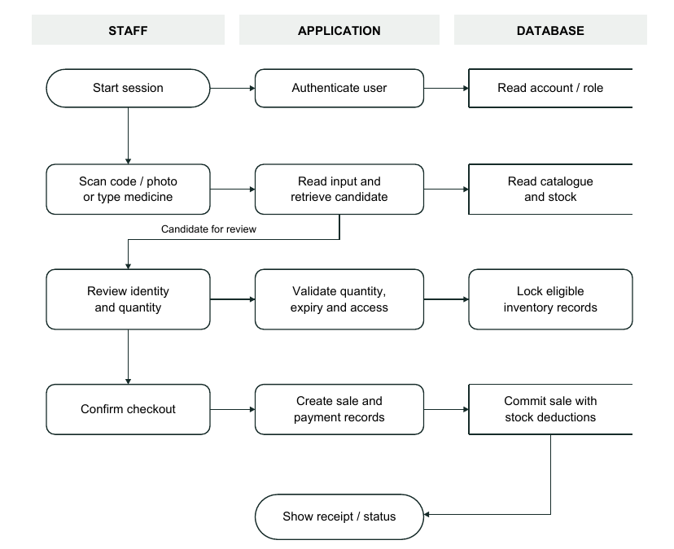
Figure 3 Activity Diagram

DFD 0 Context Diagram
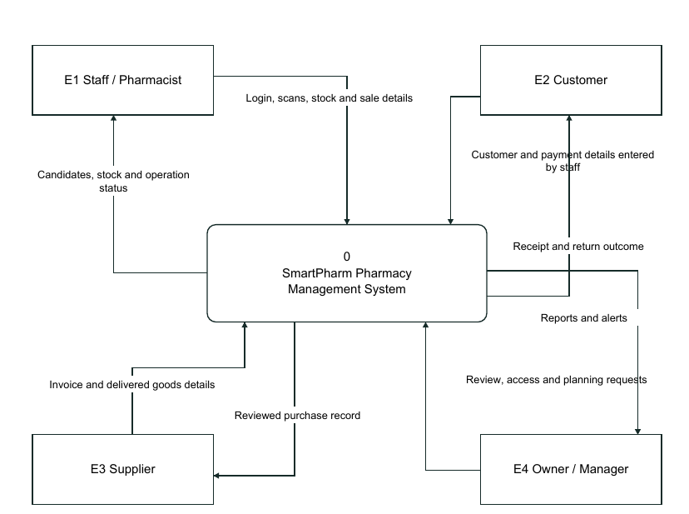
Figure 4 DFD 0 Context Diagram

DFD 1 Major Processes
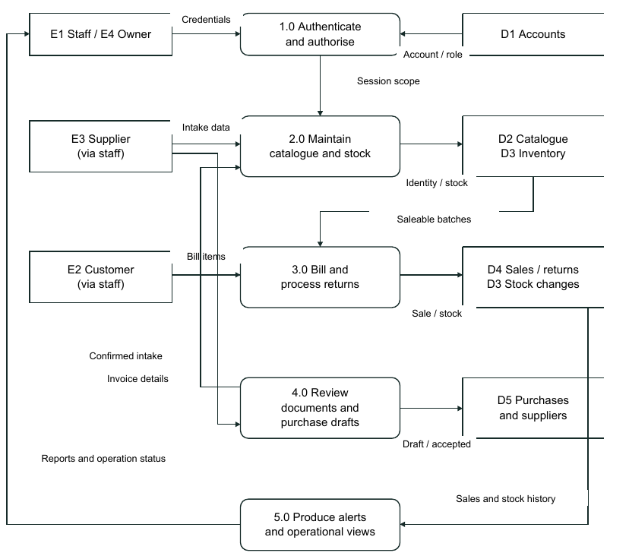
Figure 5 DFD 1 Major Processes

DFD 2 Billing Decomposition
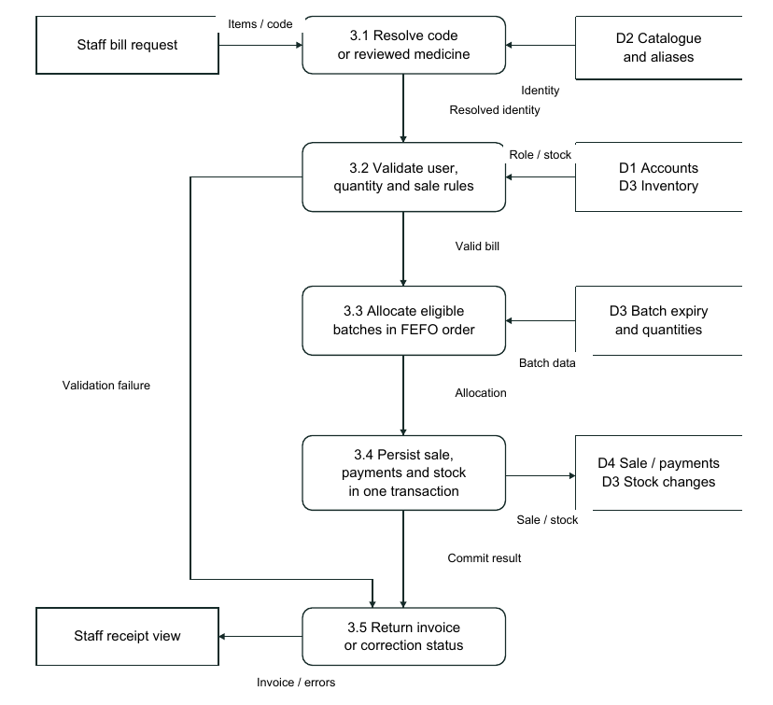
Figure 6 DFD 2 Billing Decomposition

System Flow
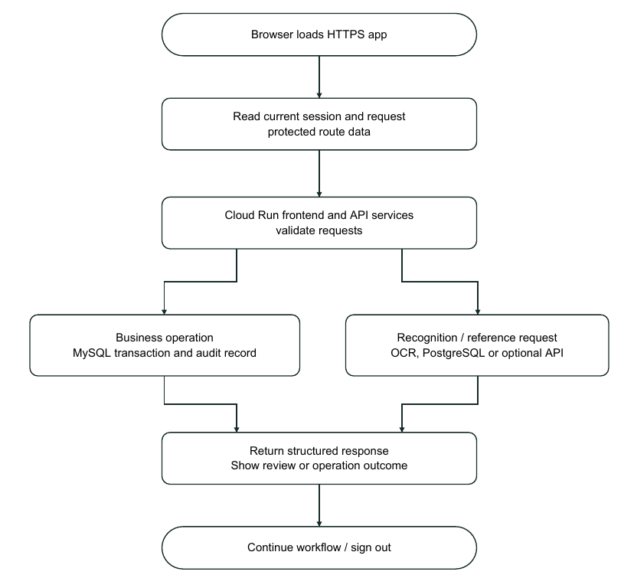
Figure 7 System Flow

Functional Flow
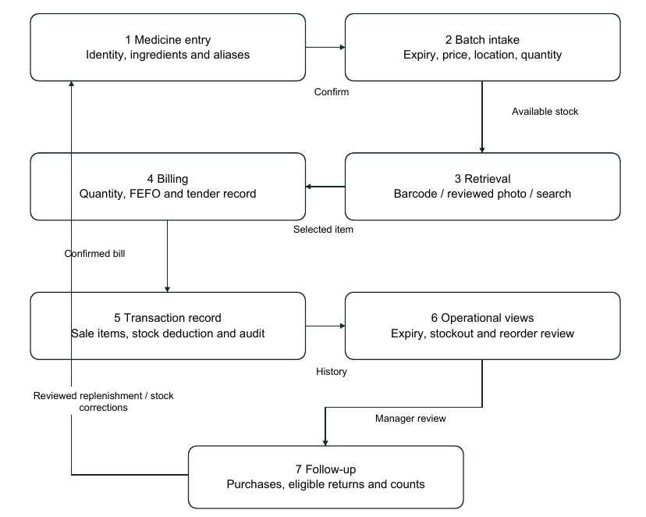
Figure 8 Functional Flow

Core Data Model
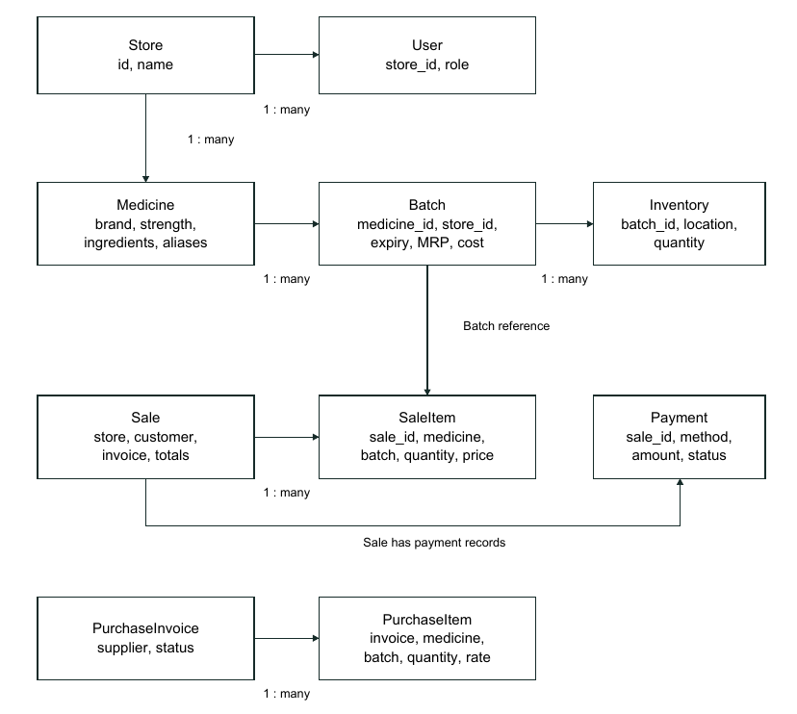
Figure 9 Core Data Model

Test Case Verification Diagram
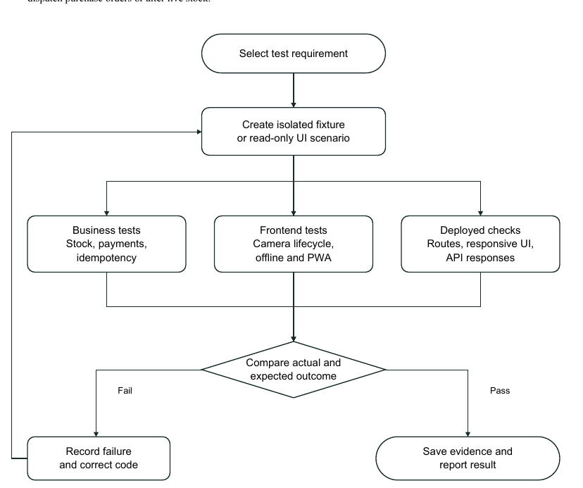
Figure 10 Test Case Verification Diagram
- API and integration inventory
Table 3.1 Business API inventory
Area | Methods and route examples | Purpose
Authentication | POST /api/auth/login; GET /api/auth/me; POST /api/auth/users | Sign in, retrieve account and manage staff.
Medicine catalogue | GET/POST /api/medicines; GET /api/medicines/search | Search and maintain store medicine identities.
Barcode | GET /api/medicines/barcode; POST /api/medicines/barcode-image | Resolve a mapped barcode or decode an image.
Inventory | GET/POST /api/batches; POST /api/inventory/adjust | Record batches and audited quantity adjustments.
Expiry / location | GET /api/inventory/expiry; GET /api/locations; GET /api/shelf/layout | Review expiry and physical storage.
Sales | GET/POST /api/sales; GET /api/sales/{id} | Create bills and retrieve transaction details.
Returns | GET /api/returns/eligible-items/{reference}; POST /api/returns | Check return eligibility and record reviewed returns.
Purchases | GET/POST /api/purchases; POST /api/purchases/{id}/accept | Maintain drafts and accept verified intake.
Suppliers / expenses | GET/POST /api/suppliers; GET/POST /api/expenses | Maintain supplier and operating-expense records.
Branches / audit | GET /api/multibranch/stores; GET /api/audit-logs | Inspect branches and operation history.
Table 3.2 Recognition and support APIs
API group | Route examples | Function
Vision | POST /api/vision/recognize; POST /api/vision/verify | Produce and verify packaging candidates.
Stocking | POST /api/vision/stocking/read, /search, /confirm | Read, search and confirm reviewed entry.
Distributor invoice | POST /api/distributor/scan-invoice; /verify-delivery; /confirm-delivery | Extract invoice rows and verify delivery.
Prescription | POST /api/ai/prescription/scan; POST /api/prescriptions/{id}/verify | Draft transcription and pharmacist review.
Planning / copilot | GET /api/ml/reorder-recommendations; POST /api/ai/copilot/query | Read estimates and query grounded records.
Offline sync | GET /api/sync/offline-pack; POST /api/sync/replay | Account-scoped catalogue and idempotent replay.
External integrations: Google Gemini for optional handwriting/copilot synthesis; Tavily for optional medicine-reference search; Aiven MySQL and PostgreSQL for server-side persistence; Google Cloud Run, Cloud Build, Artifact Registry and Secret Manager for hosting and configuration. Browser integrations include ZXing, camera permission, optional speech recognition and PWA APIs. No payment-gateway settlement or automatic supplier ordering is claimed.
- Working methodology and test cases
Verification combines isolated transactional tests, frontend tests, read-only live-service checks and browser interaction checks. The focused demo/ML group passed 7 tests and the frontend suite passed 28 tests. The frontend production build/type check passed; lint recorded 0 errors and 81 existing warnings. These are scoped recorded checks, not exhaustive or clinical validation.
ID | Input or action | Expected result | Evidence status
TC01 | Import the eight-medicine demo fixture twice. | Second run creates no duplicate sales or stock. | Automated regression passed.
TC02 | Compute imported stock and payment totals. | Stock is 480 - 217 + 20 = 283; line/payment totals balance. | Automated fixture passed.
TC03 | Forecast a short series of selling days. | Use baseline; avoid recursive thousands-of-units suggestion. | Automated regression passed.
TC04 | Open dashboard with stored demo activity. | Render chart, stock/expiry alerts and purchase drafts. | Live browser observed.
TC05 | Open return lookup at 375 and 1440 px. | Icon does not overlap text; no page-level overflow. | Live dimensions checked.
TC06 | Present mapped barcode frames; repeat same code. | Resolve code, suppress duplicate add and stop camera stream on close. | Simulated browser/component checks; physical device retest needed.
TC07 | Scan a weak or rotated package photo. | Show review candidate or explicit recapture/manual fallback. | Workflow observed; general accuracy not quantified.
TC08 | Load protected deep link offline. | Public reconnect screen; do not cache private response. | Prior PWA browser evidence.
TC09 | Transcribe handwritten prescription. | Editable rows, warnings for ambiguity, no invented quantity. | Sample workflow observed; pharmacist review required.
Demonstration data: eight active medicines with sixteen front/back photographs; fifty added synthetic sales, twelve fictional customers, three fictional suppliers, five purchases including three drafts, six expenses and three new near-expiry batches. The isolated seed fixture balances 480 - 217 + 20 = 283 units; later live transactions can change stock.
- Frontend screenshots

Sign In
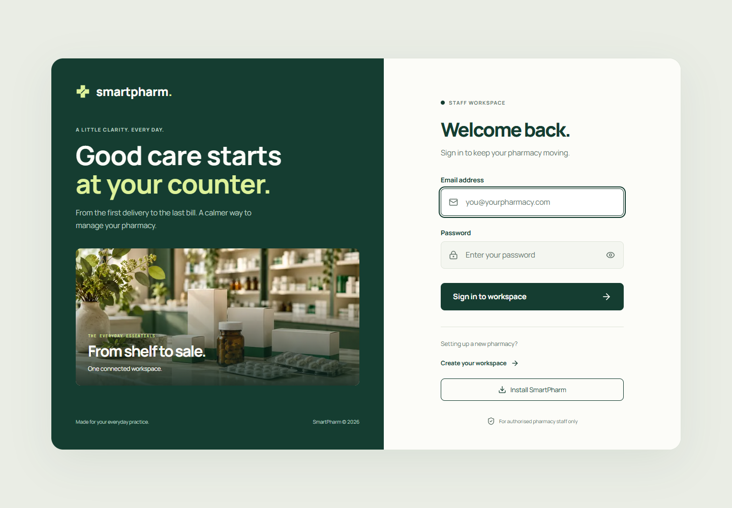
Figure 11 Sign In Actual Frontend
Actual deployed frontend captured on 26 October 2026. The screenshot documents visible functionality with classroom demonstration records; it does not submit a payment or stock operation.

Dashboard
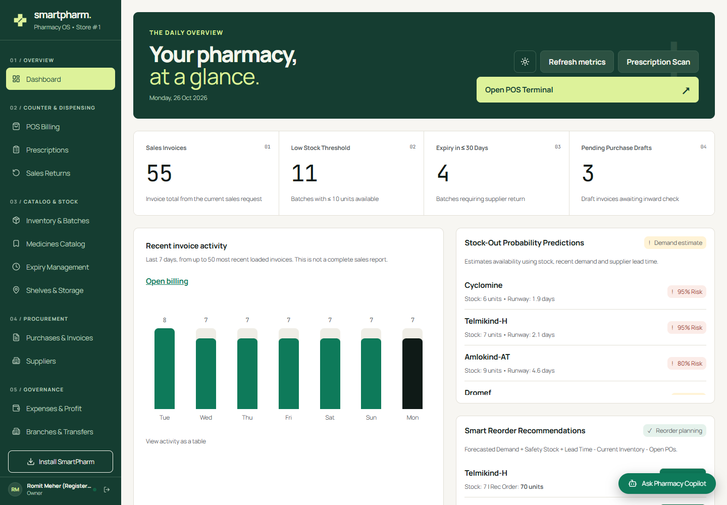
Figure 12 Dashboard Actual Frontend
Actual deployed frontend captured on 26 October 2026. The screenshot documents visible functionality with classroom demonstration records; it does not submit a payment or stock operation.

POS Billing Terminal
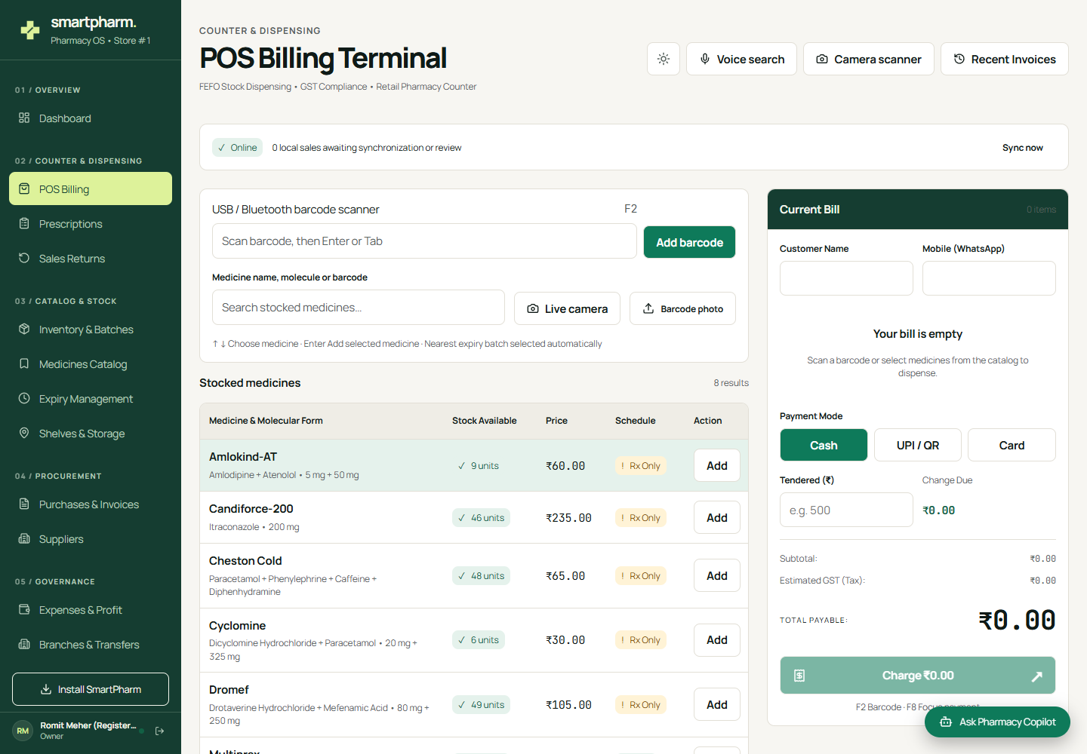
Figure 13 POS Billing Terminal Actual Frontend
Actual deployed frontend captured on 26 October 2026. The screenshot documents visible functionality with classroom demonstration records; it does not submit a payment or stock operation.

Inventory and Batches
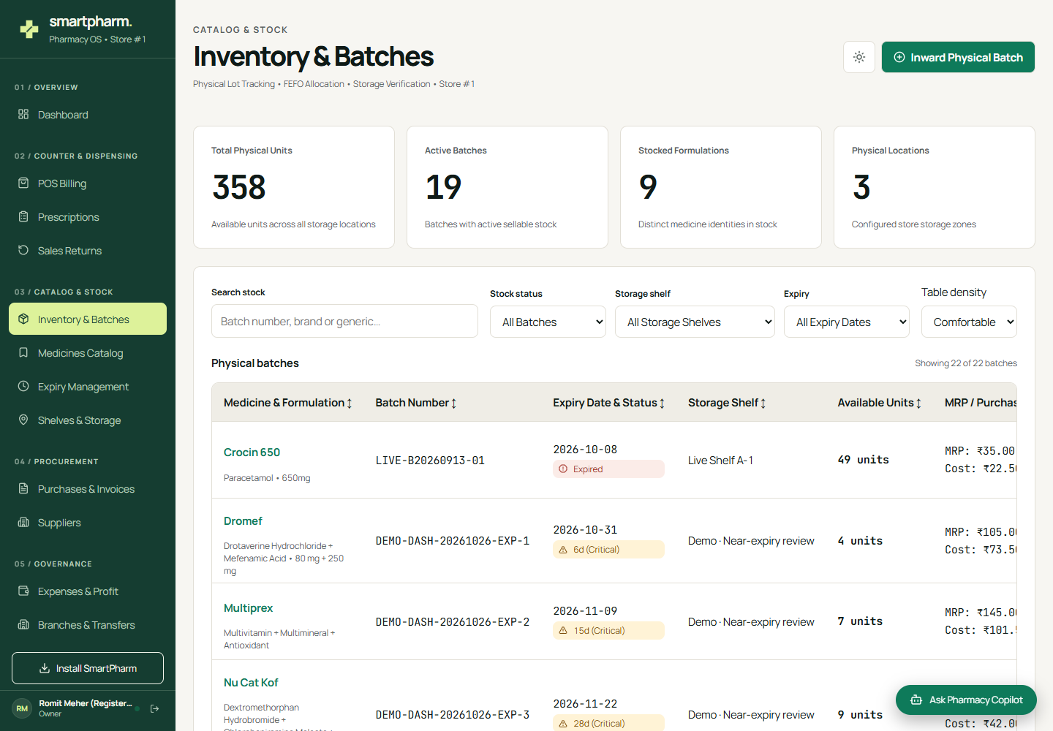
Figure 14 Inventory and Batches Actual Frontend
Actual deployed frontend captured on 26 October 2026. The screenshot documents visible functionality with classroom demonstration records; it does not submit a payment or stock operation.

Medicines Catalogue
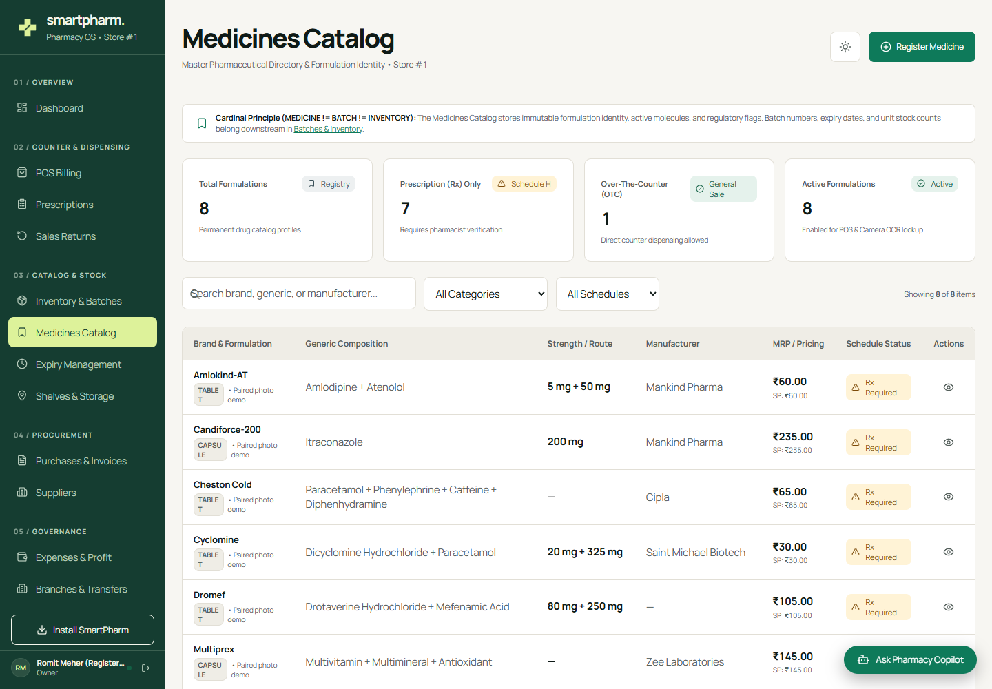
Figure 15 Medicines Catalogue Actual Frontend
Actual deployed frontend captured on 26 October 2026. The screenshot documents visible functionality with classroom demonstration records; it does not submit a payment or stock operation.

Purchases and Invoices
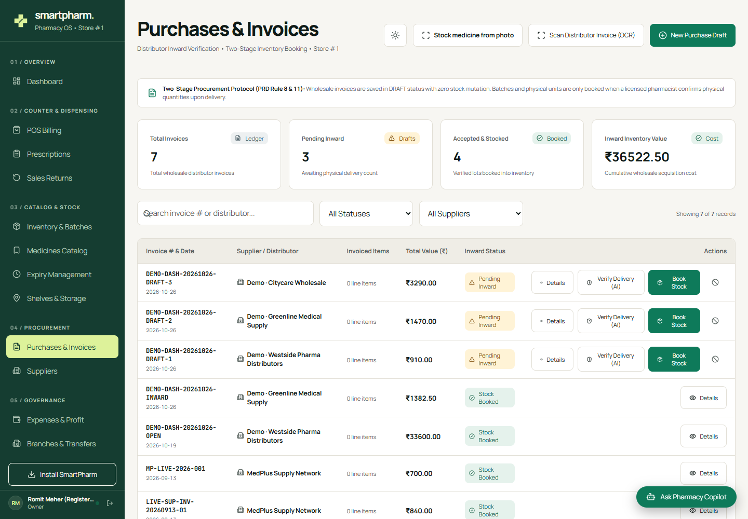
Figure 16 Purchases and Invoices Actual Frontend
Actual deployed frontend captured on 26 October 2026. The screenshot documents visible functionality with classroom demonstration records; it does not submit a payment or stock operation.

Prescription Workspace
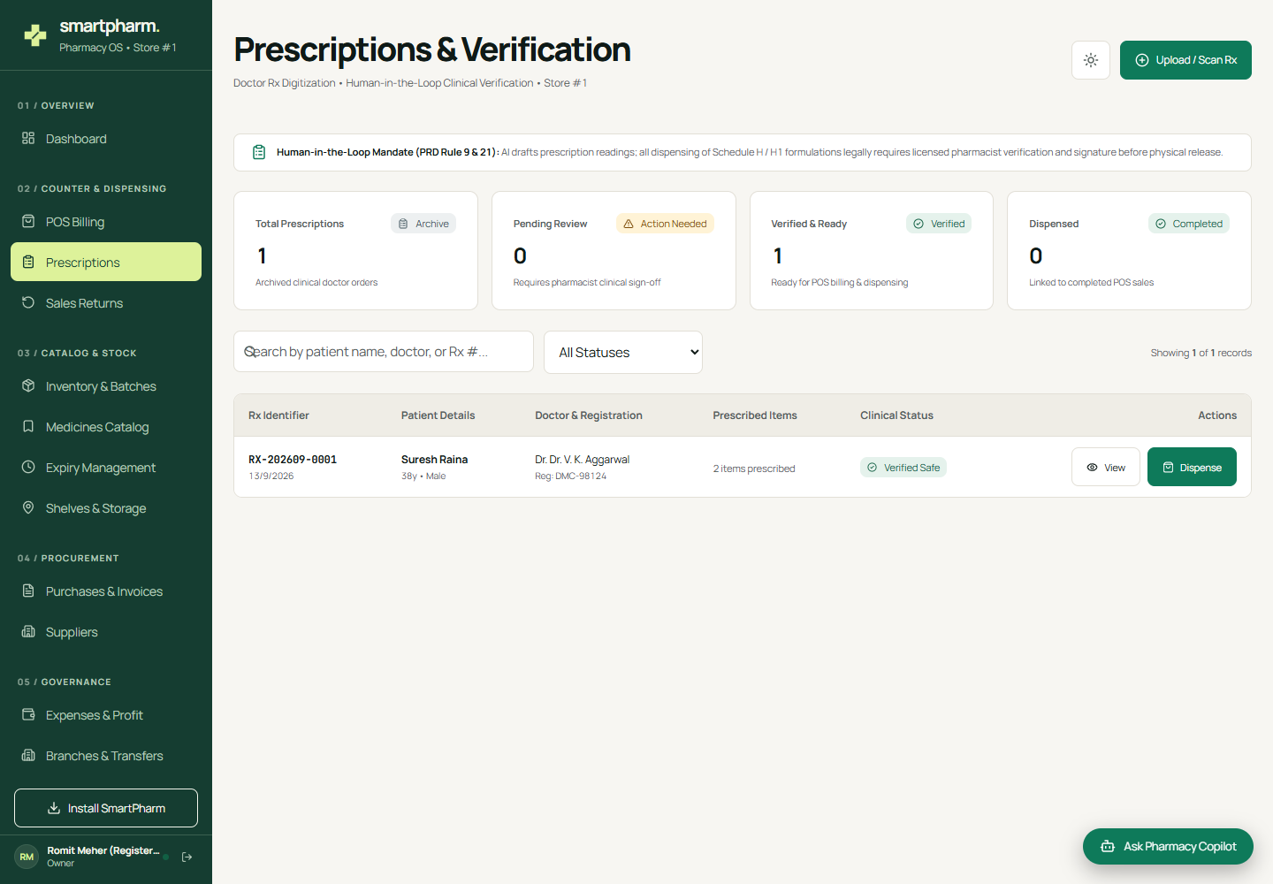
Figure 17 Prescription Workspace Actual Frontend
Actual deployed frontend captured on 26 October 2026. The screenshot documents visible functionality with classroom demonstration records; it does not submit a payment or stock operation.

Expiry Management
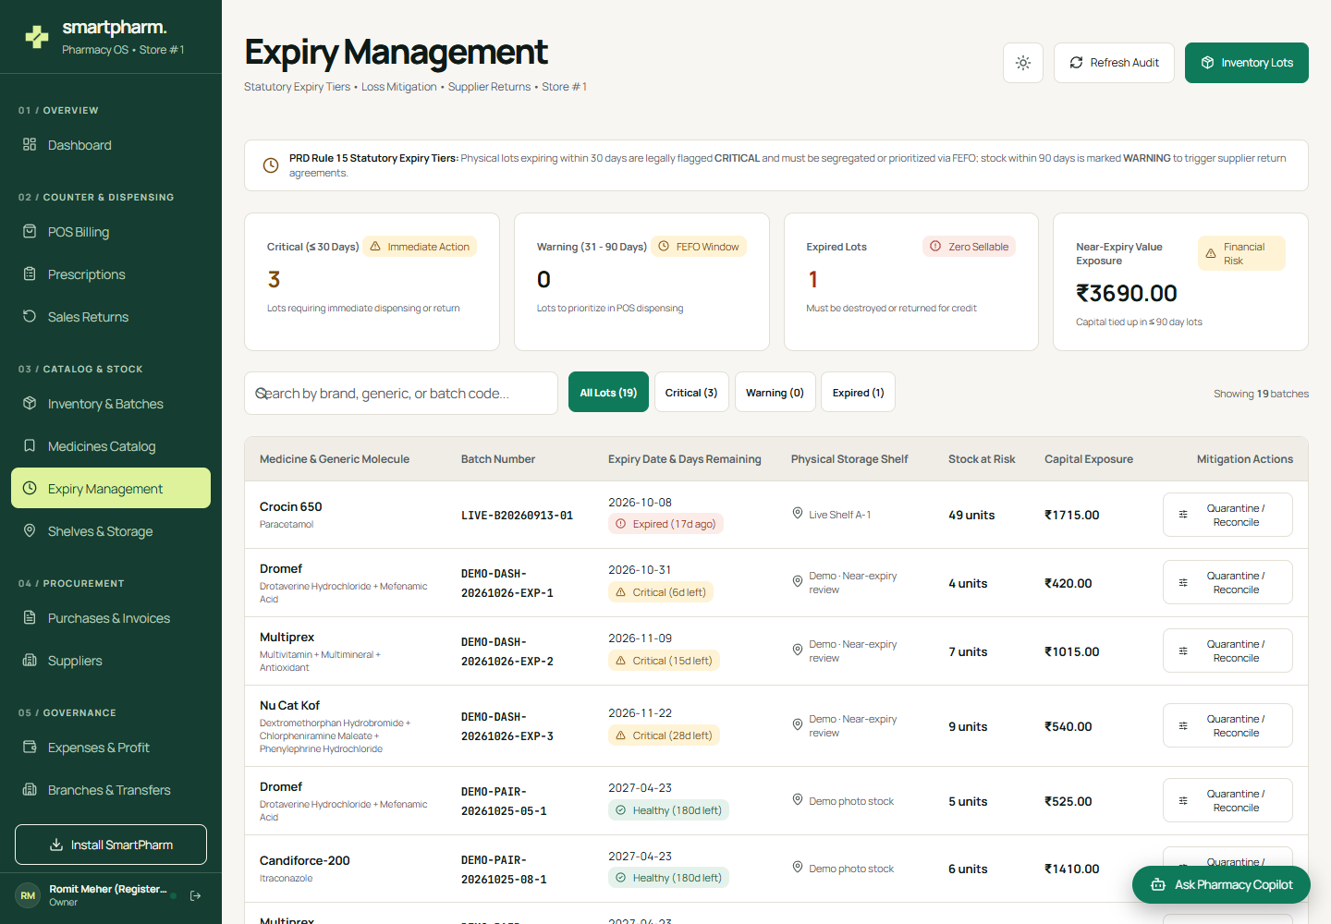
Figure 18 Expiry Management Actual Frontend
Actual deployed frontend captured on 26 October 2026. The screenshot documents visible functionality with classroom demonstration records; it does not submit a payment or stock operation.

