ASU Ground Station Link Budget:
Ground Station Notes:
Assuming Similar ASU ground station that we have used in the past.
50W PA
.5 NF LNA with 20dB of Gain.
12 meters between lna and receiver (plus some other short cables in between).
RF Switch with to go between the LNA and PA cables.

Desired bit rate is around 35kbps but targeting closer to 21.875 kbps (SF 7, CR 4/5, BW 500kHz)

https://www.researchgate.net/figure/Uncoded-BER-vs-E-b-N-0-performances-of-LoRa-dashed-lines-and-single-sideband-M-ASPM_fig1_354375439

For now using this paper to get a rough idea for BER vs Eb/no for LoRa. Not guaranteed to be perfect for all bandwidths but should get close (at least unless I want to see about simulating it instead).

For BER vs SNR for lora. I utilized some Matlab LoRa code that you configure for the similar channel performance metrics (SF, bw) to get decent plots for BER vs SNR

Remote Sensor / User Link Budget:
User Mode swaps the groundstation uplink to a user uplink (so much lower power transmits).
Downlinks are still the same setup though (I.e ASU Ground station parameters).

I am going to first see how much improvement would be needed if they just used a 200mW transmitter (+23dBm) and then add the info.

Without changing much we get around 4.8 to 5 dB of link margin which isn’t terrible. By adding the PA that is being recommended for users https://www.amazon.com/dp/B09T39P1C1 We get around extra 10dB of margin.

Going to run with this for now with the user PA.

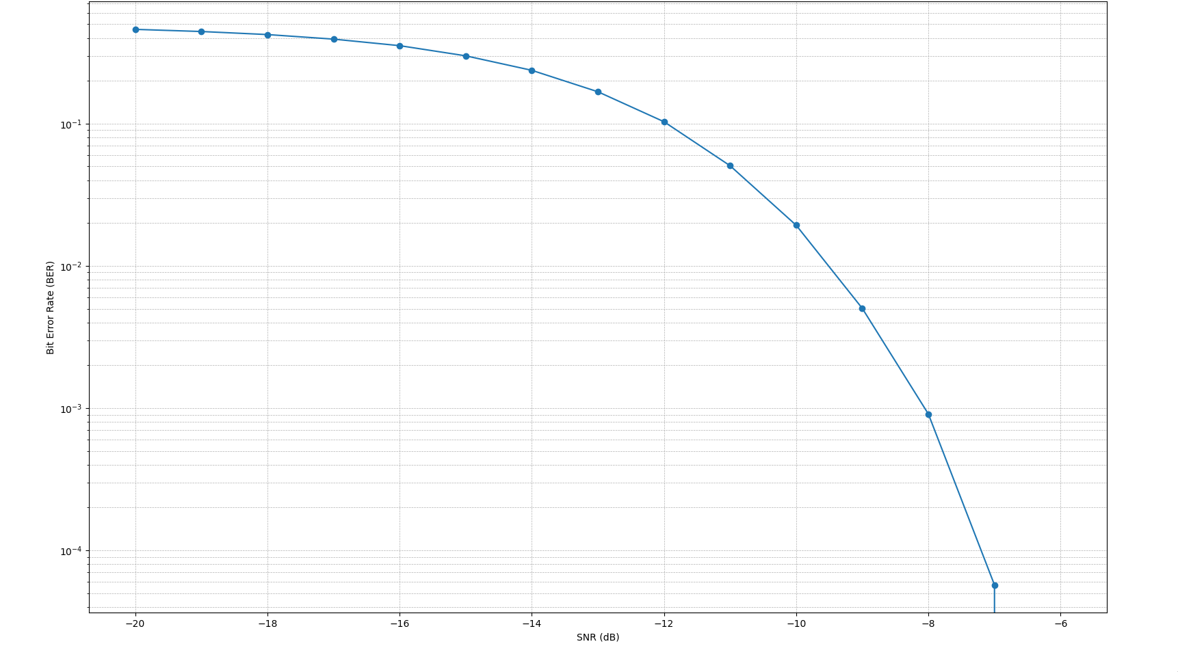
SF=7 for above

SF=9 for below to help with user:
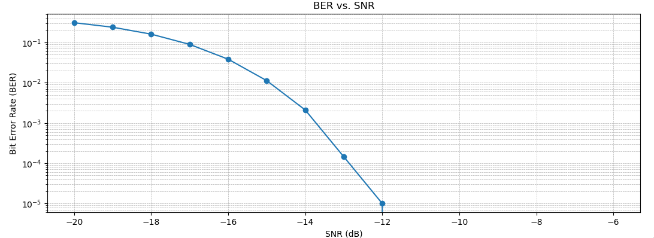

https://hal.science/hal-01977497/document
Use this for a quick SNR to Eb/No formula for Lora.

It seems like the current configuration would be pretty desirable:
Satellite Commanding and downlink radio has the following config:
SF = 7
BW = 500kHz
Cr=4:5
bitrate: 21.875 kbps

User/Sensor Config:
SF = 9
BW = 500kHz
Cr=4:5
bitrate: 7.031 kbps

