SOLUTION DESIGN DOCUMENT
Bias-Aware Decision-Making RAG Copilot
—
Decision Intelligence | Applied AI for Societal Impact
Author | Rommel Sharma
Version | v4.1
Issue Date | 14 May 2026
Classification | Portfolio / Public
Stack | Python · AWS Bedrock · FAISS · BM25 · Claude · Titan v2

Disclaimer: This system provides research-informed decision support only. It does not replace professional judgment, legal counsel, or organisational policy.

Document Control
Version | Date | Description
v0.1 | — | Initial scaffolding
v1.0 | 08 May 2026 | Baseline portfolio design — pipeline, FAISS retriever, bias detector, eval spine
v1.1 | 13 May 2026 | Adds eval spine, metrics, connectivity, baseline scenario capture, run cards, roadmap
v2.0 | 14 May 2026 | Hybrid BM25+dense retrieval, RRF fusion, optimal directory structure, full evaluation framework
v3.0 | 14 May 2026 | Enterprise review: src-layout, pyproject.toml, OCR ingestion, query classification, groundedness metrics, acceptance thresholds, 5-phase roadmap
v4.0 | 14 May 2026 | Ontology upgrade: 8-layer decision-intelligence ontology; concept graph; three parallel chunk representations; hierarchical retrieval; synthesis artefacts
v4.1 | 14 May 2026 | Advanced governance: claim-level attribution, contradiction modelling, confidence calibration, authority weighting, intervention playbooks, contextual compression roadmap

1. Executive Summary
The Bias-Aware Decision-Making RAG Copilot is a local-first, enterprise-style decision-support system that ingests PDFs from a MacBook, normalises and chunks them into traceable evidence units, builds a versioned retrieval index, and answers questions through Claude on Amazon Bedrock. v4.1 builds on the v4.0 ontology foundation with advanced governance: claim-level attribution, contradiction modelling, confidence calibration, and structured intervention playbooks.
The corpus forms a coherent intellectual graph around judgment quality, cognitive bias, decision hygiene, uncertainty, forecasting, group dynamics, institutional failure, and probabilistic reasoning. The 8-layer decision-intelligence ontology with concept relationships, failure modes, intervention techniques, and evidence hierarchies — combined with three parallel chunk representations and hierarchical retrieval — produces qualitatively superior answers compared to direct LLM prompting.

1.1 Design Principles
- Measurable lift — every scenario runs twice: baseline (no retrieval) and RAG-enhanced. The value of retrieval is observed, not assumed.
- Single enterprise control plane — Bedrock for both generation (Claude Sonnet) and embeddings (Titan v2). No split-provider complexity.
- Honest about limits — the system refuses to assert claims the corpus does not support. Taxonomy constraint and retrieval trace are mandatory in every response.
- Ontology depth over index size — the biggest unlock is not a better LLM or a bigger database. It is ontology quality, concept relationships, intervention structure, evidence hierarchy, and synthesis layers.
- Local-first simplicity — FAISS stays in-process; no managed vector database needed at portfolio scale.
- Production discipline — pyproject.toml packaging, src-layout, single config module, immutable versioned prompts, append-only evaluation logs.

1.2 What Was Already Strong
The current implementation has solid foundations: Bedrock integration, FAISS retrieval, metadata-rich chunks, taxonomy-driven enrichment, run cards, and paired baseline-vs-RAG evaluation. The best upgrade path is not a rewrite — it is disciplined consolidation, with ontology depth as the primary quality lever.
Existing Strength | Treatment in v4.1
Bedrock + Claude generation | Keep. Centralise configuration in config.py. Validate credentials on startup.
FAISS IndexFlatIP vector search | Keep for local-first. Add BM25 for exact-match recall via hybrid retrieval.
Metadata-rich chunks (20+ fields) | Extend. Schema now carries all 8 ontology layers per chunk.
Baseline-vs-RAG paired evaluation | Formalise with gold scenarios, groundedness metric, and formal acceptance thresholds.
Run cards for reproducibility | Extend to record corpus manifest hash, ontology version, and governance settings.
Taxonomy-driven concept extraction | Upgrade to 8-layer ontology with concept graph. decision_intelligence_ontology.json is the system brain.

2. Current-State Assessment
The main gap in the existing v1.1 system is not conceptual quality — the architecture is sound. The gaps are: purely dense-vector retrieval, no OCR fallback for scanned PDFs, a taxonomy too shallow to unlock corpus depth, and scattered configuration.
Gap | Severity | v4.0/v4.1 Resolution
Flat bias-name taxonomy cannot represent failure modes, interventions, group dynamics, or evidence hierarchy | CRITICAL | Replace with 8-layer decision-intelligence ontology. Concept graph with relationships. Single brain file: decision_intelligence_ontology.json.
No synthesis layer: chunk retrieval misses book-level and cross-book insights | HIGH | Three parallel representations: dense embeddings, symbolic ontology metadata, and knowledge summaries (synthesis.json).
Dense-only retrieval misses exact-term queries (bias names, authors, titles) | HIGH | Add BM25 + RRF hybrid retrieval. +15–30% recall (Sager et al., 2025).
Flat top-k retrieval does not use ontology structure for hierarchical reasoning | HIGH | hierarchical_retriever.py: concept → book → chapter → chunk → intervention.
No OCR fallback for scanned or image-heavy PDFs | HIGH | ocrmypdf + tesseract fallback in pdf_parser.py. Per-page confidence scoring.
No claim-level attribution or contradiction modelling | HIGH (v4.1) | Add claim_attributor.py and contradiction_handler.py for governance-grade outputs.
Flat app/ + rag/ layout — not standard Python packaging | MEDIUM | src/rag_copilot/ src-layout with pyproject.toml.
Evaluation lacks groundedness and formal thresholds | MEDIUM | metrics.py with acceptance thresholds and per-run pass/fail records.

3. What is RAG? (Retrieval-Augmented Generation)
RAG is an AI architecture that grounds language model responses in retrieved evidence from a curated knowledge base, rather than relying solely on patterns learned during pre-training. The diagram below illustrates the three-stage concept.
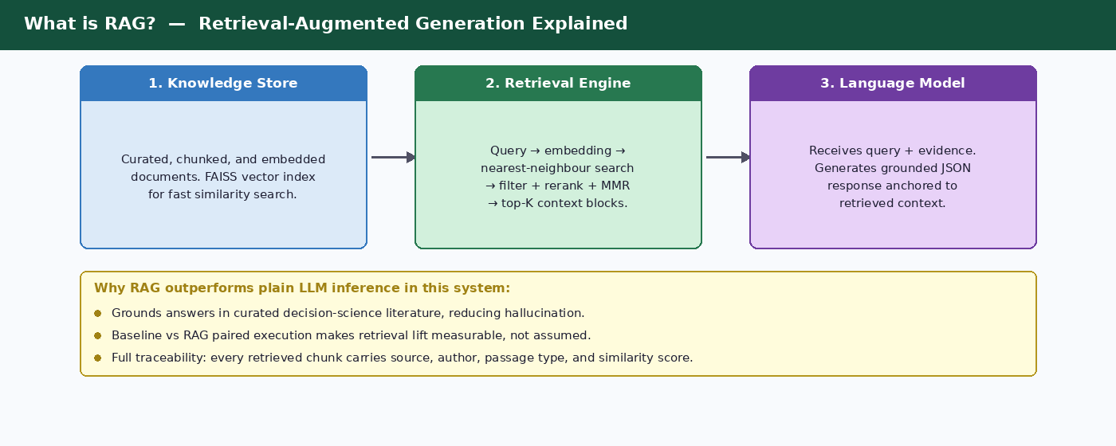
Figure 1 — RAG concept: Knowledge Store → Retrieval Engine → Language Model

3.1 Key RAG Benefits in this Solution
- Grounds answers in peer-reviewed decision-science literature, reducing hallucination risk.
- Makes retrieval lift explicit: every scenario runs with and without retrieval so quality gains are measured, not assumed.
- Full traceability: each retrieved chunk carries source, author, passage type, all 8 ontology dimensions, and similarity score.
- Ontology-driven reasoning: the system reasons over concept relationships, failure modes, and interventions — not just keyword similarity.
- Synthesis layer: book-level, chapter-level, and cross-book synthesis artefacts provide epistemic grounding beyond individual passages.

4. Information Retrieval Techniques
Basic vector similarity search has two well-documented failure modes in production RAG systems: result redundancy (top-K chunks from the same source) and retrieval mismatch (semantic search missing exact terms; keyword search missing paraphrased intent). The retrieval stack addresses both through five complementary techniques.

4.1 Maximal Marginal Relevance (MMR)
Origin: Carbonell and Goldstein (SIGIR 1998), "The Use of MMR, Diversity-Based Reranking for Reordering Documents and Producing Summaries." 1,000+ citations. Now the default diversity mechanism in FAISS, Elasticsearch, OpenSearch, and Azure AI Search.

How MMR Works
MMR selects documents iteratively. At each step it scores every candidate by a weighted combination of query similarity and maximum similarity to already-selected documents:
MMR = argmax [ λ × Sim₁(dᵢ, query) − (1 − λ) × max Sim₂(dᵢ, dⱼ) ]
where λ ∈ [0,1] is the diversity-relevance trade-off. In v4.0, λ is set per query class: 0.85 for recall queries, 0.60 for comparison, 0.65 for synthesis, 0.75 for mitigation.
λ Range | Behaviour | Default Use in v4.0
0.8–1.0 | High relevance, lower diversity | Recall queries; precise factual lookups
0.6–0.75 | Balanced (default 0.70) | Research and analysis tasks
0.5–0.65 | Higher diversity | Comparison and synthesis queries needing multi-source coverage

Why MMR Matters for Bias Analysis
Cognitive bias literature is inherently multi-perspective: confirmation bias, anchoring, and framing often co-occur. Without MMR, top-K retrieval surfaces multiple excerpts from the same dossier. With MMR at λ=0.7, the context window contains contributions from multiple source documents and authors, reducing single-source echo chambers.
MMR — Key Properties: Grounded in Carbonell & Goldstein (SIGIR 1998); 1,000+ citations; integrated natively in FAISS, Elasticsearch, OpenSearch. Controlled by a single parameter (λ). In this solution RAG_MMR_LAMBDA defaults to 0.7 and is overridable per query class. Applied as a post-retrieval re-ranking step over an enlarged candidate pool.

4.2 Self-Querying Retrievers
A Self-Querying Retriever uses the LLM to parse a natural-language query into a semantic search string and a structured metadata filter expression — allowing queries like "recent empirical evidence on confirmation bias in hiring" to decompose automatically into semantic search plus filters passage_type=empirical AND decision_phase=evaluation. Each chunk carries 20+ metadata fields ready for this pattern.
Self-Querying — Key Properties: Combines semantic similarity with structured metadata filtering in a single retrieval pass. Roadmap: implement once a managed vector store replaces in-process FAISS (Phase 5), as FAISS does not natively support metadata filtering comparators. LLM parsing overhead adds one Haiku call per query.

4.3 Contextual Compression
Retrieved chunks often contain more text than is relevant to the query. Passing full chunks consumes context-window tokens, increases inference cost, and introduces noise. Contextual compression reduces each retrieved passage to only the query-relevant content before entering the prompt.
Strategy | Mechanism | Trade-off
LLM Chain Extractor | Pass chunk + query to a small LLM; extract only relevant sentences. | High quality; adds one LLM call per chunk.
LLM Chain Filter | Return full chunk or discard entirely based on LLM relevance judgment. | Binary; faster than extractor; no partial extraction.
Embeddings Filter | Cosine similarity between each sentence and query; retain above threshold. | No LLM call; sentence granularity; threshold tuning required.
EXIT (Hwang et al., 2024) | Extractive compression framework; selects spans context-aware to the full query. | State-of-art extractive; open-source; no fine-tuning needed.
RECOMP (Xu et al., 2024) | Fine-tuned compressor generates abstractive summary conditioned on query. | Best compression quality; requires a fine-tuned model.
Contextual Compression — Key Properties: LLMChainExtractor reduces context tokens by 40–65% while retaining 92–96% of full-context answer accuracy (LangChain, 2026). Most valuable when top-K > 5. Phase 5 roadmap: add LLMChainExtractor (Haiku) when top-K ≥ 8 causes token budget pressure.

4.4 Ensemble Retrieval (Hybrid BM25 + Dense)
No single retrieval strategy excels across all query types. Dense vector search captures semantic paraphrase but misses exact-term matches. BM25 lexical search excels at exact anchoring but fails on conceptually related queries that share no vocabulary. Hybrid retrieval with Reciprocal Rank Fusion (RRF) recovers the strengths of each.
Research support: Hybrid BM25 + dense + RRF improves recall by 15–30% over single-method retrieval across 23,088 queries (Sager et al., arXiv:2604.01733, 2025). RRF is scale-agnostic: Score(d) = Σ 1/(60 + rank_i), using only ranks and not raw scores.
Fusion Method | Mechanism | Best Used When
Reciprocal Rank Fusion (RRF) | Score = Σ 1/(k + rank_i). Scale-agnostic; uses only ranks. | Default choice; incompatible score scales across retrievers.
Weighted Score Combination | Score = α × dense_score + (1−α) × sparse_score. | Scores normalised to same range; asymmetric weighting needed.
Voting / Majority | Document included if present in ≥ N/2 retriever result sets. | Simple ensemble of 3+ retrievers; prioritises consensus.
Ensemble Retrieval — Key Properties: Hybrid BM25 + dense + RRF improves recall 15–30% (arXiv:2604.01733). RRF is score-scale agnostic and robust. Implemented in v4.0 via build_bm25_index.py, bm25_retriever.py, and fusion.py. Cross-encoder reranking (optional Haiku reranker) adds precision on the final top-K.

4.5 Ontology-Guided Filtering and Concept Graph Traversal
Unique to v4.0: after RRF fusion, the ontology filter traverses the concept graph rather than doing a flat keyword match. A query about "confirmation bias" automatically expands to include motivated_reasoning (related_to), premortem and red_team_review (mitigated_by), and groupthink and hierarchy_pressure (amplified_by) — surfacing intervention and group dynamics chunks that would be missed by semantic search alone.
This is what distinguishes a decision reasoning system from a search engine: the concept graph makes implicit knowledge relationships explicit at retrieval time.

4.6 Technique Composition and Implementation Status
Technique | Pipeline Stage | Status | Roadmap
MMR | Post-retrieval re-ranking | Implemented. λ per query class via RAG_MMR_LAMBDA. | Tune λ per query type once per-query eval metrics are captured.
Hybrid BM25 + Dense + RRF | Retrieval (parallel) | Implemented in v4.0. build_bm25_index.py, bm25_retriever.py, fusion.py. | None.
Ontology-guided filter | Post-RRF filtering | Implemented in v4.0. Concept graph traversal (related_to, mitigated_by, amplified_by). | Expand graph coverage as corpus grows.
Hierarchical Retrieval | Multi-level retrieval | Implemented in v4.0. hierarchical_retriever.py. | None.
Synthesis Injection | Pre-generation context | Implemented in v4.0. synthesis_builder.py + synthesis.json. | Automated quality checks on synthesis artefacts.
Self-Querying Retriever | Pre-retrieval query parsing | Not yet. Metadata fields ready; awaits managed vector store. | Phase 5: add once FAISS migrated to managed store.
Contextual Compression | Post-retrieval context trimming | Partial: format_retrieved_context() manually compact. Full LLM extraction not yet active. | Phase 5: add LLMChainExtractor (Haiku) for top-K ≥ 8.

5. System Architecture Overview
The system operates in two distinct execution phases sharing a single configuration module, path resolver, ontology loader, and Bedrock client. The offline ingestion pipeline is idempotent and produces a versioned corpus manifest. The runtime path always produces both a baseline and a RAG response for the same input.

5.1 Offline Ingestion Pipeline
Runs once per corpus build or refresh. Each stage is independently re-runnable.
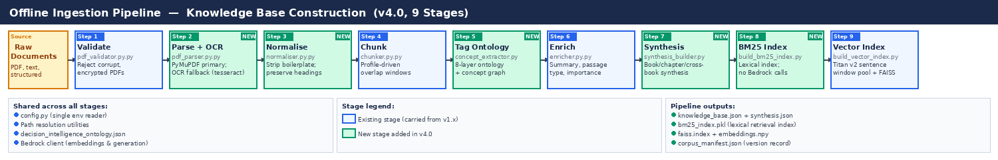
Figure 2 — Offline pipeline v4.0: 9 stages — Validate → Parse+OCR → Normalise → Chunk → Tag Ontology → Enrich → Synthesis → BM25 Index → Vector Index
Stage | Script | Input → Output | Key Quality Control
1. Validate | ingestion/pdf_validator.py | raw/*.pdf → validated_manifest.json | Reject corrupt/encrypted PDFs; record page count and text-layer presence before any Bedrock spend
2. Parse + OCR | ingestion/pdf_parser.py | validated PDFs → processed/extracted/{slug}.txt + .meta.json | PyMuPDF + pymupdf4llm primary; ocrmypdf + tesseract OCR fallback; per-page confidence in .meta.json
3. Normalise | ingestion/normaliser.py | extracted/{slug}.txt → processed/normalised/{slug}.txt | Strip boilerplate; normalise whitespace; preserve heading structure for chapter detection
4. Chunk | ingestion/chunker.py | normalised/{slug}.txt → processed/chunks/chunks.json | Profile-driven overlap windows (dossier 350/60, book 500/80, auto); chapter_title on every chunk
5. Tag Ontology | ingestion/concept_extractor.py | chunks.json → processed/chunks/chunks_with_concepts.json | Tags all 8 ontology dimensions; concept graph traversal adds related_to and mitigated_by automatically
6. Enrich | ingestion/enricher.py | chunks_with_concepts.json → processed/enriched/knowledge_base.json | Adds summary, importance, passage_type; schema validation fails hard on missing ontology fields
7. Synthesis | ingestion/synthesis_builder.py | knowledge_base.json → processed/enriched/synthesis.json | Book-level, chapter-level, cross-book synthesis via Claude Haiku
8. BM25 Index | indexing/build_bm25_index.py | knowledge_base.json → processed/index/bm25_index.pkl | rank_bm25 BM25Okapi; no Bedrock calls required
9. Vector Index | indexing/build_vector_index.py | knowledge_base.json → processed/index/{embeddings.npy, faiss.index, manifest.json} | Titan v2 sentence-window pooling (±3 sentences, mean-pooled, L2-normalised)

5.2 Runtime Path — Scenario to Bias Analysis
Executes on every user query. Classifies intent, runs hierarchical retrieval over three parallel representations, and calls Claude twice to produce a measurable baseline-vs-RAG comparison.
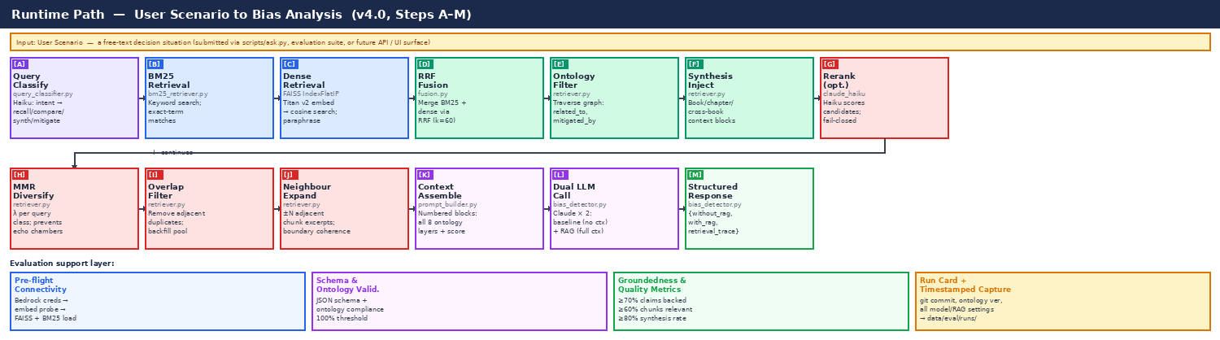
Figure 3 — Runtime path v4.0: Steps A–M — Query Classification → BM25 + Dense → RRF Fusion → Ontology Filter → Synthesis Inject → Rerank → MMR → Overlap → Expand → Context Assemble → Dual LLM Call → Structured Response
Step | Component | Description
A | Query classification | Lightweight Haiku call: recall | comparison | synthesis | mitigation. Returns intent class and recommended MMR λ. Fail-open: defaults to recall on error.
B | BM25 retrieval | Tokenised keyword search over bm25_index.pkl. Captures exact bias names, author surnames, specific titles.
C | Dense retrieval | Titan v2 embeds full scenario → FAISS IndexFlatIP cosine search. Captures semantic paraphrase.
D | RRF fusion | Reciprocal Rank Fusion (k=60) merges BM25 and dense lists. Scale-agnostic; uses only ranks.
E | Ontology-guided filter | Traverses concept graph: related_to, mitigated_by, amplified_by. Falls back to full pool if < min_results remain.
F | Synthesis injection | Pulls book-level and cross-book synthesis blocks from synthesis.json for matched concepts. Injects as high-authority context.
G | Optional reranker | Haiku scores each candidate against query. Fail-closed: reverts to RRF order on error.
H | MMR diversification | Selects top-K using MMR (λ per query class). Prevents single-source echo chambers.
I | Overlap filter | Greedy pass removes adjacent-chunk duplicates. Backfills from deeper pool.
J | Neighbour expansion | Adds bounded excerpts from ±N adjacent same-source chunks for boundary coherence.
K | Context assembly | Numbered blocks with author, title, year, all 8 ontology layers, evidence type, and matched concepts.
L | Dual LLM call | Claude Sonnet ×2: (1) system prompt + ontology only (baseline); (2) + retrieved context + synthesis (RAG).
M | Structured response | Returns {without_rag, with_rag, retrieval_trace}. Both share strict JSON schema.

5.3 Target AWS Deployment Architecture
The deployment architecture is unchanged from v1.1. The internal processing is richer (ontology-guided retrieval, synthesis injection) but the deployment layer — CloudFront, API Gateway, Fargate, S3, Bedrock — remains the same.
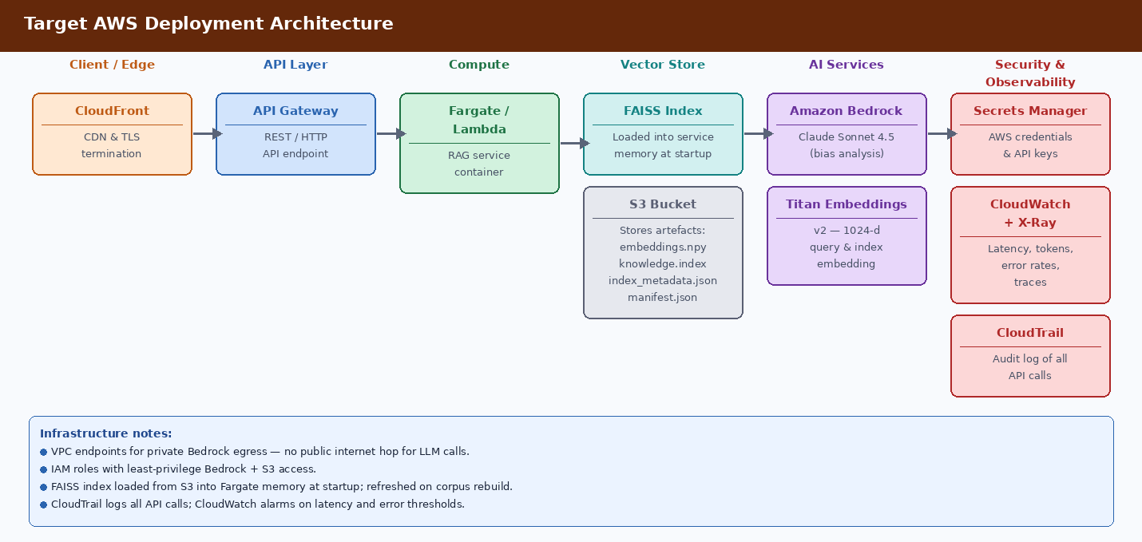
Figure 4 — AWS deployment: CloudFront → API Gateway → Fargate → FAISS (memory) + S3 → Bedrock (Claude Sonnet + Titan Embeddings) → Secrets Manager / CloudWatch / CloudTrail

6. Decision-Intelligence Ontology
The ontology is the most important quality lever in the system. It distinguishes a decision reasoning system from a search engine. The flat bias-name list used in v1.x was too shallow to represent the intellectual structure of the corpus. The 8-layer ontology captures the full reasoning graph.
Key insight: the corpus forms a coherent intellectual graph around judgment quality, cognitive bias, decision hygiene, uncertainty, forecasting, group dynamics, institutional failure, and probabilistic reasoning. The ontology makes that graph retrievable and reasoned over — not just searched.

6.1 The 8-Layer Ontology Structure
Layer | Name | Purpose | Example Values
1 | Decision Domain | Organisational or life context of the decision | strategic_investment, hiring, performance_review, product_development, clinical_judgment
2 | Failure Mode | Decision-level outcome failure — more important than raw bias | escalation_of_commitment, premature_convergence, failure_to_update, narrative_lock_in, poor_calibration
3 | Cognitive Mechanism | Individual psychological mechanism underlying the failure | confirmation_bias, anchoring, availability_bias, overconfidence, loss_aversion, base_rate_neglect
4 | Group / Org Dynamics | Social and institutional amplifiers — critical for enterprise realism | groupthink, hierarchy_pressure, political_alignment, reputation_defense, diffusion_of_responsibility
5 | Decision Phase | Where in the decision process the failure occurs — enables precision filtering | problem_framing, evidence_collection, forecasting, option_evaluation, decision_commitment, postmortem_review
6 | Intervention Technique | Actionable mitigation mechanisms — highest direct value for users | premortem, red_teaming, outside_view, reference_class_forecasting, devils_advocate, base_rate_analysis
7 | Evidence Type | Epistemic authority of the passage — not all sources have equal weight | meta_analysis, empirical_study, controlled_experiment, case_study, framework, expert_opinion, anecdote
8 | Confidence Level | Derived from evidence type — enables model to reason about certainty | high (meta_analysis / empirical_study), medium (case_study / framework), low (expert_opinion / anecdote)

6.2 The Concept Graph
Every concept in decision_intelligence_ontology.json carries explicit relationships. This enables concept graph traversal at retrieval time — a query about "confirmation bias" automatically pulls in groupthink chunks, premortem interventions, and Sibony/Kahneman sources.
Relationship | Meaning | Example
related_to | Concepts that co-occur or reinforce each other | confirmation_bias → motivated_reasoning, belief_perseverance, sunk_cost_fallacy
mitigated_by | Interventions that address this concept | confirmation_bias → red_team_review, outside_view, independent_estimation
failure_mode_of | Which higher-level failure mode this mechanism produces | confirmation_bias → escalation_of_commitment
amplified_by | Group dynamics that strengthen this individual bias | confirmation_bias → groupthink, hierarchy_pressure, consensus_pressure
evidence_from | Source books that provide evidence for this concept | confirmation_bias → kahneman_thinking_fast_slow, sibony_you_are_about_to_make_mistake

6.3 Three Parallel Chunk Representations
Representation | What It Captures | Primary Use
Dense semantic embeddings | Paraphrase matching, conceptual recall. Titan v2 sentence-window pooled vectors in FAISS. | Broad semantic retrieval: "what is conceptually similar to this scenario?"
Symbolic ontology metadata | All 8 ontology layers as structured JSON fields per chunk. Precision filtering and reasoning structure. | Targeted filtering: "find empirical_study chunks with groupthink + hierarchy_pressure in forecasting phase"
Knowledge summaries (synthesis.json) | Book-level thesis, chapter-level argument, cross-book concept synthesis. Generated by synthesis_builder.py. | High-authority context injection: "what does the corpus collectively say about escalation_of_commitment?"

6.4 How This Upgrades Answer Quality
A system with a flat bias list produces: "This scenario involves confirmation bias and groupthink." A system with the full ontology produces:
Example: "The scenario exhibits escalation_of_commitment dynamics (failure mode), driven by confirmation_bias and motivated_reasoning (cognitive mechanisms), amplified by hierarchy_pressure and reputation_defense (group dynamics) during the option_evaluation phase. Documented in Sibony (2020) as a high-frequency executive decision failure, with empirical support from Kahneman and Tversky. Recommended interventions: premortem (Kahneman), red_team_review (Sibony), and outside_view reference_class_forecasting (Wiser)."

7. Canonical Directory Structure
v4.0 adopts the Python src-layout standard, consolidates all data under a single data/ root, and keeps only the files essential to run, test, or evaluate the system.

7.1 Repository Root
Path | Purpose
pyproject.toml | Dependency management, packaging, tooling. Replaces requirements.txt. Defines dev/test/prod dependency groups.
README.md | Quickstart, architecture overview, run-order reference.
.env.example | All runtime settings with inline documentation. Never committed with real values.
.gitignore | Excludes: data/corpora/*/processed/, data/corpora/private/, data/eval/runs/, .env

7.2 src/rag_copilot/ — Application Code
Path | Purpose
src/rag_copilot/config.py | Single source of truth: reads os.environ once. All other modules import from here.
src/rag_copilot/clients/bedrock.py | Thin Bedrock boto3 wrapper: converse() + embed_text(). Validates credentials on construction.
src/rag_copilot/ingestion/pdf_validator.py | Validates PDFs; records page count and text-layer presence. Rejects corrupt files before Bedrock spend.
src/rag_copilot/ingestion/pdf_parser.py | PyMuPDF + pymupdf4llm primary; ocrmypdf + tesseract OCR fallback. Per-page confidence in .meta.json.
src/rag_copilot/ingestion/normaliser.py | Strips boilerplate. Normalises whitespace. Preserves heading structure for chapter detection.
src/rag_copilot/ingestion/chunker.py | Profile-driven overlapping windows: dossier (350/60), book (500/80), auto. chapter_title on every chunk.
src/rag_copilot/ingestion/concept_extractor.py | Loads decision_intelligence_ontology.json; tags all 8 layers per chunk; traverses concept graph for related_to and mitigated_by.
src/rag_copilot/ingestion/enricher.py | Summary, importance, passage_type. Schema validation fails hard on missing ontology fields. Writes knowledge_base.json.
src/rag_copilot/ingestion/synthesis_builder.py | Generates book-level, chapter-level, cross-book synthesis via Claude Haiku. Writes synthesis.json.
src/rag_copilot/indexing/build_bm25_index.py | rank_bm25 BM25Okapi index → bm25_index.pkl. No Bedrock calls.
src/rag_copilot/indexing/build_vector_index.py | Titan v2 sentence-window embeddings. FAISS IndexFlatIP. Writes embeddings.npy, faiss.index, manifest.json.
src/rag_copilot/retrieval/query_classifier.py | Classifies query intent via Haiku. Returns intent class + MMR λ. Fail-open.
src/rag_copilot/retrieval/bm25_retriever.py | Loads bm25_index.pkl; returns (chunk_id, bm25_score) ranked list.
src/rag_copilot/retrieval/fusion.py | RRF (k=60). Merges BM25 and dense lists. Handles entries absent from one list.
src/rag_copilot/retrieval/hierarchical_retriever.py | Five-level retrieval: concept → book synthesis → chapter synthesis → chunk → intervention.
src/rag_copilot/retrieval/retriever.py | Orchestrator: classify → BM25+FAISS → RRF → ontology filter → synthesis inject → reranker → MMR → overlap → expand.
src/rag_copilot/generation/prompt_builder.py | Assembles system prompt from ontology constraint + retrieved context (chunks + synthesis blocks).
src/rag_copilot/generation/bias_detector.py | Orchestration: loads ontology + prompt; runs retrieval; dual LLM call; parses strict JSON with one retry.
src/rag_copilot/evaluation/metrics.py | Schema + ontology compliance + groundedness + ontology coverage + synthesis injection rate + acceptance thresholds.
src/rag_copilot/evaluation/run_card.py | UTC timestamp, git commit, file SHA-256s, ontology_version, all model/RAG settings, index manifest.
src/rag_copilot/evaluation/connectivity.py | Pre-flight: Bedrock → embed probe → FAISS + BM25 load → synthesis.json presence → retrieval probe.

7.3 data/ — Corpus, Registry, and Evaluation
Path | Committed? | Purpose
data/registry/decision_intelligence_ontology.json | Yes | Single brain of the system. 8-layer ontology with concept graph. Replaces bias-taxonomy.json + retrieval-concepts.json.
data/registry/corpus_manifest.json | Yes | Source file hashes, build timestamps, index manifest references, ontology version.
data/corpora/<corpus>/raw/ | Public: Yes Private: No | Source PDFs. Public dossiers committed. Entire private/ tree gitignored.
data/corpora/<corpus>/processed/ | No | Generated: extracted/, normalised/, chunks/, enriched/ (knowledge_base.json + synthesis.json), index/
data/eval/gold/baseline_scenarios.json | Yes | Three frozen scenarios for longitudinal baseline-vs-RAG comparison.
data/eval/gold/test_scenarios.json | Yes | ~30 realistic scenarios spanning hiring, sunk cost, groupthink, base-rate neglect, and more.
data/eval/gold/gold_labels.json | Yes | Expected failure modes, interventions, relevant source passages. For retrieval precision@K.
data/eval/runs/ | No | Append-only: <ts>_<label>_eval.json, sample_results_comparison.md, connectivity_log.txt.

8. Evaluation Framework
Evaluation is a formal part of the product. Every scenario runs twice: once with retrieval disabled (baseline) and once with retrieval enabled. This isolates the value of the corpus and makes retrieval lift observable.

8.1 Baseline: Without RAG
Characteristic | Expected Behaviour
Bias identification | Generally correct on common, well-named biases. May miss domain-specific, co-occurring, or corpus-specific concepts.
Source citations | None — no retrieval means no traceable evidence.
Mitigation depth | Generic, textbook-level. Not grounded in specific frameworks from the corpus.
Hallucination risk | Higher — model may confidently misattribute mechanism without external grounding.
Consistency across runs | Lower — without retrieval, repeated runs may vary in bias selection and framing.

8.2 RAG-Enhanced Path
Characteristic | Expected Behaviour
Bias identification | Broader and more precise. Multi-source context surfaces co-occurring failure modes, cognitive mechanisms, and group dynamics.
Source citations | Full traceability: author, title, year, passage type, evidence type, matched ontology layers per retrieved chunk.
Mitigation depth | Ontology-grounded: interventions linked to failure modes via mitigated_by relationships and sourced from specific books.
Hallucination risk | Lower — anchored to retrieved text; ontology constraint prevents invented concept names.
Consistency across runs | Higher — deterministic retrieval (same index + ontology + settings) produces stable context across runs.

8.3 Metrics and Acceptance Thresholds
Metric | Formula / Method | Acceptance Threshold | Failure Action
Schema validity (baseline) | JSON schema check on without_rag payload | 100% | Flag run; do not publish; investigate prompt regression
Schema validity (RAG) | JSON schema check on with_rag payload | 100% | Flag run; do not publish; investigate prompt regression
Ontology compliance | % of named concepts in decision_intelligence_ontology.json | 100% | Flag run; indicates ontology or prompt constraint drift
Ontology coverage | Avg ontology layers populated per scenario response | ≥ 4 layers | Low coverage means ontology not used; check concept_extractor
Groundedness | % of claims backed by at least one retrieved passage | ≥ 70% | Investigate retrieval quality; check chunking and enrichment
Retrieval hit quality | % of top-K chunks rated relevant by LLM judge (Haiku) | ≥ 60% | Tune MMR λ, overlap filter, or reranker; check query classification
Synthesis injection rate | % of RAG responses including at least one synthesis block | ≥ 80% | Check synthesis_builder.py output; verify synthesis.json populated
Bias lift (count) | len(with_rag.biases) − len(without_rag.biases) | ≥ 0 | Negative lift means retrieval adds noise; investigate context assembly
Source diversity | Distinct sources in retrieved top-K | ≥ 3 | Tune MMR λ downward; check corpus breadth
Latency per scenario | Wall-clock for dual LLM call + retrieval | < 30s | Profile; consider disabling reranker or reducing candidates

9. Configuration Reference
All configuration is supplied via environment variables loaded from .env (never committed). src/rag_copilot/config.py is the only module that reads os.environ.
Variable | Default | Description
BEDROCK_REGION | us-west-2 | AWS region for Bedrock runtime client
BEDROCK_MODEL_ID | claude-sonnet-4-6 | Chat model for generation
BEDROCK_HAIKU_MODEL_ID | claude-haiku-4-5-20251001-v1:0 | Haiku model for query classification, synthesis, reranker, enrichment
BEDROCK_EMBEDDING_MODEL_ID | amazon.titan-embed-text-v2:0 | Embedding model — must match at index build and query time
BEDROCK_EMBEDDING_DIMENSIONS | 1024 | Vector dimension; must match FAISS index
CORPUS_NAME | public | public (committed dossiers) or private (full books, local-only)
CHUNK_PROFILE | auto | dossier | book | auto
RAG_TOP_K | 8 | Final context chunks returned after MMR
RAG_MMR_LAMBDA | 0.7 | Default MMR λ; overridden per query class when query classification enabled
RAG_BM25_ENABLED | true | Enable BM25 leg of hybrid retrieval; false = dense-only (legacy)
RAG_BM25_TOP_K | 20 | Candidate pool size from BM25 before RRF fusion
RAG_RRF_K | 60 | RRF smoothing constant; 60 is the standard recommendation
RAG_QUERY_CLASSIFICATION | true | Enable query intent classification to route strategy and MMR λ
RAG_RERANKER | none | none or claude_haiku
RAG_RERANKER_CANDIDATES | 24 | Candidate pool depth passed to the Haiku reranker
RAG_EMBED_SENTENCE_WINDOWS | true | false = one Titan call on full chunk text (legacy)
RAG_EMBED_SENTENCE_RADIUS | 3 | Sentences before/after each centre sentence in a window
RAG_EMBEDDING_MAX_WINDOWS | 0 | 0 = no cap; set to limit Bedrock calls per chunk on large corpora
RAG_OVERLAP_FILTER | false | Enable overlap-aware greedy filter; recommended true for corpora > 2k chunks
RAG_CONTEXT_EXPAND_NEIGHBORS | 0 | 0 = off; N = include bounded excerpts from ±N adjacent same-source chunks
OCR_CONFIDENCE_THRESHOLD | 0.7 | Pages with tesseract confidence below this are flagged and may be skipped
EVAL_GROUNDEDNESS_THRESHOLD | 0.70 | Minimum % of bias claims backed by retrieved passages to pass eval
EVAL_RETRIEVAL_QUALITY_THRESHOLD | 0.60 | Minimum % of top-K chunks rated relevant by LLM judge to pass eval

10. Best-Practice Alignment (15-Point Playbook)
This solution is designed against a 15-point playbook synthesised from Google Cloud, Microsoft Azure Architecture Center, Redwerk, and ChatRAG guidance.
# | Practice | v4.1 Status | Remaining Gap
1 | Define use case & success criteria | IMPLEMENTED. Ontology compliance, coverage, groundedness, retrieval quality, synthesis injection rate, and acceptance thresholds in metrics.py. | Formal latency/cost SLO dashboards; pilot human rubrics.
2 | Prepare knowledge foundation | IMPLEMENTED. Curated dossiers; OCR-hardened extraction; ontology-tagged knowledge base. | Automated staleness detection and event-driven reindex.
3 | Build representative test set early | IMPLEMENTED. ~30 scenarios; 3 frozen; gold_labels.json with failure modes and interventions. | Expand gold labels to 50+ pairs for precision@K automation.
4 | Analyse documents before chunking | IMPROVED. pdf_validator.py classifies extraction class. OCR fallback. Per-page confidence. | Optional docling path for complex multi-column layouts.
5 | Structure documents for retrieval | IMPLEMENTED. Dossiers authored for retrieval quality; enricher adds all 8 ontology dimensions. | None.
6 | Choose chunking strategy deliberately | IMPLEMENTED. Profile-driven overlap; chapter awareness; normaliser strips boilerplate. | Automated grid search over profiles × frozen eval.
7 | Clean & enrich chunks with metadata | IMPLEMENTED. Full 8-layer ontology schema enforced by enricher validation; ocr_used and extraction_confidence included. | Enterprise ACL fields for multi-tenant deployments.
8 | Select & evaluate embedding model | IMPLEMENTED. Titan v2 1024-d; sentence-window pooling; manifest records model ID. | Benchmark alternate embeddings against frozen eval before switching.
9 | Design index & retrieval strategy | IMPLEMENTED. FAISS + BM25 hybrid with RRF. Ontology-guided filtering with concept graph traversal. Hierarchical retrieval. Synthesis injection. | Self-querying metadata filters (requires managed vector store).
10 | Re-rank & assemble context | IMPLEMENTED. Optional Haiku reranker; MMR per query class; overlap filter; neighbour expansion; synthesis block injection. | Contextual compression via LLMChainExtractor for top-K ≥ 8.
11 | Design prompts for grounded answers | IMPLEMENTED. Versioned prompt files; ontology constraint; JSON schema; temperature 0.1. | Automated A/B harness tied to frozen scenarios.
12 | Evaluate retrieval & generation separately | IMPLEMENTED. Ontology coverage + groundedness + retrieval hit quality + synthesis injection rate with acceptance thresholds. | CI regression gate against frozen baseline_metrics.json.
13 | Controlled experimentation & root cause | IMPLEMENTED. run_card.py; corpus_manifest_hash; ontology_version; label-based filenames under data/eval/runs/. | None.
14 | Human evaluation before rollout | IMPLEMENTED. sample_results_comparison.md supports qualitative review. | Structured reviewer rubrics (clarity, trustworthiness, citation usefulness).
15 | Operations, governance & CI | PARTIAL. Connectivity logging; versioned manifests; corpus registry; ontology versioning. | CloudWatch dashboards; cost tracking; CI gate against frozen baseline_metrics.json.

11. Engineering Roadmap
Phase | Focus | Key Deliverables
Phase 1 — Repository & Config | Structural foundation | Migrate to src-layout + pyproject.toml. Centralise config.py. Merge outputs into data/eval/. Consolidate docs/ to three canonical files.
Phase 2 — Ingestion Hardening | Extraction quality | Add pdf_validator.py, OCR fallback, normaliser.py. Enforce fixed chunk schema. Add corpus_manifest.json.
Phase 3 — Ontology & Synthesis | Knowledge depth (highest quality lever) | Build decision_intelligence_ontology.json. Update concept_extractor.py for all 8 dimensions. Add synthesis_builder.py and hierarchical_retriever.py.
Phase 4 — Hybrid Retrieval | Retrieval quality | Add build_bm25_index.py, bm25_retriever.py, fusion.py. Add query_classifier.py. Wire ontology-guided filter and synthesis injection.
Phase 5 — Evaluation & CI | Measurement and production readiness | Ontology coverage + synthesis injection rate metrics. Freeze gold_labels.json (50+ pairs). Publish baseline-vs-RAG report. CI regression gate. LLM-as-judge.

12. Advanced Reasoning and Governance Enhancements (v4.1)
The v4.0 architecture establishes a strong enterprise-grade retrieval and reasoning foundation. The enhancements below represent the next maturity layer: claim-level attribution, contradiction handling, confidence calibration, temporal evidence weighting, authority weighting, contextual compression, organizational learning, and structured intervention playbooks.

12.1 Claim-Level Attribution
Every generated claim should reference supporting chunk IDs and synthesis blocks. This enables auditability, governance review, explainability, and downstream verification. Each bias finding should carry a list of evidence_ids referencing the specific chunks and synthesis blocks that support it.

12.2 Contradictory Evidence Handling
The synthesis layer should explicitly model disagreement, uncertainty, competing frameworks, and contradictory findings between authors or evidence types. When Kahneman and Sibony disagree on the mechanism of a failure mode, the system should surface that disagreement rather than collapsing to a single view.

12.3 Confidence Calibration
Response-level confidence should consider: evidence strength (evidence_type in the ontology), source agreement (convergent_findings in cross-book synthesis), retrieval ambiguity (similarity score spread), and corpus support (number of independent chunks supporting the claim).

12.4 Temporal Evidence Weighting
Future versions should include publication recency, replication strength, and evidence age weighting in the synthesis and retrieval pipeline. Seminal work (Kahneman 1974) and recent replications carry different evidential weight.

12.5 Corpus Authority Weighting
Authority weighting should influence reranking and synthesis generation. Meta-analyses and controlled experiments outweigh expert opinion and anecdotes — this is already captured in evidence_type and confidence_level in the ontology schema, but should be surfaced in the prompt and synthesis generator.

12.6 Structured Intervention Playbooks
Interventions should evolve into procedural playbooks with facilitation steps, anti-patterns, and prerequisites. A premortem is not just a concept name — it is a facilitation process. The corpus (especially Sibony and Wiser) contains enough procedural detail to generate playbooks.

12.7 Recommended Advanced Roadmap
Capability | Priority | Primary Value
Claim-level attribution | HIGH | Auditability and explainability
Contradiction modelling | HIGH | Epistemic honesty and nuanced reasoning
Confidence calibration | HIGH | Trustworthy enterprise responses
Contextual compression | MEDIUM | Token efficiency and larger effective top-K
Authority weighting | MEDIUM | Higher quality synthesis prioritisation
Intervention playbooks | MEDIUM | Operational usefulness for practitioners
Organizational learning memory | LOW (future) | Longitudinal institutional intelligence

13. Common Pitfalls and Mitigations
Pitfall | Mitigation | Residual Risk
Flat bias list produces shallow, generic responses | v4.0 replaces flat taxonomy with 8-layer ontology + concept graph. Ontology coverage metric measures depth. | Ontology quality depends on initial construction; iterate based on coverage scores.
Concept graph not traversed at retrieval time | Ontology-guided filter traverses related_to, mitigated_by, and amplified_by. Tested in test_concept_extractor.py. | Closed in v4.0.
Synthesis blocks not generated or injected | synthesis_builder.py runs as explicit pipeline stage 7. Synthesis injection rate is a formal eval metric (≥80%). | synthesis_builder.py requires Bedrock access; check connectivity before pipeline run.
Scanned PDFs produce empty or garbage chunks | pdf_validator.py classifies extraction class. OCR path triggered by low char density. Per-page confidence in .meta.json. | Heavily degraded scans flagged in parser_notes for manual review.
Dense-only retrieval misses exact-term queries | v4.0 hybrid retrieval: BM25 + RRF fusion. +15–30% recall. | Closed in v4.0.
Single-source echo chamber in retrieved context | MMR (query-class-adjusted λ) + overlap filter + source diversity metric with acceptance threshold. | Requires periodic λ tuning against frozen scenarios as corpus grows.
Invented concept names in output | Ontology constraint in system prompt. ontology_compliance is a hard acceptance metric (100%). | Prompt regression can open this gap; the metric is the guard.
Embedding model changed without index rebuild | manifest.json records model ID + window settings. config.py validates manifest model matches env setting. | Operator must re-run build_index.py if BEDROCK_EMBEDDING_MODEL_ID changes.
No experiment auditability | run_card.py + corpus_manifest_hash + ontology_version + timestamped data/eval/runs/ captures. | No CI gate yet against frozen baseline_metrics.json.

14. Run-Order Reference

14.1 First-Time Setup
# 1. Install all dependencies (dev group includes pytest, rich, etc.)
pip install -e ".[dev]"
# 2. Install OCR tools (macOS)
brew install tesseract
# 3. Configure environment
cp .env.example .env # edit: add AWS bearer token, set BEDROCK_REGION
# 4. Validate source PDFs (no Bedrock calls)
python scripts/ingest_corpus.py --corpus public --stage validate
# 5. Run full ingestion pipeline (includes synthesis_builder; requires Bedrock)
python scripts/ingest_corpus.py --corpus public --profile auto
# 6. Build BM25 index (no Bedrock calls)
python scripts/build_index.py --corpus public --bm25-only
# 7. Build vector index (requires live Bedrock access)
python scripts/build_index.py --corpus public
# 8. Pre-flight connectivity check
python scripts/evaluate.py --check-only

14.2 Daily Workflows
# Interactive query — baseline + RAG response side-by-side
python scripts/ask.py
# Full evaluation suite
python scripts/evaluate.py --scenarios data/eval/gold/test_scenarios.json
# Frozen baseline scenarios → timestamped capture
python scripts/evaluate.py --scenarios data/eval/gold/baseline_scenarios.json --label v4_ontology
# Compare public vs private corpus versions
python scripts/compare_corpora.py --versions public,private
# Unit tests (no Bedrock calls)
pytest tests/ -v --cov=src/rag_copilot
# Run against private corpus (full books)
CORPUS_NAME=private python scripts/evaluate.py

Appendix A — Alternative Deployment Approaches (AWS vs GCP)
This appendix analyses what changes when the Bias-Aware Decision-Making RAG Copilot is deployed on Amazon Web Services (AWS) versus Google Cloud Platform (GCP). The core solution design — chunking strategy, FAISS vector index, dual baseline/RAG execution, evaluation spine, ontology, and bias taxonomy — is cloud-agnostic and unchanged. What differs is the managed service layer.
The two architectures are structurally identical: edge → API gateway → compute → vector store + object storage → LLM/embedding AI service → secrets + observability. Each AWS service maps cleanly to a GCP equivalent.

A.1 Target AWS Deployment Architecture
Already shown in Figure 4 (Section 5.3). The AWS deployment uses CloudFront, API Gateway, Fargate (always-on), S3, Bedrock (Claude Sonnet + Titan Embeddings), Secrets Manager, CloudWatch, and CloudTrail.

A.2 Target GCP Deployment Architecture
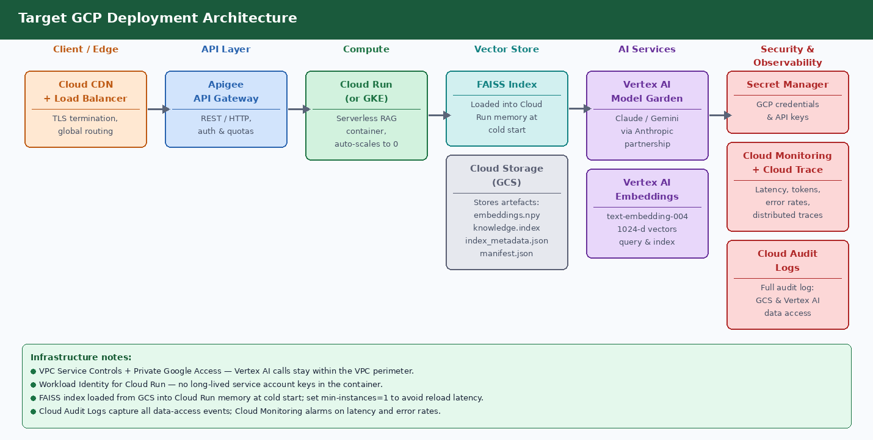
Figure 5 — GCP deployment: Cloud CDN → Apigee → Cloud Run → FAISS (memory) + GCS → Vertex AI Model Garden → Secret Manager / Cloud Monitoring / Cloud Audit Logs

A.3 Side-by-Side Component Comparison
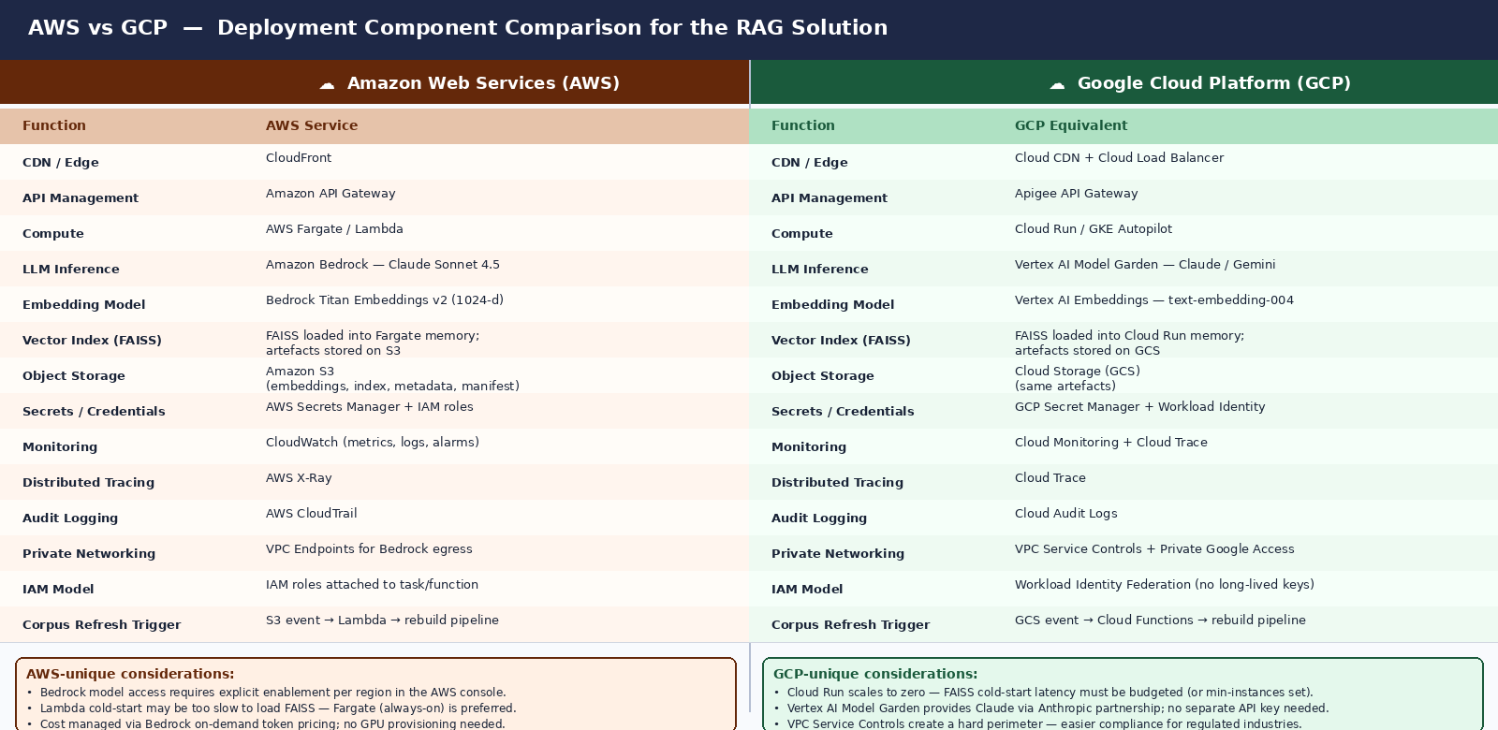
Figure 6 — Full AWS vs GCP component mapping with platform-unique considerations

A.4 Key Differences and Decision Factors
Factor | AWS | GCP
LLM access | Claude via Bedrock (on-demand token pricing; must enable model per region) | Claude via Vertex AI Model Garden (Anthropic partnership; no separate API key; Gemini alternative available)
Embedding model | Bedrock Titan Embeddings v2 (1024-d, normalize=true) | Vertex AI text-embedding-004 (768-d or 1024-d — must re-embed on migration)
Compute | AWS Fargate (always-on; no cold start) | Cloud Run (scales to zero; set min-instances=1 to avoid FAISS reload latency)
IAM model | IAM roles attached to ECS task; credentials injected via instance metadata | Workload Identity Federation; no long-lived key files; no accidental key commit risk
Private networking | VPC Endpoints for Bedrock, S3, Secrets Manager | VPC Service Controls — hard logical perimeter; stronger for regulated industries
Compliance posture | Standard IAM + VPC | GCP preferred for healthcare, finance, government (harder perimeter, auditor-friendly)
For this portfolio project, AWS remains the primary deployment target because the solution is already built against the Bedrock API. GCP becomes preferred when: (1) strict data residency or regulated-industry compliance is required, or (2) the organisation is already standardised on GCP and Google Workspace.

A.5 FAISS in a Cloud Deployment
FAISS is an in-process library, not a managed service. On both AWS and GCP it follows the same pattern: the offline pipeline uploads embeddings.npy, faiss.index, index_metadata.json, and manifest.json to object storage. At container startup, the RAG service downloads and loads the FAISS index into heap memory. Search latency is then sub-millisecond. Memory sizing: a 1024-dimension float32 index over ~5,000 chunks is roughly 20 MB.

Appendix B — Traceability Contract
Every artefact preserves the full chain from source PDF to final LLM output. The contract is enforced by schema validation; any break surfaces as a metrics failure.
Layer | Traceability Fields
Corpus registry | corpus_manifest.json: source file hashes, build timestamps, index manifest references, corpus version, ontology_version
Chunk | id, source, file_name, author, title, publication_year, chunk_index, chapter_title, chunking_profile, corpus_version, parser_notes, extraction_confidence, ocr_used, biases, failure_modes, cognitive_mechanisms, group_dynamics, decision_phases, interventions, evidence_type, confidence_level, keywords, summary, importance, passage_type, decision_domains
Synthesis block | level (book|chapter|cross_book), source_book(s), matched_concepts, synthesis_content, evidence_type, generated_by (ontology version + model)
Retrieval result | All chunk fields + similarity_score, bm25_score, rrf_score, matched_ontology_layers, retrieval_method (bm25 | dense | hybrid | synthesis)
Response payload | corpus, corpus_manifest_hash, ontology_version, retrieval_trace (full array), without_rag (JSON), with_rag (JSON)
Run card | git_commit, scenario_file_sha256, system_prompt_sha256, corpus_manifest_hash, ontology_version, all model/RAG settings, index manifest, UTC timestamp
Eval capture | Run card + per-scenario metrics (ontology coverage, groundedness, synthesis injection rate, threshold pass/fail per metric) + aggregated rollup

Appendix C — Key References
Reference | Relevance
Carbonell & Goldstein (SIGIR 1998). The Use of MMR, Diversity-Based Reranking. | Foundational MMR paper (1,000+ citations). Basis for query-class-adjusted MMR λ in this solution.
Sager et al. (arXiv:2604.01733, 2025). From BM25 to Corrective RAG. | Hybrid RRF +15–30% recall over single-method retrieval; 23,088-query benchmark. Primary justification for v4.0 hybrid retrieval.
Verma (arXiv:2409.13385, 2024). Contextual Compression in RAG: A Survey. | Taxonomy of compression paradigms. Basis for Phase 5 contextual compression roadmap.
Hwang et al. (arXiv:2412.12559, 2024). EXIT: Context-Aware Extractive Compression. | State-of-art extractive compression; Phase 5 implementation target.
Xu et al. (ICLR 2024). RECOMP: Improving Retrieval-Augmented LMs. | Abstractive compression with fine-tuned compressor; highest quality option for contextual compression.
Robertson & Zaragoza (2009). The Probabilistic Relevance Framework: BM25. | Foundational BM25 paper; basis for rank_bm25 BM25Okapi implementation.
LangChain (2026). RAG Case Study: Advanced Retrieval Patterns. | LLMChainExtractor: 40–65% token reduction, 92–96% accuracy retention.
Amazon Bedrock docs. Titan Text Embeddings v2. | normalize=true behaviour; 1024-d dimension; on-demand pricing model.
ocrmypdf documentation. ocrmypdf.readthedocs.io. | OCR quality, tesseract confidence scoring, and per-page processing patterns.
Elasticsearch Labs (2025). MMR & Elastic: Diversifying Search Results. | Practical λ tuning guidance; λ = 0.5–0.7 recommended for balanced retrieval.
Kahneman, D. (2011). Thinking, Fast and Slow. | Primary corpus source: dual-process theory, heuristics and biases, loss aversion. Foundation of Layer 3 cognitive mechanisms.
Kahneman, D., Sibony, O. & Sunstein, C. (2021). Noise. | Primary corpus source: judgment variability, decision hygiene. Foundation of Layer 2 failure modes.
Sibony, O. (2020). You Are About to Make a Terrible Mistake. | Primary corpus source: executive decision failures, de-biasing techniques. Foundation of Layer 6 interventions.
Sunstein, C. & Hastie, R. (2015). Wiser: Getting Beyond Groupthink. | Primary corpus source: group intelligence dynamics, collective failure modes. Foundation of Layer 4 group/org dynamics.

Disclaimer: This system provides research-informed decision support only. It does not replace professional judgment, legal counsel, or organisational policy.

