SOLUTION DESIGN DOCUMENT
Bias-Aware Decision-Making RAG Copilot

Decision Intelligence | Applied AI for Societal Impact

Author | Rommel Sharma
Version | 1.1
Issue Date | 13 May 2026
Classification | Portfolio / Public

Disclaimer: This system provides research-informed decision support only. It does not replace professional judgment or organisational policy.

Document Control
Version | Date | Description
v0.1 | — | Initial scaffolding
v1.0 | 08 May 2026 | Baseline portfolio design
v1.1 | 13 May 2026 | Playbook-aligned sequence; adds eval spine, metrics, connectivity, baseline scenario capture, run cards, and explicit gap/roadmap call-outs

Executive Summary
The Bias-Aware Decision-Making RAG Copilot is decision-support software that analyses free-text scenarios for cognitive and systemic biases. It is not legal, medical, HR-policy, or financial advice.
Core Components
- Curated decision-science corpus of synthesised dossiers authored for retrieval quality.
- Amazon Bedrock (Titan Text Embeddings v2 + Claude Sonnet 4.5) with FAISS vector retrieval.
- Optional MMR diversification and Claude Haiku reranking, plus concept / decision-domain filters.
- Closed bias taxonomy embedded in a strict JSON output contract.
- Dual execution: every scenario runs baseline (no retrieval) and RAG-enhanced — so lift is measurable, not assumed.

Engineering Highlights (v1.1)
- Reproducible evaluation spine: pre-flight Bedrock + vector-store connectivity checks.
- Per-response schema/taxonomy metrics and aggregate rollups via evaluation/metrics.py.
- Run cards capture git commit, prompt/scenario hashes, model and RAG settings for traceability.
- Timestamped captures under response/ (via scripts/record_response_run.py) anchor before/after comparisons.
- Three frozen baseline scenarios in evaluation/baseline_scenarios.json for longitudinal comparison.

What is RAG? (Retrieval-Augmented Generation)
RAG is an AI architecture that grounds language model responses in retrieved evidence from a curated knowledge base, rather than relying solely on patterns learned during pre-training. The diagram below illustrates the three-stage concept.

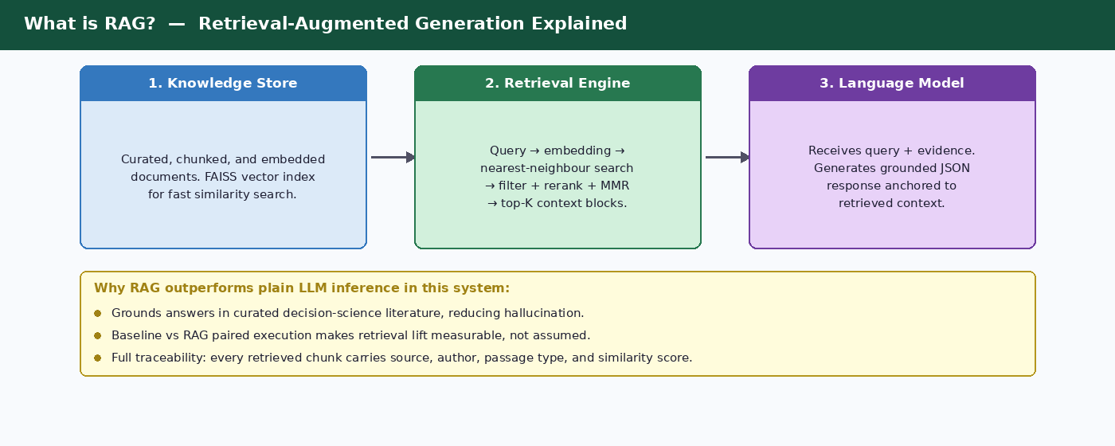
Figure 1 — RAG concept: Knowledge Store → Retrieval Engine → Language Model

Key RAG Benefits in this Solution
- Grounds answers in peer-reviewed decision-science literature, reducing hallucination risk.
- Makes retrieval lift explicit: every scenario runs with and without retrieval so quality gains are measured.
- Full traceability: each retrieved chunk carries source, author, passage type, decision phase, and similarity score.
- Configurable retrieval stack: top-K, MMR lambda, concept/domain filters, and optional Haiku reranker via environment settings.

System Architecture Overview
The system operates in two distinct execution phases sharing a common configuration, path resolution, taxonomy, and Bedrock provider layer.

Offline Ingestion Pipeline
The offline pipeline transforms raw PDFs into a vector-searchable, traceable knowledge base. It runs once per corpus, or on corpus refresh.
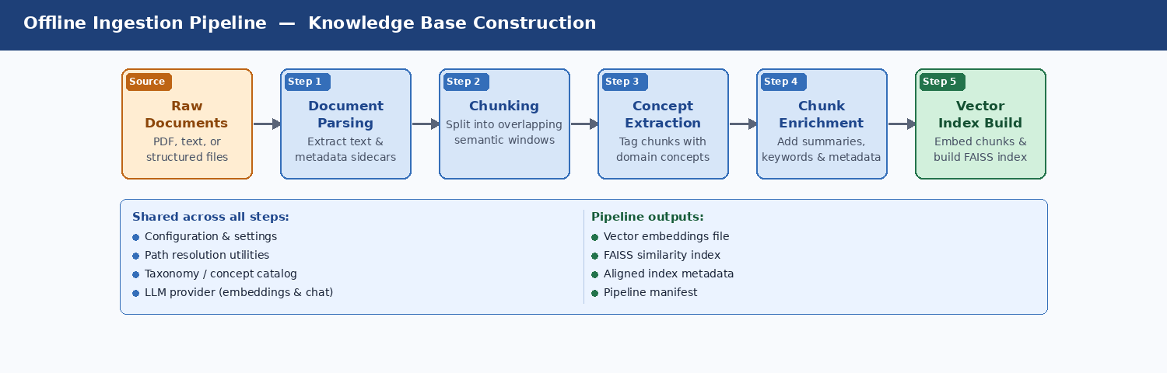
Figure 2 — Offline pipeline: PDF → parse → chunk → concepts → enrich → FAISS vector index

Runtime Path — Scenario to Bias Analysis
The runtime path executes every time a user submits a scenario. It retrieves relevant evidence and calls the language model twice — once without retrieval (baseline) and once with (RAG-enhanced) — enabling direct lift measurement.
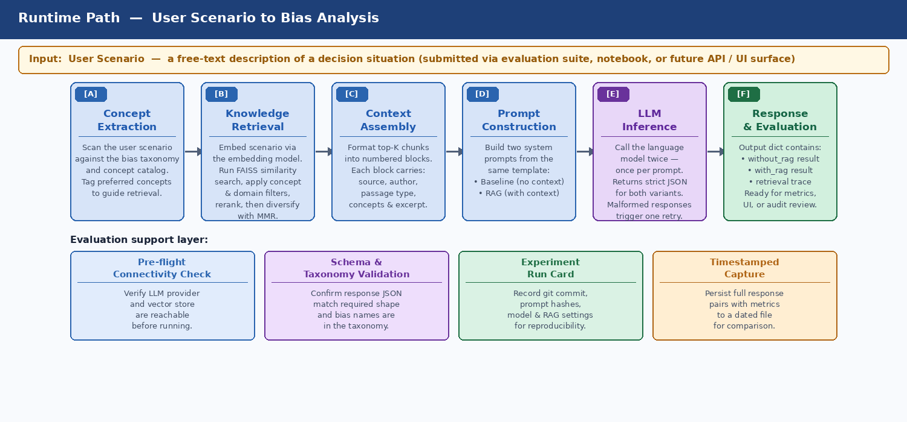
Figure 3 — Runtime path: concept extraction → retrieval → context assembly → dual LLM calls → response dict

Target AWS Deployment Architecture
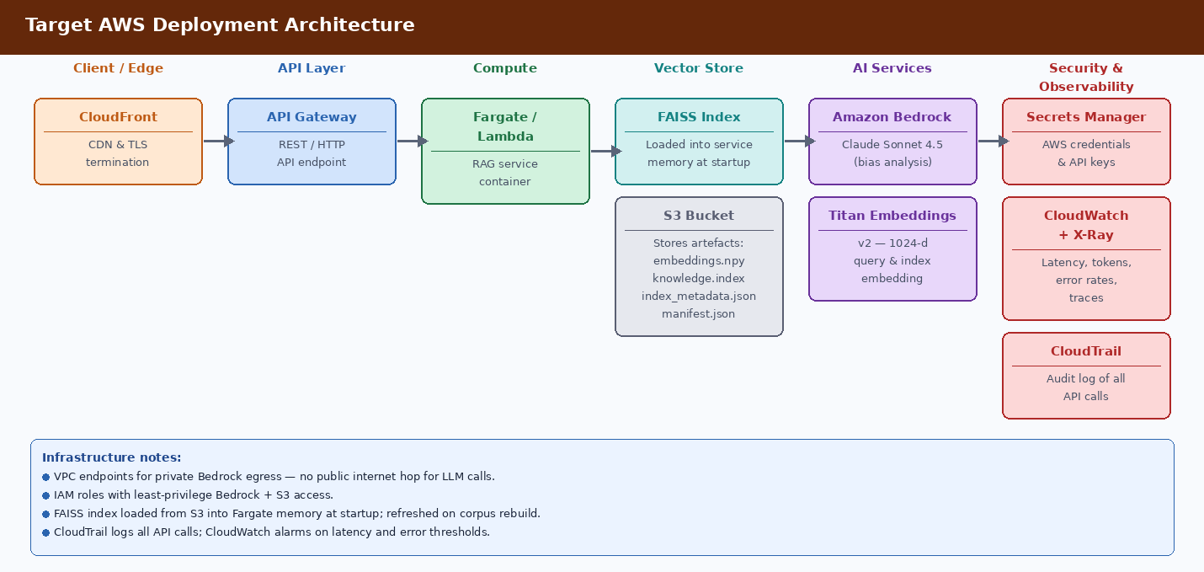
Figure 4 — GCP deployment: Cloud CDN → Apigee → Cloud Run → FAISS (memory) + GCS → Vertex AI → Secret Manager/Cloud Monitoring/Audit Logs

Repository Structure & Module Map
Directory / File | Purpose
app/services/bedrock_provider.py | Thin Bedrock client wrapper. Exposes converse() for Claude Sonnet 4.5 and embed_text() for Titan v2. Validates credentials on construction.
app/services/bias_detector.py | Orchestration brain. Loads taxonomy + prompt, extracts concepts, runs retrieval, formats context, builds dual system prompts, calls Claude twice, parses strict JSON.
rag/retriever.py | Corpus-aware retriever. FAISS search → concept/domain filters → optional Haiku rerank → MMR diversification. Returns RetrievalResult dataclasses.
data_pipeline/pdf_parser.py | Extracts text from PDFs via PyMuPDF, infers author/title/year with regex, writes .txt + .meta.json sidecar per book.
data_pipeline/chunker.py | Profile-aware overlapping windows: dossier (350w/60), book (500w/80), auto. Strips front/back matter; stamps chapter_title on every chunk.
data_pipeline/concept_extractor.py | Builds unified concept catalog from bias-taxonomy.json + retrieval-concepts.json. Tags chunks with concepts + confidence.
data_pipeline/enrich_chunks.py | Final pre-embedding enrichment: summary, importance, decision_domains, keywords, passage_type, decision_phase. Writes knowledge_base.json.
data_pipeline/build_vector_index.py | Calls Bedrock Titan v2 per chunk, stacks float32 matrix, builds FAISS IndexFlatIP, writes embeddings.npy + knowledge.index + index_metadata.json + manifest.json.
shared_components/settings.py | Single source of truth: BEDROCK_SETTINGS and RAG_SETTINGS frozen dataclasses loaded from .env.
shared_components/utilities/path_utils.py | Corpus-aware path resolution for all pipeline directories.
shared_components/utilities/taxonomy_utils.py | Lazy-cached loaders for bias-taxonomy.json and retrieval-concepts.json; build_concept_catalog() merges both.
prompts/bias_detection_system_prompt.txt | Locked output contract: role, taxonomy constraint, JSON schema, quality expectations, worked example. Kept outside code for prompt iteration.
evaluation/metrics.py | Schema and taxonomy validation for without_rag/with_rag payloads plus per-run aggregates.
evaluation/run_card.py | Reproducibility metadata: UTC/local timestamps, git commit, SHA-256 of scenario file + system prompt, all model/RAG settings.
evaluation/connectivity.py | Pre-flight smoke checks: Bedrock credentials → embedding probe → vector load → retrieval check.
scripts/record_response_run.py | Connectivity check → runs baseline_scenarios.json → attaches metrics + run card → writes response/<timestamp>_<label>_rag_eval.json.

Best-Practice Alignment (15-Point Playbook)
This solution is designed against a 15-point playbook synthesised from Google Cloud, Microsoft Azure Architecture Center, Redwerk, and ChatRAG guidance. The table below maps each practice to current implementation status and open gaps.
# | Practice | Current Implementation | Gap / Roadmap
1 | Define use case & success criteria | JSON schema validity, taxonomy compliance, retrieval trace presence, baseline vs RAG pairs, metrics.py flags. | Formal latency/cost SLO dashboards; richer pilot KPIs (groundedness judges, human rubrics).
2 | Prepare knowledge foundation | Curated dossiers under data/corpora/public/raw/; pdf_parser.py extracts text + sidecar metadata. | Source-system inventory for enterprise; automated deduplication, staleness, and event-driven reindex.
3 | Build representative test set early | evaluation/test_scenarios.json (~30 scenarios); baseline_scenarios.json (3 frozen); run_evaluation.py. | Golden reference answers; out-of-corpus decline scenarios; automated retrieval-precision metrics.
4 | Analyse documents before chunking | pdf_parser.py: regex heading cues, parser_notes on inferred fields. chunker.py: front/back-matter stripping. | Optional markdown-normalisation path for complex PDF layouts.
5 | Structure documents for retrieval | Dossiers authored with descriptive titles and tight topical focus. enrich_chunks.py adds summaries, keywords, decision_domains. | —
6 | Choose chunking strategy deliberately | Profile-driven overlapping windows: dossier 350/60, book 500/80, auto. Chapter titles on every chunk. | Automated experiment grid (profiles × frozen eval) to optimise recall vs noise.
7 | Clean & enrich chunks with metadata | 20+ fields per chunk: id, source, author, title, year, chapter_title, profile, concepts, domains, keywords, passage_type, decision_phase, summary. | Enterprise metadata (source system, effective date, geography) and ACL tags.
8 | Select & evaluate embedding model | Titan Text Embeddings v2 at 1024-d with normalize=true. Same model at index and query time. | Benchmark alternate embeddings on held-out queries before switching BEDROCK_EMBEDDING_MODEL_ID.
9 | Design index & retrieval strategy | FAISS IndexFlatIP; concept + domain filters with unfiltered fallback; optional Haiku reranker; MMR. | Hybrid vector + BM25 lexical; query decomposition; metadata security filters once ACL fields exist.
10 | Re-rank & assemble context | Optional LLM reranker; MMR final cut; format_retrieved_context emits numbered blocks with full traceability. | Token-budget-aware assembly modes (excerpt vs full chunk vs expanded section).
11 | Design prompts for grounded answers | bias_detection_system_prompt.txt locks role, taxonomy-only names, uncertainty signal, JSON schema. Temperature 0.1. | Versioned prompt files with automated A/B harness tied to baseline_scenarios.json.
12 | Evaluate retrieval & generation separately | Connectivity checks isolate Bedrock + vector health. metrics.py scores JSON shape + taxonomy. Paired payloads. | Labelled gold chunks; LLM-as-judge; CI regression against frozen baseline_metrics.json.
13 | Controlled experimentation & root cause | run_card.py records all experiment variables; label-based filenames under response/. | —
14 | Human evaluation before rollout | sample_results_comparison.md supports qualitative review. | Structured reviewer rubrics (clarity, trustworthiness, citation usefulness) feeding back into workstreams.
15 | Operations, governance & CI | ml-ops.plan.md: versioned corpora, manifests, drift thinking. Logging stub in bedrock_provider.py. | CloudWatch dashboards; cost tracking; re-evaluation triggers on material changes.

Configuration Reference
Environment Variable | Default | Description
BEDROCK_REGION | us-west-2 | AWS region for Bedrock runtime client.
BEDROCK_MODEL_ID | claude-sonnet-4-5-20250929-v1:0 | Chat model for bias analysis (Claude Sonnet 4.5).
BEDROCK_EMBEDDING_MODEL_ID | amazon.titan-embed-text-v2:0 | Embedding model — must match at index and query time.
BEDROCK_EMBEDDING_DIMENSIONS | 1024 | Vector dimension; must match FAISS index.
CORPUS_NAME | public | 'public' (committed dossiers) or 'private' (full books, local-only).
CHUNK_PROFILE | auto | dossier | book | auto. Auto selects book for docs > 30k words.
RAG_TOP_K | 8 | Final context chunks returned to the generator after MMR.
RAG_MMR_LAMBDA | 0.7 | 1.0 = pure relevance; 0.0 = pure diversity. 0.7 balances both.
RAG_RERANKER | none | 'none' or 'claude_haiku'. Haiku reranker adds latency but may improve precision.
RAG_RERANKER_CANDIDATES | 24 | Candidate pool depth passed to the Haiku reranker.
ENRICHMENT_USE_LLM | false | When true, routes passage_type/decision_phase classification through Claude Haiku.

Common Pitfalls & Mitigations
Pitfall | Mitigation in this Solution | Residual Risk
Indexing low-quality content | Curated dossiers only in public corpus; pdf_parser + chunker hygiene. | Grows if unvetted PDFs enter without review workflow.
Naive / fixed chunking | Profile-driven overlap, chapter awareness, planned experiment grid. | Optimal profile not yet validated by automated grid search.
Single retrieval mode | Acknowledged gap; hybrid lexical + vector is on roadmap (Phase 5). | Exact-match queries may underperform until BM25 is added.
Prompt overload with weak chunks | MMR limits chapter dominance; concept/domain filters; reranker option. | Context assembly modes still tunable by experiment, not locked.
Optimising only end-to-end | Connectivity + schema/taxonomy checks isolate component failures today. | Retrieval-precision metrics (gold chunk labels) not yet automated.
No experiment auditability | run_card.py + timestamped response/ captures + label-based filenames. | No CI gate yet against frozen baseline_metrics.json.

Engineering Roadmap
Phase | Focus | Key Deliverables
Phase 1 — Eval spine | Evaluation infrastructure | evaluation/metrics.py (schema + taxonomy checks), extended scenarios, retrieval/generation metrics to grow over time.
Phase 2 — Content ops | Corpus governance | Source manifest, content hashes, incremental re-embed/reindex, deduplication and staleness handling.
Phase 3 — ACL & metadata | Multi-audience readiness | Audience-aware metadata on chunks when multi-tenant deployments require entitlement filtering at retrieval time.
Phase 4 — Run cards | Reproducibility | evaluation/run_card.py + timestamped response/*_rag_eval.json for reproducible before/after comparisons.
Phase 5 — Retrieval science | Retrieval quality | Hybrid lexical + vector retrieval, query decomposition for multi-part scenarios, configurable context assembly modes.
Phase 6 — Chunking & telemetry | Quality & observability | Chunking grid automation, expanded human evaluation, production latency/token/failure telemetry.
Phase 7 — Prompt versioning | Prompt engineering rigour | Versioned prompt files, optional refusal/insufficient-evidence fields, prompt A/B harness tied to frozen scenarios.

Appendix A — Recommended Delivery Sequence
Based on the best-practices playbook, the recommended implementation order is:
- Define use case, personas, risks, and pilot metrics.
- Curate and govern source content (public dossiers today; private books under strict controls).
- Build and freeze evaluation scenarios early; add gold labels incrementally.
- Analyse document structures; extend parsers as new formats appear.
- Tune chunking with measured retrieval and answer quality — not intuition alone.
- Enrich metadata for filters, citations, and future ACLs.
- Benchmark embeddings when corpus or question style shifts.
- Design retrieval logic (vector today; hybrid and decomposition on roadmap).
- Add reranking and context-assembly experiments.
- Iterate prompts with version control and A/B metrics.
- Automate retrieval/generation/E2E evaluation with regression gates.
- Run human evaluation; deploy in phases; monitor continuously.

Appendix B — Traceability Contract
Every artefact preserves the chain from source PDF to final LLM output:
- Each chunk carries: id, source, file_name, author, title, publication_year, chunk_index, cleaning_notes, parser_notes, chapter_title, chunking_profile, passage_type, decision_phase.
- Each retrieval result carries those fields plus similarity score and matched concepts.
- The bias detector response payload includes corpus plus retrieval array so callers can show which chunks — from which corpus — shaped the answer.
- Run cards record git commit, file hashes, and all model/RAG settings so experiments are fully reproducible.

Appendix C – Alternative Deployment Approaches
This supplement analyses what changes when the Bias-Aware Decision-Making RAG Copilot is deployed on Amazon Web Services (AWS) versus Google Cloud Platform (GCP). The core solution design — chunking strategy, FAISS vector index, dual baseline/RAG execution, evaluation spine, and bias taxonomy — is cloud-agnostic and unchanged. What differs is the managed service layer that hosts, secures, and observes the system.
The two architectures are structurally identical: edge → API gateway → compute → vector store + object storage → LLM/embedding AI service → secrets + observability. Each AWS service maps cleanly to a GCP equivalent, with a small set of meaningful differences in IAM model, cold-start behaviour, LLM access pattern, and compliance posture.

Architecture Diagrams

AWS Architecture (updated — includes FAISS)
The diagram below reflects the corrected AWS architecture with FAISS explicitly shown as a distinct Vector Store layer. The FAISS index is loaded from S3 into the Fargate container's memory at startup, making it available for sub-millisecond similarity search during runtime without any additional network hop.

Figure 1 — AWS deployment: CloudFront → API Gateway → Fargate → FAISS (memory) + S3 → Bedrock → Secrets/CloudWatch/CloudTrail

GCP Architecture
The GCP architecture mirrors the AWS design. Cloud Run replaces Fargate, GCS replaces S3, Vertex AI Model Garden (Claude or Gemini) replaces Bedrock, and Workload Identity replaces IAM roles attached to tasks. FAISS loads identically from GCS into Cloud Run container memory at cold start.
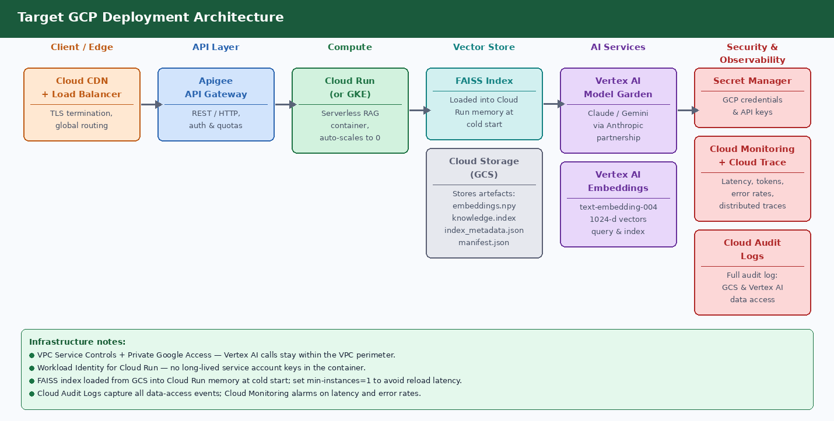
Figure 2 — GCP deployment: Cloud CDN → Apigee → Cloud Run → FAISS (memory) + GCS → Vertex AI → Secret Manager/Cloud Monitoring/Audit Logs

Side-by-Side Component Comparison
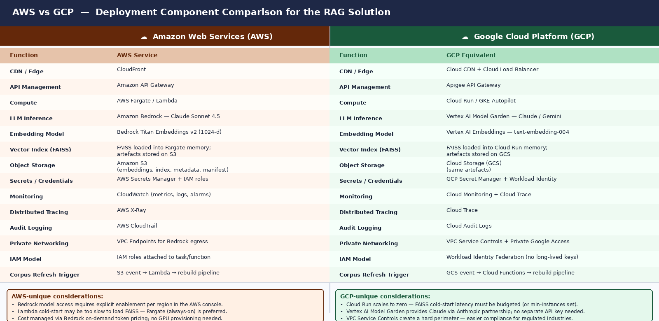
Figure 3 — Full AWS vs GCP component mapping with platform-unique considerations

FAISS in a Cloud Deployment
FAISS is an in-process library, not a managed service. On both AWS and GCP it follows the same pattern:
- The offline pipeline produces embeddings.npy, knowledge.index, index_metadata.json, and manifest.json and uploads them to object storage (S3 or GCS).
- At container startup, the RAG service downloads these artefacts and loads the FAISS index into heap memory. Search latency is then sub-millisecond, with no network hop per query.
- On corpus refresh, the pipeline re-uploads the artefacts and the service restarts (or reloads) to pick up the new index.
- Memory sizing: a 1024-dimension float32 index over ~5,000 chunks is roughly 20 MB — well within Fargate task or Cloud Run container defaults.

Why not a managed vector database?
- FAISS keeps infrastructure simple and cost-free at portfolio scale. A managed service (AWS OpenSearch, GCP Vertex AI Vector Search) would add latency, cost, and operational overhead.
- The tradeoff is that FAISS is in-process: no multi-instance sharing, no real-time index updates. For production scale with concurrent users, a managed vector DB becomes the right choice.
- The codebase is designed so that retriever.py can be swapped to a different backend without changing the orchestration layer (bias_detector.py).

Detailed Component Mapping
Function | AWS Service / Approach | GCP Service / Approach
CDN & TLS termination | Amazon CloudFront | Cloud CDN + Cloud Load Balancer
API management | Amazon API Gateway (REST/HTTP) | Apigee API Gateway (REST/gRPC, auth & quotas)
Compute | AWS Fargate (always-on, no cold start penalty) | Cloud Run (scales to zero; set min-instances=1 to avoid FAISS reload latency)
LLM inference | Amazon Bedrock — Claude Sonnet 4.5 (on-demand token pricing, region-locked model access) | Vertex AI Model Garden — Claude via Anthropic partnership or Gemini; no separate Anthropic API key required
Embedding model | Bedrock Titan Text Embeddings v2 (1024-d, normalize=true) | Vertex AI Embeddings — text-embedding-004 (768-d or 1024-d depending on model version)
Vector index (FAISS) | Loaded into Fargate task memory; artefacts on S3 | Loaded into Cloud Run container memory; artefacts on GCS
Object storage | Amazon S3 (versioned bucket for corpus artefacts) | Cloud Storage (GCS) — same structure, bucket-level versioning
Secrets & credentials | AWS Secrets Manager + IAM roles attached to ECS task definition | GCP Secret Manager + Workload Identity Federation (no long-lived service account keys)
Metrics & alerting | Amazon CloudWatch — metrics, logs, alarms, dashboards | Cloud Monitoring — metrics, uptime checks, alert policies
Distributed tracing | AWS X-Ray — trace IDs propagated through Lambda/Fargate | Cloud Trace — integrated with Cloud Run automatically
Audit logging | AWS CloudTrail — all API calls logged to S3 | Cloud Audit Logs — Data Access logs for GCS + Vertex AI
Private networking | VPC Endpoints for Bedrock, S3, Secrets Manager (no public internet egress) | VPC Service Controls + Private Google Access (hard perimeter for regulated data)
IAM model | IAM roles attached to ECS task or Lambda execution role; least-privilege policies | Workload Identity binds a Kubernetes/Cloud Run service account to a GCP IAM role — no long-lived keys
Corpus refresh trigger | S3 event notification → Lambda → rebuild pipeline | GCS Pub/Sub notification → Cloud Functions → rebuild pipeline
Observability dashboards | CloudWatch dashboards (manual setup); AWS Cost Explorer for token cost | Cloud Monitoring dashboards; GCP Billing with label-based cost allocation

Key Differences and Decision Factors

1. LLM Access Pattern
On AWS, Claude Sonnet 4.5 is accessed through Amazon Bedrock, which requires the model to be explicitly enabled in the target region via the AWS console. Bedrock uses on-demand token pricing with no GPU provisioning. On GCP, Claude is available through Vertex AI Model Garden under the Anthropic partnership — no separate Anthropic API key is needed, and billing flows through the GCP account. GCP also offers Gemini as a native alternative if model substitution is ever required.

2. Embedding Model Alignment
Critical: the same embedding model must be used at index build time and query time. On AWS, Titan Embeddings v2 at 1024 dimensions is the baseline. On GCP, Vertex AI text-embedding-004 is the closest equivalent but may output a different default dimension. If migrating from AWS to GCP, the entire corpus must be re-embedded and the FAISS index rebuilt before the system is functional.

3. FAISS Cold-Start Latency
AWS Fargate runs always-on containers with no cold-start penalty. GCP Cloud Run scales to zero by default, meaning the first request after idle triggers a container startup that must download and load the FAISS index from GCS. For a 20 MB index this is typically 2–5 seconds. Setting min-instances=1 in the Cloud Run configuration eliminates this but removes the cost-saving zero-scale behaviour.

4. IAM and Credential Model
AWS uses IAM roles attached to the ECS task definition — credentials are injected via instance metadata and rotated automatically. GCP Workload Identity Federation achieves the same result differently: it binds the Cloud Run service identity to a GCP IAM role without any long-lived service account key file. Both approaches are secure; GCP's model eliminates the risk of a key file being accidentally committed or leaked.

5. Compliance and Network Perimeter
AWS VPC Endpoints keep Bedrock and S3 traffic within the AWS network. GCP VPC Service Controls go further, creating a hard logical perimeter around a set of GCP services — any API call from outside the perimeter is denied even if the caller has valid credentials. This makes GCP the stronger default choice for regulated industries (healthcare, finance, government) where data residency and access control must be demonstrated to auditors.

6. Cost Model
Both platforms price LLM inference on a per-token basis. AWS Bedrock and GCP Vertex AI are broadly comparable for Claude Sonnet 4.5 at portfolio scale. The main cost variable at scale is embedding: re-embedding a large corpus on a different provider is a one-time batch cost but must be budgeted when switching clouds.

Migration Considerations (AWS → GCP or vice versa)
Steps required when switching cloud providers
- Re-embed the full corpus using the target platform's embedding model (Titan → Vertex AI or vice versa), as vector spaces are not interchangeable.
- Rebuild the FAISS index (build_vector_index.py --corpus <name>) against the new embeddings.
- Update BEDROCK_EMBEDDING_MODEL_ID and BEDROCK_MODEL_ID in settings.py (or introduce a provider abstraction layer).
- Update bedrock_provider.py to call the Vertex AI SDK instead of boto3 (or abstract behind an interface).
- Migrate secrets from AWS Secrets Manager to GCP Secret Manager; update IAM policies.
- Reconfigure the corpus refresh trigger (S3 event → Lambda becomes GCS Pub/Sub → Cloud Functions).
- Re-run the full evaluation suite (run_evaluation.py) to confirm output quality is preserved after the model switch.

Recommendation
For this portfolio project, AWS remains the primary deployment target because the solution is already built against the Bedrock API (boto3 client, Titan embeddings, Claude Sonnet 4.5). The cost to migrate to GCP is dominated by re-embedding the corpus and updating the provider layer — non-trivial but achievable in a few days.
GCP becomes the preferred choice in two scenarios:
- The deployment must satisfy strict data residency or regulated-industry compliance requirements (VPC Service Controls provide a stronger perimeter than AWS VPC Endpoints).
- The organisation is already standardised on GCP and Google Workspace — Vertex AI Model Garden provides Claude without a separate Anthropic billing relationship, and Workload Identity simplifies the credential model.

In both cases, the solution's architecture remains sound. Only the managed service names and SDK calls change — the chunking, FAISS index, evaluation spine, bias taxonomy, and prompt contract are fully portable.

Disclaimer: This system provides research-informed decision support only. It does not replace professional judgment or organisational policy.

