Jaguar Re-Identification Challenge
Help identify the jaguars in Brazil's Pantanal Park.
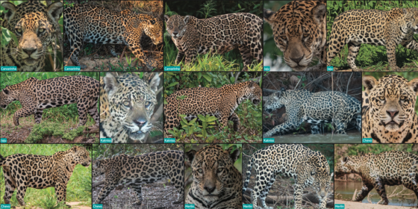

Jaguar Re-Identification Challenge
Submit Prediction

Overview
Jaguars are the apex predators of the Americas, but tracking their populations across vast landscapes like the Pantanal is a monumental task. Researchers have relied on manual identification by comparing unique spot patterns, which act like a biological fingerprint, to distinguish individuals. With the rise of eco-tourism and citizen science, thousands of photographs are captured each year. However, the volume of data makes manual identification a bottleneck for conservation efforts. The Jaguar Identification Project aims to automate this process. The goal of this competition is to develop a computer vision model capable of identifying individual jaguars (such as "Medrosa," "Patricia," or "Ousado") from wildlife photographs. By contributing your expertise, you help advance wildlife demographics research and support the survival of this near-threatened species.

The Challenge
Identifying individuals in the wild is harder than standard image classification. Challenges include:
- Intra-class Variation: The same jaguar can look different depending on lighting, angle, and posture.
- Inter-class Similarity: Different jaguars can have similar spot patterns.
- Data Imbalance: Some jaguars have dozens of high-quality photos, while others have only a few.
- Spurious Correlations: Models can "cheat" by learning the background or the riverbank where a jaguar is seen, rather than the animal's unique patterns.

Evaluation
Identity-balanced Mean Average Precision (mAP) Identity-balanced mean Average Precision (class-balanced mAP) is a retrieval metric in which mean Average Precision is computed per identity/class and then averaged to compensate for class imbalance, instead of allowing frequent identities to dominate the score. It is used in person and object re-identification because the number of images per identity is uneven, and raw mAP can be biased toward identities with many examples.

Dataset Description
The dataset consists of thousands of images curated from the Jaguar Field Guide 2025 and the Pantanal Jaguar ID Project.
- Train Set: Images labeled by individual ID.
- Test Set: A hidden set of images for which participants must predict the correct jaguar ID. Note that these images include the original background information on their RGB channels. The alpha mask to separate the jaguar from its background is present, but you are not obliged to use it.

Suggested Baseline
Participants are encouraged to explore foundation models and self-supervised learning approaches. A starting point includes:
- Backbone: MegaDescriptor-Large for dense image embeddings.
- Fine-tuning: Implementing ArcFace Loss to cluster images of the same jaguar in the embedding space.

* Handling Imbalance: Using Focal Loss or weighted cross-entropy to address the long-tail distribution of the data.
Join KINETO.AI and the Pantanal Jaguar ID Project in this effort to turn citizen science photos into actionable conservation data.
Start
2 months ago

Close
2 days to go

Description
Each jaguar possesses a distinct rosette pattern that functions as a natural fingerprint. These patterns remain consistent throughout the animal's life and are distinguishable across different body regions, particularly along the flanks. While human experts can identify jaguars by comparing their spot patterns, the process is time-intensive and requires specialized training. Machine learning offers a scalable solution to automate this identification task, enabling conservationists to process large image datasets efficiently.

The Task

Participants must develop models that predict similarity scores between all pairs of test images. The task follows a closed-set, all-vs-all re-identification approach: given 371 test images containing 31 unique jaguars.

Understanding Jaguar Spot Patterns
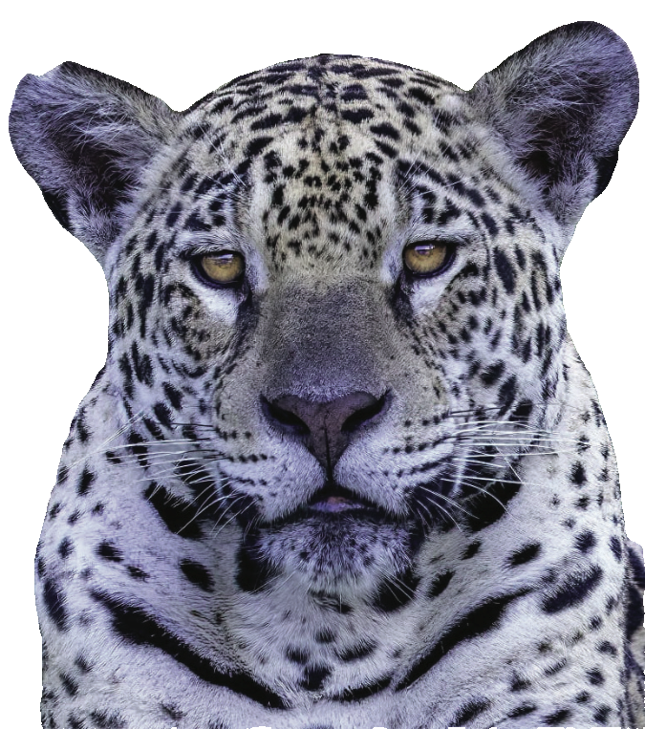 Marcela photographed from the front.
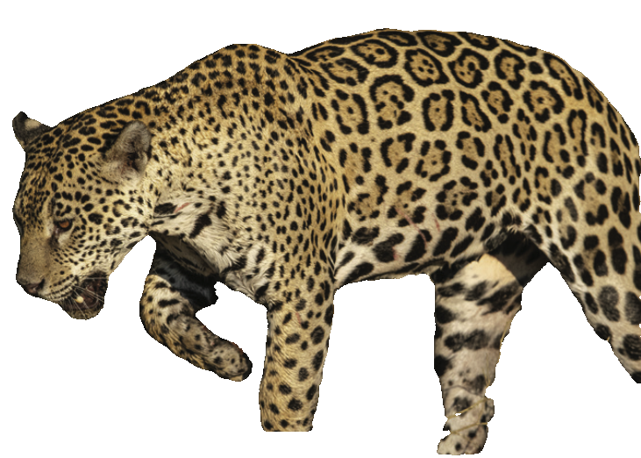 Marcela's left flank
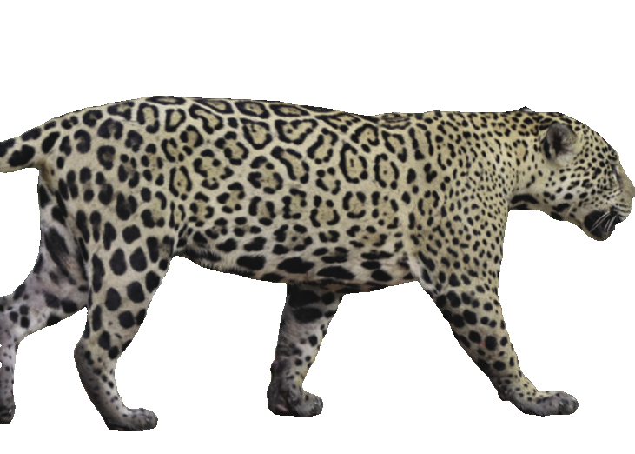 Marcela's right flank.
These three images of Marcela demonstrate how jaguar spot patterns remain distinctive across multiple viewpoints. The flank regions contain the most informative rosette patterns for identification, though the patterned region in a jaguar's forehead and its overall body shape are highly informative. Your model must learn to recognize these patterns despite variations in pose, lighting, and image quality.

Dataset Characteristics
The test set contains 371 images representing 31 individual jaguars. The dataset exhibits significant class imbalance, which reflects real-world monitoring scenarios where some jaguars are photographed more frequently than others.
This imbalance presents a substantial challenge. Models that perform well on common identities but fail on rare ones will not achieve strong scores under the evaluation metric used in this competition.
Image preprocessing All images have been processed using the SAM3 (Segment Anything Model 3) semantic segmentation model with the prompt "jaguar" to remove backgrounds. This preprocessing focuses attention on the jaguar itself while introducing variability in segmentation quality across images.
Image quality variability The images come from citizen scientists, which introduces natural variations:
- Lighting conditions (daylight, dusk)
- Image quality and resolution
- Distance from the camera to the subject
- Viewing angles (frontal, lateral, rear views)
- Partial occlusion by vegetation and the segmentation artifacts produced while removing it
Training set considerations The training set contains near-duplicate images where the same jaguar was captured multiple times in quick succession by the same photographer. These near-duplicates can help models learn robust features but may also lead to overfitting if not handled carefully. Note that near-duplicates between the training and test sets have been removed to ensure fair evaluation.

Evaluation Metric
This competition uses Identity-Balanced Mean Average Precision (mAP), a macro-averaged metric that ensures each jaguar contributes equally to the final score regardless of how many images they have in the test set.

Why identity-balanced evaluation matters
Standard mAP would be dominated by frequently photographed individuals. An identity with 36 images generates 36 query results, while an identity with only 3 images generates just 3 query results. Without balancing, the model could achieve a high score by focusing on common identities while ignoring rare ones.
Identity-balanced mAP addresses this by:
- Computing the average precision for each query image
- Averaging the precision scores for all queries of the same identity
- Computing the final mAP as the mean across all identities (macro-average)
This approach aligns with conservation priorities: every individual jaguar has equal importance, regardless of how often it appears in camera trap footage.

Mathematical formulation
For each query image $q$, the Average Precision $AP(q)$ is:
- Where $P_q$ is the set of relevant (matching) images for query $q$
- The term $P(k)$ is the precision at rank $k$
- Finally, $rel(k)$ is an indicator that equals 1 if the image at rank $k$ matches the query identity, else 0
The identity-balanced mAP is then:
where:
- $I$ is the set of all identities
- $Q_i$ is the set of queries for identity $i$

Recommended Approaches
Successful solutions to re-identification problems typically involve:
- Feature extraction Use pre-trained vision models (e.g. MegaDescriptor, DINOv3, ResNet, EfficientNet, Vision Transformers) or models designed for fine-grained recognition.
- Metric learning Fine-tune embeddings using losses like ArcFace, CosFace, or Triplet Loss to optimize similarity-based matching.
- Data augmentation Apply geometric and photometric augmentations to handle pose and lighting variations.
- Handling class imbalance Use sampling strategies or loss functions that prevent the model from ignoring rare identities.

Suggested Reading
- Jaguar ID Project https://www.jaguaridproject.com/ Background on the conservation context and field data collection workflow, illustrating how automated ID supports long-term population monitoring.
- MegaDescriptor: A Universal Approach to Animal Re-Identification https://arxiv.org/abs/2311.09118 A general framework for wildlife re-identification that performs strongly across multiple species, emphasizing metric learning under few-shot and imbalanced conditions.
- HotSpotter: Computer Vision for Conservation https://arxiv.org/html/2508.17605v1 A practical system and methodology for identifying individual animals from spot patterns, including algorithmic choices and deployment considerations.

Competition Structure
Leaderboard split The test set is divided into public (50.9%) and private (49.1%) portions, stratified by identity to maintain proportional representation. Your final ranking will be determined by performance on the private leaderboard, which is revealed after the competition closes.
Submission limits You may submit up to 5 predictions per day. This limit encourages thoughtful iteration rather than excessive tuning to the public leaderboard.

Conservation Impact
Developing accurate, automated identification systems has direct conservation applications. By reducing the time required to process camera trap images, your solutions enable researchers to:
- Monitor population sizes and trends across large areas
- Track individual movement patterns and territory use
- Identify genetic connectivity between populations
- Detect population declines or range contractions earlier
The methods developed in this competition can transfer to other spotted cat species (leopards, cheetahs, ocelots) and contribute to global wildlife monitoring efforts.

Evaluation

Evaluation

Submission Format Specification
Your submission must predict similarity scores for all query-gallery image pairs in the test set.
File Format:
- Format: CSV with comma delimiter
- Encoding: UTF-8
- Columns: 2 (row_id, similarity)
- Rows: 137,270 (excluding header)
CSV Structure:
row_id,similarity
0,0.8745
1,0.2341
2,0.6789
...
137269,0.4521

Column Specifications
Column 1: row_id
- Type: Integer
- Range: 0 to 137,269
- Purpose: Identifies the query-gallery pair from test.csv
- Requirement: Must match the row_id values in test.csv in exact order
Column 2: similarity
- Type: Float
- Range: [0.0, 1.0] inclusive
- Meaning: Predicted similarity score between query and gallery image
  - 1.0 = Maximum confidence that images show the same jaguar
  - 0.0 = Maximum confidence that images show different jaguars
  - 0.5 = Uncertain

Understanding the Test Set Structure
The test.csv file contains 137,270 query-gallery pairs:
row_id,query_image,gallery_image
0,test_0001.png,test_0002.png
1,test_0001.png,test_0003.png
2,test_0001.png,test_0004.png
...
137269,test_0371.png,test_0370.png
Key Facts:
- Total test images: 371 (test_0001.png through test_0371.png)
- Total pairs: 137,270 (371 × 370, all pairs except self-comparisons)
- Each image appears as both query and gallery
- No image is compared to itself
Your submission must provide one similarity score for each of these 137,270 pairs.

How to Create a Valid Submission

Method 1: Modify Sample Submission (Recommended)
The simplest approach is to load the sample submission template and fill in your predictions:
import pandas as pd
import numpy as np

# Load the template
submission = pd.read_csv('sample_submission.csv')

# Load test pairs
test_df = pd.read_csv('test.csv')

# Generate your similarity scores
# Replace this with your actual model predictions
similarities = []
for idx, row in test_df.iterrows():
query_img = row['query_image']
gallery_img = row['gallery_image']

# Your model computes similarity here
score = your_model.predict_similarity(query_img, gallery_img)
similarities.append(score)

# Update submission
submission['similarity'] = similarities

# Validate
assert len(submission) == 137270, f"Wrong number of rows: {len(submission)}"
assert (submission['similarity'] >= 0).all(), "Found values < 0"
assert (submission['similarity'] <= 1).all(), "Found values > 1"

# Save
submission.to_csv('my_submission.csv', index=False)
print(f"Submission saved: {len(submission)} predictions")

Method 2: From Similarity Matrix
If your model computes a full similarity matrix between all test images:
import pandas as pd
import numpy as np
from sklearn.metrics.pairwise import cosine_similarity

# Load test data
test_df = pd.read_csv('test.csv')

# Get unique image filenames
unique_images = sorted(set(test_df['query_image']) | set(test_df['gallery_image']))
n_images = len(unique_images) # Should be 371

# Extract embeddings for all images
embeddings = []
for img_file in unique_images:
img = load_image(f'test/{img_file}')
embedding = your_model.extract_features(img)
embeddings.append(embedding)

embeddings = np.array(embeddings)

# Compute similarity matrix (371 × 371)
similarity_matrix = cosine_similarity(embeddings)

# Ensure values are in [0, 1]
similarity_matrix = np.clip(similarity_matrix, 0, 1)

# Create filename to index mapping
img_to_idx = {img: idx for idx, img in enumerate(unique_images)}

# Extract similarities for each test pair
similarities = []
for _, row in test_df.iterrows():
query_idx = img_to_idx[row['query_image']]
gallery_idx = img_to_idx[row['gallery_image']]
sim = similarity_matrix[query_idx, gallery_idx]
similarities.append(sim)

# Create submission
submission = pd.DataFrame({
'row_id': test_df['row_id'],
'similarity': similarities
})

submission.to_csv('my_submission.csv', index=False)

Method 3: Batch Processing with PyTorch
For efficient processing with deep learning models:
import pandas as pd
import torch
import numpy as np
from torch.utils.data import DataLoader

# Load test pairs
test_df = pd.read_csv('test.csv')

# Create dataset for pair-wise predictions
class PairDataset(torch.utils.data.Dataset):
def __init__(self, test_df, transform=None):
self.test_df = test_df
self.transform = transform

def __len__(self):
return len(self.test_df)

def __getitem__(self, idx):
row = self.test_df.iloc[idx]
query_img = load_image(f"test/{row['query_image']}")
gallery_img = load_image(f"test/{row['gallery_image']}")

if self.transform:
query_img = self.transform(query_img)
gallery_img = self.transform(gallery_img)

return query_img, gallery_img

# Create dataloader
dataset = PairDataset(test_df, transform=your_transform)
dataloader = DataLoader(dataset, batch_size=32, shuffle=False)

# Generate predictions
model.eval()
similarities = []

with torch.no_grad():
for query_batch, gallery_batch in dataloader:
query_batch = query_batch.to(device)
gallery_batch = gallery_batch.to(device)

# Extract features
query_features = model(query_batch)
gallery_features = model(gallery_batch)

# Compute similarity (cosine similarity)
sim = torch.nn.functional.cosine_similarity(
query_features, gallery_features
)

# Map from [-1, 1] to [0, 1]
sim = (sim + 1) / 2

similarities.extend(sim.cpu().numpy())

# Create submission
submission = pd.DataFrame({
'row_id': test_df['row_id'],
'similarity': similarities
})

submission.to_csv('my_submission.csv', index=False)

Validation Checklist
Before submitting to Kaggle, verify:
- File format: CSV with comma delimiter
- Encoding: UTF-8
- Dimensions: 137,270 rows (excluding header), 2 columns
- Header row: Contains exactly row_id,similarity
- row_id column:
  - Integer values from 0 to 137,269
  - In sequential order
  - Matches test.csv row_id values
- similarity column:
  - All numeric (float)
  - All values in range [0.0, 1.0]
  - No missing values (NaN)
  - No infinite values
- File size: Approximately 3-4 MB

Python Validation Script
Use this script to validate your submission before uploading:
import pandas as pd
import numpy as np

def validate_submission(submission_path, test_path='test.csv'):
"""
Validates submission file format and content.

Args:
submission_path: Path to your submission CSV
test_path: Path to test.csv for verification
"""
# Load files
submission = pd.read_csv(submission_path)
test_df = pd.read_csv(test_path)

# Check dimensions
assert submission.shape == (137270, 2), \
f"Wrong shape: {submission.shape}, expected (137270, 2)"
print("Dimensions correct: 137,270 rows × 2 columns")

# Check column names
assert list(submission.columns) == ['row_id', 'similarity'], \
f"Wrong columns: {list(submission.columns)}, expected ['row_id', 'similarity']"
print(" Column names correct")

# Check row_id values
expected_ids = list(range(137270))
assert submission['row_id'].tolist() == expected_ids, \
"row_id values do not match expected sequence 0 to 137269"
print(" row_id values correct")

# Check row_id matches test.csv
assert (submission['row_id'] == test_df['row_id']).all(), \
"row_id does not match test.csv"
print(" row_id matches test.csv")

# Check similarity values
similarities = submission['similarity'].values

assert np.isfinite(similarities).all(), \
"Contains NaN or infinite values"
print(" No NaN or infinite values")

assert (similarities >= 0).all(), \
f"Contains values < 0 (min: {similarities.min()})"
print(" All values >= 0")

assert (similarities <= 1).all(), \
f"Contains values > 1 (max: {similarities.max()})"
print(" All values <= 1")

# Summary statistics
print("\n" + "="*50)
print("VALIDATION PASSED")
print("="*50)
print(f"File: {submission_path}")
print(f"Rows: {len(submission):,}")
print(f"Similarity range: [{similarities.min():.6f}, {similarities.max():.6f}]")
print(f"Similarity mean: {similarities.mean():.6f}")
print(f"Similarity std: {similarities.std():.6f}")

return True

# Run validation
validate_submission('my_submission.csv')

Common Errors and Solutions

Error 1: Wrong Number of Rows
Error: "Expected 137,270 rows, got [different number]"
Cause: Missing predictions for some pairs or duplicate entries
Solution:
test_df = pd.read_csv('test.csv')
submission = pd.read_csv('sample_submission.csv')

# Ensure submission has same length as test set
assert len(submission) == len(test_df) == 137270

# Check for duplicates
assert not submission['row_id'].duplicated().any()

Error 2: Missing or Wrong Column Names
Error: "Missing required columns"
Cause: Columns not named exactly row_id and similarity
Solution:
# Ensure correct column names (case-sensitive)
submission.columns = ['row_id', 'similarity']

# Or rename if needed
submission.rename(columns={
'id': 'row_id',
'score': 'similarity'
}, inplace=True)

Error 3: Values Outside Valid Range
Error: "Similarity scores must be in [0, 1]"
Cause: Model outputs not normalized to [0, 1] range
Solution:
# Method 1: Min-max normalization
scores = submission['similarity'].values
scores = (scores - scores.min()) / (scores.max() - scores.min())
submission['similarity'] = scores

# Method 2: Clip to valid range
submission['similarity'] = np.clip(submission['similarity'], 0, 1)

# Method 3: Sigmoid transformation (for unbounded scores)
submission['similarity'] = 1 / (1 + np.exp(-submission['similarity']))

Error 4: NaN or Infinite Values
Error: "Submission contains NaN or infinite values"
Cause: Failed similarity computations or numerical instability
Solution:
# Check for problems
print(f"NaN count: {submission['similarity'].isna().sum()}")
print(f"Inf count: {np.isinf(submission['similarity']).sum()}")

# Replace NaN with neutral score
submission['similarity'].fillna(0.5, inplace=True)

# Replace infinite values
submission['similarity'].replace([np.inf, -np.inf], 0.5, inplace=True)

# Verify
assert submission['similarity'].notna().all()
assert np.isfinite(submission['similarity']).all()

Error 5: Wrong row_id Order
Error: "row_id values not in correct order"
Cause: Submission rows were shuffled or sorted incorrectly
Solution:
# Reload test.csv to get correct order
test_df = pd.read_csv('test.csv')

# Merge to ensure correct order
submission = test_df[['row_id']].merge(
submission[['row_id', 'similarity']],
on='row_id',
how='left'
)

# Verify no missing predictions
assert submission['similarity'].notna().all()

Error 6: File Encoding Issues
Error: "Unable to parse CSV file"
Cause: Wrong file encoding or line endings
Solution:
# Save with explicit UTF-8 encoding
submission.to_csv(
'my_submission.csv',
index=False,
encoding='utf-8',
lineterminator='\n'
)

# Or if you need to fix an existing file
submission = pd.read_csv('my_submission.csv', encoding='utf-8')
submission.to_csv('my_submission_fixed.csv', index=False, encoding='utf-8')

Understanding the Metric

Identity-Balanced Mean Average Precision (mAP)
This competition uses identity-balanced mAP, a variant of mean Average Precision designed for re-identification tasks with class imbalance.
How it works:
- For each query image:
  - Rank all gallery images by predicted similarity (highest to lowest)
  - Identify which gallery images show the same jaguar (ground truth matches)
- Calculate Average Precision (AP) per query:
  - AP measures how well the ranking places true matches at the top
  - Perfect ranking (all matches before all non-matches) = AP of 1.0
  - Random ranking = AP around 0.1-0.3 (depends on match ratio)
- Group by identity:
  - Collect all AP scores for queries of the same jaguar
  - Calculate mean AP per jaguar identity
- Macro-average across identities:
  - Average the per-identity mAP scores
  - Each jaguar contributes equal weight regardless of image count
Why identity-balanced?
Standard mAP gives higher weight to identities with more images. In this dataset:
- Some jaguars have 30+ images
- Other jaguars have only 3-5 images
With identity balancing:
- A rare jaguar with 3 images contributes the same weight as a common jaguar with 30 images
- This reflects the conservation goal: every individual jaguar matters
- Prevents models from optimizing only for frequently photographed individuals
Mathematical formulation:
For a single query q with ground truth matches G_q and ranking r:
AP(q) = (1/|G_q|) × Σ [Precision(k) × rel(k)]
where:
- k ranges over all gallery positions
- Precision(k) = (number of matches in top k) / k
- rel(k) = 1 if item at position k is a match, 0 otherwise
Identity-balanced mAP:
mAP = (1/N) × Σ [mean AP for identity i]
where N is the number of unique jaguar identities in the test set.
Performance interpretation:
- 0.00 - 0.10: Below random performance (check for bugs)
- 0.10 - 0.30: Random baseline range
- 0.30 - 0.50: Basic feature extraction (e.g., pretrained ResNet)
- 0.50 - 0.70: Decent re-identification model
- 0.70 - 0.85: Strong model with metric learning
- 0.85 - 0.95: Excellent model with fine-tuning and augmentation
- 0.95 - 1.00: Near-perfect performance
Tips for optimization:
- Focus on hard cases: similar-looking individuals, difficult poses
- Balance performance across rare and common identities
- Use techniques like ArcFace or CosFace to separate identities in embedding space
- Apply test-time augmentation for robust predictions

Example Workflow

Step 1: Set Up Environment
import pandas as pd
import numpy as np
from pathlib import Path

# Define paths
DATA_DIR = Path('.')
TRAIN_DIR = DATA_DIR / 'train'
TEST_DIR = DATA_DIR / 'test'

# Load data files
train_df = pd.read_csv(DATA_DIR / 'train.csv')
test_df = pd.read_csv(DATA_DIR / 'test.csv')
sample_submission = pd.read_csv(DATA_DIR / 'sample_submission.csv')

print(f"Training images: {len(train_df)}")
print(f"Test pairs: {len(test_df)}")
print(f"Unique test images: {len(set(test_df['query_image']))}")

Step 2: Explore Test Set Structure
# Understand test set structure
print("\nTest set structure:")
print(test_df.head(10))

# Count pairs per query image
query_counts = test_df['query_image'].value_counts()
print(f"\nPairs per query image: {query_counts.iloc[0]}")

# Verify total pairs
n_images = len(set(test_df['query_image']))
expected_pairs = n_images * (n_images - 1)
print(f"Total images: {n_images}")
print(f"Expected pairs: {expected_pairs:,}")
print(f"Actual pairs: {len(test_df):,}")

Step 3: Train Your Model
# Example: Train a metric learning model
from your_model import JaguarReIDModel

model = JaguarReIDModel(
backbone='resnet50',
embedding_dim=512,
loss='arcface'
)

model.fit(
train_images=train_df,
train_dir=TRAIN_DIR,
epochs=50,
batch_size=32
)

model.save('jaguar_reid_model.pth')

Step 4: Generate Predictions
# Load model
model = JaguarReIDModel.load('jaguar_reid_model.pth')

# Get unique test images
unique_images = sorted(set(test_df['query_image']) | set(test_df['gallery_image']))

# Extract embeddings for all test images
print("Extracting embeddings...")
embeddings = {}
for img_file in unique_images:
img_path = TEST_DIR / img_file
embedding = model.extract_embedding(img_path)
embeddings[img_file] = embedding

# Compute similarities for all test pairs
print("Computing similarities...")
similarities = []
for _, row in test_df.iterrows():
query_emb = embeddings[row['query_image']]
gallery_emb = embeddings[row['gallery_image']]

# Cosine similarity
sim = np.dot(query_emb, gallery_emb) / (
np.linalg.norm(query_emb) * np.linalg.norm(gallery_emb)
)

# Map from [-1, 1] to [0, 1]
sim = (sim + 1) / 2

similarities.append(sim)

print(f"Generated {len(similarities)} predictions")

Step 5: Create Submission
# Create submission dataframe
submission = pd.DataFrame({
'row_id': test_df['row_id'],
'similarity': similarities
})

# Validate
assert len(submission) == 137270
assert submission['row_id'].tolist() == list(range(137270))
assert (submission['similarity'] >= 0).all()
assert (submission['similarity'] <= 1).all()

print("\nSubmission statistics:")
print(submission['similarity'].describe())

Step 6: Validate and Save
# Run validation
validate_submission('my_submission.csv')

# Save submission
submission.to_csv('my_submission.csv', index=False)
print("\nSubmission saved: my_submission.csv")
print(f"File size: {Path('my_submission.csv').stat().st_size / 1024 / 1024:.2f} MB")
content_copy

Step 7: Submit to Kaggle
Upload my_submission.csv to the competition submission page. The evaluation system will compute your identity-balanced mAP score on the private test set.
Good luck!

