SOLUTION DESIGN DOCUMENT
Bias-Aware Decision-Making RAG Copilot

Decision Intelligence | Applied AI for Societal Impact

Author | Rommel Sharma
Version | 1.1
Issue Date | 13 May 2026
Classification | Portfolio / Public

Disclaimer: This system provides research-informed decision support only. It does not replace professional judgment or organisational policy.

Document Control
Version | Date | Description
v0.1 | — | Initial scaffolding
v1.0 | 08 May 2026 | Baseline portfolio design
v1.1 | 13 May 2026 | Playbook-aligned sequence; adds eval spine, metrics, connectivity, baseline scenario capture, run cards, and explicit gap/roadmap call-outs

Executive Summary
The Bias-Aware Decision-Making RAG Copilot is decision-support software that analyses free-text scenarios for cognitive and systemic biases. It is not legal, medical, HR-policy, or financial advice.
Core Components
- Curated decision-science corpus of synthesised dossiers authored for retrieval quality.
- Amazon Bedrock (Titan Text Embeddings v2 + Claude Sonnet 4.5) with FAISS vector retrieval.
- Optional MMR diversification and Claude Haiku reranking, plus concept / decision-domain filters.
- Closed bias taxonomy embedded in a strict JSON output contract.
- Dual execution: every scenario runs baseline (no retrieval) and RAG-enhanced — so lift is measurable, not assumed.

Engineering Highlights (v1.1)
- Reproducible evaluation spine: pre-flight Bedrock + vector-store connectivity checks.
- Per-response schema/taxonomy metrics and aggregate rollups via evaluation/metrics.py.
- Run cards capture git commit, prompt/scenario hashes, model and RAG settings for traceability.
- Timestamped captures under response/ (via scripts/record_response_run.py) anchor before/after comparisons.
- Three frozen baseline scenarios in evaluation/baseline_scenarios.json for longitudinal comparison.

What is RAG? (Retrieval-Augmented Generation)
RAG is an AI architecture that grounds language model responses in retrieved evidence from a curated knowledge base, rather than relying solely on patterns learned during pre-training. The diagram below illustrates the three-stage concept.

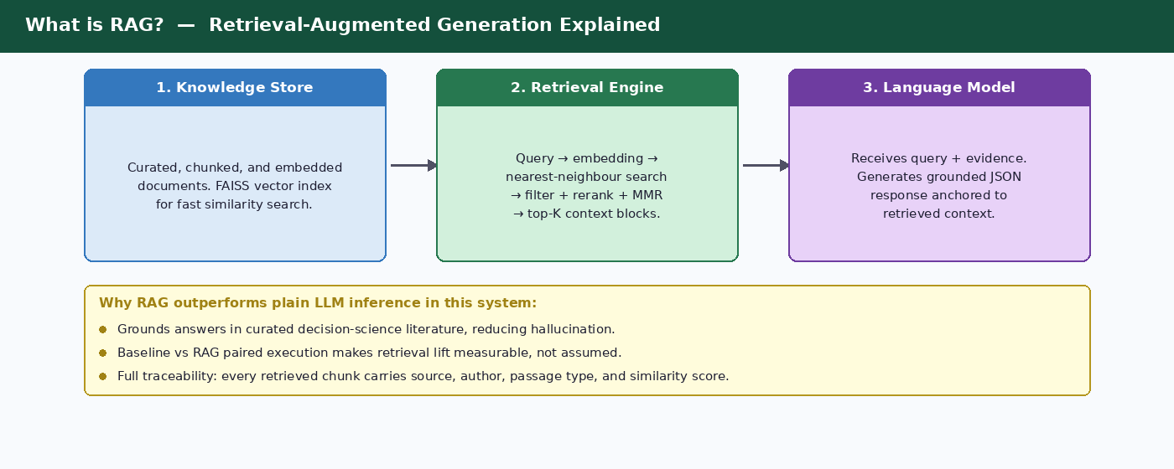
Figure 1 — RAG concept: Knowledge Store → Retrieval Engine → Language Model

Key RAG Benefits in this Solution
- Grounds answers in peer-reviewed decision-science literature, reducing hallucination risk.
- Makes retrieval lift explicit: every scenario runs with and without retrieval so quality gains are measured.
- Full traceability: each retrieved chunk carries source, author, passage type, decision phase, and similarity score.
- Configurable retrieval stack: top-K, MMR lambda, concept/domain filters, and optional Haiku reranker via environment settings.

Information Retrieval Techniques
Basic vector similarity search is effective for simple queries but has two well-documented failure modes in production RAG systems: result redundancy (top-K chunks from the same source repeating the same argument) and retrieval mismatch (semantic search missing exact-term queries; keyword search missing paraphrased intent). The retrieval stack in this solution addresses both through four complementary techniques — each grounded in published research and implemented in rag/retriever.py.

1. Maximal Marginal Relevance (MMR)
Origin and scholarly basis: MMR was introduced by Carbonell and Goldstein (1998) in their SIGIR paper “The Use of MMR, Diversity-Based Reranking for Reordering Documents and Producing Summaries” (Carnegie Mellon University / ACL Anthology). The algorithm has accumulated over 1,000 citations and has seen renewed significance since 2023 as the default diversity mechanism in RAG vector stores including FAISS, Elasticsearch, OpenSearch, and Azure AI Search.

How MMR Works
MMR selects documents iteratively. At each step it scores every candidate document by a weighted combination of two signals: its cosine similarity to the query, and the maximum cosine similarity it shares with any document already selected. The formula is:
MMR = argmax [ λ × Sim₁(dᵢ, query) − (1 − λ) × max Sim₂(dᵢ, dⱼ) ]
where λ ∈ [0, 1] is the diversity-relevance trade-off parameter. When λ = 1 MMR reduces to pure similarity search. When λ = 0 it selects maximally diverse documents regardless of relevance. Practical guidance (Elasticsearch Labs, 2025; ESPC / Azure AI Search, 2024) recommends:
- λ = 0.7–0.9 — high relevance, low diversity: precise factual queries where the user knows exactly what they want.
- λ = 0.5–0.7 — balanced: research and analysis tasks requiring broad coverage (default in this solution: 0.7 via RAG_MMR_LAMBDA).
- λ = 0.3–0.5 — high diversity, lower relevance ceiling: exploratory or open-ended discovery queries.

Why MMR Matters for Bias Analysis
Cognitive bias literature is inherently multi-perspective: confirmation bias, anchoring, and framing often co-occur in a single scenario. Without MMR, top-K retrieval tends to surface multiple excerpts from the same dossier, providing the LLM with a narrow evidentiary base. With MMR at λ = 0.7, the final context window contains contributions from multiple source documents and authors, reducing the risk of a single-source echo chamber in the bias analysis.

MMR — Key Properties
- Grounded in Carbonell & Goldstein (SIGIR 1998); 1,000+ citations; integrated natively in FAISS, Elasticsearch, OpenSearch, and Azure AI Search.
- Controlled by a single parameter (λ). In this solution RAG_MMR_LAMBDA defaults to 0.7 and is overridable per deployment without code changes.
- Applied as a post-retrieval re-ranking step: a larger candidate pool (RAG_RERANKER_CANDIDATES) is fetched first, then MMR cuts it to top-K.
- Diminishing returns beyond top-K ≈ 10; increasing the candidate pool improves quality more than increasing K.

2. Self-Querying Retrievers
A Self-Querying Retriever uses the language model itself to parse a natural-language query into two components: a semantic search string and a structured metadata filter expression. Rather than relying on the user to phrase their query in a way that matches indexed metadata fields, the retriever infers the appropriate filter automatically. LangChain’s 2023 State of AI survey ranked self-querying among the top six most widely used retrieval strategies in production RAG systems.

How Self-Querying Works
When a query arrives, the LLM acts as a structured query parser. It receives a description of the available metadata fields (e.g., author, publication_year, decision_phase, passage_type) and the user’s natural-language input. It produces a structured output containing:
- A reformulated semantic search string optimised for vector similarity (e.g., stripped of date/author qualifiers that would confuse embedding distance).
- A metadata filter expression using comparators supported by the vector store (e.g., year > 2018 AND passage_type = "empirical").
- The vector store then executes both components in a single pass: metadata pre-filter narrows the candidate set, then vector search ranks within that set.
Elasticsearch Labs (2025) describes this as “bridging the gap between natural language queries and structured metadata filtering” — where pure keyword or semantic search alone falls short because the query contains both intent (what the document should be about) and constraints (who wrote it, when, for which decision stage).

Relevance to This Solution
Each chunk in this system carries 20+ metadata fields including author, publication_year, decision_phase, passage_type, decision_domains, and concepts. A self-querying retriever would allow queries such as “recent empirical evidence on confirmation bias in hiring decisions” to be decomposed automatically into a semantic search on confirmation bias combined with filters passage_type = empirical AND decision_phase = evaluation. This is identified as a Phase 5 roadmap item (see Engineering Roadmap).
Self-Querying — Key Properties
- Combines semantic similarity search with structured metadata filtering in a single retrieval pass.
- Requires the vector store to support metadata filtering comparators; FAISS (in-memory) does not natively; a migration to OpenSearch or Pinecone would unlock this.
- Particularly valuable when queries mix topical intent with constraints on author, date, source type, or decision phase.
- LLM parsing overhead adds one extra inference call per query; mitigated by using a fast model (e.g., Claude Haiku) for the query-parsing step.
- Roadmap: implement once metadata ACL fields are added and a managed vector store replaces in-process FAISS.

3. Contextual Compression
Retrieved chunks often contain more text than is relevant to the query. Passing full chunks to the LLM consumes context-window tokens, increases inference cost, and — critically — introduces noise that can dilute or distract from the most pertinent evidence. Contextual compression is the post-retrieval step that reduces each retrieved passage to only the content most relevant to the current query before it enters the prompt.
Scholarly grounding: Verma (2024), “Contextual Compression in Retrieval-Augmented Generation for Large Language Models: A Survey” (arXiv:2409.13385), provides a comprehensive taxonomy of compression paradigms. The survey establishes that contextual compression addresses the three core RAG limitations it was designed to solve: limited context-window capacity, irrelevant information in retrieved passages, and high processing overhead for extensive contextual data.

Compression Strategies
Table: Contextual Compression Strategies
Strategy | Mechanism | Trade-off
LLM Chain Extractor | Pass retrieved chunk + query to a small LLM; ask it to extract only the relevant sentences. | High quality; adds one LLM call per chunk retrieved.
LLM Chain Filter | Pass chunk + query to LLM; return the full chunk or discard it entirely based on a relevance judgment. | Binary — no partial extraction; faster than extractor.
Embeddings Filter | Compute cosine similarity between each sentence embedding and the query embedding; retain sentences above a threshold. | No LLM call; sentence granularity; threshold tuning required.
RECOMP (Xu et al., 2024) | Fine-tuned compressor generates an abstractive summary of retrieved evidence conditioned on the query. | Best compression quality; requires a fine-tuned model.
EXIT (Hwang et al., 2024) | Extractive compression framework; selects spans context-aware to the full query. | State-of-art extractive; open-source; no fine-tuning needed.

Relevance to This Solution
The current system passes full enriched chunks (which include summary, keywords, and passage body) to the LLM. The format_retrieved_context() function assembles numbered blocks containing source, author, passage type, concepts, and excerpt — already a lightweight form of manual compression. True contextual compression (LLM-based sentence extraction) is a Phase 5 roadmap item that would reduce token consumption per query and allow a larger effective top-K without exceeding the context window.
Contextual Compression — Key Properties
- Reduces LLM inference cost and context noise without discarding retrieved chunks entirely.
- LLMChainExtractor (LangChain) reduces context tokens by 40–65% while retaining 92–96% of full-context answer accuracy (LangChain case study, 2026).
- Extractive methods (embeddings filter, EXIT) require no extra LLM call; abstractive methods (RECOMP) produce the tightest output but require a fine-tuned model.
- Most valuable when top-K > 5: without compression, 8–10 full chunks can saturate the prompt and degrade response coherence.
- Particularly beneficial in this solution for passages with long preambles (book introductions, methodology sections) where only 2–3 sentences are actually query-relevant.

4. Ensemble Retrieval (Hybrid Search)
No single retrieval strategy excels across all query types. Dense vector search captures semantic paraphrase and concept proximity but can miss exact-term matches — product codes, legal clause numbers, proper nouns, or specific author names. BM25 lexical search excels at exact-term anchoring but fails on conceptually related queries that share no vocabulary. Ensemble retrieval (also called hybrid search) combines both to recover the strengths of each.
Research support: Hybrid BM25 + dense retrieval with Reciprocal Rank Fusion (RRF) consistently improves recall by 15–30% over single-method retrieval in benchmarked RAG pipelines (arXiv:2604.01733, 2025). A production study across 23,088 queries found that Hybrid RRF with cross-encoder reranking dominated all other retrieval methods tested, including pure vector, pure BM25, and contextual hybrid variants.

How Ensemble Retrieval Works
The standard pattern runs two retrievers in parallel against the same query:
- Dense retriever — embeds the query using the same model used at index time (Titan v2 in this solution) and performs FAISS similarity search. Returns top-N by cosine similarity.
- Sparse retriever (BM25) — tokenises the query and scores documents by term frequency and inverse document frequency. Returns top-N by BM25 score.
- Fusion — combines the two ranked lists. Reciprocal Rank Fusion (RRF) is the standard method: each document is scored as the sum of 1/(k + rank_i) across retrievers, where k is a smoothing constant (typically 60). RRF is scale-agnostic: it ignores raw scores and works on ranks only, avoiding the problem of incompatible score distributions.
- Reranker (optional) — a cross-encoder model re-scores the merged top-M candidates based on full query-document interaction before final top-K selection.

Fusion Strategy Comparison
Table: Fusion Strategy Comparison
Fusion Method | Mechanism | Best Used When
Reciprocal Rank Fusion (RRF) | Score = Σ 1/(k + rank_i). Scale-agnostic; uses only ranks. | Default choice; scores from different retrievers are on incompatible scales.
Weighted Score Combination | Score = α × dense_score + (1−α) × sparse_score. Direct blend. | Scores have been normalised to the same range; allows asymmetric weighting.
Voting / Majority | Document included if it appears in ≥ N/2 retriever result sets. | Simple ensemble of 3+ retrievers; prioritises consensus over ranking precision.

Relevance to This Solution
The current retrieval stack (FAISS IndexFlatIP) is pure dense vector search. The Best-Practice Alignment table (row 9) explicitly records hybrid lexical + vector as an open gap. BM25 would be most beneficial for queries that reference specific bias names (e.g., “Dunning–Kruger”), author surnames, or dossier titles exactly, because embedding distance may rank a semantically similar but differently-named concept higher than the exact match.

Ensemble Retrieval — Key Properties
- Hybrid BM25 + dense + RRF improves recall by 15–30% over single-method retrieval in benchmarked RAG pipelines (arXiv:2604.01733).
- RRF is the preferred fusion method because it is score-scale agnostic and robust across retriever types.
- Roadmap for this solution: add BM25 index alongside FAISS; fuse with RRF in rag/retriever.py before the MMR step.
- Cross-encoder reranking after fusion adds precision on the final top-K; this is already partially implemented via the optional Claude Haiku reranker (RAG_RERANKER=claude_haiku).
- Implementation cost is low: rank_bm25 (Python) can index the same chunk text used for embeddings; no schema changes required.

5. Technique Composition and Current Implementation Status
These four techniques are not mutually exclusive — they operate at different stages of the retrieval pipeline and can be layered. The table below maps each technique to its pipeline stage, current implementation status in this solution, and roadmap priority.
Table: Retrieval Technique — Implementation Status and Roadmap
Technique | Pipeline Stage | Current Status | Roadmap
MMR | Post-retrieval re-ranking | Implemented. Controlled via RAG_MMR_LAMBDA (default 0.7). Applied in rag/retriever.py after concept/domain filtering. | Tune λ per query type once evaluation harness produces per-query metrics.
Self-Querying Retriever | Pre-retrieval query parsing | Not yet implemented. Metadata fields (author, year, decision_phase, passage_type) are indexed and ready to filter against. | Phase 5: add once managed vector store replaces in-process FAISS.
Contextual Compression | Post-retrieval context trimming | Partial: format_retrieved_context() manually assembles a compact block. Full LLM-based sentence extraction not yet active. | Phase 5: add LLMChainExtractor (Haiku) when top-K ≥ 8 causes token budget pressure.
Ensemble / Hybrid BM25 | Retrieval (parallel to dense) | Not yet implemented. Gap noted in Best-Practice row 9. | Phase 5: add rank_bm25 index; fuse with FAISS results via RRF before MMR step.

The current retrieval quality is sufficient for the portfolio corpus at its present scale. The Phase 5 roadmap items — hybrid BM25 fusion, self-querying metadata filters, and LLM-based compression — collectively address the scenarios most likely to degrade with corpus growth: exact-term queries, complex multi-constraint queries, and long-context saturation.

6. Key References
- Carbonell, J. & Goldstein, J. (1998). The Use of MMR, Diversity-Based Reranking for Reordering Documents and Producing Summaries. SIGIR 1998, pp. 335–336. ACM. [Foundational MMR paper; 1,000+ citations]
- Verma, S. (2024). Contextual Compression in Retrieval-Augmented Generation for Large Language Models: A Survey. arXiv:2409.13385. [Comprehensive taxonomy of compression paradigms for RAG]
- Hwang, T. et al. (2024). EXIT: Context-Aware Extractive Compression for Enhancing Retrieval-Augmented Generation. arXiv:2412.12559. [State-of-art extractive compression framework]
- Xu, W. et al. (2024). RECOMP: Improving Retrieval-Augmented LMs with Compression and Selective Augmentation. ICLR 2024. [Abstractive compression with fine-tuned compressor]
- Sager, C. et al. (2025). From BM25 to Corrective RAG: Benchmarking Retrieval Methods. arXiv:2604.01733. [Hybrid RRF +15–30% recall over single-method retrieval; 23,088-query benchmark]
- Elasticsearch Labs (2025). Maximum Marginal Relevance & Elastic: Diversifying Search Results. elastic.co. [Practical λ tuning guidance]
- Elasticsearch Labs (2025). LangChain Self-Querying Retriever with Elasticsearch. elastic.co. [Self-querying implementation with metadata filtering]
- Van Oudenhove, L. (2024). Enhancing RAG Performance with Metadata: The Power of Self-Query Retrievers. Medium / Towards Data Science. [Metadata filtering patterns]
- Ramadurai, S. (2024). Advanced Techniques in RAG: A Deep Dive into MMR, Self-Querying Retrievers, Contextual Compression, and Ensemble Retrieval. DEV Community. [Primary reference article for this section]
- LangChain (2026). RAG Case Study: Advanced Retrieval Patterns. Medium. [LLMChainExtractor: 40–65% token reduction, 92–96% accuracy retention]

System Architecture Overview
The system operates in two distinct execution phases sharing a common configuration, path resolution, taxonomy, and Bedrock provider layer.

Offline Ingestion Pipeline
The offline pipeline transforms raw PDFs into a vector-searchable, traceable knowledge base. It runs once per corpus, or on corpus refresh.
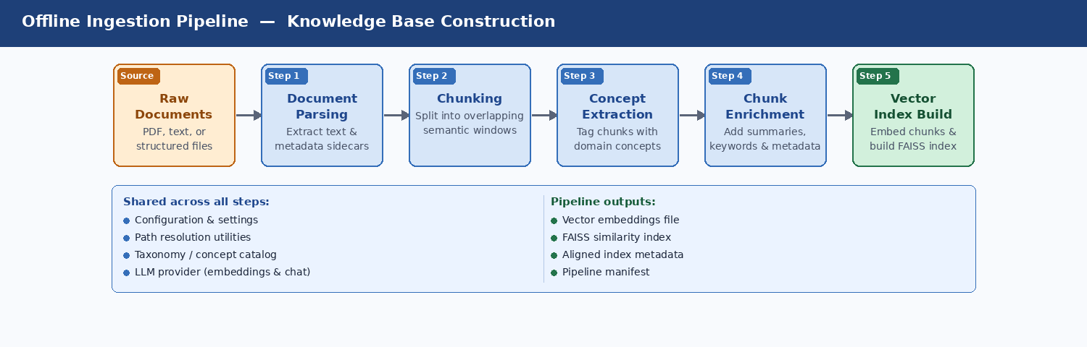
Figure 2 — Offline pipeline: PDF → parse → chunk → concepts → enrich → FAISS vector index

Runtime Path — Scenario to Bias Analysis
The runtime path executes every time a user submits a scenario. It retrieves relevant evidence and calls the language model twice — once without retrieval (baseline) and once with (RAG-enhanced) — enabling direct lift measurement.
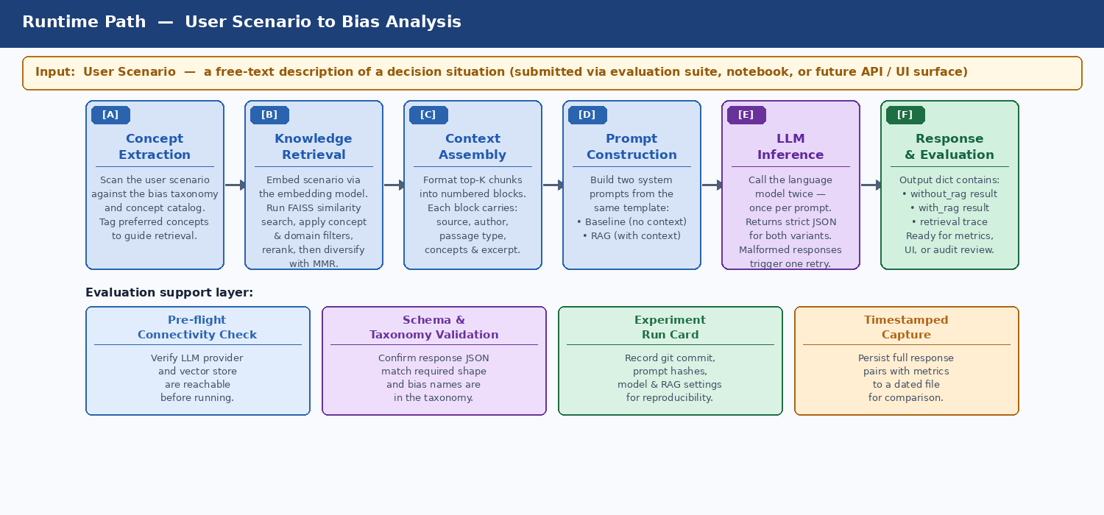
Figure 3 — Runtime path: concept extraction → retrieval → context assembly → dual LLM calls → response dict

Target AWS Deployment Architecture
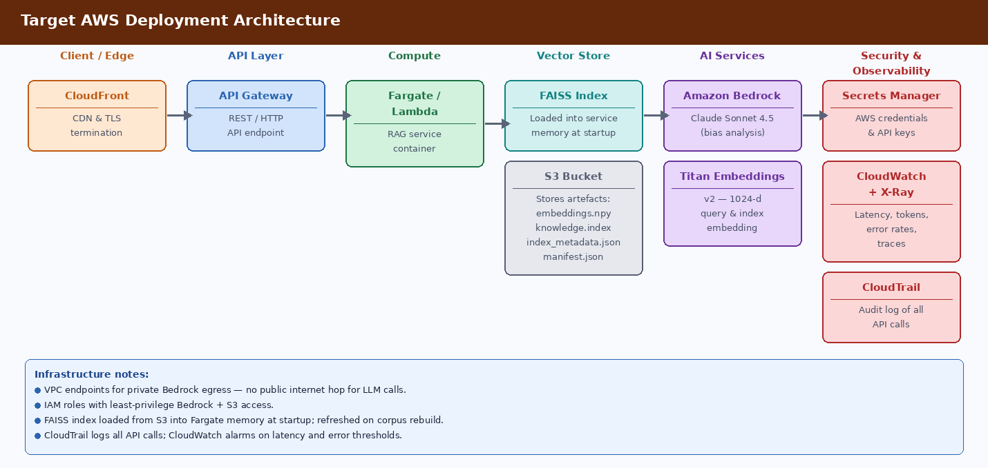
Figure 4 — GCP deployment: Cloud CDN → Apigee → Cloud Run → FAISS (memory) + GCS → Vertex AI → Secret Manager/Cloud Monitoring/Audit Logs

Repository Structure & Module Map
Directory / File | Purpose
app/services/bedrock_provider.py | Thin Bedrock client wrapper. Exposes converse() for Claude Sonnet 4.5 and embed_text() for Titan v2. Validates credentials on construction.
app/services/bias_detector.py | Orchestration brain. Loads taxonomy + prompt, extracts concepts, runs retrieval, formats context, builds dual system prompts, calls Claude twice, parses strict JSON.
rag/retriever.py | Corpus-aware retriever. FAISS search → concept/domain filters → optional Haiku rerank → MMR diversification. Returns RetrievalResult dataclasses.
data_pipeline/pdf_parser.py | Extracts text from PDFs via PyMuPDF, infers author/title/year with regex, writes .txt + .meta.json sidecar per book.
data_pipeline/chunker.py | Profile-aware overlapping windows: dossier (350w/60), book (500w/80), auto. Strips front/back matter; stamps chapter_title on every chunk.
data_pipeline/concept_extractor.py | Builds unified concept catalog from bias-taxonomy.json + retrieval-concepts.json. Tags chunks with concepts + confidence.
data_pipeline/enrich_chunks.py | Final pre-embedding enrichment: summary, importance, decision_domains, keywords, passage_type, decision_phase. Writes knowledge_base.json.
data_pipeline/build_vector_index.py | Calls Bedrock Titan v2 per chunk, stacks float32 matrix, builds FAISS IndexFlatIP, writes embeddings.npy + knowledge.index + index_metadata.json + manifest.json.
shared_components/settings.py | Single source of truth: BEDROCK_SETTINGS and RAG_SETTINGS frozen dataclasses loaded from .env.
shared_components/utilities/path_utils.py | Corpus-aware path resolution for all pipeline directories.
shared_components/utilities/taxonomy_utils.py | Lazy-cached loaders for bias-taxonomy.json and retrieval-concepts.json; build_concept_catalog() merges both.
prompts/bias_detection_system_prompt.txt | Locked output contract: role, taxonomy constraint, JSON schema, quality expectations, worked example. Kept outside code for prompt iteration.
evaluation/metrics.py | Schema and taxonomy validation for without_rag/with_rag payloads plus per-run aggregates.
evaluation/run_card.py | Reproducibility metadata: UTC/local timestamps, git commit, SHA-256 of scenario file + system prompt, all model/RAG settings.
evaluation/connectivity.py | Pre-flight smoke checks: Bedrock credentials → embedding probe → vector load → retrieval check.
scripts/record_response_run.py | Connectivity check → runs baseline_scenarios.json → attaches metrics + run card → writes response/<timestamp>_<label>_rag_eval.json.

Best-Practice Alignment (15-Point Playbook)
This solution is designed against a 15-point playbook synthesised from Google Cloud, Microsoft Azure Architecture Center, Redwerk, and ChatRAG guidance. The table below maps each practice to current implementation status and open gaps.
# | Practice | Current Implementation | Gap / Roadmap
1 | Define use case & success criteria | JSON schema validity, taxonomy compliance, retrieval trace presence, baseline vs RAG pairs, metrics.py flags. | Formal latency/cost SLO dashboards; richer pilot KPIs (groundedness judges, human rubrics).
2 | Prepare knowledge foundation | Curated dossiers under data/corpora/public/raw/; pdf_parser.py extracts text + sidecar metadata. | Source-system inventory for enterprise; automated deduplication, staleness, and event-driven reindex.
3 | Build representative test set early | evaluation/test_scenarios.json (~30 scenarios); baseline_scenarios.json (3 frozen); run_evaluation.py. | Golden reference answers; out-of-corpus decline scenarios; automated retrieval-precision metrics.
4 | Analyse documents before chunking | pdf_parser.py: regex heading cues, parser_notes on inferred fields. chunker.py: front/back-matter stripping. | Optional markdown-normalisation path for complex PDF layouts.
5 | Structure documents for retrieval | Dossiers authored with descriptive titles and tight topical focus. enrich_chunks.py adds summaries, keywords, decision_domains. | —
6 | Choose chunking strategy deliberately | Profile-driven overlapping windows: dossier 350/60, book 500/80, auto. Chapter titles on every chunk. | Automated experiment grid (profiles × frozen eval) to optimise recall vs noise.
7 | Clean & enrich chunks with metadata | 20+ fields per chunk: id, source, author, title, year, chapter_title, profile, concepts, domains, keywords, passage_type, decision_phase, summary. | Enterprise metadata (source system, effective date, geography) and ACL tags.
8 | Select & evaluate embedding model | Titan Text Embeddings v2 at 1024-d with normalize=true. Same model at index and query time. | Benchmark alternate embeddings on held-out queries before switching BEDROCK_EMBEDDING_MODEL_ID.
9 | Design index & retrieval strategy | FAISS IndexFlatIP; concept + domain filters with unfiltered fallback; optional Haiku reranker; MMR. | Hybrid vector + BM25 lexical; query decomposition; metadata security filters once ACL fields exist.
10 | Re-rank & assemble context | Optional LLM reranker; MMR final cut; format_retrieved_context emits numbered blocks with full traceability. | Token-budget-aware assembly modes (excerpt vs full chunk vs expanded section).
11 | Design prompts for grounded answers | bias_detection_system_prompt.txt locks role, taxonomy-only names, uncertainty signal, JSON schema. Temperature 0.1. | Versioned prompt files with automated A/B harness tied to baseline_scenarios.json.
12 | Evaluate retrieval & generation separately | Connectivity checks isolate Bedrock + vector health. metrics.py scores JSON shape + taxonomy. Paired payloads. | Labelled gold chunks; LLM-as-judge; CI regression against frozen baseline_metrics.json.
13 | Controlled experimentation & root cause | run_card.py records all experiment variables; label-based filenames under response/. | —
14 | Human evaluation before rollout | sample_results_comparison.md supports qualitative review. | Structured reviewer rubrics (clarity, trustworthiness, citation usefulness) feeding back into workstreams.
15 | Operations, governance & CI | ml-ops.plan.md: versioned corpora, manifests, drift thinking. Logging stub in bedrock_provider.py. | CloudWatch dashboards; cost tracking; re-evaluation triggers on material changes.

Configuration Reference
Environment Variable | Default | Description
BEDROCK_REGION | us-west-2 | AWS region for Bedrock runtime client.
BEDROCK_MODEL_ID | claude-sonnet-4-5-20250929-v1:0 | Chat model for bias analysis (Claude Sonnet 4.5).
BEDROCK_EMBEDDING_MODEL_ID | amazon.titan-embed-text-v2:0 | Embedding model — must match at index and query time.
BEDROCK_EMBEDDING_DIMENSIONS | 1024 | Vector dimension; must match FAISS index.
CORPUS_NAME | public | 'public' (committed dossiers) or 'private' (full books, local-only).
CHUNK_PROFILE | auto | dossier | book | auto. Auto selects book for docs > 30k words.
RAG_TOP_K | 8 | Final context chunks returned to the generator after MMR.
RAG_MMR_LAMBDA | 0.7 | 1.0 = pure relevance; 0.0 = pure diversity. 0.7 balances both.
RAG_RERANKER | none | 'none' or 'claude_haiku'. Haiku reranker adds latency but may improve precision.
RAG_RERANKER_CANDIDATES | 24 | Candidate pool depth passed to the Haiku reranker.
ENRICHMENT_USE_LLM | false | When true, routes passage_type/decision_phase classification through Claude Haiku.

Common Pitfalls & Mitigations
Pitfall | Mitigation in this Solution | Residual Risk
Indexing low-quality content | Curated dossiers only in public corpus; pdf_parser + chunker hygiene. | Grows if unvetted PDFs enter without review workflow.
Naive / fixed chunking | Profile-driven overlap, chapter awareness, planned experiment grid. | Optimal profile not yet validated by automated grid search.
Single retrieval mode | Acknowledged gap; hybrid lexical + vector is on roadmap (Phase 5). | Exact-match queries may underperform until BM25 is added.
Prompt overload with weak chunks | MMR limits chapter dominance; concept/domain filters; reranker option. | Context assembly modes still tunable by experiment, not locked.
Optimising only end-to-end | Connectivity + schema/taxonomy checks isolate component failures today. | Retrieval-precision metrics (gold chunk labels) not yet automated.
No experiment auditability | run_card.py + timestamped response/ captures + label-based filenames. | No CI gate yet against frozen baseline_metrics.json.

Engineering Roadmap
Phase | Focus | Key Deliverables
Phase 1 — Eval spine | Evaluation infrastructure | evaluation/metrics.py (schema + taxonomy checks), extended scenarios, retrieval/generation metrics to grow over time.
Phase 2 — Content ops | Corpus governance | Source manifest, content hashes, incremental re-embed/reindex, deduplication and staleness handling.
Phase 3 — ACL & metadata | Multi-audience readiness | Audience-aware metadata on chunks when multi-tenant deployments require entitlement filtering at retrieval time.
Phase 4 — Run cards | Reproducibility | evaluation/run_card.py + timestamped response/*_rag_eval.json for reproducible before/after comparisons.
Phase 5 — Retrieval science | Retrieval quality | Hybrid lexical + vector retrieval, query decomposition for multi-part scenarios, configurable context assembly modes.
Phase 6 — Chunking & telemetry | Quality & observability | Chunking grid automation, expanded human evaluation, production latency/token/failure telemetry.
Phase 7 — Prompt versioning | Prompt engineering rigour | Versioned prompt files, optional refusal/insufficient-evidence fields, prompt A/B harness tied to frozen scenarios.

Appendix A — Recommended Delivery Sequence
Based on the best-practices playbook, the recommended implementation order is:
- Define use case, personas, risks, and pilot metrics.
- Curate and govern source content (public dossiers today; private books under strict controls).
- Build and freeze evaluation scenarios early; add gold labels incrementally.
- Analyse document structures; extend parsers as new formats appear.
- Tune chunking with measured retrieval and answer quality — not intuition alone.
- Enrich metadata for filters, citations, and future ACLs.
- Benchmark embeddings when corpus or question style shifts.
- Design retrieval logic (vector today; hybrid and decomposition on roadmap).
- Add reranking and context-assembly experiments.
- Iterate prompts with version control and A/B metrics.
- Automate retrieval/generation/E2E evaluation with regression gates.
- Run human evaluation; deploy in phases; monitor continuously.

Appendix B — Traceability Contract
Every artefact preserves the chain from source PDF to final LLM output:
- Each chunk carries: id, source, file_name, author, title, publication_year, chunk_index, cleaning_notes, parser_notes, chapter_title, chunking_profile, passage_type, decision_phase.
- Each retrieval result carries those fields plus similarity score and matched concepts.
- The bias detector response payload includes corpus plus retrieval array so callers can show which chunks — from which corpus — shaped the answer.
- Run cards record git commit, file hashes, and all model/RAG settings so experiments are fully reproducible.

Appendix C – Alternative Deployment Approaches
This supplement analyses what changes when the Bias-Aware Decision-Making RAG Copilot is deployed on Amazon Web Services (AWS) versus Google Cloud Platform (GCP). The core solution design — chunking strategy, FAISS vector index, dual baseline/RAG execution, evaluation spine, and bias taxonomy — is cloud-agnostic and unchanged. What differs is the managed service layer that hosts, secures, and observes the system.
The two architectures are structurally identical: edge → API gateway → compute → vector store + object storage → LLM/embedding AI service → secrets + observability. Each AWS service maps cleanly to a GCP equivalent, with a small set of meaningful differences in IAM model, cold-start behaviour, LLM access pattern, and compliance posture.

Architecture Diagrams

AWS Architecture (updated — includes FAISS)
The diagram below reflects the corrected AWS architecture with FAISS explicitly shown as a distinct Vector Store layer. The FAISS index is loaded from S3 into the Fargate container's memory at startup, making it available for sub-millisecond similarity search during runtime without any additional network hop.
Figure 1 — AWS deployment: CloudFront → API Gateway → Fargate → FAISS (memory) + S3 → Bedrock → Secrets/CloudWatch/CloudTrail

GCP Architecture
The GCP architecture mirrors the AWS design. Cloud Run replaces Fargate, GCS replaces S3, Vertex AI Model Garden (Claude or Gemini) replaces Bedrock, and Workload Identity replaces IAM roles attached to tasks. FAISS loads identically from GCS into Cloud Run container memory at cold start.
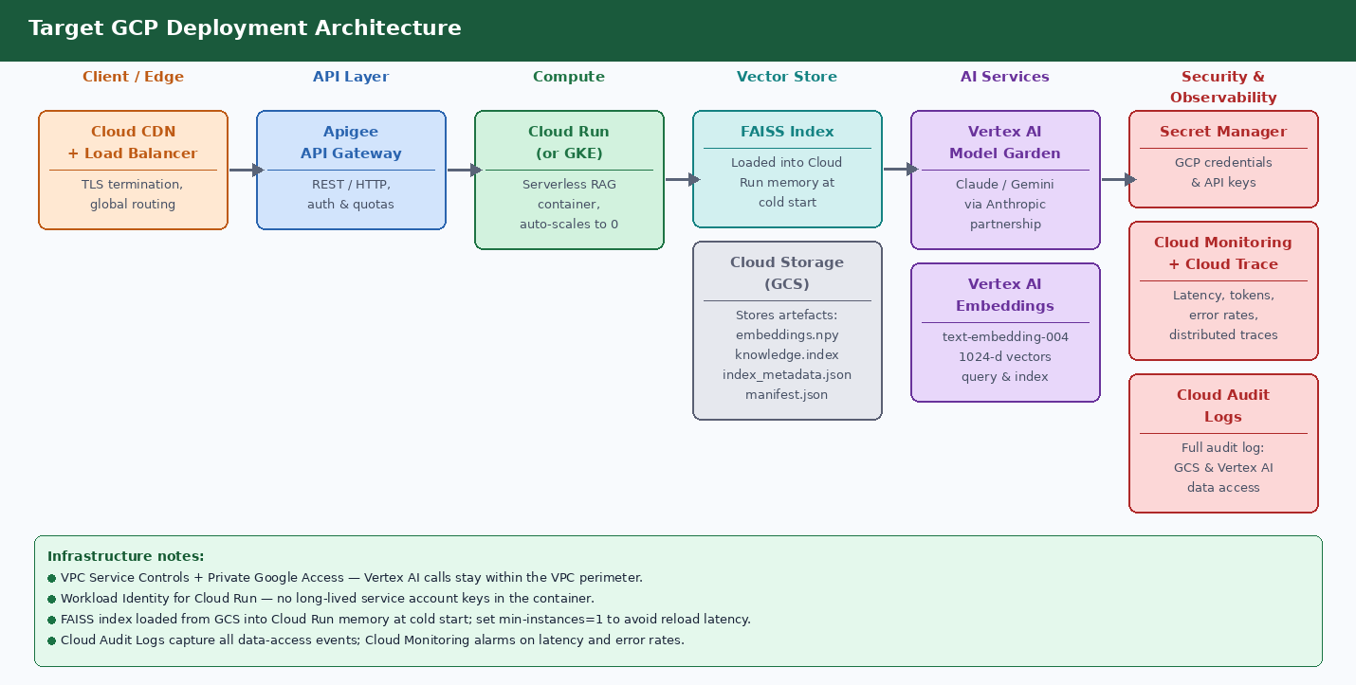
Figure 2 — GCP deployment: Cloud CDN → Apigee → Cloud Run → FAISS (memory) + GCS → Vertex AI → Secret Manager/Cloud Monitoring/Audit Logs

Side-by-Side Component Comparison
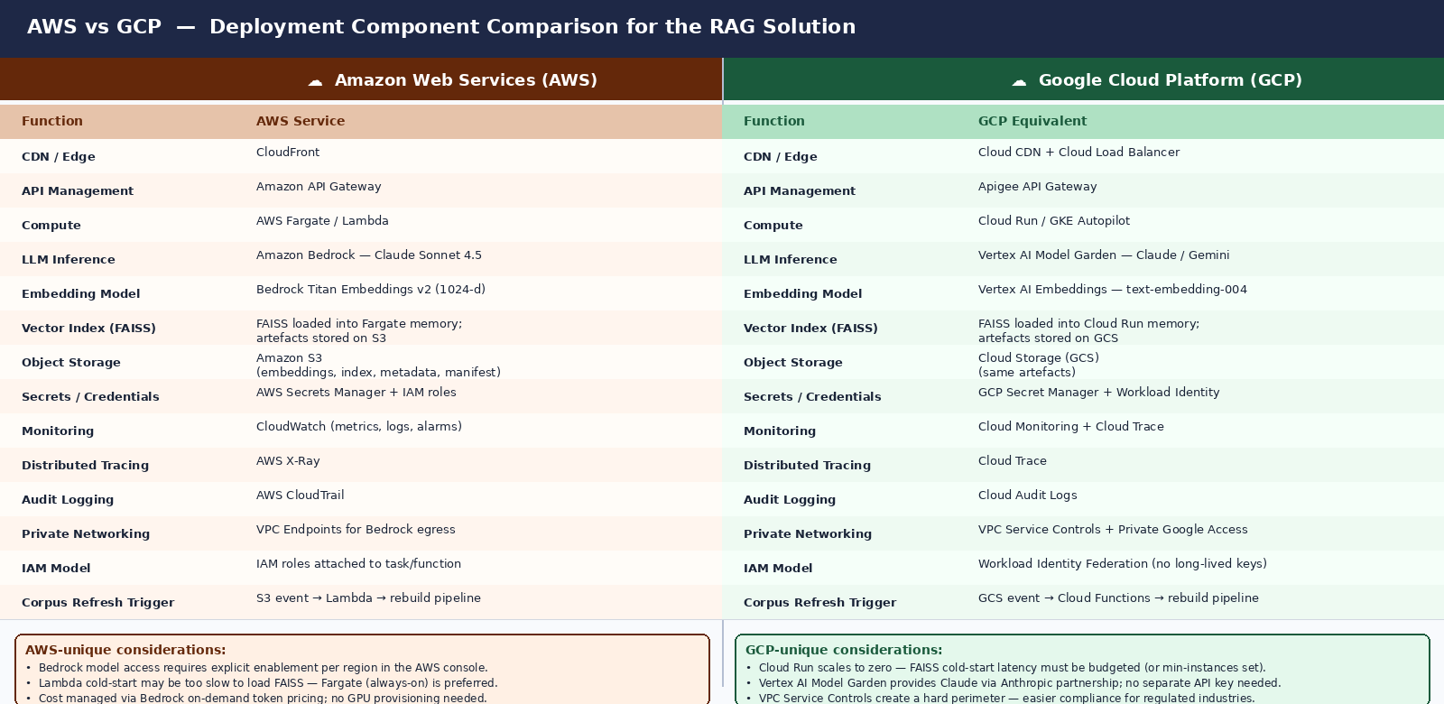
Figure 3 — Full AWS vs GCP component mapping with platform-unique considerations

FAISS in a Cloud Deployment
FAISS is an in-process library, not a managed service. On both AWS and GCP it follows the same pattern:
- The offline pipeline produces embeddings.npy, knowledge.index, index_metadata.json, and manifest.json and uploads them to object storage (S3 or GCS).
- At container startup, the RAG service downloads these artefacts and loads the FAISS index into heap memory. Search latency is then sub-millisecond, with no network hop per query.
- On corpus refresh, the pipeline re-uploads the artefacts and the service restarts (or reloads) to pick up the new index.
- Memory sizing: a 1024-dimension float32 index over ~5,000 chunks is roughly 20 MB — well within Fargate task or Cloud Run container defaults.

Why not a managed vector database?
- FAISS keeps infrastructure simple and cost-free at portfolio scale. A managed service (AWS OpenSearch, GCP Vertex AI Vector Search) would add latency, cost, and operational overhead.
- The tradeoff is that FAISS is in-process: no multi-instance sharing, no real-time index updates. For production scale with concurrent users, a managed vector DB becomes the right choice.
- The codebase is designed so that retriever.py can be swapped to a different backend without changing the orchestration layer (bias_detector.py).

Detailed Component Mapping
Function | AWS Service / Approach | GCP Service / Approach
CDN & TLS termination | Amazon CloudFront | Cloud CDN + Cloud Load Balancer
API management | Amazon API Gateway (REST/HTTP) | Apigee API Gateway (REST/gRPC, auth & quotas)
Compute | AWS Fargate (always-on, no cold start penalty) | Cloud Run (scales to zero; set min-instances=1 to avoid FAISS reload latency)
LLM inference | Amazon Bedrock — Claude Sonnet 4.5 (on-demand token pricing, region-locked model access) | Vertex AI Model Garden — Claude via Anthropic partnership or Gemini; no separate Anthropic API key required
Embedding model | Bedrock Titan Text Embeddings v2 (1024-d, normalize=true) | Vertex AI Embeddings — text-embedding-004 (768-d or 1024-d depending on model version)
Vector index (FAISS) | Loaded into Fargate task memory; artefacts on S3 | Loaded into Cloud Run container memory; artefacts on GCS
Object storage | Amazon S3 (versioned bucket for corpus artefacts) | Cloud Storage (GCS) — same structure, bucket-level versioning
Secrets & credentials | AWS Secrets Manager + IAM roles attached to ECS task definition | GCP Secret Manager + Workload Identity Federation (no long-lived service account keys)
Metrics & alerting | Amazon CloudWatch — metrics, logs, alarms, dashboards | Cloud Monitoring — metrics, uptime checks, alert policies
Distributed tracing | AWS X-Ray — trace IDs propagated through Lambda/Fargate | Cloud Trace — integrated with Cloud Run automatically
Audit logging | AWS CloudTrail — all API calls logged to S3 | Cloud Audit Logs — Data Access logs for GCS + Vertex AI
Private networking | VPC Endpoints for Bedrock, S3, Secrets Manager (no public internet egress) | VPC Service Controls + Private Google Access (hard perimeter for regulated data)
IAM model | IAM roles attached to ECS task or Lambda execution role; least-privilege policies | Workload Identity binds a Kubernetes/Cloud Run service account to a GCP IAM role — no long-lived keys
Corpus refresh trigger | S3 event notification → Lambda → rebuild pipeline | GCS Pub/Sub notification → Cloud Functions → rebuild pipeline
Observability dashboards | CloudWatch dashboards (manual setup); AWS Cost Explorer for token cost | Cloud Monitoring dashboards; GCP Billing with label-based cost allocation

Key Differences and Decision Factors

1. LLM Access Pattern
On AWS, Claude Sonnet 4.5 is accessed through Amazon Bedrock, which requires the model to be explicitly enabled in the target region via the AWS console. Bedrock uses on-demand token pricing with no GPU provisioning. On GCP, Claude is available through Vertex AI Model Garden under the Anthropic partnership — no separate Anthropic API key is needed, and billing flows through the GCP account. GCP also offers Gemini as a native alternative if model substitution is ever required.

2. Embedding Model Alignment
Critical: the same embedding model must be used at index build time and query time. On AWS, Titan Embeddings v2 at 1024 dimensions is the baseline. On GCP, Vertex AI text-embedding-004 is the closest equivalent but may output a different default dimension. If migrating from AWS to GCP, the entire corpus must be re-embedded and the FAISS index rebuilt before the system is functional.

3. FAISS Cold-Start Latency
AWS Fargate runs always-on containers with no cold-start penalty. GCP Cloud Run scales to zero by default, meaning the first request after idle triggers a container startup that must download and load the FAISS index from GCS. For a 20 MB index this is typically 2–5 seconds. Setting min-instances=1 in the Cloud Run configuration eliminates this but removes the cost-saving zero-scale behaviour.

4. IAM and Credential Model
AWS uses IAM roles attached to the ECS task definition — credentials are injected via instance metadata and rotated automatically. GCP Workload Identity Federation achieves the same result differently: it binds the Cloud Run service identity to a GCP IAM role without any long-lived service account key file. Both approaches are secure; GCP's model eliminates the risk of a key file being accidentally committed or leaked.

5. Compliance and Network Perimeter
AWS VPC Endpoints keep Bedrock and S3 traffic within the AWS network. GCP VPC Service Controls go further, creating a hard logical perimeter around a set of GCP services — any API call from outside the perimeter is denied even if the caller has valid credentials. This makes GCP the stronger default choice for regulated industries (healthcare, finance, government) where data residency and access control must be demonstrated to auditors.

6. Cost Model
Both platforms price LLM inference on a per-token basis. AWS Bedrock and GCP Vertex AI are broadly comparable for Claude Sonnet 4.5 at portfolio scale. The main cost variable at scale is embedding: re-embedding a large corpus on a different provider is a one-time batch cost but must be budgeted when switching clouds.

Migration Considerations (AWS → GCP or vice versa)
Steps required when switching cloud providers
- Re-embed the full corpus using the target platform's embedding model (Titan → Vertex AI or vice versa), as vector spaces are not interchangeable.
- Rebuild the FAISS index (build_vector_index.py --corpus <name>) against the new embeddings.
- Update BEDROCK_EMBEDDING_MODEL_ID and BEDROCK_MODEL_ID in settings.py (or introduce a provider abstraction layer).
- Update bedrock_provider.py to call the Vertex AI SDK instead of boto3 (or abstract behind an interface).
- Migrate secrets from AWS Secrets Manager to GCP Secret Manager; update IAM policies.
- Reconfigure the corpus refresh trigger (S3 event → Lambda becomes GCS Pub/Sub → Cloud Functions).
- Re-run the full evaluation suite (run_evaluation.py) to confirm output quality is preserved after the model switch.

Recommendation
For this portfolio project, AWS remains the primary deployment target because the solution is already built against the Bedrock API (boto3 client, Titan embeddings, Claude Sonnet 4.5). The cost to migrate to GCP is dominated by re-embedding the corpus and updating the provider layer — non-trivial but achievable in a few days.
GCP becomes the preferred choice in two scenarios:
- The deployment must satisfy strict data residency or regulated-industry compliance requirements (VPC Service Controls provide a stronger perimeter than AWS VPC Endpoints).
- The organisation is already standardised on GCP and Google Workspace — Vertex AI Model Garden provides Claude without a separate Anthropic billing relationship, and Workload Identity simplifies the credential model.

In both cases, the solution's architecture remains sound. Only the managed service names and SDK calls change — the chunking, FAISS index, evaluation spine, bias taxonomy, and prompt contract are fully portable.

Disclaimer: This system provides research-informed decision support only. It does not replace professional judgment or organisational policy.

