Computer Vision: Foundations, Architectures, Models, and MLOps
This article presents an overview of computer vision (CV), machine learning (ML), and artificial intelligence (AI). It explains the theoretical foundations, architectural building blocks, practical solution approaches, modern model ecosystems, and operational considerations involved in building production-grade computer vision systems.

1. Introduction to AI, ML, and Computer Vision
Artificial Intelligence (AI) refers to systems capable of performing tasks that normally require human intelligence. Machine Learning (ML) is a subset of AI focused on learning patterns from data. Computer Vision (CV) is a specialized domain of AI that enables machines to understand and interpret images and video streams.

2. Fundamental Concepts
Key concepts include supervised learning, unsupervised learning, reinforcement learning, feature engineering, convolutional neural networks (CNNs), transformers, embeddings, transfer learning, attention mechanisms, and multimodal representation learning.

3. Core Building Blocks of Computer Vision Systems
Modern computer vision pipelines generally contain: data acquisition, annotation, preprocessing, augmentation, model training, validation, deployment, inference, monitoring, and feedback loops. Data quality and annotation consistency are often more important than model complexity.

4. Common Computer Vision Tasks
Computer vision problems are commonly categorized into image classification, object detection, semantic segmentation, instance segmentation, keypoint estimation, OCR, anomaly detection, image retrieval, visual search, and video understanding.

5. Common Approaches for Solving Real-World Problems
Common approaches include transfer learning using pretrained models, foundation vision models, multimodal models, self-supervised learning, ensemble learning, edge inference optimization, synthetic data generation, and active learning. Real-world deployments often combine classical CV methods with deep learning pipelines.

6. Major Model Families and Their Use Cases
CNN families such as ResNet, EfficientNet, MobileNet, DenseNet, and ConvNeXt remain highly effective. Transformer-based models such as ViT, Swin Transformer, DINOv2, Segment Anything (SAM), CLIP, and Florence are increasingly dominant in foundation-model-based vision systems.

7. Cloud and Open Model Ecosystems
Amazon Web Services provides Rekognition, Rekognition Custom Labels, SageMaker JumpStart, and managed deployment pipelines. Google Cloud offers Vision AI, Vertex AI Vision, and Model Garden. NVIDIA provides TAO Toolkit, TensorRT, DeepStream, and optimized inference frameworks. Hugging Face hosts thousands of pretrained computer vision and multimodal models.

8. Model Suitability Matrix
• ResNet / EfficientNet: General image classification.
• YOLO family: Real-time object detection.
• DETR / RT-DETR: Transformer-based detection.
• SAM: Segmentation and annotation acceleration.
• CLIP: Image-text similarity and retrieval.
• DINOv2: Feature extraction and embeddings.
• MobileNet / EfficientNet Lite: Edge and mobile inference.
• OCR Models (TrOCR, PaddleOCR): Document intelligence.
• Florence / Gemini Vision / GPT-4o Vision: Multimodal reasoning.
• NVIDIA TAO models: Industrial deployment optimization.

9. TIMM Library
TIMM (PyTorch Image Models) is one of the most widely used open-source computer vision libraries in the PyTorch ecosystem. It provides hundreds of pretrained models, training recipes, augmentation pipelines, schedulers, optimizers, and benchmarking utilities. TIMM enables rapid experimentation and transfer learning across CNNs and Vision Transformers. Advantages include standardized APIs, reproducibility, pretrained checkpoints, efficient training scripts, and strong integration with Hugging Face and PyTorch ecosystems.
Example Usage:
import timm
model = timm.create_model('vit_base_patch16_224', pretrained=True)
model.eval()

10. Wildlife Identification Models
Wildlife identification systems are increasingly used for biodiversity conservation, camera trap analytics, ecological monitoring, and anti-poaching initiatives. Common approaches include species classification, re-identification, multi-camera tracking, and embedding-based retrieval systems.
Frequently used architectures include EfficientNet, ResNet, Vision Transformers, CLIP-based embedding systems, MegaDetector, and self-supervised embedding models. Large-scale wildlife datasets often contain long-tail class imbalance challenges.

11. MegaDetector
MegaDetector is an object detection model developed primarily for wildlife camera trap workflows. It is widely used in ecological and conservation projects to detect animals, humans, and vehicles in images before downstream classification. MegaDetector significantly reduces manual image review workload.
Common approaches for using MegaDetector include:
• Pre-filtering empty camera trap images.
• Integrating with species classification models.
• Building embedding pipelines for retrieval and clustering.
• Human-in-the-loop annotation workflows.
• Edge deployment in remote conservation environments.
• Combining with active learning and continual retraining.

12. MLOps for Model-Agnostic Computer Vision
Production-grade computer vision systems require robust MLOps workflows including data versioning, experiment tracking, reproducible training, CI/CD pipelines, model registries, drift monitoring, and retraining orchestration. Frameworks commonly used include MLflow, Kubeflow, SageMaker Pipelines, Vertex AI Pipelines, Weights & Biases, DVC, BentoML, Triton Inference Server, and Kubernetes.
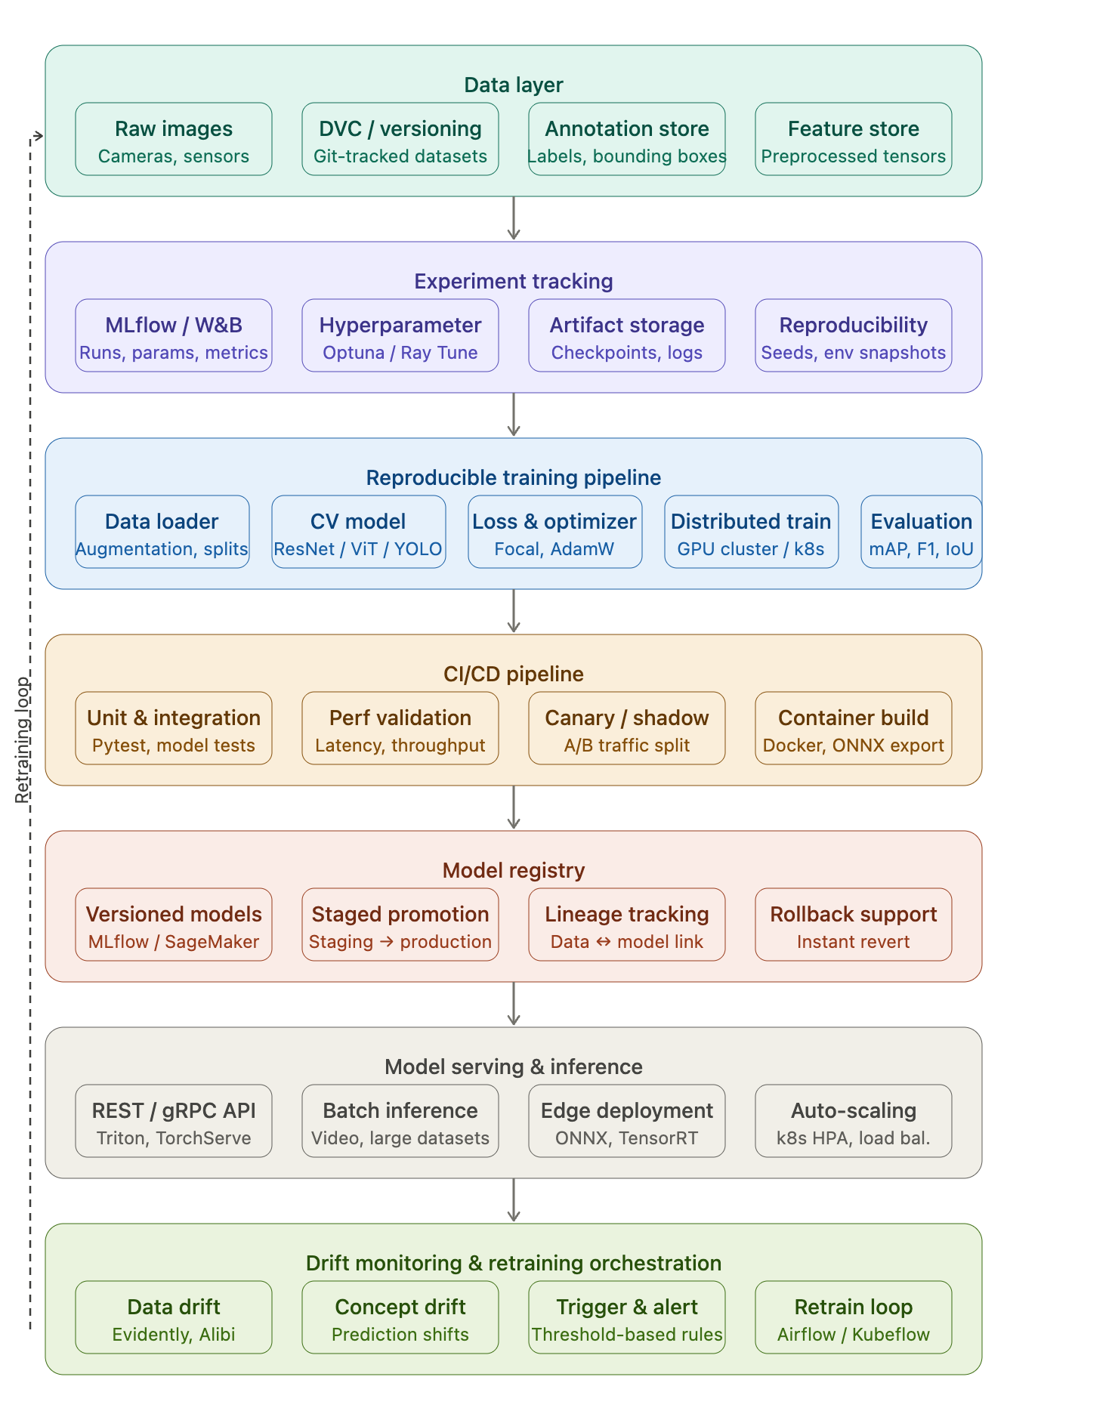

Here's the full MLOps pipeline for a production computer vision system, organized into 7 horizontal layers:
Data layer — raw image ingestion, DVC-based dataset versioning, annotation management, and a feature store for preprocessed tensors.
Experiment tracking — MLflow or W&B for run logging, hyperparameter search (Optuna/Ray Tune), artifact storage, and reproducibility through seed and environment snapshotting.
Reproducible training — the core CV training loop covering data loading with augmentation, model architectures (ResNet/ViT/YOLO), distributed GPU/k8s training, and evaluation metrics like mAP and IoU.
CI/CD pipeline — automated testing, latency/throughput validation, canary/shadow A/B traffic splitting, and container builds with ONNX export.
Model registry — versioned model artifacts, staged promotion (staging → production), data-to-model lineage tracking, and instant rollback.
Serving — REST/gRPC inference via Triton or TorchServe, batch video processing, edge deployment via TensorRT, and auto-scaling with k8s HPA.
Drift monitoring & retraining — data and concept drift detection (Evidently, Alibi), threshold-based alerting, and orchestrated retraining loops via Airflow or Kubeflow. The dashed arrow on the left shows the closed retraining loop feeding new data back into the pipeline.

14. Conclusion
Computer vision continues to evolve rapidly with the convergence of deep learning, multimodal AI, foundation models, and scalable MLOps platforms. Organizations increasingly adopt pretrained vision models and model-agnostic deployment architectures to accelerate production delivery. Libraries such as TIMM and specialized models such as MegaDetector demonstrate how reusable model ecosystems can dramatically reduce development effort while improving performance and scalability.

References and Further Reading
- TIMM / PyTorch Image Models Documentation
- AWS Rekognition and SageMaker Documentation
- Google Vertex AI Vision Documentation
- NVIDIA TAO Toolkit Documentation
- Hugging Face Model Hub
- MegaDetector GitHub Repository
- MLflow and Kubeflow Documentation

