Crossword Mastermind

*Master your crosswords*



**User manual**

What does this application do?

Crossword Mastermind ® *is a crosswords game that creates hot outta the oven new crosswords boards consists of questions about your favorites knowledge areas. It has a lot of cool and easy-to-use features that every child or adult will enjoy.   
Simply choose your topics, warm up with a little trivia question and GO!*

Crossword Mastermindrelies on a large variety of data gathered from , a huge semantic knowledge base, [freely available online](http://www.mpi-inf.mpg.de/yago-naga/yago/). This data is stored in a remote MySQL database which the application is configured to work with. Nonetheless, you can choose to work with your own local MySQL database and the application will store the required data over there (configuration instructions will be described later).   
The crosswords consist of many different definitions from the following topics:

* Cinema & TV – movies, film and TV actors, directors and TV series.
* Music – singers, musicians, composers, bands and records producers.
* Geography – cities and capitals, countries, holy places, seas and lakes, ancient cities, etc.
* Personalities – politicians, philosophers, presidents, writers, celebrities and more.
* Sports – football players, basketball players, football clubs and athletes.
* Israel – all of the topics above but this time focusing only on Israeli people and places.

Besides those topics, every crossword may also include:

* 'General knowledge' definitions like programing languages, astronomy constellations, fashion magazines, characters from 'The Lord of the rings' and many other exciting subjects.
* Have a nice definition of your own? Wonderful! Enter it into the game and your definitions might surprise you in the crosswords.

To keep your experience fresh, a smart algorithm will build for you a new crossword board by randomly choosing definitions from the topics that you chose, and while processing the board you can warm up with a nice trivia question.   
If the crossword is too challenging (no offense) you can get some hints to help you through. If you've got an idea for a hint of your own or maybe found a mistaken hint in our system, you can add your hint or delete hints that already exist.   
The 'Hall of fame' will save your scores so you can show off a bit about your achievements. ☺

More instructions and details in the following sections.

Connecting the DB server

When starting the application you will have to establish a connection to a MySQL database server.  
NOTICE: please be case sensitive, because computers might be so without letting you know!  
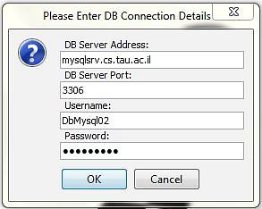

You can choose one of the following options:

1. Connect to our remote DB on Nova:

* If you just happen to be working with one of the computers in Schreiber's lab, simply use the default values already filled in (exactly the same as in the image above).
* If you're working with your own computer you have to first open a ssh tunnel pointing to "mysqlsrv.cs.tau.ac.il:3306" through your localhost port 3305 (using Putty) and only then run the application with: ***localhost***, ***3305*** respectively. Username and password are the default values.

1. Connect to a local DB server:

* If this is the first time you run the application with that DB server, you'll need to create our schema on the server before running the application. To do so you should run the attached MySQL script (you can find it in the "Source" directory). Afterwards, run the application and then fill in the correct parameters: The local DB server address and port, your username and password. Then you need to populate the DB with the data – **doing it in this point is crucial!** You won't find the application entertaining if the DB is empty. To do so, use the "Massive Import" feature (see page 11).   
  Now you are ready to go. Of course, the next time you run the application with that DB server won't be that complicated, you would enter the parameters and start the game.

Failing to connect a DB server will pop up a message to inform you about the problem and then the application will exit. To fix that, check you've entered the parameters correctly and if you're using a local server then make sure it is up.

The screens of the application:

The main screen of the application is displayed after the DB connection is established. On the left side of the screen you can find buttons that will take you to all the corners of the application.

Play:

Clicking the play button will show you the next screen: 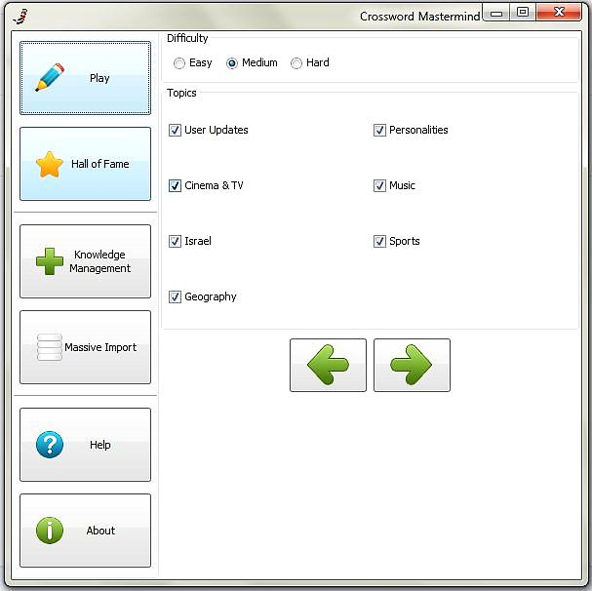

Use the navigator buttons to move back to the main screen or forward to get the next one.

**Difficulty -**   
The difficulty level will determine the size of the crossword board:

* Easy - 8x8,
* Medium -11x11,
* Hard - 13x13.

**Topics -**

Choose the topics your crossword will consist of.

The 'User Updates' topic will add the users' definitions to the crossword.   
***Notice you have to choose at least two topics, besides 'User Updates' topic.***

The next screen will entertain you with a light trivia question while the application is constructing the crossword:

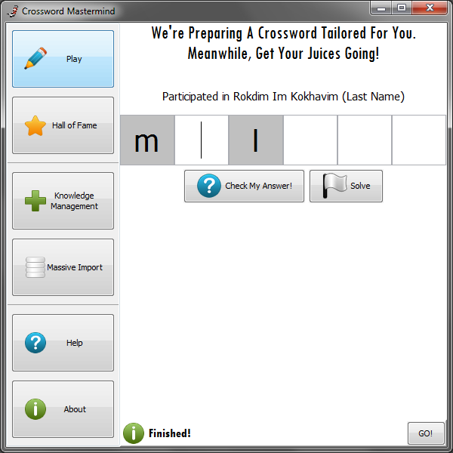

Type in the answer and press 'Check My Answer' to know the truth. Press 'Solve' if you give up...

When this state 'finished' press the GO! button and start the game.

Since the mission of constructing a crossword is not simple, to say the least, it might take a while for the application to build an appropriate board that suit your choices. Thus, if the process last more than a minute, then instead of "Finished!" you'll get a message asking you to choose another topic, or simply give it another try.

When the application has finished building your crossword you can start playing. The crossword will be displayed and the clock will start ticking!

The Game:

This is how the crossword's screen looks like:

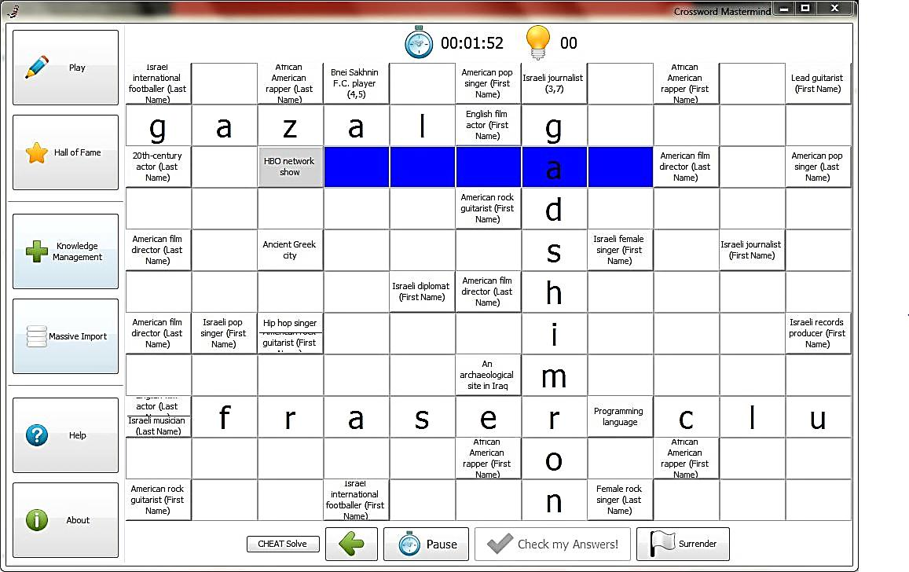

Hovering over a definition's square will make the corresponding squares blue, to demonstrate where you should type the answer.

On the screen's top you'll find a timer  and the hints counter.   
The time it takes you to solve the crossword will affect your score. Using the "Pause" button (on the bottom) you can stop the timer for a while without screwing your score. The hints counter lets you know how many hints you've used.

Sometimes the definition is a bit too long for the square it's written in. To see it properly, just right click the definition and a pop up window will appear with the full definition, for example: 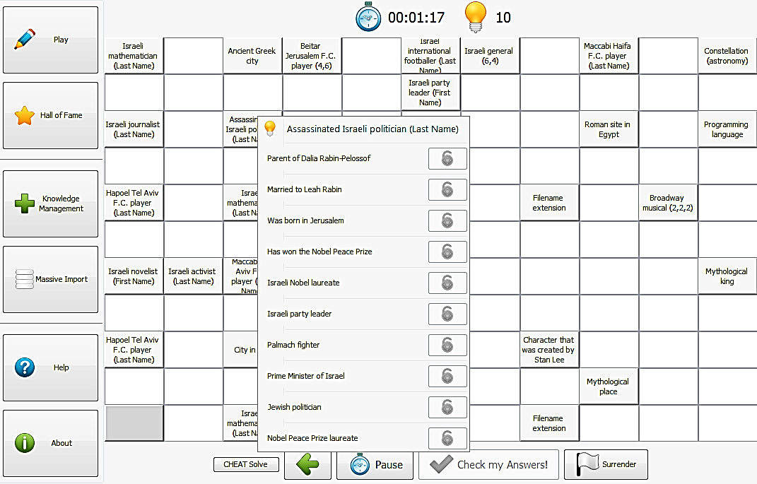.

After you complete the whole board, the "Check my Answers!" button will be enabled and by pressing it you can find out whether you were actually right or maybe learn new facts from your mistakes. If you did well, you'll be able to enter your name into the "Hall of Fame" along with your fine score.

Press "Surrender" if you give up and decide you better learn a bit more before the next challenge. Doing so won't get you to the "Hall of Fame" right now, but probably you will get there in the future.

["CHEAT Solve" is especially for the grader's use – press is to "solve" the crossword.]

Using Hints:

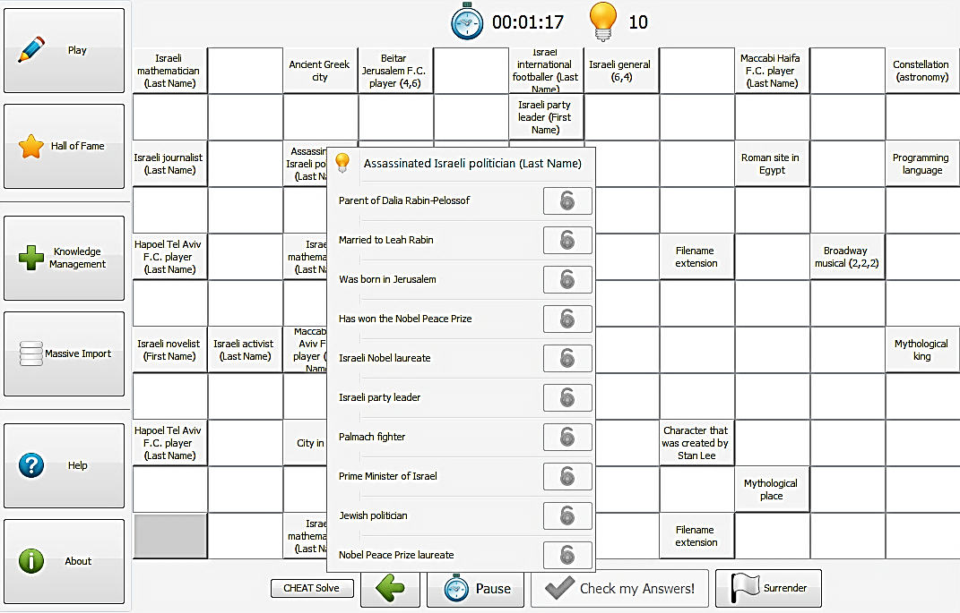If you would like a little help, right click the definition square you want to get a hint about.

Don't worry; the hints window won't spoil the fun. The hints will be hidden until you unlock them by clicking the locks on the right side.

Beware!

Using too many hints will lower your final score.

Hall of Fame:

Exactly what you expect it to be.  
The score is dependent on the difficulty level, elapsed time of the game and the number of hints you used.

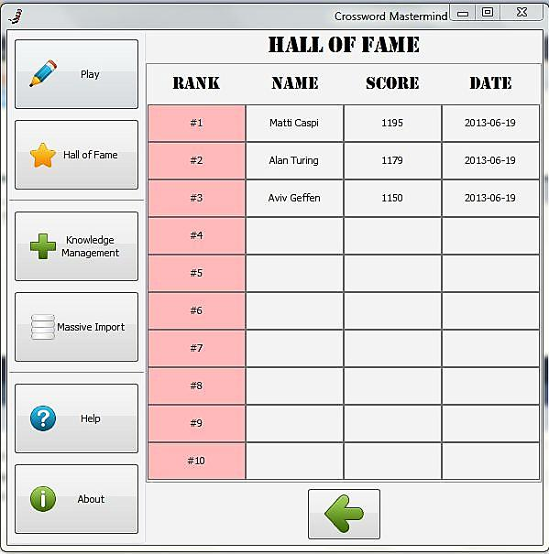

Don’t panic!

*If a crossword stops being fun and starts feeling like work, simply walk away and come back to it a little later – that's what "Pause" is for!  
The answers may come more easily after you take a breather (or consulted Google).*

Knowledge Management:

This is one of the application's nicest features. Here you can add or delete definitions and hints.  
Let's say you have a cool definition you would like to add to the game – for example: "Main character on games of thrones" and you want the answer to be "Daenerys Targaryen". All you have to do is to choose the first option, "New Knowledge Fact", and type in the answer.   
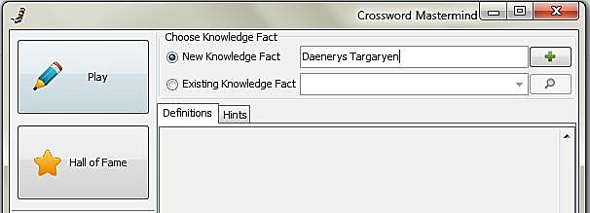

Now click the 'Plus' button on the right side and it will let you fill in the definition:

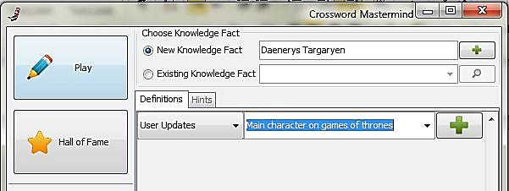

Use the scrolling menu on the right side to set the matching topics of your new definition.

To approve the change you've made press the 'Plus' button near the definition field.  
This is what you'll get:

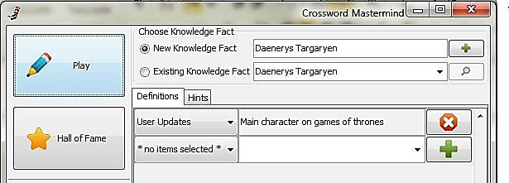

Entering an answer without any definition won’t have any effect.

Now, let say you want to add another definition that relates to the same answer. If you try to add the same answer twice it will give you this message:

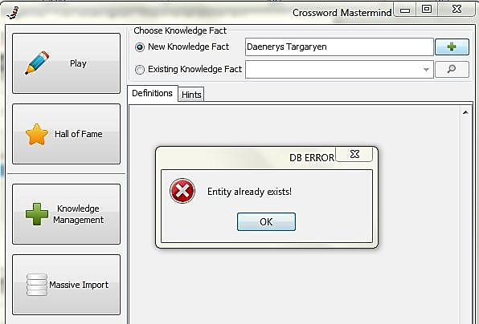

Instead, just add another definition to the existing answer (the one you've just entered):

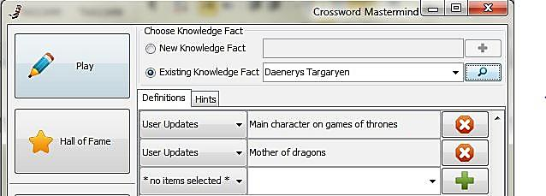

Now that you've created a new definition, you can add more answers that fit it, for example:  
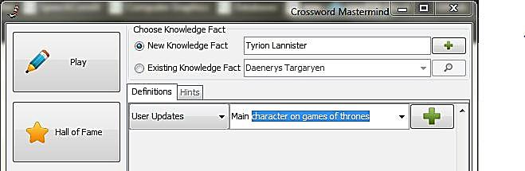

The autocomplete feature of the definition's text box will make it quite easy to find a definition which already exists in the system.

In the same manner, you can add hints:  
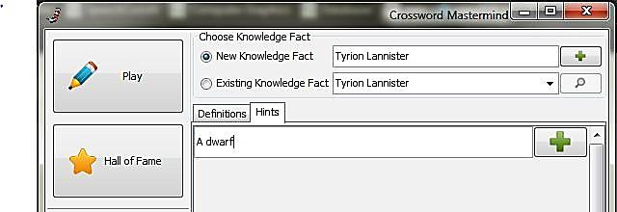

The same goes for an already existing knowledge fact:

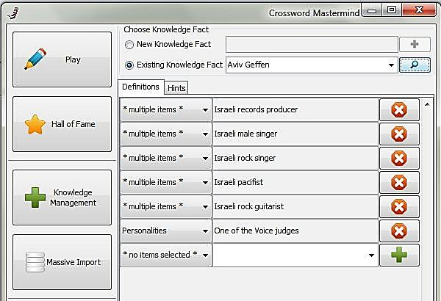

**The scrolling menus on the left side of the definitions indicate the topic/s which the current definition belongs to.**

When entering a new definition, use the scrolling menu to select the topics it belongs to.

Notice that you won't be able to change the topics of an already existing definition.

Well, you probably got the idea by now...

Massive Import:

This window allows you to update the data stored in the DB server you work with.   
Caution!!  
The import process will delete all the data from the server, including the updates you've made (everything but the "Hall of Fame" table)!

As always, there are two options:

* *"Download files from Yago website"* – will connect to the website and download the newest files directly from Yago. Since the files needed are quite large, downloading might take a while.   
  When the application finishes the download process, it will automatically create and populate the DB.
* *"Choose Folder..."* – Simply supply the path to the folder where your files are located: press the directory button and in the dialog window browse to the wanted folder. Make sure the folder you supply contains the files: 'yagoTypes.tsv', 'yagoFacts.tsv' and 'yagoLiteralFacts.tsv'.   
  When it finishes – your DB server is ready to go with the newest facts on Yago knowledge base.

In both cases, if you sure you want to do this, just push the "Start Import" button.  
Anyhow, this process takes time. Be patient.

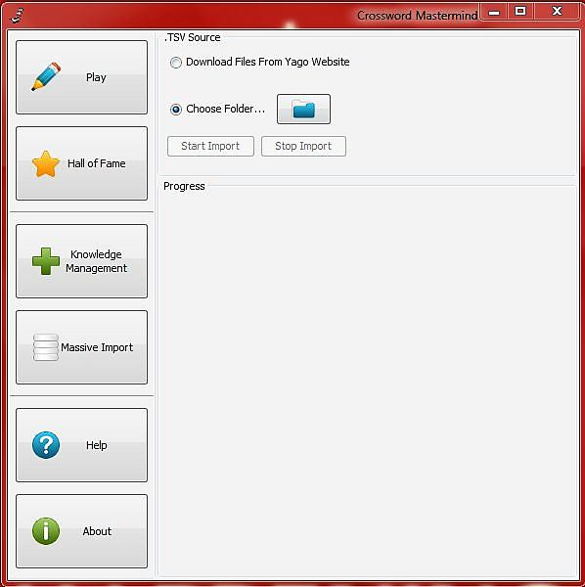

Installation guidelines

Installation is very simple: copy the 'runme' / 'runme.bat' and the JAR files from the "Executable" directory to your working directory and then run the 'runme' file.   
You will need java version 1.7 installed on your executing host. That's it.

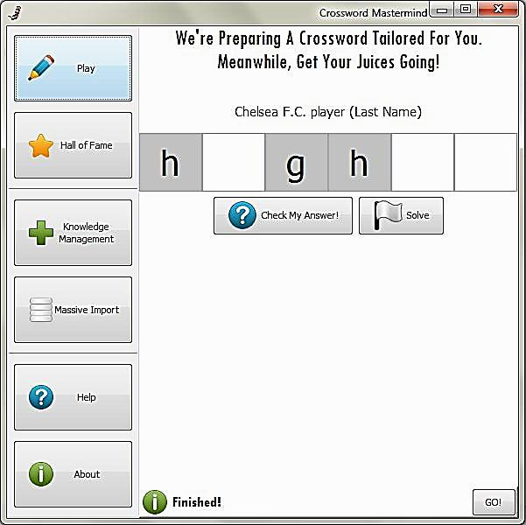

You are now familiar with the use of Crossword Mastermind ® and ready to start your quest to the top of the HALL OF FAME.

***Enjoy!***