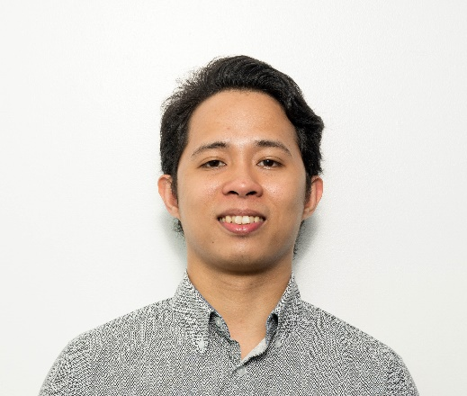**FRANCISCO, ROMMIEL JOHN TAPICERIA (RJ)**

Current Address: #501 Cebu st. Brgy. Pitogo, Makati City

Permanent Address: #299 Baloc Sto. Domingo, Nueva Ecija

Email Address: rommieljohnfrancisco@gmail.com

Contact Number: 09954139796

**WORK EXPERIENCE:**

* **Position: Campaign Manager From: March 2018 - present**

**Mapp Digital**

**Campaign manager** (digital marketing) – Ensures that all email marketing campaigns of our client globally meets their requirement and standard.

* **Position:** **Product Development Assistant** **From: August 2015 – March 2018**

**PLDT Inc. - Under Agency: Servflex Inc.**

**Quality assurance tester** (Web, Voice, Data Service, Devices) – Review and analyze system requirements. Creates user scenarios (User Acceptance Test script) to document testing phases and defects. Communicate to internal and external teams related to the projects. Conduct post-release/ post-implementation testing.

**Product technical support** – Provides assistance in configuring devices on different events such as product launching, product demo, product cascade and other related events.

**Technical trainer** – Responsible for developing the knowledge and skills of a company's workforce. To ensure that a company has a workforce that can meet its current and future business objectives, and deliver quality products and services that meet customers' needs.

* **Position:** **Data Analyst** **From: June 2014 - August 2015**

**Datahold Philippines**

**Quality assurance tester** (email broadcast) – Ensures that all email campaigns are based on the requirements. Checks all components of an email campaign from the subject line to its rendering view across different email platforms.

**Email campaign manager** – Design, build and manage email campaigns. Propose new design of email creative to different clients. Build the email creative using HTML. Manage campaigns and provide reports to the client.

* **Position:** **Student trainee / On-the-job training** **From: November 2013 – February 2014**

**PLDT Inc.**

**Responsibility as a student trainee** – Assists in setting up network connections, configuring PCs, laptops and servers, troubleshooting network and hardware issues. Participated in the completion of special project: “Live streaming on video conferencing using media server”.

**ACHIEVEMENTS:**

* Computer Hardware and Servicing NC2 Passer/TESDA Certified
* Participated in the computer network set up for College of Business Administration and Accountancy at Central Luzon State University.

**TECHNICAL SKILLS**

**Network Administration**

* Knowledgeable in Internet Protocol Addressing, Network Design and Implementation
* Knowledgeable how to configure and setup in LAN and WAN network.
* Knowledgeable how to Configure Routers, Switch, Hub and Access Point.
* Knowledgeable how to configure and setup IP Camera and CCTV camera.

**Hardware**

* Repairing and Troubleshooting (PC or Laptop)
* Network Cabling

**Operating System**

* Knowledgeable how to Operate: Windows, Mac, Linux, Android and iOS

**Applications**

* Proficient in Microsoft Office (Word, Excel, PowerPoint and Outlook)

**Programming language**

* Proficient in HTML, Java, Visual Basic and Turbo C.

**EDUCATIONAL BACKGROUND**

**Tertiary: Central Luzon State University (CLSU)**  **2010-2014**

Bachelor of Science in Information Technology

Major in Network Administration

**Secondary: Talavera National High School 2004-2008**

Pag-Asa district Talavera, Nueva Ecija

**Elementary: Baloc Elementary School 1998-2004**

Baloc Sto. Domingo, Nueva Ecija

**PERSONAL BACKGROUND**

Date of Birth: May 7, 1993 Age: 25

Gender: Male Religion: Christian

Citizenship: Filipino Status: Single

Height: 5’8” Weight: 60 kgs

**CHARACTER REFERENCES**

Edzel H. Carrascal

Head of Email Broadcasting Services, Datahold Philippines

Daniel L. Pis-an

Head of PLDT- HOME Service Quality Management, PLDT Inc.

Dlpis-an@pldt.com.ph / 09209135520

Jeremy B. Cheng

Supervisor, PLDT-HOME Service Quality Management, PLDT Inc.

jbcheng@pldt.com.ph / 09998862564