Infovox 230 version 2.1
Text-to-Speech Conversion Software

User's Guide

Contents
1. Introduction 4
1.1 Getting in touch 4
2. The Infovox 230 5
2.1 What’s new 5
3. System requirements 6
4. Installation procedures 7
4.1 Upgrading from previous versions of Infovox 230 7
4.2 Installing the Infovox 230 7
4.3 Uninstalling the Infovox 230 9
4.4 Troubleshooting 10
5. Infovox 230 standard dialog boxes 11
5.1 The Text-to-Speech Engine Properties dialog box 11
5.1.1 Mode 12
5.1.2 Lexicon 12
5.1.3 Reading mode 13
5.1.4 Voice 14
5.1.5 Special characters 14
5.1.6 Sample Text 14
5.2 The Text-to-Speech Lexicon Browser 15
5.2.1 User lexicon filenames conventions 15
5.2.2 Lexicon File 15
5.2.3 Lexicon File size limitations 16
5.2.4 Language 16
5.2.5 How is letter case handled 16
5.2.6 Creating a new user lexicon 16
5.2.7 Saving the active user lexicon 16
5.2.8 Opening an existing user lexicon 17
5.2.9 Lexicon Entries 17
5.2.10 Entry Properties 17
5.2.11 Phonetic transcription 18
5.3 The About dialog 18
6. Infovox 230 language licenses 19
6.1 Getting a new language license 19
6.2 If you already own a language license for Infovox 230 19
6.3 Site Authorization license 19
6.3.1 Site Code and Site Key 19
6.3.2 Multisession licenses 20
6.3.3 The CRYPKEY.INI file and CKCONFIG program (Windows NT only) 20
6.3.4 Compatibility with hard disk defragmenter 21
6.4 Software Key license (Windows 95 only) 21
6.4.1 The demonstration time-limited licenses 22
6.4.2 Checking the Software Keys on the installation disk 22
6.5 Hardware Key license (Windows 95 only) 23
7. The License Manager 24
7.1 Windows 95 and NT version 24
7.2 The license list 25
7.3 Site Authorization management 25
7.3.1 Site Code 25
7.3.2 Entering the Site Key 25
7.3.3 Detailed info 26
7.3.4 Advanced 26
7.3.5 30-days Trial License 27
7.4 Moving the Site Authorization license 28
7.4.1 Moving the Site Authorization license to a different directory 28
7.4.2 Moving the Site Authorization license to another computer via the network 28
7.4.3 Moving the Site Authorization license to another computer via floppy disk 29
7.5 Notes on sharing a Site Authorization license on the network 30
7.5.1 Configuring the client computers 30
7.6 Software Key management (Windows 95 only) 31
7.6.1 Enabling a language license 31
7.6.2 Disabling a language license 31
7.6.3 Changing drive letters 32
7.7 Hardware Key Management (Windows 95 only) 32
8. The Infovox 230 Speech Application 33
8.1 Starting the Speech Application 33
8.2 The menus 33
8.2.1 File menu 33
8.2.2 Edit menu 34
8.2.3 Setting menu 34
8.2.4 Speak menu 34
8.2.5 Infovox Tour menu 34
8.2.6 Window menu 35
8.3 Selecting a mode 35
8.4 Tagged Text 35
9. The Infovox 230 Speech Clipboard 36
9.1 Starting the Speech Clipboard 36
9.2 Configuring the Speech Clipboard 36
9.2.1 The Speech Clipboard Icon 37
9.3 Speech activation 37
9.4 Stopping speech 37
10 The Voice Manager 38
10.1 Infovox 230 and Infovox 330 38
10.2 Starting the Voice Manager 38
10.3 The Main Window 38
10.4 Tutorials 39
10.4.1 Creating a new voice 39
10.4.2 Using the new voice 41
10.4.3 Editing a voice 41
10.4.4 Deleting a voice 42
11 Developer’s corner 43
Notes on the Microsoft Speech API implementation 43
ITTSDialog::TranslateDlg 43
ITTSCentral::Inject and ITTSCentral::Phoneme 43
ITTSAttributes::VolumeSet 43
Control Tags 44
Bookmark 44
Pitch 44
Reset 44
Speed 44
Voice 44
Volume 44
ITTSIvxAttributes2 interface 45
IvxAttr2.h Include file 45
Getting a pointer to ITTSIvxAttributes2 45
ITTSIvxAttributes2::ReadModeSet 46
ITTSIvxAttributes2::ReadModeGet 46
ITTSIvxAttributes2::CharSet 46
ITTSIvxAttributes2::CharGet 46
ITTSIvxAttributes2::SpeechSet 47
ITTSIvxAttributes2::SpeechGet 47
ITTSIvxAttributes2::VoiceSet 48
ITTSIvxAttributes2::VoiceGet 48

1. Introduction
A text-to-speech converter is a talking device that has many applications for enhancing communication between a computer and its users. Text-to-speech conversion is not restricted to a given vocabulary. Any text can be input and it is converted automatically to synthetic speech, thus permitting information to be presented as speech instead of as printed words on paper or text on a screen.
Linguistic knowledge such as how letters and combinations of letters are pronounced in different linguistic contexts, vowel length, stress level, and even exceptions to pronunciation rules are all part of the language rules used for text-to-speech conversion.
The text-to-speech conversion is performed in roughly two stages. First, text input is converted into a phonetic transcription, using a combination of lexical look-up and general pronunciation rules. Special rules deal with digits, dates, measures and so on. Secondly, the phonetic transcription is converted into speech sounds by means of rules that control a speech production model.

1.1 Getting in touch
For all inquiries regarding the Infovox license or for any support question, please contact your local dealer. For general information about the Infovox products, please visit our Web site:
http://www.infovox.se
You can also reach us using any of the following methods:
By e-mail: sales@infovox.se
By fax: +46 8 764 35 99
By phone: +46 8 764 35 00

2. The Infovox 230
The Infovox 230 Text-to-Speech Engine is a native 32-bit object based on the Microsoft Speech Technology. It does not require specific hardware devices, that is, any personal computer that is provided with a 16-bit sound card supported by Windows 95 (a Sound Blaster card, for example) can be used to produce high quality speech in any of the available languages.
Technically speaking, the Infovox 230 Text-to-Speech Engine is a COM object which adheres to the Microsoft Speech API standard (See chapter 11 for details). This implies that the Infovox 230 Text-to-Speech Engine is completely integrated in your system, and that it will follow smoothly the evolution that the Windows operating systems may have in the future. What’s more, you will be able to use the Infovox 230 Text-to-Speech Engine with any client application that uses the Microsoft Speech API.
The Infovox 230 Text-to-Speech Engine implements all the required dialog boxes defined by the Microsoft Speech API. These dialog boxes enable the user to configure the Infovox 230 Text-to-Speech Engine by setting a number of parameters and options. Although the engine and the Microsoft Speech API (provided with the engine) are the only things needed to enable a client applications to use text-to-speech, the Infovox 230 package also includes the Speech Application, the Speech Clipboard, the Voice Manager and the License Manager.
The Speech Application explains the various parameters that can be used to control the text-to-speech conversion and allows the user to try different settings. It also includes a text editor, which can be used to read text either by typing it in directly or by loading text files. The Speech Clipboard can be used to read text from any application, as for example a word processor or a mail reader, by selecting text in the document and copying it to the clipboard. The Voice Manager allows you to customize the voices according to your taste and needs. The License Manager allows the user to manage the licenses for the Infovox 230 languages.
To provide sound output the PC should be equipped with a 16 bit sound board supported by the Windows operating system.

2.1 What’s new
For a detailed and updated list of all changes/fixes in version 2.1 of Infovox 230, please check the "What's new" file on the distribution CD.

3. System requirements
The Infovox 230 requirements are the following:
- 486 DX 33 MHz processor (or higher)
- 8 MB of memory
- You also need to have 10 MB of free disk space for a complete installation of the Infovox 230.
- MicrosoftTM Windows 95 (or higher) or MicrosoftTM Windows NT 3.51 or higher.
A 16-bit digital audio board or a 16-bit external audio adapter supported by the operating system must be installed.

4. Installation procedures
The installation procedure allows you to install the following items:
- Infovox 230 Text-to-Speech engine version 2.1.
- Infovox 230 Speech Application.
- Infovox 230 Speech Clipboard.
- Infovox Voice Manager.
- Infovox 230 License Manager.
- Infovox 230 language files.
- Runtime for the Microsoft Speech API 4.0.

4.1 Upgrading from previous versions of Infovox 230
If you have a previous version of Infovox 230 installed on your machine, please uninstall it before installing the Infovox 230 version 2.1. Note that you do not need to worry about the language licenses you own. The licenses will be automatically found and kept by the new version of Infovox 230.
To uninstall a previous version of Infovox 230, please follow this procedure:
- Open the Windows Control Panel.
- Open the Add/Remove Programs icon.
- Find the Infovox 230 item in the list, and select it.
- Click on the Add/Remove button and then follow the instruction on the screen.

4.2 Installing the Infovox 230
Before you install the Infovox 230 version 2.1, please make sure that you do not have the Infovox 230 version 1.0 installed. Refer to the previous chapter for more information on how to uninstall the Infovox 230 version 1.0.
To install the Infovox 230:
1 How you are going to start the installation of the Infovox 230 is depending on how you have received the installation files:
- If you have the installation CD, insert the CD in your CD reader, a pop up application will appear on your screen, then click on the "Infovox 230 Setup" button.
- If you have the files on your hard disk, launch the "autostart.exe" application. A pop up application will appear on your screen, then click on the "Infovox 230 Setup" button. Alternatively, go in the "Ivx230" directory and start the "setup.exe" application.
2 A welcome message appears, press Next to start the installation.
A dialog box appears where you are prompted to accept the default directory where the Infovox 230 applications is going to be installed (the default directory is "C:\Program Files\Telia Promotor\Ivx230"). To select a different directory, press the Browse button, enter the new destination path and then press OK.
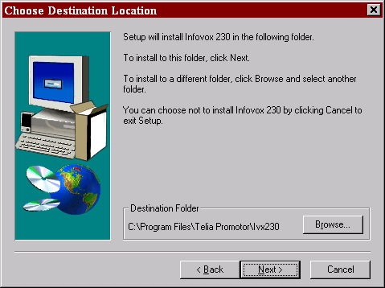
3. Select a directory and press Next.
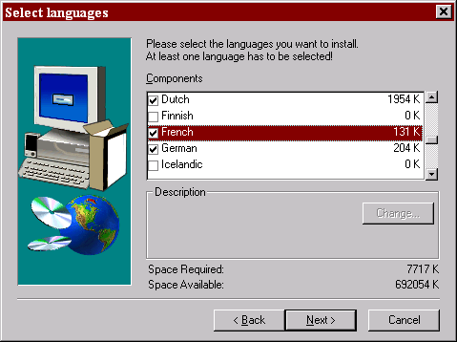
You are now prompted to choose which languages you want to install. All languages are unchecked by default. Please remember to scroll down the list to see all 12 available languages.

4. Choose the languages you wish to install and then press Next.
You are then prompted to choose the name of the folder where to store the icons for the Infovox 230 applications. The default name is "Infovox 230 2.1".
5. Choose a folder name and then press Next.
At the end of the copy the setup is complete and you'll see a "Setup Complete" message where you are prompted to launch the "License Manager" at the end of the installation.
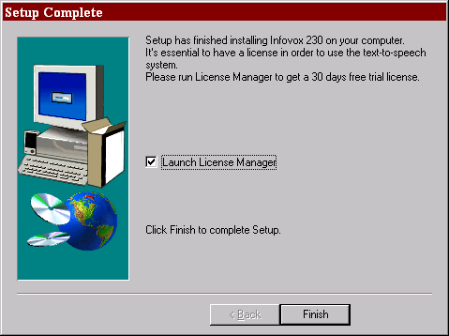
Before leaving the setup program you are presented with a message box explaining how to buy a license for the Infovox products
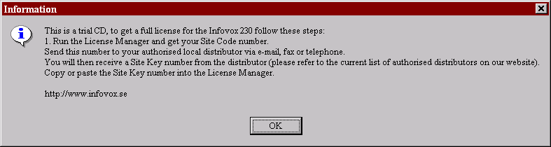
In the License Manager you can for instance activate a 30 DAYS FREE TRIAL LICENSE, that will give you full access to the Infovox 230 features for testing the system. See the License manager chapter for more information on the trial license.

4.3 Uninstalling the Infovox 230
To uninstall the Infovox 230 version 2.1 you should always use the Windows Control Panel applet called ”Add/Remove Program”.
The uninstallation of the Infovox 230 does not affect the licenses you have. The information about Licenses are left untouched just in case you would like to reinstall the Infovox 230 later.
To uninstall the Infovox 230:
1. Start the Control Panel.
You can for instance start the Control Panel by pointing on Settings from the Start menu of Windows and then choose Control Panel in the pop-up menu.
The Control Panel windows appear on the screen.
2. Double-click on the ”Add/Remove Programs” icon.
The Add/Remove Programs Properties windows appear on the screen.
3. Select Infovox 230 2.1 in the list box and click on the Add/Remove button.

4.4 Troubleshooting
It is unlikely that you will encounter any problem installing the applications. If something goes wrong you will be notified with an error message telling you what is wrong and how to proceed.
However, if after the installation you are not able to start the Speech Application or the Speech Clipboard, you should verify the following:
1. You own a license for at least one Infovox 230 language, and that license is not already used by another application. See the chapter on the Infovox licenses for more information.
2. You really have a 16-bit sound board and that you have installed the proper driver for the sound card. Since Infovox uses many of the sound card possibilities, it is possible that the sound card works fine when simply playing a WAVE file, but not when you run Infovox 230. In this case you should check that you have installed the driver that matches exactly the sound card model you have installed, and not only a generic driver for sound blaster compatible sound cards.

5. Infovox 230 standard dialog boxes
Every text-to-speech engine complying with the Microsoft Speech API specifications must provide a certain number of dialog boxes through which to perform standard operations. The reason for this is that any client application that uses a text-to-speech engine, through the Microsoft Speech API, needs to know how to access certain features in a standard way.
The dialog boxes can be invoked by any client application to allow the user to set a number of parameters. The Speech Application and the Speech Clipboard, shipped with Infovox 230, are two example of client applications accessing the Infovox 230 Text-to-Speech Engine standard dialog boxes.
What follow now is a brief introduction to the general purpose of each of these dialog boxes. You will find a detailed explanation of the specific implementation and use of these boxes with the Infovox 230 Text-to-Speech Engine in the remaining part of this chapter.
Text-to-Speech Engine Properties. By means of this dialog box the user can modify the settings of the voice and of the speech output. From this dialog box it is also possible to access the other dialog boxes.
Text-to-Speech Lexicon Browser. Via this dialog box the user can select and edit the user lexicon.
About. Displays the familiar dialog box providing information such as the version number of the Infovox 230 Text-to-Speech Engine.

5.1 The Text-to-Speech Engine Properties dialog box
The Text-to-Speech Engine Properties dialog box is used to set values for a number of parameters controlling various aspects of the text-to-speech conversion. When a client application connects to the Infovox 230 Text-to-Speech Engine, all parameters are set to their default values. Any client application can of course interact with the engine and override the default settings via the Speech API interface, but it is also possible to let the user control the values for the Infovox 230 Text-to-Speech Engine parameters via the Text-to-Speech Engine Properties dialog box.
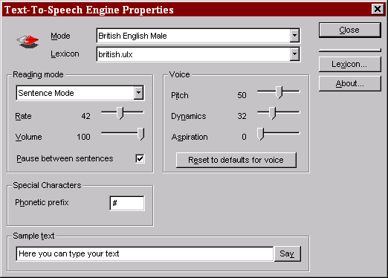

5.1.1 Mode
With the Infovox 230 Text-to-Speech Engine the user can choose to install several languages on the same machine, and with each language the user is provided with five different voices: a male voice, a female voice, a child voice, a deeper male voice named ”Giant”, and a more synthesized voice named ”Zombie”. In the Microsoft Speech API terminology, the coupling of a particular voice and a particular language is called mode. That is, if the user has received 12 languages, each shipped with five different voices, the user can at any time decide to use one among the 60 resulting modes.
The list of the available modes is shown in the Mode list.
To select a mode:
1. Click the small arrow to the right of the Mode list box.
A list of all the available modes appears.
2. Select the desired mode by clicking the corresponding entry in the list.
The list disappears and the selected option is shown in the Mode list box.
After you have chosen a mode you can immediately test it using the Sample text entry field (please refer to the related paragraph for information on the Sample text entry field).

5.1.2 Lexicon
A user lexicon is created through the Text-to-Speech Lexicon Browser dialog box, or by editing the lexicon file with any text editor (as NOTEPAD, for example). For an overall description of what the lexicon is and how to use it, please refer to the chapter on the Text-to-Speech Lexicon Browser.
To select a user lexicon:
1. Click the small arrow to the right of the Lexicon list box.
A list of the available user lexicon files appears.
2. Select the desired lexicon by clicking the corresponding entry in the list.
The list disappears and the selected option is shown in the Lexicon list box.
Please make sure that you select a lexicon that has been created for the current language, the use of a lexicon created for a different language might give unpredictable results, since the interpretation of the phonetic symbols is language dependent.
From the Text-to-Speech Engine Properties dialog box it is also possible to access the Text-to-Speech Lexicon Browser dialog box, where it is possible to actually edit the user lexicon.
To start the Text-to-Speech Lexicon Browser dialog box:
- Click on the Lexicon button.

5.1.3 Reading mode
The settings in this group are used to control how the text is read by the Infovox 230 Text-to-Speech Engine.

Reading mode
The reading mode controls how the text is read. The following reading modes are available.
Letter Mode Each character is spelled separately.
Sentence Mode This is the standard reading mode. The text processing takes into account the whole sentence, choosing the prosody that renders the structure of the sentence in the most appropriate way. A sentence is delimited by any of the punctuation characters, please note that a line feed is not considered to be a sentence delimiter by the text processor.
To select a reading mode:
1. Click the small arrow to the right of the list box under the Reading mode caption.
2. Select an option by clicking one of the entries in the list.

Rate
The Rate setting determines the reading speed of the text-to-speech engine. The level can be set to a value between 1 and 100. Level 100 corresponds to a very high speaking rate (500 words per minute), while level 1 corresponds to a very low rate. The level 50 corresponds to a normal rate for conversation or reading (150 words per minute).

Volume
The Volume control is directly connected to the speech output device, i.e. the sound card, except that a scale from 0 to 100 is used rather than 0 to 65535 used by the Windows low level audio services volume control. The volume settings are interpreted as logarithm. This means that the perceived increase in volume level from 50 to 60 is the same as it is from 40 to 50. The default value is taken from the current Wave volume setting of Windows.

Pause between sentences
The Pause setting selects whether to have a short or a long pause between sentences. By clicking the check box, the user toggles between the selections. A selected check box indicates that a long sentence pause is selected.

5.1.4 Voice
The settings in this group allow the user to control parameters related to the quality of the voice.

Pitch
The Pitch control sets the average pitch level for the selected voice. It corresponds to the base frequency for the voice. The level can be set from 0 to 100, corresponding to a pitch range of 30 Hz to 250 Hz. A level of 50 corresponds to 100 Hz.

Dynamics
The Dynamics parameter controls the amount of pitch variation in the speech, that is, how big can the frequency excursions be over and under the base frequency set with the Pitch parameter. For this parameter too, the level range is from 0 to 100. A low level setting results in a robot-like voice with no pitch variations, while a high setting corresponds to a large pitch variation, which adds expression to the voice.

Aspiration
The Aspiration parameter adds aspiration noise to all the sounds that are spoken. Level 0 means that no extra aspiration is added and 100 means maximum aspiration and absence of ordinary voicing, making the speech sound like whisper.

Reset to defaults for voice
This button works as a shortcut to reset the Pitch, Dynamics and Aspiration values to the standard settings for the reading mode currently selected.

5.1.5 Special characters

Phonetic Prefix
The Phonetic Prefix is used to switch text processing between non-phonetic (normal text) and phonetic mode. It can be used to embed phonetic strings in normal text. Any text enclosed by phonetic prefix characters will be interpreted as phonetic text by the text-to-speech converter.
To select a phonetic character:
1. Click in the Phonetic Prefix entry box.
The cursor appears in the entry box.
2. Type in the desired phonetic prefix character.

5.1.6 Sample Text
The purpose of the Sample Text entry field is to allow the user to enter a brief text and have it spoken, in order to check the result of a certain combination of parameter settings.
To enter and listen to a text:
1. Click in the Sample Text entry field.
The cursor appears in the field.
2. Enter the text.
The Say button is enabled.
3. Click the Say button to have the text spoken.

5.2 The Text-to-Speech Lexicon Browser
The Infovox 230 Text-to-Speech Lexicon Browser allows users to edit an user lexicon. An user lexicon allows the user to change the standard pronunciation of a word or to use acronyms or abbreviation in the text and to have them spoken by the Infovox 230 in the expanded form.
More specifically an entry in a user lexicon consists of a name (which works as a lookup string) and a translation. For instance, let’s suppose that we want the Infovox 230 Text-to-Speech Engine to actually speak the sentence ”as soon as possible” every time in the text the acronym ”ASAP” is encountered. To achieve this we have to add to the active user lexicon file an entry whose name is ”ASAP” and whose translation is ”as soon as possible”. The translation string can also be specified as phonetic text, by enclosing it with phonetic prefix characters and using the phonetic symbols defined for the language in use. Refer to the language-specific manuals for a in-depth coverage of the phonetic alphabets used by Infovox.
The specific user lexicon to be used during a working session can be selected in the Text-to-Speech Engine Properties dialog box or the Text-to-Speech Lexicon Browser dialog box.
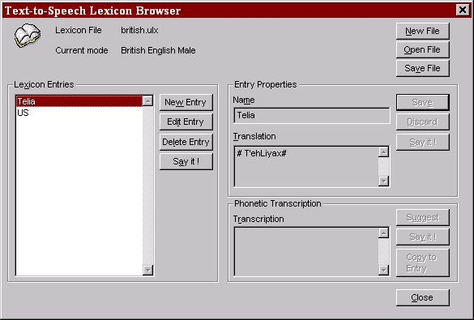

5.2.1 User lexicon filenames conventions
From version 1.1 of Infovox 230, the user can choose whatever name for a lexicon, with the only restriction for the extension to be ULX or ILX. It is anyway recommended to save lexicon files with a name that can be easily associated with the language for which they have been created.

5.2.2 Lexicon File
In this text box you will see the name of the user lexicon file. All lexicon files are placed in the ”Lex” subdirectory of the directory where you have chosen to install the Infovox 230. Typically this would be ”C:\Program Files\Telia Promotor\Ivx230\Lex”.

5.2.3 Lexicon File size limitations
Though the number of the entries allowed in a lexicon file is virtually unlimited, there are practical limits. As a rule of thumb, you can create a lexicon up to a 4000 entries without bothering thinking about performances, but if you make a much bigger lexicon than the system might slow down and, for extremely large lexicon (let’s say 50.000 entries) the system might collapse and loading time for the lexicon can become very long.

5.2.4 Language
In this text box you will see the name of the mode currently active and therefore associated to the active user lexicon file. A lexicon created while using a mode can be opened and used while using a different mode. For instance, you can create a lexicon while using the ”British English Male” mode, and then use the same lexicon for the ”British English Child” mode. Also, a lexicon created for the Infovox 230 can be used with the Infovox 330 text-to-Speech Engine, and viceversa.

How is letter case handled
When writing new entries in the lexicon you have to put some attention to the case, since this will affect the way the entry is used by Infovox.
The rule is quite simple:
- If you only use small case character when specifying an entry, then the entry will always be replaced by the specified transcription, no matter whether it is encountered in the text as lower or upper case. This option should be used when you want to improve the pronunciation of a common word.
- If you use one or many uppercase character when specifying the entry, then the entry will be replaced by the transcription only if the exact case combination is encountered in the text. You should use this option when specifying acronyms.
This rule allows you, for instance, to specify that “US” should be read as “United States” (or “ubi supra” if you wish) only when in uppercase form, leaving intact the utterance of any lowercase occurrence of the pronoun “us”. It would allow to expand the nickname “Bob” to Robert, leaving any lowercase occurrence of the verb “bob” untouched.

5.2.6 Creating a new user lexicon
The New File button allows the user to create a new lexicon file. When you create a new lexicon file, you are immediately prompted to give the new file a name.
To create a new lexicon file:
- Click on the New File button.
The Create Lexicon dialog box appears.
- Type a name for the new lexicon file.
- Click on the Save button to create the new lexicon file.

5.2.7 Saving the active user lexicon
The Save File button allows the user to save the changes to the active user lexicon file.
To save the active lexicon file:
- Click on the Save File button.
The active lexicon file is saved with the filename shown in the Lexicon File text box.

5.2.8 Opening an existing user lexicon
The Open File button allows the user to load a user lexicon file for editing.
- Click on the Open File button.
The Open Lexicon dialog box appears.
- Select the user lexicon file that you want to open.
- Click on the Open button.

5.2.9 Lexicon Entries
In this list box you will see all the names of the entries registered in the active user lexicon file, listed alphabetically. When you select an entry in this list box you will see its translation appearing in the Translation box in the Entry Properties group.

New Entry
Use this button when you want to create a new entry in the active user lexicon file.

Edit Entry
Use this button when you want to edit an entry. If you edit an entry but forget to save it, as soon as you select another entry, a dialog box will appear asking you whether you wish to save the edited entry or not.

Delete Entry
Use this button to delete the current entry. Before the actual operation takes place a dialog box will appear, prompting to confirm your choice.

Say it!
Use this button to speak the selected entry.

5.2.10 Entry Properties
The controls grouped in this section allow the user to edit the lexicon entries.

Name
In this box the user can enter or edit the name of the entry.

Translation
In this box the user can enter or edit the translation of the current entry.

Save
Use this button to save the changes to the current entry.

Discard
Use this button to discard the changes to the current entry.

Say it!
Use this button to have the text placed in the Translation box spoken. This option is particularly helpful when you are trying to change the pronunciation of a word entering phonetic text in the Translation box.

5.2.11 Phonetic transcription
The controls grouped in this section are meant to make the process of creating an user lexicon file easier. They are particularly fit to situations in which the user wants to edit the pronunciation of a word using the phonetic text.

Transcription
In this text box you can edit a string to be spoken and then, eventually, copied to the Translation box in the Entry Properties group. In case you want to edit the phonetic text, make sure that the text begins with the phonetic prefix character defined in the Text-to-Speech Engine Properties dialog box.

Suggest
Use this button to get the phonetic transcription of the string contained in the Name text box of the Entry Properties group. The phonetic transcription suggested by the Infovox 230 Text-to-Speech Engine is placed in the Transcription text box and it is ready to be edited in order to fit the user requirements.

Say it!
Use this button to have the text placed in the Transcription text box spoken.

Copy to Entry
Use this button to have the text placed in the Transcription text box copied to the Translation text box of the Entry Properties group.

5.3 The About dialog
The About dialog shows product information, such as the version number of the Text-to-Speech engine, and can be invoked by clicking on the About button in the Text-to-Speech Engine Properties dialog box.

6. Infovox 230 language licenses
In order to properly use any of the Infovox 230 languages you are required to get a language license.
Starting with version 1.1 of the Infovox 230, the language licenses will be delivered as Site Authorization licenses. However, to preserve a complete backward compatibility, the Software Key and Hardware Key licenses are still fully supported on the Windows 95 environment. On Windows NT, however, the only type of license supported is the Site Authorization.

6.1 Getting a new language license
When you have decided to actually buy a language license, then you should contact your authorized local distributor for the Infovox products.
The procedure for getting the language license is the following:
1. Run the License Manager and get your Site Code number.
2. Send this number to your authorized local distributor via e-mail, fax or telephone, and specify which language(s) you want to buy.
You will then receive a Site Key number from the distributor (please refer to the current list of authorized distributors on our web site).
4. Copy or paste the Site Key number into the License Manager.
To get more information about Site Authorization licenses, Site Keys and Site Codes, please refer to the Site Authorization section later in this chapter.

6.2 If you already own a language license for Infovox 230
If you already own a language license for Infovox 230, then you do not need to perform any particular operation. This language license will be automatically detected and used by the Infovox 230 version 2.1.

6.3 Site Authorization license
The Site Authorization license has been introduced with release 1.1 of Infovox 230. It is based on a completely numeric algorithm, and it binds a license to the Hard Disk. Once you own a license then you can transfer it to another hard disk or share it on a network. For detailed information on transferring the license or sharing the license in a network, refer to the dedicated sections in the next chapter.
One Site Authorization license can enable several languages at once, you do not need to get a separate Site Authorization license for each language you want to buy.
Please note that you have to take care of transferring the license before you substitute or reformat the Hard Disk, otherwise the license will be lost.

6.3.1 Site Code and Site Key
In order to get a Site Authorization license, you need to provide your authorized distributor with a Site Code. The Site Code is a numeric code that contains encrypted information about the current status of your license (if any) and the hard disk that you intend to license. Once you have provided the Site Code, you will be given the corresponding Site Key. The Site Key contains updated information on your license and can only be used on the same hard disk from where you have generated the Site Code.
The Site Codes and Site Keys are quite long strings of hexadecimal digits. They can contain any number (0-9) plus the first 6 letters (A-F), letter case is ignored so you can use both upper or lower case.
To make the keys more readable it is common to insert a blank space every four digits. Blank spaces do not affect the keys and can be inserted everywhere. Here is an example of Site Code / Site Key pair:
Site Code: D978 C312 D888 5D8B 71
Site Key: E47B 414D 3BFC 667C 7EA9 3CA7 45
All operations regarding the Site Key and the Site Code are handled through the License Manager application. Refer to the chapter dedicated to the License Manager for more information on the subject.
Please note that when you enter a valid Site Key, your Site Code will change. If you need to update your license, make sure you provide your distributor with an updated Site Code.

6.3.2 Multisession licenses
It is important to note that the Site Authorization license always works as a network license, even for computers that are not connected to a network. That means that a Site Authorization license automatically counts the number of applications using Infovox 230 at the same time.
For instance, let’s say that the Site Authorization license you own gives you the possibility to start three simultaneous sessions. Then if you start four applications using the Infovox 230 at the same time, only the three applications that you have started first will get a license, the fourth application will not be able to use Infovox 230.
Please note that the License Manager needs to take one Site Authorization license to run properly, so you should never run the License Manager when you are running another application using Infovox 230.
A side effect of the network license concept, is that every application needs to properly communicate to the Site Authorization license server when it has finished using the Infovox 230, so that the license will be immediately released and made available for other applications. If the application fails to do this (due to an application error or to an unexpected crash or shutdown, for example), then the Infovox 230 license will stay pending, i.e. unavailable, for few minutes before the system has detected that the license is no longer in use.

6.3.3 The CRYPKEY.INI file and CKCONFIG program (Windows NT only)
The file CRYPKEY.INI, stored in your Windows NT directory (usually C:\WINNT), specifies the directory where your Site Authorization license files are stored on your hard disk. You should never delete or manually edit this file.
If you need to add or remove directories from the CRYPKEY.INI file, use the CKCONFIG.EXE application, also stored in your Windows NT directory. You are required to use this application when performing a Move License operation.
To add a directory to the list in the CRYPKEY.INI file:
1. From the Start menu of Windows NT select Run.
The Run dialog box appears.
2. Type ”ckconfig.exe” in the Open box and click on OK.
First you will see a warning message saying that your modification will not take effect immediately, then the Crypkey NT Server Configure dialog box appears.
3. Look at the list of directory already listed in the CRYPKEY.INI file. Then, if you want to Add a directory click on the Add button.
The Open box shows up
4. Now, if you want to select a directory containing the Site Authorization license files, you have to write ”*.lic” in the File name box and click on Open. This will give you the possibility to see the files.
In case you intend to use hidden directories or files, please make sure that you have selected the appropriate options in the Windows Explorer application.
5. Browse your hard disk and go to the directory that you want to add to the CRYPKEY.INI list, locate the Ivx230.lic file and click on Open.
In the main window of the Crypkey NT Server Configure application you will see the new directory.
6. Click on Close to exit the application.
If you want to remove a directory, follow step 1 and 2 of the procedure here above. And then click on the directory name that you want to remove, and then on the Remove button. Click then on Close to exit the application.
Please note that the CRYPKEY.INI file might be used by other applications as well, using the same licensing system used by the Infovox 230 Text-to-Speech Engine. Do not delete directories from this file unless you are sure they are not used by any program.
The default directory for the Infovox 230 Site Authorization license files is ”C:\INFOVOX.LIC”. This directory is hidden to diminish the risk of accidental delete or move.

6.3.4 Compatibility with hard disk defragmenter
The Site Authorization license has proved to be highly reliable and compatible. However a known threat is represented from special defragmentation programs. Most of the defragmentation application will not have any effect on the license, but if you use some special defragmentation program or some advanced option that allows relocation of system hidden files, then you could harm the Site Authorization license. At the moment of writing, the only program known to do this is the Symantec's Norton Utilities SpeedDisk. If you use this utility, then you have to make sure that you disable the relocation of system files and files with the following extension: *.ENT, *.KEY, and *.RST.

6.4 Software Key license (Windows 95 only)
Many of the licenses distributed with the first release of Infovox 230 were Software Keys. These have been replaced by Site Authorization licenses mainly because of increasing compatibility problems, which would prevent the Infovox 230 to run on Windows NT computer or on few portable computers.
Software Keys licenses are always delivered on a floppy disk and are language specific, so you will get a separate Software Key for each language you buy. The only exceptions to this rule are the demonstrative time-limited licenses, described later in this chapter.
If you got your language license as a Software Key, then it is extremely important that you keep the original floppy disk which contains the Software Key, even after you have enabled the language license on your computer. In fact, whenever in future you decide to disable the Software Key from your computer you will have to provide that floppy disk again in order to perform the operation. You might want to disable the Software Key from your computer for many reasons, for instance because you want to move it to another computer, or because you are going to change your hard disk and you need to reinstall all your software.
Please remember that you cannot copy or move Software Keys as normal files, you always need to use the License Manager to perform operations on Software Keys.

6.4.1 The demonstration time-limited licenses
There are three special demonstration time-limited licenses that are sometimes delivered as Software Key licenses. These licenses are going to be replaced by Site Authorization licenses which provide a higher flexibility and reliability than Software Key licenses.
The Southern Limited License is a time-limited demonstration license which gives to the user a time limited language license for all Infovox 230 languages. It is usually delivered on a disk containing the American English, British English, French, German, Italian, and Spanish languages.
The Northern Limited License is a time-limited demonstration license which gives to the user a time limited language license for all Infovox 230 languages. It is usually delivered on a disk containing the British English, Danish, Finnish, Icelandic, Norwegian, and Swedish languages.
The Developer Limited License is a time-limited license that is meant to be used by developers who need to have complete access to all the Infovox 230 languages under a period of time which is supposed to cover the development process. It works in the same way as the two other time-limited demonstration licenses previously described, but it usually lasts for a longer period of time.

6.4.2 Checking the Software Keys on the installation disk
If you want to know how many Software Keys are left on your Infovox language disk, follow this procedure:
1. Start the PC in DOS mode (or open an MS-DOS window from Windows).
2. Insert the disk containing the Infovox Software Key license in the A: drive.
3. Type "A:" to log to the A: directory.
4. Type the following command (note that the "A" must be uppercase):
VFLANGS A:
After few seconds you will get a list similar to the following:

Language Exp.Date Exp Rem.Days Exp Rem.Execs Exp Rem.Inst ==================================================================
North Demo Problem reading the installation coding, not installed ?
South Demo Problem reading the installation coding, not installed ?
[...]
Norwegian Problem reading the installation coding, not installed ?
Spanish - - - - - - 2
Swedish Problem reading the installation coding, not installed ?

Ignore all the lines saying "Problem reading..." and find in the list the line starting with the name of the language for which you want to check how many Software Keys are left on the Infovox language disk. The number displayed under the "Rem.Inst" column (last column on the right) indicates the number of Software Keys left on the Infovox language disk.
In the example above the Infovox language disk has two Software Keys left for the Spanish language.

6.5 Hardware Key license (Windows 95 only)
The Hardware Key (often referred to as Dongle) is a small hardware device that has to be inserted into the parallel port of your computer. Notice that the Hardware Key will not prevent the use of the parallel port for other purposes, the Hardware Key has a female connector on the rear to which you can connect the devices usually connected to the parallel port (for instance a printer). The presence of the Hardware Key will not influence the performance of the devices you want to connect to your parallel port. A Hardware Key was generally shipped to users that for some incompatibility problem could not use Software Keys. From version 1.1 of Infovox 230, there is no more need to ship Hardware Keys, since they have been replaced by Site Authorization licenses. However, Hardware Keys are still fully supported in the Windows 95 environment, to provide full backward compatibility.
Each Hardware Key is programmed to license one or more languages, thus avoiding the need to use a Hardware Key for each language. Inserting the Hardware Key into the parallel port is all you need to do to enable the language licenses contained on the Hardware Key on your computer.
Please note that for safety reasons you should always turn your computer off before inserting or removing the Hardware Key from the parallel port.
As long as the Hardware Key is inserted you will be able to use the language licenses, when you remove the Hardware Key the language licenses automatically disappear. You can then insert the Hardware Key into another computer thereby immediately enabling the language licenses on that computer.
You do not need to run the License Manager in order to enable the language licenses on your computer when you have a Hardware Key. However, running the License Manager will allow you to check which language licenses are enabled by the Hardware Key and provide some other information on the type of language license.

7. The License Manager
All operations on the Infovox 230 language licenses are handled through the License Manager application. The License Manager is installed by the Infovox 230 setup program.
To start the License Manager:
1. Open the Infovox 230 v2.1 program group.
2. Double-click on the License Manager icon.
The License Manager dialog box appears.
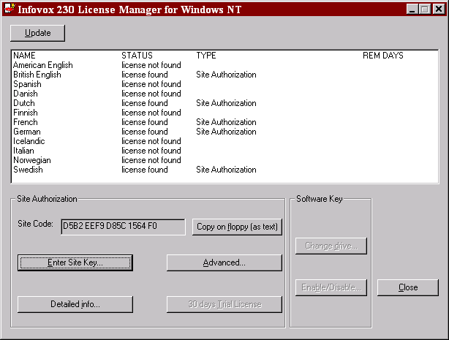

7.1 Windows 95 and NT version
The License Manager for the Infovox 230 is also available in a separate Windows NT version. If you run Infovox 230 under Windows NT, it is necessary that you use this version of the License Manager. The Infovox 230 Setup program takes care of installing the proper version of the license manager on your computer.
The only difference between the two versions of the License Manager is that in the Windows NT version there is no support for Software Keys and Hardware Keys. This is due to the incompatibility between this type of licenses and Windows NT.
The title of the License Manager Windows will report which version of the License Manager is currently being used.

7.2 The license list
The main box in the License Manager window reports the current status of the language licenses for the installed languages.
Each row of the license list corresponds to a language which has been installed on your machine. To add a language to the license list you must run the Infovox 230 installation program, please refer to the installation instructions for more details on this topic.
The license list is divided in four columns: NAME, STATUS, TYPE and REM DAYS.
Under the NAME column you can see the name of the languages that have been installed.
Under the STATUS column you can see which is the current status for each license. The string ”License found” means that a license for that language is currently present on your computer. The string ”License not found” means that you do not currently own any license for using that language on your computer. The string ”File error” usually means that a file is missing, running the installation program will generally solve the problem. For detailed instruction on how to get a license, please refer to the previous chapter.
Under the TYPE columns you will be able to see, for each language, which type of license you are currently owning. For more information on the different types of licenses, please refer to the previous chapter.
Under the REM. DAYS column you can see how many days are left before the language license will expire. If this field is empty, then your license is valid for an unlimited time.

7.3 Site Authorization management
All operations on the Site Authorization licenses are performed using the controls in the Site Authorization group.

7.3.1 Site Code
In the Site Code box you can see the current Site Code number for your computer. This number has to be provided to your authorized distributor in order to receive a Site Key and enable your Site Authorization license.
To make things easier, and to avoid risk for spelling mistakes, you can copy this number in the Windows Clipboard (using the standard Ctrl+C shortcut) and then paste it in a mail or fax document.
An even easier way is to use the Copy on floppy (as text) button. This will create a text file on a floppy disk containing your Site Code. You can then send the floppy disk to your distributor with no need of any other operation. The file on the floppy disk will be called IVX230CODE.TXT.
To save the Site Code on a floppy disk.
1. Enter a floppy disk in the floppy disk drive. Please make sure that the disk is not write protected.
2. Click on the Save on floppy button.

7.3.2 Entering the Site Key
Once you have received the Site Key from your authorized distributor, you can enter it in the License Manager using the Enter Site Key feature.
You might have received the Site Key on a floppy disk, in this case the procedure is even simpler, since you do not even need to type or paste the key in your application. The file on the floppy disk must be called IVX230KEY.TXT.
To enter the Site Key:
1. If you have received the Site Key on a floppy disk, insert the floppy disk in your computer.
2. Click on the Enter Site Key button.
The Enter Site Key dialog box will pop up.
3. Type or paste the Site Key number in the edit box.
Or
If you have received the Site Key on a floppy disk, just click on the Copy from floppy (as text) button.
4. Click on OK.
A message box will appear reporting the result of the operation. In case something went wrong, please check that the spelling of the Site Key is correct.
After you have entered the Site Key the information in the Site Code box and the license list will be automatically updated.

7.3.3 Detailed info
The Detailed info button allows you to get further information on the Site Authorization license status.
To get detailed information on the Site Authorization license:
1. Click on the Detailed info button.
The Detailed info dialog box will pop up.
The Available multisessions box shows how many concurrent licenses you can access from your computer.
The License level box shows which type of Site Authorization license you have been granted.
The License directory box shows the directory containing the Site Authorization files. This directory and its content must never be manually modified, renamed or deleted.
The License option and Auth function return value boxes contain information that can be reported to the support engineers in case something would not work.

7.3.4 Advanced
The Advanced button allows you to perform administrative operations on the license. You should not use the options listed here unless you are completely confident with the program. On Windows NT this button is disabled for users who do not belong to the administrative group.
When you click on the "Advanced" button, then you get a window with 4 buttons: Move license to another computer, Specify a new license directory, Kill license, and Reset license.

7.3.4.1 Specify a new license directory
The Specify a new license directory button allows you to specify in which directory are the Site Authorization license files stored. You will most likely never need to specify a new license directory, one exception might be a situation in which you want to access a license that resides on a network path. Refer to the ”Notes on sharing a license on the network” section at the end of this chapter for more information on this subject.
To know which is the current Site Authorization license directory, please refer to the section dedicated to the Detailed info command.
Please note that this command will not move the license, it only tells the Infovox 330 to look for the license in a directory different from the current one.
To specify a new license directory:
1. Click on the License directory button.
The Specify new license directory dialog box will pop up.
2. Type the new license path in the Enter new license path box.
Or
Click on the Browse button to search the new path using the graphic interface.
3. Click on OK.
After you have specified a new license directory the information in the Site Code box and in the license list will be automatically updated.

7.3.4.2 Kill License
Never use the Kill License feature unless you are 100% convinced that you want to permanently delete your license. This feature does exactly this: permanently remove your Infovox 230 license.

7.3.4.3 Reset License
If the application using Infovox does not correctly release the Infovox 230 engine when shutting down, then the license will not be released and it might result busy even if the application has been closed. This is for instance the case when you shut the computer without exiting the applications, or experience a system crash. In these cases Infovox is abruptly interrupted and cannot close the licensing session. The license is generally automatically recovered within 5 minutes from the crash, but you can also restore it immediately by using the Reset License button.
The Reset License button should never be used when Infovox is active.

7.3.4.4 Move license to another computer
See the section 7.4 for extended instruction on how to move a license.

7.3.5 30-days Trial License
If you do not have a license, you can use this button to grant yourself a 30 days demo on your computer. Please note that you are allowed to create the 30 days license only once on each computer.
To create a 30-days license
1. Click on the 30-days Trial License button.
The License Agreement dialog box will pop up.
2. Read the agreement and click on I Accept if you accept the conditions.

7.4 Moving the Site Authorization license
In case you want to move the Site Authorization license to another location on your hard disk, to another computer connected via a network, or even to another computer that has no connection with the computer currently owning the license, you can use the Move license feature.
This is a quite powerful feature that allows you to move your license to another computer with no need to buy new licenses or get a new Site Key from your authorized distributor.
When you want to transfer the license between two directories on the same hard disk, or to transfer the license via the network (only for Windows NT computers), the operation is very straightforward.
When you need to move the license to another computer not connected through the network, the operation gets slightly more complicated, since you are required to use a blank floppy disk and perform a three-steps operation.

7.4.1 Moving the Site Authorization license to a different directory
If you ever need to move the Site Authorization license files on your computer, then you have to use this feature. Please do not place the Site Authorization license in a directory that is commonly used for file transfers or that might possibly be deleted. The lost of any of the files associated with the license (usually files with name ”ivx230.*”) will result in the lost of the license itself.
Please note also that any attempt to move the Site Authorization license files manually will damage your Site Authorization license.
Note for Windows NT computers only:
Before running this command you need to start the CKCONFIG.EXE application that you find in your Windows NT directory (usually C:\WINNT) and make sure that the target directory is among those registered by the Site Authorization license server.
Note that you need Administrator privileges to perform this operation.
To move the Site Authorization license to a new directory:
1. Click on the Advanced button and then on the Move license to another computer button.
The Move license dialog box will pop up.
2. Click on the Move license directly button.
The Move license to another directory dialog box will pop up.
3. Type the new license path in the Enter new license path box.
Or
Click on the Browse button to specify the new path using the graphic interface.
4. Click on OK.
After you have moved the license the information in the Site Code box and in the license list will be automatically updated.

7.4.2 Moving the Site Authorization license to another computer via the network
Site Authorization licenses can be moved directly between two computers in a network, without using floppy disks. A current limitation is that the computers have to run Windows NT. A procedure that would allow the license to be directly moved between computers running Windows 95, Windows 98 or Novell Netware is not yet available. Please check our web site or contact us if you need more information on this.
Before running this command you need to start the CKCONFIG.EXE application on the target computer that you find in your Windows NT directory (usually C:\WINNT) and make sure that the target directory is among those registered by the Site Authorization license server. Note that you need Administrator privileges to perform this operation.
To move the license to a new computer through the network:
1. Click on the Advanced button and then on the Move license to another computer button.
The Move license dialog box will pop up.
2. Click on the Move license directly button.
The Move license to another directory dialog box will pop up.
3. Type the new network license path in the Enter new license path box. You can use mapped drive names (for instance ”F:\NewPath”) or UNC names (for instance ”\\NETSERVER\NewPath”).
Or
Click on the Browse button to browse through the network using the graphic interface.
4. Click on OK.
After you have moved the license the information in the Site Code box and in the license list will be automatically updated.
On the TARGET computer you only need to make sure that the license directory specified in the Detailed info box corresponds to the one where you have moved the license to. If not, use the License directory button to specify the proper directory.

7.4.3 Moving the Site Authorization license to another computer via floppy disk
If you want to move the license to another computer using a floppy disk, then you need to perform a three-steps operation that will require you to move the floppy from the target computer to the source computer, and then back again. For this reason it is very convenient to have the two computers close to each other.
Please follow the procedure carefully while performing this operation. To perform this operation you need to have:
- a source computer (referred here as SOURCE), that has Infovox 230 installed and has a Site Authorization license on the hard disk.
- a target computer (referred here as TARGET) with Infovox 230 installed but no Site Authorization license yet on the hard disk. If the target computer has a license that you want to get rid of (for instance a time limited license), then you should use the Kill License feature before starting the move operation.
- a blank formatted floppy disk.
To perform the procedure here described you also need to have the License Manager application active on both computers.
1. On the TARGET computer, click on the Advanced button and then on the Move license to another computer button.
2. When the Move license dialog box comes up, click on the Move license with floppy button.
3. Then, in the Move license with floppy dialog box, click on the Target computer option.
4. Insert the floppy disk in the disk drive and click on 1. Create floppy for transferring license to start the operation.
The Prepare floppy to receive license dialog box will pop up.
5. Select the unit number of the drive where you have inserted the floppy disk and click on OK.
6. Leave the License Manager opened and take the floppy disk to the SOURCE computer.
7. On the SOURCE computer, click on the Advanced button and then on the Move license to another computer button.
8. When the dialog box comes up, click on the Move license with floppy button.
9. In the new Move license dialog box, click on the Source computer option.
10. Insert the floppy disk that you have created on the TARGET computer on steps 5 in the disk drive and click on 2. Transfer license to floppy to transfer the license from the hard disk to the floppy disk.
Please note that the license on the floppy disk now it is already prepared for the TARGET computer and it would not work on any other computer. You cannot at this point cancel the operation, since the Site Authorization license on the SOURCE computer has been registered for the transfer and is not accessible anymore. So you must now take the floppy disk with the license to the TARGET computer and complete the operation.
11. Take the floppy disk to the TARGET computer, insert it in the drive and click on 3. Transfer license from floppy.
The license has now been transferred from the SOURCE computer to the TARGET computer.
After you have moved the license the information in the Site Code box and in the license list will be automatically updated on both computers.

7.5 Notes on sharing a Site Authorization license on the network
Site Authorization licenses might be shared on a network. A current limitation is that the server computer has to run Windows NT. An installation procedure that would allow Windows 95, Windows 98 or Novell Netware to work as server is not yet available. Please check our web site or contact us if you need more information on this.
Sharing a Infovox 330 Site Authorization license on the Network is a quite straightforward operation, it only requires to perform an additional configuration step on the client computers (i.e. the computer accessing a license on a remote computer).

7.5.1 Configuring the client computers
On the client computers all that is required to do is to use the ”License directory” command of the License Manager to specify the network path to the server directory containing the license files.
For instance, if the server computer is called NETSERVE and the Site Authorization license files are stored in the C:\INFOVOX.LIC directory of the server computer, then you will probably have to specify a path like ”\\NETSERVE\INFOVOX.LIC” if you use UNC names, otherwise it might be something like ”H:\INFOVOX.LIC”, if the ”C:” drive of the server is mapped to the ”H:” drive on the client computers.
Please note that the client computers needs both READ and WRITE access to the license directory of the server.

7.6 Software Key management (Windows 95 only)

7.6.1 Enabling a language license
To enable a language license you must have a floppy disk containing a Software Key for one of the Infovox 230 languages. Please note that the floppy disk must not be write protected.
To enable a Software Key language license:
1. Insert the floppy disk containing the Software Key in the floppy disk drive. Make sure that the disk is not write protected.
2. Click on the Enable/Disable button.
The Enable/Disable Software Key dialog box will pop up.
3. Select the name of the language, or the name of the limited license, from the Select license combo box.
The Select license combo box contains a list of all the installed languages plus the three standard demonstrative time-limited licenses, namely the Develop limited license, the Northern limited license, and the Southern limited license.
4. Click on the Enable button.
The enabling operation starts. The operation can take up to 30 seconds, depending on the computer used, so please be patient and do not try to interrupt the operation in any way. When the operation is done, you will see another dialog box reporting the result of the operation. If the result is negative, please check that you inserted the right floppy disk and that the floppy disk is not write protected.
At the end of this operation, the license list will show the updated status of the licenses on your computer.

7.6.2 Disabling a language license
Disabling a language license is an operation very similar to enabling the language license. Once you have disabled a language license you can use the floppy disk containing the language license to enable the language license on another computer.
To disable a language license you must have the floppy disk, from which you installed the corresponding language file, inserted in the floppy disk drive of your computer. Please note that the operation will fail if the floppy disk is write protected.
To disable a Software Key language license:
1. Insert the floppy disk from which you installed the Software Key in the floppy disk drive. Make sure that the disk is not write protected.
2. Click on the Enable/Disable button.
The Enable/Disable Software Key dialog box will pop up.
3. Select the name of the language, or the name of the limited license, from the Select license combo box.
The Select license combo box contains a list of all the installed languages plus the three standard limited licenses, namely the Develop limited license, the Northern limited license, and the Southern limited license.
4. Click on the Disable button.
The disabling operation starts. The operation can take up to 30 seconds, depending on the computer used, so please be patient and do not try to interrupt the operation in any way. When the operation is done, you will see another dialog box reporting the result of the operation. If the result is negative, please check that you inserted the right floppy disk and that the floppy disk is not write protected.
At the end of this operation, the license list will show the updated status of the licenses on your computer.

7.6.3 Changing drive letters
In all operation dealing with Software Keys it is assumed that the floppy disk drive is named ”A:” and the hard disk where you want to place the Software Keys is ”C:”. If your configuration is different, then you can use the Change drive feature to correct this.
Please note that this operation will also influence the way in which the Infovox 230 will try to determine whether a Software Key is present on the computer. Please make sure that the drive names are always up to date.
To change the drive names:
1. Click on the Change drive button.
The Software Key source and destination drive dialog box will pop up.
In the Enter software key source drive box you can specify the drive letter of the hard disk unit where the Software Key has to be placed (or found, if you already enabled it).
In the Enter software key source drive box you can specify the drive letter of the floppy disk unit for your computer.
3. Once you have typed the new drive letters, click on OK to return to the main window.

7.7 Hardware Key Management (Windows 95 only)
The management of the Hardware Key licenses does not require any other operation than inserting and removing the Hardware Key from the parallel port of the computer.
Make sure that you always operate on the Hardware Key when the computer is off. For more information on the Hardware Key licenses please refer to the dedicated section in the previous chapter.

8. The Infovox 230 Speech Application
The Infovox 230 Speech Application shows some of the capabilities of the Infovox 230 Text-to-Speech Engine, but has many of the typical features of a professional text-to-speech client application. As a matter of fact, through this client application it is possible to speak out aloud any text file or whatever you write in the Speech Application window.

8.1 Starting the Speech Application
To start the Speech Application:
1. Open the Infovox 230 v2.1 program group.
2. Double-click on the Infovox 230 Speech Application icon.
The Infovox 230 Speech Application window appears.
In the Infovox 230 Speech Application window you will see an empty document window. You can type any text and then have it played by the Infovox 230 Text-to-Speech engine.
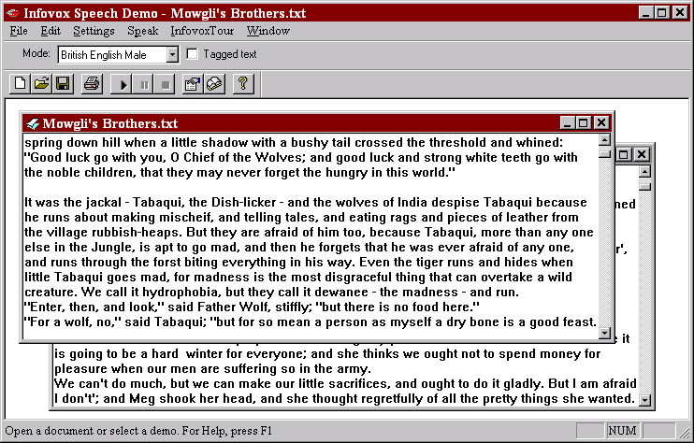

8.2 The menus

8.2.1 File menu
Use the New command from the File menu to create a new text file. An empty document window appears, ready for editing.
Use the Open command from the File menu to open a file, you will be prompted with the familiar Open File dialog box. Double-click on the name of the file you want to open and its content will appear in a new document window. Please consider that the maximum size for a file to be opened with the Speech Application is limited to 32 KB (approximately 32.000 characters).
Use the Close and Save commands from the File menu to close and save files. To save the file with a different name, choose Save as.
You can also take advantage of all the printing facilities commonly supported by the windows applications, through the Print, Print Preview and Print Setup commands in the File menu. Right below these commands on the File menu you will see a list of the text files opened most recently. Click on a filename to open it in a new document window.
Use the Exit command from the File menu to quit the Speech Application.

8.2.2 Edit menu
You can edit the text in the open document in the familiar way, using the Undo, Cut, Copy, Paste and Delete commands from the Edit menu.
Use the Select All command from the Edit menu to highlight all the text in the active document window.

8.2.3 Setting menu
Use the Properties command from the Settings menu to bring up the Text-to-Speech Engine Properties dialog box. Refer to the related chapter for more information on the Text-to-Speech Engine Properties dialog box.
Use the Lexicon command from the Settings menu to bring up the Text-to-Speech Lexicon Browser. Refer to the related chapter for more information on the Text-to-Speech Lexicon Browser.
Use the About command from the Settings menu to bring up the About dialog box.

8.2.4 Speak menu
Use the Play command from the Speak menu to have the text spoken aloud. The Speech Application automatically starts to read the text from the beginning of the file. If you wish to listen only to a specific portion of text, highlight that portion before you choose the Play command.
While the speech is in progress, you can choose the Stop command from the Speak menu to stop the speech. You can also choose the Pause command from the Speak menu to suspend the speech, then when you choose the Pause command again, the speech output will resume.

8.2.5 Infovox Tour menu
The purpose of the commands grouped in this menu is to demonstrate and explain the different parts of the Infovox 230 Text-to-Speech Engine.
The Speech options command from the Infovox Tour menu presents a dialog box with several tabs, corresponding to the different settings made available by the Infovox 230 Text-to-Speech Engine. Each setting has its own tab where changes can be entered. In addition, each tab includes a picture and a brief explanation of the setting. You can browse through the different tabs by clicking on the tabs captions. You can immediately try the effect of your changes by using the small icons of the Play and Stop buttons on the right-low corner of each tab: a short demonstrative text in the currently selected language is then spoken out aloud using the settings you specified.
The Speech Engine Object, and Speech Clipboard commands from the Infovox Tour menu provide some information on how the various parts of the Infovox 230 work.
The OLE interfaces command from the Infovox Tour menu is a valuable resource that provides quick reference information and examples on the OLE standard interfaces supported by the Infovox 230 Text-to-Speech Engine. This option will prove to be particularly useful for developers who want to access the Infovox 230 Text-to-Speech Engine services from their client applications.
The Control tags command from the Infovox Tour menu is another quick reference information resource which provide descriptions and examples for all the control tag command recognized by the Infovox 230 Text-to-Speech Engine. This information is less technical and will prove to be useful to everyone who wants to use the Infovox 230 Text-to-Speech Engine in a more creative manner.

8.2.6 Window menu
The commands grouped in the Windows menu can help the user to organize multiple files on the screen. There is virtually no limit to the number of documents that can be open at the same time.

8.3 Selecting a mode
If you want to select a different mode to speak the text in the current window you can do it quickly by using the Mode box in the main window of the Speech Application. As an alternative you could of course also choose a mode from the Speech Properties box, and there you could also set new values for the various parameter (Speed, Pitch and Dynamics for instance).
To select a new mode you only need to click on the small arrow next to the Mode box, and select a new mode from the drop-down list.

8.4 Tagged Text
If you want to use the Microsoft Speech API control tags in your text, you need to check the Tagged Text option in the main window of the Speech Application.
Here is an example of tagged text:
\Spd=150\ Now I speak normal, \Spd=300\ here I speak a bit faster, and soon I will \Spd=40\ speak very slowly!
For more information on Control Tags refer to the Microsoft Speech API 3.0 specifications. Few special remarks on the control tags available for the Infovox 230 refer to the chapter dedicated on the Speech API implementation in this guide.

9. The Infovox 230 Speech Clipboard
This client application provide a simple way to use the Infovox 230 Text-to-Speech Engine in combination with your computer. In fact you can, through the Speech Clipboard, add voice to any windows program. Simply highlight the text you want to be spoken and copy it to the clipboard (through the Copy command or the common Ctrl+Ins or Ctrl+C key combination) and the Infovox 230 Text-to-Speech Engine will start reading the text out aloud for you.
The Speech Clipboard application might not be your best bet if you need to have a professional screen reading tool, but it is a powerful tool that will prove to be of great help in many situations. It provides also an excellent overview of the enormous potential that the Infovox 230 Text-to-Speech Engine can add to the presentation capabilities of your computer.

9.1 Starting the Speech Clipboard
To start the Speech Clipboard:
1. Open the Infovox 230 v2.1 program group.
2. Double-click on the Infovox 230 Speech Clipboard icon.
The Speech Clipboard icon then appears on the task bar at the bottom of the screen, usually next to the Windows 95 clock.

9.2 Configuring the Speech Clipboard
The Speech Clipboard may be configured to function in different ways. You can choose to have automatic speech activation or you might choose to control the start and stop of the speech with the mouse. You can also choose to have an animation appear whenever the Speech Clipboard is reading text.
To configure the Speech Clipboard:
1. Right-click on the Speech Clipboard icon on the task bar.
A pop-up menu appears.
2. Choose Properties from the pop-up menu.
The Speech Clipboard Properties dialog box appears.
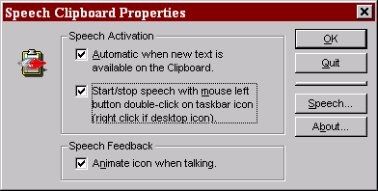
3. Use the check boxes to switch options on and off.
4. Press OK to save the settings.
Use the Quit button in the Speech Clipboard Properties to close the Speech Clipboard. You can also quit the Speech Clipboard by right-clicking on the Speech Clipboard icon in the task bar and then choose Close from the pop-up menu.
Use the Speech button in the Speech Clipboard Properties to start the Text-to-Speech Engine Properties dialog box. You can also start the Text-to-Speech Engine Properties dialog box by right-clicking on the Speech Clipboard icon in the task bar and then choose Engine Properties from the pop-up menu.
Analogously, the About dialog box can be brought up by clicking on the About button in the Speech Clipboard Properties, or by right-clicking on the Speech Clipboard icon in the task bar and then choose About from the pop-up menu.
To bring up the Lexicon Browser dialog box, right click on the Speech Clipboard icon in the task bar and then choose Lexicon from the pop-up menu.

9.2.1 The Speech Clipboard Icon
You can configure the Speech Clipboard so that a “speech bubble” animation appears on the task bar whenever text is being spoken out aloud. You will also see, on the Clipboard icon, the familiar symbol for ”paused”, represented by two vertical thick lines, whenever the speech is paused.
To activate this function click on the Animate icon when talking check box from the Speech Clipboard Properties dialog box.

9.3 Speech activation
The Speech Clipboard can be configured to run in automatic mode, meaning that whenever text is copied into the Clipboard, it will be automatically spoken out aloud. The Speech Clipboard checks the Clipboard continuously and speaks out aloud any text that is placed there, typically through the copy and cut commands. To activate this function click on the Automatic when new text is available on the Clipboard check box.
It is also possible to use the mouse button to control the speech. Double click on the Speech Clipboard icon in the task bar once to start speech. From then on, the double click toggles between pause and resume speech. If the icon is placed on the desktop instead of on the task bar, you should click with the right button to achieve the same result. To activate this function click on the Start/stop speech with mouse left button double-click on taskbar icon (right click if desktop icon) check box.

9.4 Stopping speech
From version 1.1 of the Infovox 230 you can also stop the speech in the clipboard application. This means that if you copy a large text in the clipboard and you do not want to listen to the all of it, then you can right-click on the Speech Clipboard icon on the task bar, and then choose the Stop command from the pop-up menu. You can then copy a different text in the Clipboard and the Speech Clipboard will speak it aloud for you.

10 The Voice Manager
The Voice Manager is a simple application providing you a way to customize the Infovox 230 or Infovox 330 voices. You simply choose a base voice, change the settings and then save the new voice with the name you choose. Every SAPI compliant application will then list your voices among the available Infovox voices.

10.1 Infovox 230 and Infovox 330
The Voice Manager application allows you to customize voices for both the Infovox 230 and Infovox 330. If you only have one of these two products installed on your machine, then you should ignore all references to the other product made in this chapter. It also allows you to customize voices that are installed on your machine, but not licensed. These voices will be created, but then they will not be available until you acquire a license for the original voice.

10.2 Starting the Voice Manager
To start the Voice manager:
1. Open the Infovox 230 2.1 program group.
2. Choose the Voice manager icon.
The Voice Manager window appears.
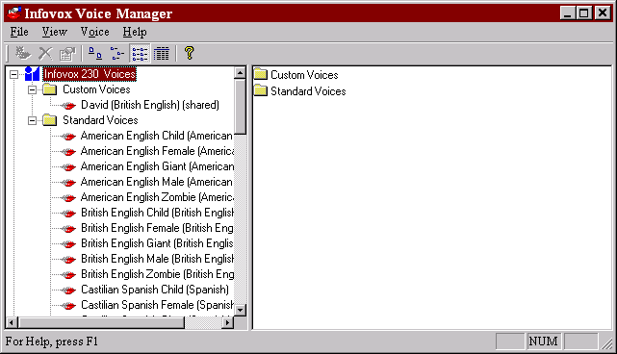

10.3 The Main Window
The Voice Manager's main Window is organized as a tree structure. This type of organization is quite common to Windows applications, see for instance the Windows File Explorer. In the rest of the chapter we'll use a terminology common to the tree structures: the term node indicates a generic point in the tree structure, the term branch indicates a node that is a sub-tree, and leaf indicates a terminal node. In the screenshot here above, "Custom Voice" is a branch of "Infovox 230 Voices", and "David (British English) (shared)" is a leaf.
The Window is splitted vertically. On the right hand side you can see the tree structure itself. You can click on the small "+" or "-" icons to show or hide all branches and leaves below a node.
In the pane on the right hand side of the main Window you'll see all branch and leaves names that are directly below the name selected in the structure pane. For instance, in the screenshot here above we clicked on "Infovox 230 Voices" in the tree structure pane, this node has two direct branches, namely "Custom Voices" and "Standard Voices" which are shown in the right hand pane. If you click on a voice (always a leaf in this structure), then you'll see on the right pane a preview of the properties for the voice (see screenshot here below):
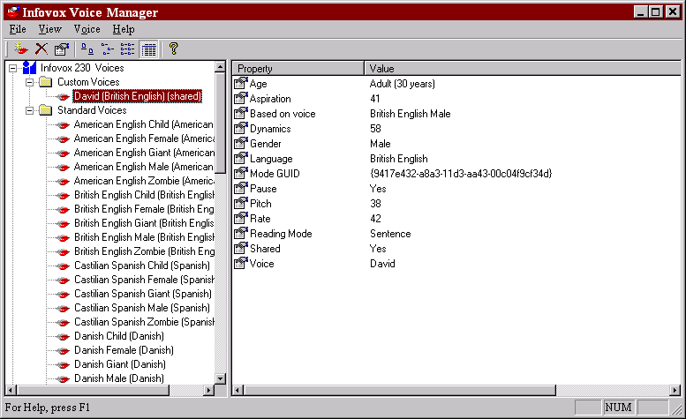
Please note that you can adjust the way that information is presented on the right pane by choosing Large Icons, Small Icons, List or Details in the View menu.

10.4 Tutorials
The Voice Manager is a quite simple program. Follow the tutorials and you will learn how to perform the most common operations, like creating, editing and deleting a customized voice.
In the rest of the chapter we will use the terms new voice to indicate the custom voice you are creating/editing or deleting, original voice will instead refer to the Infovox voice that you are using as a starting point for the new voice.

10.4.1 Creating a new voice
In this example we create a new voice that we call David and that is based on the British English Male voice. David will have a deeper whispering tone, and will speak somehow slower and more expressive than the standard British English Male.
If you do not have the "British English Male" voice installed and licensed on your computer, you can still follow this example by replacing " British English Male " with one of the voices that are installed and licensed on your computer.
Do as follow:
1. Start the Voice Manager.
2. Expand the "Infovox 230 Voices" node.
3. Expand the "Standard Voices" node.
A list of all installed voices appears.
4. Click on the name of the voice you want to use as a template for the new voice. For our example we will use "British English Male".
5. Choose Create from the Voice menu.
The Voice Properties dialog box appears.
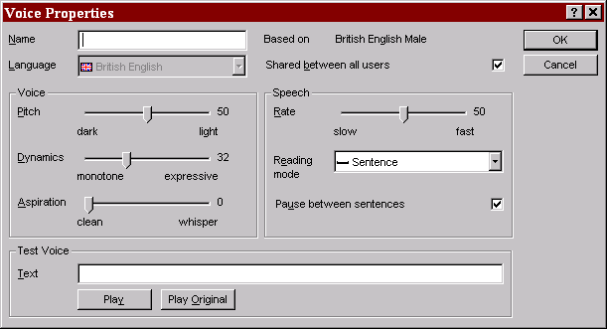
6. Type the name of the new voice in the Name box. For this example we'll use "David".
7. Choose the settings for the new voice:
Set the Pitch level for the new voice using the Pitch ruler. For this example we choose 38.
Set the Dynamic level for the new voice using the Dynamics ruler. For this example we choose 58.
Set the Aspiration level for the new voice using the Aspiration ruler. For this example we choose 41.
Set the Rate level for the new voice using the Rate ruler. For this example we choose 42.
Choose the desired Reading Mode in the Reading Mode list.
Select whether you want a long or a short pause between sentences by selecting the Pause between sentences option.
For more information on these settings see the chapter on the Infovox 230 Standard Dialog Boxes.
11. Clear the Shared between all users option if you wish that the new voice will be accessible only when you login to the computer with your current identity. This means that people logging on the computer with a different identity will not be able to use the new voice.
Once you have specified the desired settings you can write a text in the Test Voice box and play it using the settings you have specified (Play button) or using the original settings (Play Original button). If you are not satisfied with the new voice, you can adjust the settings and then check the result again. Once you are satisfied you can save the voice.
12. Click on OK to save the new voice.
The new voice is saved and listed among the "Custom Voices". Please note that the language name is automatically added to the voice name. In the main window of the Voice Manager you can also see whether the voice is shared or not. Shared voices have the string "(shared)" added to the name in the left window pane.

10.4.2 Using the new voice
The voice we created in the previous section can now be used in any application that can access the Infovox Text-to-Speech engine. For instance let's close the Voice Manager and let's open the Infovox 230 Speech Application. We'll see that the voice "David" is listed among the available voices.
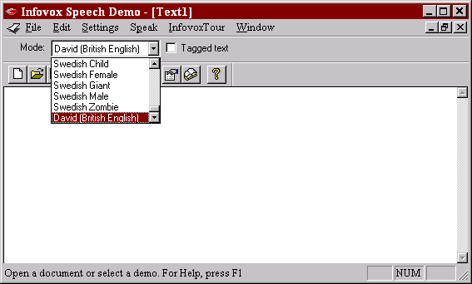

10.4.3 Editing a voice
All custom voices can be edited. The original voices distributed with the Infovox Text-to-Speech Engine cannot be changed.
So, you have been using the voice "David" created in the previous section for a while. Now you realize that the pitch is too low and the speech rate should be a bit faster, so you want to change the voice instead of creating a new one. Do as follow:
1. Start the Voice Manager.
2. Expand the "Infovox 230 Voices" node.
3. Expand the "Custom Voices" node.
A list of all custom voices appears.
4. Click on the name of the voice you want to edit, for this example choose "David (British English)".
5. Choose Properties from the Voice menu.
The Voice Properties dialog box appears.
6. Change the settings as you wish. Use the Play and Play original button to control the result of the new settings.
7. When you are satisfied click on OK to save the new settings. Click on Cancel if you do not wish to save the new settings.

10.4.4 Deleting a voice
You can delete custom voices. But you cannot delete the original voices distributed with the Infovox Text-to-Speech Engine.
Let's say that you want to delete the voice "David" created in the previous sections. Do as follow:
1. Start the Voice Manager.
2. Expand the "Infovox 230 Voices" node.
3. Expand the "Custom Voices" node.
A list of all custom voices appears.
4. Click on the name of the voice you want to delete, for this example we choose "David (British English)".
5. Choose Delete from the Voice menu.
A dialog box appears asking whether you really want to delete the voice.
6. Click on Yes to proceed with the operation.
The voice immediately disappears from the Custom Voices list.

11 Developer’s corner
This chapter is targeted to developers who intend to develop an application using the Infovox 230 or Infovox 330 Text-to-Speech engines.

Notes on the Microsoft Speech API implementation
The version of the Microsoft Speech API that is supported by the Infovox 330 is version 3.0. However we currently distribute runtime for versions 4.0a of the Microsoft Speech API, since in the new release there is a bunch of improvements and new objects that Infovox users can take advantage of.
The Microsoft Speech SDK can be downloaded from the internet at the Microsoft research site. At the time of writing the internet address is http://www. microsoft.com/iit
The Infovox Text-to-Speech engines meet the Microsoft Speech API 3.0 requirements, except in few cases here documented.

ITTSDialog::TranslateDlg
This dialog box (not mandatory according to the Speech API implementation) is not supported by the Infovox Text-to-Speech engines.

ITTSCentral::Inject and ITTSCentral::Phoneme
These functions are not implemented and, if called, always return E_NOTIMPL.

ITTSAttributes::VolumeSet
Due to an ambiguity in the Microsoft Speech API specifications, there are two ways of interpreting the volume level. The first way is to interpret the double word (= 4 bytes) input as 2 words specifying independently the volume for the right channel (high-order word) and left channel (low-order word). The second description is to assume monophonic output and accept a single word (= 2 bytes) parameter to specify the level for both channels.
Since the Text-to-Speech Engine has no way to know what is meant by the client application, Microsoft has adopted a compromise solution that has been adopted also by Infovox starting from release 1.12. The compromise solution is the following:
- If the input value is a single word value (i.e. less than 65.535), then it is assumed that both right and left channel has to be set to the level specified by the user.
- If the input value is a double word value (i.e. greater or equal to 65.636) then it is assumed that the right and left channel levels are being specified separately.
Examples:

input parameter = 32768
The volume is set to 50% to both channels.
input parameter = 4294918144
A value of 4294918144 (0xffff4000 in hexadecimal notation) sets the maximum level for the right channels, and a level of 25% for the left channel.

Control Tags
Here is the set of control tags implemented in release 1.12 or higher of the Infovox Text-to-Speech engines. All control tags are Microsoft Speech API standard.

Bookmark
Syntax: \Mrk=number\
Example: \Mrk=75000\

Pitch
Syntax: \Pit=number\
Example: \Pit=90\
This example sets the base frequency of the speech to 90 Hz.

Reset
Syntax: \Rst\
The Rst tag resets the voice parameter to the default values.

Speed
Syntax: \Spd=number\
Example: \Spd=120\
This example sets the speech rate to 120 words per minute.

Voice
Syntax: \Vce=charact=value[[,charact=value]]\
Where charact can be one of the following: language, speaker, gender, or age.
Examples:
\Vce=language=”English”,accent=”American”\ or
\Vce=language=”American English”\ or
\Vce=language=”Swedish”\
\Vce=speaker=”Rik”\ (for Infovox 330) or
\Vce=speaker=”Swedish female”\ (for Infovox 230)
\Vce=gender=”female”\ or \Vce=gender=”male”\
\Vce=age=”child”\ or \Vce=age=”adult”\

Volume
Syntax: \Vol=number\
See the considerations about the ITTSAttributes::VolumeSet function on how to specify the input value for this control tag.
Example: \Vol=32768\
This example sets the volume to 50% to both channels.
Example: \Vol= 4294918144\
A value of 4294918144 (0xffff4000 in hexadecimal notation) sets the maximum level for the right channels, and a level of 25% for the left channel.
Note: A limitation of the volume tag is that the volume change will take place at the beginning of the text containing the Volume control tag, not at the exact point where the tag is inserted.

ITTSIvxAttributes2 interface
The ITTSIvxAttributes2 interface has been explicitly designed for the Infovox Text-to-Speech engines, and it is not part of the Microsoft Speech API. The interface allows you to control special features of the Infovox 230 and 330 Text-to-Speech engines.
The features that you can control through the ITTSIvxAttributes2 interface are:
- Dynamics
- Aspiration (only for the Infovox 230 Text-to-Speech engine)
- Reading mode
- Pause between sentences
- Phonetic char

This interface provide you also with an alternate method of controlling these standard Speech API features:
- Speech rate
- Volume
- Pitch

IvxAttr2.h Include file
In order to use the ITTSIvxAttributes2 interface you have to include the IvxAttr2.h file in your application. This file is distributed together with the Infovox 230 and Infovox 330 Text-to-Speech engine.

Getting a pointer to ITTSIvxAttributes2
The ITTSIvxAttributes2 interface is implemented as a standard COM interface. In order to obtain and release a pointer to the ITTSIvxAttributes2 interface you use the common QueryInterface and Release functions:
PITTSCENTRAL pITTSCtrl = NULL;
PITTSIVXATTRIBUTES2 pITTSIvxAttr = NULL;
// ... use standard way to get a valid pointer pITTSCtrl ...
if (pITTSCtrl)
pITTSCtrl->QueryInterface(IID_ITTSIvxAttributes2,(VOID**)&pITTSIvxAttr);
// ... use the pITTSIvxAttr pointer ...
if(pITTSIvxAttr)
{
pITTSIvxAttr->Release();
pITTSIvxAttr = NULL;
}

ITTSIvxAttributes2::ReadModeSet
HRESULT ReadModeSet(WORD wReadMode);
This function sets the engine in one of the reading modes allowed by the Infovox Text-to-Speech engines.
wReadMode
IVX_READMODE_LETTER The text is spelled out character by character
IVX_READMODE_SENTENCE Default mode

ITTSIvxAttributes2::ReadModeGet
HRESULT ReadModeGet(WORD *pwReadMode);
This function returns the currently selected reading mode in the *pwReadMode variable. The possible values for *pwReadMode are the same defined for the ReadModeSet function.

ITTSIvxAttributes2::CharSet
HRESULT CharSet(WORD wProp, TCHAR chChar);
This function allows you to set characters who have a particular interpretation in the Infovox text processing. At the moment, the only character that is possible to set is the so-called ”Phonetic Prefix”, that is, the character that delimits a phonetic representation of a word or a sentence. The Phonetic Prefix character can also be set in the Engine Property box.
wProp
The only allowed value is IVX_CHAR_PHONETIC.
chChar
Specify the character that delimits the phonetic string. The default character is ‘#’.

ITTSIvxAttributes2::CharGet
HRESULT CharSet(WORD wProp, TCHAR* pchChar);
This function allows you to get the current setting for characters who have a particular interpretation in the Infovox text processing. At the moment, the only character that is possible to set is the so-called ”Phonetic Prefix”, that is, the character who delimits a phonetic representation of a word or a sentence.
wProp
The only allowed value is IVX_CHAR_PHONETIC.
pchChar
Retrieves the current setting for the character that delimits the phonetic string.

ITTSIvxAttributes2::SpeechSet
HRESULT SpeechSet(WORD wProp, DWORD dwValue);
This function allows you to set several speech parameters, depending on the value of the wProp variable.
wProp
IVX_SPEECH_RATE Sets the speech rate.
IVX_SPEECH_VOLUME Sets the volume level.
IVX_SPEECH_PAUSE Sets whether the pause between sentences should be long or short.
dwValue
The dwValue argument specifies the value for the selected property. It can assume different values depending to the wProp argument.
For IVX_SPEECH_RATE and IVX_SPEECH_VOLUME the dwValue specifies the rate and the volume on a scale 0-100. For IVX_SPEECH_PAUSE dwValue can be FALSE (short pause between sentences) or TRUE (long pause between sentences).
Please note that the scale used here for the IVX_SPEECH_RATE is not the same as Speech API defines, but is the 0-100 scale used in the Engine Property box. If you want to use the Speech API scale (corresponding to words per minute), then you should use the standard Speech API function ITTSAttributes::SpeedSet.

ITTSIvxAttributes2::SpeechGet
HRESULT SpeechGet(WORD wProp, DWORD* pdwValue);
This function allows you to retrieve the current setting for the property specified in the wProp argument.
wProp
IVX_SPEECH_RATE Retrieves the current speech rate.
IVX_SPEECH_VOLUME Retrieves the current volume level.
IVX_SPEECH_PAUSE Tells whether the pause between sentences is long or short.
pdwValue
The pdwValue argument can return different values depending to the wProp argument. For IVX_SPEECH_RATE and IVX_SPEECH_VOLUME the *pdwValue specifies the rate and the volume on a scale 0-100. For IVX_SPEECH_PAUSE *pdwValue can be FALSE (short pause between sentences) or TRUE (long pause between sentences).
Please note that the scale used here for the IVX_SPEECH_RATE is not the same as Speech API defines, but is the 0-100 scale used in the Engine Property box. If you want to use the Speech API scale (corresponding to words per minute), then you should use the standard Speech API function ITTSAttributes::SpeedGet.

ITTSIvxAttributes2::VoiceSet
HRESULT VoiceSet(WORD wProp, DWORD dwValue);
This function allows you to set several voice parameters, depending on the value of the wProp variable.
wProp
IVX_VOICE_PITCH Sets the pitch level for the voice
IVX_VOICE_DYNAMICS Sets the dynamics level for the voice
IVX_VOICE_ASPIRATION Sets the aspiration level for the voice (only for the Infovox 230)
dwValue
The dwValue argument specifies the level for the selected property. Its range is from 0 to 100 in all cases.
Please note that the scale used here for the IVX_VOICE_PITCH is not the same as Speech API defines, but is the 0-100 scale used in the Engine Property box. If you want to use the Speech API scale (corresponding to base frequency expressed in Hertz), then you should use the standard Speech API function ITTSAttributes::PitchSet.

ITTSIvxAttributes2::VoiceGet
HRESULT VoiceGet(WORD wProp, DWORD* pdwValue);
This function allows you to retrieve the current setting for the property specified in the wProp argument.
wProp
IVX_VOICE_PITCH Retrieves the current pitch level
IVX_VOICE_DYNAMICS Retrieves the current dynamics level
IVX_VOICE_ASPIRATION Retrieves the current aspiration level (only for the Infovox 230)
pdwValue
The *pdwValue argument returns the current level for the specified property.
Please note that the scale used here for the IVX_VOICE_PITCH is not the same as Speech API defines, but is the 0-100 scale used in the Engine Property box. If you want to use the Speech API scale (corresponding to base frequency expressed in Hertz), then you should use the standard Speech API function ITTSAttributes::PitchGet.

