**Detection of Ammonia Factor Based on pH and Temperature Sensors in Fish Pond with Automated Water Regulator and Monitoring using ATmega328P and Zigbee Module**

**by**

**Marene Joecel B. Sembrano**

**Kristoffer K. Viray**

A​ ​Design​ ​Report​ ​Submitted​ ​to​ ​the​ ​School​ ​of​ ​Electrical​ ​Engineering, Electronics​ ​Engineering, ​ ​and​ ​Computer​ ​Engineering​ ​in​ ​Partial

Fulfillment​ ​of​ ​the​ ​Requirements​ ​for​ ​the​ ​Degree

**Bachelor​ ​of​ ​Science​ ​in​ ​Computer​ ​Engineering**

**Mapúa​ ​University**

**October ​2018**

**CHAPTER 1**

**DESIGN BACKGROUND AND INTRODUCTION**

Ammonia is a toxic compound that can adversely affect fish health. Ammonia stress and poisoning is often the number one cause of fish illness and deaths when setting up new aquariums, small ponds and quarantine tanks. The nature and degree of toxicity depends on many factors, including the chemical form of ammonia, the pH and temperature of the water, the length of exposure, and the life stage of the exposed fish. If the pH of water is too high or too low, the aquatic organisms living within it will die. pH can also affect the solubility and toxicity of chemicals and heavy metals in the water. The recommended pH range for most fish is between 6.0 and 9.0 with a minimum alkalinity of 20 mg/L, with ideal CaCO3 levels between 75 and 200 mg/L. Harmful effects become noticeable when the pH of water falls below 5.0 or rise above 9.6. Ill effects due to acidification are more pronounced in saltwater fish due to their adaptation to a higher pH. When pH is below optimal levels, fish become susceptible to fungal infections and other physical damage. Fish reproduction is affected at pH levels below 5.0 fish begin to die when pH falls below 4.0.As a general guideline for a water temperature of 70° F, most Koi would be expected to tolerate an ammonia level of 1 ppm for a day or so if the pH was 7.0, or even as high as 10.0 if the pH was 6.0. At a pH of 8.0, just 0.1 ppm can be dangerous. Ammonia is the primary waste product of fish and is excreted mainly through their gills and to a lesser extent as urine. It tends to block oxygen transfer from the gills to the blood and can cause both immediate and long term gill damage. Koi and goldfish as well as many aquarium fish are quite resilient and can withstand low ammonia levels for a few days without any adverse effects. But ammonia levels can rise to dangerous levels quite quickly and lead to serious fish health problems and deaths. Even low levels of ammonia, below 0.25 ppm (parts per million), can suppress the immune system and make the fish more susceptible to bacterial and parasitic infections. Ammonia levels should always be zero. The presence of any ammonia in an established pond or aquarium should be a sign that something is amiss and should be investigated. Ammonia levels above 0.25 ppm should be a concern, anything above 1.0 ppm should be acted upon immediately. The fish are vulnerable to situations where the pH, temperature, DO, or ammonia levels become harmful. It only takes one of those parameters to be at a lethal level for entire batches of fish to die off and cause major losses for the whole growing cycle. This requires constant vigilance which can be cumbersome for the staff.

There are existing studies in which they tackle about the four important parameters of water when it comes to fish farming and these are ammonia, dissolved oxygen, temperature, and pH. These studies mainly focuses on fish tanks and solely focuses on fish farming of tilapias. This study is based on a fish pond containing koi fishes to be able to regulate the pond without having a manual check up for the pond.

**Customer**

MG Fish Garage is a shop that mainly focuses on fish and has the tools and tips to ensure every step of water tank setup, pond set up, and live fish care goes as swimmingly as possible. It is located with its business address at 180 Speaker Perez Street Cor. Sta. Catalina Street Quezon City. The business company is owned by Michael Go, who specializes also in the field of being a pond maker, breeder, importer, wholesaler, retailer, and an organizer for fish events.

**Need**

The client presented to the researchers the problem in his business. Due to the excess waste of the koi fish, the ammonia content of the fish pond can reach to a certain level that it can be hazardous to the koi. Maintaining the fish pond’s ammonia level can be time-consuming for the reason that it needs to be checked and regulated for a time to time basis. The client currently uses a color chart in measuring the four components that is present in a fish pond which are the ammonia, nitrite, nitrate, and pH. The need of the client is to have a digital water ammonia monitoring and detection to determine the ammonia factor level in the fish pond. Also, if the ammonia factor level detected by the system is hazardous, the system must automatically add some water to the fish pond in order to lower the ammonia level of the pond.

**Solution**

In order to solve the needs of the client, an Ammonia Factor water detector is proposed. The system design consists of a pH sensor, temperature sensor, Atmega microcontroller, water level sensors, a water pump, lcd screen, a switch, buzzer and a Zigbee module to monitor the fish pond. The system would gather data from the two sensors gaining pH values and temperature of the water. By obtaining the said data, the ammonia factor of the water can be computed. The ammonia factor will be sent to the database and if it exceeds the predefined values in the system, the system will initialize the water pump to regulate the fish pond by reducing the ammonia level of the pond. The system will display the desired values of the chosen parameter on the LCD screen installed in the device. The data gathered by the system will be recorded and will be presented to a server by using Zigbee module.

The researchers will design the circuit that would process the incoming data to be passed on the microcontroller. The microcontroller will then calculate the ammonia factor and will give the signal to the water pump if water is needed or not. The system will send the data in the server continuously hour and the server will present the data in excel format in order to monitor the pH, temperature and the calculated ammonia factor of the fish pond.

The scope of the system is that it only measures the ammonia factor of the pond through its pH and temperature values. The system is specifically designed for the client’s fish pond’s dimensions.

**Objectives**

The main objective of this design project is to solve the problem of the client by applying an automatic water regulator system for koi fish pond.

Specifically, this design aims to (1) create a control system that measures and regulates the ammonia factor through the pH and temperature value of the pond; (2) to implement a submersible water pump that automatically fills the fish pond when the ammonia factor is high enough to cause damage to the fish; (3) and to be able to display the measured parameters in the LCD screen of the device and to the server.

**Scope and Delimitation**  
 The study focuses in regulating the Total Ammonia of the pond by calculating the Ammonia Factor of the pond by using the temperature and pH value of the pond. The Total Ammonia will be regulated by using the water pump installed in the system wherein it will continuously fill in the pond with water until the ammonia factor is below 0.050 level. The study is only limited to detect and regulate the Ammonia factor of the pond which is used to determine the unionized ammonia which is dangerous to the fish when it is at high level.

**Differentiation**

The study “Automated Aquaculture System that Regulates Ph, Temperature and Ammonia” by Aaron Don M. Africa, et al. (De La Salle University Manila, 2017) contains the closest similarity with this paper.

|  |  |  |
| --- | --- | --- |
| **Technology, Functionality, Features** | **Design Solution** | **Nearest similarity** |
| Technology | The proposed system will use an ATMEGA328P Microcontroller, pH sensor, temperature sensor, buzzer, water level sensors, water pump, and a Zigbee module to monitor the fish pond. The system would gather data from the two sensors gaining pH values and temperature of the water. With this data, the ammonia factor of the water can be computed. | The existing system uses two Arduino Mega 2560 Microcontrollers with Arduino boards for all functions of pH, temperature, ammonia factor, water level, and GSM modules; and all functions of DO levels were handled by the other controller. |
| Functionality | The proposed design solution uses water level sensor for the system to detect the depth of the pond and will fill it until a certain level is reached. | The existing system used two water level switches to determine whether the water level was too high or too low (one for each). |
| Features | The system will provide an automated water filling system when ammonia reached into hazardous level. | The existing system does not include this feature. |

The difference between the proposed system and the paper with the nearest similarity are categorized as technology, functionality and features.

**Benefits**

With the completed Detection of Ammonia factor based on pH values and temperature in fish pond with water regulator, the proposed system is intended to provide a solution for a real-time measurements and regulation for pH, temperature, and ammonia factor as these conditions are very critical for the surviving of the aquatic lives in the fish pond. The system is designed to measure and automatically take corrective action as soon as harmful levels of any of the said parameters are detected to reduce the possibility of fish kill. The system used electronic sensors to provide real-time parameter measurements, a microcontroller to process and store the data, and automatically take corrective action when needed. The user can also monitor the parameters of the fish pond through the device’s dashboard which can be accessed on the server of the system.

The implementation of the proposed system is applied to replace the supervisory personnel responsibility and will be notified of the pH, temp, and the ammonia factor if they have exceeded the allowable values for these parameters and will perform an automatic refill of fish pond water to be able to set back these parameters back to normal as these aquatic livesin the fish pond are easily affected with the changes of the fish pond water condition such as these parameters and will lead to the capability of fish killing.

**Chapter 2**

**REVIEW OF RELATED DESIGN LITERATURES AND STUDIES**

**Ammonia**

Ammonia is the major end product in the breakdown of proteins in fish. Fish digest the protein in their feed and excrete ammonia through their gills and in their feces. The amount of ammonia excreted by fish varies with the amount of feed put into the pond or culture system – increasing as feeding rates increase. Ammonia also enters the pond from bacterial decomposition of organic matter such as uneaten feed or dead algae and aquatic plants.

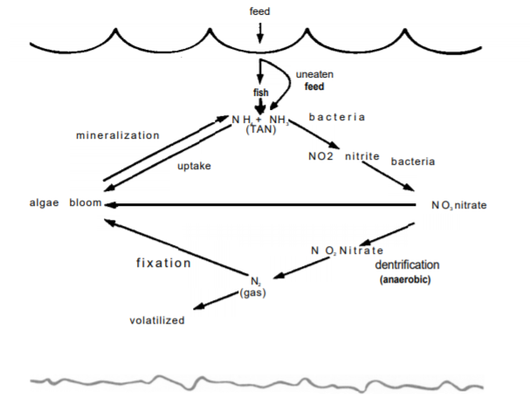

**Figure 2.1.** Nitrogen cycle in a fish pond

Uptake (assimilation) of ammonia by plankton algae is important in reducing the amount of ammonia coming in contact with fish. Ammonia increases in the fall and winter because of reduced algae populations in the pond and algae populations which are not as capable of taking ammonia from the water. Additionally, lower water temperatures slow down aerobic bacterial activity, thus slowing the vitrification process whereby ammonia is converted to harmless nitrate as shown in Figure 2.1. Algae dieoffs can also lead to very high ammonia concentrations, but, fortunately, the low pH associated with the disappearance of the algae reduces the proportion of toxic un-ionized ammonia present.

*Forms and Toxicity*

Total ammonia nitrogen (TAN) is composed of toxic (un-ionized) ammonia () and nontoxic (ionized) ammonia (). Only a fraction of the TAN exists as toxic (un-ionized) ammonia, and a balance exists between it and the nontoxic ionized ammonia:

+ () = ()

**Equation 2.1**

The proportion of TAN in the toxic form increases as the temperature and pH of the water increase. For every pH increase of one unit, the amount of toxic unionized ammonia increases about 10 times.

The amount of toxic unionized ammonia in your pond can be found by measuring the TAN with a water quality test kit and then looking up the fraction of TAN that is in the toxic form which is based on water temperature and pH. Multiply this fraction by the TAN to find the concentration (mg/L or ppm) of toxic un-ionized ammonia present in the water.

Dangerous short-term levels of toxic un-ionized ammonia which are capable of killing fish over a few days start at about 0.6 mg/L (ppm). Chronic exposure to toxic un-ionized ammonia levels as low as 0.06 mg/L (ppm) can cause gill and kidney damage, reduction in growth, possible brain malfunctioning, and reduction in the oxygen-carrying capacity of the fish.

*Ammonia Calculations*

To be able to determine the value of the ammonia, the ammonia factor is computed based on the pH and temperature values using Equation 2.2 which was derived from Millichip [11]. The ammonia factor is indirectly controlled by controlling the pH and temperature.

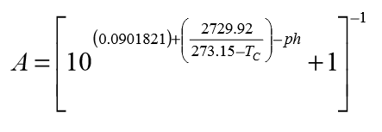

**Equation 2.2**

Where:

= Ammonia Factor

=Temperature in Celsius

=pH reading

**Ammonia Factor**

Un-ionized ammonia (UIA) is about 100 times more toxic to fish than ionized ammonia. This UIA toxicity begins as low as 0.05 mg/L, so the result of the TAN test needs to be further calculated to find the actual concentration of UIA. Anytime the UIA is higher than 0.05 mg/L, the fish are being damaged. As the concentration rises above 0.05 mg/L, it causes more and more damage. At 2.0 mg/L, the fish will die. To solve for UIA:

**Equation 2.3**

Where:

*TAN =* Total Ammonia

*A* = Ammonia Factor

**Water Temperature in Fish Pond**

Water temperature influences the onset of fish spawn, aquatic vegetation growth and the biological demand for oxygen in ponds. As water temperature increases, it holds less oxygen. Additionally, plants and animals use more oxygen due to increased respiration rates. These factors commonly result in less available oxygen for fish during the summer and fall months. Another temperature-related phenomenon is water stratification. This occurs in deeper ponds as increased ambient temperature causes a warm, less dense layer of water to stratify over a cool, dense layer of water. Most of the oxygen is produced in the warm surface layer of water and over time oxygen can be depleted in the cooler layer. These layers may not mix for a long period until a cold front or thunderstorm cools the surface layer allowing the two layers to mix. This is often referred to as "turn-over." The result is a sudden dilution of oxygen and a simultaneously increased demand for oxygen from decaying organic matter. This can cause severe fish kills.

**pH Value**

The term “pH” is a mathematical transformation of the hydrogen ion (H+) concentration; it conveniently expresses the acidity or basicity of water. The lowercase letter “p” refers to power or exponent, and pH is defined as the negative logarithm of the hydrogen ion concentration. Each change of one pH unit represents a ten-fold change in hydrogen ion concentration. The pH scale is usually represented as ranging from 0 to 14, but pH can extend beyond those values. At 25 °C, pH 7.0 describes the neutral point of water at which the concentrations of hydrogen and hydroxyl ions (OH) are equal (each at 10-7 moles/L). Conditions become more acidic as pH decreases and more basic as pH increases.

**ATMEGA328P​ ​Microcontroller**

ATMEGA328P is an 8-bit AVR RISC-based microcontroller combines 32K bytes of ISP flash memory with read-while-write capabilities, 1024 bytes of EEPROM, 2K bytes of SRAM, 23 general purpose I/O lines, 32 general purpose working registers, three flexible timer/counters with compare modes, internal and external interrupts, serial programmable USART, a byte-oriented 2-wire serial interface, SPI serial port, a 6-channel 10-bit A/D converter (8-channels in TQFP and QFN/MLF packages), programmable watchdog timer with internal oscillator, and five software selectable power saving modes. The device operates between​ ​1.8-5.5​ ​volts.

By executing powerful instructions in a single clock cycle, the device achieves throughputs approaching 1 MIPS per MHz, balancing power consumption and processing speed. ATMEGA328P is manufactured using non-volatile memory technology, compatible with industry-standard instruction set and pin-out. Also, the on-chip Flash allows the program memory to be reprogrammed in-system or via programmer. With this features, ATMEGA328P is a low-power high performance microcontroller that​ ​provides​ ​flexibility​ ​and​ ​cost-effective​​ ​​option​​ ​​to​​ ​​many​​ ​​applications.

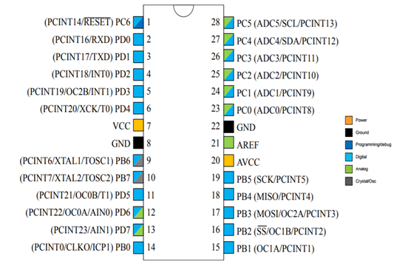

**Figure 2.2.** Pin​ ​Configurations​ ​for​ ​ATMEGA328P​ ​Microcontroller

**Zigbee Module**

The fish are vulnerable to situations where the pH, temperature, DO, or ammonia levels become harmful. It only takes one of those parameters to be at a lethal level for entire batches of fish to die off and cause major losses for the whole growing cycle. This requires constant vigilance which can be cumbersome for the staff. It is important to notify the user immediately about the problem. It is recommended that future studies utilize a database to record data trends (Chou et al., 2009). In view of the characteristics for aquaculture environment, which are of diversity, dynamics and dispersion, the pond water quality monitoring system based on ZigBee can save a lot of manual operation and electricity consumption for the fish farmers, and can prevent control the loss caused by fish diseases effectively, and reduce the death rate. Through long term continuous monitoring, adjustment and control of water quality, the breeding production and aquatic product quality can be obviously increased and improved (Huang et al., 2013).

ZigBee wireless communication technology is used to realize the communication between host computer and lower computer monitoring software. Wireless passthrough mode is adopted in Zigbee, each terminal is worked as the router, host computer links with the coordinator (Wang,2011). Zigbee builds star network automatically, that is, host computer is able to receive data from each node and each node can receive monitoring commands from host computer.

ZigBee is a wireless networking standard that is aimed at remote control and sensor applications which is suitable for operation in harsh radio environments and in isolated locations. ZigBee technology is a wireless communication technology based on the IEEE 802.15.4, which is concerned with network building, security and software (Sheng et al.,2011).

**LabView Database**

LabVIEW is an integrated development environment software made by National Instruments, a program specifically for visual programming and system-design platform for creating custom applications that interact with data or signals. LabVIEW is also used to interface hardware devices for data collection by example. LabVIEW programs are called Virtual Instruments (VI) as this simulate in appearance and operation of physical instruments. Each VI has a front panel and a block diagram. Front panel is the user interface of the program while block diagram is the graphical source code of the program (Tan et al., 2012).

LabVIEW is used as the real time display and extraction of parameter data from the system to LabVIEW (Yu et al., 2012) . “Equal? function” and “Replace Substring function” from the block diagram is used to segregate the raw data to their respective parameter “Case Structure” that goes through indicators, plots, and charts. In layman’s terms, LabVIEW detects the corresponding character that is coming from the raw data to segregate the parameter data so if LabVIEW detects the character “p” from the incoming raw data LabVIEW would treat the incoming raw data as pH, if character “t” it means for temperature, “a” for calculated ammonia. Write to Measurement file Express VI is used as the automatic extraction of parameter data for every 1 hour interval in excel format.

**Chapter 3**

**DESIGN PROCEDURES**

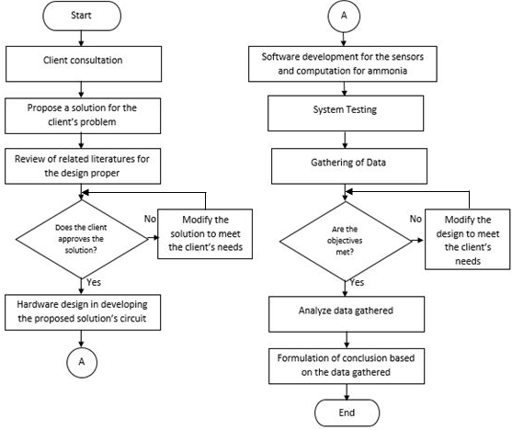

**Figure 3.1** Design Procedure

Figure 3.1 shows a step by step process in creating the design process for the proposed system. Initially, the group consulted the client in order to identify the problem and the specific needs of the client. Once the problem is stated various studies will be reviewed to create a possible solution for the need of the client. If the proposed solution is approved and accepted by the client, the software and hardware design of the proposed solution will be created as well as the prototype. The prototype will be put through a series of test such as measuring the pH values and temperature of the water to threshold values and if the specific objectives are met. Otherwise, the designed system will then be modified until the objectives are met. The data gathered after testing the prototype will then be interpreted and analyzed to form a conclusion as well as recommendation to further improve the study.

**Conceptual Framework**

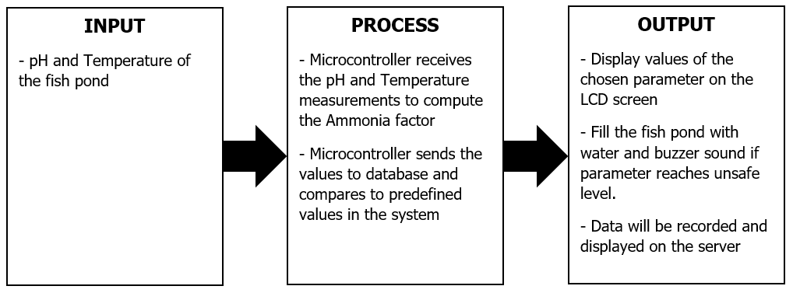

**Figure 3.2** Conceptual Framework

Figure 3.2 shows the conceptual framework of the proposed system. The inputs of the proposed design solution are the pH and Temperature measurements from these two sensors of the fish pond. With these acquired data, it will be sent to the ATmega328P Microcontroller to compute for the Ammonia factor and will then send the computed Ammonia factor and measured parameters to the database. Comparing these to the predefined values in the system, the water pump will be initialized and automatically regulate the fish pond by filling water to reduce and dilute the ammonia level of the pond. The water pump will automatically stop once the ammonia level of the fish pond is back to normal and at a safe level. The data gathered by the system will be recorded and displayed on the server continuously by using Zigbee Module and will be presented in an excel format to monitor the pH, Temperature, and the calculated Ammonia factor of the fish pond. The system will display the values on the LCD screen.

**Hardware Development**

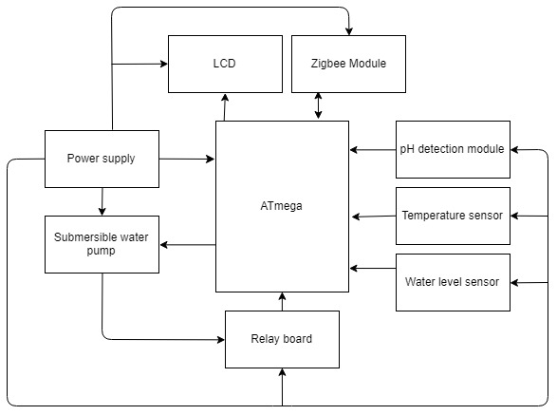

**Figure 3.3** Hardware Block diagram of the proposed system

Figure 3.3 shows the hardware block diagram of the proposed system. The temperature probe and pH probe serves as the measuring device of the system in order to get the pH and temperature values of the fish pond. If performed by a proper drainage, the procedure will reduce the ammonia factor of the pond.

Hardware Development Procedures:

1. Understand the needs of the client to identify the necessary requirements for the hardware design of the proposed system.
2. Discern the different approaches or methods in implementing the needs of the client and determine the specifications of the components needed in building the system.
3. Conceptualize the flow and connections of the input, process, and output of the proposed design system needed for the hardware design by constructing conceptual framework.
4. The input for the system consists of the data being measured by the pH sensor, temperature sensor, and water level sensor which are all connected to the ATMEGA328P microprocessor.
5. The process of the system is through the Microcontroller that receives the pH and Temperature measurements to compute for the Ammonia Factor, and sends these values to the database and compares to predefined values in the system.
6. The output of the system can be seen in the LCD screen of the device and also to the server of the system which is a laptop or a desktop.
7. Construct the hardware block diagram to visualize the proper connection required to make the system functional.
8. Construct a schematic diagram of the design from its corresponding block diagram made in the previous step to understand the connections of the components better.
9. The system device is placed in a casing to avoid the device to be exposed to the water from the fish pond.

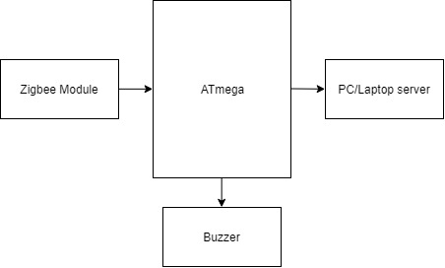

**Figure 3.4** Hardware Block diagram of the server

The server of the system receives the data from the device on the fish pond. Zigbee module of both devices will be used for the transmitting and receiving of data.

**Schematic Diagram**

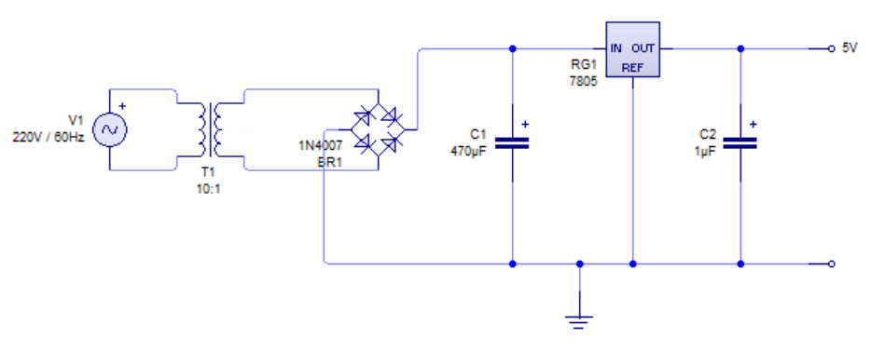

**Figure 3.5** Schematic Diagram for 5V VCC

Figure 3.5 shows the schematic diagram of the power supply designed for the proposed system. From a 220V AC at 60Hz power source, a 12V output rated transformer will be used. Voltage Regulator LM7805 will provide a 5V DC operating voltage to the system.

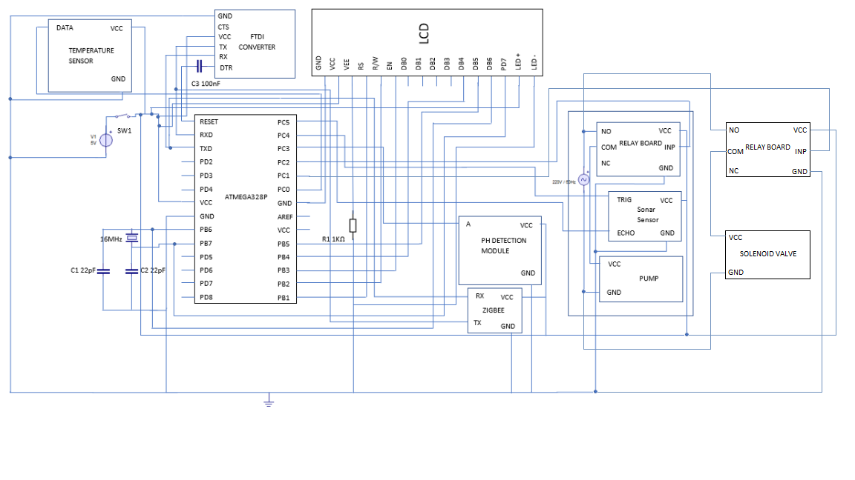

**Figure 3.6** Schematic Diagram of the Proposed System

Figure 3.6 shows the schematic diagram of the proposed device system installed on the fish pond of the client. The device consists of an ATmega328P microcontroller which processes, controls, and coordinates all the data, pH sensor which is responsible in determining the presence and get the pH in the fish pond, the temperature sensor which will get the temperature of the water in the fish pond, sonar sensor to measure the water level of the fish pond wherein they are all connected to the digital pin of the microcontroller. The data gathered by the system will be recorded and displayed on the server for every hour by using Zigbee Module and will be presented in an excel format to monitor the pH, Temperature, and the calculated Ammonia factor of the fish pond. This will also prompt a message to notify and alert the user whenever Ammonia Factor reaches unsafe level in the fish pond. The system will also display these values on a 16x2 LCD screen display. The system is supported by a 5 Volts power source.

As for the Automated Water Regulator of the proposed system, it consists of the Single Channel Relay Board in which its control pin is connected to the digital pin of the microcontroller and will be controlling the Pump using this section, the submersible pump will be used to refill the water in the fish pond. Common pin of the relay is connected to positive terminal of the Submersible water pump and Normally Open port is connected to AC phase. Voltage regulator LM7805 will provide 5 Volt operating voltage to microcontroller while relay is operated by 12V DC.

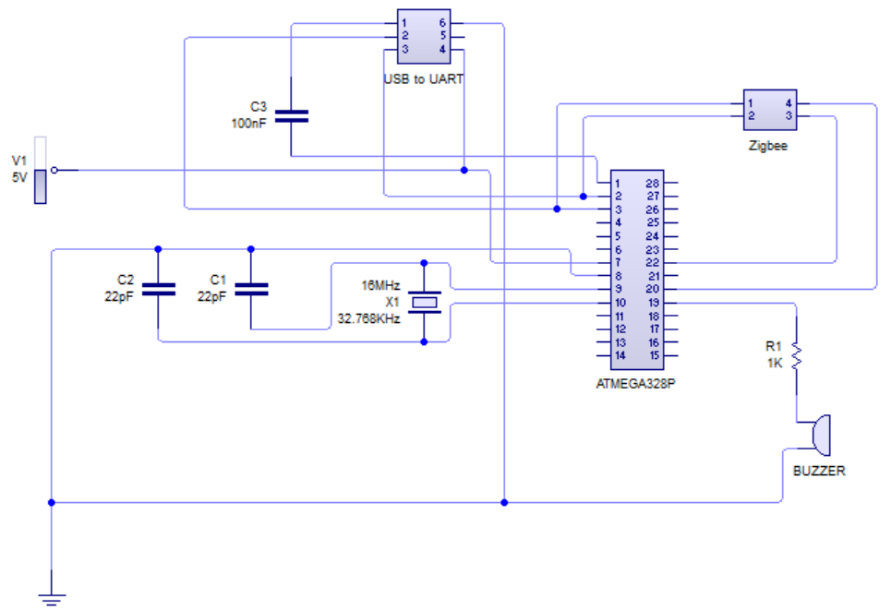

**Figure 3.7** Schematic Diagram of the Server Device

Figure 3.7 shows the schematic diagram of the device of the server. The device consists of a ZigBee module, USB to UART module, an ATmega328P microcontroller, and a buzzer. The system is powered by a 5V power supply via a USB cable that is connected to the computer. The ATmega328P microcontroller uses a full swing crystal oscillator because this is the type of oscillator that operates from 2.7-5.5 DC Volts power supply. Under the full swing crystal oscillator, the recommended frequency range is between 0.4 to 20 MHz and for its ceramic capacitor, 12 to 22 pF. The Buzzer will be used for this system to produce Buzzing sound when the water level reaches its maximum level.

**Software Development**

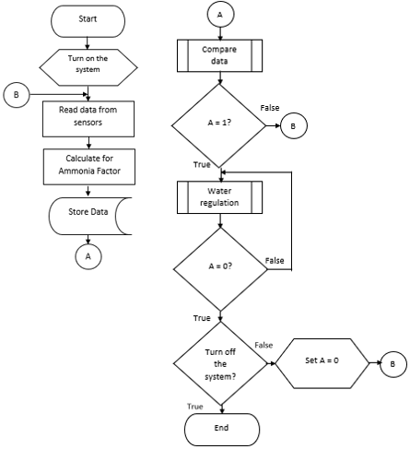

**Figure 3.8** Water regulator and monitoring Software Flowchart

Figure 3.8 shows the flow of the system. The flowchart indicates the process of the system in regulating the parameters of the fish pond. The initial step is to turn on the system, which means to turn on the device and place the sensors to their respective locations. The sensors will continuously monitor the pH values and temperature of the pond. The measured value of the data gathered will be compared to the programmed data. If the gathered data exceeded the programmed set points, the flag will be setted to the value of 1 and the gathered values will then be sent to the server which contains the pH value of the pond, the temperature, the water level and the computed Ammonia factor. Every measured data by the system will be sent to the system’s database. If the Ammonia factor of the pond exceeded to the programmed set points, the A value will be setted to the value of 1 and the system will regulate the water until the ammonia of the pond is reduced. By successfully reducing the ammonia factor of the pond, the system will continue to monitor the fish pond. The program will end if the system is turned off by the user.

Software Development Procedures:

1. The program will start when the user turned on the system.
2. After turning on the program and its components, the sensors will have the initial readings.
3. After the initial readings, the program will let the system read the sensor readings continuously.
4. By having the pH and temperature data of the pond, the Ammonia factor of the pond will be computed by the program.
5. The measured and calculated data will be sent to the database.
6. The data will be compared to the predefined values in the program to check if the data measured and calculated is hazardous for the fish.
7. If the Ammonia Factor calculated shows a high count of unionized ammonia, it is considered hazardous. This will set A to 1. If A = 1, the system will trigger the water pump to regulate the ammonia factor of the pond.
8. The system will not stop until the Ammonia factor is reduced to a safe level.
9. The system will end if the user turned it off.

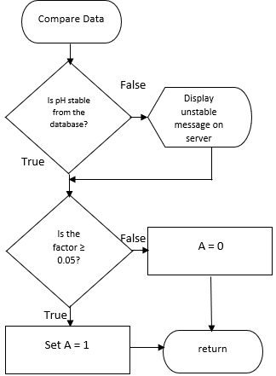

**Figure 3.9** Compare data subprocess

In the Compare data subprocess, the data gathered are compared to the programmed values. The data on the server will indicate if the parameters of the fish pond is in stable condition or not. The calculated ammonia factor will be compared to the predefined values and if the calculated ammonia factor is high enough to be hazardous to the fish, A will be set to 1. If it is not in hazardous level, the value of A will remain at 0.

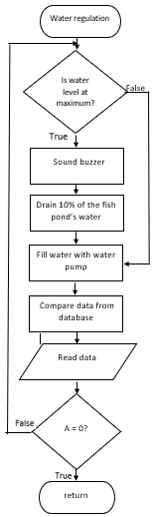

**Figure 3.10** Water regulation Subprocess

Figure 3.10 shows the water regulation subprocess of the system. This subprocess aims to reduce the Ammonia Factor of the fish pond by continuously filling the fish pond with water using a automated water pump. The water sensor will initially check the water level of the pond. The water pump will not fill the pond with water if the water level is at maximum. The buzzer will sound if the water level of the fish pond is at maximum. The system will drain 10% of the fish pond to if it is at maximum level using another submersible water pump. Once the water level is not at maximum, the water pump will fill in the pond until it reaches at maximum level and new data will be measured and compared. The process will stop once the Ammonia Factor of the pond decreases.

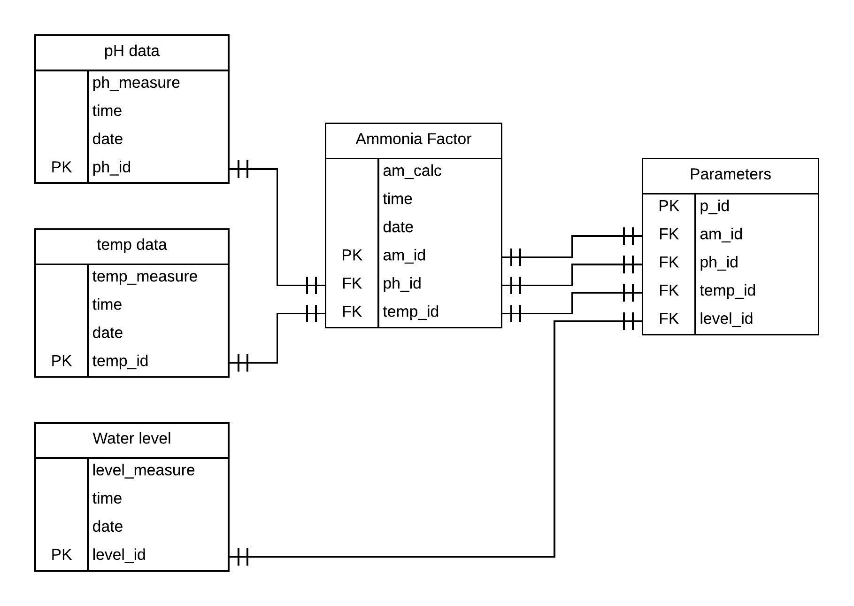

**Figure 3.11** Entity-relationship model

Figure 3.11 shows the ERD diagram of the system. The database of the system consists of the parameters of the fish pond. The data measured by the sensors and calculated by the system will be sent to the database. The ph level, the temperature, the water level, and the calculated ammonia factor will be saved to the database.

**Set-up of the Device**

For the hardware, the design project will be tested containing some of the components and microcontroller. These components include a pH sensor, temperature sensor, ATmega328P microcontroller, water level sensors, a water pump, lcd screen, a switch, buzzer and a Zigbee module to monitor the fish pond. The system would gather data from the two sensors gaining pH values and temperature of the water. Power supply will also be included to provide input voltage to the temperature sensor, sonar sensor, relay board, LCD, Zigbee, pH Detection Module, and ATmega328P microcontroller. The temperature ​sensor​ and pH ​will​ ​be​ ​tested​ ​by​ ​using​ ​the​ ​pH and temperature​ sensors to detect and measure and will be placed also in the water. Sonar sensor will be placed on the top of the fish pond water and will be measuring the water. Ammonia Factor will then be computed using the pH and Temperature values. The buzzer will be placed on the server device and will sound if the water level of the fish pond is at maximum. The system will drain 10% of the fish pond to if it is at maximum level using another submersible water pump and will be placed in the water. Once the water level is not at maximum, the water pump will fill in the pond until it reaches at maximum level and new data will be measured and compared. The process will stop once the Ammonia Factor of the pond decreases.

For the software, the data gathered by the system will be recorded and displayed on the server continuously by using Zigbee Module and will be presented in an excel format to monitor the pH, Temperature, and the calculated Ammonia factor of the fish pond by utilizing LabView database to record these data. The system will display the values on the LCD screen.

After testing, verification, and checking of both hardware and software part, the group​ ​will​ ​then​ ​layout​ ​these ​components​ ​on​ ​a​ ​PCB.

**Prototype Development**

*Step by Step Procedure in Prototype Development*

1. Based on the schematic layouts from the hardware development, draft the PCB layout in PCB Wizard.
2. Print out the PCB layout in a transparent film (acetate).
3. Expose the photosensitive layer of a new PCB board and quickly place the acetate paper (with layout printed) and place it on a UV Box for 2 minutes.
4. Develop the PCB tracks by first exposing the board to a developer solution and then to a Ferric chloride Bath.
5. Create holes in the etched PCB board using a hand drill and then attach and solder on the components.
6. Design the casing and holders of the components as shown in Figure 3.14.
7. Attach the following components on the top cover of the casing: pushbuttons, graphical LCD screen and the GPS module with the antenna block pointing up towards the sky for optimal location fix as shown in Figure 3.16.
8. Attach and connect the following components in the main casing: PCB, Micro-SD breakout, the battery and its charging circuit, and the CCD sensor as shown in Figure 3.17.
9. Orient the concave grating from specifications as shown from the image shown in Figure 3.18 that will produce a visible spectrum on the CCD sensor when light enters from the slit of the casing.
10. Close and secure the case using the screws in each side.

*Prototype Development Procedure:*

1. Draw the schematic diagram of the design using PCB Wizard.
2. Review the quick start guide documentation provided by ExpressPCB to know where to place components or link pins and such.
3. Sketch the layout of the circuit according to the schematic diagram using ExpressPCB.
4. Buy and gather the materials and components needed for the prototype.
5. Print the finished circuit layout on an acetate paper.
6. Follow instructions for developing the PCB on the pre-sensitized board.
7. Drill holes for the component pins on the board.
8. Connect the components according to the device schematic diagram.
9. Double check connections on the board.
10. Build casing for the circuit boards and place components inside.

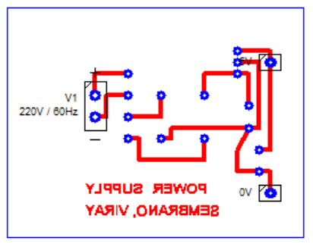

**Figure 3.12** Power Supply PCB Layout

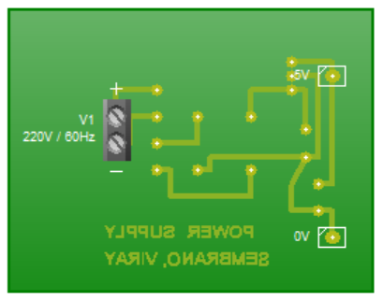

**Figure 3.13** Power Supply Component Diagram

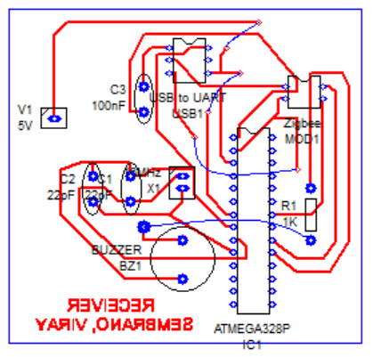

**Figure 3.14** Server PCB Layout

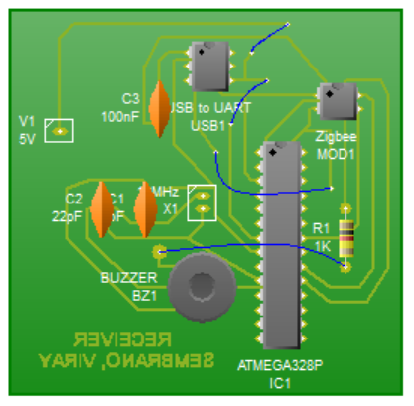

**Figure 3.15** Server Component Diagram

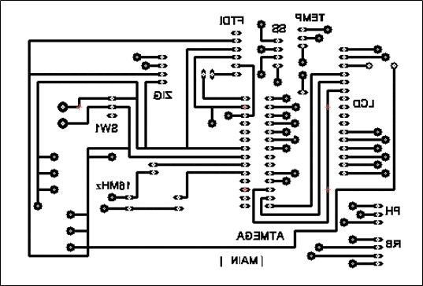

**Figure 3.16** Main PCB Layout

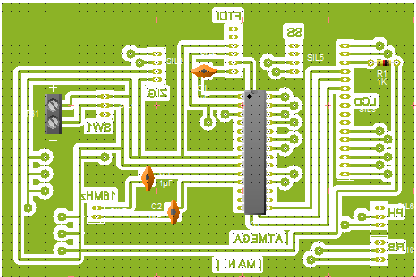

**Figure 3.17** Main Component Diagram

**Bill of Materials**

|  |  |  |
| --- | --- | --- |
| **Materials** | **Quantity** | **Amount (Php)** |
| 12V DC Water pump | 1 | 550.00 |
| Ultrasonic Sensor | 1 |  |
| DS(something) | 1 | 285.00 |
| USB TO UART | 2 | 260.00 |
| Pin header | 1 | 30.00 |
| Relay module 4 channel | 1 | 300.00 |
| LCD 16x2 | 1 | 270.00 |
| ATmega328P | 2 | 390.00 |
| PCB | 4 | 360.00 |
| Zigbee Module SZ05-STD | 2 | 3100.00 |
| pH Module | 1 |  |
| Toggle Switch | 1 |  |
| 16MHz Crystal Oscillator | 2 |  |
| Buzzer |  |  |
| 12V DC Solenoid Valve | 1 | 288.00 |
| Transformer | 1 |  |
| Bridge Rectifier | 1 |  |
| LM7805 | 1 |  |
| 1μF Capacitor |  |  |
| 470μF Capacitor |  |  |
| 22pF Capacitor | 4 |  |
| 100nF Capacitor | 2 |  |
| 1k Ohms Resistor | 2 |  |
| 4.7k Ohms Resistor | 1 |  |
| Small Casing |  |  |
| Medium Casing |  |  |
| Large Casing |  |  |

**Multiple Design Constraints**

The table below shows the restrictions of the proposed design solution of the group. A detailed tabulation of the constraints, source(s) of constraints, possible trade-offs, and alternative solutions are stated below based on the engineering​ ​standards.

|  |  |  |  |
| --- | --- | --- | --- |
| **Constraint** | **Source of Constraint** | **Possible Trade-Offs** | **Alternative Solutions** |
| Manufacturability  The system’s design for the components and other sensors can be exposed to water and corrosion. | IEEE​ ​Std 45.5-2014,​ ​IEEE Recommended Practice​ ​for Electrical Installations​ ​on Shipboard​ ​—Safety Considerations | Metal casing for the enclosure of the components. | * Non-metal casing for the whole design to protect the components. * Acrylic casing for the whole design to protect the components. |
| Sustainability  Component to be operated through a power supply | 1801-2009 - IEEE Standard for Design and Verification of Low Power Integrated Circuits | Power is supplied through a built-in solar panel. | * Provide a built-in power supply will be implemented. * Rechargeable batteries can be used as a power supply. * Directly connect device to a power socket |
| Reliability  The sensors may not detect the presence complying to its performance specification | 2700-2014 - IEEE Standard for Sensor Performance Parameter Definitions | Use a high-end sensors with longer sensing capacity to provide consistent detection | * Use a sensor that has longer sensing capacity |
| Economical  Cost of device and components should be kept to a minimum | (1332-2012 - IEEE Standard) Reliability Program for the Development and Production of Electronic Products | Use of less expensive and alternative components | * Integrate sensors that are less expensive but will meet the specific objectives * Use of pH and temperature sensors to get the ammonia factor in the fish pond. |

As shown in the table above, the constraints fall under the economical, sustainability and manufacturability factors of the designed solution. Under the Economical category, multiple sensors are integrated within components to measure and gauge accurately the required paramaterers such as pH and temperature values to get the ammonia factor of the fish pond, thus affecting the overall budget for the design. To minimize the effect, the first option is to use sensors that are less expensive but will meet the specific objectives. For the Sustainability factor, the system will provide a built-in power supply and will be implementing rechargeable batteries as this can be used as a power supply. Lastly, the Manufacturability part of the design, since the components and sensors will be based on the pH, temperature, and water level values to be able to get the ammonia factor in the fish pond and will be exposed to water thus will be prone to corrosion, the group has decided to use a Non-metal casing for the whole design to protect the components as an alternative solution for the integrated sensors to protect the components. Also, we can also use an acrylic casing for the whole design to further protect the components.

**Impact of Design Solution**

The impact of the group’s proposed design solution, Detection of Ammonia factor based on pH values and temperature in fish pond with water regulator, to the following context are as follows:

GLOBAL

In a global context, the system will not only be limited to the client and can also be used by other fish store owners, fish shops, and fish enthusiasts who uses pond water for their fishes, and can also be altered to be used also in fish tanks and aquariums depending on the dimensions.

ECONOMICAL

The system’s economical impact to the client is that it does not require any large amount of capital or budget in using the prototype since the materials used will be at minimum but durable cost and to promote low maintainability. It is also economical for the client to use since the sensors are the only components needed to be maintained or replaced in order for the design to work.

ENVIRONMENTAL

The materials and components used in the whole system will not provide a harmful impact to the environment since it does not contain any toxic and harmful chemicals. These components and materials are used and exposed everywhere​ ​thus​ ​providing​ ​that​ no​ ​effect​ ​to​ ​the​ ​environment​ ​can​ ​be​ ​done.

Furthermore, the system will help in reducing and preventing the possibility of fish kills.

SOCIETAL

The implementation of the proposed system is applied to replace the supervisory personnel responsibility and will be notified of the pH, temp, and ammonia factor level if they have exceeded the allowable values for these parameters and will perform an automatic refill of fish pond water to be able to set back these parameters back to normal as these aquatic livesin the fish pond are easily affected with the changes of the fish pond water condition such as these parameters and will lead to the capability of fish killing.

**Engineering Principles**

Different engineering approaches were used to complete the proposed design prototype.

1. **Programming**

The IF statement was mostly used in the program of the system. The IF statement executes a block of code if the condition is true; otherwise, that is, if the specified condition is false, the program exits the IF statement.

1. **Electronics**

The circuit layout of the proposed design was created and simulated using a circuit simulation software that enabled the group to test the connectivity of the components and to check errors in the connections.

The Wireless Sensor Network (WSN) is a system of communication wherein sensor nodes receive and send information from a certain area to another place. In the proposed design, the wireless sensor node has a sensing circuitry which senses static information of pH value, temperature, and water.

**Modern Engineering Tools**

1. **Microsoft Visio**

Microsoft Visio is a software program for creating diagrams, flowcharts, and vector graphics. In order to know and understand the program flow of the proposed design and the development processes for its software and hardware, diagrams and flowcharts were created using Microsoft Visio.

1. **Arduino Software (IDE)**

The Arduino IDE is a software for writing codes or sketches and compiling and uploading the binary file onto the configured board through a configured Port. The program also provides feedback using the message area while saving and exporting as well as display errors while uploading. The software also has other features for verifying syntax errors, exporting compiled binary, including libraries, addition of source files to a sketch and options for editing a sketch or code.

1. **ExpressPCB and PCB Wizard**

ExpressPCB and PCB Wizard are softwares for designing and developing electronics schematics and Printed Circuit Board layouts. The layout of the circuit is printed on a circuit board where the components are placed and connected accordingly.

1. **Microsoft Visual Studio**

Microsoft Visual Studio is an integrated development environment (IDE) for development of computer programs using a code editor and other built-in-tools for computer programming. The Windows application (program and GUI) for the server was developed using this software.

1. **Livewire**

Livewire is a computer program for designing and simulating electronic circuits. The schematic diagram of the proposed design was created and simulated using this software.

**Chapter 4**

**TESTING, PRESENTATION, AND INTERPRETATION OF DATA**

**pH, Temperature, Water Detection Test**

Testing was done in the fish pond of the client’s business shop, MG Fish Garage as shown in Figure 4.1; here, three sensor nodes and a server were used. The first sensor node (device 1) was positioned near the server device, the second sensor node (device 2) was positioned a little farther from the server device, while the third sensor node (device 3) was positioned farthest from the server device to ensure that devices were able to pass the information from one device to another./MG Fish Garage is a shop that mainly focuses on fish and has the tools and tips to ensure every step of water tank setup, pond set up, and live fish care goes as swimmingly as possible. It is located with its business address at 180 Speaker Perez Street Cor. Sta. Catalina Street Quezon City. The business company is owned by Michael Go, who specializes also in the field of being a pond maker, breeder, importer, wholesaler, retailer, and an organizer for fish events/



**Figure 4.1** MG Fish Garage Fish Pond

**Testing Procedure**

1. Install the sensor nodes on the assigned utility posts.
2. The PC, wherein the server is connected, must have an Internet connection.
3. Run the server Windows application for the fire detection system.
4. After opening, the Google map of the subdivision is shown in the application by default.
5. To check if the prototype is able to detect smoke and fire, produce smoke and/or fire near the sensor node closest to the server.
6. The buzzer rings and a notification is displayed on the Windows application indicating that a smoke and/or fire is detected, as well as the location, in longitude and latitude, of the device where the fire and/or smoke is detected. A text message is also sent to the number of the person in-charge of the server.
7. Repeat procedure 5; however, this time, one shall use the sensor node farthest from the server to test if the sensor nodes are able to pass the information from one node to another until it reaches the server.
8. Data recorded are automatically saved into an Excel file.

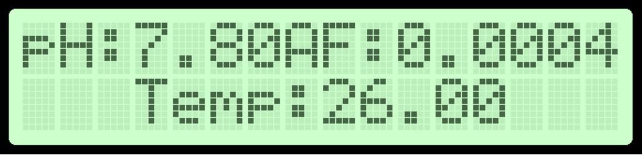

**Figure 4.2** LCD Display of pH, Temperature, and Ammonia Factor

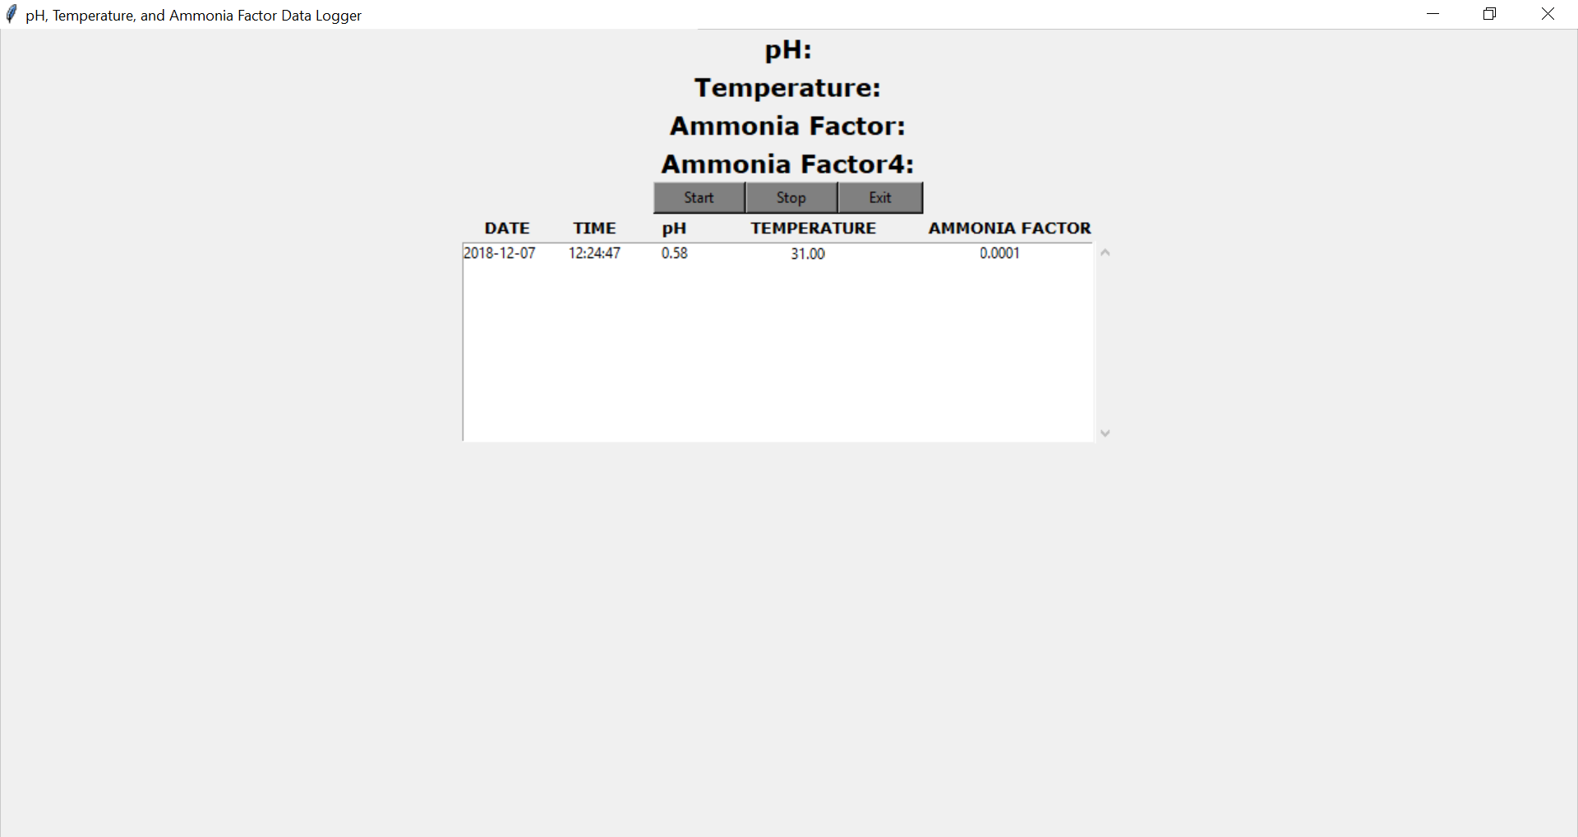

**Figure 4.2**

**Chapter 5**

**CONCLUSION AND RECOMMENDATION**

**Conclusion**

Based on the results gathered above, the group submits that:

An automated water regulator and monitoring by using pH and temperature sensors to measure the said parameters, a water pump and solenoid valve to regulate the water of the pond, and a Zigbee module to monitor and send the parameters of the fish pond to the server. The data gathered by the system will be shown the client’s end device by the means of a GUI which is made using python. The parameters will be measured continuously and will be saved as an excel file format so that the client can view the parameters with ease.

By using the prototype, the client can reduce the manual labor needed in maintaining his fish pond which can improve his revenue. The prototype will also alert the client if the hazardous level of the parameters being measured have been reached.

**Recommendation**

The researches submit the following recommendations:

An ammonia sensor can be added to the system to further improve the regulation of the fish pond. A submersible water level sensor can also be used so that measuring the water level of the fish pond will be simplified.

The researchers firmly believes that a critical innovation can be done in terms of monitoring the data being gathered is by applying the emerging technology of IoT.

**References**

1. S. Levit (2010). *A Literature Review of Effects of Ammonia on Fish*. Center for Science in Public Participation Bozeman, Montana

2. United States Geological Survey (2013). *Water Properties: pH*. The USGS Water Science School

3. Wurts, W. A., & Durborow, R. M. (1992). *Interactions of pH, Carbon Dioxide, Alkalinity and Hardness in Fish Ponds*. Southern Regional Aquaculture Center

4. N. Chou, J. Chou, T. Sun, and S. Hsiung (2009). *All solid-state potentiometric biosensors for creatinine determination based on ph and ammonium electrodes*. IEEE Sensors Journal, vol. 9, pp. 665–672, 2009

5. Labview (2017). [Online] Available: http://www.ni.com/enph/shop/labview.html

6. L. Tan, Y. Tan, X. Cui and C. Cui (2012). *The Application of LabVIEW in Data Acquisition System of Solar Absorption Refrigerator*. Energy Procedia, pp. 1496-1502, 2012

7. Y. Yu, Y. Zhang, X. Yuan and Q. Hou (2012). *A LabVIEW-based real-time measurement system for polarization detection and calibration*. Optik - International Journal for Light and Electron Optics, vol. 125, no. 10, pp. 1496-1502, 2012

8. A.D.M Africa, J.C.C.A Aguilar, C.M.S. Lim Jr., P.A.A. Pacheco, S.E.C. Rodrin (2017). *Automated Aquaculture System that Regulates Ph, Temperature and Ammonia*. IEEE, Volume 8

9. C.S. Tucker, L.R. D’Abramo (2008). *Managing High pH in Freshwater Ponds*. Southern Regional Aquaculture Center (SRAC) Publication No. 4604, July 2008

10. Russel Stevens (2009). *Fish Pond Water Quality: As Simple as Chemistry 101*. Noble Research Institute. Internet: <https://www.noble.org/news/publications/ag-news-and-views/2009/july/fish-pond-water-quality-as-simple-as-chemistry-101/>, July 2009

11. I. Millichip (2012). *Ammonia Calculations*. [Online] Available: <http://www.irishfishkeepers.com/articles/28-healthwater-and-illinesses/142-ammonia-calculations>, September 2012.

12. *Ammonia In Ponds and Aquariums and How to Lower It*. Internet:

<https://www.pondexperts.ca/pond-advice-tips/ammonia-ponds-aquariums/>

13. J. Huang, W. Wang, S. Jiang, D. Sun, G. Ou, K. Lu. (2013). *Development and test of aquacultural water quality monitoring system based on wireless sensor network*. Nongye Gongcheng Xuebao/Transactions of the Chinese Society of Agricultural Engineering 29(4): 183-190, February 2013

14. Wang Xiu (2011). *The remote environment monitoring system based on wireless transmission*. Communication technology 44(6): 95-99, 2011

15. S. Jiang, W. Wang, G. Xiao, Z. Li. (2011). *Design of wireless sensor node for drought monitoring in tea plantation*. International Conference on Electric Information and Control Engineering, ICEICE 10.1109/ICEICE.2011.5777293, IEEE Press 2011:328-1332, April 2011

16. Ruth Francis-Floyd, Craig Watson, Denise Petty, and Deborah B. Pouder. *Ammonia in Aquatic Systems 1* FA.16 (1990). Department of Fisheries and Aquatic Sciences, Florida Cooperative Extension Service, Institute of Food and Agricultural Sciences, University of Florida, February 2009

**APPENDIX**

1. **Operation’s Manual**
2. **System Requirements**
3. **Installation Procedures**
4. **User’s Manual**
5. **Troubleshooting Guides and Procedures**
6. **Error Definitions**
7. **Pictures of Prototype**
8. **Data Sheets**
9. **Article in IEEE Format**