**Color-based Detection Component Inventory System for SMA Solar Technology**

**by**

**Abram Philip I D. Magadia**

**Sev Kyle C. Montoya**

**Corleone Jorel G. Zaldarriaga**

A Design Proposal Submitted to the School of Electrical Engineering, Electronics Engineering, and Computer Engineering in Partial Fulfillment of the Requirements for the Degree

**Bachelor of Science in Computer Engineering**

**Mapúa University**

January 2019

**CHAPTER 1**

**DESIGN BACKGROUND AND INTRODUCTION**

Warehouses have always provided a temporary housing for materials that needs a large storing space. When the component is going in and out of storage, the caretaker of the warehouse or the engineers of the company have no other way of carrying out an inventory on the items aside from manual means and through Microsoft Excel. Thus, the companies that distribute large number of items often face difficulties in organizing and monitoring these components. Some companies still resort to manual methods of inventory, like SMA Solar Technology. These methods may cause problems to the company’s inventory system due to human error, and it normally takes a significant amount of time to carry out the manual method of inventory on large number of components. Component Inventory using Color-coded Stickers identified using color sensors is the proposed solution to the underlying problem of the company.

**Customer**

The Company of SMA Solar Technology uses the warehouse of ServoElectric Inc. owned by Gideon Javier, in the province of Laguna. The group’s client will be SMA Solar Technology and ServoElectric Inc., the proposed color-coded sticker will be placed on the parts of SMA Solar Technology but the users will be from the engineers of ServoElectric Inc., engineers that monitor all of the incoming and outgoing components tagged with the color-coded stickers in the warehouse.

**Need**

Some components of the SMA Solar Technology do not have valid identification or barcodes. This posed a problem since it takes the staff tasked for inventory to contact the component’s manufacturer to ask for details and thereafter create a temporary identification. This also has to be coordinated to the destination of the component if it has to be shipped out or taken out of storage. Furthermore, the workload takes a significant amount of time that may be allocated elsewhere. The process of inventory becomes tedious at a point wherein there are multiple components that do not have proper tags or identification. Since the staff of ServoElectric Inc., still employs the outdated manual encoding of inventory system through Microsoft Excel. Their inventory system is flawed due to the possibility of human error in every cycle that their current system is used. This flaw presents the need of the company which are:

* To have an alternative solution to their inventory system through technology
* To provide a low-cost alternative to manual item identification
* To have a more reliable and correct data with regards to components that goes into their inventory

**Solution**

The group will develop a device capable of replicating a color sensor to achieve the needs of the client. Hence, the device would detect incoming and outgoing components tagged with color-coded stickers. The stickers would serve as an identifier for the program embedded in the design as a designated item for inventory. The group will use 5 LEDs and 5 LDRs as the substitute for color sensors modules, each improvised color sensor is directed to each color strip. There will be 5 strips of color, first strip will be the category of the item, then second is the classifier for that category,then the remaining three strips will be the item number. The sticker will be printed on an I-Tech High Quality Vinyl Sticker paper which is tested to be scratch proof, waterproof as well as UV-resistant. To add to that, the ink that will be used to print the stickers will be a Pigment-based Ink which is expected to prolong the integrity of the color for long-term storage use.

**Objectives:**

The main objective is to design a device capable of processing components for inventory through an alternative method. Specifically, the study aims to accomplish the following:

* To develop a prototype that can detect color-coded stickers by integrating an ATMega328 microcontroller to multiple improvised color sensors made of LED and LDR
* To develop the software application that will process the patterns of the color-coded stickers when scanning tagged components
* To develop a database that maintains the data recorded through the software

**Scopes and Delimitations**

SMA Solar Technology have a trouble keeping records of their components specifically those without serial number, that is where the design would come in. The Color-based Detection Component Inventory System Design would be employed on those components that does not have an existing identification tagged like barcodes or serial numbers, the design will have the following features: (1) it can show how long that component have stayed in the warehouse, (2) it will be able to identify which specific item has been scanned by means of identification through the use of color-coded stickers, (3) it will have details of the components, including user inputs for the components, (4) and lastly the design will have two users of the system admin and viewer.

Of course for every designed technology, it would have its limitations. The Color-based Detection Component Inventory System Design will have the following limitations: (1) it will not cover improperly labeled components as a result of human interference, (2) it will not be able to handle labeled components that are simultaneously scanned, (3) it will only be able to support predefined distances of the item to be scanned from the sensor, (4) it will not be liable for any further discoloration/fading caused by environmental issues with regards to the color printed on the stickers, (5) In the software design, only the admin can create an account for the user, (6) The user accounts will be limited to viewing the inventory and exporting a copy of it, (7) and lastly the wireless transmission of data is limited to 100 meters.

**Differentiation**

**Table 1.1 Differentiation of Designed System to Its Nearest Similarity**

|  |  |  |
| --- | --- | --- |
|  | **Design Solution -**  Color-based Detection Component Inventory System for SMA Solar Technology | **Nearest Similarity -** Item labeling,inspection and verification system for use in manufacturing, packaging, product shipment-fulfillment, distribution, or on-site operations  Patent Number: US 7,918,402 B2 |
| **Technology** | Detection of color coded stickers through color sensors. Uses Atmega328 and Zigbee module for wireless technology. | Luminescent detection using coded-indicia thermal scanner |
| **Functionality** | The system will identify the coded stickers from the components to the software application and log into the the database. | The system identifies color coded-indicia using UV light radiation and identifies the component. |
| **Features** | The system will log each item into the database for inventory. The database is flexible or editable. The scanner is wireless. | The system database is fixed. It uses a conveyor belt to move the items to the scanning apparatus. |

The difference between the designed system and the system of the nearest similarity which is the Item labeling,inspection and verification system for use in manufacturing, packaging, product shipment-fulfillment, distribution, or on-site operations,are categorized by three factors the technology, functionality, and features. For the Color-based Detection Component Inventory System for SMA Solar Technology the technology it uses a microcontroller of Atmega328 while the other system uses UV thermal scanner. The difference between the two with regards to its functionality is that the proposed system will identify the coded stickers from the components to the software application using 5 sensors and log into the the database, while the other system uses a color coded-indicia to be scanned by using thermal scanner by the use of UV light radiation. In terms of features the designed system is wireless and the database is flexible meaning it can be edited, the system can add new items, edit description or add properties into the inventory while the other system is fixed, it can only scan items that are already in there database it will only show or know the item names.

**Benefits**

With the completed prototype of Color Coded Scanner for SMA Solar Technology, The Company could implement this prototype on their component inventory system and would have a benefits of (i) the client would have better results in its inventory management compared to the previous method, (ii) the client should be able to consume lesser time in inventory management (iii) the client does not need to input the fundamental details to the inventory manually every time to the laptop unless the client wants to add some additional information about the item, (iv) the client could view the date of entry and date of exit of the component scanned, (v) Having a computerized database will allow viewing of records in just a few clicks since storing and summarizing all log information will all be in one place, (vi) the device can also be used by other companies that has a similar problem with the client. With the benefits mentioned, the Color-coded Scanner may be an asset to the SMA Solar Technology since having a device purposely made for inventorying will help them create a near error-free inventory.

**CHAPTER 2**

**REVIEW OF RELATED LITERATURE**

**Inventory System**

According to the article Optimal Control of Inventory Systems with Multiple Suppliers inventory system is about monitoring and quantifying items from on-hand stock concurrently. It is also a critical component of businesses in order to gain bigger profits [2]. There are manual and automatic means of managing inventories,

one hand uses only human, paper, and pen method, while the other hand uses advanced technology. For the company to improve its productivity, technology should be enforced in certain areas specifically in organizational platforms such as inventory management [1].

**Item labeling**

Items are distinguished by its name, type, size, color, weight, etc. It is dependent on the company’s design and logical way of labeling its inventory. Business labels its items for many reasons but the main aspect is for organization. For it to identify the component certain labels are attached onto it, one of which is the database identifier. Inside the manufacturing warehouse, items are labeled in order to know the details of the components that were taken in and out. Labeling each item helps in monitoring the inventory list of the company. Types of labels are RFID, barcode, qr code, etc. An innovative way of labeling the items is through color-coded stickers [1].

**Color Detection in Object**

Light is a combination of wavelengths of light, every wavelength has its specific color. The color that our naked eye sees is the product of which wavelength are reflected back to our eyes. The color of visible light relies on its wavelength. those wavelengths varies from color to color, like end to end of the color spectrum: red to violet with 665 nm to 400 nm, respectively. The color sensor identifies the color in the object, RGB scale is the usual parameter.‘When a light wave strikes an object, it can be absorbed, reflected and transmitted by the object. An object that appears a certain color reflects the light frequency that corresponds to that color, and it absorbs all the other frequencies in the visible light spectrum’ [1]. One great example of this is, when an observer shines a blue light on a blue object, that light will be reflected back, but if the observer shine a green light on a red object, the object will absorb some of the light shined and the less of it will be reflected back.

**RGB Color System**

The RGB Color System is composed of compound properties from color building blocks which are Red, Green and Blue. These properties include the use of HSL System which is another term of Hue, Saturation and Luminosity (Light Intensity). These three parameters, when viewed as one system, can be perceived as a form of alternative color system to the RGB Color System. The RGB color system has been modified and standardized in different ways, the most notable modifications and standards come from CIE and NTSC. [9] CIE defines the patterns of the RGB color system based on different measurements. This refers to Red, Green and Blue as definitive threshold measurements of the following values respective to colors mentioned: 700nm, 546.1nm and 435.8nm. [9] In this design, we focus more on the RGB color system since the color sensor to be utilized is based upon the aforementioned system.

**Light-Dependent Resistor (LDR)**

The LDR is a photoresistor that depends on the conduction of photo optical light of which its resistance is variable towards. The resistance increases or decreases depending on the intensity of the light it is subjected to which brings it to a photoconductive state. Since it is a variable resistor it has no definite value, only a continuously changing value with respect to luminosity. With the variety of applications that a photoresistor can be used for, the LDR can act as a low-cost sensor designated for detecting and identifying colors [6]. This can be achieved with the use of LEDs that emit either Red, Green or Blue colors. The emitted light from the LEDs will then bounce of the LDR which gives it a resistance reading that determines the color intensity of Red, Green or Blue light sources.

**Database**

Inventory systems are much effective nowadays to be done using web services like HTML5, PHP, MySQL, and NodeJS. These are system databases that could provide sufficient help in storing data. Inventories would be easier to manage, especially for people or companies that are in different locations. Updating the database would be faster, and the inventory would be accessible to all [4].

Based from the article Application of data warehouse and data mining in the steel enterprise information integration system, MySQL database can cater the responsibility of data storing, managing inventories, and also controlling the items inside the system. It is a great tool for enterprises that wants organization for their business transactions [5].

**Zigbee**

An effective way to transmit data wirelessly is by the use of zigbee transmitter module. The main function of the zigbee is to send out the information or data that was received by the detecting equipment to the main device such as laptop, computer, or any kind of equipment that would serve as the control center, then send out the instruction from the laptop to the detecting equipment [7]. It can operate frequency band of 868 MHz, 915 MHz and 2.4 GHz frequency bands. The maximum data rate of a typical zigbee is 250K bits per second [8].

**CHAPTER 3**

**Design Procedures**

**Step by Step Procedure in Hardware Development**

1. Create a design process flow (Figure 3.1.1 & Figure 3.1.2) based on the contents of the Need and Solution of the design found on Chapter 1.
2. If all steps of the design process flow can be directly correlated to the contents of Chapter 1, proceed to designing a conceptual framework (Figure 3.2). Otherwise, refer again to the proposed Need and Solution of this design.
3. On the conceptual framework (Figure 3.2), identify the input entity, the processes it will be subjected to, and its output once it has been processed by the system.
4. Conceptualize and design a block diagram (Figure 3.3) with the materials needed to create a functioning prototype of the design. Use the website (www.draw.io) to create the block diagram.
5. Download and Install the Multisim Software for the creation of the schematic diagram (Figure 3.4).
6. Search for the all the components to be used and place it in the layout; If the component is not in the software, search and download the component’s library.
7. Integrate the downloaded library to the Multisim Software.
8. Then search for the component and place it in the layout.
9. After that, connect every component to its respective pin connection.
10. If the schematic is done, export it and save it.
11. To create the design for the hardware device search for the dimensions of the parts that will be used.
12. Conceptualize a possible casing for the prototype.
13. Determine if the components are placed ergonomically on the conceptual design. If not, redo step 2 with flaws of the preceding design/s in mind.
14. Download and Install the SketchUp. This will be used to create a 3D Model of the design that was previously conceptualized.
15. Go through the initial tutorial and create the 3D Model (Figure 3.5 & Figure 3.6).
16. If the model is finalized, export it in a .skp format so that it can be catered for 3D printing.

**Step by Step Procedure in Software Development**

1. Recall the intended functionality of the design’s software which is Component Inventory and the system designed to implement it.
2. Break it down to major functions that will make up the system. Major functions include: View Inventory, Edit Inventory, etc.
3. Conceptualize a detailed flowchart for all major functions and integrate it to a system that will facilitate these functions. System flowchart (Figure 3.9) will include the Login and the implementation of the major functions as parts of the system.
4. To construct the flowchart, use an open source diagram software which is browser-based. The site is linked as: draw.io
5. Review the system flowchart and conceptualize the use case diagram (Figure 4.6) to be created.
6. Determine the actors that will be present in the use case diagram.
7. If there are 2 or more actors, specify their roles in the system.
8. Enumerate all the processes or functions in the system which eventually be the use cases in the diagram.
9. Determine the relationship of the actors and the use cases.
10. Finally, construct the use case diagram (Figure 4.6) in a diagram creator. (In this case www.draw.io was used in creating the diagram)

## Hardware Development

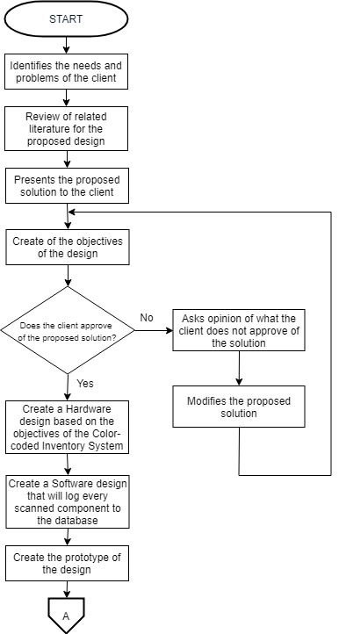

**Figure 3.1.1** Design Process Flow

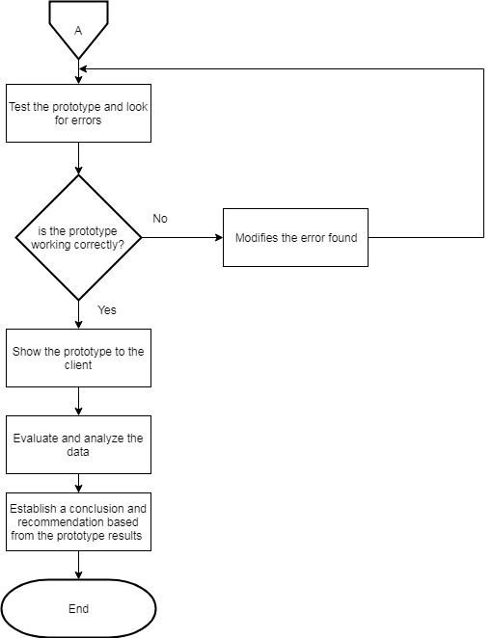

**Figure 3.1.2** Design Process Flow cont.

Figure 3.1 shows the process flow of the design that was and will be conducted on the system. The critical part of the step-by-step procedure was the identification of the needs and requirement of the client. After identifying the statement of the problem, researching related journals or articles for the topic was conducted in order to gather informations and to gain further knowledge to proposed a valid solution. Once the group of researchers came up with a possible solution a meeting was held to present the objective and solution of the design to the client. If the clients accept the proposal, it will proceed to creating the hardware of the device and continuing the process of creating the software system both based on the objectives, but if the client declines the proposed solution the researchers will modify it until an agreement occurs. Proceeding to the next process, hardware and software development of the design are engineered until a prototype of the system is finally created. Testing and debugging of the said prototype are the next preceding method to be done, to ensure that the system is ready and working. If the prototype is not working correctly, the errors that were found will be modified until no errors will no longer be present. Then, the researchers will present the working prototype to the client to show the capability of the design. Finally, the researchers will evaluate and analyze the data, then a conclusion and recommendation will be made.

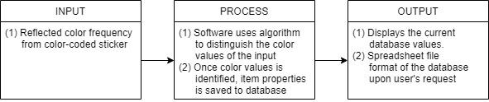

**Figure 3.2** Conceptual Framework

Figure 3.2 shows the conceptual framework of the Device’s system, after the user places the color-coded sticker to the component, the user will now scan that sticker for the ingoing component, making the reflected light from it as the input for the LDR sensor, after which that sensor will now process that input to relay a signal to the ATMega328 Microcontroller to check if that sticker has been scanned and saved to the database. If it is, then the system will now output the details of that scanned item to the Engr.’s laptop and the system can also output a spreadsheet format of the records in the database upon the Engr.’s request. Otherwise, the system will ask the User “If there is anymore additional information for the scanned item?”. If the user chooses No, then the scanned item will then be saved to the database, But if the user chooses Yes, then the system will now direct to an Fill-up section for the User to add any additional information about the component. Once the fill-up is done, the information is now considered also as an input to the system, and processes it to be saved to the database. The whole process for scanning the outgoing component, is the same as with the ingoing.

## Block Diagram

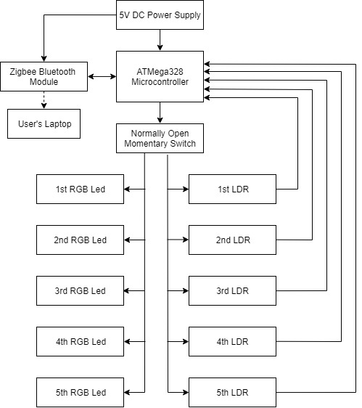

**Figure 3.3** Handheld Color-coded device Scanner Block Diagram

Figure 3.3 shows the Block diagram of the Handheld Color-coded device Scanner. The whole system is connected to a 5v DC Power supply which is enough to power the five improvised color sensor and the Zigbee Bluetooth Module. The Zigbee module is connected to the User’s Laptop via bluetooth technology, this bluetooth technology will be the one responsible for the transferring of data to the user laptop. In the block diagram there is a Normally open momentary switch, that is the trigger button of the handheld device in which when the user presses that trigger button the RGB Led will flash a light in order for the LDR sensor to gather the reflected light. That reflected light will be the input for the LDR sensor which will be sent back to the ATMega328. This Zigbee module is also responsible for the relaying of the processed data from the ATMega328 Microcontroller that was gathered from the five improvised color sensors, back to the User’s Laptop which will now output the details of the color-coded sticker in an organized manner.

**Schematic Diagram**

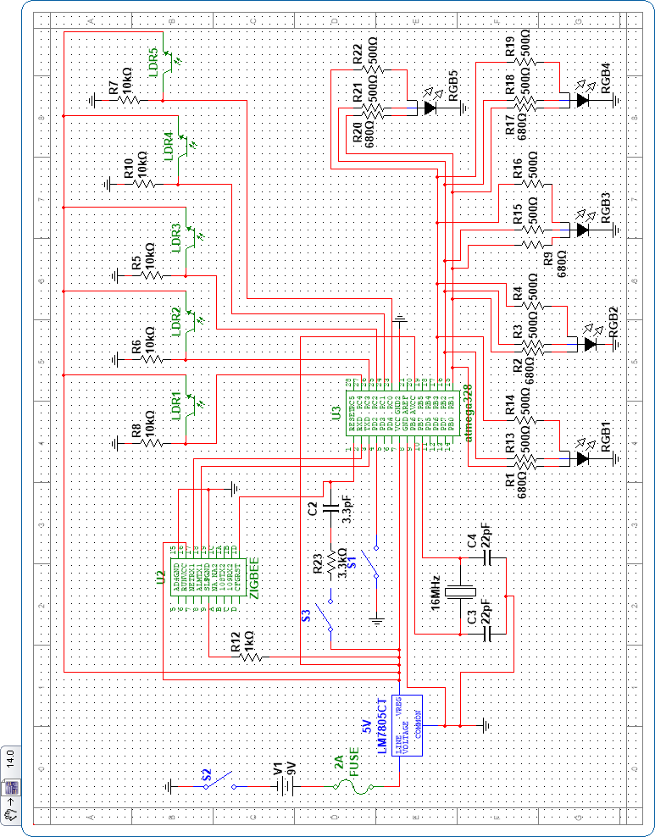

**Figure 3.4** Schematic Diagram Overview

The circuit diagram uses an Atmega328 as the microcontroller interfaced with a Xbee bluetooth module and 5 improvised color sensors. Each color sensor is made up of a Light-Dependent Resistor and an RGB LED which mimics the usual components of dedicated color sensors available on the market. The XBee radios are based on IEEE 802.15.4 which is the standard for low-rate wireless personal area networks and is designed for P2P communication over the air. XBee radios work on a 2.5GHz frequency and is only capable on lower data transfer rate spectrums (~250Kbps). XBee also has a relatively low power consumption and lower data transfer distances for wireless communication. The switch will be used for the ON/OFF switch for the XBee module and the 10k Potentiometer as the analog sample for the module.

The 16 MHz Oscillator will function as a Low-power crystal oscillator internal clock for the microcontroller and is supported by two capacitors that are of 22 pF values as they provide the operational internal clocking of the microcontroller. These are calculated values based on the oscillator properties.

The Power supply will consist of the LM7805 which is responsible for the regulation of the 9V supply to a 5V stable supply. This will be achieved through the capacitors used in conjunction with the LM7805 module to reduce the lowering cap, it is a filter for high frequency noises. The numbers in the module 7805 retains that the voltage regulation be of a positive (78) value and of a magnitude of 5 Volts (05) bringing the conclusive voltage to +5VDC.

A typical 5mm RGB LED has 4 pins where 3 of those correspond to each color from the RGB scale. These 3 pins each have their respective forward voltage or voltage drop values from which we can determine the resistance needed for it to properly function. As per the datasheet of the 4-pin 5mm RGB LED, the forward voltage are 2.90 Volts, 2.90 Volts, and 1.90 Volts for Green, Blue, and Red, respectively. Using Ohm’s Law, the resistances can be calculated. Since each pin of the ATMega328P can max out at 5mA as the forward current, this is used as a reference point for the resistor that will be connected to the LED for each corresponding pin. As the design uses 5 RGB LEDs the forward current will be divided to each LED, equally which totals to about 1.00mA per LED. At this point it is also necessary to know the effective resistance of each LED as it is crucial when dealing with the output of the LDR. The magnitude of the resistors used were rounded up to compensate for the tolerance for non-ideal conditions and their market availability.

(eqn. 3.x)

(eqn. 3.1)

(eqn. 3.xx)

(eqn. 3.2)

(eqn. 3.xxx)

(eqn. 3.3)

Since LEDs gives their best light at 5mA, the researchers opted to use the values computed at eqn. 3.1, 3.2, and 3.3. This is because every pin of the ATMega328 outputs a 20mA, and those three PWM pins of the ATMega is connected to a 5 improvised color sensor, therefore it is logical to use a parallel connection from the ATMega to the Resistors and RGB Leds in order to obtain a current close to 5mA.

**Proposed Isometric Model**

**3D View**



**Figure 3.5** Isometric View of the Proposed Hardware Design

Figure 3.5 shows the isometric design of the proposed design hardware for the color-coded inventory device. The design contains a XBee (Zigbee Bluetooth Module) with an antenna and it is placed on the top so that the antenna has a broader coverage, and lesser interruptions when transmitting data to the user’s laptop. On the horizontally-inclined head of the model is where the PCB and Xbee will be mounted which makes up for the amount of area it encompasses in the model. Also inside is where the RGB LEDs and LDRs are located which is interfaced to the front side of the head. That part is layered and each pair of LDR and RGB LED will have a barrier separating it from the other pairs to avoid compromising either data that will be transferred to the laptop as they will function as the color sensor for this design. In this model, the batteries or power sources will be placed on the handle since it is the most ergonomic area of the model to place them.

**Cross-section view of the Prototype**

## 

**Figure 3.6** Cross Section View and Dimensions of the Device

In the front side, there are 5 boxes, each boxes contains the improvised color sensor that consists of LDR and a RGB Led, with a 1 square inch in size. The head is designed to be 7 inches in length, 5.60 inches in width, and 1.5 inch in height, because the estimated size of the PCB to be used is 2.76 x 2.54 x 0.10 inch, in the PCB that is where all the connection of the system will be placed, connection from the LDR and RGB led back to the ATMega382 which has a size of 1.7 x 0.7 x 0.5 inches and also the bluetooth module model SZ05 with a dimensions of 1.9 x 1.1 x 0.11. If the components are placed inside the head of the designed prototype and strategically placed it would have a size of 6.36 x 4.34 x 0.71 inches, length x width x height, respectively.

The handlebar is designed to have a 3 inch in length and 2.5 inch in width, because the handle bar is where the 9v battery pack is placed. The dimensions of the 9v battery is 1.9 in × 1 in × 0.6 in. The trigger button is a rocker button switch, this type of button is a momentary switch which means it is a normally open kind of switch, it has a dimensions of 1.933 x 1.479 inches.

The Color Strip will have a total of 1.00 x 5.60 inches wherein each color will be encased a 1.00 x 1.00 inch box with the gaps being 1.00 x 0.1 inch each.

**Color coded Sticker**

For this study, the assigned identifier for each strip is as follows: 1st strip - Item Category; 2nd strip - Item Subcategory/Item Name; 3rd strip - first digit of item quantity; 4th strip - second digit of item quantity; 5th strip - third digit of item quantity.

Number of Colors: 10  
Number of Colored Strips: 5

Colors Chosen: Red, Black, Orange, Teal, Violet, Blue, Green, Brown, Pink, Yellow

Total Number of Permutations: 30240  
Item Quantity Limit: 000-999  
Item Category Limit: 10 Categories  
Item Subcategory Limit: 10 Subcategories

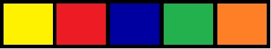

**Figure 3.7** Color-coded sticker (Example)

An example would be when scanning the Service Card due for storage (for example purposes only) the color strips would then have a specific pattern. A visual representation is provided below (Fig 3.8):

## 

**Figure 3.8** Visualization of the Color-coded sticker on a component (Example)

Pattern Solution for the Color-coded sticker

|  |  |  |  |  |
| --- | --- | --- | --- | --- |
| **Item**  **Category** | **Item Subcategory**  **(Changes depending on Item Category)** | **First Digit of Item Quantity** | **Second Digit of Item Quantity** | **Third Digit of Item Quantity** |
| Yellow =  Industrial Service Card | Red =  4GB | Blue = 0 | Green = 0 | Orange = 0 |

**Table 3.1** Pattern Solution for figure 3.8

Since the improvised Color Sensor will output a light resistance values, it will still need calibration depending on the external light sources (if any) and the sensor’s initial calibration itself. The sensor depends on R, G, and B light resistance reflected back to to the sensor to be able to identify a specific color. The readings will then be converted in terms of RGB values that are between 0 and 255 to ease referencing.

## B. Software Development

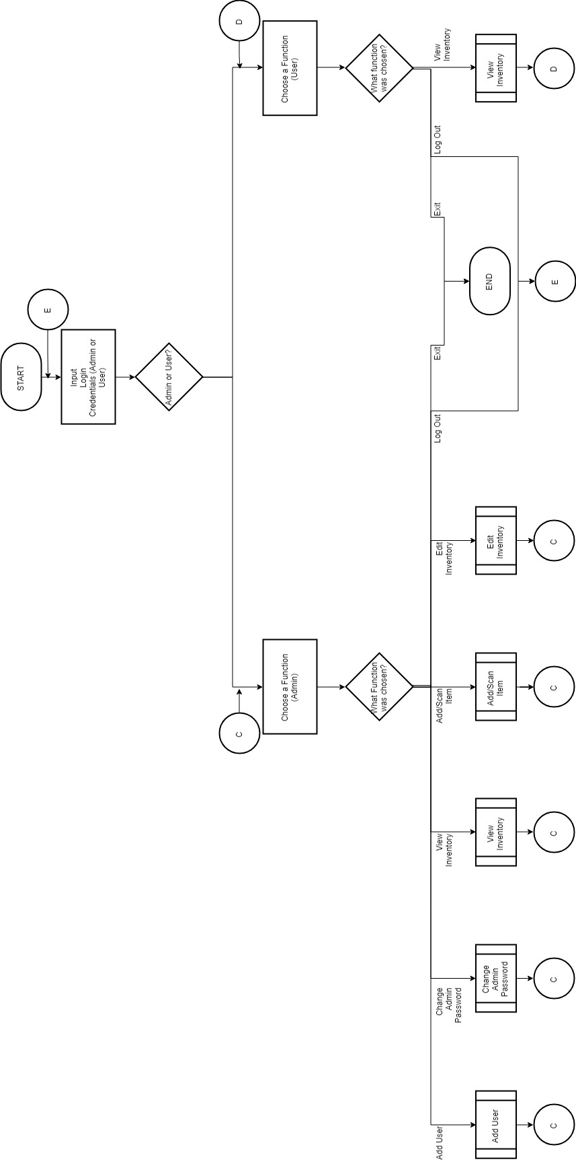

**Figure 3.9.** Inventory System Flowchart

The software flowchart revolves around the inventory system and its implementation along with the use of the designed scanner. At the main process flow of the software it starts with a login screen where the user or admin has to input their respective login credentials. The user will only need to login through the use of a designated username as provided by the admin. There will be no need for passwords on user accounts as these are limited to viewing the inventory and/or exporting it as a .csv file if necessary. Thereafter, once the nature of the account has been determined, the admin will then be presented with a variety of options that are only available to an admin account. Same goes with the user account.

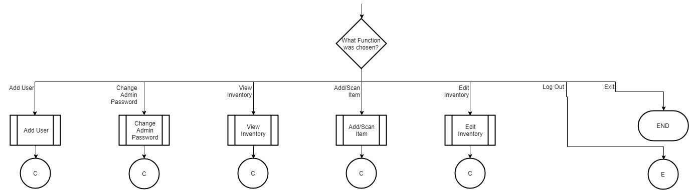

**Figure 4.0.** Admin Functions (Viewing Purposes Only/Part of Fig 3.9)

The admin functions shows a series of available functions for the admin to access or utilize. These functions also determine the scope of the software that is designed for use by the client. These functions will also be discussed in order below.

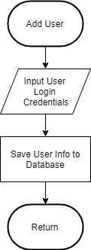

**Figure 4.1** Add User

Add User function allows the admin to provide another account for a requesting user(Accountant or other personnel). This will require the admin to input the user credentials which will be provided by the requesting user. After which, the account will then be generated and its corresponding credentials saved to the database.

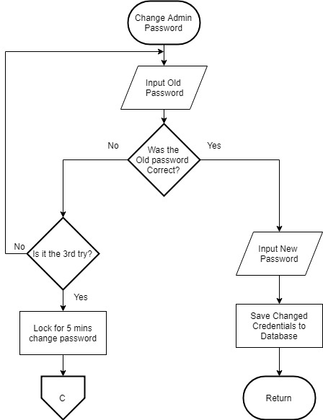

**Figure 4.2** Change Admin Password

Change Admin Password function will allow the admin to change the password if desired. It will prompt the admin to enter the old password, and if it checks out it will then require a new password and another input of the same password as confirmation. If the admin fails to enter the correct old password thrice the program will automatically issue a warning and revert back to the login screen.

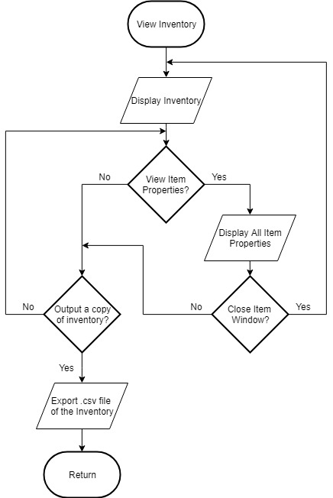

**Figure 4.3** View Inventory

In the View Inventory, the inventory will be displayed with an overview of scanned items with some but not all of their properties shown. The admin will be given the choice of exporting the whole inventory as a .csv file or viewing the a specific item’s properties. When exporting the whole inventory as a .csv file, all of the item properties will be included as well. When viewing a specific item’s properties the admin can choose whether or not to export the item properties as a .csv file or close the item window which brings the window back to the inventory overview.

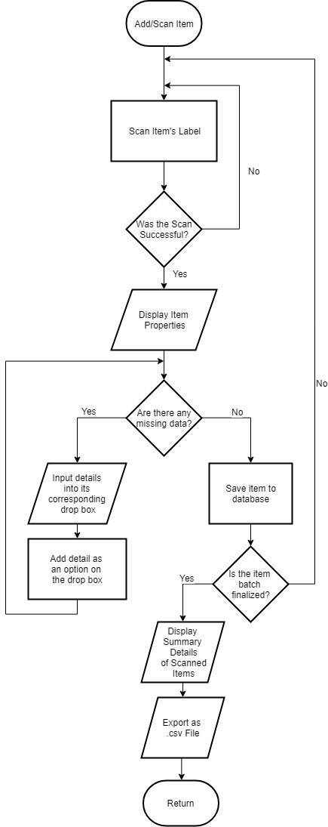

**Figure 4.3** Add/Scan Item

When adding or scanning an item, the admin will select if the item to be scanned will use their existing barcode system or the color-coded system. When the barcode system will be used, the current running program will call their respective program for the barcode system and close the color-coded inventory program as they use and maintain a different inventory system for their barcode system. After successfully scanning the item label, the item properties will be displayed according to the color-coded label that was scanned which contains fundamental item properties (Item category, subcategory, and item quantity number). If there are missing data or the admin desires to add more details to the database, they will input the corresponding details onto its respective dropbox and it will automatically be added to the database and can be used as an entry for similar items that will be scanned thereafter. If there are no more missing details/data, it will ask if the item batch is finalized or not, if not the admin will then be prompted to scan another item. If it is finalized it will then display the summary of the details of the scanned items and automatically exports it as a .csv file as a security measure to enable counter-checking of results if there are any errors in uploading recent updates to the local database. After which it will then go back to the admin selection screen.

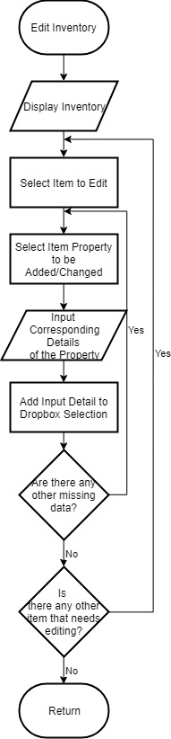

**Figure 4.4** Edit Inventory

In Editing Inventory, the inventory will be displayed and the admin is prompted to select an item due for editing. After which, the property of the item to be changed or added in the database will be selected by the admin as well. The admin will then be prompted to input the desired value or entry of the selected item property. Once it is done the value or entry will also be replicated to the database for future use on the dropboxes when scanning similar items. If there are no more missing data and no other items that need altering, the admin will then be brought back to the admin selection screen.

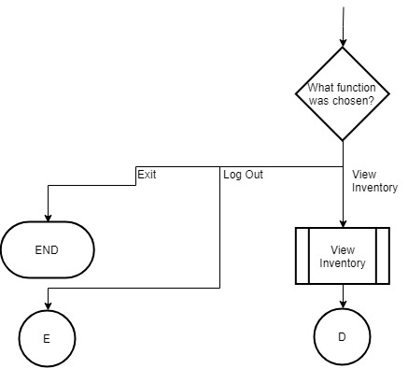

**Figure 4.5** User Flowchart (Viewing Purposes Only/Part of Fig. 3.9)

This flowchart shows the structure of the functions the user accounts are entitled to. These function are more or less given to designated personnel of the company. The user accounts are given or are issued by the admin account per request. The only real function that these user accounts will be capable of using is the View Inventory function which entails the same procedural flow as the admin’s View Inventory.

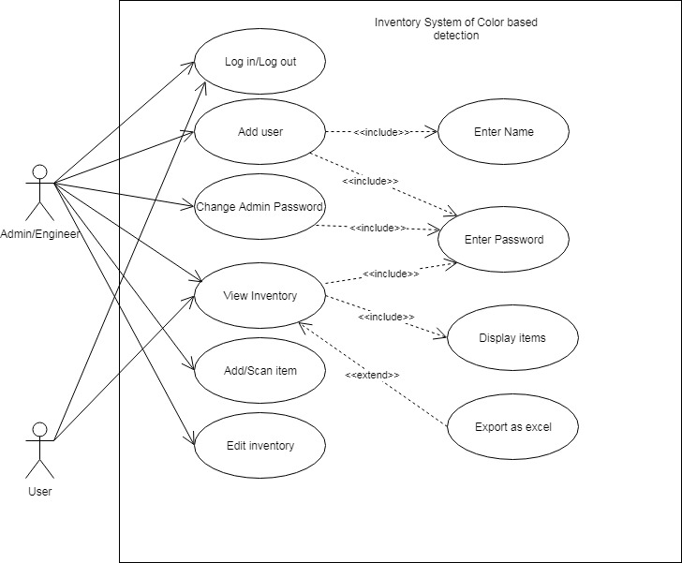

**Figure 4.6** Use Case Diagram

Figure 3.6 shows the use-case diagram of the system. In the diagram there are two Actors, the Admin/Site Engineer and the user. The Admin/Engineer is the person who is incharge of adding items, editing inventory, and creating new users. While the user are the employees that has access to the system but can only view essential details of the inventory. All of the actors have the capability of changing their own passwords, viewing the inventory and exporting the list of items into excel spreadsheet, but only the Admin/Site Engineer can edit information or details of the items in the inventory. By scanning the color coded stickers, the Engineer can add items into the inventory and edit the details of the scanned item.

Each strip is independent on other strips with regards to color identification. This will ensure a much more organized manner of identifying a specific item due for storage from another.

**References**

[1] E. Fetrina, E. Rustamaji, T. Nuraeni and Y. Durrachman, "Inventory management information system development at BPRTIK KEMKOMINFO Jakarta," *2017 5th International Conference on Cyber and IT Service Management (CITSM)*, Denpasar, 2017, pp. 1-4.

[2] Y. Akikuni, K. Okuhara and Y. Fujisaki, "Optimal control of inventory systems with multiple suppliers," *2017 56th Annual Conference of the Society of Instrument and Control Engineers of Japan (SICE)*, Kanazawa, 2017, pp. 353-354.

[3] P. K. Dasgupta, I.-Y. Eom, K.J. Morris, J. Li. Light Emitting Diode-based Detectors: Absorbance, Fluorescence and Spectroelectrochemical Measurements in a Planar Flow-through Cell. Anal. Chim. Acta 500, 337-364 (2003).

[4] P. Tangtisanon, "Web Service Based Food Additive Inventory Management with Forecasting System," *2018 3rd International Conference on Computer and Communication Systems (ICCCS)*, Nagoya, 2018, pp. 448-452.

[5] S. Pei and G. Jia, "Application of Data Warehouse and Data Mining in the Steel Enterprise Information Integration System," *2014 Sixth International Conference on Intelligent Human-Machine Systems and Cybernetics*, Hangzhou, 2014, pp. 181-184.

[6] R. Mondal, I. Mazumdar, and S. Pal, “Design and Development of a Low Cost Colour Sensor and its application in Angular Position Control System of a Stepper Motor,” *International Journal of Electronics and Computer Science Engineering,* 2013, Volume 2, Number 4

[7] Wu, Qiong & Shi, Yunbo. “Data Analysis with a Wireless Multisensory Toxic Gas Detection System”. *International Journal of Distributed Sensor Networks.* 2015. 1-14.

[8] T. Elarabi, V. Deep and C. K. Rai, "Design and simulation of state-of-art ZigBee transmitter for IoT wireless devices," *2015 IEEE International Symposium on Signal Processing and Information Technology (ISSPIT)*, Abu Dhabi, 2015, pp. 297-300.

[9]S. Supannarach and D. Thanapatay, "The study of using RGB color sensor to measure the Curcuminiods amount in Turmeric (Curcuma longa Linn.) and Zedoary (Curcuma Zedoarie Rose.) by comparing colors with HSL system," *2008 5th International Conference on Electrical Engineering/Electronics, Computer, Telecommunications and Information Technology*, Krabi, 2008, pp. 529-532.

## C. Prototype Development (ALL)

### PCB Design

#### PCB Component Diagram

#### Prototype Casing Model

**Hardware Setup**

**Bill of Materials**

|  |  |
| --- | --- |
| **Components** | **Specifications** |
| **PROGRAMMABLE COLOR LIGHT-TO-FREQUENCY CONVERTER(TCS3200)** | **Power Input: 4.5 – 20V DC**  **Detection Range: 7 Meters**  **Logic output: 3.3V**  **Output type:** |
| **ATMega382P Microcontroller** | **Operating Voltage: 1.8V – 5.5V**  **Temperature Range: -40oC - 105oC** |
| **74HC165 (Parallel-in/Shift-Out Register)** | **VCC (2-6V DC)**  **Operating Temperature Range: -40°C to 125°C** |
| **USB to TTL UART CP2102 Module** | **USB Specification: 2.0 compliant with full speed 12Mbps**  **Supply Voltage: 3.0 to 3.6V (supply powered)**  **4.0 to 5.25V (USB bus powered)**  **Temperature Range: -40 to +85°C**  **Baud rates: 300bps to 1Mbps**  **576B receive buffer**  **640B transmit buffer**  **Output: 3.3V** |
| **User’s Laptop** | **CPU: Intel Core i7-6500**  **Memory(RAM): 8GB DDR4**  **Operating System: Windows 7 64-bit**  **Graphics Card: NVIDIA GEFORCE 940M** |
| **LED Indicators (Red)** | **Reverse Voltage: 5V**  **Forward Voltage: 1.8 – 2.2V**  **Operation Temperature: -40 to 85°C**  **Forward Current: 20mA** |

**D. Multiple Design Constraints**

**Decision Matrix**

|  |  |  |  |
| --- | --- | --- | --- |
| **Selection matrix** | **performance** | **flexibility** | **information gathering** |
| **economical** | **asdasd** | **asdkjasd** | **asdasda** |
| **ethical** |  |  |  |

**E. Impact of Design Solution (K)**

**F. Engineering Principles and Modern Engineering Tools Used**

**Visual Studio**

Visual Studio will be used as the main IDE to develop the inventory system responsible for managing a wide variety of data needed by the client. This will also be used to construct and implement the design of the graphical user interface.

**mySQL**

mySQL will be used for the implementation of the database on the inventory system. This is necessary to organize and integrate the software for multiple server uses.

**Engineering Principles (Schematic Principles) (K)**

In this section, the group was engage in different engineering principles that were used to met the objectives of this Color-Coded Scanner Device using Color Sensor in both Hardware and Software part:

For the Hardware part:

*Knowledge in Electronics*

The group used their knowledge learned from the electronics courses that was part of their curriculum. knowledge

For the Software part: