**Design Project Summary**

1. **Software:**

**1.1 Login Page**

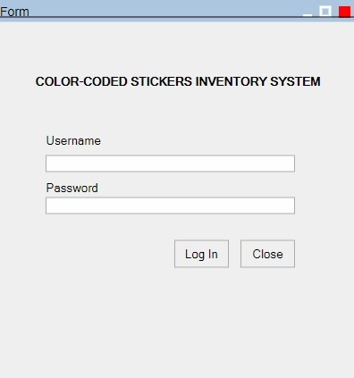

**Figure 1.1.1. Mock GUI of Login Window**

Login Page will consist of Two TextBoxes that correspond to both Username and Password. There are two types of users in the program: *Admin* and *User*.

There will only be a specified number of active Admin accounts at any time. They can only be created through re-programming(coding) the system and not through the program itself. User accounts can be created through the use of an admin account function. User accounts are only usernames without passwords as they can only view the inventory and as such they are only required to fill out the username and leave the password blank.

Once login credentials are met and login is successful. There will be a confirmation label that will be shown to clarify the user that the program will redirect them to the next window.

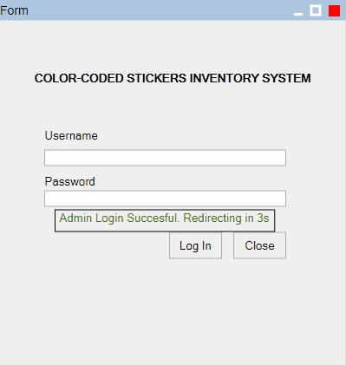

**Figure 1.1.2. Admin Login Successful**

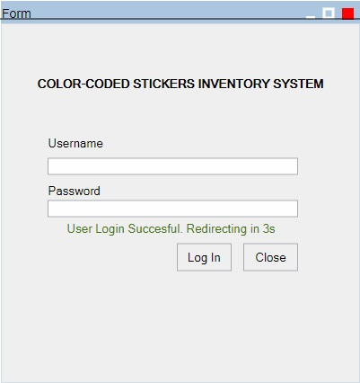

**Figure 1.1.3. User Login Successful**

In this Login Page, there is a limit of 5 tries when logging in. If the user has failed 5 times, the program will automatically close and/or prohibit them from logging in for 5-10 minutes (depends on which you prefer Kuya Rom). The following are dialogs that show failed logins.

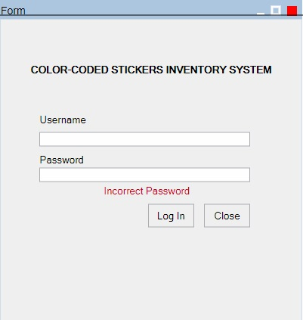

**Figure 1.1.4. Incorrect Admin Password**

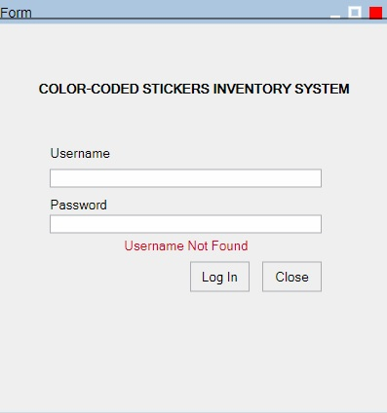

**Figure 1.1.5. Incorrect Username (User Accounts/Admin Account)**

**1.2. Admin**

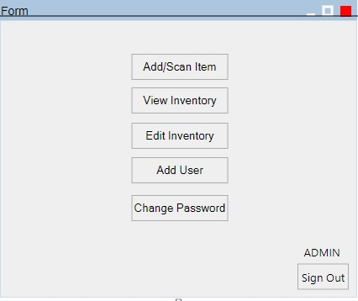

**Figure 1.2. Admin Window after Login**

This window comes after the successful login of an admin account. The buttons summarize all the functions available to the admin. Please add another button to allow the admin to EXIT the program as it is included in our flowchart. Each button corresponding to a function will redirect the admin to the window for that specific function, they are as follows:

**1.2.1 Add User**

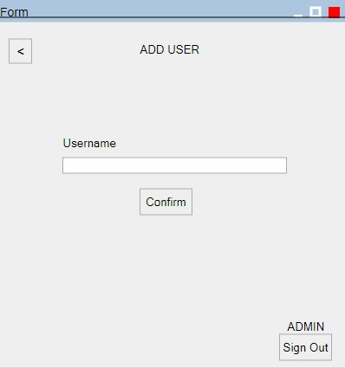

**Figure 1.2.1. Add User**

This window allows the user to add a new user account. Whenever the admin enters an existing username. Please put a dialog box anywhere in the window signifying that the username already exists in the users database. Also another if the operation was a success and the new user account has been added. Thanks in advance.

**1.2.2 Add/Scan Item**

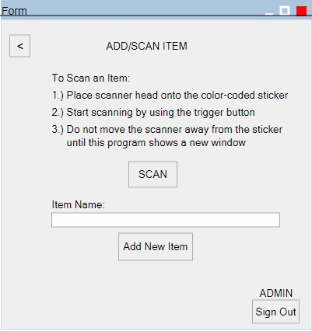

**Figure 1.2.2. Add/Scan Item Window**

When the admin chooses to add/scan item from the function window, this will appear. It allows the admin to either scan an item or add new item.

In Scanning an item, the admin has to press the scan button. After the scan is successful. It will then redirect the admin to a page where he/she can find the initial details of the item scanned based on the result from the color-coded sticker. This will be the window:

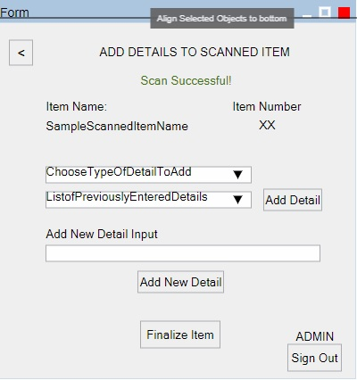

**Figure 1.2.2.1. Scan Success/Item Details Window**

Once the scan has concluded, the window above allows the admin to view the item name and item number that was detected using the code of the color-coded sticker. Furthermore, the admin is given the option to add details to the item or finalize it.

When adding details to the item, the admin has to choose the type of detail (Item Manufacturer, Item Origin Location, etc.) and the list of previously entered details (second dropbox) are the details that has already been entered by the admin before, it is kind of like an autocomplete but a dropbox. The second dropbox allows the admin to choose the previously entered details of items with similar manufacturers or origin locations, etc.

If there are no existing/previously entered details that match the desired detail, the admin can then enter this to the textbox located below “Add New Detail Input”. This allows the admin to enter new details that are not found on the second dropbox. Once successful, the new detail entered will then be located on the second dropbox on the next instance.

The following are variants of the same window that show several confirmation dialogs:

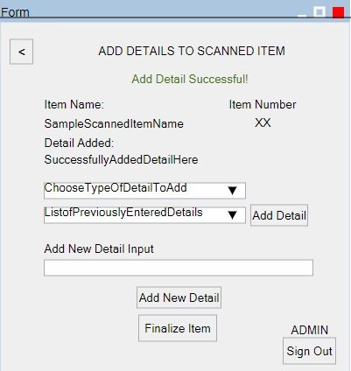

**Figure 1.2.2.2. Add Detail Successful Dialog**

This window shows the dialog when the admin has successfully added a detail using the first and second dropboxes (NOT THE TEXTBOX). Furthermore, it also shows the detail that was added below the SampleScannedItemName.

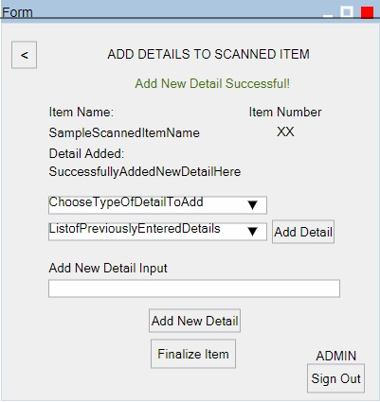

**Figure 1.2.2.3. Add New Detail Successful Dialog**

Same as the previous figure, only this time the admin used the textbox in adding a new detail. This also means that the admin can now see what he/she entered in the textbox in the second dropbox the next time scan item function is triggered/used.

**1.2.3 View Inventory**

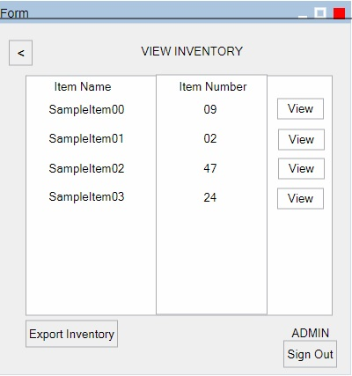

**Figure 1.2.3. View Inventory Window (Admin/User Accounts)**

This window applies to both admin/user accounts. This will appear once the admin/user has chosen the “View Inventory” function. Which will then show a spreadsheet-like display of the items that were previously scanned. This window will also offer the user to “View” each specific item to view all of the item’s details.

The admin can also export the inventory using the “Export Inventory” button and this will export the current version of the entire inventory in a .csv or .xls (Excel) format (whichever you prefer Kuya Rom).

If the admin/user chooses to view a specific item’s details this window will appear:

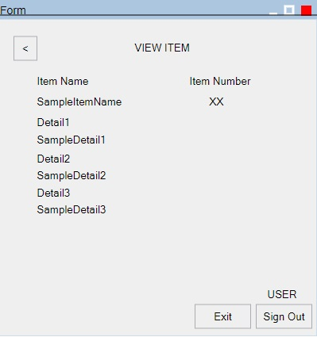

**Figure 1.2.3.1 View Item (Admin/User Accounts)**

This will show all of the item details on this window.

If the admin chooses to export the inventory, the following dialog box will appear if successful:

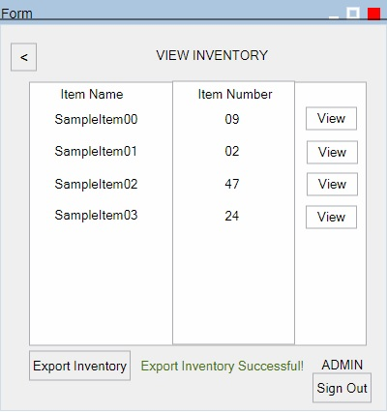

**Figure 1.2.3.2. Export Inventory Successful Dialog**

**1.2.4 Edit Inventory**

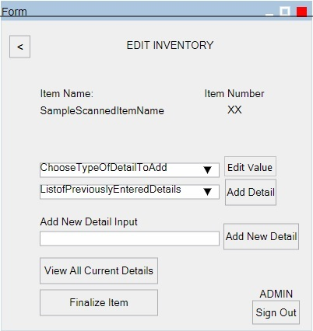

**Figure 1.2.4.A. Edit Inventory Window A**



**Figure 1.2.4.B Edit Inventory B**

When the admin presses the “Edit” button on a specific item on the window A; Window B will appear and allow the admin to add/view details to the item.

Window B will behave very similarly to the “Add Details To Scanned Item” window found on “Add/Scan Item” function. Aside from the “Edit Value” button.

“Edit Value” is available or visible when the admin chooses a Type of Detail on the first dropbox. Once the admin, has chosen a specific type of detail, the button will appear. This allows the admin to EDIT the current value of the string variable of that type of detail. Example:

Type of Detail Chosen: “Item Manufacturer”

Current Detail Value in Database: “Texas Instruments”

Once the admin clicks edit, a textbox will appear and show the current value which is “Texas Instruments” and allows the admin to edit that value. The admin can also leave it blank which is similar to deleting that specific detail on the database.

Window B has the following possible dialogs:

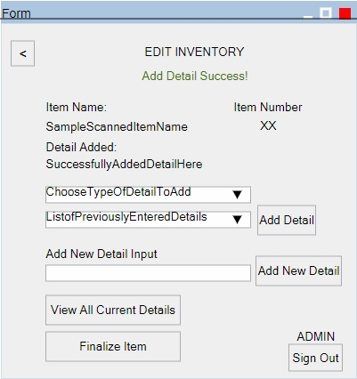

**Figure 1.2.4.1. Edit Inventory Add Detail Success Dialog**

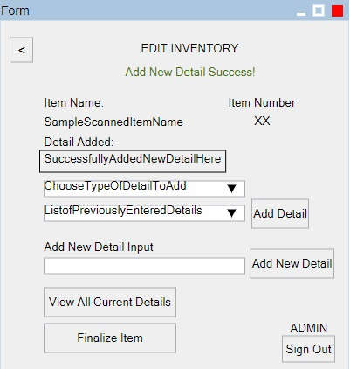

**Figure 1.2.4.2. Edit Inventory Add New Detail Success Dialog**

**1.2.5 Change Password (Admin)**

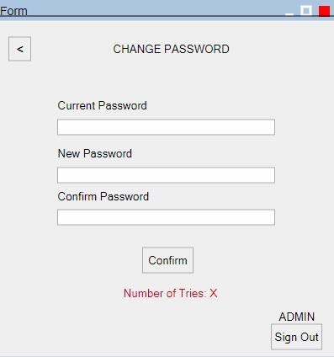

**Figure 1.2.5 Change Password Window**

When the admin chooses “Change Password” function this window will appear. This allows the admin to change the password with a limit of three tries. Once the limit has been reached the admin is logged out and redirected back to the login page.

**1.3 User**

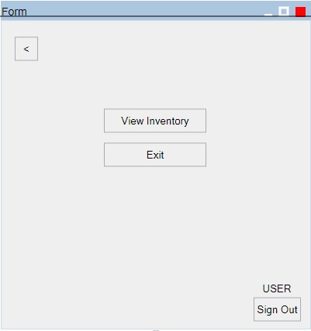

**Figure 1.3. User Functions Window**

Since the user account is only allowed to view inventory, this window shows all the possible functions the user account is entitled to after logging in. The “View Inventory” window is the same as the one from the admin as well as the “View Item” window and “Export Inventory Success” window.

**2. Inventory Data**

|  |  |
| --- | --- |
| Red | 0 |
| Black | 1 |
| Orange | 2 |
| Teal | 3 |
| Violet | 4 |
| Blue | 5 |
| Green | 6 |
| Brown | 7 |
| Pink | 8 |
| Yellow | 9 |

|  |  |  |  |  |
| --- | --- | --- | --- | --- |
| A | B | C | D | E |

**A**=1st color, **B**=2nd color, **C**=3rd color, **D**=4th color, and **E**=5th color

**ABC** – item number  
**DE** – item quantity

Ex:

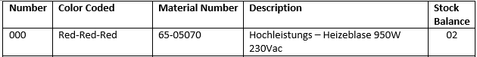

**A B C =** Red-Red-Red = 000

**Red-Red-Red-Red Black = 00001**

**D E =** Red – Black = 01

*stock balance kung ilan yung nasa warehouse, ibig sabihin meron syang dalawang Hochleistung – Heizeblase 950W 230Vac.  
  
so yung unang Hochleistung – Heizeblase 950W 230Vac. Ang magiging color code nya is RED-RED-RED-RED-BLACK (00001)  
  
tas yung pangalawang Hochleistung – Heizeblase 950W 230Vac. Ang color code naman nya is RED-RED-RED-RED-ORANGE (00002)

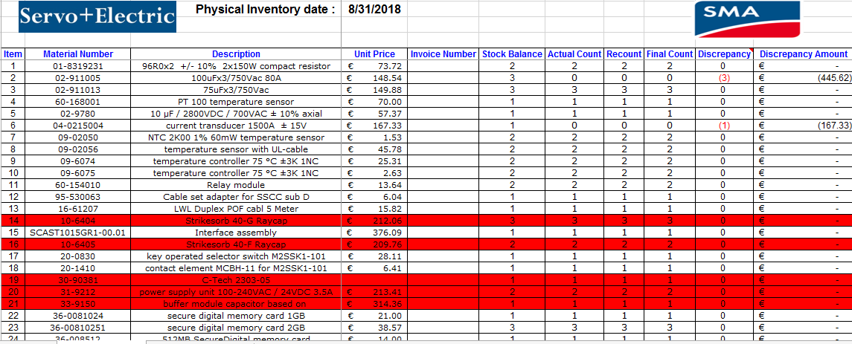

**Categories(Added Details):**

* Unit Price – To be added information

* Invoice -To be added information

* Stock balance (item quantity) – **C, D, and E** (ex. Red-Red-Black = 001)

* Actual Count, Recount, Final Count – To be added information

* Descrepancy Amount- To be added information

* Remarks- To be added information

|  |  |  |  |  |
| --- | --- | --- | --- | --- |
| **Number** | **Color Coded** | **Material Number** | **Description** | **Stock Balance** |
| 000 | Red-Red-Red | 65-05070 | Hochleistungs – Heizeblase 950W 230Vac | 02 |
| 001 | Red-Red-Black | 01-8319231 | 96R0x2 +/- 10% 2x150W compact resistor | 02 |
| 002 | Red-Red-Orange | 02-911005 | 100uFx3/750Vac 80A | 03 |
| 003 | Red-Red-Teal | 02-911013 | 75uFx3/750Vac | 03 |
| 004 | Red-Red-Violet | 60-168001 | PT 100 temperature sensor | 01 |
| 005 | Red-Red-Blue | 02-9780 | 10 µF / 2800VDC / 700VAC ± 10% axial | 01 |
| 006 | Red-Red-Green | 04-0215004 | current transducer 1500A ± 15V | 01 |
| 007 | Red-Red-Brown | 09-02050 | NTC 2K00 1% 60mW temperature sensor | 02 |
| 008 | Red-Red-Pink | 09-02056 | temperature sensor with UL-cable | 02 |
| 009 | Red-Red-Yellow | 09-6074 | temperature controller 75 °C ±3K 1NC | 02 |
| 010 | Red-Black-Red | 09-6075 |  | 02 |
| 011 | Red-Black-Black | 60-154010 | Relay module | 02 |
| 012 | Red-Black-Orange | 95-530063 | Cable set adapter for SSCC sub D | 01 |
| 013 | Red-Black-Teal | 16-61207 | LWL Duplex POF cabl 5 Meter | 01 |
| 014 | Red-Black-Violet | SCAST1015GR1-00.01 | Interface assembly | 01 |
| 015 | Red-Black-Blue | 20-0830 | key operated selector switch M2SSK1-101 | 01 |
| 016 | Red-Black-Green | 20-1410 | contact element MCBH-11 for M2SSK1-101 | 01 |
| 017 | Red-Black-Brown | 36-0081024 | secure digital memory card 1GB | 01 |
| 018 | Red-Black-Pink | 36-00810251 | secure digital memory card 2GB | 03 |
| 019 | Red-Black-Yellow | 36-008512 | 512MB SecureDigital memory card | 01 |
| 020 | Red-Orange-Red | 41-518907 | System Cable M12 | 01 |
| 021 | Red-Orange-Black | 36-50323 | patch cable SFTP 2xRJ45 Cat5e grey 1.0m | 01 |
| 022 | Red-Orange-Orange | 36-6128 | Compact fast ethernet Switch RS20-0800M | 01 |
| 023 | Red-Orange-Teal | 36-6134 | redundancy module with operation control | 01 |
| 024 | Red-Orange-Violet | 16-13134 | LVDS Cable 1400 MM | 01 |
| 025 | Red-Orange-Blue | 41-5191 | M12 Cable 8 pole | 01 |
| 026 | Red-Orange-Green | 09-02059 | Temperature Sensor UL Cable 800 MM | 01 |
| 027 | Red-Orange-Brown | 41-52101501 | cable set multi-core door left | 02 |
| 028 | Red-Orange-Pink | 41-5190 | Voltage cable assembly | 01 |
| 029 | Red-Orange-Yellow | 95-104100.01 | Cable set voltage | 01 |
| 030 | Red-Teal-Red | 42-5101 | terminating plug 8-pole M12x1 | 02 |
| 031 | Red-Teal-Black | 43-9389 | TK ISDN-terminator 2x100Ohm RJ45 BK | 01 |
| 032 | Red-Teal-Orange | 46-87900.01 | closing shutter fan | 01 |
| 033 | Red-Teal-Teal | 60-0091632 | Auxiliary switch 1-pole CEL18-10 | 02 |
| 034 | Red-Teal-Violet | 60-154050 | Relay 24VDC 1x CO PLC-RSP-24DC/21AU | 02 |
| 035 | Red-Teal-Blue | 60-154070 | Relay 230AC 2 x UM Gold PLC-RSC-230UC | 02 |
| 036 | Red-Teal-Green | 60-154072 | Relay 230VAC 1x CO PLC-RSP-230UC/21AU | 02 |
| 037 | Red-Teal-Brown | 60-15800.01 | Power relay 4x CO 230VAC 12A | 02 |
| 038 | Red-Teal-Pink | 60-167002 | coupling device AGH-PV | 01 |
| 039 | Red-Teal-Yellow | 42-4611 | RJ 45 CAN - Bus Termination Plug 120 R | 03 |
| 040 | Red-Violet-Red | 61-01590311400 | LV HRC fuse link size 3 400A 1100VDC | 06 |
| 041 | Red-Violet-Black | 61-763500.01 | HV/HRC fuse link 1000A | 03 |
| 042 | Red-Violet-Orange | 62-280402 | Adjacent jumper 24A insulated | 02 |
| 043 | Red-Violet-Teal | 62-289172 | Transfer module RJ45/RJ45 1:1 wiring | 02 |
| 044 | Red-Violet-Violet | 10-30026 | 1100V 20k Surge | 03 |
| 045 | Red-Violet-Blue | 62-900100.01 | 255V 25kA surge arrester | 03 |
| 046 | Red-Violet-Green | 60-207357 | Selecto switch cable | 01 |
| 047 | Red-Violet-Brown | 62-952315 | overvolt. Arrestor modular Typ2 3+1 pol. | 02 |
| 048 | Red-Violet-Pink | 64-01201 | 4-line EMC filter 520/300VAC | 01 |
| 049 | Red-Violet-Yellow | 64-0175 | EMI-filter 4x63A/480V 63AYC10B | 01 |
| 050 | Red-Blue-Red | 65-05066 | fan heater 1000W CS 032 | 02 |
| 051 | Red-Blue-Black | 60-0003461 | PCB Multi pack for contractor AF 1650 | 02 |
| 052 | Red-Blue-Orange | 10-130055600.01 | 1500V 20K surge arrester | 01 |
| 053 | Red-Blue-Teal | 65‐0507 | hygrostat 1x C/O 24‐230VAC/DC | 02 |

Note: Highliighted items already have a serial number, see the excel spreadsheet for more info.

*009 doesn’t have a description, its okay to leave it blank for the description