**Attendance Monitoring Using Fingerprint Authentication and Weekly Gross Income Computation with Desktop Application for Webert Marketing’s Employees**

**by**

**Paul Daniel C. Divina**

**John Philip T. Felices**

**Nicodemus G. Teves**

A Design Report Submitted to the School of Electrical Engineering, Electronics Engineering, and Computer Engineering in Partial Fulfilment of the Requirements for the Degree

**Bachelor of Science in Computer Engineering**

**Mapúa University**

December 2017

**CHAPTER 1  
DESIGN BACKGROUND AND INTRODUCTION**

         In some small companies, the checking of the attendance of the employees is done and managed by a specific person in charge. Every day, that person manually checks, records, and manage each of the employee’s attendance record. This traditional way of managing employees’ attendance often leads to a problem where the employees wonder whether their attendance have been recorded correctly. Additionally, the salary of the employees are also computed based on their attendance record for how many times they were absent, present or if they worked half-day. So if the attendance was recorded incorrectly, the salary that will be computed will also be wrong. This problem can become a great concern to both the employees and the company since it affects the credibility of the attendance records kept by the person in charge as well as the salary computation. To address the issue, an automated attendance monitoring system can be created that records the employee’s time-in and time-out and determines whether the employee worked for the whole day or half day. The attendance monitoring system may also be linked to a desktop application for keeping the attendance record and computing the employees’ salaries.

**Customer**

The client of the design project is Webert Marketing, a company engaged in wholesaling of hardware, electrical, plumbing materials and construction supplies, located in No. 11 Lanzones Street Brgy. Potrero Malabon City. It is owned by Mr. Jun De Guzman. The group converse with his son and heir, Mr. Jelson De Guzman, regarding with the company’s problem about the attendance and salary of their workers.

**Need**

The Webert Marketing’s way of checking the attendance is still traditional in which the workers will sign in the logbook, write their time-in, name and signature. Then the Secretary will check for the employee's attendance after lunch break and until work ends. In this procedure the Secretary of Webert Marketing takes a lot of time in monitoring the attendance of more than fifty employees, that is why the client want us to create a system that will automate the attendance monitoring of the employees at the start of work, after lunch break, and at the end of work. This system will serve as an assistance for the Secretary which will result to less time for the Secretary to manually monitor the attendance of the workers and for the Secretary to focus more on other works such as monitoring the inventory, job deliveries, return of items and others. Furthermore, the client wants to automate their payroll system. With this concern, the client wants to record and calculate the earned weekly gross income of the workers based on their attendance and generate a weekly report. The salary of workers is per day and summed for the whole week and if the worker took a half-day, the employee will take half of their daily salary.

**Solution**

To fulfill the needs of the client, the group proposes an attendance monitoring system using a fingerprint scanner, which is synchronized to a payroll desktop app. The components that will be used to implement the proposed design are Atmega328p, fingerprint scanner, USB module and cable connected to a computer. The fingerprint scanner will be used as an input device. The Atmega328p will serve as the microcontroller for the device. After the fingerprint of an employee is successfully authenticated by the fingerprint scanner, it will automatically record the time-in of the employee, the same with the time-out. The device will also be connected to a computer through USB connection to be able to communicate with the desktop app. The desktop app contains the attendance records of the employees which will be updated automatically. The app also provides a payroll system which computes the salary of the employees based on their attendance.

The payroll system of the device will only compute for the gross income and will not include deductions from taxes, etc. as preferred by the client. The device also lets the employees to have their fingerprint scanned on their right thumb, left thumb, right index finger, and left index finger just in case they may have an injury or wounds that would hinder the process of scanning.

**Objectives**

The main objective of the design is to monitor the attendance of the workers for the whole week and generate their earned weekly salary.

*Specific Objectives*

1. To design and build a fingerprint authentication attendance system that will determine the time-in and time-out of workers.
2. To create a local and secured Desktop Application to be used only by the company, specifically the Secretary/Administrator.
3. To generate a weekly report, that shows the remarks for each day, and gross income that a worker will acquire for the week.

**Constraints**

    In Table 1.1, the constraints, source of constraints, trade-offs, and alternative solutions are presented. This describes the process of designing the system and shows how the designers will achieve the needs of the client.

**Table 1.1 Constraints, Source of Constraint, Trade-Offs, and Alternative Solutions**

|  |  |  |  |
| --- | --- | --- | --- |
| **Constraint** | **Source of Constraint** | **Trade-Offs** | **Alternative Solutions** |
| Interoperability - Compatibility of the hardware device and software application | IEEE Std 1636-2009 - IEEE Standard for Software Interface for Maintenance Information Collection and Analysis (SIMICA) | The convenience of having a portable device. | 1. Use of USB Module for the connection of the desktop and device  2. Use of Third-Party Integrated Development Environment (IDE)  3. Use of Wi-Fi or Bluetooth for the connection of the desktop and device  4. Use of Open Source Application |
| Maintainability-  Security of the software application | IEEE Std 730-2014 - IEEE Standard for Software Quality Assurance Processes | Having multiple access within the software system | 1.  Use of desktop application with a local host admin having authentication system  2. Applying system updates  3. Troubleshooting to detect and fix errors |
| Reliability –  The quality of components | IEEE 1012-2016- IEEE Draft Standard for System, Software and Hardware Verification and Validation | The expenses of the design materials | 1. Use of good quality components  2. Use of well performing components |
| Security and Privacy –  Disclose information given by the client on business processes, employees, and business’s policies | PHILIPPINE LAW  REPUBLIC ACT NO. 10173  An act protecting individual personal information in information and communications systems in the government and the private sector, creating for this purpose a national privacy commission, and for other purposes | Limited information given by the client | 1. Add feature that Administrator can change the information and salary of the employee  2. Using the minimum wage given by the law as the salary of the employees to test the system  3. Creating a systematic device and user-friendly application for the client |

       The first design constraint is the interoperability, compatibility of the hardware device and software application. The device must communicate or link with other devices and to be able to access the software system and database, it is according to the IEEE Std 1636-2009 - IEEE Standard for Software Interface for Maintenance Information Collection and Analysis (SIMICA). Further, we set aside the convenience of having a portable device. The, solutions that can help are the use of use of USB module for the connection of the desktop and device, use of Third-Party Integrated Development Environment (IDE), use of Wi-Fi or Bluetooth for the connection of the desktop and device, and use of Open Source Application.

    The second constraint of the design is about the maintainability, security of the software application and maintaining the system database it is the assurance of the system to develop and maintain. The standard is according to IEEE Std 730-2014 - IEEE Standard for Software Quality Assurance Processes. In this system we prohibited the use of multiple software system accounts. The solution for a secured system is, use of desktop application with a local host admin having authentication system and to maintain our software we can apply system updates and troubleshooting to detect and fix errors.

The third constraint is the reliability, the quality of components to be used. Setting aside the expenses that this project will spend, we can have a good quality and well-performing device. With this solution we can satisfy the intended use of the device for the client, this is based on IEEE 1012-2016- IEEE Draft Standard for System, Software and Hardware Verification and Validation.

The fourth and last constraint is security and privacy of the business, the client didn’t disclose enough information on business processes, information of employees and business’s policies. This is the right of the company according to the PHILIPPINE LAW REPUBLIC ACT NO. 10173 it is an act protecting the information of the business and employees. Setting aside the limited information given by the client, we design our solutions that it has a feature that the Administrator can change the information and salary of the employee, the salary that can be tested for the device is minimum wage given by the law and creating a systematic device and user-friendly application for the client.

**Design Impact**

         In a global context, the design project contributes as an engineering solution to the problem of business establishments regarding the method of getting the correct attendance by providing an automated attendance system. With the project utilizing the usage of existing technologies including fingerprint biometric scanner and ATmega328P microcontroller, this can be used as a reference or guideline for others to improve it or come up with a solution to another problem using the same technologies.

         Looking at the economic context, with the design being able to accurately manage and monitor the attendance of employees, a company receives an increased income. This comes from cutting unnecessary expenses from the distribution of additional salary to certain employees.

The design manages to also affect in an environmental context through reduction of waste produced, the use of papers in logbook will be reduced and the used ink for the pen as well.

         In a societal context, the design project provides convenience and increase of productivity in a workplace. It will take lesser time to check the attendance of the employees and also the waiting time when the salary is to be given since everything was already computed and does not need to be recalculated.

**Differentiation**

Table 1.2 shows the differentiation between the proposed system and an existing design for automated attendance system designed by Md. Shakil and Rabindra Nath Nandi. We used the information from their paper titled “Attendance Management System for Industrial Worker using Fingerprint Scanner” to differentiate it from our work based on the technology used, functionality, and features.

**Table 1.2** Differentiation from the existing patented design

|  |  |  |
| --- | --- | --- |
|  | **Proposal** | **Nearest Similarity** |
| **Technology** | The system uses a fingerprint scanner with LCD display. It is accompanied by a desktop application for data processing and management. | The design uses fingerprint scanner and LCD display for its hardware that is connected to a web server. |
| **Functionality** | Registration of four different fingerprint templates for each employee specifically the thumb and the index fingers.  Automated checking of the daily attendance.  Automated calculation of the weekly gross income.  Generating of the weekly report outputted in an Excel File. | Automated checking of attendance that is viewable by both the admin and the employees through a web page. |
| **Features** | The system is equipped with LCD display to show the status of attendance checking.  Features of the desktop application:  Administrator features   * Administrator Login * New employee registration * Edit employee’s information * Delete registered employees * Update employee work status * View daily record of employee   Employee features   * Register fingerprint * View attendance record   Calculate weekly gross income. | Features of the webpage:  Administrator Page   * Login admin account * Add new user page * Edit existing user page * Delete existing user page * Post a message for employees * View attendance record and worker’s message * Site edit   Worker’s attendance Page   * Login * View own attendance record * Send a personal message to the admin |

**Benefits**

         The design provides convenience and ease in taking up the daily record of attendance for employees of the company reducing the time and effort to do so. With the actual time in and time out being recorded, our client can confidently see who's been working for full-day and half-day to give them their respective amount of salary each day resulting to decrease in direct labor costs. This also prevents employees from making excuses and false arguments regarding their working time. With the feature of the design for the gross income computation, the accounting department can use this for the calculation and makes it even more reliable and less prone to human error.

**CHAPTER 2**

**REVIEW OF RELATED LITERATURE**

         This chapter presents the related studies that were reviewed and evaluated by the group as a source of reference to be able to continue the process presented from the previous chapter and to develop the design. This will also present the ideas behind the existing programs and design technologies that will be utilized in the proposed design.

**2.1 Fingerprint Biometric System**

         Fingerprint biometric data have been already used as a method of identification and verification for a long time now. Fingerprint is a unique physical characteristic of a human. Fingerprints of every person are distinctive and fingerprint details are permanent even if you temporarily get cuts or bruises on the skin (Maltoni et al., 2003). This means that it can possibly be the most convenient and secure method of verifying the identity of a person for the reasons that it can’t be borrowed, stolen or be forgotten, and practically you cannot forge a fingerprint. Fingerprint sensors and readers are developed to materialize the automated process of identifying and confirming the identity of an individual by using fingerprints.

         Fingerprint sensor is an electronic device used to capture a digital image of the fingerprint pattern (Qiu, 2014). This captured image is called a live scan where it will be digitally processed in order to create a biometric template (a collection of minutiae points) which will be stored and used for matching. The process of checking the identity of a person on a fingerprint authentication system is done by comparing an individual’s fingerprint to a stored biometric template. Today, the application of fingerprint sensors on different systems such as door lockers and attendance systems are being considered for it provides the solution for the security vulnerability. Fingerprint-based biometric systems is one of the most preferred method for authentication because of the need of a convenient but still reliable security measures.

**2.1.1 Fingerprint Sensor Technology**

Fingerprint sensors comes in different shapes and sizes, but generally it is categorized as either area scan (or touch) sensor and swipe sensor. With a touch sensor, the user will just place their finger on the surface of the sensor to register the fingerprint. On a swipe sensor, the user will slide their finger vertically on the surface of the sensor. There are several fingerprint sensor technology that are available to use but the two commonly used are the optical sensor and capacitive sensor.

Optical sensor is a type of fingerprint scanner that uses an LED light that will illuminate the finger. This type of fingerprint sensor uses frustrated refraction over a glass prism, the light is absorbed when the skin touches the glass. The finger is illuminated on one side and the image is transmitted to a camera on the other side using a lens. The fingerprint image is formed by determining the light and dark areas produced by the fingerprint ridges. The advantages of using this type of sensor are low cost and prevention of electro static discharge (ESD) and its disadvantage is it is big in size and its high power consumption. This sensor is commonly used on fingerprint door lockers, indoor devices, and time attendance.



**Fig 2.1** Optical Fingerprint Sensor Technology

         Capacitive sensors on the other hand uses multiple array of capacitor plates to create the image of the fingerprint. Capacitive sensors use the electrical property of “capacitance” to make measurements. It captures the fingerprint image by sensing the image from the electrical current instead of using the light. The human skin is conductive enough that it will be able to generate a capacitive coupling along with the arrays of capacitive elements on the sensor. The fingerprint’s physical ridges are much closer to the capacitive plates which in return produces a higher capacitance compared to the lower portions of the fingerprint. The advantages of capacitive sensor technologies are its small size and its low power consumption and the disadvantages is its vulnerability to strong electrical fields such as ESD and the high cost of the silicon area sensors. It has been mainly used on mobile phones, laptops and other electronic devices.



**Fig 2.2** Active Capacitive Fingerprint Technology

**2.2 Automated Attendance System**

         Because fingerprint sensors provides reliability of identifying a person, it is now preferably used as a method for creating an automated attendance system. Attendance management is the act of managing the attendance or presence in a work setting to minimize loss due to employee downtime (Akindutye et al., 2013). The traditional approach in taking up attendance is by using time clocks and timesheets. An automated attendance management system designed by Akindutye (2013) was used in a university environment which integrates the fingerprint authentication in dealing with the process of attendance checking for both staff and students. The system has two processes, the enrollment and authentication. During enrollment, the fingerprint of the user is stored as a template in the database along with the user’s identity. On the authentication part, the fingerprint of the user is captured again and will be compared with the template on the database to look for a match before the attendance is done. The result of the implementation of the system shows that the system is well secured and reliable that it is capable of preventing impersonation.

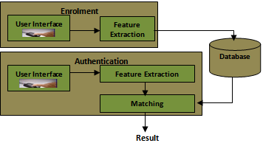

**Fig. 2.3** Architecture of the fingerprint-based attendance management system

**2.3 Payroll System**

A computer program can maintain accurate and consistent database, resulting to an improved performance in a system. Particularly, an automated payroll system has fast data retrieval capabilities calculations. This will dramatically reduce the manual error and effort. This kind of system relies especially in software design and database system. Doing manual computation of all payroll employees causes a large volume of payroll data and calculations, it is very difficult to handle the data manually and it delays the payroll process. That is why a payroll management system is needed to be develop. This payroll database system will avoid the delay in generating salaries, schedules, payment reports, pay slips and so on.

The database of Payroll Management System (PMS) provides the proper data input forms with self-descriptive labels and consist of inter-related modules for better summaries. Such modules are, insertion, data update, deletion, and pay slips. This user friendly system can directly implemented on the server environment. Furthermore, this comprehensive database facilitates fast on data upload, data retrieval and reports generation.

On the other hand, the system description, it is simple in its structure and operations. The operation procedures are easily understandable and sufficiently flexible to cope with future requirements (Connolly and Begg, 2004; Ahmad et al., 2010). Moreover, the system is user friendly, that the user can enter data easily and gets reports in timely basis. The study is developed using Java Server Pages (JSP), TOMCAT, JAVA, JAVA SCIRPT and SQL Server. The JSP is selected for this study for the following reasons like portability, efficiency, robust, independency of layers and easy integration with other sources Java Database Connectivity (JDBC) and so on (Xavier, 2006; Schildt, 2002).

This study presented the database and software design for PMS. The software changes the manual operation into a computer-based system to automate study, provide efficiency, accuracy, timelessness, security and economy. Further, analyzing the shortcomings of manual payroll management, it is considered necessary to remove its deficiencies and provide suitable solutions for this problem. That is why this kind of system can help the organization to manage efficiently the employee pay related data as personal information, salary information, loan information and so on. (Gautam, Ragumani, & Sharma, 2010).

**2.4 ATmega328/ATmega328P**

Atmel’s ATMega328P has a lot of features that is why it widely used in many devices. Some features of ATMega328P is that it is a high-performance, low power 8-bit microcontroller. Further, it has advanced RISC-based microcontroller having 131 powerful instructions – most single clock cycle execution, 32x8 general purpose working registers, fully static operation up to 16 MIPS throughput at 16MHz and an on-chip 2-cycle multiplier. Moreover, it has High endurance non-volatile memory segments 32KB ISP flash memory with read-while-write capabilities, 1K bytes of EEPROM, 2K bytes SRAM, 23 general purpose I/O lines, 32 general purpose working registers. On the other hand, the peripheral features of it contains three flexible timer/counters with compare modes, internal and external interrupts, serial programmable USART, a byte-oriented 2-wire serial interface, SPI serial port, a 6-channel 10-bit A/D converter (8-channels in TQFP and QFN/MLF packages), programmable watchdog timer with internal oscillator, and five software selectable power saving modes. Lastly, this device operates between 2.7-5.5 volts. There are still other features of this microcontroller but the most important thing we must know is that by executing powerful instructions in a single clock cycle, the device achieves throughputs approaching 1 MIPS per MHz, balancing power consumption and processing speed.

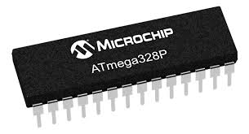

**Figure 2.4** AtMega328P Microcontroller

**2.5 Database Management**

         A database is an organized collection of the data information. It was built for a system so that it can access, manage and update a particular pieces of stored information every time the system is used. Our proposed design will basically require a database since we are trying to automate the attendance and payroll system of a business establishment and it will require the employees’ information.

         The SQL (structured Query Language) is a programming language used and designed for managing relational database management system (RDBMS). The Fingerprint-Based Attendance Management System by Akinduyite (2013) utilized the usage of this programming language. The program in the system was implemented using Microsoft’s C# on the .NET framework and Microsoft’s Structured Query Language (SQL) Server 2005 as the backend. The testing result shows that the system was dependable in the verification of the user’s fingerprint with an accuracy of 97.4%.

**Chapter 3**

**DESIGN PROCEDURES**

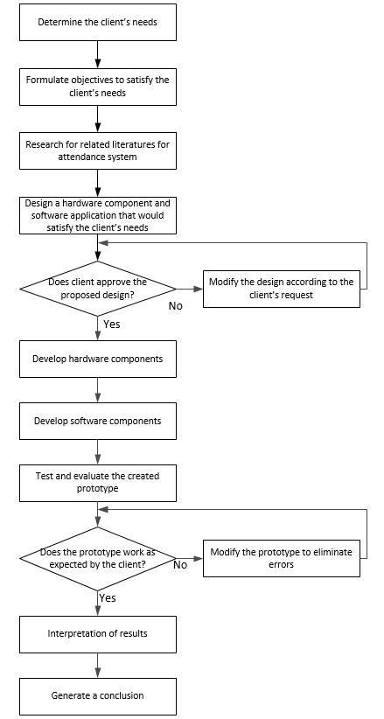

**Figure 3.1** Design Procedure of Attendance Monitoring Using Fingerprint Authentication and Weekly Gross Income Computation with Desktop Application for Webert Marketing’s Employees

The initial step in the design procedure is to determine the client’s needs. A set of objectives is then formulated based on the client’s needs. To have a well-established basis, a research for related literatures on attendance systems is conducted by the group. A design proposal for the hardware and software is then submitted to the client. After the client conforms to the proposed design, the development of software and hardware components is done. Testing and evaluation of the created prototype is performed after the development. Lastly, interpret results and generate conclusion after the client accepts the results of the created prototype.

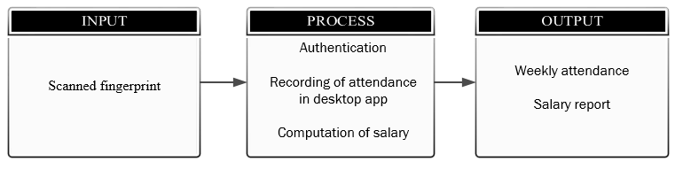

**Figure 3.2** Conceptual Framework of Attendance Monitoring Using Fingerprint Authentication and Weekly Gross Income Computation with Desktop Application for Webert Marketing’s Employees

Figure 3.2 shows the conceptual framework for the proposed system. The fingerprint of each employee will serve as the input for the device which will then be authenticated using a fingerprint sensor. After a fingerprint is verified, it will then record the attendance for the specific time and date. The record for the attendance will also serve as the basis for the computation of the employees’ weekly gross income. The administrator can monitor the attendance in the desktop app as well as generate the weekly salary report.

**HARDWARE DEVELOPMENT**

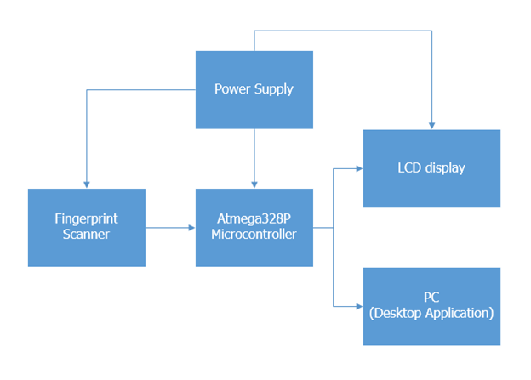**Figure 3.3** Hardware Block Diagram

    Figure 3.3 shows the hardware block diagram of the attendance monitoring system. The fingerprint scanner is connected to the Atmega328P microcontroller which processes and verifies the input fingerprints. The LCD display outputs the result of the authentication- if it is successful or not. The PC along with the desktop application will serve as the monitoring unit for the system where it shows the employees’ time-in and time-out.

**Schematic Diagram**

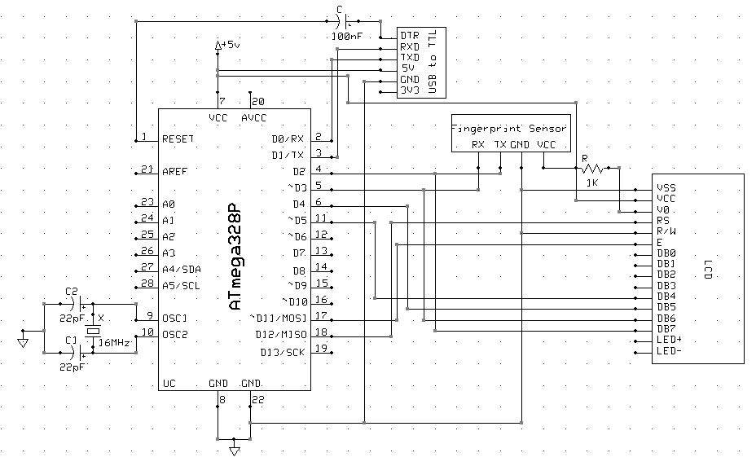

**Figure 3.4** Schematic Diagram of the Daily Attendance Monitoring System

Figure 3.4 shows the schematic diagram of the attendance monitoring system. The fingerprint sensor is directly connected to the microcontroller ATmega328P and will be powered by a 5V source. The LCD display is also connected directly to the microcontroller and will be powered by a 5V source. The USB to TTL board will be used to program the microcontroller as well as a medium to obtain data from the fingerprint sensor to the desktop application.

**Software Development**

**System Flowchart**

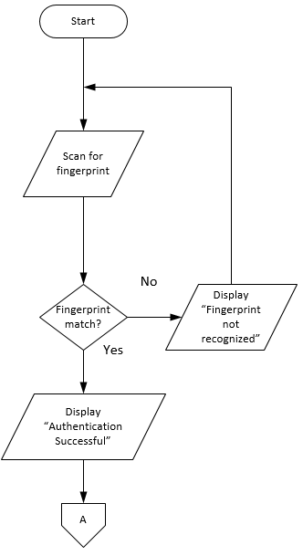

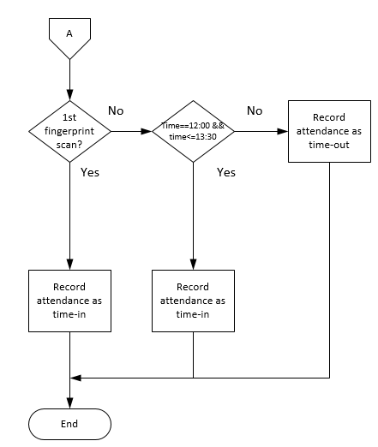

**Figure 3.5** System Flowchart of the Attendance Monitoring System

        Figure 3.5 shows the system flowchart of the attendance monitoring system. After the employee puts his finger on the fingerprint scanner, it will scan his fingerprint and the system will then verified if the fingerprint is registered or not. If the fingerprint is not registered then the LCD display will output a message telling the user that the fingerprint is not recognized hence, it is not registered. If the authentication is successful, the system will check whether the scanned fingerprint is for the time-in, lunch break end, or time-out. After determining which, the system will then record the corresponding attendance.

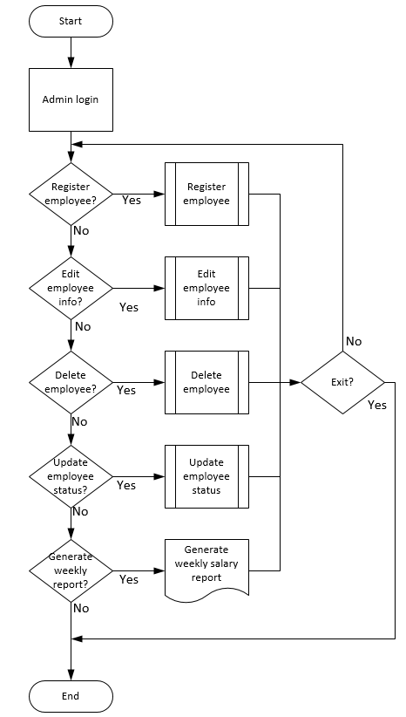

**Figure 3.6** Flowchart for Attendance and Desktop Application

Figure 3.6 shows the flowchart for the payroll system. The system allows the administrator to register an employee to the database, edit the employees’ information, delete an employee entry, and update the status of the employee including their allowed overtime. After the attendance for the week is completed, the weekly salary of the employees’ can be computed and the administrator has an option to generate a weekly report of the employees’ salary in an excel file.

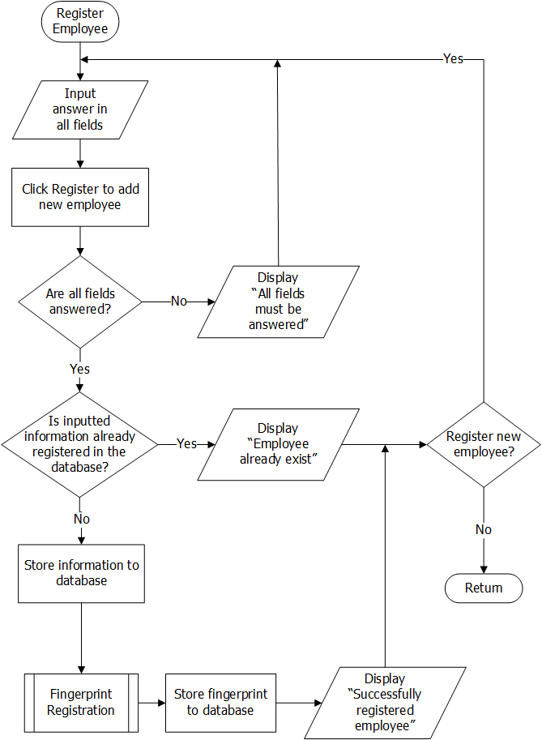

**Figure 3.7** Flowchart for Registering Employee

Figure 3.7 shows the registering of an employee in the database. In this process there are some information’s that is needed to be answered shown in textboxes this are, Last Name, Given Name, Middle Name, Age, Sex, Home Address, Contact Number, Marital status, Contact person(relationship and contact number), salary, and the employees’ fingerprint.

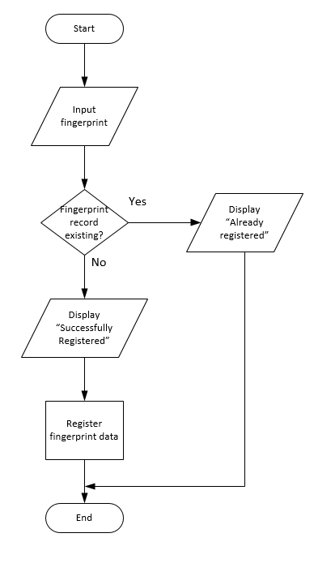

**Figure 3.8** Flowchart for the Fingerprint Registration

Figure 3.8 shows the flowchart for the fingerprint registration process. The program will initially ask for an input fingerprint. When a fingerprint is detected, it will then check whether it already has a record of it in the database. If there is none, then the fingerprint will be registered and an ID will be generated for the fingerprint. If the program found a match on the database, it will no longer create another one and prompts the user that the fingerprint is already registered in the database.

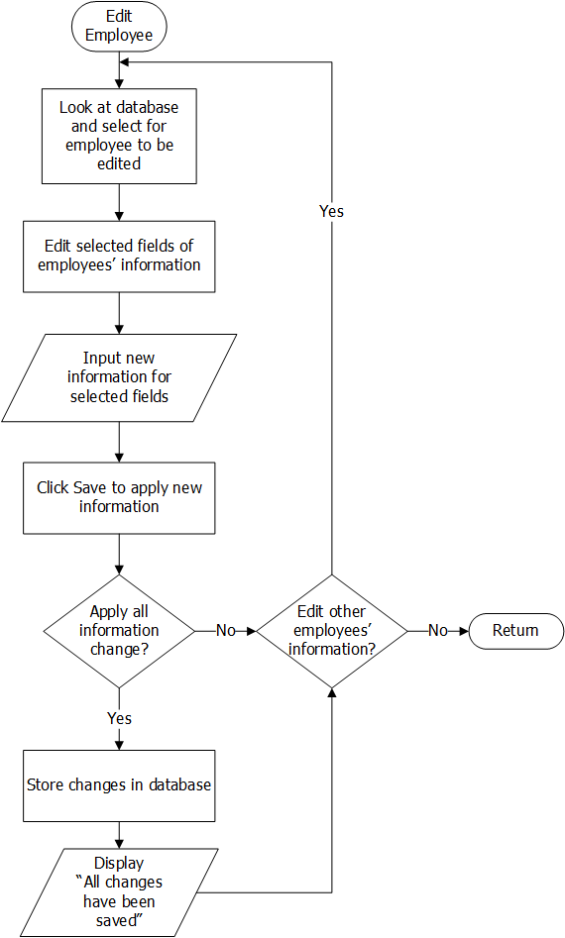

**Figure 3.9** Flowchart for Editing Employee

Figure 3.9 shows the editing of an employee in the database. In this process the administrator should look for and select for the employee to be edited. The employee selected will open and shows its information, in there the Administrator could select what fields should be edited this are, Last Name, Given Name, Middle Name, Age, Sex, Home Address, Contact Number and Marital status, Contact person (relationship and contact number), salary. After, completing it, save it and if you wish to completely edit the employees’ information click yes and a message box will appear that changes have been saved and updated in the database.

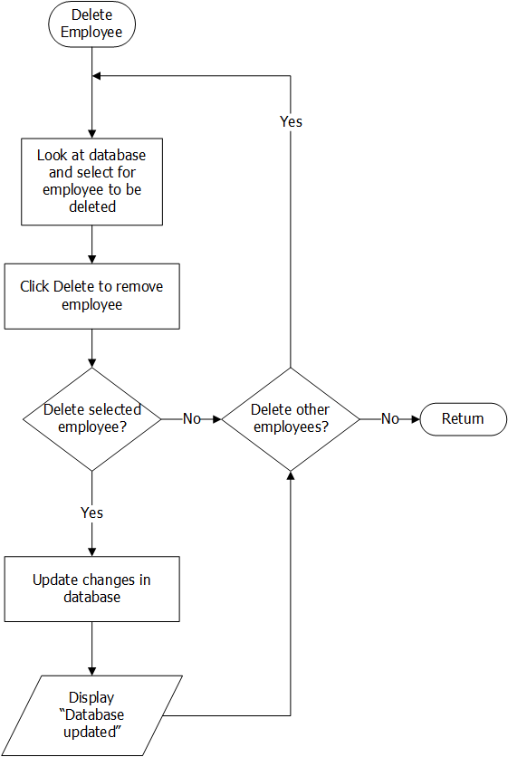

**Figure 3.10** Flowchart for Editing Employee

Figure 3.10 shows the deleting of an employee in the database. In this process the administrator should look for and select for the employee to be deleted. If the Administrator click delete for that selected employee a message box of confirming of deletion will prompt and if the Administrator clicks yes it will be permanently deleted and the database will be updated.

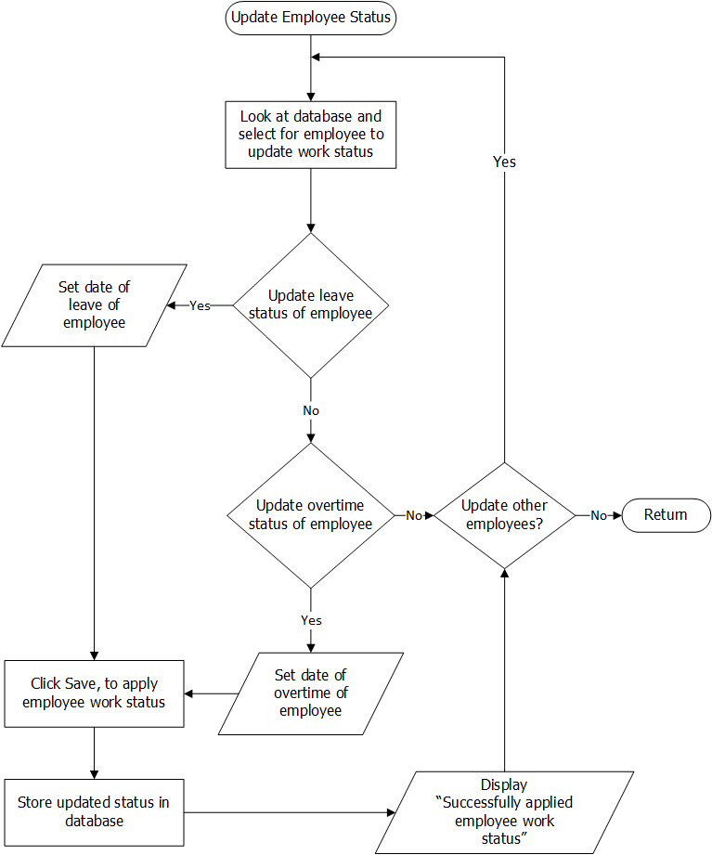

**Figure 3.11** Flowchart for Updating Employee

Figure 3.11 shows the updating of the work status of an employee in the database. In this process the administrator should look for and select for the employee to be updated. After selecting the employee, the Administrator can update or remove the leave, half-day, or overtime of employee. Applying changes will be done by clicking the save button. All changes will be save and updated and a prompt will saying all changes are applied

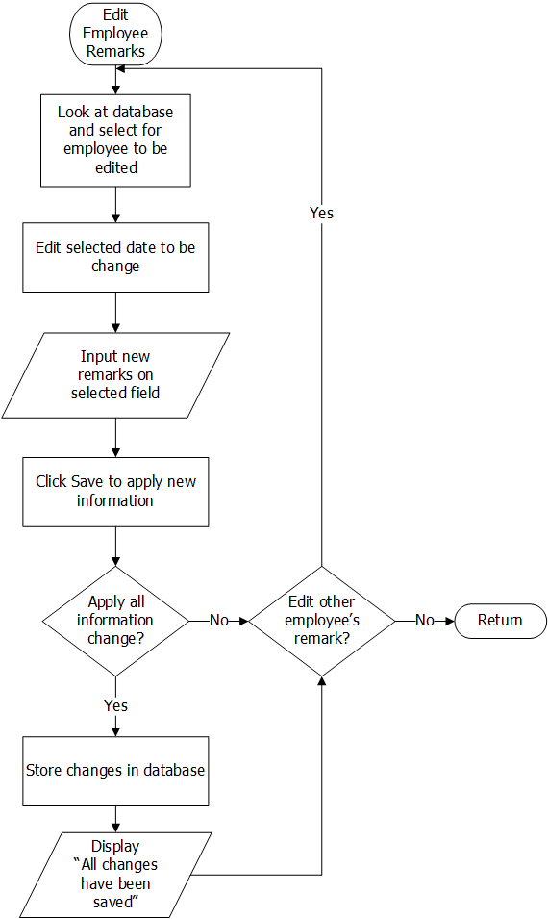

**Figure 3.12** Flowchart for Editing Employee’s Remarks

Figure 3.12 shows the editing of a selected employee’s recorded remarks on his or her previous records, the Administrator is the one that can edit the remarks. Upon applying changes it will be stored in the database and will be asked to edit other remarks of employee

**Use Case Diagram**

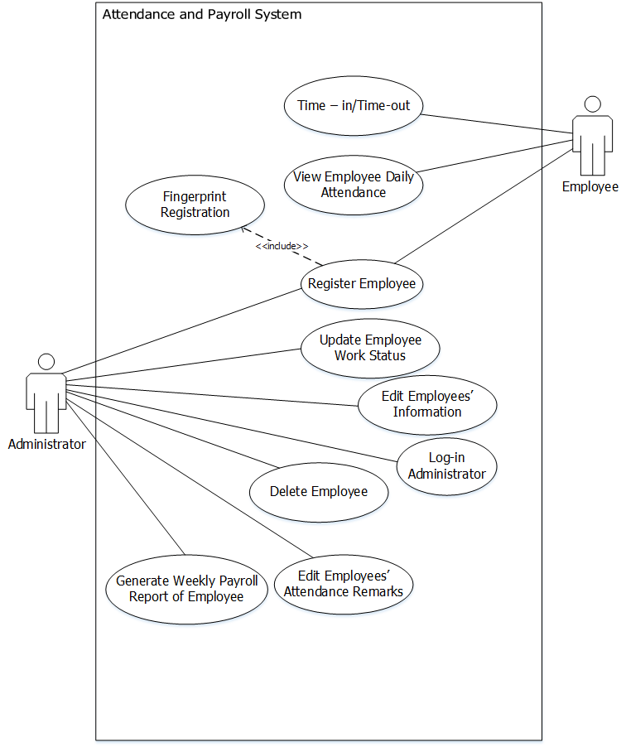

**Figure 3.13** Use Case Diagram of a Daily Attendance Monitoring Using Fingerprint Authentication and Weekly Gross Income Computation

**Use Case Narrative**

**Table 3.1** Use Case Narrative for Log-in

|  |  |
| --- | --- |
| Use Case Name: | Log-in Administrator |
| Summary: | Log-in is required to access the application. |
| Actor: | Administrator |
| Precondition: | None |
| Main Sequence: | 1.    Administrator inputs username and password  2.    Log-in  3.    If incorrect check username or password |
| Alternative Sequence: | None |
| Post-Condition | The Administrator is now welcomed to the Main menu and can now select register new employee, edit employee, edit employee remarks, delete employee, update employee, or generate weekly report. |

**Table 3.2** Use Case Narrative for Update Employee Work Status

|  |  |
| --- | --- |
| Use Case Name: | Update Employee Work Status |
| Summary: | The Administrator can update the work status of the employee if the worker requested for a leave, a half-day or an overtime. |
| Actor: | Administrator |
| Precondition: | The Administrator must be logged-in. |
| Main Sequence: | 1. Administrator selects employee to be updated  2. Update schedule of employee or work status of employee  3. Set if employee will take leave, half-day, or overtime  4. Save and wait for update of database |
| Alternative Sequence: | None |
| Post-Condition | The updated status of employees is now saved and shown |

**Table 3.3** Use Case Narrative for Register Employee

|  |  |
| --- | --- |
| Use Case Name: | Register Employee |
| Summary: | The Administrator can add and register new employee. |
| Actor: | Administrator & Employee |
| Precondition: | The Administrator must be logged-in. |
| Main Sequence: | 1.    Administrator register new employee  2.    Fill up all required fields  3.    Save and then Next  4.    Employee must register fingerprint  5.    Scan employees’ fingerprint  6.    Save new information at database |
| Alternative Sequence: | None |
| Post-Condition | A message box will appear that the employee was successfully registered. |

**Table 3.5** Use Case Narrative for Edit Employees’ Information

|  |  |
| --- | --- |
| Use Case Name: | Edit Employees’ Information |
| Summary: | The Administrator can edit the employees’ information. |
| Actor: | Administrator |
| Precondition: | The Administrator must be logged-in. |
| Main Sequence: | 1.    Administrator selects employee to be edited  2.    Select fields to be edited  3.    Type new information  4. Save new information at database and wait for update of database |
| Alternative Sequence: | None |
| Post-Condition | A message box will appear that the employee’s information was successfully edited. |

**Table 3.5** Use Case Narrative for Editing Employees’ Remarks

|  |  |
| --- | --- |
| Use Case Name: | Editing Employee’s Remarks |
| Summary: | The Administrator can edit the employees’ remarks. |
| Actor: | Administrator |
| Precondition: | The Administrator must be logged-in. |
| Main Sequence: | 1.    Select employee to edited  2.    Select date to be edited  3.    Edit remark of selected employee and date  4.    Save and wait until database is updated |
| Alternative Sequence: | None |
| Post-Condition | A message box will appear that the employee’s information was successfully edited. |

**Table 3.6** Use Case Narrative for Delete Employee

|  |  |
| --- | --- |
| Use Case Name: | Delete Employee |
| Summary: | The Administrator can delete employees. |
| Actor: | Administrator |
| Precondition: | The Administrator must be logged-in. |
| Main Sequence: | 1.    Administrator selects employee to be deleted  2.    Delete employee  3.    Verify if this is the employee to be deleted  4.    Delete and Save wait for database update |
| Alternative Sequence: | None |
| Post-Condition | A message box will appear that the employee’s information was successfully deleted. |

**Table 3.7** Use Case Narrative for Generate Weekly Gross Income Report

|  |  |
| --- | --- |
| Use Case Name: | Generate Weekly Gross Income Report |
| Summary: | The Administrator can view the daily attendance of the worker and here the weekly gross income wil be computed |
| Actor: | Administrator |
| Precondition: | The Administrator must be logged-in. |
| Main Sequence: | 1. The Administrator selects “Generate Report”  2. Wait until report is completed |
| Alternative Sequence: | None |
| Post-Condition | The summary of the attendance and earned salary of workers is shown |

**Table 3.8** Use Case Narrative for Fingerprint Registration

|  |  |
| --- | --- |
| Use Case Name: | Fingerprint Registration |
| Summary: | The Employee must register his/her “thumb” fingerprint for him/her to access the fingerprint attendance verification |
| Actor: | Administrator and Employee |
| Precondition: | The Employee must be added first by the Administrator |
| Main Sequence: | 1.    The Administrator starts the fingerprint registration  2.    Employee must place his/her thumb in the fingerprint scanner  3.    Wait for successful registration of fingerprint  4. Administrator saves the registered fingerprint |
| Alternative Sequence: | None |
| Post-Condition | In the LCD display it will say for successful registration |

**Table 3.9** Use Case Narrative for Time-in and Time-out

|  |  |
| --- | --- |
| Use Case Name: | Time-in |
| Summary: | The Time-in of fingerprint is considered at 8am and before 11:59am. There will be another Time-in of fingerprint it is considered at 12:00 noon to 13:30. Finally, work is finish at 17:00 and Employees can now leave the premises at this time. They can also take overtime. |
| Actor: | Employee |
| Precondition: | The Employee must be registered |
| Main Sequence: | 1.  The employee must place his/her thumb in the fingerprint scanner  2.  Wait for LCD display a success message |
| Alternative Sequence: | None |
| Post-Condition | Employee’s recorded time-in, second time-in and time-out will be recorded |

**Data Flow Diagram**



**Figure 3.14**Context-Level Data Flow Diagram of the Attendance System Function

The Figure 3.14 shows the context-level DFD for the Attendance System Function of the project. Getting the attendance of the employees is illustrated through a single process. This process receives a data input from employee which can either be a Time In or Time Out. After processing this input, the output produced which is the Employee Information and with the time will then proceed to the desktop application.



**Figure 3.15**Level 1 Data Flow Diagram of the Attendance System Function

On Figure 3.15 is the illustration of the Level 1 DFD for Attendance System Function which shows more details about data flows and data storing. The single process from the context-level DFD is now split up into a larger subsystem. Using their fingerprint for the time in and time out data, the system will verify if the user is a real employee using the record of the fingerprint templates from the database. Once verification is done, the result will be shown on the LCD display and then the output will proceed to the desktop application to update the information. The employee information and time record will be stored to the database.



**Figure 3.16** Context-Level Data Flow Diagram of the Payroll System Function

The Figure 3.16 shows the Context-level DFD for the Payroll System Function of the design project. The Administrator will look at the list of registered employees. The payroll for the employees will be processed. From the process, a weekly payroll report will then be generated.



**Figure 3.17** Level 1 Data Flow Diagram of the Payroll System Function

Figure 3.17 shows the representation for the Level 1 DFD for the Payroll System function where the Context-level DFD was further expanded.  From the employees’ time record, the weekly paycheck will be computed based on the recorded hours they have worked for the week. A weekly payroll record will be processed based from the computation. Then the weekly payroll record will be stored to the database. The payroll record will also be used to produce the weekly payroll report.

**Fingerprint Testing Tables**

**Table 3.10** Fingerprint Registration

|  |  |
| --- | --- |
| **Trial No.** | **Test Successful (Yes/No)** |
| Trial 1 |  |
| Trial 2 |  |
| Trial 3 |  |
| Trial 4 |  |
| Trial 5 |  |
| Trial 6 |  |
| Trial 7 |  |
| Trial 8 |  |
| Trial 9 |  |
| Trial 10 |  |
| **Success Rate:** | |

Table 3.10 shows ten trials of successful registration of an employees’ fingerprint in the fingerprint scanner. The expected outputs will be YES or NO. Failure to register the fingerprint are cause by improper way of placing the finger to the scanner that it cannot detect the users’ finger or some time delays by the device. The “YES” output means that the fingerprint was successfully registered on the database.

**Table 3.11** Fingerprint Identification Test

|  |  |
| --- | --- |
| **Trial No.** | **Test Successful (Yes/No)** |
| Trial 1 |  |
| Trial 2 |  |
| Trial 3 |  |
| Trial 4 |  |
| Trial 5 |  |
| Trial 6 |  |
| Trial 7 |  |
| Trial 8 |  |
| Trial 9 |  |
| Trial 10 |  |
| **Success Rate:** | |

Table 3.11 shows ten trials of successful identification and matching information of an employee’s fingerprint in the fingerprint scanner. The expected outputs will be YES or NO. Failure to register the fingerprint are cause by improper way of placing the finger to the scanner that it cannot detect the users’ finger or some time delays by the device. The “YES” output means that the fingerprint was successfully registered on the database.

**Table 3.12** Fingerprint Verification

|  |  |
| --- | --- |
| **Trial No.** | **Test Successful (Yes/No)** |
| Trial 1 |  |
| Trial 2 |  |
| Trial 3 |  |
| Trial 4 |  |
| Trial 5 |  |
| Trial 6 |  |
| Trial 7 |  |
| Trial 8 |  |
| Trial 9 |  |
| Trial 10 |  |
| **Success Rate:** | |

Table 3.12 shows ten trials of successful verification of ten employees’ fingerprints in the fingerprint scanner. The expected outputs will be YES or NO. The fingerprint should match the ones that are registered stored from the database. Unmatched fingers are cause by improper way of placing the finger to the scanner that it cannot detect the users’ finger, some time delays by the device or the fingerprint is not yet registered.

**Table 3.13** Non-registered EmployeesTesting

|  |  |
| --- | --- |
| **Trial No.** | **Test Successful (Yes/No)** |
| Trial 1 |  |
| Trial 2 |  |
| Trial 3 |  |
| Trial 4 |  |
| Trial 5 |  |
| Trial 6 |  |
| Trial 7 |  |
| Trial 8 |  |
| Trial 9 |  |
| Trial 10 |  |
| **Success Rate:** | |

Table 3.13 shows ten trials of employees who are not yet registered and to test them if they can be identified. The expected outputs will be YES or NO. Having an output of NO with a non-registered employees means success because only registered employees can be verified.

**Desktop Application and Database Testing Tables**

**Table 3.14** Time Recording in Desktop Application

|  |  |
| --- | --- |
| **Trial No.** | **Test Successful (Yes/No)** |
| Trial 1 |  |
| Trial 2 |  |
| Trial 3 |  |
| Trial 4 |  |
| Trial 5 |  |
| Trial 6 |  |
| Trial 7 |  |
| Trial 8 |  |
| Trial 9 |  |
| Trial 10 |  |
| **Success Rate:** | |

Table 3.14 shows ten trials of successful recording of an employees’ attendance. The expected outputs will be YES or NO. The recorded attendance will be checked for the whole day and we will test if remarks are successfully recorded.

**Table 3.15** Generated Weekly Report in Desktop Application

|  |  |
| --- | --- |
| **Trial No.** | **Test Successful (Yes/No)** |
| Trial 1 |  |
| Trial 2 |  |
| Trial 3 |  |
| Trial 4 |  |
| Trial 5 |  |
| Trial 6 |  |
| Trial 7 |  |
| Trial 8 |  |
| Trial 9 |  |
| Trial 10 |  |
| **Success Rate:** | |

Table 3.15 after doing ten trials of successful recording of time and attendance another testing is needed which is ten trials of successful recording of an employees’ attendance and payroll. The expected outputs will be YES or NO. The recorded attendance will be checked for the whole week and their expected salary will also be computed. After, that we will verify if all data are successfully recorded.

**Table 3.16** Administrator Login

|  |  |
| --- | --- |
| **Trial No.** | **Test Successful (Yes/No)** |
| Trial 1 |  |
| Trial 2 |  |
| Trial 3 |  |
| Trial 4 |  |
| Trial 5 |  |
| Trial 6 |  |
| Trial 7 |  |
| Trial 8 |  |
| Trial 9 |  |
| Trial 10 |  |
| **Success Rate:** | |

Table 3.16 shows ten trials of successful logging-in of the Administrator or Secretary to the desktop application. The expected outputs will be YES or NO. Unsuccessfully logging-in maybe cause of wrong username or password.

**Table 3.17** Edit Employee Information

|  |  |
| --- | --- |
| **Trial No.** | **Test Successful (Yes/No)** |
| Trial 1 |  |
| Trial 2 |  |
| Trial 3 |  |
| Trial 4 |  |
| Trial 5 |  |
| Trial 6 |  |
| Trial 7 |  |
| Trial 8 |  |
| Trial 9 |  |
| Trial 10 |  |
| **Success Rate:** | |

Table 3.17 shows ten trials of successful editing of an employees’ information in the database through the desktop application. The expected outputs will be YES or NO. The success of the testing is when the information of the employee is updated in the database.

**Table 3.18** Delete Registered Employee

|  |  |
| --- | --- |
| **Trial No.** | **Test Successful (Yes/No)** |
| Trial 1 |  |
| Trial 2 |  |
| Trial 3 |  |
| Trial 4 |  |
| Trial 5 |  |
| Trial 6 |  |
| Trial 7 |  |
| Trial 8 |  |
| Trial 9 |  |
| Trial 10 |  |
| **Success Rate:** | |

Table 3.18 shows ten trials of successful deleting of an employees’ in the database through the desktop application. The expected outputs will be YES or NO. If the employee is not found in the database or in the daily record the testing is successful, otherwise it failed.

**Table 3.19** Register New Employee

|  |  |
| --- | --- |
| **Trial No.** | **Test Successful (Yes/No)** |
| Trial 1 |  |
| Trial 2 |  |
| Trial 3 |  |
| Trial 4 |  |
| Trial 5 |  |
| Trial 6 |  |
| Trial 7 |  |
| Trial 8 |  |
| Trial 9 |  |
| Trial 10 |  |
| **Success Rate:** | |

Table 3.19 shows ten trials of successful registering of a new employee, applying all needed information to be stored in the database through the desktop application. The expected outputs will be YES or NO. The success of the testing is when the information of the employee is stored in the database.

**Table 3.20** Update Employee Work Status

|  |  |
| --- | --- |
| **Trial No.** | **Test Successful (Yes/No)** |
| Trial 1 |  |
| Trial 2 |  |
| Trial 3 |  |
| Trial 4 |  |
| Trial 5 |  |
| Trial 6 |  |
| Trial 7 |  |
| Trial 8 |  |
| Trial 9 |  |
| Trial 10 |  |
| **Success Rate:** | |

Table 3.20 shows ten trials of successful updating of an employees’ work status, such as applying leave, half-day or overtime for the following dates in the database through the desktop application. The expected outputs will be YES or NO. Upon updating the employees’ work status it can be verified if his work status for some days to change.

**Prototype Development**

The Figure 3.18 shows the main components used on the design prototype. The prototype will be built by combining several components together that will then be connected to a computer with the desktop application installed that is designed specifically for the system.



**Figure 3.18** Design Prototype

**Determination of Materials and Components Used**

The hardware materials and components to be used in developing the design prototype includes the following:

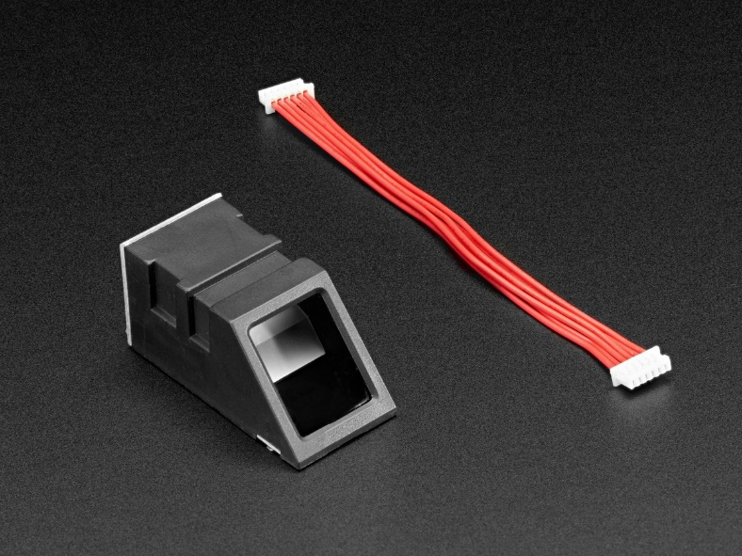

**Figure 3.19** Adafruit Fingerprint Sensor

On Figure 3.. shows the Adafruit Fingerprint Sensor which is an optical fingerprint sensor that has a built-in flash memory that can be used to hold the fingerprint templates of the employees. This will be utilized on our system as the main scanning device for employees’ fingerprint registration and verification.

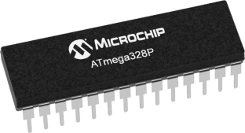

**Figure 3.20** Arduino Bootloader-programmed Chip (ATmega328P)

On Figure 3.20 shows the ATmega328P which is a low-power CMOS 8-bit microcontroller. This will be the main processing component for the system. It can be programmed using the Arduino IDE to produce the desired output.

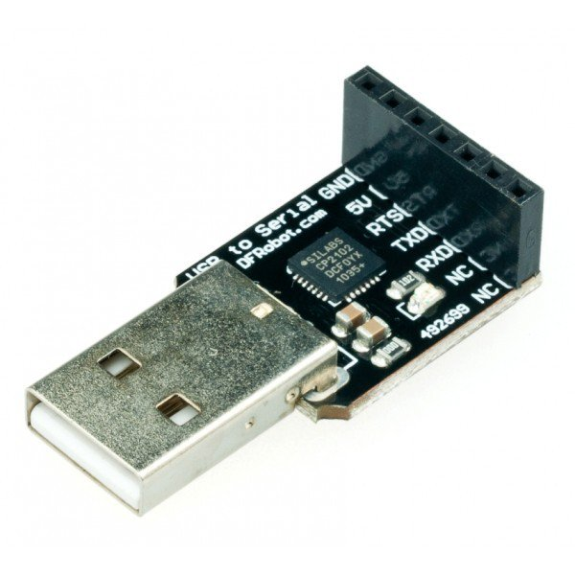

**Figure 3.21** USB to TTL Converter (CP210)

On Figure 3.21 shows the USB to TTL Converter. The USB to TTL converter combines the USB-232-1 (USB to Single RS232 Adapter) and TTL-232-1 (Port-powered RS232/TTL converter). The USB to TTL converter will be used to connect the microcontroller to the computer to be able to program it as well as to obtain data from the fingerprint sensor to the desktop application.

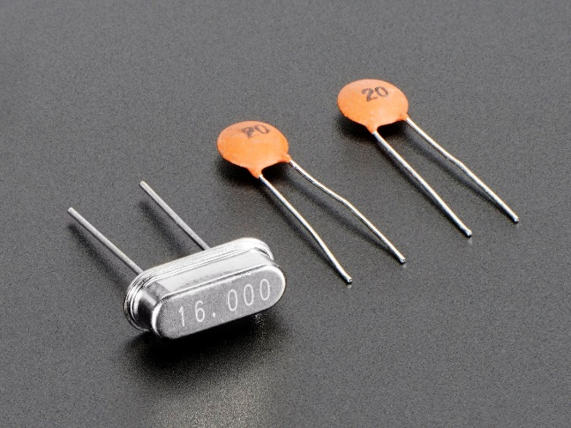

**Figure 3.22** 16 MHz Crystal + 20pF Capacitors

On Figure 3.22 shows the 16 MHZ Crystal with the 20pF capacitors. These are often built-in on Arduino boards. The crystal and the capacitors are used as the clock signal source. These are required for the microcontroller to have an electrical signal with a precise frequency.

**References**

C.O, A., A.O, A., O.O, O., & E.O, I. (2013). Fingerprint-Based Attendance Management System. Journal of Computer Sciences and Applications, 1(5), 100-105.

Connolly, T.M. and C.E. Begg, 2004. Database System: A Practical Approach to Design, Implementation and Management. 4rd Edn., Addison Wesley, USA., ISBN: 10: 0321210255, pp: 1236.

D. Maltoni, D. Maio, A. K. Jain, and S. Prabhakar. Handbook of fingerprint recognition, New York, Springer Verlag, 2003

Qiu, L. (2014). Fingerprint sensor technology. 2014 9th IEEE Conference on Industrial Electronics and Applications.

Shakil, Md, and Rabindra Nath Nandi. "Global Journal of Computer Science and Technology Graphics & Vision." Attendance Management System for Industrial Worker using Finger Print Scanner, 1st ser., 13, no. 6 (2013).

Xavier, C., 2006. Web Technology and Design. 1st Edn., New Age International Publishers, New Delhi, ISBN: 8122414508, pp: 388.