**Design of a Global Positioning System and GSM based** **Delivery Vehicle Tracking System using Smartphone Google Map Application**

**by**

**Dave Roycethon M. De Ramos**

**Julie Ann A. Parañal**

A Design Report Submitted to the School of Electrical Engineering, Electronics Engineering, and Computer Engineering

in Partial Fulfilment of the Requirements for the Degree

**Bachelor of Science in Computer Engineering**

**Mapua University**

April 2019

**CHAPTER 1  
DESIGN BACKGROUND AND INTRODUCTION**

Vehicle Tracking System, from the name itself, is defined as the technology having the capacity to locate a given vehicle with the help of methods such as GPS and or radio navigation systems like GSM and GRPS – operating with the use of either satellites and ground-based stations. And since vehicle security is the primary concern of those whose personal and business interest deals with vehicles, the use of such a tracking system proves to be quite important and essential.

Building on the said data, the proposed design is a vehicle tracking hardware that is to be fitted inside a delivery vehicle – powered by the vehicle’s USB port; ensuring it’s provided with the needed power supply for continuous operation. The machine would then be used to determine or trace the location at which the transportation automobile is at, with the help of GPS and GSM/GRPS modules – accessible via smartphone application; most likely handled by the person in charge.

**Customer**

The customer for the given project is the ‘Magna Gold Pharma Incorporated’ – a pharmaceutical company located in Manila; incorporated on March 2005 and is located at 2000-B Dr. M. Carreon Street, Sta. Ana, Manila. It is also worthy to take note that it has been appointed as the exclusive distributor of United Laboratories Inc. (UNILAB), tasked with distributing UNILAB products into drugstores, supermarkets, and wholesalers assigned thereto, with sales amounting to approximately twenty-four (24) million pesos, with an additional expected sale volume of up to ten (10) million pesos.

**Need**

Since the company possesses such a massive task of delivering important products to countless outlets, its only form of location monitoring its delivery vehicle is limited to the communication it has with the automobile’s driver – usually done via text message. Such methods however, proves to be quite inefficient and has the capacity to pose a potential risk for the driver, and in turn, the company as well

Listed below are the features the client wants the device to have.

* The device must be able to provide exact location of the vehicle(s).
* The person in charge can monitor the vehicle location by using a smartphone.
* The device should have a way of informing the company of any emergency occurrences – one that would cater to a wide range of scenarios.

**Solution**

The solution is to construct a device that utilizes GPS and GSM/GPRS tracking systems, determining the exact location of the delivery vehicle. Access to the location would then only involve any person present within the company, and a smartphone to monitor the delivery’s location; eliminating the need to keep in contact with the driver.

To cater to the emergency detection requirement, the presence of a piezoelectric buzzer is put into place – for emergencies with regards to anomalies with regards to vehicle function and delivery time. Also, a vibration sensor is put into place to cater to any event that would render the driver unconscious. Thus, still allowing the design to inform the company about their driver/delivery in distress.

**Objectives**

The main objective of this product is to design a delivery vehicle tracking system using smartphone Google map application.

Specific Objective:

* To design a device that would provide the exact location of the delivery vehicle with the use of Google map application.
* To develop a system that is compatible to any smartphone.
* To have a system that has panic button that can alert the person in charge in case of emergency.

**Impact**

**Global Impact:** Related researches that were accessed, enumerated different versions of the proposed project. Each having a number of diverse functions but, ultimately have a somewhat similar function. It is then clearly presented that the need for a universal vehicular tracking system is a must, and the impact for a multi functioned is massive. It is however, worthy to take note that the presented project is different from the aforementioned researches – resulting in a real-time vehicular tracking having functions like an emergency buzzer and an accident alert system. Thus, the creation of a multifunctional tracking system would fulfill the needs a massive group of people.

**Economic Impact:** The impact of the proposed project with respect to the economy varies with the need for it. And since the proposed project is multifunctional, doubling as a monitoring function; with the location function continuously running, it could pose to be a design that paves way towards the future, possibly playing a role in the economy of cars and other companies.

**Environmental Impact:** The environmental impact of the project is still unclear. Since, the need and scope of the project is yet to be determined.

**Societal Impact:** The presented project has the capability of being of benefit to society in general. Its functions would not only improve the client-supplier relationship for companies similar to Magna Gold Pharma Inc. but, it also has the capacity to provide service to those who are wary of their vehicles being stolen. Moreover, the presented project could also be of use to others via its ‘accident alert’ function.

**Differentiation**

The project presented is quite similar to an already existing paper authored by Pham Hoang Oat, Michael Drieberd, and Nguyen Chi Cuong back in 2013, entitled ‘Development of Vehicle Tracking System using GPS and GSM Modem’. However, the difference between their paper and ours is significantly highlighted in Table 1.2;

|  |  |  |
| --- | --- | --- |
|  | **Proposal** | **Nearest Similarity**  **(**Development of Vehicle Tracking System using GPS and GSM Modem by Pham Hoang Oat, Michael Drieberd & Nguyen Chi Cuong , 2013**)** |
| **Technology** | Uses Arduino Uno microcontroller with ATmega328p as its core chip.  Uses Ublox Neo 6m V2 as the GPS receiver module and SIM900A as its GSM/GPRS module. | Uses ATmega328p as its microcontroller to control both modules and to provide an easily customizable platform for any required application  Uses a NEO-6Q GPS receiver module to determine the current position of the vehicle and LEON-GIOO GSM module to establish communication between device and mobile phone. |
|  | Uses ADXL377 a 3-axis accelerometer with signal conditioned analog voltage outputs that has a full-scale range of ±200g for measuring more extreme changes in motion, shock or vibration. | Uses SW18010P vibration sensor for measuring and analyzing linear velocity, displacement or acceleration. |
| **Functionality** | Uses a map application wherein the GSM module coordinates are copied to view the current location of the vehicle. | A smartphone application is to be used – obtaining the vehicle’s current location via GSM module. |
| **Features** | Uses an independent power supply in the form of a battery of the vehicle to provide power to the device. | Converts the car’s 12V power supply into a 5V supply that is set to power the device. |

**Table 1.1** Differentiation of Study to Existing Study

**Benefits**

The proposed system would benefit the company – Magna Gold Pharma Inc., and other companies as it would provide a system that uses GPS to monitor their delivery vehicles. Since, the system is not limited to a single transport machine, it is possible to keep track of all their deliveries simultaneously. Moreover, the system also has the capacity to send distress signals if and when their drivers encounter a sort of hazard; like road accidents and vehicular failure – allowing them to inform their trusted customers in advance of any changes in the arrival of their delivery.

Moreover, users are updated real time – every five (5) minutes, and or when they wish to get updated on their own time. Making sure they build better relations with their customers and their delivery personnel. It also has the additional capacity to reduce costs, enabling them to instruct their drivers of a more reliable route for them to take

**Constraints**

|  |  |  |
| --- | --- | --- |
| **Design Constraints** | **Trade Offs** | **Alternative Solutions** |
| Limited budget set by the client | Ease of development  Long term quality assurance | Cheaper components and materials in building the device |
| Reliability  Quality of components used | Expensiveness of components | a) Use of well performing components  b) Use of quality components. |

**Table 1.2** Constraints for this System

A restriction to the project would be the amount of money the company is willing to spend for its development, as the entire quality of the project is highly dependent on their budget. This leads to the next project constraint – quality and reliability.

However, a proposed solution like opting for the middle ground between budget and quality could be taken.

**CHAPTER 2**

**REVIEW OF RELATED DESIGN LITERATURES AND STUDIES**

**ARM7 GPS and GSM Technology – Real Time Vehicle Tracking System**

A GPS transmitter is a device commonly used in location tracking systems. Its main components are the transmitter, receiver, module, and microcontroller. The GP receiver communicates with satellite and receives the location data and converts this data string into NMEA 0183 format, containing numerous information (latitude, longitude, altitude, speed and etc.). The GPS receiver is then fed with the said information periodically.

ARM7 is a controller that is specific to collecting information regarding location. Its focus is on longitude and latitude alone. It is worthy to take note of the microcontroller used (LCP2148) which is powered by a 3.3-volt supply.

The block diagram for both the transmitter and the receiver is show in Figure 2.1 and Figure 2.2 respectively.



Figure 2.1 Transmitter Block Diagram



Figure 2.2 Receiver Block Diagram

**Tracking and Alert System Design – Vehicle Tracking for Commercial Inter-City Buses**

Vehicles can be tracked remotely through the use of mobile networks or of TCP/IP connections over the internet, coupled with a GPRS modem or a satellite transmission via satellite modem. The location can then be displayed on a map using a compatible software.

The GPS module utilizes information like position and speed, transmitting it to a microcontroller that then sends the data to the GSM modem, and in turn is sent to the GSM network via SMS. It is also within the microcontroller where a proprietary trigger for the connecting circuitry is processed. An LCD screen can also be connected to display information regarding to the place the vehicle is at.

**Tracking Development – Vehicle Tracking System using GPS and GSM Modem**

The GPS can obtain vehicle coordinates and transmit it using the GSM modem to a phone. The process is executed with the use of the u-blox NEO-6Q GPS receiver module, u-blox LEON-GIOO GSM module, and an Arduino Uno microcontroller. It is through these that a real-time vehicle tracking system could be made feasible.

**IoT Based Tracking and Monitoring – Vehicle Tracking and Monitoring System to Enhance the Safety and Security Driving Using IoT**

The process can be utilized using the C programming language, developed in compatibility with the LPC2148 to act as a storing database. Moreover, the use of GPS and GSM partnered with the SIM800 module provides vehicle tracking and monitoring capabilities. The block diagram for the tracking system is shown in Figure 2.4.

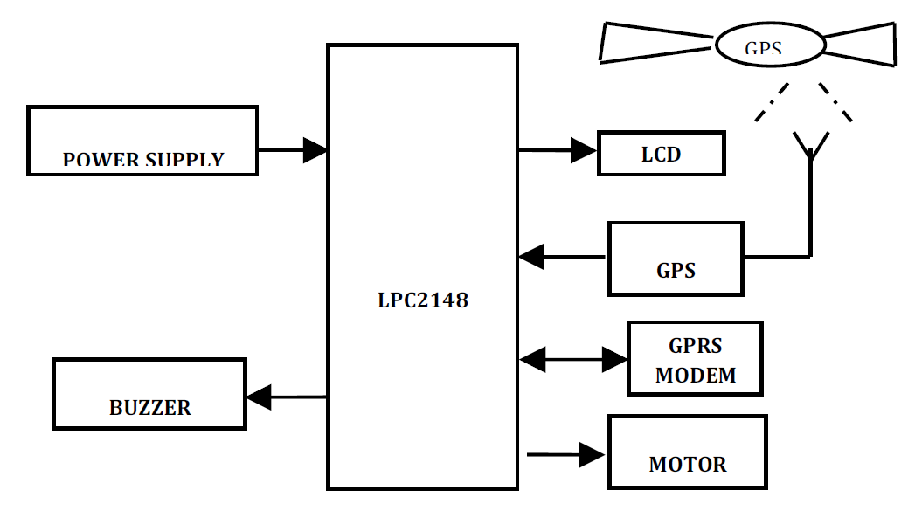

**Figure 2.4** Block Diagram for Vehicle Tracking System

The figure shores the different parts of the system; vehicle and monitor section. Including a buzzer that functions when the driver feels drowsy or drunk.

**Real Time Vehicle Monitoring - Tracking System Based on Embedded Linux Board**

The proposed approach would get controlled with the support of Raspberry pi which placed throughout the vehicle. The GPS/GPRS/GSM SIM900A module get keep up a correspondence with raspberry pi utilizing USB interface. The longitudes and latitudes of the current path obtained from GPS get compared with the stored longitudes and latitudes in the specific file layout inside the database of raspberry pi. If that longitudes and latitudes no longer fit with the saved one, then mistaken path detection alert massage will get dispatched to vehicle’s owner mobile. Also, the longitudes and latitudes of the present route obtained from GPS will get dispatched to the server with the support of GPRS which helps to monitor the vehicle’s present location on the net page utilizing Smartphone.

Right here for monitoring the vehicle, the proposed approach provides login facility on net web page for automobile’s owner, student and their parents. Also proposed system provides student’s safeguard with the support of DS18B20 temperature sensor and gas leakage sensor MQ6. These sensors get interface with raspberry pi. If the temperature within the vehicle crosses the targeted value or LPG gas get leakage within the vehicle then the alert message will be sent to the vehicle’s owner. Likewise, protection mechanism provided by method.

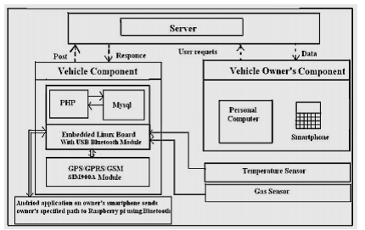

**Figure 2.5** System Block Diagram

**Accident Detection and Reporting System Using GPS and GSM Module**

Proposes combine independent and complementary solutions in a global accident detection system to provide stable and accurate positioning of car accident even in severe urban environments. The proposed solutions consist of augmenting the navigation solution exploiting the inertial sensor to estimate the dynamics of vehicle to extract the accident. Arduino is used as main microcontoroller, this system is made for accident alert, the whole system is to be implemented in the vehicle itself. So, when the 15 accident happens, the vibration sense the shock and send it to an Arduino microcontroller, at the same time, with GPS the latitude and longitude of that particular location is obtained, And with that the exact location of the accident site is determined. And here, GSM modem SIM900 is interfaced with microcontroller. So that, when accident happens, the SMS will be sending automatically to the particular numbers which would be entered in the database. LCD will display the shock intensity and the validity of sending message. Also display the delay time to give the person chance to press the key if the accident is normal.

**Accelerometer Sensor for Transportation System Accident Detection**

In the field of transportation system, car to car communication area is very popular area of research. Many systems deal with the accident detection. In such type of detection system vibration sensor play a vital role. We can detect the accident by abrupt vibration in the vehicle at the time of accident. The major problem in existing system is misfiring of the alert system. The airbag system is used to save the life of accident victim. The airbag systems have explosive firing, and have high contact forces resulting in head and neck injuries. Front bumper sensors can be used for both airbag deployment and pedestrian protection systems. This system may help to save the life of accident victim by providing information about accident detection or crash detection through GSM module. Table 2.1 shows the Thresholds g-forces for Accident Detection.

|  |  |
| --- | --- |
| **Accident Severity** | **Actual Maximum G Range Represented** |
| No Accident | 0-4g |
| Mild Accident | 4-20g |
| Medium Accident | 20-40g |
| Severe Accident | 40+g |

**Table 2.1** Thresholds g-forces for Accident Detection

**CHAPTER 3**

**DESIGN PROCEDURES**

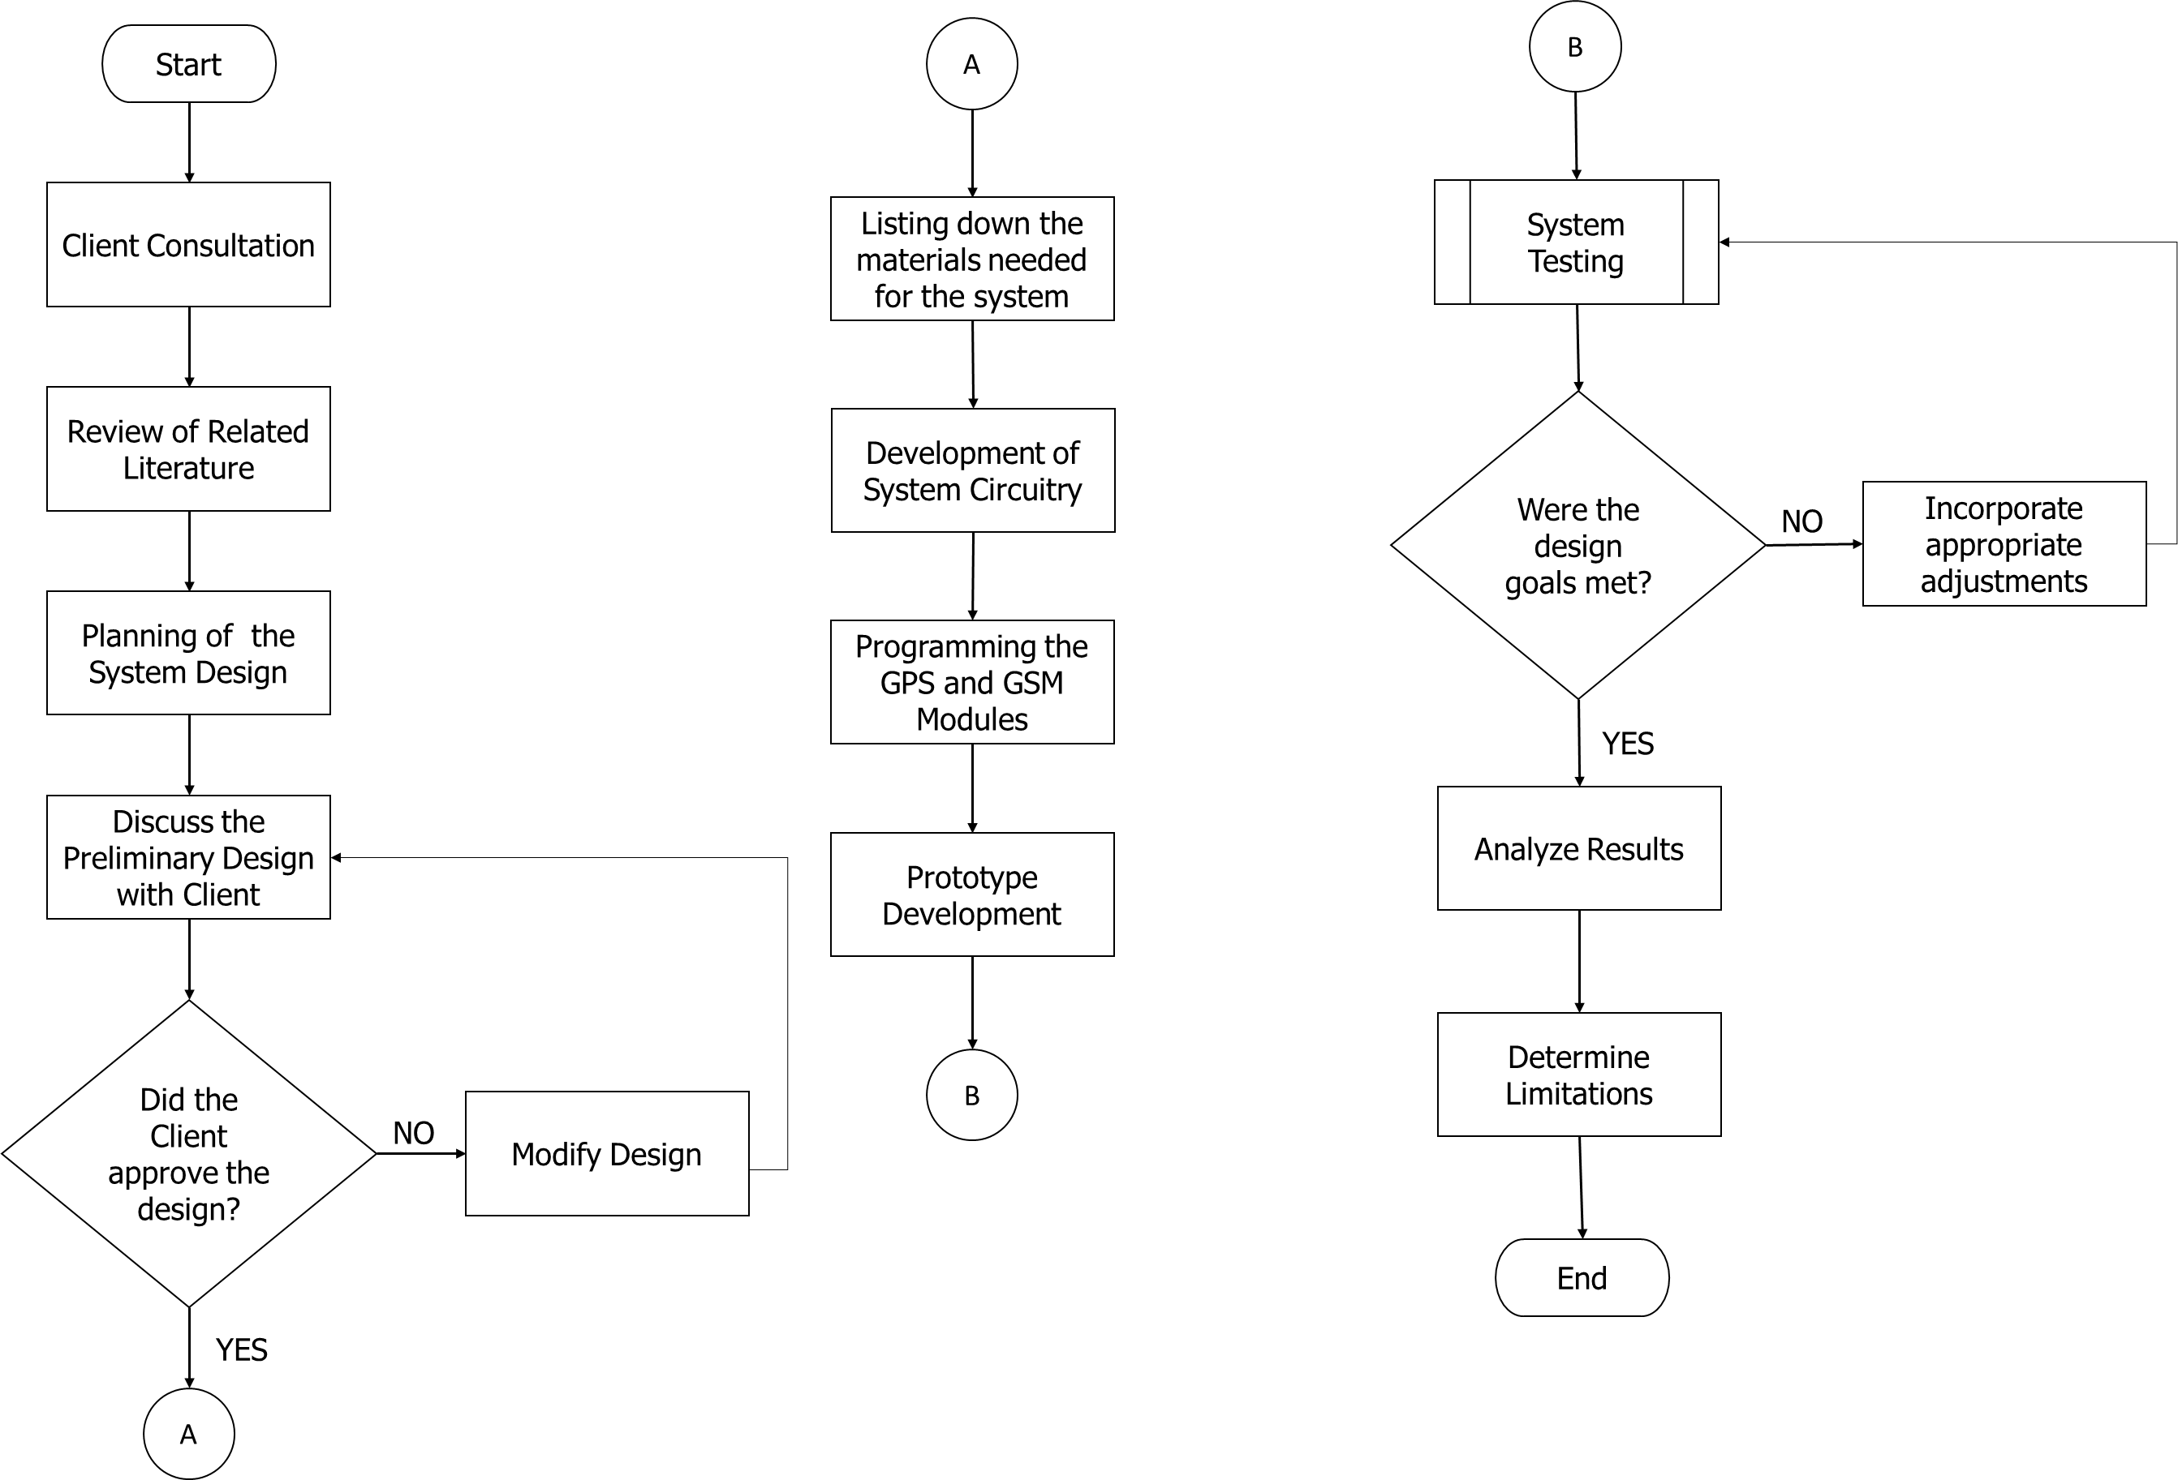

**Figure 3.1** Design Flow of the Project

This chapter provides detailed explanations on how our system was designed and created. The entire design process started with searching for a client needing a design that would make their operations easier and more efficient. After which, a meeting wherein the needs of the company are analyzed is done. Then, review of any related literature that is within the scope of the problem is done and planning for a system design is what followed. Once that has been completed, the said design was set up for approval by the client and any necessary changes that may be lacking was incorporated in the design until all client concerns were taken into consideration – coming up with a way to solve every one of them.

The next step involved listing all the components to implement the project. This involves computing for the needed budget for the finished project followed by developing the system circuitry. Programming the GPS and GSM module, in the form of software development was then done after, and the creation of the hardware. Finally, comes the testing, and determining whether all the functions (objectives) were met – performing minor edits to make sure the prototype’s functions is within the requirements set by the client; leading up to its finalization. The process for the said testing is as follows;

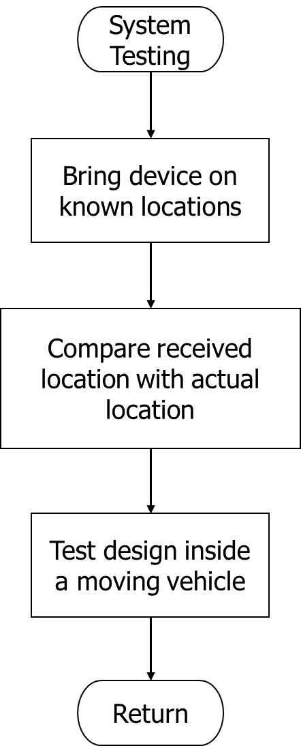

**Figure 3.1.1** System Testing sub-process

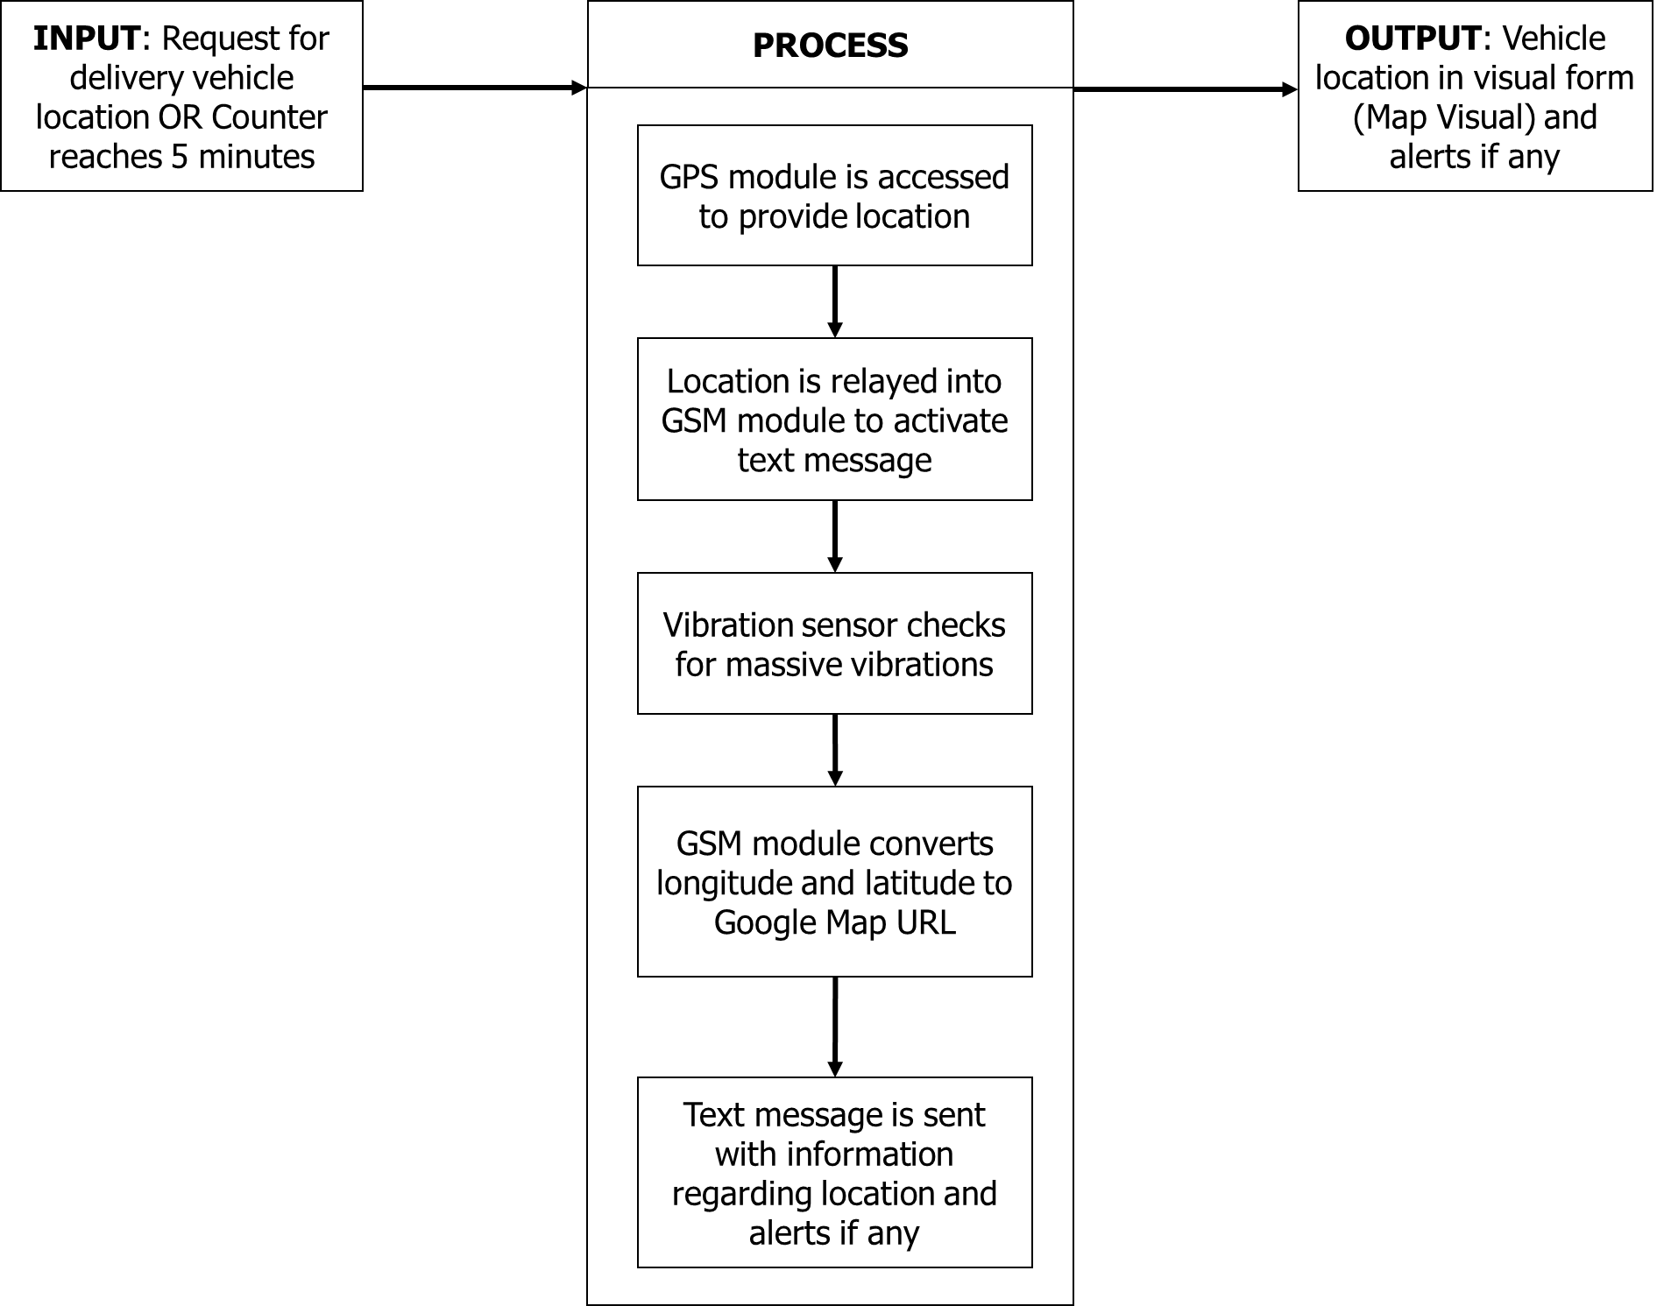

**Figure 3.2** Conceptual Framework

The function process for the given prototype is as follows; wherein the input exists in the form of a request from the person in charge – accessing the needed app that outputs the location of the vehicle carrying its hardware counterpart. The prototype then utilizes its GPS and GSM components and sends its exact location – in terms of URL address of the Google Map, and the said application then converts it into a visual representation by plotting the said coordinates in a map and displaying the marked location along with the map.

**Hardware Development**

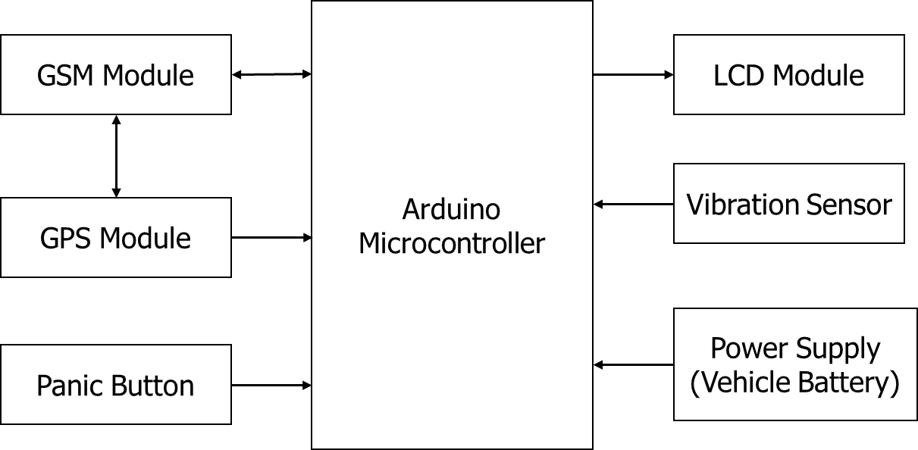

**Figure 3.3** Block diagram of the design project

The block diagram of the design project consists of Arduino Uno Microcontroller, GSM Module, GPS, Panic Button, Piezoelectric Buzzer and LCD. As shown in Figure 3. The GPS and GSM modules are interfacing with Arduino Uno microcontroller. The purpose of GPS modem is constantly gathering the latitude and longitude data that specifying the vehicle. The purpose of the GSM module is to receive the information from a remote location that includes Latitude and Longitude information of the vehicle. The processed data is sent to the user’s mobile through a GSM modem. The user’s mobile number should be included in the source code written for the microcontroller. Thus, the user’s mobile number resides in the internal memory of the MCU.

**Schematic Diagram**

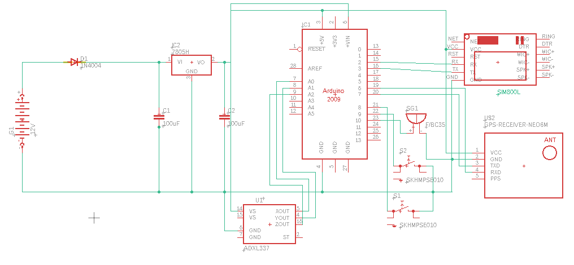

**Figure 3.4** Schematic Diagram of the design project

This schematic diagram shows the connection of the Arduino Uno Microcontroller to the GPS and the GSM/GPRS module. For the power supply, it uses the LM7805 IC that would convert the 12V power supply from the car’s battery to 5V.

Moreover, the circuit uses a SIM800L that is connected to the GSM module. This is the component responsible for sending and receiving text messages. Additionally, the project also makes use of the NEO-6M Arduino GPS module, enabling the use of GPS satellites. It is also worthy to take note of the presence of a piezoelectric buzzer that serves as a panic button that would cater to a selected scope of emergencies.

Lastly, is the ADXL337 – an Arduino bases accelerometer, this is the component to act as a massive vibration sensor, serving as an emergency alert backup in the case of the vehicle’s collision with another object.

**Software Development**

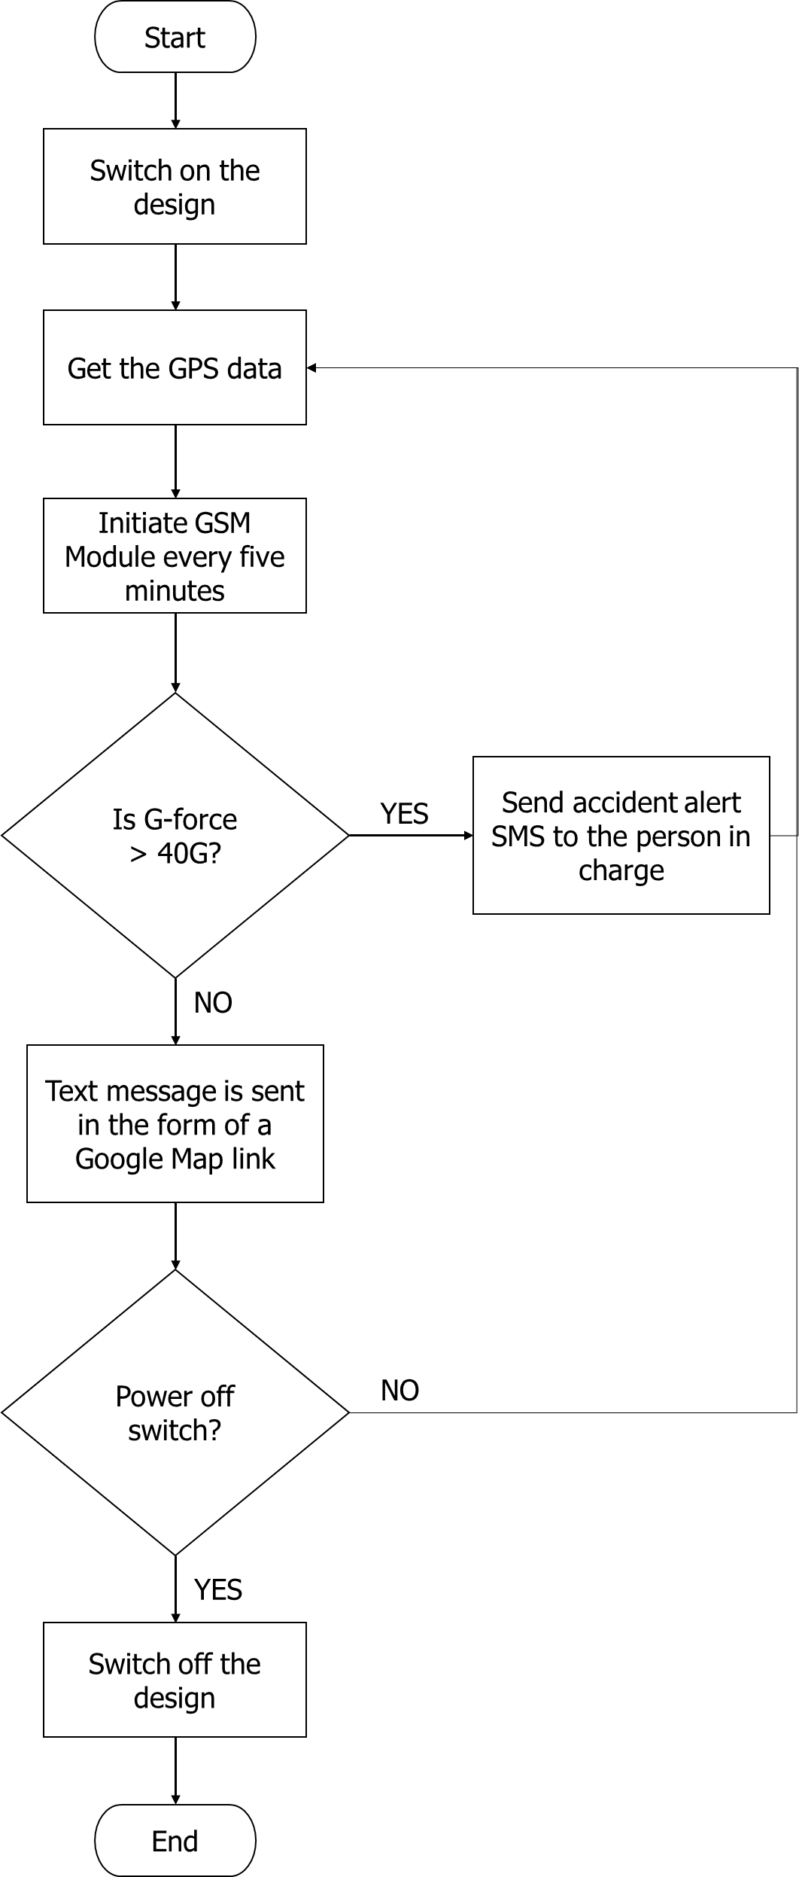

**Figure 3.5** Main System Flowchart

Figure 3.4 shows the main process of the system. After the system is powered up and get the GPS data, the GPS data will be sent to the user every 5 minutes its message is compose with the Google map link format. If the accelerometer triggers by a massive vibration, the accident alert SMS will be sent to the person in charge informing something happened to the vehicle. If there is no massive vibration detected it would continuously send GPS data to the user every 5 minutes until it reaches its destination.

**Mobile Application Flowchart**

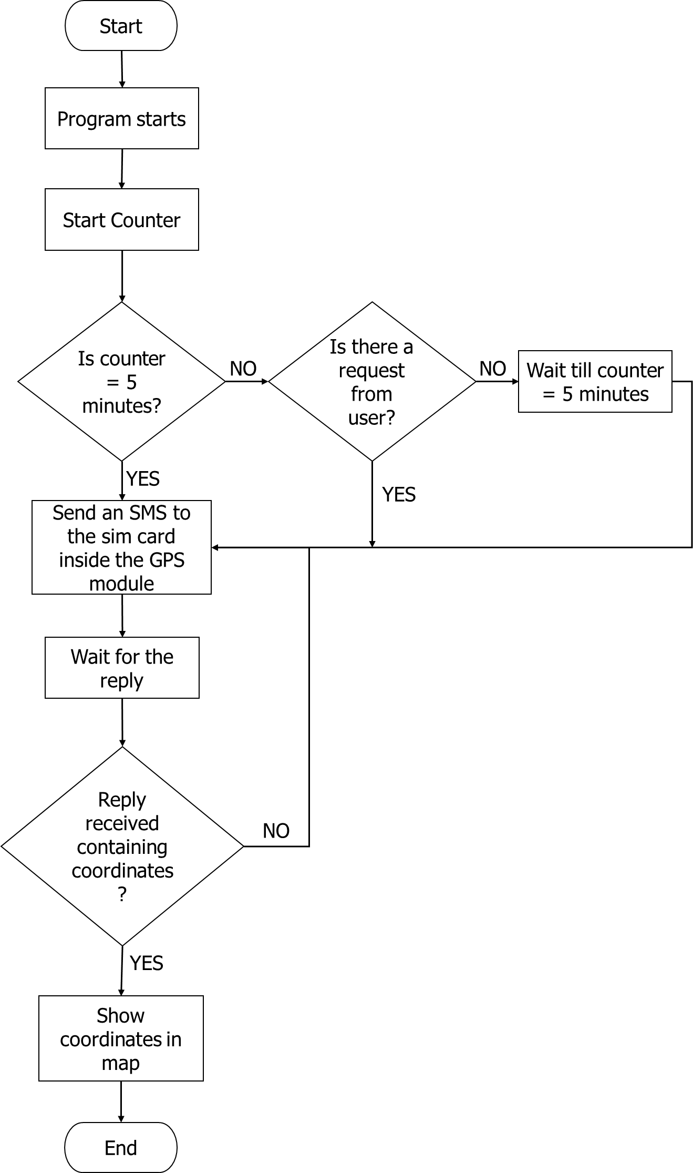

**Figure 3.6** Mobile application flowchart

This flowchart illustrates the flow of steps or procedures that will happen in the mobile application. After the mobile application is started, it will show the main page containing the “Locate” button for each of the vehicles to be tracked, when a “Locate” button is clicked or tapped, the mobile application will send and SMS to the tracking device, which would then send a reply containing the coordinates. The mobile application will then show the current location of the vehicle.

**Use Case Diagram of the System**

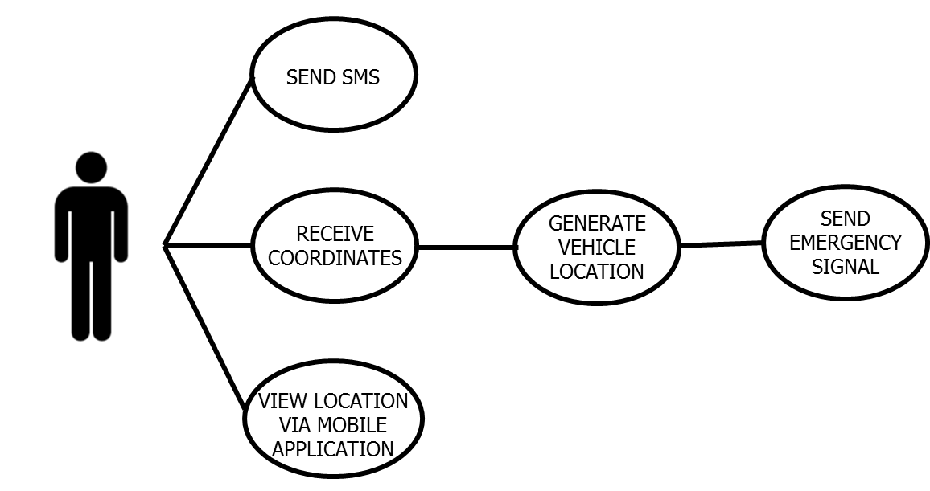

**Figure 3.7** Use Case Diagram of the System

The figure above shows the use case diagram of the system. It illustrates the relationship of the user to the certain actions it can perform. First, the user can send an SMS to the device if he/she wishes to find the location of the vehicle. The user will then receive the coordinates of the device and he/she can view the location through the mobile application created.

**Use Case Specifications**

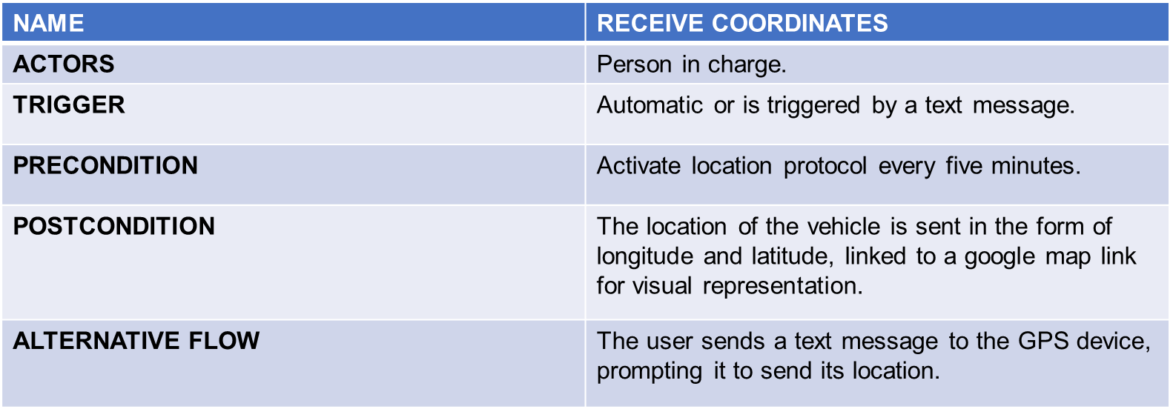

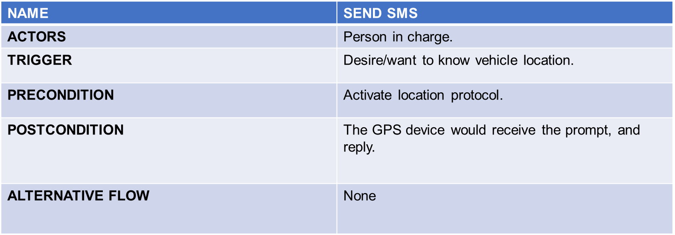

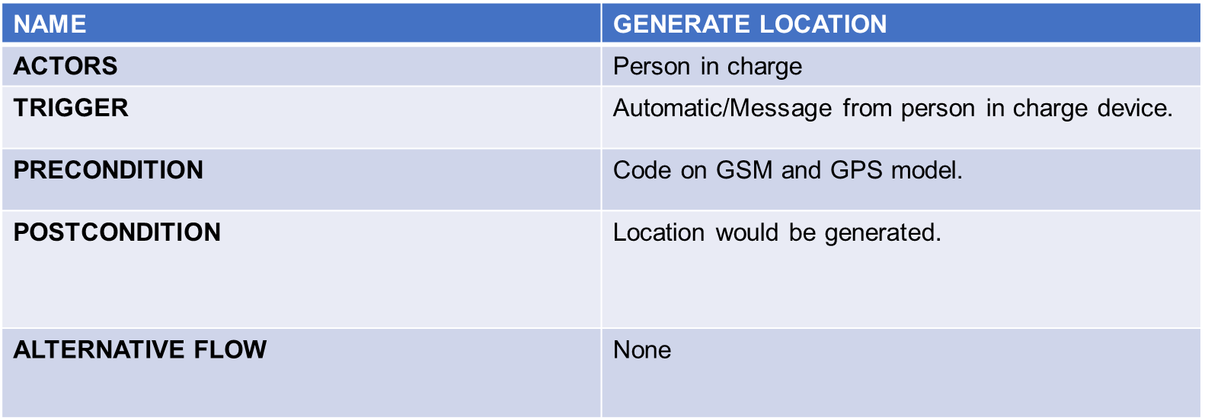

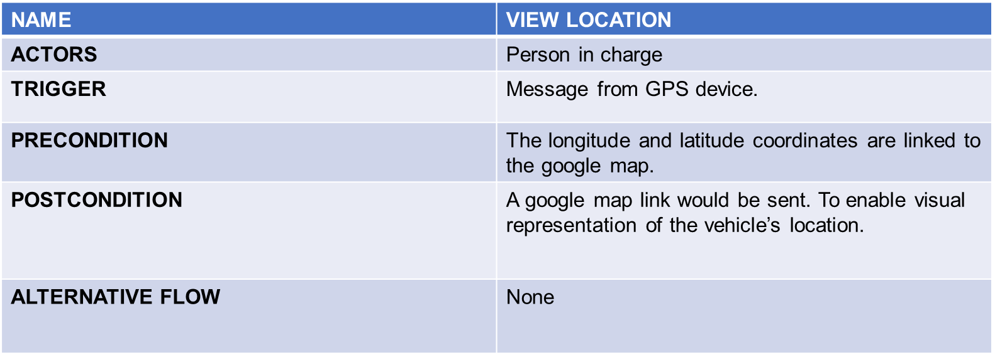

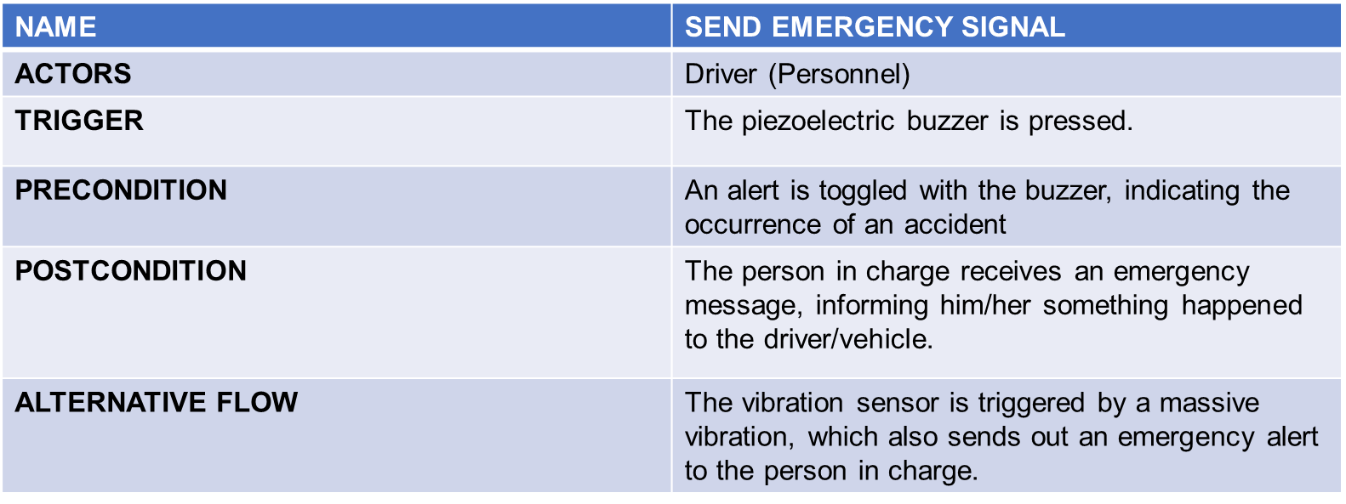

**Figure 3.8** Use Case Specification of the System

**Prototype Development**

List of Components

Below is a list of components that were used in the making of this system. 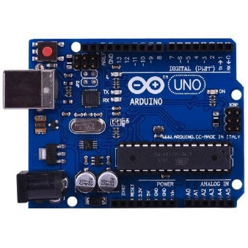  
**Figure 3.9** Arduino Uno

Arduino Uno is a microcontroller board based on the ATmega328P (datasheet). It has 14 digital input/output pins (of which 6 can be used as PWM outputs), 6 analog inputs, a 16 MHz quartz crystal, a USB connection, a power jack, an ICSP header and a reset button. It contains everything needed to support the microcontroller; simply connect it to a computer with a USB cable or power it with a AC-to-DC adapter or battery to get started.

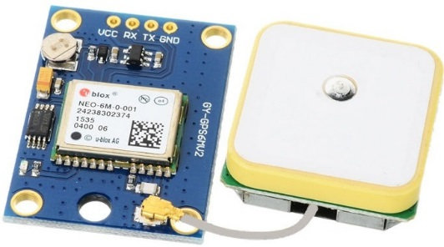

**Figure 3.10** NEO-6M GPS Receiver Module

The GPS receiver module uses UART communication to communicate with controller or PC terminal. The signals received from the satellites and ground stations contain time stamps of the time when the signals were transmitted.

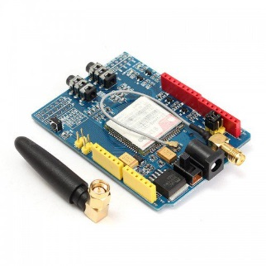

**Figure 3.11** GSM/GPRS module Sim900

The GPRS / GSM SIM900 for Arduino provides you a way to use the GSM cell phone network to receive data from a remote location，it delivers GSM/GPRS 850/900/1800/1900MHz signals for Audio, SMS and GPRS Service. It is compatible with all boards which have the same form factor (and pinout) as a standard Arduino Board. This GPRS / GSM SIM900 for Arduino is configured and controlled via its UART using AT commands. GPRS / GSM SIM900 for Arduino Also has 6 GPIOs,2 PWMs and 1 ADC(They are all 2V8 logic), which can be controlled by AT commands of Controller.

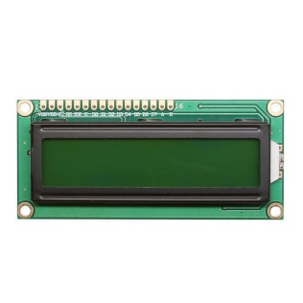

**Figure 3.12** 16X2 LCD Module

A 16x2 LCD display is very basic module and is very commonly used in various devices and circuits. These modules are preferred over seven segments and other multi segment LEDs. n this LCD each character is displayed in 5x7 pixel matrix. This LCD has two registers, namely, Command and Data. The command register stores the command instructions given to the LCD. A command is an instruction given to LCD to do a predefined task like initializing it, clearing its screen, setting the cursor position, controlling display etc. The data register stores the data to be displayed on the LCD.

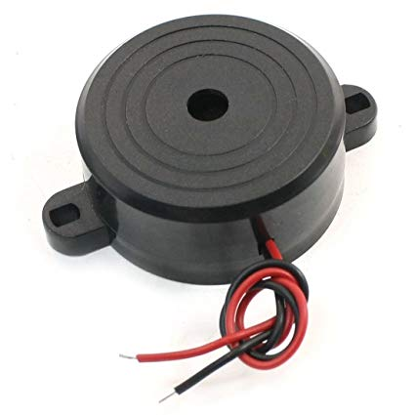

**Figure 3.13** Piezoelectric Buzzer

A small piezoelectric buzzer on the Arduino UNO, by pulling pin P0.7 low, current will flow through the buzzer and a relatively sharp, single-tone frequency will be heard.The alternative PWM feature of pin P0.7 (the PWM2 signal) can be used to modulate the buzzer to oscillate around different frequencies. Then the volume of the sound will be changed by alternating the pulse width. The buzzer can be disconnected by removing jumper JP1, and this is also the default position for this jumper since the buzzer sound can be quite annoying if always left on.

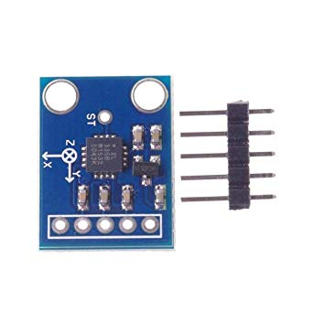

**Figure 3.14** ADXL377

The ADXL377 is a small, thin, low power, complete 3-axis accelerometer with signal conditioned analog voltage outputs that has a full-scale range of ±200g for measuring more extreme changes in motion, shock or vibration. This board has broken out all the pins you’ll need to get the necessary data from the accelerometers. The breakout is perfect for applications like concussion and head trauma detection or high force event detection.

**Sensor Module**

|  |  |
| --- | --- |
| **Accident Report** | **G Force Value** |
| No Accident | 40g< |
| Accident | 40g> |

**Table 3.1** Thresholds g-forces for Accident Detection

The accelerometer sensor is based on the detection of the g-forces in the system. This sensor senses the change in the g-forces in the object. The value of the g-forces tells about the absence or presence of collision or crash. A threshold value is set wherein if the specific conditions are met, a report is generated by relaying the information to the microcontroller and into the GSM module.

**Testing Table**

|  |  |  |  |  |
| --- | --- | --- | --- | --- |
| **Vehicle** | **Time** | **Latitude** | **Longitude** | **Message Send** |
| 1 |  |  |  |  |
| 2 |  |  |  |  |
| 3 |  |  |  |  |
| 4 |  |  |  |  |

**Table 3.2** Record of the location of the vehicle.

This table records the coordinates of a vehicle together with the time the device sends its current location and if the message was sent.

**3D Simulation**

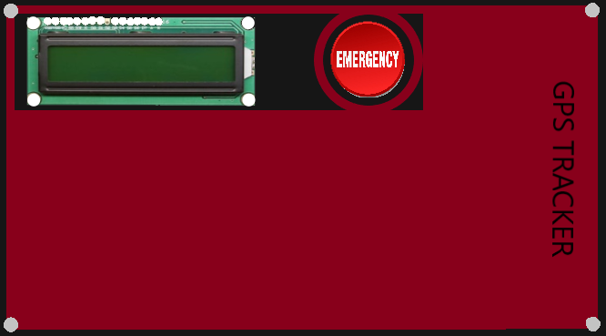 The image below shows the final output of the GPS tracker of the delivery vehicle prototype.

**Figure 3.15** Front View of the Prototype

**Data Gathering Procedures**

The first step that will be done to gather the required data for testing is to install the device to a vehicle. When the device is all powered up using the car’s battery, then the device is ready to work. The user is inside the car so the data regarding the location that the user will receive can be verified for accuracy. The user will use the mobile application to locate the vehicle. The device will reply the coordinates and the time to the user.

**REFERENCES**

Md. Marufi R., Jannatul R., Kusum T., Md. Ismail S., (December 2016). Real Time Google Map and Arduino Based Vehicle Tracking System - *2nd International Conference on Electrical, Computer & Telecommunication Engineering (ICECTE)*

Pham Hoang D., Michael D., Nguyen Chi C., (December 2013). Development of Vehicle Tracking System using GPS and GSM Modem *- 2013 IEEE Conference on Open Systems (ICOS)*

Fleischer, Paul Benjamin N., Atso Y., Robert A., Bremang A., (2012). Design and Development of GPS/GSM based Vehicle Tracking and Alert System for Commercial Inter-City Buses - *2012 IEEE 4th International Conference*

Junaid A., Shaib N., Taha A., Naveed A., Syed Riaz N., (SCOReD 2009), Nov. 2009). Implementation of GSM based Commercial Automobile Tracker Using PIC 18F452 and Development of Google Earth Embedded Monitoring Software Proceedings - *2009 IEEE student conference on Research and development Malaysia.*

Dr. Ali O., Alih S., Cagatay A., Koray C., (May 2011). Micro-Controller Based Vehicle Tracking System via Use of GPS and GSM. - *2008 Certified Journal*

A. Amusha., Syed Musthak A., (July 2017). Vehicle Tracking And Monitoring System to Enhance the Safety and Security Driving Using IoT *– 2017 IEEE* *Conference on Open Systems (ICOS)*

R. Surender Reddy1., M. Hymavathi2., E. Shilpa3 (October 2016). Real Time Vehicle Monitoring and Tracking System based on Embedded Linux Board – *2016 International Journal of Innovative Research in Computer and Communication Engineering*

Deepak P., Deepak K., Vartika M., (July 2012). Design and Realization of the Accelerometer based Transportation System*- International Journal of Computer Applications*

Waleed I., Momen A., Musab M., Hassan H., (October 2017). Accident Detection and Reporting System Using GPS and GSM Module *- Almughtaribeen University College of Engineering Department of Communication*