**DESIGN_GPSTRACKER**

The main objective of this product is to design a delivery vehicle tracking system using smartphone Google map application.

Specific Objective:

* To design a device that would provide the exact location of the delivery vehicle with the use of Google map application.
* To develop a system that is compatible to any smartphone.
* To have a system that has panic button that can alert the person in charge in case of emergency.

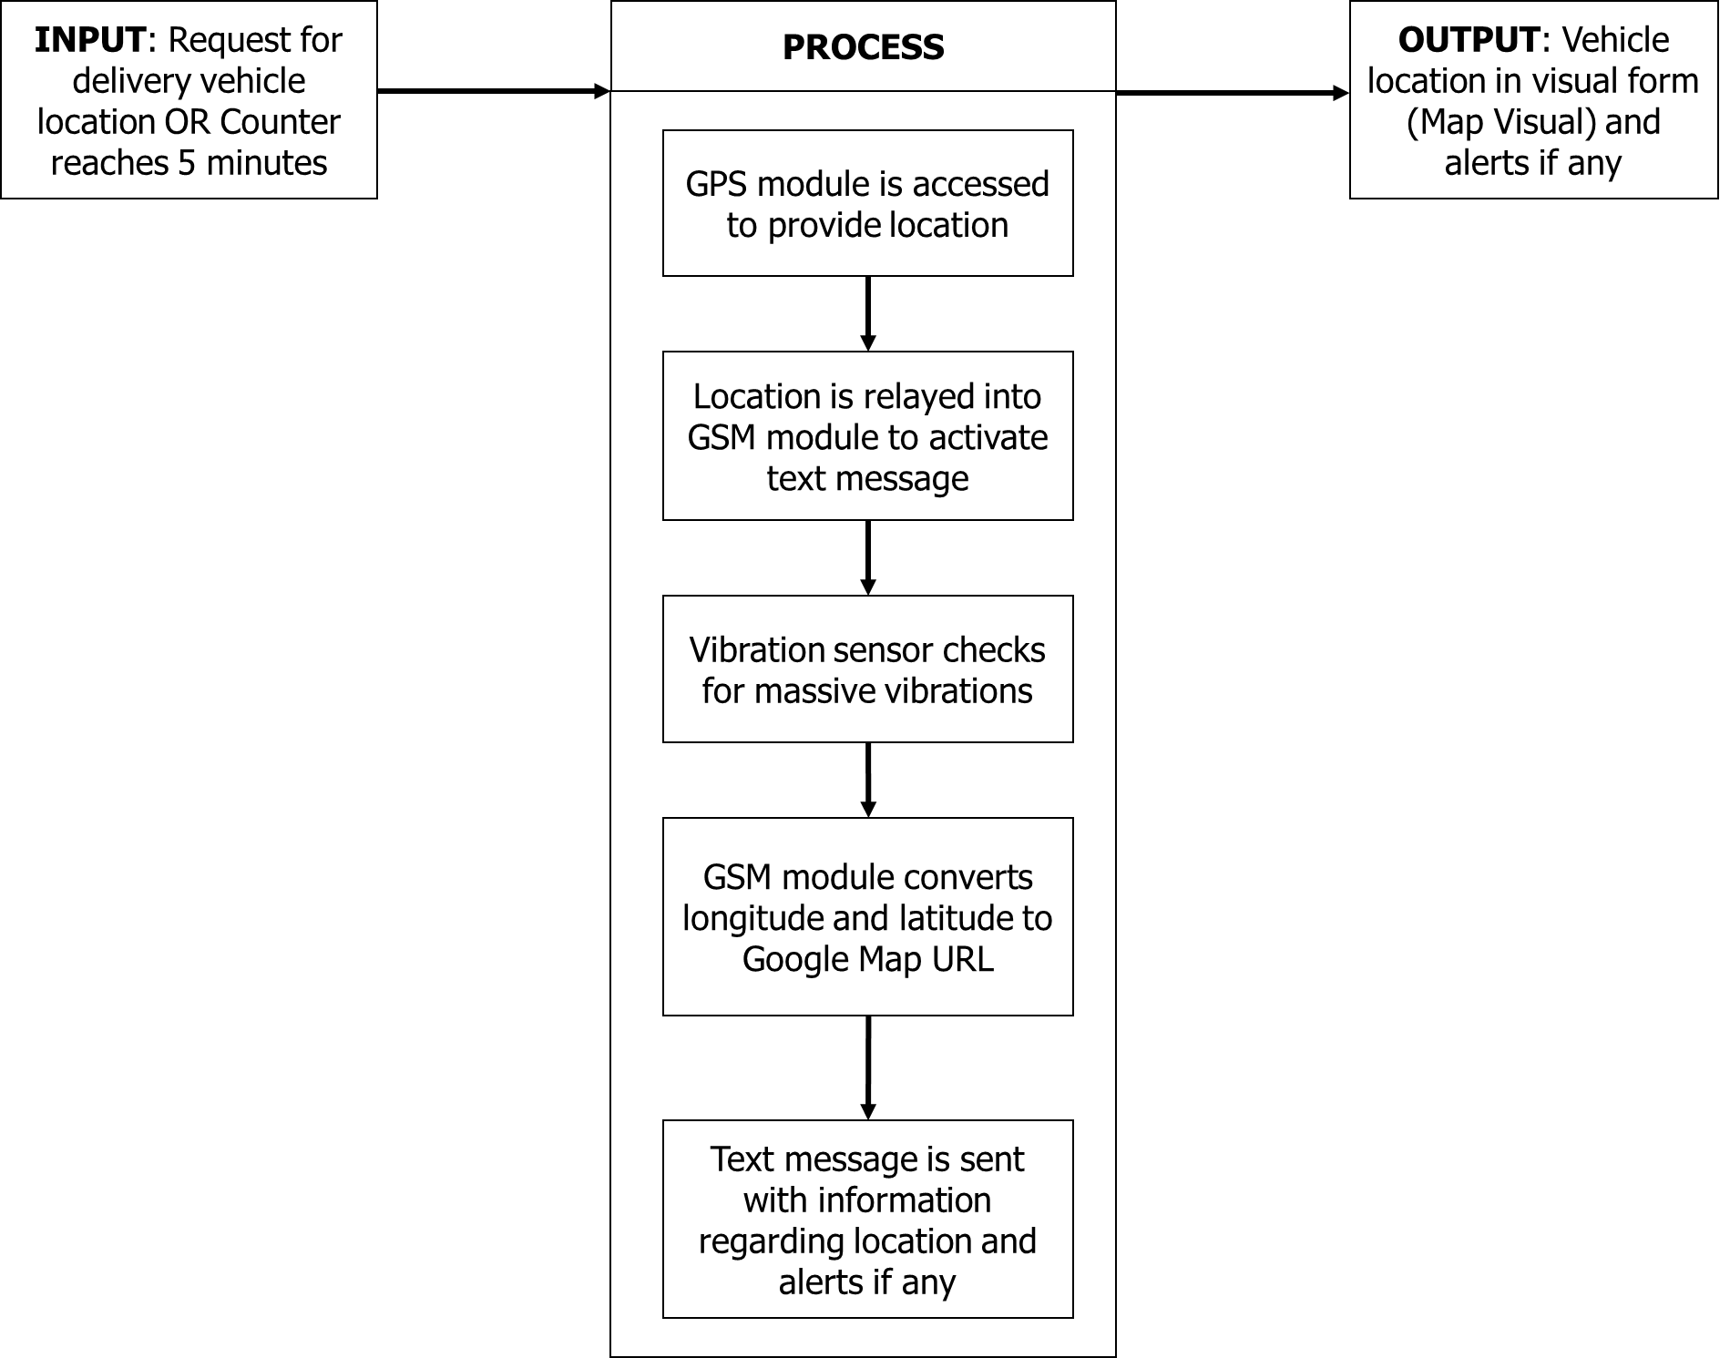

This project simply tracks the GPS location using a GPS module, format the latitude and longitude along with Google Maps Link and send it to a certain number via SMS using a GSM module. The sending of location is done every 5 minutes or if the user send a certain SMS to the device (ex: “WHEREAREYOU”) to request where is it now. Additionally, there are two inputs, the panic button and the G-force readings of the accelerometer. If the panic button was pressed, it will send an SMS to the user that “An emergency occurred at *insert google location link*”. When the G-force readings became abnormal, it means that it detects a vibration or accident, it will send SMS to the user that “Vibration detected at *insert google location link*” and the buzzer will be triggered. Additionally, an LCD is connected to output the device’s status.

Over all the IPO is changed to:

Inputs:

* Location coordinates.
* Panic button.
* G-Force readings from the accelerometer.

Process:

* Send google link coordinates every 5 mins.
* Send google link coordinates if the user text the device with “WHEREAREYOU”.
* Send SMS of Google location link if panic button is pressed.
* Send SMS of Google location link if vibration is detected and turn on the buzzer.

Outputs:

* Buzzer
* SMS to the user.
* Device status in the LCD.

**Materials**

* Arduino Nano
* MPU6050
* GPS Module (NEO-6M-V2)
* SIM800L
* 16x2 LCD (With I2C interface)
* Piezo Electric Buzzer
* Breadboard
* 2 pcs buttons for breadboard.
* 2 pcs buttons for finalization (the big square one from e-Gizmo).
* Male to Male wires.
* Female to Female wires.
* LM7805
* 330 nF capacitor
* 100 nF capacitor
* 12V power supply, it should output at least 2000 mA because SIM800L needs a lot of power.
* 16x 2 pre-synthesized PCB.
* Developer powder.
* Ferric chloride.

**Tasks**

Our job is to:

* Create the circuit of the device.
* Create the program of the device.

You job will be to:

* Create the PCB of the project.
* Create the casing of the project.