Integration of Fuzzy Logic and Wireless Accelerometer-based Motion Recognition Sensors for the Determination of Cerebral Palsy in Babies

by

**Gheznna Maria C. Rotoni**

**Sophia Alexandra V. Unabia**

A Thesis Submitted to the School of Electrical Engineering, Electronics Engineering, and Computer Engineering in Partial Fulfillment of the Requirements for the Degree

Bachelor of Science in Computer Engineering

Mapúa University

October 2018

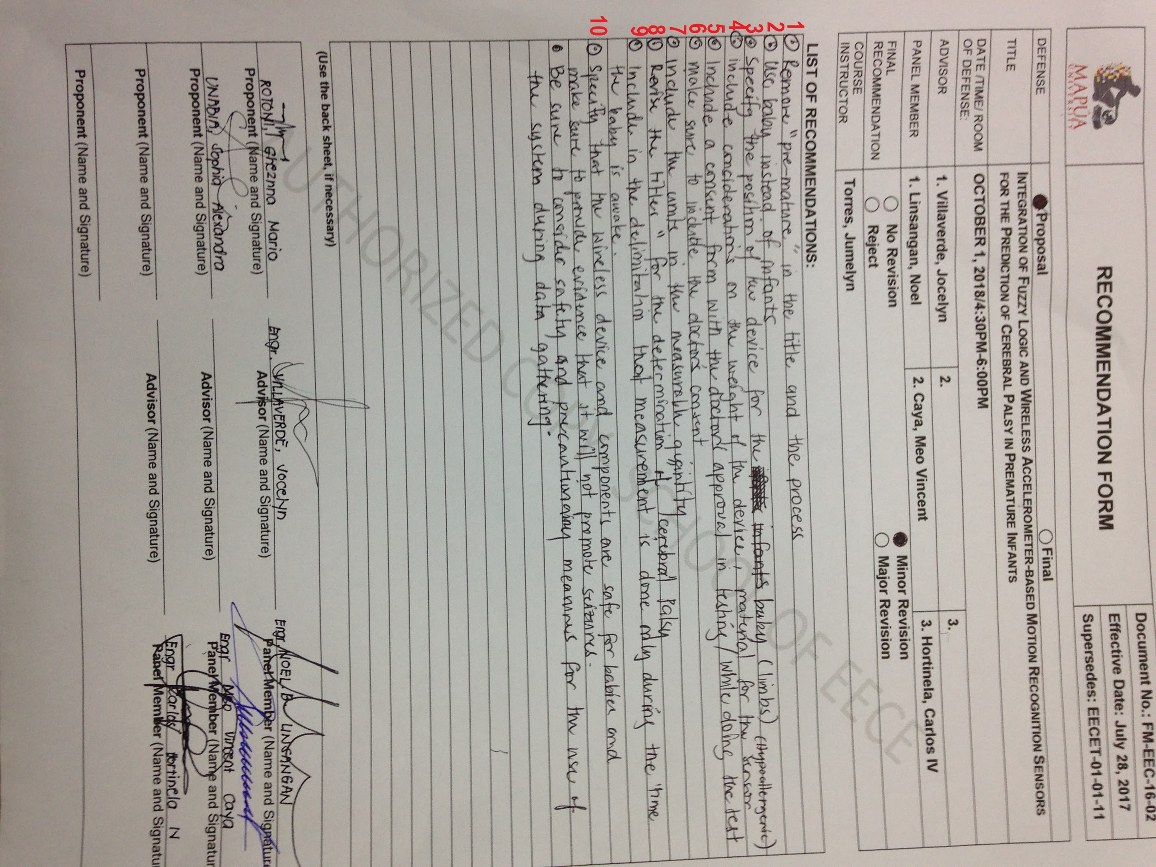

**Chapter 1**

**INTRODUCTION**

The cases of premature birth have quickly escalated over the years and have led to the increase in the number of children who suffer from chronic health conditions like neurodevelopmental and motor impairments. Premature infants are babies born before 37 weeks of gestation or the measured date from the mother’s last menstrual period [4-5]. They are born too soon that some organs are still underdeveloped depending on how premature the baby is. Advanced technology and improved medical specialist collaboration increased the survival rate of premature infants [8], one of this is with the aid of an incubator. Even with the existence and availability of advanced technology nowadays, complications still occur to babies born premature for they have a higher risk of developing chronic health conditions like motor impairments [5, 11]. Being physically disabled has many causes but motor impairment is one of the major causes which includes poor balance, impaired sensation,and weakness, fatigue, contracture, and spasticity in the muscle. The most common and major motor disability that may occur to premature born babies is cerebral palsy. Premature babies have higher risk of developing CP than full term babies [1-3]. Ranging from 2 up to 3 out of 1000 babies is the estimated prevalence of this condition [10] and it significantly increases for preterm babies. Cerebral palsy, also known as CP, is a term for conditions with collection of brain disorder which affect the movement, posture and motor system of a person that is due to abnormal brain development and injuries [1-3] Among the signs that may occur that is related to CP, developmental delay is the most apparent early sign. This condition is a permanent illness, so it is critical to determine at its earliest stage to engage in appropriate treatment as soon as possible [7] and to prevent further damage for a higher chance of recovery [6, 9].

A child is suspected to have CP when he exhibits abnormal movements particularly about his limbs and gait [3]. Various studies have used camera-based methods and wearable sensors to collect and analyze data about limb motion [12]. Early determination of cerebral palsy is performed by means of video-based motion segmentation where it tracks individual body parts using a video camera and extracts the features by means of standard deviation, periodicity, and correlation between trajectories, or the support vector machine (SVM) [7]. Since CP affects the variability of the motions, a study by Martens (2016) focused on prediction of CP through the movement of the young infants by means of frequency analysis and used a feature selection method which determines the features with significant predictive ability this is through feature reduction method. There are many available brain-imaging techniques that can be used in order to diagnose the abnormal development in the brain, like the cranial ultrasound and the magnetic resonance imaging (MRI) [1]. The cranial ultrasound is a neurological imaging where it uses high-frequency sound waves to capture a not-so detailed images of the brain just enough to provide preliminary assessment. The Magnetic Resonance Imaging or MRI is almost similar to the cranial ultrasound, but it captures a detailed cross-sectional or 3-D images of the brain where it uses radio waves and magnetic field and it can provide specific details like any abnormalities in the brain.

The diagnosis of a child who is suspected to have CP requires physical evaluation and other tedious observational procedures. As stated above, there are existing methods which can be used to determine CP in a baby however these methods either require hours of manual observation or involve procedures inappropriate for very young children. Other methods have high costs or less availability while some procedures are not yet reliable for early diagnosis.

The general purpose of the study is to be able to develop a system that would be able to determine the occurrence of cerebral palsy to babies at an early age. This study aims to develop a non-invasive device that would be able to detect the acceleration of the moving limbs of the test subject through the use of wireless motion sensor. The irregular limb movements of the test subject that may link to the development of cerebral palsy will also be identified. Finally, to be able to analyze and interpret the obtained data using Fuzzy Logic algorithm.

The study is highly beneficial for practical medical use specifically as an aid in accurately diagnosing CP in the earliest stages of childhood. It may be used as an alternative way in determining a child’s risk of having CP using a wireless non-invasive lightweight device that will identify irregular limb movements that may link to CP. The main significance of this study is to detect CP as early as possible to prevent any further damage and to acquire medication and/or therapy immediately for improvement in the quality of life.

This study focuses on the determination of cerebral palsy to babies. There are several types of cerebral palsy which may develop to a child, however this study cannot identify the special types of CP. Since clinical diagnosis can be made to children aging from 1 to 5 years old, the preferred age range of babies to be tested in this study is 6 months up to 20 months. As stated earlier, the level of severity and effect of CP varies from different person, thus there will be four wireless accelerometers that will be attached to the extremities of the baby to achieve a more accurate data. Considering the fragility of the testing population, a letter of consent will be given to the parents of the baby to be tested and testing will only occur upon approval. Testing will only be performed with the supervision of the medical practitioner and the thesis adviser. The testing on babies will only occur if they are awake. The proposed system will be tested exclusively for babies.

**Chapter 2**

**REVIEW OF RELATED LITERATURES AND STUDIES**

**Cerebral Palsy**

Cerebral Palsy is the term used to refer to a collection of neurological disorder which is caused by the irregularity inside the brain where it affects the ability of the brain to control the movement and posture [8]. It develops before, during, or shortly after a child’s birth, and is evident to the child as early as 1 to 5 years old.Among the factors and reasons why children suffer from this motor disability, the following are the most common: way below the average weight upon birth, reproductive technology-assisted conception, complications during pregnancy and premature birth. According to Miller and Bachrach (2017), CP can possibly occur more in babies that are extremely premature compared to full term babies where it reaches 20% up to 40% risk where it can be proven by some experimental evidence. The level of severity and effect of CP varies widely from one person to another, that sometimes, it is very difficult to determine if a child has it. However, children showing poor coordination, poor balance and movement patterns, stiffness of muscles, limpness, feeding difficulty, seizures attack, or worst, a combination of all these characteristics are most likely having the early signs of CP.

**Clinical Assessment and Diagnosis of Cerebral Palsy**

Physicians evaluate a child’s risk of having CP by reviewing his medical history and by assessing his motor skills through the administration of a neurological exam [8].The babies reflexes are primarily observed and studied in this exam. However, according to McQueen (2013), uncontrolled and irregular body movements are understudied by neurological exam. Movement assessment will be based on the physician’s observation and acquired expertise thus it can be subjective procedure [18]. Neuroimaging is a more modern approach in diagnosing CP in the clinical setting. In this method, several images of the brain are captured and collected for the visual analysis and detection of brain abnormalities by medical experts. This method is dangerous for a young child as it exposes him to radiation [3] and mild sedatives are given [1].

**Cramped Synchronized General Movement (CSGM)**

The most conventional and reliable method for the clinical prediction and detection of CP is the general movements assessment (GMA), a study by Heinz Prechtl. General movements (GMs) of a baby follow a distinct pattern without any outside simulation affecting his own movement. General Movement Assessment is an assessment which is based on observation; it evaluates the movements of the baby and identifies which among them are the irregular movements that can serve as an indication of a neurological disorder. In this study, a video recording showing the spontaneous and irregular movements of the baby’s body is visually identified and assessed by a medical expert. According to Prechtl, the general movements (GM) of a normal baby consists of writhing movements (WM) then fidgety movements (FM) where the former appears before the latter as the child develops and grows [12]. One other type of movement that the GMA can classify is the cramped synchronized general movement (CSGM). This is characterized as abnormal body movements that are caused by concurrent limb muscle contraction and relaxation. As a result, limbs move simultaneously while they are rigid. By the age of 3-5 months, where an infant is supposedly exhibiting FMs but shows CSGMs instead, then it is possibly already an indication of CP development [21].

**Movement and Gesture Recognition Technologies**

The automated detection and diagnosis of movement disorders has aided and profoundly improved the accuracy of the conventional clinical assessment of such diseases. Movement and gesture recognition technologies focus on the analysis of limb motion where abnormal and irregular features that may be indicators of movement disorders are extracted and further studied. The application of these technologies to potential patients may either be direct or indirect [12]. Video-based technologies offer a more indirect approach on movement analysis as this setup does not require any equipment to be in contact with the patient. Adde (2013) developed a computer vision-based system that identified fidgety movements in young infants through the quantitative analysis of one to two video recordings about the young infants’ movements. One existing study that presents a direct approach in determining CP in young children is the application of electromagnetic tracking in the detection of spontaneous movements of the limbs. Stereotype scores of the limb movements were found to be possible predictors of CP [16]. Wearable sensors also serve as another form of direct approach in motion and gesture recognition technology. A study by Martens (2016) make use of a frequency-based system to analyze the irregular movements of babies related to CP. They utilized feature reduction method to select important features with predictive ability. A study by Heinze (2010) presented an accelerometer-based system that could record the movements of a baby. The diagnosis of CP was based on the decision tree algorithm where the collected data from the accelerometers analyzed and classified as either normal or abnormal.

**Accelerometer**

Accelerometers are sensors which measure inertial forces in one or three spatial axes, resulting in high-resolution time-series data that represent the dynamics of the acceleration of the sensor during movements. In clinical assessment automation, the device has been popularly used as a tool to investigate potential movement disorders by studying the motion of the human body particularly that of the limbs. According to Heinz (2010), since then, accelerometers provide sufficient data reliability and quality in assessing abnormal movement pattern of physical activities. In a study by Garcia (2016), the early diagnosis of Parkinson’s disease was based on the analysis of hand tremors through the application of accelerometry. Accelerometers were also used in the earliest studies on the determination and rehabilitation of cerebral palsy who typically have abnormal muscle tone, muscle weakness, or irregular movements. To be specific, they have been used to measure physical activity levels in children [17]. The closest study to our research is performed by Gravem (2012) wherein they focused on the prediction of CP using accelerometer system and it was found that accelerations related to CSGMs were high in value and were almost equal across the affected limbs. Shown in Figure 2.1 is the orientation of the axis of the accelerometer.

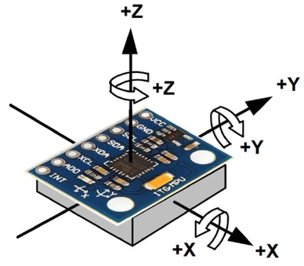

**Figure 2.1** Axis of the Accelerometer

**Wearable Devices**

The purpose of a wearable device or *wearables* is usually to continuously monitor certain diseases or health issues that can be measured by their quantifiable features. Accelerometer-embedded wearables are used to track and measure the physical activity (PA) and motion of a human [24]. As mentioned in the previous parts of this chapter, various studies have focused on utilizing accelerometer-based sensors to identify movement disorders in babies. To date, there have been no reports on harmful effects on health of using low-powered accelerometer-based devices, such as the proposed prototype, on human motion tracking. In fact, the device has been used to automatically identify other motor disorders such as seizures and epilepsy [25]. However, according to the World Health Organization (WHO), motion trackers such as in mobile phones and smart watches are more likely to pose threat to humans as they emit a much higher level of radiation.

**Arduino Nano**

The Arduino Nano is a small, complete, and breadboard-friendly board based on the ATmega328 microcontroller. It offers the same connectivity and specs of the UNO board in a smaller form factor. It comes with an operating voltage of 5V, however, the input voltage can vary from 7 to 12V. There are 14 digital pins which can be configured as input or output and 8 analog pins incorporated on the board. More or less all these analog pins can be used and configured exactly the same way as digital pins.

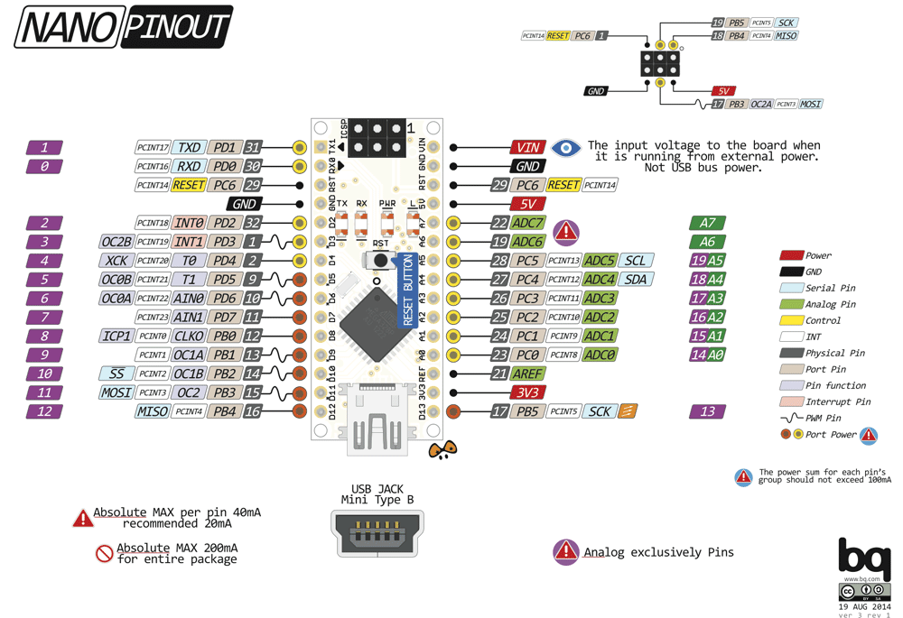

**Figure 2.2** Arduino Nano Pin Diagram

**Fuzzy Logic**

A fuzzy logic (FL) system facilitates solving problems in a given field or application by drawing inference from a knowledge base developed from human expertise. It can be defined as the nonlinear mapping of an input data set to a scalar output data. Fuzzy logic system consists of four main parts - fuzzifier, rules, inference engine, and defuzzifier [20]. The diagram for the fuzzy logic system is shown in Figure 2.2.

**Figure 2.2** The fuzzy logic system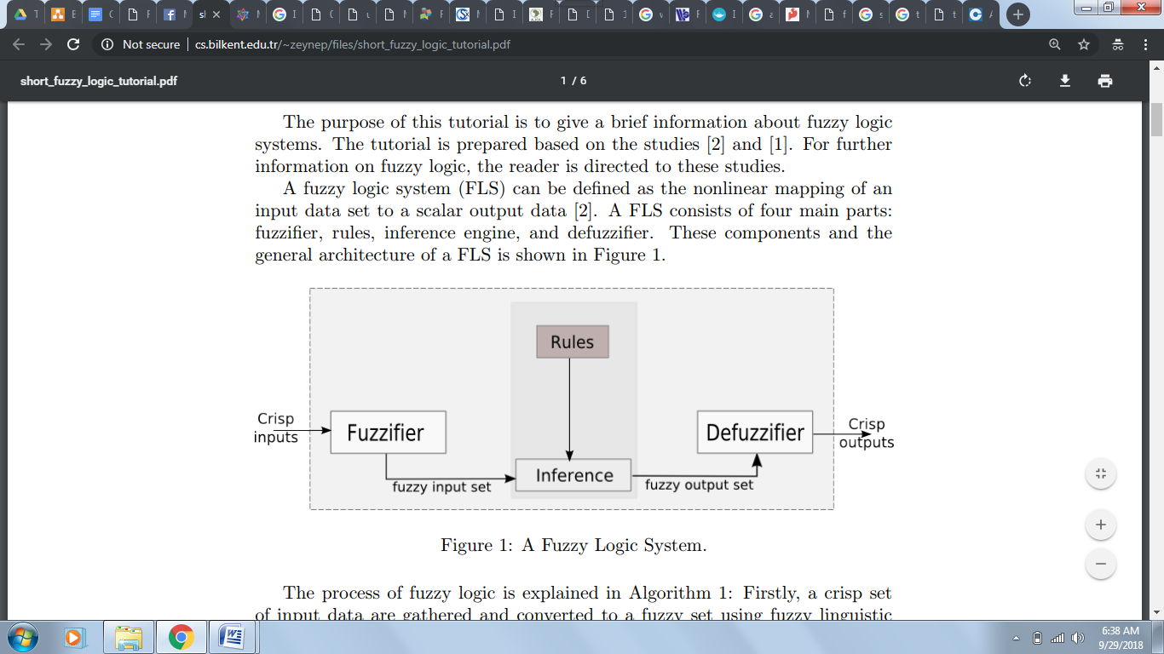

More recent studies on cerebral palsy diagnosis and monitoring has used FL to analyze and interpret collected data. In the study made by Alcan (2017), it was aimed to analyze with different methods the surface electromyography (EMG) signals obtained in different positions from hemiplegic patients with spasticity and in a healthy control group for the quantitative measurement of spasticity and to realize the diagnosis of spasticity with a fuzzy logic classifier (FLC).

**Statistical Analysis**

Statistical Analysis will be done to determine the accuracy of the built system [23]. Accuracy is measured by how often the system can conform with the true value. For this system, the researcher will be using T-test in comparing the results obtained from the built system to the results based from the analysis of the medical expert present during testing. The T-test assesses whether the means of two groups, or conditions, are statistically different from one other. It is a reasonably powerful test used on data that is parametric and normally distributed. The outcome will allow is to accept or reject the hypothesis.

**Chapter 3**

**METHODOLOGY**

**Research Methodology**

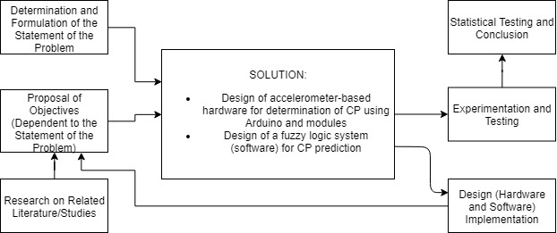

**Figure 3.1** Constructive Methodology

Figure 3.1 discusses the constructive methodology for this study, determination of Cerebral Palsy in babies with the use of wireless accelerometer-based motion recognition sensor and integration of fuzzy logic. Constructive methodology is a common research method that aims to validate research without being too empirical. The goal of this type of research is to be able to define and solve problems while providing an academic approach in scientific and theoretical contribution. Constructive research includes the following steps - first is to identify the relevant problem, next is to obtain a theoretical body of knowledge from the available related studies, then the researchers design a solution to the problem, and finally to identify the practical and theoretical relevance of the study. The statement of the problem and the objective of the research was determined and formulated based on the current clinical diagnosis and assessment method and the available movement and gesture recognition techniques to determine the occurrence of CP among babies. However, traditional methodologies for determination of CP are subjective, and can be dangerous for sedatives are given and children are exposed to radiation. Through researching and reviewing the several related literatures and studies, the researchers were able to obtain a comprehensive understanding of the area of study which could help in developing a solution to the problem. After gathering relevant information, the researchers came up with a solution that aims to determine Cerebral Palsy through a non-invasive method by means of a wireless accelerometer-based motion recognition sensor and fuzzy logic. For the development of the hardware, the components to be used are listed including their uses. This includes the major components which are the accelerometer, and Arduino Nano. For the development of the software, it will be done by performing different processes and algorithms necessary for the system, in this case, data annotation and data filtering will be used to filter relevant features with significant determination ability, and fuzzy logic will be trained to interpret the result using the Arduino Nano to arrive at a result. After developing and implementing the system, data will be gathered which involves testing the system and results will be validated by comparing clinical diagnosis from the results obtained in this system.

**Conceptual Framework**

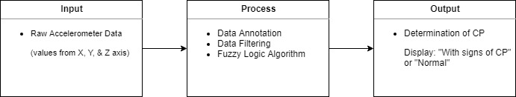

**Figure 3.2** Conceptual Framework

Shown in Figure 3.2 is the conceptual framework of the system. The acceleration of the baby’s limbs will serve as the input of the system to be obtained by the accelerometer. The raw acceleration data will then undergo processes including data, annotation, data filtering, and fuzzy logic algorithm. Data annotation will be used to obtain ground truth values and to train the fuzzy system*.* Data filtering will be used to remove the unnecessary data that was collected by the accelerometer that is not related to motion, like gravity and sensor calibration drift. The decision of the cleaned data is finalized using fuzzy logic, it will output regarding whether the baby is normal or with signs of CP.

**HARDWARE DEVELOPMENT**

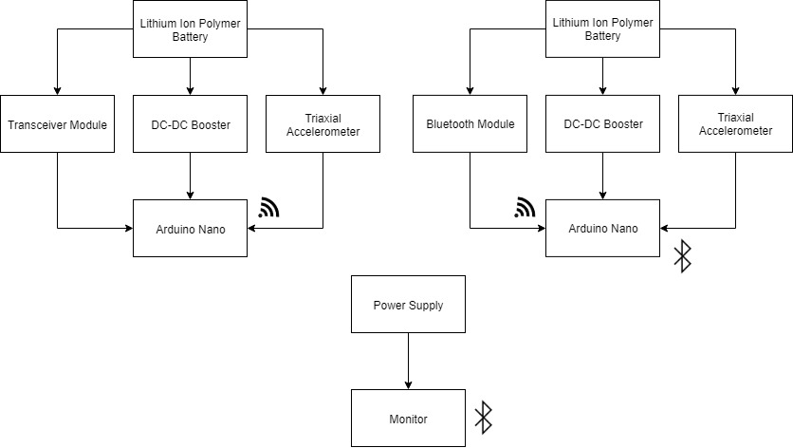

**Figure 3.3** Block Diagram of the System

Shown in Figure 3.3 is the block diagram of the components that will be used in the design of the hardware. The wireless triaxial accelerometer will be used to measure the movement of the limbs of the baby. The accelerometer and transceiver module will be connected to the Arduino Nano on 3 limbs. While on one limb, the accelerometer and Bluetooth module will be connected to the Arduino Nano. The raw acceleration data that was gathered will be sent to the Arduino Nano. The Arduino Nano will be the main part of the system wherein it will be used to process the data gathered from the accelerometer. The processed data from the 3 Arduino Nano will be sent to the limb containing the Bluetooth module wirelessly thru transceiver module. The limb that contains the Bluetooth module will be in charge of gathering the data from the 3 limbs and the gathered data will be sent thru the monitor via Bluetooth. The extracted data will be analyzed and interpreted using fuzzy logic. The results will be displayed in the monitor.

**Table 3.1** Tabulated List of Materials

|  |  |  |
| --- | --- | --- |
| MATERIALS | FUNCTIONALITY | SPECIFICATIONS |
| **MPU6050 gyro & accelerometer** | It is a sensor of a combination of 3-axis accelerometer and 3-axis gyroscope. It will be used to measure the acceleration of the baby. It will gather the raw acceleration data of every limb. | * Combination of 3-axis accelerometer and 3-axis gyroscope * 1 x 0.6 x 0.9 inches * 2.1g weight * measures from +/-2g up to +/-16g * 3.3V - 5V Voltage Range |
| **Arduino Nano v3.0** | The Arduino Nano is a small, lightweight, and breadboard-friendly board. It is a compact board almost like the Arduino Uno. In this component, the accelerometer and Bluetooth module are connected to it. | * 1.70” x 0.73” * 5g weight * ATmega328 microcontroller * 5V operating voltage * 7-12V Recommended Input Voltage * 8 analog input pins * 14 digital I/O pins * 32 KB Flash Memory * 16 MHz Frequency Clock Speed |
| **HC-05 Bluetooth Module** | Bluetooth module will be used to transmit data wirelessly from the Arduino Nano to the Monitor. | * 3g weight * 1.06” x 0.51” x 0.09” * Built-in CSR company Bluetooth chip BC417143 * Coverage up to 30 ft / 10 m * 7 I/O ports * 2.4GHz ISM band * Gaussian Frequency Shift Keying * 3.3V DC 50mA Power Supply * Asynchronous 2.1Mbps max speed * Synchronous 1Mbps speed |
| **DC-DC 5V CE8301 Booster** | Booster is used to get a stable 5V output voltage for the Arduino Nano. | * 4g weight * 1.34” x 0.64” * 0.9~5V input voltage. * Type-A USB connector * PFM Control DC-DC Converter |
| **NRF24L01**  **Transceiver Module** | Transceiver module will be used to transmit data wirelessly from Arduino Nano to Arduino Nano. | * 6g weight * 0.59” x 1.14” * 19 ~ 3.6V Power Supply * +7dB Transmitting Rate * -90dB Receiving sensitivity * 250mm in open area transmission range * 2.4GHz ISM band operation |
| **GMB042035 Lithium-ion Polymer battery** | Lithium-ion Polymer battery will be used to supply power to the Arduino Nano together with the accelerometer and the Bluetooth module. | * 4.8g * 1.42” x 0.81” * 3.7V Nominal Voltage * Rechargeable battery * 4.2+/-0.03V Charging Voltage * 4.0h charge time |
| **Monitor** | A monitor will be used to display the output of the system. | * Any available laptop or computer may be used. |
| **Camera** | A camera will be used to record the procedure for the annotation of data. This is relevant to mark the time wherein CSGM occurred. | * Any available video camera or webcam may be used. |
| **Hospital band** | This band is placed on the wrist or ankle of the baby. The accelerometer and Bluetooth module will be placed here. | * 5.5 x 1.25 inches * Made of the highest medical grade foam * Contains non-abrasive and hypoallergenic properties |

Table 3.1 shows the materials to be used to construct the hardware design of the study. It briefly discussed the purpose of the components together with the functionality and the specifications. We briefly considered the weight of the materials we used for it will be worn to a baby; thus, the approximate weight of the device to be worn by the baby is 18.9 g with the Bluetooth module and 21.9 g with the transceiver module*.*

**PROPOSED HARDWARE SETUP**

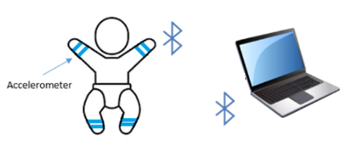

**Figure 3.4** Proposed Hardware Setup

Shown in Figure 3.4 is the proposed hardware setup for this study. Wireless accelerometers will be attached to four extremities of a baby, the limbs, as the effect of CP differs from one person to another which means that the condition can be very weak in one or more limbs of a person which prevents voluntary movement. The degree of acceleration due to gravity and the changes in physical movements in the limb of the baby will be measured by the accelerometer. The gathered data will be transmitted wirelessly from the accelerometer to the microcontroller by means of Bluetooth module. The size and weight of the components to be attached to the limbs of the baby is not too heavy for the test subject and that the frequency of the transceiver module and Bluetooth module that will be used is harmless and safe for humans especially for babies. The microcontroller will record the data during the monitoring period, and process and interpret the raw data. The processed data from the Arduino Nano will be sent to the monitor wirelessly and the output will be displayed on the monitor.

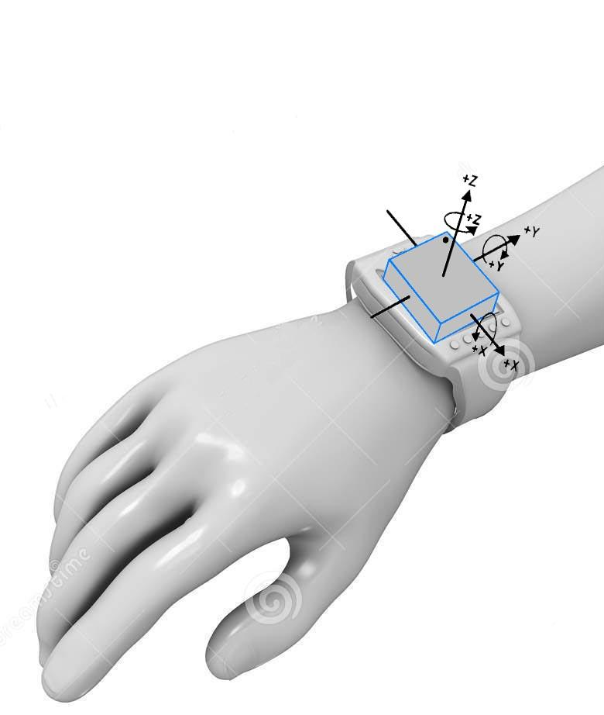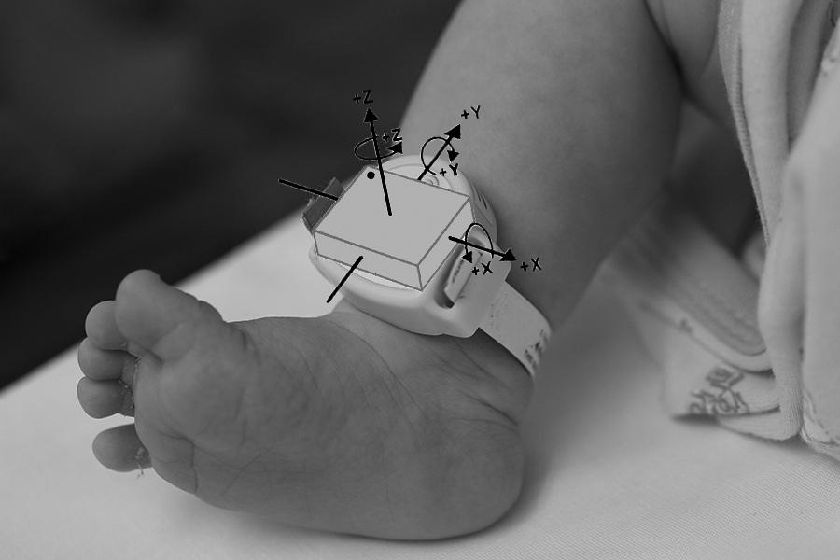

**Figure 3.5** Position and orientation of the accelerometer

Shown in Figure 3.5 is the position of the device when attached to the arms and legs of the baby. The overall weight of the device to be worn by the baby is approximately 18.9 g with the Bluetooth module and 21.9 g with the transceiver module which is approximately three to four times as light as a sheet of paper.

**SOFTWARE DEVELOPMENT**

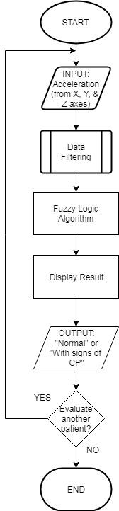

**Figure 3.6** System Flowchart

Shown in Figure 3.6 is the flowchart for the implementation of the system. The acceleration of the limb movements will be measured by the triaxial accelerometer. The raw acceleration data that was gathered will undergo data filtering process to filter out unwanted data and select relevant information necessary for determination of CP. Fuzzy logic will be trained to make a decision, so the extracted data will be analyzed and processed to arrive at a result. The result, either “With signs of CP or Normal”, will be displayed on a monitor. The whole process is iterated when a new baby is to be tested.

**Data Filtering**

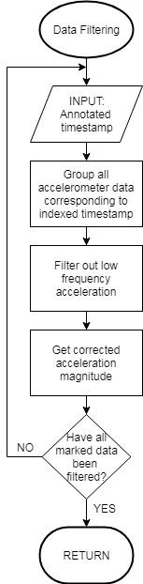

**Figure 3.7** Data Filtering Flowchart

Shown in Figure 3.7 is the flowchart for the data filtering process. The raw acceleration data will undergo significant filtering and processing. It will focus on significant information and cancel out the readings that were not related to motion, like gravity and sensor calibration drift which have low frequency*.* Data will be arranged by their timestamp and it is associated with the values which corresponds to the 3-axes of acceleration data which is collected for every limb. Shown in Equation 3.1 is the equation to get the magnitude of the 3-axis accelerometer from every limb, wherein *i* is the baby to be tested, *L* is the limb where the values obtained, and *a* is the value of the accelerometer.

**(Equation 3.1)**

**Fuzzy Logic**

Fuzzy Logic is trained in order to take a decision on the determination of CP by the detection of CSGMs. The input parameters to be fuzzified are the corrected acceleration magnitude of the limbs while the expected output is the diagnosis of CP.

Configuration:

1. The acquired input parameters from the accelerometer will be fuzzified.
2. The fuzzy rules for the CP determination will be set by performing the max-min method of fuzzification on the membership functions.
3. A crisp value of the acceleration will be acquired by defuzzification.

**Fuzzy Rule**

1. IF acceleration is high OR too high, THEN output “With signs of CP”.
2. IF acceleration is low OR too low, THEN output “Normal”.

**Data Gathering Procedure**

Before proceeding to the actual data gathering on the babies, the attending medical practitioner and the parents will be requested to try and wear the wireless accelerometer devices. This is necessary to ensure that the device is comfortable and painless when worn.

* + - 1. The wireless accelerometers will be worn on all 4 limbs of the baby.
      2. The accelerometer will measure limb accelerations while simultaneously video recording the whole procedure.
      3. Accelerometer data will be gathered using Arduino Nano.
      4. Accelerometer data filtering will be performed to remove the unnecessary data that was collected by the accelerometer that is not related to motion.
      5. The processed data from the three limbs with the transceiver module will be sent to the limb with the Bluetooth module wirelessly with the use of transceiver module.
      6. The limb with the Bluetooth module will gather all data from all the limbs and will transmit the gathered data to the monitor wirelessly.
      7. A medical expert on CSGM identification runs through the video and identifies on which CSGMs has occurred.
      8. Cleaned data will be analyzed interpreted using Fuzzy Logic to arrive at a result.
      9. CP determination will be displayed on screen.

**Testing Tables**

Babies whose age ranges from 6 months up to 20 months old can still be still very fragile. Conducting a test to this kind of population can be quite challenging for us because not all parents would allow their child to be used as a test subject. Thus, a letter of consent to the parents of the babies will be given prior to the start of testing and an assurance that no children will be harmed. There will be no babies who are currently placed inside the incubator to be tested.

**Table 3.2.** Testing of the Triaxial Accelerometer

|  |  |  |  |  |  |  |  |  |  |  |  |  |
| --- | --- | --- | --- | --- | --- | --- | --- | --- | --- | --- | --- | --- |
| **Baby** | **Left Leg (**m/s2**)** | | | **Right Leg (**m/s2**)** | | | **Left Arm (**m/s2**)** | | | **Right Arm (**m/s2**)** | | |
| **x** | **y** | **z** | **x** | **y** | **z** | **x** | **y** | **z** | **x** | **y** | **z** |
| 1 |  |  |  |  |  |  |  |  |  |  |  |  |
| . |  |  |  |  |  |  |  |  |  |  |  |  |
| . |  |  |  |  |  |  |  |  |  |  |  |  |
| . |  |  |  |  |  |  |  |  |  |  |  |  |
| n |  |  |  |  |  |  |  |  |  |  |  |  |

Table 3.2 shows the testing whether the triaxial accelerometer is working or not. If the accelerometer is working, the specific value of the acceleration at any time will be placed in the table, else “x”.

**Table 3.3** Triaxial Accelerometer Reading for Normal Babies

|  |  |  |  |  |
| --- | --- | --- | --- | --- |
| **Baby** | **Left Leg (m/s2)** | **Right Leg (m/s2)** | **Left Arm (m/s2)** | **Right Arm (m/s2)** |
| 1 |  |  |  |  |
| . |  |  |  |  |
| . |  |  |  |  |
| . |  |  |  |  |
| n |  |  |  |  |

The purpose of Table 3.3 is to determine a basis on normal limb accelerations. A number of babies who have no risk of developing any movement disorders such as CP will be tested for the said values. The values to be recorded will be the corrected magnitude acceleration.

**Table 3.4** Triaxial Accelerometer Reading for Babies at risk of CP

|  |  |  |  |  |
| --- | --- | --- | --- | --- |
| **Time Frame**  **(mm:ss-mm:ss)** | **Left Leg (m/s2)** | **Right Leg (m/s2)** | **Left Arm (m/s2)** | **Right Arm (m/s2)** |
| 1 |  |  |  |  |
| . |  |  |  |  |
| . |  |  |  |  |
| . |  |  |  |  |
| n |  |  |  |  |

In Table 3.4, the time frame to which the medical expert has annotated to be CSGM positive will be recorded. The corresponding data from the accelerometer at the same time frame will be recorded. Again, the values to be recorded will be the corrected acceleration magnitude. This table will also show the synchronized relationship of the affected limbs by the closeness of values.

**Table 3.5** Medical Expert Diagnosis compared to the Fuzzy System Diagnosis

|  |  |  |
| --- | --- | --- |
| **Baby** | **Medical Expert Diagnosis** | **Fuzzy System Diagnosis** |
| 1 |  |  |
| . |  |  |
| . |  |  |
| . |  |  |
| n |  |  |

Table 3.5 shows the comparison between the CP diagnosis of the medical expert and the fuzzy system. The diagnosis of the medical expert is the ground truth. The output will either be “With signs of CP” or “Normal”.

**Statistical Treatment**

After the system has been trained and tested, the crisp acceleration values from the fuzzy system and the actual accelerations based on the CSGM positive time frame will be statistically tested using the T-test.

**Assumption:** The fuzzy system can correctly determine CP as a medical expert would by identifying limb accelerations related to CSGMs.

*1. Null Hypothesis:*H0: μ1 = μ2; where in H0 is the null hypothesis wherein there was no significant difference the two.

*2. Alternative Hypothesis:*H1: μ1 ≠ μ2; where H1 is an alternative hypothesis wherein there was a significant difference between the two.

**Table 3.6** Hypothesis Testing

|  |  |  |
| --- | --- | --- |
| **Hypothesis** | **p-value** | **Confidence Level, ∝ at 5%** |
| Null Hypothesis (H0: μ1=μ2) |  |  |
| Alternative Hypothesis (H1: μ1≠μ2) |  |  |

Shown in Table 3.6 is the hypothesis testing for the system. We are considering 5% error as an acceptable tolerance.

**REFERENCES**

[1] Panteliadis, C. (2018). Cerebral Palsy: A Multidisciplinary Approach, 3rd edition, Springer International Publishing AG, Thessaloniki, Greece.

[2] Miller, F. S. and J. Bachrach (2017). Cerebral Palsy: A Complete Guide for Caregiving, 3rd edition, Johns Hopkins University Press, Baltimore, Maryland.

[3] Olsen, M. D. and R. R. Paulsen (2015). Motion Tracking of Infants in Risk of Cerebral Palsy, DTU Compute, Kgs. Lyngby.

[4] Lantos, J. D. and D. S. Lauderdale (2015). Preterm Babies, Fetal Patients, and Childbearing choices. The MIT Press. Cambridge, MA.

[5] Gardner S., et al, (2016). Merenstein & Gardner's Handbook Of Neonatal Intensive Care, 8th ed, Elsevier, Inc., St. Louis, Missouri.

[6] Zhang, J. (2017). Multivariate Analysis and Machine Learning in Cerebral Palsy Research. *Frontiers in Neurology*. Volume **8,** 715.

[7] Rahmati, H., et al, (2014). Video-based early cerebral palsy prediction using motion segmentation. *2014 36th Annual International Conference of the IEEE Engineering in Medicine and Biology Society*, Chicago, IL, 3779 - 3783. doi: 10.1109/EMBC.2014.6944446

[8] Singh, M. and D. J. Patterson (2010). Involuntary gesture recognition for predicting cerebral palsy in high-risk infants, *International Symposium on Wearable Computers (ISWC)*, Seoul, 2010, 1-8. doi: 10.1109/ISWC.2010.5665873

[9] Handryastuti, S., et al, (2018). Risk factors and the occurrence of cerebral palsy in high risk infants. *Paediatrica Indonesiana*, Volume **58** (2), 95-100. doi:10.14238/pi58.2.2018.95-100

[10] Himpens, E., et al, (2008). Prevalence type distribution and severity of cerebral palsy in relation to gestational age: A meta-analytic review, *Developmental Medicine and Child Neurology.*, Volume **50**, 334340-334340.

[11] Odd, D., et al, (2013). Movement outcomes of infants born moderate and late preterm. *Acta Paediatrica,* Volume **102** (9), 876-882. doi:10.1111/apa.12320

[12] Marcroft, C., et al, (2014). Movement Recognition Technology as a Method of Assessing Spontaneous General Movements in High Risk Infants. *Frontiers in Neurology*, Volume ***5***, 284. doi: 10.3389/fneur.2014.00284

[13] Alcan V., M. Canal and M. Zinnuroğlu (2017). Using fuzzy logic for diagnosis and classification of spasticity. *Turkish Journal of Medical Sciences,* Volume **47**, 148-160. doi:10.3906/sag-1512-65

[14] Adde, L., et al, (2010). Early prediction of cerebral palsy by computer-based video analysis of general movements: A feasibility study. *Developmental Medicine and Child Neurology*, Volume **52** (8), 773-778. doi: 10.1111/j.1469-8749.2010.03629.x.

[15] Heinze, F., et al, (2010). Movement analysis by accelerometry of newborns and infants for the early detection of movement disorders due to infantile cerebral palsy. *Medical & biological engineering & computing*, Volume **48** (8), 765-772. 10.1007/s11517-010-0624-z.

[16] Philippi, H., et al, (2014). Computer-based analysis of general movements reveals stereotypies predicting cerebral palsy. *Developmental Medicine & Child Neurology*, Volume **56** (10), 960-967. doi: 10.1111/dmcn.12477

[17] Cliff, D. P., J. J. Reilley and A. D. Okely (2009). Methodological considerations in using accelerometers to assess habitual physical activity in children aged 0-5 years. *Journal of Science and Medicine in Sport,* Volume **12** (5), 557–567. doi: 10.1016/j.jsams.2008.10.008

[18] Gravem, D., et al, (2012). Assessment of Infant Movement with a Compact Wireless Accelerometer System. *Journal of Medical Devices,* Volume **6** (2), 021013. doi:10.1115/1.4006129

[19] Martens, H., et al, (2016). Frequency Analysis and Feature Reduction Method for Prediction of Cerebral Palsy in Young Infants. *IEEE Transactions on Neural Systems and Rehabilitation Engineering,* Volume **24** (11), 1225-1234. doi:10.1109/tnsre.2016.2539390

[20] Mendel J. (1995). Fuzzy logic systems for engineering: a tutorial. *Proceedings of the IEEE*. 1995;83(3):345-377. doi:10.1109/5.364485

[21] McQueen, D., et al, (2016). *U.S. Patent No. US00932912B2*. Washington, DC: U.S. Patent and Trademark Office.

[22] Garcia, R. G., et al, (2016). Hand Tremor Analyzer using Accelerometry for Preliminary Diagnosis, Classification and Monitoring of Selected Movement Disorders. *2016 6th IEEE International Conference on Control System, Computing and Engineering (ICCSCE),* 392-296

[23] Ropella K. (2007). Introduction to Statistics for Biomedical Engineers, Morgan & Claypool Publishers, San Rafael, California

[24] Wanjari N. D. and S. C. Patil. (2016). Wearable devices. *2016 IEEE International Conference on Advances in Electronics, Communication and Computer Technology (ICAECCT)*, Pune, 2016, pp. 287-290. doi: 10.1109/ICAECCT.2016.7942600

[25] Ulate-Campos, A., et al, (2016). Automated seizure detection systems and their effectiveness for each type of seizure. *Seizure.* Volume 40, 88-101. https://doi.org/10.1016/j.seizure.2016.06.008.