**Development of Non-invasive Glucose Sensor Patch**

**based on Beer-lambert Law**

by

**Christian L. Manaois**

**Shannen Mae R. Villanueva**

A Thesis Report Submitted to the School of Electrical, Electronics,

and Computer Engineering in Partial Fulfilment of the

Requirements for the Degree

Bachelor of Science in Computer Engineering

Mapúa University

April 2019

**Chapter 1**

**INTRODUCTION**

One of the major health problems faced by the patients today is Diabetes, which occurs to a person suffering from high blood sugar, this appears when the pancreas is incapable of producing adequate amount of insulin (type1 diabetes), or due to the cells that do not respond to the produced insulin (type 2 diabetes). Insulin is one of the hormones that regulate the glucose in the body and with the right amount of insulin will compensate the lack and excess of amount of glucose level. Regular glucose monitoring, diet plan, insulin shots and oral medications are the foundation of diabetes treatment. Regular blood glucose monitoring is the key step in efficient management of diabetes to control blood glucose.

Various optical non-invasive techniques have been explored for development of glucose measurement system. Optical methods are one of the painless and promising methods that can be used for non-invasive blood glucose measurement. A research has been made about a development of a portable non-invasive blood glucose monitoring device is developed using near infrared sensors [1]. Besides being able to detect glucose concentration in blood, the device is also able to display the glucose level and the required insulin dose, corresponding to the body mass index (BMI) of the user. The study applied near-infrared spectroscopy and uses the light in 750-2500 nm region which enters the tissue with low energy radiation and allows the glucose measurement up to the depth of few mm under the skin. Photodiodes is used to detect the attenuation of radiation due to changes in the glucose concentration. The sensor patch is placed on inner side of forearm for measurement of glucose. The measurement using diffuse reflectance spectra through forearm is collected for the study.

Most of commercially available glucose measurement devices are invasive. Diabetic patients need to monitor their blood glucose two to three times a day. The invasive methods are painful, have high recurring cost and danger of spreading infectious diseases. Although many patients already know that tight glucose control monitoring is very important. However, they still fail to monitor their blood glucose level in actual clinical practice because of the frequent and painful fingerstick tests. Commercially available glucose meter offers patient to take down glucose readings manually and cannot store glucose readings nor interpret them if low, normal or high.

The study aims to develop a non-invasive glucose sensor. The specific objectives of this research are as follows: (a) To design a sensor patch that detects blood glucose using Near- infrared (NIR) radiation. (b) To develop a device that determines the required amount of insulin dose based on the glucose level. (c) To develop a mobile application that stores and displays the input and processed information of the user.

Regular monitoring of blood glucose is important to avoid complication of diabetes. With the help of this study, it would give assistance to the patients with diabetes, they can easily monitor their glucose level without intermittent blood collection through a prick on the finger since this is a non-invasive method. Also, the number of medical complications and medical costs involving blood glucose levels can be greatly reduced, promoting frequent blood testing and improving patient’s life quality. The study will benefit to the persons with diabetes and for those who wants to maintain a normal blood glucose level for a healthy life cycle.

This study mainly covers the development of the glucose sensor and the determination of the amount of insulin that must be administered based on the readings of the glucose sensor. The device will measure the glucose level in blood using near infrared sensors on the inner side of the forearm. The system collects and stores the data from the device. The device will not notify the user when to measure its glucose level. The user can use the device depending on its preference of when to use. This study is exclusive on type 1 diabetes and will not test on other types of diabetes.

**Chapter 2**

**REVIEW OF RELATED LITERATURE**

**2.1 Diabetes**

According to International Diabetes Federation report, globally, in 2017, there is an urgency for greater action to improve diabetes outcomes and reduce the global burden of diabetes now affecting more than 425 million people, of which one-third are people older than 65 years. The estimates of children and adolescents below age 20 with type 1 diabetes has risen to over a million. If nothing is done, the number of people with diabetes may rise to 629 million in 2045, although positively the incidence has started to drop in some high-income countries. At the same time, a further 352 million people with impaired glucose tolerance are at high risk of developing diabetes [2]. A recent study have indicated that the health risks associated with diabetes are significantly reduced when the blood glucose level are well and frequently controlled. Thus, having proper monitoring at home or work is important. [3]

The blood glucose level mainly contains three categories, they are hypoglycemia or low blood sugar level, normal blood glucose level and hyperglycemia or high blood sugar level. The normal range of blood glucose level is between 70mg/dl to 100mg/dl for children while 70mg/dl to 150mg/dl for adults. It is considered hyperglycemia when the glucose level rises above 150mg/dl while it is hypoglycemia when the glucose level is below 70mg/dl [4]. One study stated that the time of insulin action is from several hours to a day, and the time of glucose absorption in patient’s organism from food eaten to blood glucose values is tens of minutes and depends also on food composition. The researches added that it is strongly

needed to predict future blood glucose levels according to present time information in order to correctly calculate the insulin dose value [5].

**2.2 Invasive Glucose Measurement**

At present, most of commercially available glucose measurement devices are invasive. In the pathology laboratories, glucose is been measured by pricking the patient’s finger to take out a small quantity of blood sample. Then the sample of blood will be placed on the strip and is inserted into the blood glucose meter. Inside a glucometer, a series of chemical reactions will take place and as a result of chemical reaction Potassium Ferro cyanide is produced and it reacts with the metals on electrode layer and causes the electric current to flow through the electrodes. More the concentration of glucose in the blood, more the Potassium Ferro cyanide production and more the current through the electrode. This strength of current is used to predict the glucose level present in the blood. [6]

**2.3 Non-invasive Glucose Measurement**

The recent development of the blood glucose monitoring devices is more toward noninvasive method. This method is used to measure blood glucose levels in the human body by only placing the sensors directly to the human targeted area without drawing blood and insertion of needles or any types of biosensors. The study on the development of this technology has begun since 1957 and the works are continuing up to the present. [7]

A self-powered sensor patch for glucose monitoring in sweat was developed in 2017. According to the researchers, sweat glucose monitoring offers considerable promise as a wearable platform that can provide continuous and real-time analysis. When the device was assembled, various artificial sweat samples with different glucose concentrations were introduced into the device. The maximum power outputs were obtained under a 10kΩ resistor indicating that the internal resistance of the devices was approximately 10kΩ, which was significantly lower than that of their recent paper-based enzymatic fuel cell (1MΩ). The researchers stated that this paper-based enzymatic fuel cell developed in this work showed a remarkable potential as a self-powered glucose sensor because it generated enough current and power to sensitively resolve varying glucose concentrations in the artificial sweat samples [8].

Spectroscopy is the study of the interaction between matter and radiated energy. Spectroscopic techniques are used to determine the presence or concentration of a substance by measuring how it interacts with light. This spectrum contains information about the optical properties and structure of the medium being measured. Each material shows a specific and reasonably unique spectrum, depending on its chemical structure, physical state, and temperature. The amount of information contained in the spectrum can vary tremendously from one region to another. [9]

According to [2], optical methods are one of the painless and promising method that is used for non-invasive blood glucose measurement. Near infrared (NIR) is one of the most widely explored optical techniques because of its high penetration capability in skin. This technique is applicable on various body parts: finger, palm, arm, forearm, and earlobe. In the Near Infrared (NIR) Spectroscopy, glucose cells will produce the weakest NIR absorption signals in the human body as glucose is one of the biological com­ponent present inside the human body. In measuring the glucose level, the NIR spectroscopy enables the penetra­tion of signals inside the tissue within the range of 1 to 100 millimeters depth. Penetration depth decreases as the signal wavelength value increases [6].

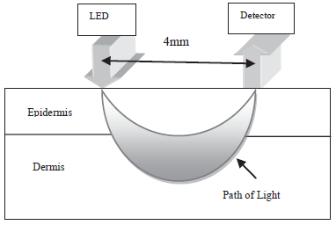

**Fig. 2.3.1** Schematic of cross section area of skin layers and light path using NIR [9].

According to [9], spectroscopic techniques are used to determine the presence or concentration of a substance by measuring how it interacts with light. Two different types of reflection can be observed; they are specular and diffuse reflection. Specular reflection is associated with reflection from smooth, polished surfaces like mirror. Diffuse reflection is the reflection that occurs from rough surfaces where multiple scattering occurs as shown in Figure 2.3.3. This spectrum contains information about the optical properties and structure of the medium being measured. Each material shows a specific and reasonably unique spectrum, depending on its chemical structure, physical state, and temperature. The amount of information contained in the spectrum can vary tremendously from one region to another. A great advantage of NIR spectroscopy is that there is no need for extensive sample preparation. The amount of radiation absorbed in the NIR region is small and therefore measurements can be made directly from the material itself.

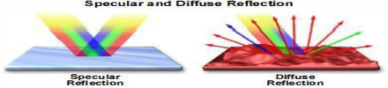

**Fig. 2.3.3** Specular and Diffuse Reflection [9].

A device has also been developed to detect blood glucose noninvasively using near infrared spectroscopy and for the measurement sites, earlobe is chosen since it is thin. Photodiode’s current is converted into voltage using transimpedance amplifier circuit. In order to minimize high frequency noise, low pass filter is applied consecutively. Early testing is conducted by measuring penetrated light in various concentration of glucose solution with wavelength 1300nm, 1450nm, and 1550nm. Measurement indicates correlation between voltage and glucose concentration. In earlobe testing, light can penetrate tissue with detected voltage, 300mV – 4V depend on the wavelength. Linear approximation and two point equation is applied to the data. This two approach extracts formula that can estimate blood glucose concentration with maximum 30% error. [10].

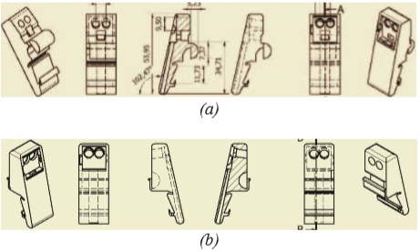

(a)



(b)

**Figure 2.3.4** Sensor Casing (a) Left side clamp, (b) Right side clamp.

A study was conducted that measures the blood glucose level using sensor patch through diffused reflectance spectra on the inner side of the forearm. The Arduino microcontroller does the processing of the information from the sensor patch while the Bluetooth module wirelessly transmits to the android device the measured glucose level for storing, interpreting and displaying. Results showed that there is no significant between the measured values using the commercially available glucose meter and the created device. Based on ISO 15197 standard 39 of the 40 trials conducted, or 97.5% fell within the acceptable range. [11]

One study developed a portable non-invasive blood glucose monitoring device using near infrared sensors. Besides being able to detect glucose concentration in blood, the device is also able to display the glucose level and the required insulin dose, corresponding to the body mass index (BMI) of the user.The algorithm for the microcontroller is designed to calculate the concentration of glucose as well as the required insulin dose, corresponding to the body mass index (BMI) of the user. Several glucose solutions of different concentrations ranging from 10 mg/dL - 320 mg/dL were prepared by dissolving glucose in 1 dL of distilled water. The glucose solutions were prepared in tinted amber reagent bottles to avoid from being affected by light. For voltage measurements, 30ml of glucose solutions for each concentration were placed into a cuvette and positioned as shown in Figure 2.3.5. The output voltage obtained from the photodiode is used as a parameter to determine the glucose concentration. The data are based on subcutaneous insulin order set of Banner Good Samaritan Medical Centre, Phoenix by using a mathematical equation acquired from the glucose calibration experiments [1].

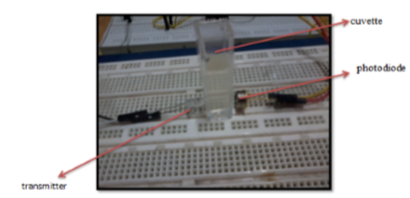

**Fig. 2.3.5** Glucose calibration experimental setup

The proposed method of one study uses near infrared sensor for determination of blood glucose. Near-Infrared light is sent through the fingertip before and after blocking the blood flow as shown in Figure 2.3.6. By analyzing the voltage variation received after transmission through fingertip, approximate glucose level is predicted. The obtained glucose level is further transmitted to the smart android app for further analysis and storage of the data. A linear regression model is used for analysis which is performed by making the use of dataset. The dataset has been acquired by analyzing individual patients using the accu-check glucometer as well as developed hardware setup. The result is displayed on LCD as well as can be sent to a smart phone android application [12].

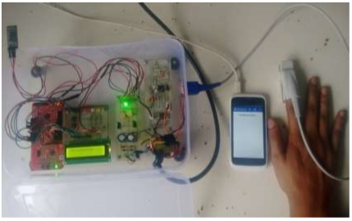

**Figure 2.3.6** Glucose measurement through the fingertips

A study has been conducted about the comparative investigation using GaAs (950nm), GaAIAs (940nm) and InGaAsP (1450nm) sensors for glucose level measurement. Firstly they proceed by using test tube which contains various percentage of glucose concentration and then same method has been used for human blood samples. There is larger voltage range for 950nm as compared to 940nm wavelength and more consistency in pattern. [13]

Researchers have introduced voltage intensity based Non-invasive blood glucose monitoring. The proposed method makes the use of near-infrared sensor. The NIR is sent through the fingertip, before and after blocking of blood flow. By analysing the variation in voltages received after reflection, the current diabetic condition as well as approximate glucose level of individual is predicted. The obtained result is then communicated with a smart phone through Bluetooth. [1 4]

Another study have introduced the non-invasive measurement of blood component. They used principle of photoplethysmography and NIR spectroscopy. They have measured the different blood component including glucose non-invasively. The blood absorbs NIR light with different absorption coefficient. This characteristic is used for measurement of blood component. This technique is also used to measure the haemoglobin and oxygen saturation in blood. For measurement of different components, a range of 600nm to 1400nm wavelength is used for system. [15]

**2.3 Glucose Monitoring**

Another study in which they proposed a design of continuous subcutaneous insulin infusion pump with real-time continuous glucose monitoring called artificial pancreas. The system they developed produces the file to keep track of monitoring data for the user. The system evaluates the glucose level every five minutes. Once the system detects the new glucose level, it is recorded in a file. The file also holds the data such as time for new glucose level, and flow rate for insulin pump for further use. Thus, it will help a user to manage their diabetes later. The file is produced as daily basis meaning that it automatically creates a file to keep data every day. Therefore, a user can keep as many daily data as possible [16].

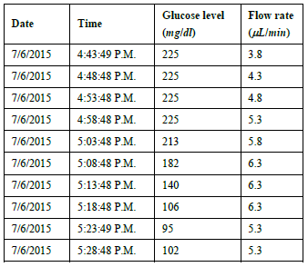

**Table 2.3** File Structure Recorded [3].

**2.5 Blood Glucose Measurement**

When a light ray interacts with human body tissues, it is attenuated by scattering as well as by absorption by the tissues. Due to the mismatch between the refraction index of extracellular fluid and the cell membrane, light scattering occurs in tissues. Refraction index of extracellular fluid varies with the glucose concentration whereas the cellular membrane index is assumed to be remain relatively constant. Beer-lambert law states the relationship between absorbance and concentration of absorbance through which it is travelling. Absorbance is declared by logarithm of light intensity ratio.

**(2.1)**

Where:

absorbance of material

Intensity of incident light

Intensity of attenuated light

When IR light is incident on a material, part of it is absorbed by the molecules in the material. The absorption of IR light is different for different wavelength. From the law, the absorbance of light is proportional to the concentration of material. The light absorption depends on how many molecules it interacts with. As light passes through the material, the intensity of light exponentially decays because it is absorbed by molecules of material. [17]

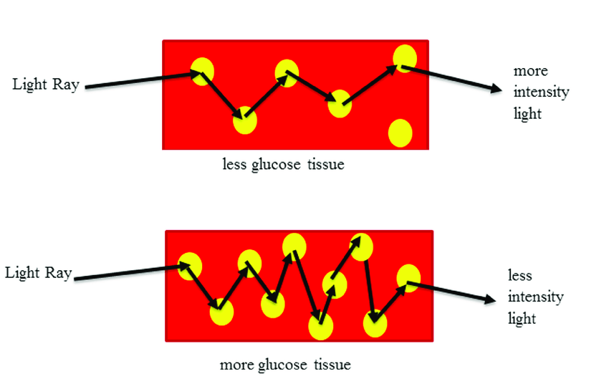

**Figure 2.3.7** shows the description of effect of glucose molecules on the light path

Less glucose leads to more scattering, more path length and hence less absorption whereas more glucose tissues result in less scattering, less optical path length and hence more absorption by the tissues. Due to more absorption in high glucose tissue reflected light is having less intensity compared to tissue with less glucose content.

**2.6 Pearson Correlation**

The correlation between two variables numerically describes whether larger and smaller than average values of one variable are related to larger or smaller than average values of the other variable. It is measuring the strength and direction of a linear relationship between two variables. In a recent study by [18], Pearson’s correlation is used to test the two groups of data that will be processed: the controlled group and the uncontrolled group. The controlled group represents the students that will be performing the experiments with the gamified OBTL platform and then uncontrolled group that will be performing in the traditional way. It denoted by coefficient, r, which ranges from -1.0 for negative correlation to +1.0 for positive correlation. The values of the Pearson correlation coefficient, r, for controlled and uncontrolled data, -0.9081 and -0.7520 respectively. The time of completing the procedures of the experiments and the experiment scores are weak or negatively correlated. This proves that the two variables of the controlled and uncontrolled group, x for time and y for grades, are inversely proportional; with the notion that as the time decreases, the grade is increasing.

**2.7 T-test statistical Treatment**

Paired T-test is used to compare two population means where you have two samples in which observations is one sample can be paired with the other observation sample. In [19], the researchers determined if the effect of its measured data is positive or negative. For the null hypothesis of the study, the positive effect means there is a great probability of a good effect and for the negative effect, or the alternative hypothesis, there is no effect. Also, by using the T-test significance of the difference between the two data is determined. If the value of P is lower than 0.01 that is highly significant and must not exceed on .05 that is significant at 5% level.

**Chapter 3**

**Development of Non-invasive Glucose Sensor**

In this chapter, the research methodology, conceptual framework, experimental setup, both the hardware and the software components of the design of the system, and the statistical treatment of the resulting data will be discussed, all in all comprising the experiment proper of the research.

## Research Methodology

The entire framework of any research would be its research methodology, wherein the steps to be undertaken in order to complete the research are laid out.

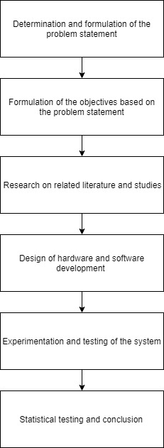

**Figure 3.1** Research Study Methodology

Figure 3.1 shows the research study methodology of the system and how each step of the above figure is implemented by the group to arrive at the goal of the study. First, the researchers start determining and formulating the problem that will be solved. Based on the problems identified, the objectives were then formulated. The objectives will serve as the guiding factor on which the study will be basing upon the validity of results. To develop the necessary prototype for the system, the group gathered several related literatures to aid their understanding and have enough knowledge that can contribute to the development of solutions to the problem of the study. In those related literatures, the group encountered several parameters to be considered in measuring the blood glucose, such as the reading accuracy, techniques and approach, size of the device and technology of the embedded systems. The researchers were able to come up with a solution that aims to design a non-invasive glucose monitoring system. The design will be implemented with a glucose patch applying spectroscopy sensor and photodiode sensor to detect the glucose level that will be subjected to the microcontroller to determine the required insulin dose. The system will be implemented with a wireless mobile application on an Android smartphone in connection with Arduino as the microcontroller. After developing the system prototype, the designers will determine how accurate the results of the created device compared to the results of the commercially available glucose meter. The group can visualize these as data findings for the study and can determine whether the blood sugar level is too high. This will give way to more testing to gather the data needed to achieve the objectives of the study and to provide solution to the problem stated. Analysis of the gathered data using the statistical tools chosen will prove if the study has indeed able to meet the objectives set. The study shall, then, proceed in creating its conclusions and any recommendations for future studies.

**Conceptual Diagram**

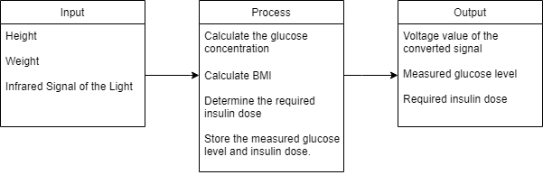

**Figure 3.2 Conceptual Framework**

Figure 3.2 refers to the conceptual framework of the overall system. It has 3 major parts. The inputs of the system are the height and weight of the user to compute for the body mass index (BMI). For the input of the glucose sensor, it transmits infrared signal which is exposed to the skin of the user. The glucose molecule in the blood reflects the infrared signal to the receiver. The receiver receives the infrared signal which is converted to an equivalent voltage value. The algorithm for the microcontroller is designed to calculate the concentration of glucose as well as the required insulin dose, corresponding to the calculated BMI of the user. Finally, the measured glucose concentration and insulin dose will be displayed. These outputs will be stored and displayed via mobile application for the user to continuously monitor its glucose level.

**HARDWARE DEVELOPMENT**

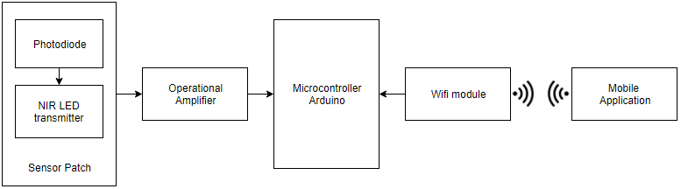

**Figure 3.3** Block Diagram of the system

Figure 3.3 shows the block diagram of the components used in the hardware design. The sensor patch consists of a transmitter and a photodiode. The transmitter to be used has a wavelength of 1550 nm to observe the glucose substance in the blood. The photodiode to be used is suitable to be used with the transmitter as it has a wavelength sensitivity which is within 800 nm-1800 nm. The photodiode is used to measure continuous wave light source and converts the optical power received from the transmitter to an electrical current value. The value of the output voltage depends on the intensity of the infrared signal it receives, which is between 0 V to 5 V. An operational amplifier is used to amplify the output signal. The control system of the device is the Arduino Uno. It can be powered by a 5 V-12 V battery or by a serial connection to the computer. The microcontroller supplies voltages to bias both transmitter and photodiode. The output voltage obtained from the photodiode is used as a parameter to determine the glucose concentration. The application is controlled by a mobile application on an android smartphone. The application is used to enter the height and weight of the user and displays the glucose concentration and insulin dose. This is sent over to the device via WiFi with the use of a microcontroller.

**PROPOSED HARDWARE SETUP**

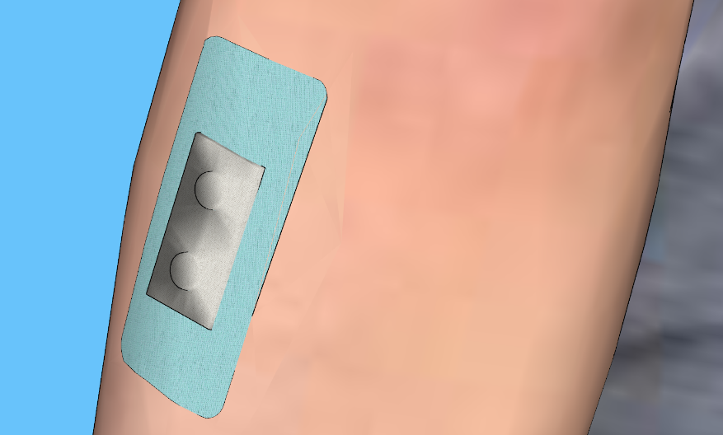

photodiode

NIR LED

**Figure 3.4** Hardware design of the glucose sensor

The propose hardware design is shown above where it is placed to observe diffused reflectance spectra on the inner side of the forearm for measurement of glucose. The sensor patch is designed by placing the NIR LED and a photodiode at a distance from each other. The patch around the sensor is a disposable material that will provide support for the device when attached to human skin.

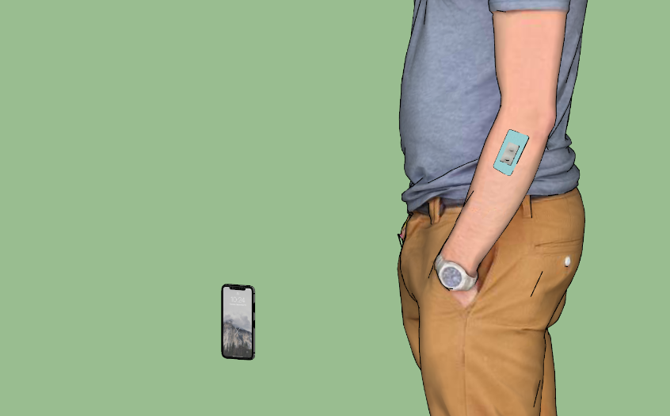

**Figure 3.5.** Hardware setup of the device

Figure 3.5 shows the hardware setup of the proposed glucose sensor. To activate the light on the sensor, the mobile phone must be connected to the WiFI to receive information that is coming from the wireless sensor patch. When the mobile phone is successfully connected to the Wi-Fi, the user can now set its height and weight for the glucose sensor.

**Software Development**

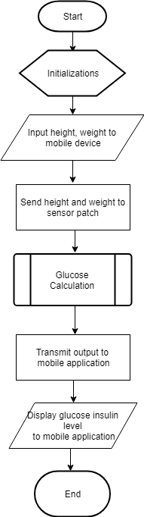

**Figure 3.6** Process Flowchart

Shown in Figure 3.6 is the process flowchart for the microcontroller. Initializing all the variables and pins to be used is the first step by setting all pins to 0V. After the initializations, the user can already input his or her height and weight in the mobile device through a mobile application. The data is then sent to the sensor patch and the Arduino microcontroller will perform the glucose calculations accordingly as shown in Figure 3.10. The result will be transmitted back to the mobile application and display the glucose insulin level that corresponds to the input parameters.

**Mobile Application Flowchart**

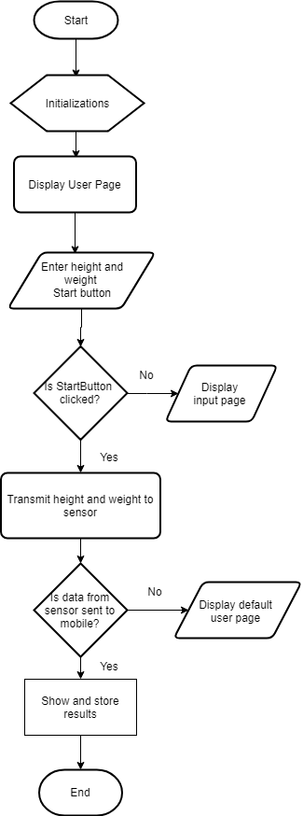

**Figure 3.9** Mobile Application Flowchart

Figure 3.9 shows the flowchart for the android mobile application. The mobile application first needs to establish connection to the microcontroller to be able to control the glucose sensor by scanning and connecting if found. The user is directed to the mobile application’s user page upon accessing the application. The user needs to enter its height and weight and click the “Start” button. If the “Start” button is clicked, the data will be transmitted to the glucose sensor patch and if the “Start” button is not clicked, it will stay in the input page. When the glucose sensor patch received the data, it will then display and store the results in the mobile application and if there is no received data from the glucose sensor patch, the default user page is being displayed.

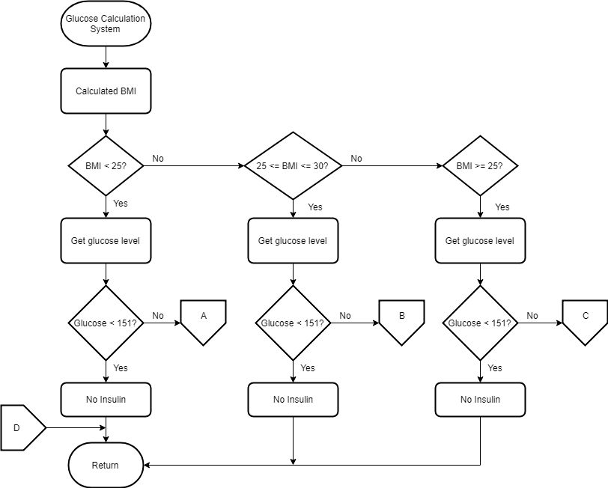

**Figure 3.10** Arduino Glucose Calculation Module

The algorithm for the microcontroller is used to calculate the concentration of glucose as well as the required insulin dose, corresponding to the body mass index (BMI) of the user. The output voltage obtained from the photodiode is used as a parameter to determine the glucose concentration by using a mathematical equation acquired from the glucose calibration experiments. Figure 3.10 illustrates the algorithm of the glucose and insulin calculations for three (3) different BMI groups; underweight (BMI < 25), normal (25 ≤BMI ≥30), and overweight (BMI > 30).

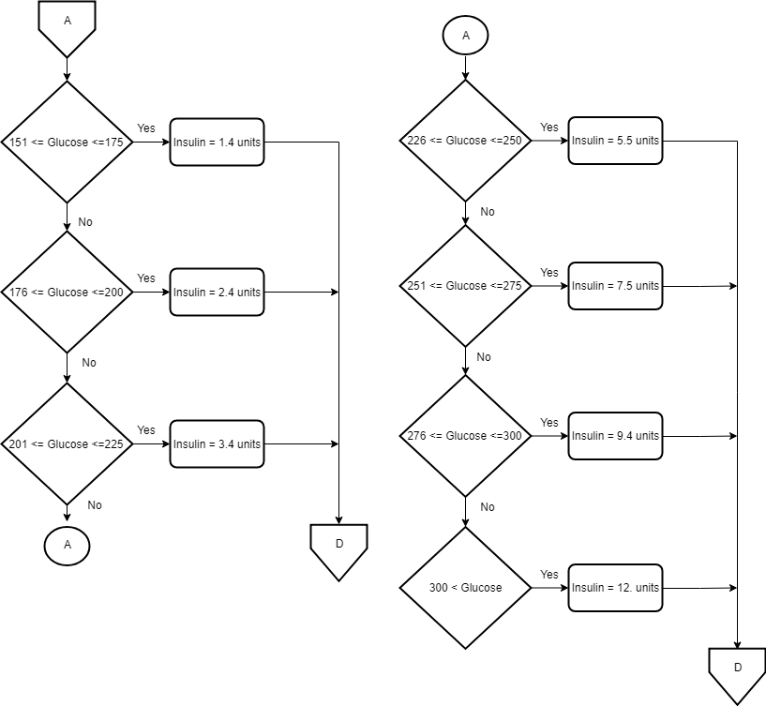

**Figure 3.11** Insulin level for underweight group

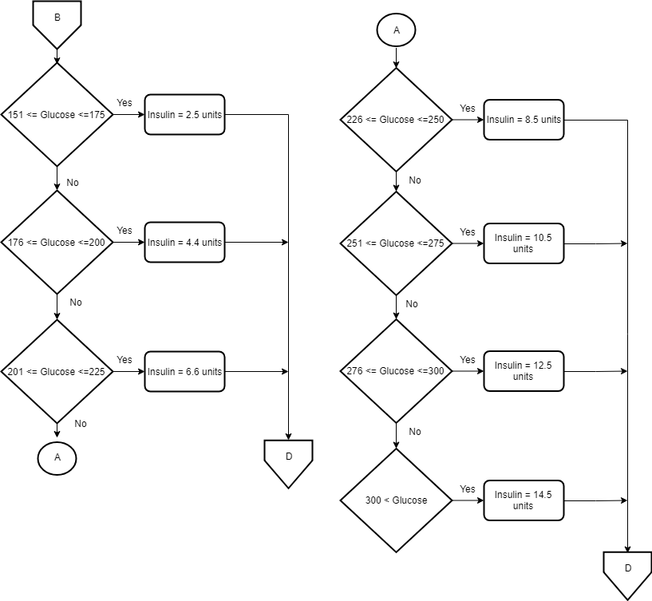

**Figure 3.12** Insulin level for normal weight group

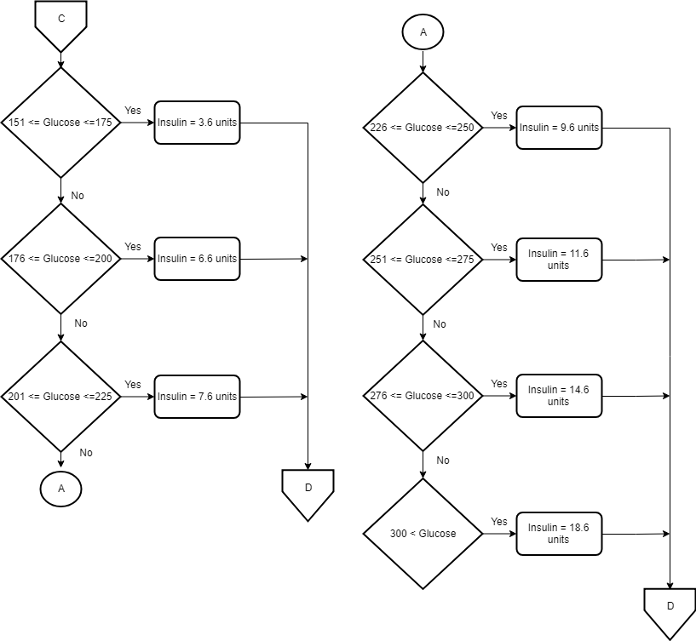

**Figure 3.13** Insulin level for overweight group

**Data Gathering Procedures**

In this study, two types of tests have been conducted to evaluate the system: first, on glucose solution and second, on the human body.

1. Several glucose solutions of different concentrations ranging from 10 mg/dL - 400 mg/dL were prepared by dissolving glucose (dextrose monohydrate) in 1 dL of distilled water.

2. The glucose solutions were prepared in tinted amber reagent bottles to avoid from being affected by light.

3. For voltage measurements, 30ml of glucose solutions for each concentration were placed into a cuvette. Cuvette is a container used for spectroscopic experiments, in which a beam of light is passed through the sample to measure the absorbance or transmittance.

4. Experiments will be conducted in a darkroom to decrease other beams of light. The test was repeated twice for each solution, and the output voltage was recorded.

**Table 3.1.** Relationship Between the Output Voltage and the Calculated Glucose Level

|  |  |  |
| --- | --- | --- |
| **Trial** | **Output Voltage (mv)** | **Glucose Concentration (mg/dl)** |
| 1 |  |  |
| 2 |  |  |
| 3 |  |  |
| **.** |  |  |
| **.** |  |  |
| 30 |  |  |

Table 3.1 displays voltage output obtained as a result of variation in signal intensity from the glucose sensor in sensing the glucose level of each concentration.

**Correlation between Voltage and Glucose Concentration**

Correlation is intended to find blood glucose concentration as a function of photodiode voltage. The first experiment is to be conducted to get data of blood glucose versus photodiode voltage.

The approach used to get blood glucose concentration formula from the data gathered is applied using two-point equation. First data is correlated linearly, and linear blood glucose concentration function of photodiode voltage is obtained. Linear approach is applied based on beer-lambert law (2.1), equation is formulated using two-point equation 3.2.

**(3.2)**

After getting the equation, the approximation blood glucose concentration is calculated. The difference between actual and approximate blood glucose concentration can lead to sensor accuracy.

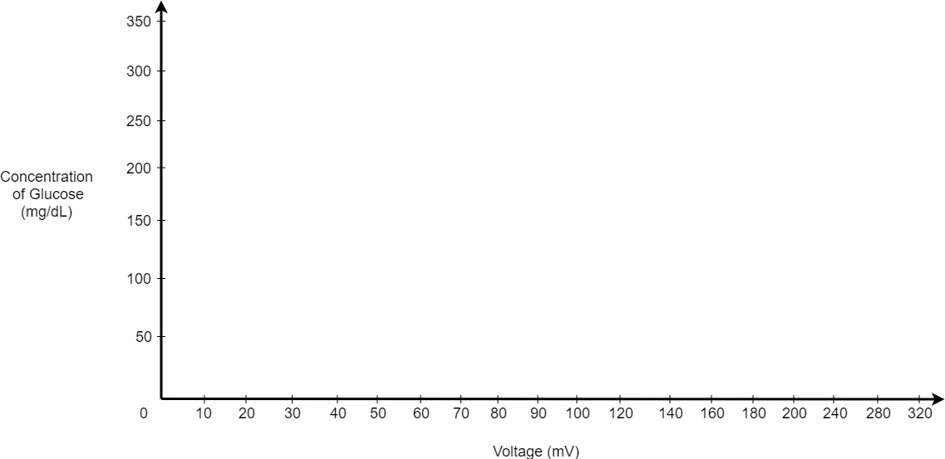

**Figure 3.1** Glucose Concentration vs. Voltage

The collected data in Table 3.1 is plotted in Figure 3.1. Results from the calibration experiments and by using linear regression technique, we can find out the relationship between the glucose concentration and voltage as shown in Equation 3.3.

**(3.3)**

where y is the glucose concentration (in mg/dl) and x is output voltage (in mV). This equation is used to measure the glucose value in real time.

**Statistical Treatment**

The correlation value r of the data between the X-axis (voltage) and Y-axis (glucose concentration) that is computed can either suggest a positive or negative correlation. Values of r range from -1 to +1.

A correlation coefficient of 0 means that there is no relationship. A value of -1 implies that all data points lie on a line for which Y decreases as X increases. A correlation value of +1 implies that a linear equation describes the relationship between X and Y perfectly, with all data points lying on a line of the graph for which Y increases as X increases.

Positive correlation indicates that both variables increase or decrease together, whereas negative correlation indicates that as one variable increases, so the other decreases, and vice versa.

The formula for finding the correlation value is shown in Equation 3.4.

**(3.4)**

where:

number of ordered pairs (x,y)

sum of the xy products

sum of x values

sum of y values

sum of squared x values

sum of x values squared

sum of y values

sum of y values squared

A second test will be conducted on 30 subjects using invasive technique with the finger-prick method, while at the same time, the glucose sensor will be attached to their skin. The testing phase determines the acceptability of the results by comparing of the results between the commercially available blood glucose meter and of the created device.

**Table 3.2** Comparison of Glucose Concentration Measurements Using Invasive and Non- Invasive Method

|  |  |  |  |
| --- | --- | --- | --- |
| **Subject** | **Glucose Concentration Measurements (mg/dL)** | | **Percentage Difference (%)** |
| **Invasive**  **Glucometer** | **Non-Invasive**  **Sensor Patch** |
| 1 |  |  |  |
| 2 |  |  |  |
| **.** |  |  |  |
| **.** |  |  |  |
| **.** |  |  |  |
| 30 |  |  |  |

Blood glucose measurements from both methods were compared in Table 3.2. The first column shows the number of trials conducted. The second column records the glucose level using a commercially available glucose meter. The third column records the created device’s readings through the NIR sensor. The last column shows the percentage difference of each measurement.

By using the results, we can analyze the designed method by calculating percentage difference as shown in equation 3.4.

**(3.5)**

Where the Invasive is the glucose measured from the invasive technique and the NonInvasive is the glucose calculated from the non-invasive technique.

**Statistical Treatment**

Paired-sample t-test will be used for Table 3.2. The null hypothesis is that the measured glucose level of the non-invasive sensor patch is reliably close to the measured glucose level of the invasive glucometer. The percent difference falls within 20%. It is denoted by Equation 3.6.

**(3.6)**

The alternative hypothesis is that the two measured glucose levels are reliably different from each other. The percent difference is greater than 20%. This is denoted by the Equation 3.7.

**(3.7)**

A sample size of 30 is to be extracted from a population having normal distribution. Equation 3.8 is used as the formula to get the t-score of the set of samples.

**(3.8)**

where:

= t-value,

= mean of difference between data sets,

= sample size, and;

= standard deviation of difference

The calculated t-value is then compared to the critical t-value of 0.05 from the t-distribution table. If the calculated t-value is less than the critical t-value 0.05, the researchers reject the null hypothesis and therefore conclude that there is a significant difference with the measured values of the glucometer and the glucose patch. If the calculated t-value is greater than the critical t-value 0.05, the researchers do not reject the null hypothesis and therefore conclude that there is no significant difference with the measured values of the glucometer and the glucose patch.

**Table 3.3** Mobile Application Table

|  |  |  |
| --- | --- | --- |
| **BMI** | **Glucose Level (mg/dl)** | **Insulin Level (units)** |
|  |  |  |
|  |  |  |
|  |  |  |
|  |  |  |

Table 3.3 shows the corresponding table to be displayed in the mobile app in storing the blood glucose level and insulin level of the user based on its calculated BMI.

# **References**

|  |  |
| --- | --- |
| [1] | M. M. ADDI, "A Portable Non-Invasive Glucose Monitoring Device," in *IEEE Conference on Biomedical Engineering and Sciences*, Miri, Sarawak, Malaysia, 2014. |
| [2] | S. SADIKOT and N. H. CHO, IDF Diabetes Atlas, Brussels, Belgium: International Diabetes Federation, 2017. |
| [3] | K. SAIRAM, A. GOVADA, C. RENUMANDHAVI, B. SATYANARAYANA and K. RAMESH, "Design and Development of Non-Invasive Blood Glucose Measurement System using Near Infrared technique," *International Journal of Advanced Research in Computer and Communication Engineering,* vol. 4, no. 7, pp. 74-79, 2015. |
| [4] | P. SAMPATH REDDY and K. JYOSTNA, "Development of Smart Insulin Device for Non Invasive Blood Glucose Level Monitoring," in *IEEE 7th International Advance Computing Conference*, India, 2017. |
| [5] | P. RUDENKO, K. POZHAR, E. LITINSKAIA and A. ZHIGAYLO, "Development of the Short-term Blood Glucose Prediction Algorithm for Using in Closed-loop Insulin Therapy Device," in *IEEE Conference of Russian Young Researchers in Electrical and Electronic Engineering*, 2018. |
| [6] | P. NARKHEDE, S. DHALWAR and B. KARTHIKEYAN, "NIR Based Non-Invasive Blood Glucose," *Indian Journal of Science and Technology,* vol. 9, no. 41, pp. 2-7, 2016. |
| [7] | G. DARSAF, M. YACINE and N. KHALED, "Non-Invasive Glucose Monitoring: Application and Technologies," *Current Trends in Biomedical ENgineering and Biosciences,* vol. 14, no. 1, pp. 1-5, 2018. |
| [8] | E. CHO, M. MOHAMMADIFAR and S. CHOI, "Sweat, A Self-powered Sensor Patch for Glucose Monitoring in Sweat," in *2017 IEEE 30th International Conference on Micro Electro Mechanical Systems (MEMS)*, New York, 2017. |
| [9] | T. LEKHA and C. KUMAR, "NIR Spectroscopic Algorithm Development for Glucose Detection," in *IEEE Sponsored 2nd International Conference on Innovations in Information Embedded and Communication Systems*, India, 2015. |
| [10] | R. HOTMARTUA, P. W. PANGETSU, H. ZAKARIA and Y. S. IRAWAN, "Noninvasive Blood Glucose Detection Using Near Infrared Sensor," in *The 5th International Conference on Electrical Engineering and Informatics 2015*, Bali, Indonesia, 2015. |
| [11] | N. LINSANGAN and M. A. MALBOG, "Non-Invasive Glucose Meter for Android-Based Devices," in *ICCAE 2018 Proceedings of the 2018 10th International Conference on Computer and Automation Engineering*, Brisbane, Australia, 2018. |
| [12] | C. BODAHE and D. M. S. PATIL, "Non-Invasive Monitoring of Glucose Level in Blood using NearInfrared Spectroscopy," *International Journal of Recent Trends in Engineering & Research (IJRTER),* vol. 2, no. 6, pp. 491-498, 2016. |
| [13] | N. K. MADZHI, S. A. SHAMSUDDIN and M. F. ABDULLAH, "Comparative Investigation Using GaAs(950nm), GaAIAs (940nm) and InGaAsP (1450nm) Sensors for Development of Non-Invasive Optical Blood Glucose Measurement System," in *Proc. of the IEEE International Conference on Smart Instrumentation, Measurement and Applications (ICSIMA)*, Kuala Lumpur, Malaysia, 2014. |
| [14] | K. A. U. MENON, D. HEMACHANDRAN and A. T. KUNNATH, "Voltage Intensity Based Non-Invasive Blood Glucose Monitoring," in *2013 Fourth International Conference on Computing, Communications and Networking Technologies (ICCCNT)*, India, 2013. |
| [15] | K. LAWAN, M. PARIHAR and S. N. PATIL, "Design and Development of Infrared LED Based Non Invasive Blood Glucometer," in *2015 Annual IEEE India Conference (INDICON)*, New Delhi, India, 2015. |
| [16] | C. A. JUNG and S. J. LEE, "Design of Automatic Insulin Injection System with Continuous Glucose Monitoring (CGM) Signals," in *2016 IEEE-EMBS International Conference on Biomedical and Health Informatics (BHI)*, 2016. |
| [17] | C. D. BODABE and D. M. S. PATIL, "Non-invasive Blood Glucose Level Monitoring System for Diabetic Patients using Near-Infrared Spectroscopy," *American Journal of Computer Science and Information Technology,* vol. 4, no. 1, pp. 1-8, 2016. |
| [18] | A. Yumang, A. Paglinawan, G. Avendano, C. Paglinawan, M. Sejera, N. Aquino, A. Garvida and R. J. Datu, "Gamified Outcomes-Based Teaching and Learning Assessment Tool for Mapua Institute of Technology," in *6th IEEE International Conference on Control System, Computing and Engineering*, Penang, Malaysia, 2016. |
| [19] | M. V. Caya and A. M. Pagarigan, "Development of LED Light Compensation System for Agricultural Application," in *2018 IEEE 10th International Conference on Humanoid, Nanotechnology, Information Technology, Communication and Control, Environment and Management, HNICEM* , Baguio, Philippines, 2018. |