|  |  |  |
| --- | --- | --- |
| **Trial** | **Output Voltage (mv)** | **Glucose Concentration (mg/ 0.80 dl)** |
| 1 | 441.9355 | 50 |
| 2 | 441.9355 | 75 |
| 3 | 445.1613 | 100 |
| 4 | 448.3871 | 125 |
| 5 | 448.3871 | 150 |
| 6 | 451.6129 | 175 |
| 7 | 451.6129 | 200 |
| 8 | 451.6129 | 225 |
| 9 | 458.0645 | 250 |
| 10 | 464.5161 | 275 |

Calibration Procedure:

* Prepare cuvette, glucose monohydrate, weighing scale, tinted bottle, and a piece of paper for weighing the glucose monohydrate.
* Mix 50 mg of glucose monohydrate in the tinted bottle that contains 0.80 ml of water.
* Place a part of mixed solution in the cuvette and read the analog voltage reading as of the photodiode.
* See photos below.

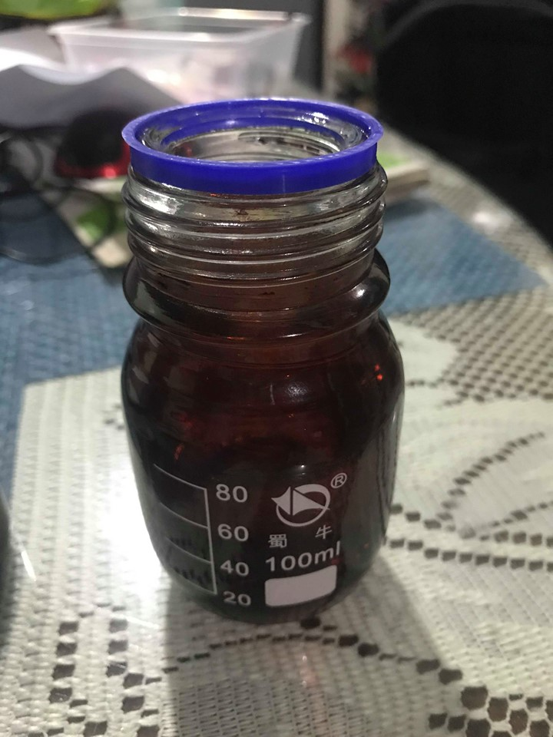

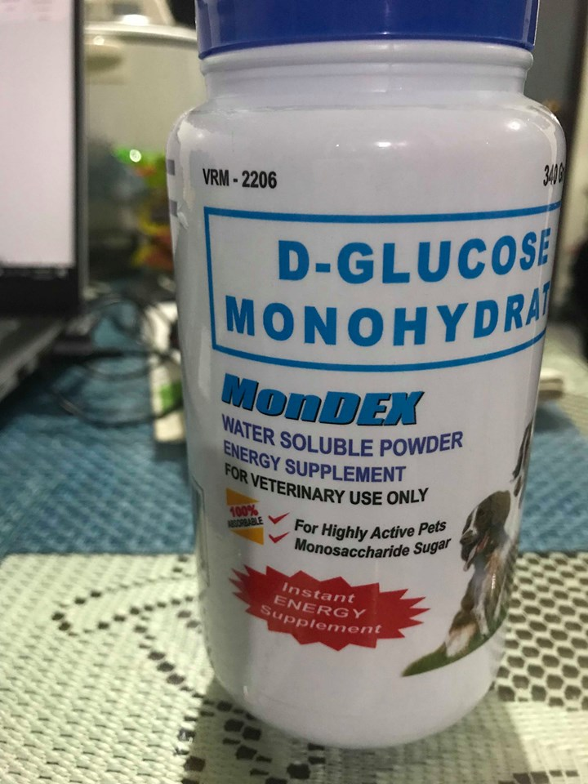

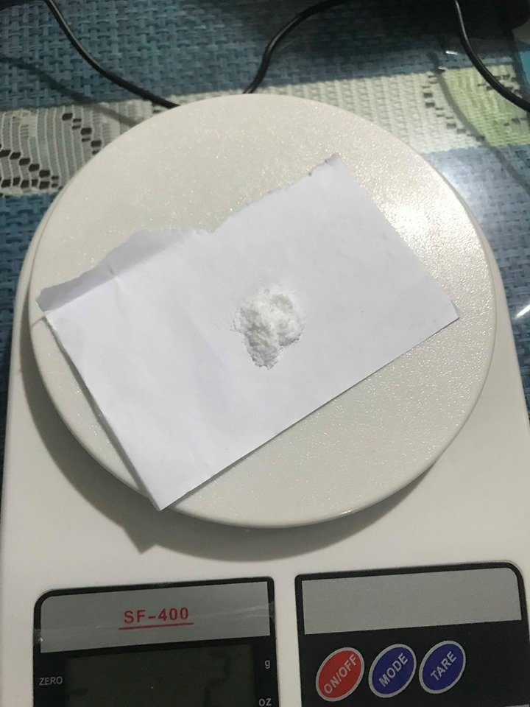

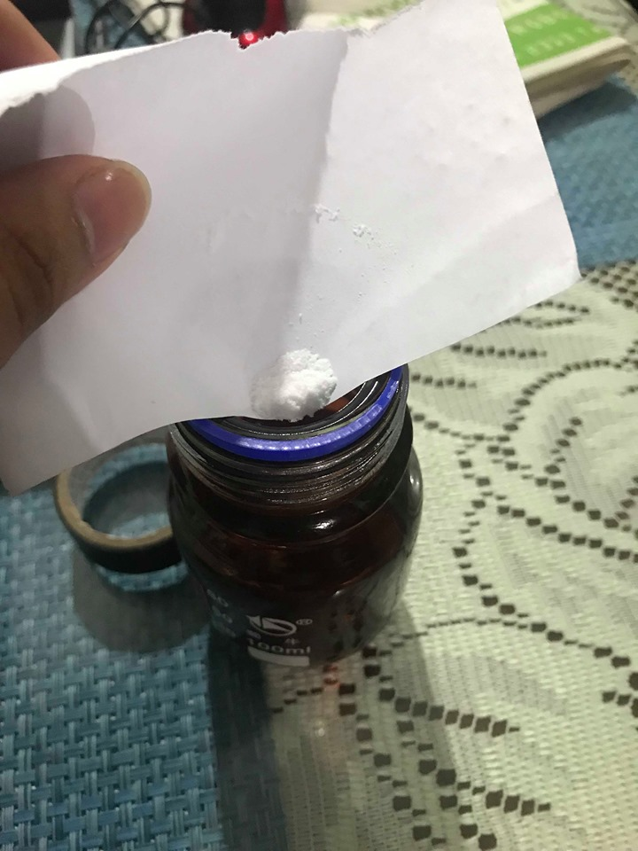

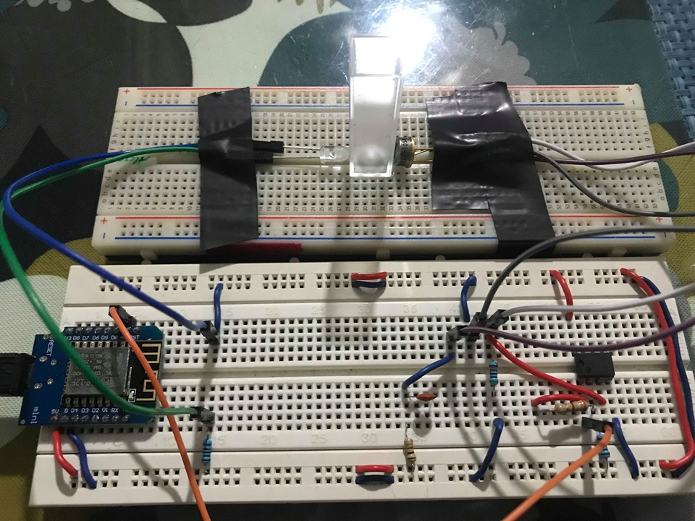

Repeat all the steps with different level of glucose concentration and fill the tables.

Based on the table, correlate the x and y values using the linear regression formula.

Sum of X = 4496.7742

Sum of Y = 1625

Mean X = 449.6774

Mean Y = 162.5

Sum of squares (SSX) = 295.5243

Sum of products (SP) = 3790.315

Regression Equation = ŷ = bX + a

b = SP/SSX = 3790.32/295.52 = 12.82573

a = MY - bMX = 162.5 - (12.83*449.68) = -5604.94112

ŷ = 12.82573X - 5604.94112

* Based dun sa table, habang tumataas yung concentration nataas din yung voltage.
* Kasi pag pure tubig lang nakalagay, yung NIR is magpapass through lang sa tubig, walang magrereflect pabalik.
* Pero kapag may mga sugar, matatamaan yung mga sugar na nakahalo sa tubig tapos magrereflect back.
* Same concept pag nilagay mo sa skin yung dalawang sensor, mas mataas yung reading pag maraming glucose.

1. Para san yung materials, ano ginagawa nito bakit siya nakaconnect sa ganyan.

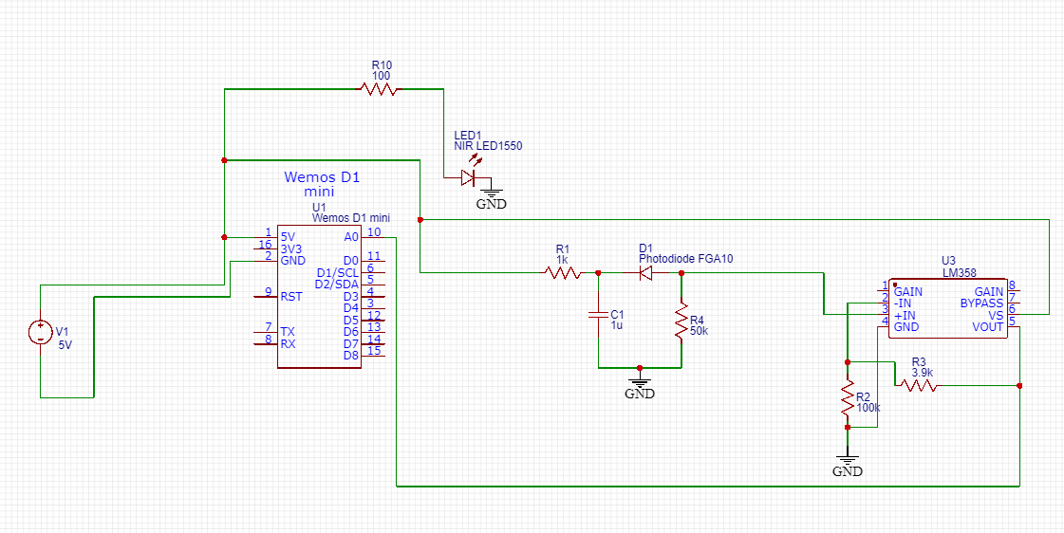

* 3.7 Volts yung battery niyo.
* May booster kayo, para maconvert yung 3.7V to 5V since ayun need nung WeMos D1 Mini.
* Wala yung booster dyan sa circuit, module lang siya na nakaconnect sa battery tapos output na nun is 5V na.
* Yung LED1550E niyo is nakaconnect sa 5V supply in series sa 100 ohms resistor. 100 ohms yun kasi pag tiningnan mo yung datasheet ng LED1550E, 100 mA yung max current niya. Bali kung 5V ang supply mo, divide mo yun sa 100 mA, 5/0.01 = 50 ohms. Ibig sabihin 50 ohms yung pinakamababang resistor na pwede mo gamitin para hindi masira yung LED1550E. 100 ohms meron ako kaya ayun ginamit ko.
* Sa photodiode na tayo, may 1k resistor dun, 1uF na capacitory saka 50k na resistor is ayun yung nasa recommended circuit ng Thorlabs based sa datasheet para hind imaging noisy yung output ng photodiode. Pag noisy ibig sabihin may random values na nalabas.
* Tapos yung LM358, amplifier yan para lang tumaas yung voltage reading ng photodiode.
* May 100k na valyes dyan saka 3.9k na values na nagdidikta kung gaanto kataas yung aamplify na voltage na output nung galling photodiode. May formula yun nasa next page.

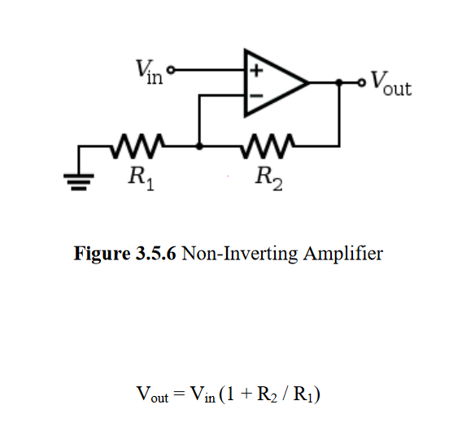

Eto link nung mga datasheet nung sensor:

* <https://www.thorlabs.com/drawings/d07cad326057a28e-401489B2-AC74-C832-CA7FE287DF763033/LED1550E-SpecSheet.pdf>
* <https://www.thorlabs.com/drawings/d07cad326057a28e-401489B2-AC74-C832-CA7FE287DF763033/FGA10-SpecSheet.pdf>

1. Paexplain yung code sa app.
2. Bakit Android Studio ang ginamit and anong programming language at bakit yun ang ginamit.

* Bali Android Studio yung ginamit dyan.
* Sa Android, Java programming language gamit.
* Java ang commonly used na language sa Android. Kotlin yung isa pero kakalabas lang nun. Matagal ng Java ang gamit para sa pag program ng Android apps. Standard na yon.
* Bali sa code, mainly basic java program lang yan, mga if-else statements based sa parameters na nangagagaling dun sa device.
* Ang pinaka center na program sa Android is yung tinatawag na Socket Programming.
* Socket programming involves yung mga ip address.
* Since WeMos yung microcontroller niyo, magbobroadcast yan as WiFi tapos may ip address na yun.
* Pag comonnnect yan Android phone mo, magkakaroon din siya ng Ip address.
* Socket programming ginagamit para maka pag send and receive ng data from two or more node sa isang network which is in your case yung android app and yung wemos.

1. Ano ibig sabihin ng values na nakukuha sa testing?

- Sinabi ko na kanina, mas mataas na voltage, mas mataas na glucose concentration, kasi nagbobouncee back yung NIR from glucose back to photo diode. Pag walang glucose o konti lang, konti yung magbobounce back.

1. Bakit close mga readings?

* Kasi di naman ganun kalaki difference ng glucose kada solution, maliliit na particles lang yon kaya hindi ganun kalaki difference pag nag bounce back yung NIR pabalik. Send ko RRL basahin niyo. Pati sa actual may chance din na magiba iba value, ayusin ko na lang code pag meron na kayo nung readings ng glucometer. Hindi pa final yan aadjust ko pa yung linear regression since nagcalibrate kayo sa cuvette kaya iibahin ulit pag dating sa patch, may aadjust lang na konti.

1. Demo pano dinevelop yung app, mamaya kila Ken punta ko pag kagising ko. xD