**Speeded-Up Robust Feature Based Stitching for Optical Compound Microscope Using Wright-Giemsa to Detect Blood Parasites.**

By

Gatus, Hanes Mar F. ECE-4

Mallari, Jose Emmanuel P. ECE-4

Maniacup, Michael Anthony G. ECE-4

Saguiguit, Aldwin A. ECE-3

A Thesis Proposal Submitted to the School of EECE

In Partial Fulfillment of the Requirements for the Degree

Bachelor of Science in Electronics and Communication Engineering

Mapua Institute of Technology

March 2017

**Chapter 1**

**INTRODUCTION**

Based on the Malaria Control program proposed by the department of health Malaria has been found to be the 9th leading cause of morbidity in the country and found that out of 81 provinces there are 58 that are prone to endemics/ 14 million people are at risk of this blood based parasite and as such is of great concern for the people. Blood borne parasites such as malaria are deadly unless diagnosed early. As such in this proposed field of research we explore the various intricacies and algorithms available in dealing with image stitching of blood slides. Particularly we aim to utilize algorithms observed to be the most efficient in aiding scientific research and diagnosis through allowing for a high resolution image to be formed from a series of images from the microscope. Algorithms such as SURF utilize a process of image registration, calibration and blending which has forms the basis for this research topic. The creation of a stitched image allows for a mobile work station to send a complete image for analysis on a central hub. Wright-Giemsa staining is a predominant player in terms of hemapathology in terms of its usage. It is a popular method of slide staining often used in the identification of blood parasites such as Malaria. With the analyzing of the Wright-Giemsa stained blood slides we can provide an ample level of detail to provide a clearer picture of the slide sample.

In the field of digital photography the use of image stitching techniques are heavily used in the capturing of panoramic images as found in most cameras however the application of such technologies are limited to commercial application in that manner. The research done by C. Cai, P. Wang and Y. h. Liang provided a base for research into the topic by utilizing a SURF(Speeded-up Robust Features) based image recognition algorithm to further optimize the identification of Robust features in an image set. Other work done on the subject matter also revolves around the further optimization and exploration of various techniques in the development of algorithms. Another work done in this field is through the utilization of SIFT (Scale Invariant Feature Transform) in order to speed up the process of recognition. In the field of hemopathology the current methods used in determining diseases focused on this study is by Microscopic Diagnosis, Antigen Detection, Molecular Diagnosis, and Drug Resistance Tests. The gold standard for diagnosing Malaria is using Microscopic Diagnosis, a drop of the patient’s blood is placed under the microscope then the laboratorian can confirm if the patient is infected with the said disease.

The research is focused more so on the application aspect of the technology. Utilizing previous research into the subject matter we focus on the practical aspect such as in microscopes where a multitude of sectional images are taken and are then stitched together to provide a high resolution image for easier observation. It lessens the burden on the operator on longer strenuous operation on said microscope on the subject. The application of this method also allows for remote diagnosis of samples so for locations that are far from medical facilities. The research covers the microscopic applications of the area instead of focusing on macro images. The sectioning of the microscopic image set determines the level and the ease of the projects image stitching capabilities.

In the pursuit of this research topic we aim to develop a system (1) to provide aid in the use of Hematopathology analyzing Wright-Giemsa Samples to determine the presence of parasites, i.e. Malaria, in the blood. In the design work we aim (2) to design an automated slide adjuster in image capturing process. We aim (3) to make use of the SURF based image stitching technique to combine multiple sample captures into a singular stitched image for the given magnification level. We aim to use an optical microscope with magnification 400x or up to perform differential white blood cell counts and to study red blood cell morphology and to provide the means of data transmission, stitched image. Limited in this study, we focus on high risk patients ages between 18 and 50 years of age. These targeted groups of people are exposed to working outside and as such are a risk of infection.

Work in this field of research is invaluable in optimizing laboratory procedures. In streamlining the research work the quick and easy access to a comprehensive library of complete sample images would greatly improve workflow performance. The aim of this research is to provide a mobile platform in obtaining microscope images for further analysis. The project aims to lessen the burden on the medical staff by providing a source of blood work from the field. This allows for easier diagnosis for remote locations and hastens the treatment if needed. Early detection of blood parasites such as malaria in patients is crucial in saving lives.

As this is designed to incorporate existing technologies and research into feasible application in a microscope the research is limited to optical microscopes. The ability to focus the subject matter on the slide is still dependent on the microscope operator. This also is designed to perform the image stitching process at a given magnification level and depends on the quality of the camera for resolution advantages. The prototype is meant to be integrated only onto one microscope. The prototype is not designed to replace the analytics of a skilled hematologist rather it is to provide support in cases where the presence of the expert cannot be provided. The design will not determine the type of parasite found and will only detect its presence.

**Chapter 2**

**REVIEW OF RELATED LITERATURE**

**2.1 Blood Tests**

There are many kinds of laboratory tests available to diagnose parasitic diseases. Some of the commonly used tests that diagnose these diseases are fecal or stool exam (which is also called ova) and parasite tests like endoscopy and colonoscopy. These tests are used to find parasites that cause diarrhea, loose or watery stools, cramping, flatulence and other abdominal illness. On the other hand, X-ray, MRI and blood tests are used to look for the specific parasite infection. Blood tests are divided into two kinds: serology and blood smear. Serology is used to look for antibodies or parasite antigens, while blood smear is used to look for parasites that are found in the blood. One of the diseases that blood smear detects is malaria [1]. Malaria is a life-threatening blood disease caused by parasites transmitted to humans through the bite of the *Anopheles* mosquito. Once an infected mosquito bites a human and transmits the parasites, those parasites multiply in the host's liver before infecting and destroying red blood cells [2].

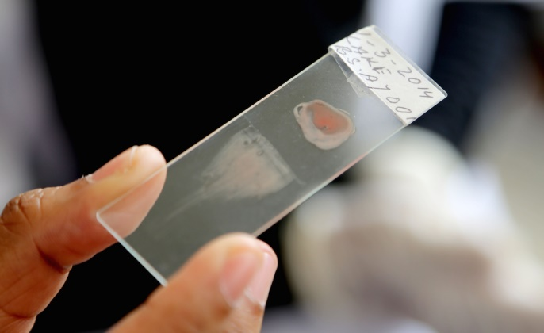

Figure 2.1 Blood Sample

**2.1.1 Wright-Giemsa**

Wright-Giemsa is a procedure of staining a blood sample to determine certain anomalies in the given sample. Wright's stain is a histologic stain that encourages the separation of platelet sorts. It is traditionally a blend of eosin (red) and methylene blue dyes. It is utilized principally to stain peripheral blood smears, urine samples, and bone marrow suctions which are inspected under a light magnifying instrument. In cytogenetics, it is utilized to stain chromosomes to encourage the finding of disorders and illnesses. It is used in different fields of research, but is dominantly utilized in the medical field. This procedure requires the use of oxidized methylene blue, azure B and eosin Y dyes. These three are the significant components needed in performing Wright-Giemsa staining. Abnormal granulocyte, lymphocyte or monocyte cell checks might be utilized to encourage the analysis of illnesses like leukemia or bacterial contaminations [3].

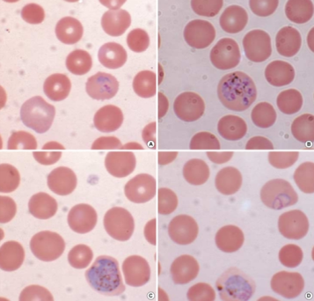

Figure 2.2 Wright-Giemsa stained blood slide.

**2.2 Optical Compound Microscope**

Optical microscopy is widely used in the different fields of medicine like biotechnology, pharmaceutic research and microbiology. It deals heavily with observing tissues, cells and tissue fragments, and can diagnose diseases and abnormalities in a given sample. The main equipment in optical microscopy is the microscope. Deemed as the most perennial design of microscope, the optical compound microscope is used to magnify small sample images through the use of visible light and a system of lenses. To capture these magnified images, a camera which is sensitive to light is utilized. This camera then creates a micrograph. The first images were developed through photographic film. Eventually, charge-coupled device (CCD) cameras were made to capture and develop digital images [4].

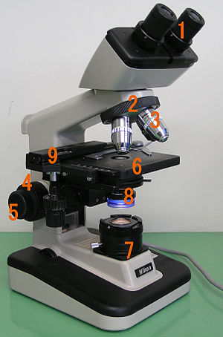

Figure 2.3 An optical compound microscope

Generally, microscopes are composed of basic structural components. These components are numbered below according to the image above:

* Eyepiece (ocular lens) (1)
* Objective turret, revolver, or revolving nose piece (to hold multiple objective lenses) (2)
* Objective lenses (3)
* Focus knobs (to move the stage)
  + Coarse adjustment (4)
  + Fine adjustment (5)
* Stage (to hold the specimen) (6)
* Light source (a light or a mirror) (7)
* Diaphragm and condenser (8)
* Mechanical stage (9)

**2.3 Charged-coupled Device and CMOS (CCD)**

A charge coupled device acts as the sensor/receiver in digital photography which is what forms as the basis of image capturing using a webcam. In a CCD or charge coupled device, there are multiple advantages over the older method of image capturing where the image is exposed on a film being in an analog form. One such advantage is that the image is stored in a digital format, that is, it is encapsulated in a format suitable for computers and lends itself to an easier to understand format for visual processing and image manipulation [5]. Similar to CMOS cameras, CCD devices allow for the sensor to convert light received into binary data. CCD sensors yield a higher overall quality when compared to their CMOS counterparts, although this comes at the cost of a more expensive manufacturing process that most applications often forgo. CMOS camera sensors are often used in low cost operations such as webcam usage [6].

**2.4 Slide Scanning**

Application of automated slide movement is seen in various fields of study more notably in the field of microscopy. In the field of microscopy it is often found that there are multiple techniques used in digital imaging of microscope slides. In such a way there are three major methods of slide scanning techniques which are the FOV scan, Line scan and the Slanted scan. In the slanted scan method of scanning, the scan time is estimated to be equivalent to multiple line scans performed simultaneously as such acquiring multiple images from several focal planes. In a field of view scan or FOV scan we can observe that this technique is straight forward and can be applied to most microscopes. In this method the motorized stage moves the specimen and images are acquired in a serpentine pattern. Line scans, similar to the FOV, follow a serpentine pattern in scanning and can be expected to perform in a relatively similar fashion. Although in this method of scanning the sensor or camera is placed perpendicular to the stage motion and is referred to as a line array sensor. It is performed with a constant velocity [7].

**2.5 Image Feature Detectors and Descriptors**

People at present live in an era of technological advancement. The peak of this technological advancement was seen in the past decades, when development in the different fields of technology was made. This forward movement in technology development is mainly impelled by the changes made in the computer world. Specifically, innovations in computer vision were made.

One of the developed fields in computer vision was the image processing. Various techniques in image processing were created and enhanced. A common product of image processing is panorama. Panorama shows the wide angle view of a captured physical space. The final image in a panoramic view is formed by detecting the common ground of the captured images, and then stitching them together to show a wide angled image with a larger field of view.

However, although image processing techniques have already been improved, there are only few applications that utilize such techniques [8].



Figure 2.4 Panoramic Image Processed

**2.6 Speed-Up Robust Feature**

There had been a number of fast detectors and descriptors which were used in the past. However, upon experimenting on benchmark image sets and real object recognition application H. Bay and his colleagues had come up with a faster and more reliable detector and descriptor. They call this feature Speed-Up Robust Feature (SURF) which came from the idea of Scale-Invariant Feature Transform (SIFT). This feature has a novel scale and rotation-invariant interest point. This detector and descriptor can imitate distinct processes, and can outperform previously used schemes in terms of repeatability, distinctiveness and robustness [9].

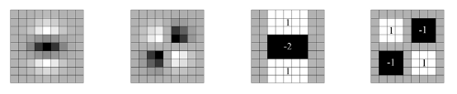

Figure 2.5 Left to right: the (discretized and cropped) Gaussian second order partial derivatives in y-direction and xy-direction, and our approximations thereof using box filters. The grey regions are equal to zero.

**2.7 Medical Services in the Philippines**

One of the saddest reality the society experiences is the shortage of proper medical service in the rural areas of the Philippines. According to Senator Edgardo J. Angara who heads the Senate Committee on Finance and authored pioneering laws such as the PhilHealth Act and the Senior Citizens' Act. “Two perennial problems haunt and hurt the health-care system in the Philippines: its shortage of doctors, and the concentration of health professionals in urban areas. For a country that exports doctors and nurses, the Philippines suffers from a low 1:15,000 doctor-to-population ratio, more than double the ideal 1:6,000 and a far cry from the US ratio of 1:150”. This is one of the main problems the country has been experiencing for a long time, the scarcity of doctors is very alarming. Senator Angara added “Worse, majority of these doctors reside in urban areas. For instance, the disparity between the number of doctors in the National Capital Region (NCR) and in provinces, such as the Cordillera Administrative Region (CAR) and the Autonomous Region in Muslim Mindanao (ARMM), is ghastly alarming." The results of the scarcity of doctors in the rural areas of the country affects many people [10].

**2.7.1 Telemedicine**

Telemedicine is the remote delivery of healthcare services and information using telecommunications technology. Also called “telehealth” or “e-health”, telemedicine allows for expert health care professionals to provide services such as evaluation, diagnosis and/or treatment for patients in remote locations using telecommunications technology. Utilizing telemedicine offers a more efficient usage of a doctor’s limited resources as a singular practitioner can provide medical consultations to a wider range of areas given ample support on the ground. Telemedicine allows smaller medical facilities to provide the necessary expertise that a city hospital can. In particular telemedicine offers developing nations such as the Philippines to provide the much needed service that a majority of the people need. The Global Observatory for eHealth of the World Health Organization lists a few of the pioneering telemedicine providers in the Philippines. For ophthalmology the University of the Philippines college of Medicine has started a pilot program in 2010, wherein they provided for the needs with regards to ophthalmology. In the field of prosthesis there are 2 pilot programs launched by the National Telehealth Center and again by the University Of Philippines College Of Medicine. Although Telemedicine offers great promises in terms of efficiency and mass deployment one of the most frequently reported barrier faced according to the same GOe survey is that implementation of telemedicine programs were too expensive to implement. Thus the GOe finds that emphasizing the need to improve on existing infrastructure and low cost telemedicine solutions within the community will allow for easier adoption among developing nations [11].

**2.8 Stepper Motor**

A stepper motor is a brushless DC electric motor that divides a full rotation into a number of equal steps. The motor’s position can be programmed to move and stop at one of the steps without any feedback sensor, the motor just need to be placed carefully with required torque and speed to its application. DC brushed motors rotate when a DC voltage is applied to its terminals. The stepper motor converts a signal of square waves to be its pulses to increment the rotation precisely. One pulse moves precisely through a fixed angle. There are different stepper motors, stepper motors varies in the number of shifts they can make before completing a full rotation or also called as “gear’s teeth”. Stepper motors can be programmed by a driver circuit or a micro controller. Programming the stepper motor to with a micro controller is the most common method, the micro controller then controls the stepper motor with the commands it needs to complete [12].

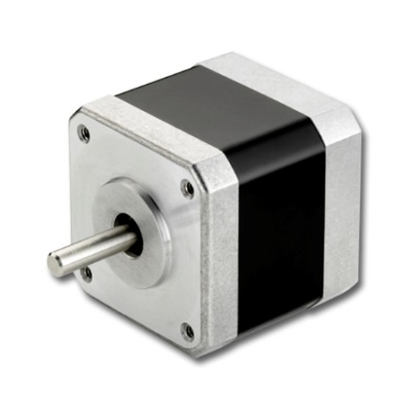

Figure 2.6 Stepper Motor

**2.9 Microcontroller**

A microcontroller or MCU is a computer that is small in size embedded on a single Integrated Circuit. In recent times it is called a system on a chip. A microcontroller contains one or more processors along with memory and programmable input/output terminals. Microcontrollers are used in automating various controlled products such as sensors, automobile engines control systems, implantable medical devices, remote controls, office machines, appliances, power tools, toys and other embedded systems [13].

**2.9.1 Arduino Uno**

The Arduino Uno is a microcontroller board based on the ATmega328. It has 14 digital input/output pins (of which 6 can be used as PWM outputs), 6 analog inputs, a 16 MHz ceramic resonator, a USB connection, a power jack, an ICSP header, and a reset button. It contains everything needed to support the microcontroller; simply connect it to a computer with a USB cable or power it with a AC-to-DC adapter or battery to get started [14].

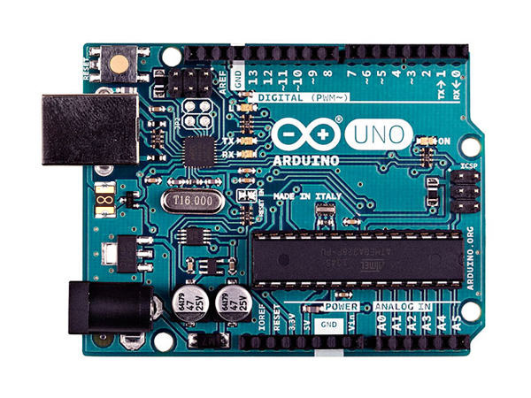

Figure 2 Arduino Uno ATmega328

**Specifications:**

* Microcontroller: ATmega328
* Architecture: AVR
* Operating Voltage: 5V
* Flash Memory: 32 KB of which 0.5 KB used by bootloader
* SRAM: 2 KB
* Clock Speed: 16 MHz
* Analog I/O Pins: 6
* EEPROM:1 KB
* DC Current per I/O Pins: 40 mA on I/O Pins; 50 mA on 3,3 V Pin

**General:**

* Input Voltage: 7-12 V
* Digital I/O Pins: 20 (of wich 6 provide PWM output)
* PWM Output: 6
* PCB Size: 53.4 x 68.6 mm
* Weight: 25 g
* Product Code: A000066 (TH); A000073 (SMD)

**2.10 Virtual Microscopy**

In the field of virtual microscopy several studies have already been performed. In such cases the use of virtual microscopy is used in aiding the researchers in the study of multiple diagnosis/analysis tools for the human body. A study performed by Hongming Xu et al. used the techniques found in virtual microscopy to perform a whole slide skin histopathology. In their research, they focused on the diagnosis of skin melanoma by analyzing the histopahological images of the epidermis and the epidermis-dermis [15]. In this research they focused on regions of interest in the WSI wherein they took a sample of 66 images. Another such paper on the use of virtual microscopy was performed by Sudaraka Mallawaarachchi et al. wherein they made use of an optical microscope to perform a general method in performing virtual microscopy. In the paper, they did not focus on a particular diagnosis tool, rather they developed a system to suit a general need in the field. They provided a method to enhance the functionality of conventional optical microscopes into a WSI microscope by utilizing an automated slide scanning with a synchronous camera [16].

**Chapter 3**

**Speeded-Up Robust Feature Based Stitching for Optical Compound Microscope using Wright-Giemsa to detect blood parasites.**

**Conceptual Framework**

**Figure 3.1 Conceptual Framework**

Figure 3.1 describes the fundamental conceptual framework for the research proposal wherein we expect to receive inputs based on the camera and the corresponding algorithm to be used at the given magnification level. The process of presenting a whole stitched image capture of the samples found in the slide is determined through the use of a Speeded up Robust Features based image stitching algorithm in a matlab environment. The Speedud up robust features is comprised of work done bu three people; Bay,H., Tuytelaars, T. And Van Gool, L. In the SURF algorithm we can find an improved version of SIFT, wherein the lowe approximated Laplacian of Gaussian with Difference of Gaussian for finding scale-space is replaced by adding further approximations of the image warping using an LoG Box Filter.

The way that the data is gathered then is through a camera module attached to a microscope which is controlled by a microcontroller in order to be able to synchronize with the movements of the automated base setup holding the slide in place. The magnification level determines the amount of shifts that the sample is expected to receive to complete a full image capture, which again is processed through the SURF algorithm detecting key features and matching. The image is then stiched which is then presented to the user in a picture file format. The output of the system is presented onto an image file which can then be disseminated by the researchers at will. This will reduce the necessary time to complete analysis in what is in essence an aid to virtual microscopy.

**System Flowchart**

**NO**

**YES**

Is the Hardware working with the Software?

Systems Calibration

Hardware Construction and Software Implementation

System Initial Design

Testing the hardware and software implementation

Data Analysis

Conclusions and Recommendations

**NO**

Does the Data correspond to the expected result?

**YES**

**Figure 3.2 System Flowchart**

Figure 3.2 represents the step-by-step procedure in the completion of the whole system. In the initial stages of the design process we focus on the planning and the information gathering of how the individual systems would interact with each other. On the hardware aspect of the design we focus primarily on the automated base construction where in it will provide the necessary assistance to the camera mount to provide clear distinctions in sectors to be produced. The software will then be focused on the implementation of SURF to provide a feature based detection algorithm in order for an image stitching process is to be performed in the Matlab environment. Implementation of the hardware and the software relies primarily on the timings and how the hardware would react to the software. Calibrations can then be performed on a system by system basis wherein we can individually tinker with the aspects of the design to suit the needed purpose. After proper calibration is performed we can expect that testing can begin and we can perform analysis and conclusions.

**Hardware Implementation**

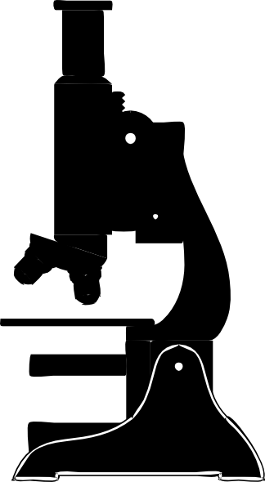

**Atmega328 board**

**Figure 3.3 Hardware Implementation**

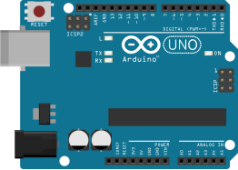

**Stepper motors**

**Camera**



**Computer**



The figure represented in image 3.3 is determined to be the different expected hardware devices/systems that need to be constructed. For the automated base design we expect that an arduino based control system needs to be implemented to provide a better cost to performance ratio rather than using other microcontroller based solutions. And for the camera system that is to be attached to the microscope we expect that a camera with usb functionality might provide ample resolution to our requirements otherwise an upgrade might be performed. The underlying microscope setup is to be an optical microscope capable of magnification levels of up to 1000x with the combination of objective and the eyepiece. The optimal level for our application is at 400x wherein the microscope is capable of observing blood cells under a wright-giemsa staining technique. In accordance with the design requirement for the automated base, we need to consider the estimated field of view for the given microscopes magnification level. In order to calibrate the automated base we first need to establish the field of view of the microscope. The approximate level of magnification is at 400x we can surmise from this that the expected field of view of the microscope against the sample would be equal to 450 microns or 450 millimeters in diameter.

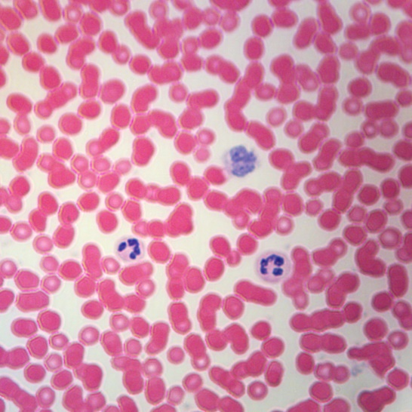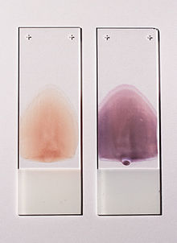

**Figure 3.4 Blood at 400x magnification**

In the design of our equipment we will need to affix a camera mount onto the microscope’s eyepiece. In this way we can design a camera mount that can be attached onto the eyepiece allowing for a level of control that we can manipulate. In terms of designing the equipment we will rely on a webcam. We can utilize the camera with little to no intermediate optics to operate with the microscope eyepiece. In such a design we need to strip down the webcam to its base electronic components while maintaining the integrity of its sensor. From its base electronic components we can fashion a body to house the components and attach the final product onto the microscope eyepiece.

**Projected Case**

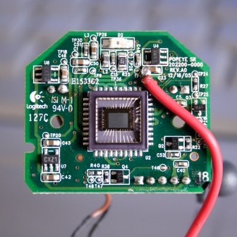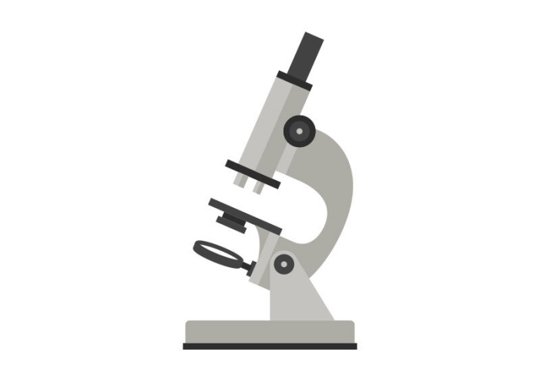



**Microscope**

**Computer**

**CCD sensor**

**Figure 3.5 Camera Microscope Integration**

In the teardown of the camera, we will still utilize the systems in place for the camera. In essence we will fabricate a new container for the camera sensors that can interface with the microscope’s eyepiece. Utilizing this method of camera attachment we can expect that the resolution will heavily depend on the webcam specifications. This also gives certain advantages over other proposed methods of camera interfacing, mainly its cost. This solution provides the lowest cost to performance ratio for providing a camera interface for the microscope. This also removes the necessity of interfacing a new camera module onto the computer as the company provided drivers are already well suited to the task.

The construction of both the base and the camera case will be fabricated on acrylic primarily unless the situation dictates a different approach. In the automated base design we will need to fabricate a base that can be run using two stepper motors and must be light enough that a certain level of accuracy can be expected. The camera casing then will need to be dark as to not let any unnecessary light to pass through to the sensors which in this case will hamper our objectives. The design for both of the device will be done through CAD.

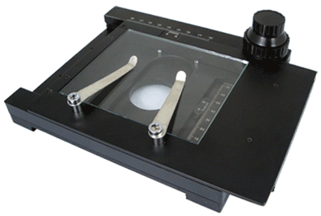

**Figure 3.6 Microscope Base**

For the automated base, we will need to modify the base of the optical microscope to accommodate for the motors and the new slide holder that must be placed. The design of the base will determine whether physical manipulations to the microscope must be performed. For our purposes we will fashion a base system that can be attached to the microscope base and will replace the pre placed slide holders as seen in the figure above.

**Hardware Calibration**

On the hardware side of things we focus on the automated base design with particular interest in the interconnections of the microcontroller software design to the motors. In the automated design process we make use of an atmega328 based microprocessor to manage the required components of the automated base design. We structure our design based on the design of the stage and of the slides samples that we will be managing. In the microscope design structure we need to provide for space underneath the slide for the light to shine through and provide a constant level of illumination,

In the automated base we need to integrate the atmega328 hardware to control the sectorization of the slide sample to be stitched with the algorithm. From the microscope we cam surmise that at a lens level of 10x and objective level of 40x we can get a magnification level of 400x. at his level of magnification we can expect the field of view to be at 450 microns or 450 millimeters. We can calculate the amount of sectorization that an image needs to go through depending on the level that the SURF algorithm performs at. Under this condition we need to calibrate the performance of the motors controlled by the microcontroller. We can quantify the data based on the accuracy of the desired level of movement versus the actual level of movement performed by the motor for the section. The atmega328 microprocessor can control stepper motors and manipulate the amount of movement in the motors by varying the level of voltage in regards to movement. With regards to the development of the system we will take control of stepper motors using the Stepper library of the arduino ide coding environment.

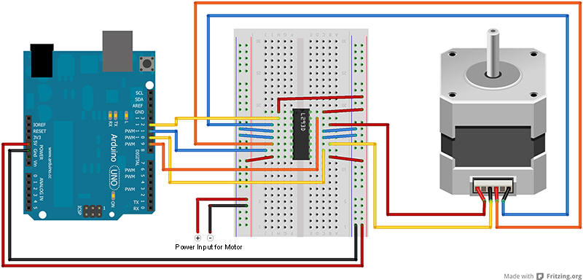

**Figure 3.7 motors/arduino integration**

|  |  |  |  |
| --- | --- | --- | --- |
| **Automated Base Calibration (1 motor)** | | |  |
| TRIAL NUMBER | Desired Movement  (mm) | Actual Movement  (mm) | Percent Difference |
| 1 |  |  |  |
| 2 |  |  |  |
| 3 |  |  |  |
| 4 |  |  |  |
| 5 |  |  |  |

In figure 3.4 the proposed motors integration with the arduino board is presented. We can control the amount of shifting necessary to provide an adequate level of accuracy for the algorithm to work through. This in part with the algorithm used in the image stitching process will allow for a clearer, more convenient image to be analyzed.

**Table 3.1 Base Calibration**

 Given that we need to control the movements of the automated base according to the required amount of shifts that the magnification level dictates we need to ensure that the accuracy of the shifts would be appropriate. In so far as controlling the movements of the motor we need to control the system through the arduino board we can control the resolution of the movements of the motors with a great deal of accuracy. Further testing is then to be performed to form the most accurate code that will suit our needs for the design of the system. In table 3.1 we can estimate the accuracy of our code depending on our desired amount of movement versus the amount performed by the motors.

**Figure 3.6 Capture movement**

We again then perform a subsequent test to calibrate the automated base to perform a 2d plane movement in the (X,Y) coordinates. We can calibrate the (X,Y) positioning of the system to correspond to the amount of shifts that is needed for the system. We can calibrate the coordinates of the (X,Y) plotting of the stepper motors by using the previous testing method, in this case we test the functionality of the motors movement using 2 directions. The motors act independently of each other though they are controlled by a single board. This means that we need to enact a code wherein the simultaneous movement of the 2 motors is considered in 2d space to achieve the desired accuracy. We can base the calibrations by using a 2d grid for the base beginning at the origin point at the center of the slide sample. The resulting data can then be counter checked and reprogramed to suit the design requirements of the process.

|  |  |  |  |
| --- | --- | --- | --- |
| **Automated Base Calibration ( 2 motors (X,Y) )** | | |  |
| TRIAL NUMBER | Movement (X,Y)  (mm) | Movement (X,Y)  (mm) | Percent Difference |
| 1 |  |  |  |
| 2 |  |  |  |
| 3 |  |  |  |
| 4 |  |  |  |
| 5 |  |  |  |

**Table 3.2 Base Calibration**

We can solve for the amount of movement that the base needs to perform depending on the algorithms necessities. We can take the Field of View of the microscope at the given magnification of 400x to be at 450 microns or 0.450 millimeter. Comparing then the area covered by the field of view which is equal to equation 3.1 which equates to an area of 0.1590 square micrometer.

(**3.1)**

Where: A = Area of the field of view π = the constant Pi (3.14156)  
 D = diameter of the field of view

We can then partition the blood smear sample by the given level of area and make appropriate adjustments to the level of accuracy. Commonly the blood smear is taken by placing a drop of blood of approximately 4mm in diameter and is smeared across the slide. The samples to be tested are both the thin and the thick smear to provide the most extensive database for perusal. There are certain advantages found in one type of smear not found in the other form of blood smears. This difference allows for a more extensive look into the blood sample of the subject.

**Camera configuration**

For the device to perform the necessary stitching we need to take image captures of the sample slides at a given rate. We need to determine the speed at which the camera must take still images of the samples in the slide for it to match up with the automated base movement. In order to achieve the necessary timings for the camera configuration we need to take into consideration once again the area that is covered by the automated base. In the design of the camera configuration we can make use of camera manipulation software such as Webcam Timershot. We can set the camera to take shots at an interval to be derived from the automated base design.

|  |  |  |  |
| --- | --- | --- | --- |
| **Camera Configuration** | | |  |
| Row Number | Time Interval | Images Taken | Time taken  (Seconds) |
| 1 |  |  |  |
| 2 |  |  |  |
| 3 |  |  |  |
| 4 |  |  |  |

**Table 3.3 Camera Calibration**

**Software Calibration/Development**

In the design of the software we make use of the SURF algorithm in order to detect common features across the sampled slide images. The program compares subsequent images against each other basing the comparisons using the SURF feature detection.

**NO**

**YES**

Initialize SURF

Output Stitched Image.

Last image in set?

Stitch Image

**YES**

**NO**

Features Match?

Feature Detection and Matching

Image Acquisition

**Figure 3.8 Program Algorithm**

Represented in figure 3.5 is the step-by-step procedure for the algorithm used in the formation of the stitched image. The first part of the program is initializing the SURF algorithm to take in the images of the slide sample and compare the features found within each image to the subsequent image in the set. The program then loops the algorithm taking into account the previous sections image set and comparing features until the last image in the set is analyzed by the algorithm. Once the images have been fully analyzed and stitched together a final image is then outputted which is then disseminated to relevant personnel for analysis. In the analysis of the images to be stitched we take into consideration the amount of processing power and time that the process will require and determine the estimated time it takes for the algorithm to perform the necessary actions. We further the optimization of the program by dividing the image sets into rows for a smaller sample size. For each rows of sectors we perform the algorithm and use the same algorithm to combine the layered sectors.

**Table 3.4 Software Calibration**

|  |  |  |  |
| --- | --- | --- | --- |
| **Software Calibration (@ GHz)** | | |  |
| Row Number | Images in set | Images stitched | Time taken  (Seconds) |
| 1 |  |  |  |
| 2 |  |  |  |
| 3 |  |  |  |
| 4 |  |  |  |

Once the calibration is complete we can then move on to trials wherein we test for the presence of parasites within the sample. As such we need to perform analysis of the blood samples as prescribed by the world health organization wherein we need to properly set up the blood samples according to the standards. Testing the blood samples requires that proper procedure for the preparation of both thin and thick smears are followed. Once the samples are prepared we then test the systems capabilities and run trials detecting whether the sample taken has the presence of blood borne parasites. In testing whether the sample has blood borne parasites found within we utilize a color detection algorithm. In the color detection algorithm we utilize HSV (Hue, Saturation, and Value) as the determining factor in identification. This method offers a rudimentary detection method for blood borne parasites and as such only determines whether the sample needs further analysis from a skilled technician. We can test for its accuracy by cross referencing the samples with blood parasites to those without.

**Table 3.6 Thick smear**

**Sample Preparation**

With regards to the sample preparation, we can expect the samples to comprise of sampled blood and pre-prepared samples that are available. The samples that we need to obtain will be a mix of blood with and without parasites. In the preparation of our samples we will utilize the prescribed method by the CDC (Center for Disease Control) for preparation of slides for the microscopic diagnosis of Malaria. Blood samples taken from malaria patients carry the risk of infection through blood injections. Malaria is not known to transmit through other bodily fluids nor through airborne factors as such focus on the sterility of needles and other testing materials that come in contact must be ensured. The most optimal way of taking blood from the patient is through capillaries particularly on the finger.

1. Tag sample slides to be used with time and other identifiers.
2. Wear gloves.
3. Clean the slides with 70% to 90% alcohol and allow to dry, keep smear location sterile.
4. Clean punctured area with alcohol; allow drying.
5. Puncture ball of the finger; wipe first drop of blood with gauze.
6. Touch the next drop to the prepared slide; Repeat as necessary.

Further steps are then taken to prepare the samples as thick or thin smears. Having both types of blood smears allow for a more comprehensive diagnosis tool when dealing with the blood parasites. Since blood parasites often follow a rather complex life cycles, blood tests are performed routinely for patients and multiple blood samples are taken.

Thin smears are prepared in a way similar to thick smears. We prepare thin smears as opposed to thick smears for its capabilities in allowing for the diagnostician to determine the type of parasite present in the blood. For thin smears we utilize the following process.

1. Bring a clean spreader slide to the specimen slide at a 45° angle.
2. Wait until blood is similar in width to the spreader slide.
3. Once of equal width, push the slide forward rapidly whilst maintain the same angle
4. Fix the film with methanol and let to dry before staining.

Similarly we can take the blood samples as thick smears, wherein we find that there is a higher concentration of blood cells at the sample and is a much smaller in size. The thick smear allows for easier diagnosis of the presence of blood parasites

1. Bring a cleaner slide to the blood drop.
2. Position the corner of the spreader slide to the center of the sample.
3. Rotate the spreader slide in a circle with a diameter of 1 to 2 centimeters; Must be thin enough to be able to read through
4. Let dry before staining sample.

For both methods we will make use of the wright-giemsa staining technique as it is the preferred method of staining for most types of blood tests. It is the most commonly used in practices around the world for its ability to hold for a long period of time as well as its ability to differentiate the different constituents of the blood cell.

**Staining Process**

Once the blood slides are prepared for staining, both thick and thin smears will be processed in similar fashion. Staining the material allows for the samples to be identifiable down to their components and with the aid of the processing that it will go through we will be able to detect the presence of blood parasites. The staining procedure that we will employ will be the Wright-Giemsa staining procedure The wright-Giemsa staining procedure is a modified Wright staining method utilizing a combination of various solutions such as eosin y and methylene blue depending on the stain proper.

1. Place 1.0ml of the Wright-Giemsa staining solution on the smear enough to cover the entire surface. Dry for 3-4 minutes.
2. Add 2.0ml of distilled water and let stand for twice as long.
3. Rinse the smear with ware repeatedly until sample appears pinkish red.
4. Allow the film to air dry.

In the process of staining we need to refer to the manufacturers technical documents on how to refer to the colors encountered in the sample. As for instance in the Emsdiasum Wright-Giemsa stain the components of the blood sample appear to be the following;

* Erythrocytes – Pink-tan
* Eosinophiles – Red
* Lymphocytes: Granules – Red-Purple
* Lymphocytes: Cytoplasm – Blue
* Neutrophils: Granules – Purple-pink

**Table 3.5 Thin smear**

|  |  |  |  |
| --- | --- | --- | --- |
| **Software Accuracy (Thin smear)** | | |  |
| Sample Number | Actual status  (Positive/Negative) | Algorithm result  (Positive/Negative) | Matched(Y/N) |
| 1 |  |  |  |
| 2 |  |  |  |
| 3 |  |  |  |
| 4 |  |  |  |

**Table 3.6 Thick smear**

|  |  |  |  |
| --- | --- | --- | --- |
| **Software Accuracy (Thick smear)** | | |  |
| Sample Number | Actual status  (Positive/Negative) | Algorithm result  (Positive/Negative) | Matched(Y/N) |
| 1 |  |  |  |
| 2 |  |  |  |
| 3 |  |  |  |
| 4 |  |  |  |
| 5 |  |  |  |

Based on the two tables presented before, we can determine whether the proposed system to deal with microscopic diagnosis is accurate to the desired level. If we find the results to be without merit then we can then further calibrate the system to adapt to circumstances that we encounter. The time taken of both tables is defined to be at the start of sample preparation as to provide the entire time of blood analysis.

**References**

[1] Diagnosis of parasitic diseases, (2014). *Centers for Disease Control and Prevention.* Retrieved from [www.cdc.gov/parasites/references_resources/diagnosis.html](http://www.cdc.gov/parasites/references_resources/diagnosis.html)

[2] Malaria: causes, symptoms and treatments, (2016). *Medical News Today.* Retrieved from [www.medicalnewstoday.com/articles/150670.php](http://www.medicalnewstoday.com/articles/150670.php)

[3] Giemsa Staining of Malaria Blood Films, (2016). *World Health Organization.*  Retrieved from www.wpro.who.int/mvp/lab_quality/2096_oms_gmp_sop_07a_rev.pdf?ua=1

[4] Van Helden, Albert; Dupre, Sven; Van Gent, Rob (2011).The Origins of the Telescope. Amsterdam University Press. [ISBN](https://en.wikipedia.org/wiki/International_Standard_Book_Number) [9069846152](https://en.wikipedia.org/wiki/Special:BookSources/9069846152).

[5] James R. Janesick (2001).[*Scientific charge-coupled devices*](https://books.google.com/?id=3GyE4SWytn4C&pg=PA3). SPIE Press. p. 4. [ISBN](https://en.wikipedia.org/wiki/International_Standard_Book_Number) [978-0-8194-3698-6](https://en.wikipedia.org/wiki/Special:BookSources/978-0-8194-3698-6).

[6] CCD vs, CMOS (2017). Teledyne Dalsa. Retrieved from www.teledynedalsa.com/imaging/knowledge-center/appnotes/ccd-vs-cmos/

[7] Yilun Fan, Yaniv Gal, Andrew P. Bradley, "Microscopic specimen delineation using auto-phase correlation index", Biomedical Imaging (ISBI) 2014 IEEE 11th International Symposium on, pp. 1336-1339, 2014.

[8] Huang, F., Klette, R., & Scheibe, K. (2008). *Panoramic Imaging: Sensor-Line Cameras and Laser Range-Finders.* John Wiley & Sons.

[9] Bay, H., Tuytelaars, T., & Van Gool, L. (n.d.). SURF: Speeded Up Robust Features.

[10] Rural areas suffer most from poor health. (2009). *Senate of the Philippines.* Retrieved from

www.senate.gov.ph/press_release/2009/0527_angara1.asp

[11] Telemedicine opportunitiesand developmentsin member states.(2010).*World Health Organization.* ISBN 978-9-2415-6414-4

[12] Liptak, Bela G. (2005). [*Instrument Engineers' Handbook: Process Control and Optimization*](https://books.google.com/books?id=TxKynbyaIAMC&dq=Instrument+Engineers%27+Handbook&pg=PP1&ots=jvrdPR7wxJ&sig=1hOUpQQDQH_8drYjW1yPVocJSYI&hl=en&sa=X&oi=book_result&resnum=1&ct=result). CRC Press. p. 2464. [ISBN](https://en.wikipedia.org/wiki/International_Standard_Book_Number) [978-0-8493-1081-2](https://en.wikipedia.org/wiki/Special:BookSources/978-0-8493-1081-2).

[13] Augarten, Stan (1983). [*The Most Widely Used Computer on a Chip: The TMS 1000*](http://smithsonianchips.si.edu/augarten/p38.htm). *State of the Art: A Photographic History of the Integrated Circuit*. New Haven and New York: Ticknor & Fields. [ISBN](https://en.wikipedia.org/wiki/International_Standard_Book_Number) [0-89919-195-9](https://en.wikipedia.org/wiki/Special:BookSources/0-89919-195-9). Retrieved 2009-12-23.

[14] *Design of Control Unit for CNC Machine Tool using Arduino based Embedded System.* Patel, Dr. D.M. and P. Desai, Dev. s.l.: 2015 Internaional Conference on Smart Technologies and Maagement, 2015

[15] *Automated segmentation of regions of interest in whole slide skin histopathological images.* Xu, Hongming, Lu, Cheng and Mandal, Mrinal.s.l: IEEE, 2015. 978-1-4244-9271-8

[16] Mallawaarachchi, S., Wimalana, K., & Liyanage, A. (2015). Automated whole slide imaging for conventional optical microscopes. *2015 8th Biomedical Engineering International*