# **Determination of Maturity Stage, Shelf-life, Nutritional Content and Suggested Use for the Stages of Tomatoes Using Color Space Conversion Algorithm, Processed Through Raspberry Pi**

# 

by

**Marron Ace E. Amarante**

**Allen R. Ang**

**Eugene Marc R. Martin**

**Scot D. Vigilia**

A Thesis Proposal Report Submitted to the School of Electrical Electronic and Computer Engineering in Partial Fulfillment of the Requirements for the Degree

Bachelor of Science in Electronics Engineering

Mapúa Institute of Technology

November 2017

# **TABLE OF CONTENTS**

**TITLE PAGE 1**

**TABLE OF CONTENTS** **2**

**LIST OF TABLES** **4**

**LIST OF FIGURES** **5**

**Chapter 1** **6**

**Chapter 2** **11**

2.1 Tomato 11

2.1.1 Vine-ripened vs. Storage Ripened Tomatoes 11

2.1.2 Controlling the Ripening Process 12

2.1.3 Inspecting the ripeness of tomatoes 12

2.1.4 Tomato Varieties 13

2.1.5 Major Crops in the Philippines 14

2.1.6 Philippine Climate: Tomato Growing Season 14

2.1.7 Development Stages of Tomato 14

2.1.8 Ethylene 15

2.1.9 Tomato Maturity Stages 16

2.1.10 Tomato Color Consistency All Throughout its Skin 19

2.1.11 Crop Age and Stage Duration 20

2.1.12 Different Chemical Compositions in each stage of Tomato 21

2.1.13 Shelf life of tomato 22

2.1.14 Tomato Storage Temperature and Shelf life 23

2.1.15 Tomato Abnormal Coloring Conditions 24

2.1.17 Tomato Proper Handling 25

2.1.18 Postharvest Handling Practices and Treatment Methods for Tomato 26

2.1.19 Handling Tomatoes at Wholesale and Retail: A Guide for Better Quality and Greater Profits 27

2.1.20 Farmer’s Loss Due To Mishandling of Tomatoes 27

2.1.21 Tomato Transportation 28

2.1.22 Ideal Use of Tomato for Each Stage 28

2.1.23 Nutritional Content of Processed Tomato products 29

2.1.24 Ascorbic Acid 29

2.1.25 Beta-Carotene 30

2.1.26 Lycopene 30

2.1.27 Potassium 31

2.1.28 Folate (B9) 31

2.1.29 Fiber 32

2.1.30 Reducing Sugars 32

2.2 Unhealthy Country: Philippines 33

2.3 Raspberry Pi 33

2.3.1 Raspberry Pi 3 vs Pi 2 34

2.3.2 Raspbian OS 34

2.3.3 Raspberry Pi Power Supply Rating 35

2.3.4 Tomato RGB Value Per Stage 36

2.3.6 Tomato Maturity Estimation 37

2.3.7 Relation of Raspberry Pi and Python 38

2.3.8 Effect of brightness to RGB Values 38

2.3.9 CMYK 39

2.3.10 Raw Image as AdobeRGB 39

2.3.11 Monitors uses RGB while Printers uses CMYK 40

2.3.12 Solving for the Mean Value of RGB 41

**Chapter 3** **43**

**METHODOLOGY** **43**

3.2 Design 45

3.2.1 Device Design Proposal 45

3.2.2 Setting Up Raspbian OS on the Raspberry Pi 46

3.2.3 Installing an LCD Display for the Raspberry Pi 48

3.2.4 Camera Installation 48

3.2.5 Python Code 49

3.2.6 Hardware Block Diagram 50

3.2.7 Algorithm Flow Chart 52

3.3 Tests and Calibration 55

3.4 Statistics 66

**REFERENCES** **67**

# **LIST OF TABLES**

Table 1.1 a* Value Comparison with a Printed Image as Reference 54

Table 1.2 RGB Value Comparison with Image Displayed on a Monitor as Reference 58

Table 1.3 Existing and Experimental Tomato Chemical Composition Comparison 61

Table 1.4 Tomato Stage Transition at Room Temperature 62

Table 1.5 Observation of Shelf life at Room Temperature 64

# 

# 

# **LIST OF FIGURES**

Figure 1.1 Tomato Flower Development 15

Figure 1.2 Tomato Fruit Development 15

Figure 2.1 The Six Maturity Stages 18

Figure 2.2 USDA Grade Standard for Fresh Tomatoes 18

Figure 2.3 Tomato Color Variation of the Maturity Stages 17

Figure 3.1 Tomato stage duration 21

Figure 4.1 Tomato chemical composition of maturity stages 21

Figure 5.1 Effect of maturity stages level on the shelf life of tomato 22

Figure 5.2 Effect of ethrel levels on the shelf life of tomato 23

Figure 6.1 Power consumption of Raspberry Pi 35

Figure 7.1 RGB Values of Tomato per Stage 36

Figure 8.1 a*-value reference for the maturity stage of tomato 37

Figure 8.2 Suggested shelf life of tomato per maturity stage 38

Figure 9.1 Conceptual Framework of Methodology 44

Figure 10.1 Design Proposal 44

Figure 11.1 Raspbian Setup Options Menu 45

Figure 11.2 Raspbian boot option 46

Figure 11.3 Raspberry pi LCD 47

Figure 11.4 Raspberry pi camera module 47

Figure 11.5 Hardware block diagram 49

Figure 12.1 Algorithm Flow Chart Part 1 51

Figure 12.2 Algorithm Flowchart Part 2 52

# 

# **Chapter 1**

**INTRODUCTION**

In the Philippines, tomato is the second most profitable major crop as of 2015 and one of the most popular fruit consumed by humans. For the past years, people only rely on their senses such as the sense of smell, vision, sound, and touch in determining the ripeness of a fruit or vegetable. These methods has insufficient accuracy, time consuming and a waste of energy. A way of improving these methods is to use image processing which are devices that were invented to easily determine the ripeness level of a fruit, in this way we can determine if the fruit meets the requirement of that product. We often see in the market that most customers when buying fruits and vegetables tend to make improper handling on the products. Bruising of tomatoes are caused by physical handling of consumers when checking for the ripeness and assortment in preparation for transportation as well as the transportation itself, degrades the quality and shortens shelf life of the tomato, thus creating loss, wasting the time, money and energy of the laborers and farmers consumed in growing the tomato, about 49% to 80% of the produce ends up with the consumer while what is left is lost which will affect the farmer’s income as well as small business owners, though farmers are compensated for mishandled tomatoes if it is usable for food processing. Bruising can be prevented by using the device in checking the ripeness of the tomato without physical contact, and transportation damage can be prevented through the information output of the device. Spoilage are a common problem when it comes to shipment of the tomato, mainly because of human error in the judgement of its maturity stage the shelf life predicted is also inaccurate, this can be prevented through the shelf life prediction of the device. Most people eat whatever they like to relieve hunger, to relieve stress, or to simply taste something good without thinking of the harm that it can do to their body. A way of preventing this is by educating consumers and retailers through the output of our device, although people preach that tomato is good for your health, the device can further increase the interest of consumers as to why it is healthy and why should they be buying it.

According to the study of Syahrir et. al, they proposed a study that can detect the maturity of tomato using an Image Processing Technique due to the major problem that relates on the color grading by the human vision due to stress and tiredness. Image processing techniques that were used including image acquisition, image enhancement and feature extraction. In the first phase of their image processing technique they used a fifty sample of tomatoes in the form of RGB color form. The image captured is then processed in the image enhancement phase wherein it will be converted to color space format (L*a*b). The last step of the process is the feature extraction, in this phase, the gathered values from the color space is used to dety. Another studyermine the maturity of tomatoes and it will be able to tell the expiry date of tomato. The study is to help the development of Malaysia’s tomato industry and to be able to compete in the field of industry globall about tomato maturity detection by Mhaski et. al, classififes the development phases of a tomato using image analysis on Raspberry Pi. In this study, the quality of the tomato is being checked based on its shape, size and ripeness. An image analysis of edge detection is used to determine the size and shape of tomato and color detection algorithm is used to determine the ripeness. This study was introduced due to the availability of expensive fruit sorting devices that is used for fruit processing industry, grading of goods based on vision by human experts is also a problem that causes the inaccuracy and inefficiency on determining the ripeness of goods. A study of Rupanagudi et. al, introduces a tomato maturity grading system that will be beneficial for farmers. It discusses a cost-effective grading device for tomato and an image processing algorithm to classify the tomato among its six different stages. Simulink is used to develop the algorithms and design of the code that would run the scanning system of the device, it is a part of MATLAB 2011b. it is also stated in the paper that the research has an overall 98% accuracy on classifying the grade detection of tomatoes. The research was done to introduce a cost-effective device that would benefit the farmers, the study is developed to create a high speed and less complex solution that would save a great amount of time.

There are several types of ripeness detector that are available in the market nowadays since technology continues to advance. Some of this were able to detect different kinds of fruits or vegetables and some only detect specific kinds of it. This study provides an innovative and cost efficient method of determining the maturity level of tomatoes with convenience and portability by using Raspberry Pi as its processing hardware and an LCD display for the suggestions, information specifically the nutritional content and shelf life prediction, and descriptions of the device for every maturity stage of the tomato. It uses the captured image from the Pi camera to determine the tomato’s stage of maturity, specifically stages from unripe to ripest; green, breakers, turning, pink, light red, and red and pulls out the stored data of the determined maturity stage then displays it on the LCD.

The main objective of the study is to create a system that would determine the maturity stage, shelf-life, nutritional content and suggested use for each stages of tomatoes using color space conversion algorithm, processed through raspberry pi. (1) to determine the maturity level of tomatoes using the Color Space Conversion Algorithm, (2) to determine the nutritional content of the tomato specifically the Reducing Sugars, Vitamin C, and Potassium of the determined stage of the tomato (3) to determine its shelf-life.(4) to suggest a use for the determined tomato stage.

The study will primarily benefit the farmers. The convenience of having a device that automatically determines the maturity stage of the tomato in a short period of time will prevent unnecessary labor work and time consumption from the speculative determination of tomato maturity stage, and for farms that lacks the advancement of technology, non-destructively determining the ripeness of the tomato reduces postharvest loss due to mishandling, therefore increases the profitability for farmers. Small businesses and retailers of fruits will be able to ship the tomatoes at an ideal date in order to have it arrive at the destination at its preferred maturity and prevent spoilage by knowing the shelf life from the device, thus increasing their profits and preventing loss. The device will provide an option for consumers and small food companies on what purpose the tomatoes should be used (cooking, processed foods, or transportation). Homeowners and potential farmers that does not have basic knowledge in vegetable gardening will benefit in this study in such a way that the device can be their guide while still learning the basics of vegetable gardening.The study is beneficial to retailers and consumers because, the output of the device will encourage the consumers to learn more about tomatoes and its health benefits, this can be a way for them to improve their eating habits and be more conscious about their health. Since the consumers will be interested because of the knowledge they learned, they will be encouraged to buy more tomatoes, this benefits the retailers. Lastly, this study will benefit agricultural studies having the same research as reference

The device in this research will only determine the maturity stage of the tomato, the shelf life, nutritional content by means of incorporation and will provide a suggested use for each stage. The number of tomatoes to be analyzed by the system is one at a time, time efficiency is not included in the scope and the accuracy of detecting the maturity stage is not 100%. The fruit that will be used in the experimentation is limited to native tomatoes that are typically sold in markets which is locally available in the Philippines. The tomatoes that will be tested are picked tomatoes on its Mature Green stage, then stored at room temperature, away from direct sunlight. The image processing system does not detect pests inside the tomato nor its internal problems but it does display the nutritional content of the tomato’s maturity stage and estimates as to when will the tomato reach its next stage of maturity and its shelf life by referring to the data of a previous research. Not all stages of tomato will have a nutritional value output due to insufficient existing studies as reference. The tomato image to be captured must be dry, i.e. haven’t been exposed to rain or haven’t been watered, properly lit and have no dust or other matter on its skin that is not of the tomato coloring. The references in this paper did not include ethylene concentration as a factor, all, only that the tomato should Due to financial restrictions, the nutrients to be included for testing are reducing sugars, ascorbic acid, and potassium.

# **Chapter 2**

**REVIEW OF RELATED LITERATURE**

## **2.1 Tomato**

Tomatoes are fruits that came from Solanaceae family which is scientifically known as Solanum lycopersicum which originated in South America[1]. Tomatoes have become a rich source of antioxidant lycopene that can help the development of bone health, prevent heart disease and cancer. Tomatoes are consumed everyday due to its high nutritional contents, lycopene as one of its most abundant compound that is a cancer-preventative phytonutrient[2]. According to Adda Bjarnadottir, amount of lycopene on a tomato can be distinguished by its redness. The redder its appearance, the higher the lycopene content [3]. Tomatoes are considered as one of the most popular fruit nationwide[4].

### **2.1.1 Vine-ripened vs. Storage Ripened Tomatoes**

Tomatoes are sometimes picked off the vine while still green, some are left on the vine until ripe. Retailers often sell the vine-ripened tomatoes more than the tomatoes ripened off the vine. Although, there has been a study that there is no perceived difference between vine-ripened tomatoes and tomatoes ripened off the vine, yet retailers still charge more for vine-ripened tomatoes. In terms of the taste that the tomato gives off, tomatoes are not needed to remain on the vine or plant to give the best flavor of the fruit. According to K state research and extension, as tomato vine-ripened tomatoes reaches the breaker stage, there is a layer of cells that is being cut off from the stem of tomatoes to the main vine of the plant, hence tomatoes can be ripened off the vine without losing flavor and quality. Ripened off the vine tomatoes provides benefits to the plant and the breeder, excessive fruit load on the plant can cause fruit damage or cracking, also it gives the breeder a chance to control the ripening process of the tomatoes[5].

### **2.1.2 Controlling the Ripening Process**

Ripening process of tomatoes can be controlled using a controlled temperature environment for storing processes. A problem was discussed by the K State Research and Extension that a temperature of surrounding affects the speed of ripening of tomatoes. In Kansas, summer temperature can reach up to ninety-five degrees which decreases the development of red pigments of their tomatoes that results in the orange-red fruit. Tomatoes stored on cooler temperature will lessen the speed of ripening, speeding the process will be done when it is stored to higher temperatures that ranges from eight-five degrees to a minimum of fifty degrees[6].

### **2.1.3 Inspecting the ripeness of tomatoes**

Tomato can be determined by its color, texture and flavor. Color and flavor are the most commonly used basis in determining its ripeness. High quality can be distinguished using its redness and the taste it gives to consumers, maximum amount of sugar and when it attains its richest color. Pigment alterations can occur during the ripening of tomatoes, from a color of green pigment, it gradually changes to have a lycopene pigment. Pigmentation first happens when the surrounding seed has a semi-liquid material until it reaches its ripest stage[7]. According to Rupanagudi et al., manual inspection of the products in the food manufacturing industry takes a lot of time, and due to human error and human fatigue , it will cause a major loss on the manufacturing company because of bad quality products [8]. Bharambe et al., also argued the same point that manual inspection of ripeness of tomatoes can also cause human errors due to visual stress and fatigue. Identification of color of human is complex due to brightness, intensity, lightness and vividness modify the perception of primary colors and their combination [9].

### **2.1.4 Tomato Varieties**

The most popular varieties for hybrid tomatoes are Better Boy Tomato, Big Beef Tomato, Big Boy Tomato, Celebrity Tomato, Early Girl Tomato, Grape Tomato, Independence Day Tomato, Jersey Tomato (Rutgers Tomato) , Juliet Tomato and Sunsugar Tomato. From all the varities of tomato, it is hard to decide which tomatoes are best to grow in your garden. At Tomato Dirt, it was uncovered that the most-searched-for tomato varieties on the web. Better Boy Tomato will be ripe in 73 days, Big Boy Tomato will be ripe in 78 days, Celebrity Tomato will be ripe in 70 days, Early Girl Tomato will be ripe in 50-52 days, Grape Tomato will be ripe in 60 days, Independence Day Tomato will be ripe in 49 days, , Jersey Tomato (Rutgers Tomato) will be ripe in 75 days, and Juliet Tomato will be ripe in 60 days[10].

### **2.1.5 Major Crops in the Philippines**

Tomato is considered as one the major crops in the philippines and second most profitable based on the “Costs of Production of Selected Agricultural Commodities 2013-2015” with a profit of Php 110620, which was published July 2016. This is the latest cost and returns publication for tomato, the next publication will be June 2018 [11].

### **2.1.6 Philippine Climate: Tomato Growing Season**

Tomatoes are able to grow any month of the year. In hill areas, it can be grown from September to January, while November to February for lowlands[12]. From November to February, the temperature varies from 81.5, 81.5 79.7, 81.9, 78.8, and 78.8 degree Fahrenheit, respectively. The mean temperature for ever month has a variation of 4 degree Celsius which an extremely low range[13].

### **2.1.7 Development Stages of Tomato**

From blossom tomatoes take 20 to 30 days to reach the full-size stage commonly called as “mature green” and another 20 to 30 days to ripen.[14] The development of a tomato fruit in 55 days. At day 0 the fertilized flower already developed the tomato fruit. From there the fruit continuously grows without change in color up until day 25. At day 30 to 35, the green color of the plant fades, then at day 40 the fruit shows shades of orange. At day 45 the fruit is almost ripe as can be seen in the diagram. And finally at day 50 the tomato fruit has ripened and redness outside its skin is very noticeable.

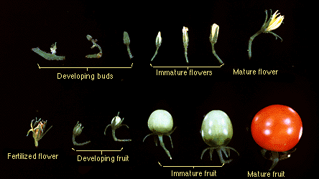**[15]**

**Figure 1.1** Tomato Flower Development

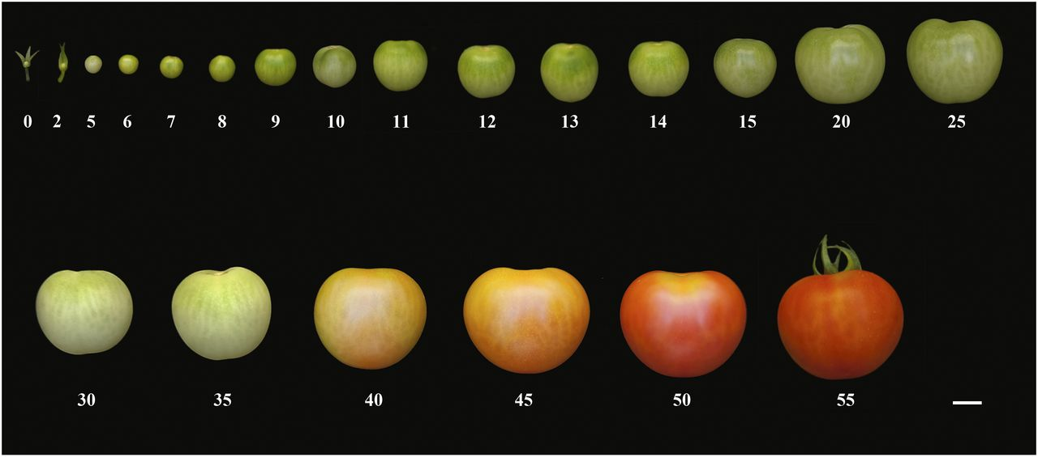[16]

**Figure 1.2** Tomato Fruit Development

### **2.1.8 Ethylene**

Ethylene is a natural occurring gas that is excreted by tomatoes, bananas, avocado, and peaches that promotes the process of ripening. Tomatoes are being picked in green state for transportation to avoid the occurrence of bruising and spoilage. Green tomatoes are ripened artificially by placing them in a room filled with ethylene gas to increase the speed of ripening[17]. According to University of Florida IFAS, ethylene is a natural plant hormone that affects the process of development of fruits. It is a sweet colorless odor excreted by fruits. Exposure to ethrel compound, which are used as a growth regulator, can affect also the shelf life of tomatoes. On the graph shown, a control data shows the highest shelf life or indicates the longest life for tomatoes of 10.11 days. It is then followed by 500, 125 and 250 ppm level, 1000 ppm level shows a shelf-life of 8 days and lastly, a lowest shelf life will occur at 2000 ppm that has 6.56 days. [14]

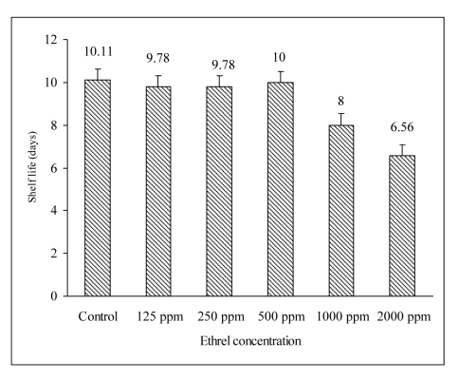

**Figure 5.2** Effect of ethrel levels on the shelf life of tomato

### 

### **2.1.9 Tomato Maturity Stages**

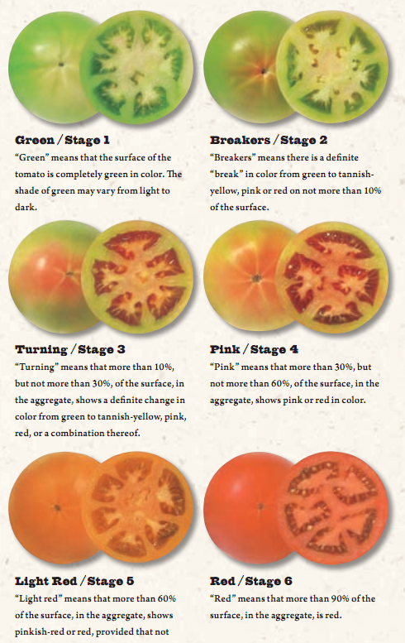

**Figure 2.1** The Six Maturity Stages

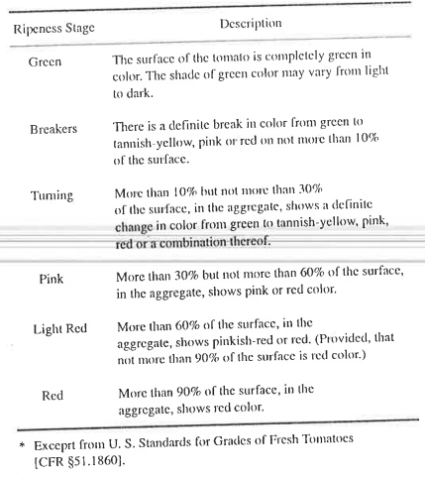

**Figure 2.2** USDAGrade Standard for Fresh Tomatoes

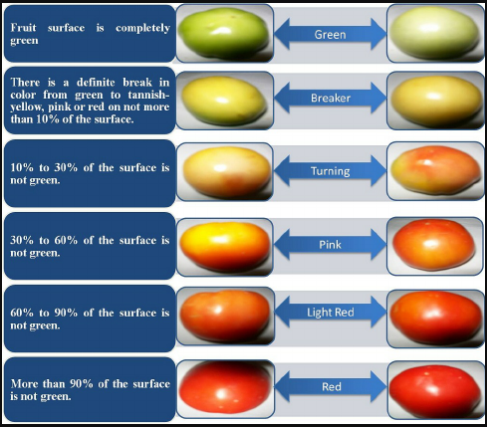

**Figure 2.3** Tomato Color Variation of the Maturity Stages

The guide has 6 stages, namely: Green, Breakers, Turning, Pink, Light Red, and Red. As the name of the stages suggest, each phase has a specific description on what degree of color a tomato should look like. Green stage means that the whole surface of the tomato is green. For Breakers shows a change of color from green, but not more than 10% of its surface[19]. “Turning” means that more than 10%, but not more than 30%, of the surface, in the aggregate, should show a definite change in color from green to tannish-yellow, pink, red, or a combination thereof. The Green stage means that the whole surface of tomato is totally green and the shade of green may vary from light to dark.The Light Red stage shows the 60 % of the surface shows pinkish red or red, and not 90 % of the surface is red. [20] Any lot of tomatoes which does not meet the requirements of any of the above color designations may be designated as Mixed Color:”[21]

### **2.1.10 Tomato Color Consistency All Throughout its Skin**

Tomato have different shape and color, the color of a tomato can classify the level of  
maturity. The research determined the maturity level of tomatoes based on its color. The average value of RGB components of the tomatoes picture were calculated to obtain the Image color of tomato levels.The red color more than 60%(ripe) indicated its shelf life 7-10 days, the red color more than 40% (half-ripe tomatoes) indicates shelf life 10-12 days, the red color more that 20% (half-unripe tomatoes) indicates shelf life 13-15 days, and the red color  
less than 20% (Unripe tomatoes) over 15 days. The study showed that the levels  
of red and green color affect the level of ripeness of tomato. The dominant color will indicate if the tomato is more ripened or less.The accuracy of determining and predicting the life of tomato varies from its image position. The study shows that when tomatoes simulcast from the side the level of accuracy reached 100%, while from the top reached 62.5 %[22].

### **2.1.11 Crop Age and Stage Duration**

Period of each stage on tomato is an important information that a breeder should know stage duration allows the breeder to know when the tomatoes should be picked and transported to markets that require long distances travel. According to the image shown (from Alba et al., 2005) their basis for tomato fruit development starts from the appearance of the flower where the counting will initialize. After seven days, small green tomatoes start to show. After seventeen to twenty-seven days the green tomato starts growing and the cell division and expansion occurs until it reaches the mature green state after thirty-nine days wherein the tomato is full in size. After reaching its maximum size, ripening phase will enter, reaching the Breaker stage wherein ethylene is rapidly produced in tomato and going to the Turning stage. At day forty-two, the tomato will reach its Pink stage continuing up to forty-seven days will transform the tomato to its Light Red stage. The final Stage of the tomato will occur on the range of the days from fifty-two to fifty-seven day[23]. The transition from Mature Green to Breakers takes two days, from Breakers it takes a day to reach Turning, from Turning it takes a day to reach Pink, then from Pink, after five days it reaches Light Red and finally turns Red after five days. It takes another five days for the tomato to be overripe, then finally it is spoiled.

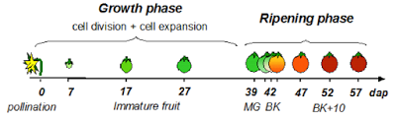

**Figure 3.1** Tomato stage duration

### **2.1.12 Different Chemical Compositions in each stage of Tomato**

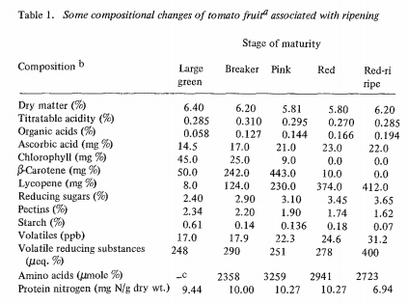

**Figure 4.1** Tomato chemical composition of maturity stages

Each stage of tomato has its chemical composition, Figure 4.1 shows the development of the chemical composition of the tomato as the maturity stage progresses [24].

### **2.1.13 Shelf life of tomato**

Based on the study of Moniruzzaman et al.(2013), green tomatoes have a higher storability compared to the breaker stage and then followed by a half-ripen tomatoes. Mature green tomatoes has a shelf life of 10.11 days, breaker stage has a shelf life of 9.11 days and a minimum of 7.88 days for half-ripen tomatoes. Based on his data, green mature has the highest shelf life of 13 days, a half-ripen tomato has a shelf life of 12 days. Exposure to ethrel compound, which are used as a growth regulator, can affect also the shelf life of tomatoes. On the graph shown, a control data shows the highest shelf life or indicates the longest life for tomatoes of 10.11 days. It is then followed by 500, 125 and 250 ppm level, 1000 ppm level shows a shelf-life of 8 days and lastly, a lowest shelf life will occur at 2000 ppm that has 6.56 days. [14]

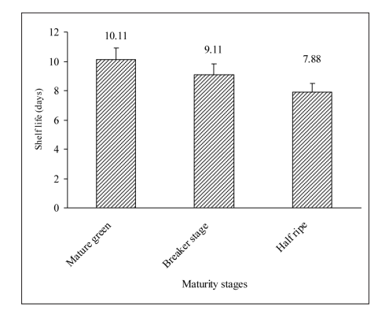

**Figure 5.1** Effect of maturity stages level on the shelf life of tomato

The storage of green tomatoes at 40 degree Fahrenheit after 3-4 weeks showed signs of insignificant color changes at the stem and in the interior of the tomato also a formation of fungi were also seen. Oxygen content can also affect the shelf life of tomatoes, a study of Tolle (1969), said that storing tomatoes at low pressure where there is only 5-21% oxygen reduces the ripening speed of Red stage tomato up to 5% level. This process is a controlled atmosphere system wherein oxygen is being controlled. Tomato storage can affect the chemical and physical characteristics of the fruit such as; color, firmness, and placental breakdown (Hall 1963). [26]

### **2.1.14 Tomato Storage Temperature and Shelf life**

Problems in spoilage were also encountered but a countermeasure was improved in packaging and refrigeration. Normally, tomatoes are purchased without considering their post harvest treatment, place of origin, packaging, and holding conditions. The lack of these practices makes it difficult to predict the loss during the shipment of these goods. Losses as high as 70% have been recorded. Storage temperature is a factor to be considered in affecting the shelf life of tomatoes. According to Parson (1959), he conducted studies on Navy reefer ships and concluded that mature green tomatoes stored at 58 degree Fahrenheit until it reaches the Red stage then transferred to room temperature of 33-35 degree Fahrenheit achieved better results. The same study of (Heiligman) also stated that transferring green tomatoes from 55 degree Fahrenheit to 32 degree fahrenheit room temperature increased their shelf life. [27]

### **2.1.15 Tomato Abnormal Coloring Conditions**

Abnormal coloring is a condition wherein the tomato does not have a color classification, it affects the inherent color of tomatoes. “Because of the nature of the defect it is difficult to accurately determine the normal color of tomatoes.” A yellow or orange flesh can be reported during the inspection of color. The United States Department of Agriculture says that: “In these cases, it is permissible to report the color using the following terms: green, breakers, turning, yellowish (orangish) green, light yellow (light orange) and yellow (orange).” Yellowish (orangish ) green can be classified as under pink, light yellow (light orange) is classified as light red, and yellow (orange) is considered as red.

The yellow color results from high temperature and lack of ventilation, these factors can alter the tomatoes color into a yellow to reddish-tan color over the entire surface of the tomato. To return to its normal color, tomatoes are provided with proper ventilation and temperature. Yellow to reddish-tan color does not affect the overall appearance of the tomato. [28]

**2.1.16 Proper harvesting of tomatoes**

According to Moniruzzaman et al., **“**Proper harvesting determines the nutrient contents as well as storage durability of any fruit. In all over the world, tomatoes are harvested at different maturity stages, such as green mature stage, breaker stage, half ripen stage and red ripen stage. Fruits are often harvested at the mature green stage to minimize the damage during postharvest handling. The fruits may later ripen spontaneously or after treatment with ethylene releasing compound (ethrel) before shipment to retailers.” (Wills et al., 2002) Deterioration of fruits can also happen during holding and marketing. The destruction of tomatoes are prone to nearly mature stages which in the breaker or more advanced stage of ripeness. Ripening of tomatoes also initiates its deterioration in climacteric fruits such as tomatoes (Abeles et al, 1992). Firmness can also be affected in storing process, storage can decrease its shelf life. A study was conducted that after 3 weeks of storing tomatoes at 15-20 degrees celsius the Red ripen tomatoes were found 78.2% rotting and only F47.5% fruit rotting was found in fruits harvested at the mature green stage (Goojing et al., 1999). Anju-Kumari et al. (1993) said that the shelf life of tomatoes were longest at the stage at which it is green stage that lasts from 10.9-13.5 days. Based on the study of Dennis et al. (1979), green matured tomatoes can be stored for up to 6 to 10 weeks in control atmospheric storage. Acid content on immature fruit are low compared to fruits that has started the stage where color starts to appear, acid content will rapidly decrease as it ripens (Boe et al., 1967). [29]

**2.1.17 Tomato Proper Handling**

According to Arah et al., improper handling during and after harvest of products can lead to bruising and injury to the shelf life of fruits, they also concluded that it is important to know the basics of handling process to maintain the quality of the tomatoes. These processes includes; harvesting, precooling, cleaning and disinfecting, sorting and grading, packaging, transportation, and storage[30]. Researchers found that more than 16% of respondents encounter produce losses because of high incidence of disease, insect pest and mechanical injuries, each of them are considered to be more than 20% of postharvest losses. Reducing postharvest losses is limited due to insufficient of technical know-how. They also lack required support and complementary resources to improve postharvest handling practices and technology[31].

### **2.1.18 Postharvest Handling Practices and Treatment Methods for Tomato**

Packaging is also one of the important aspects to consider in addressing post harvest losses in fruits and vegetables. It is enclosing food produce or product to protect it from mechanical injuries, tampering, and contamination from physical, chemical, and biological sources. Packaging as a postharvest handling practice in tomato production is essential in putting the produce into sizeable portions for easy handling. In the recent years the demand of tomato has increased due to the economic and nutritional importance of the crop. In this study, the postharvest quality and shelf life of the fruit in part depends on some postharvest handling practices and treatments after harvest. Handling practices, such as sorting and grading, packaging, storing and transportation are factors to maintain quality and extend the shelf life of the tomato. This study concluded that the value of the harvested fruit can be preserve and extend shelf life by following the appropriate postharvest handling practices and treatment methods. [32]improper care. Handlers in developing countries should be wary of the outcome of choosing the transportation option for their products.

### **2.1.19 Handling Tomatoes at Wholesale and Retail: A Guide for Better Quality and Greater Profits**

Failure in Handling tomatoes causes immature or over-ripeness at shipping point, quality control at shipping point, physical damage, long delays between harvesting and consumption. It is indeed the responsibility of each handler which are the producer, buyer, carrier, Receiver/repacker, Retailer, and Consumer. Maintaining the high quality of tomatoes and diminishing marketing losses is the responsibility of all handlers, to consumers from farmer-shippers. Buyers are included for the responsibility of providing quality tomatoes even if they don’t normally “handle” tomatoes, but because they are the influence shippers and their receivers customers with respect to the initial quality and maturity shipped. Consumers are also included because they actually handle tomatoes before consumed[33].

### **2.1.20 Farmer’s Loss Due To Mishandling of Tomatoes**

The fully ripened stage of the tomato is susceptible to mechanical damage from handling and transportation, thus reducing the shelf life and quality which will lead to postharvest loss that affects the income of farmers [34]. When the quality of tomatoes degrades due to lack of ventilation in storage facilities, the farmers are forced to dispose of the tomatoes by means of selling it for a low price. The farmer’s lack of storage forces them to sell the tomatoes to wholesalers which has proper storage facilities, at a low price [35]. For a farmer a good quality produce will yield a better income because crops is not only used for direct consumption but also in the food industry wherein it is processed to produce other products such as sauces, jams, and other canned products [36].

### **2.1.21 Tomato Transportation**

Rahman et al. stated that tomatoes are second to lettuce in value when it comes to the cost of perishable. They say that the current handling of tomatoes does not ensure the good quality that the consumers want when the products are delivered overseas. They also stated the shelf life of tomatoes on domestic markets which lasts up to 1-3 weeks, whereas shipping may require a shelf life of 5-8 weeks[37]**.**

**2.1.22 Ideal Use of Tomato for Each Stage**

For mature green, breakers, and turning stages, it shows that it can continue its maturation off the vine, these stages is said to be tough and can be ship with less damage compared to those tomatoes that are more mature , but it needs to be separated with each other in order for it to continue ripening as it reaches it’s destination[38]. Green Stage , this stage have been popular a lot for people that enjoy eating green tomatoes as fried , stewed or pickled. Green tomatoes are rich in Vitamin B and antioxidant and may help to fight cancer [39].

For pink, light red, and red tomatoes that offers standard tomato flavor:acid and sweetness in balance[40]. For overripe tomatoes, it is best used as spaghetti sauce and tomato sauce.[41]

### **2.1.23 Nutritional Content of Processed Tomato products**

According to a study, the lycopene content of processed tomato products can be easily absorbed by the body compared to raw tomatoes, other processed tomato products includes; tomato sauce, tomato paste, and tomato ketchup are better lycopene source. The study of Gartner et al also argued the same topic about lycopene availability of processed tomato products compared to fresh tomatoes, the researchers concluded that the lycopene from a tomato paste is 2.5 times more bioavailable than fresh tomatoes [42]. According to researchers, processing tomatoes can break down cell walls which makes the lycopene be easily for the body to intake. Lycopene absorption can be enhanced when tomatoes are consumed with small amount of fats which are available on cooking oil [43].

### **2.1.24 Ascorbic Acid**

Ascorbic Acid as known as Vitamin C is used to avoid or treat low levels of vitamin C in people who lacks the vitamin from their diets. Low levels of vitamin C can cause scurvy condition, Scurvy may cause symptoms such as rash, muscle weakness, joint pain, tiredness or tooth loss. Ascorbic Acid plays an important role in the body, it needs to maintain the health of skin, cartilage,teeth,bone, and blood vessels. It is also known as an antioxidant[44].A powerful source of antioxidant and water-soluble that helps the human body form and keep connective tissue as well as bones,blood vessels and skin. Ascorbic acid regenerates and repair tissues, protect anti heart disease, supports the absorption of iron, prevents scurvy and lowers total and LDL("bad")cholesterol and triglycerides. Researchers showed that ascorbic acid may also help in protecting against types of cancers by the combat of free radicals, and helping neutralize the effects of nitrites[45].

### **2.1.25 Beta-Carotene**

Beta-carotene is a red/orange pigment found in many fresh fruits and vegetables, it is converted into vitamin A as an essential vitamin. People needs vitamin A since it maintains healthy skin and mucus membranes, our immune system, and good eye health and vision. Vitamin A is an essential nutrient but Beta-carotene itself is unessential. Beta-carotene is an antioxidant, An antioxidant protects the body from free radicals, it is a substance that stops the oxidation of different molecules[46].

### **2.1.26 Lycopene**

Lycopene can be found in large amounts in tomatoes and tomato products. It is natural chemical that gives fruits and vegetables a red color, one of a number of pigments that is called carotenoids. Processed raw tomatoes with the use of heat (in the making of tomato juice,tomato paste, or ketchup) basically changes the lycopene in the raw product into a form that is simpler for the body to use. Supplements that has lycopene is about as easy for the body to use as lycopene found in food. Lycopene prevents heart disease, "hardening of arteries"; and cancer of the prostate, breast, lung, bladder, ovaries, colon and pancreas. It can treat human papillomavirus(HPV) infection. People also use lycopene for asthma and cataracts. Lycopene works as a powerful antioxidant that helps protect the cells from harm[47].

### **2.1.27 Potassium**

Potassium helps maintain a correct fluid balance it also assists the function of your cells, tissues and organs. The mineral is required for relaxation and contraction of your muscles, and keeps your heart beating normally. Enough intake of potassium will keep your bones strong and function of your digestive system will work smoothly. Potassium will lower your risk of heart disease since it keeps your blood pressure normal[48].

### **2.1.28 Folate (B9)**

Folate is a general term for a group of water soluble b-vitamins and also known as B9. Folates can be found in food and in metabolically active forms in the human body. It helps maintain the biological activity of living cells. Surely, An intake of folate(vitamin b9) contributes to the following, normal blood formation, normal homocysteine(a nerve and vessel toxin, promotes mortality and cardiovascular disease, strokes,alzheimer's disease), a normal metabolism of the immune system,normal cell division;normal maternal tissue growth during pregnancy;normal amino acid synthesis;normal psychological functions;the reduction of tiredness and fatigue;maintenance of normal vision;increases maternal folate status,which contributes to the reduction of the risk of neural tube defects (NTD)[49].

### **2.1.29 Fiber**

It is a kind of carbohydrate that the human body can't digest. We know that carbohydrates are broken down into sugar molecules,fiber cannot be broken down into sugar molecules but it will pass through the body undigested.Fiber works with regulating the use of sugars in the body, it helps keep hunger and blood sugar in check. A minimum of 20 to 30 grams of fiber per day must be consumed by children and adults for good health. There are 2 types of fiber, Insoluble and Soluble Fiber. The Latter came from tomato's tough outer skin,and also as the seeds.Throughout digestion,push out waste and easing constipation The insoluble fiber components(tomato skin,seed, etc) stay intact. A regular movement of the bowel comforts tense bloating in your gut, it lessens the chances of having hemorrhoids and lowers the risk of evolving diverticulitis, which is a painful inflammatory condition of the small intestines. Insoluble fiber also helps the stool soften, so that they are easier to pass. The Soluble Fiber then came from the inner flesh of the tomato. Compared to insoluble fiber it acts differently in the digestive tract and is easier to chew. The soluble fiber will bind with water and create a thick gel once it gets to your small intestine. The material will decelerate digestion and allows nutrients to fully absorb through the lining of your intestine. The excess of cholesterol in your will be picked up by soluble fiber and will help pass through fecal waste. It also stabilize blood sugar levels since it slows sugar absorption[50].

### **2.1.30 Reducing Sugars**

Reducing sugars is a term for a sugar reducing agent that can give electrons to another molecule. This process can react to other parts of the food like the change of the color or the taste of the food. The most important reducing sugar is the glucose since it is known as blood sugar for it is essential for brain functionality and physical energy. The fructose is the sweetest of all monosaccharides, the galactose is a component of lactose that is found in dairy products and the maltose is produced during digestion when starch molecules are broken down[51].

## **2.2 Unhealthy Country: Philippines**

According to T.Torres of The Philippines Star, Philippines is one of the unhealthiest countries in Asia as of 2016. The pan-Asian insurance giant AIA group conducted a survey, and the Philippines scored 61 out of 100, and has remained below the regional average of 64 since 2011. The survey was conducted face to face with 764 filipinos, and 80% of adults are not satisfied with their health. Due to Insufficient exercise and unhealthy eating habits, 40% of the adults from the survey are overweight and 25% would like to lose weight. 84% of the surveyed admitted that they tend to eat while distracted, 81% eat unhealthy snacks between meals and 71% had their dinner when it's almost bedtime. “Attempts to eat healthier are still restricted to the basics of drinking more water and eating more fruits and vegetables,” Isaac lamented. 52% of adults admit being addicted online, and 30% percent of Filipino parents say that their children do not get enough exercise, 22% have their child sleep deprived due to watching TV, video games, and being online through the internet. The younger generation’s health is at risk, the main health concerns are heart diseases, stroke, respiratory illness, diabetes, being bedridden or wheelchair bound, and cancer[52].

## **2.3 Raspberry Pi**

Raspberry Pi was build to develop the education of children and adults, specifically in the field of computers and computer science. Raspberry Pi works in a single circuit board and features ports for HDMI, USB 2.0 , Composite Video, Analog Audio, Power , Internet and SD Card. It operates as an open source software that can be used to mix and match software with respect to the interest of the user [53]. The Raspberry Pi is powered by a 5V micro USB AC charger or at least 4AA batteries [54].

### **2.3.1 Raspberry Pi 3 vs Pi 2**

Raspberry Pi 3’s hardware with a quadcore CPU clocked at 1.2 GHz doesn’t look good on paper and when compared to the previous Raspberry Pi 2 with a quadcore CPU clocked at 900 MH but its improvements are big. The architecture was change from 32-bit to 64 bit, thus better performance for the clock speed. The Raspberry Pi 3 also has an increase of GPU clock from 250 MHz to 400 MHz. Both are designed to deliver 1080P video and have the same RAM only the Raspberry Pi 3’s RAM is clocked at 900 MHz while the Raspberry Pi 2’s is clocked at 450 MHz. The apps and the switch from the Raspberry Pi 2 to the Raspberry Pi 3 has been smooth sailing. The apps installed through Raspbian GUI that was used in the previous model worked perfectly fine on the latest model[55].

### **2.3.2 Raspbian OS**

One of the operating systems that can be installed on a Raspberry Pi is Raspbian, it is a free operating system based on Debian. Raspbian comes with more than 35,000 packages, and pre-compiled software for ease of installation. The initial build of more than 35,000 Raspbian packages was programmed to perform well on the Raspberry Pi, the packages was complete by June 2012. Raspbian is still under development as of today and improvements for stability and performance is prioritized for the Debian packages [56].

### **2.3.3 Raspberry Pi Power Supply Rating**

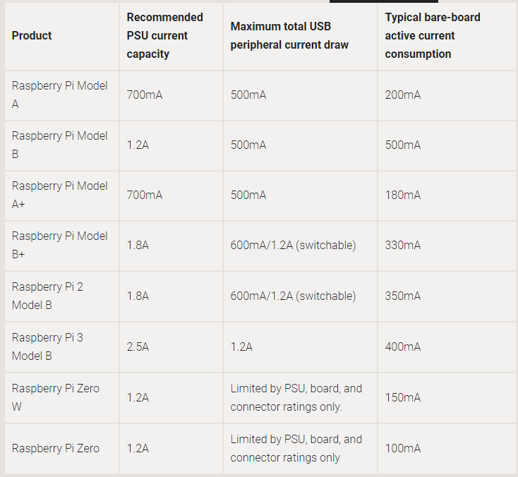

**Figure 6.1 Power consumption of Raspberry Pi**

The maximum voltage and current the Raspberry Pi can use for power are 5V and 2.5A. Anything over the specified voltage tolerance of the Raspberry Pi can damage it. Using a powerbank with constant outputs of 5V 2.1A & 5V 2.4A to power up the Raspberry Pi [57] and the external components such as the LCD and the Pi camera is safe since the RPi3 uses 1.2A while the camera module only draws 250mA [58] and the LCD 300-400mA [59] .

### **2.3.4 Tomato RGB Value Per Stage**

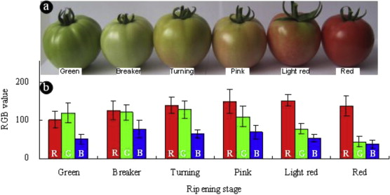

**Figure 7.1** RGB Values of Tomato per Stage

In this study, an RGB model for each maturity stage was suggested by simulating evaluating the texture of two tomato cultivars. The image of the tomato was captured by a digital camera. Using a color picker software ColorPix1.1, 10 pixel points were randomly chosen from each tomato stage image, the RGB values were obtained from the automatic transformation of the software[60].

**2.3.5 RGB vs. L*a*b* Color Space**  
Our brains are accustomed to viewing RGB on monitors and CMYK on print. Lab color space is a much closer approximation of those colors. Lab color space removes restrictions of how humans perceive the colors in the world and allows us to really see the subtle differences between the two color dimensions. RGB is how displays see the colors in the world, CMYK is how printers see the colors in the world and Lab space is how your eyes see the colors in the world.[61]

### **2.3.6 Tomato Maturity Estimation**

Using the a* in L*a*b* color space, the expiration date of the tomato can be estimated. The a* value suggests the maturity level for tomatoes, and from this an estimation was derived, which achieved 96% correctness. The table in this study shows that Breakers (10 – 20% of full maturity) is estimated to expire in 21 to 28 days, Turning (30 – 40% of full maturity) is estimated to expire in 15 to 20 days, Pink (50 – 60% of full maturity) is estimated to expire in 15 to 20 day, Light red (70 – 80% of full maturity) is estimated to expire in 5 to 6 days, and Red (full maturity) is estimated to expire in 2 to 4 days [62].

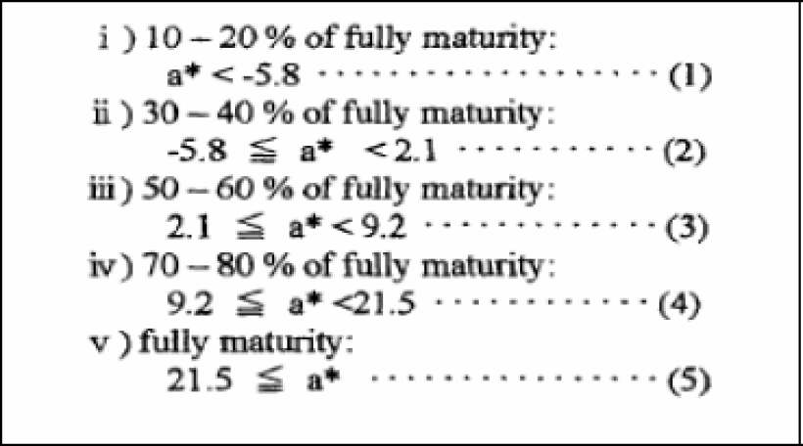

**Figure 8.1** a*-value reference for the maturity stage of tomato

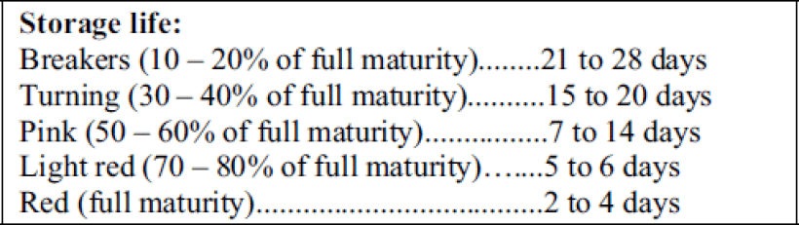

**Figure 8.2** Suggested shelf life of tomato per maturity stage

### **2.3.7 Relation of Raspberry Pi and Python**

Raspberry Pi lets you connect your project to the real world. The usage of python through Raspberry Pi can be introduced by IDLE,a Python development environment it is also the easiest way for python to be launch.REPL(Read-Evaluate-Print-Loop) a prompt that can be entered with Python commands are provided by IDLE. There are two versions of Python, Python 2 and Python 3, The latter is the latest version and is recommended, although Python 2 is available for legacy applications that doesn't support Python 3 yet.Creating a python file in IDL is simple, click file> New file and the a blank window will be given to you. It is an empty file, not a python prompt.The python file will be written in this window just save it, then run it and the output in the other window will be visible. To be able to make your Raspberry Pi ideas a reality can be achieved by Python. You can produce a entertaining and educational introduction to it by learning Python with Raspberry pi. Python is one of the most useful language to know for Raspberry Pi[63].

### **2.3.8 Effect of brightness to RGB Values**

By considering brightness, It is a fact that brighter colors obtains higher values of red,green and blue components. By increasing or decreasing the color components of each pixel we can naturally alter the brightness of an image[64].

### **2.3.9 CMYK**

CMYK is the combination of predominant pigments of a project. The C stands for cyan(aqua), M stands for magenta (pink), Y for yellow, and K for Key. Black has not always been today’s printing world key color. The CMYK pigment model generates like an “upside-down” version of the RGB color model. A lot of drawing programs and paint can make use of either CMYK or the RGB model. The difference between the two is that, the RGB model is mostly used for computer displays, while the CMYK scheme is used for printed color picture. The basic difference between color and pigment is that the color represents energy radiated by a shining object such as a light-emitting diode(LED)or a cathode ray tube(CRT). The primary colors are RGB(red,green and blue). The red area on a CRT looks red because of the large amount of light being radiated in the red portion of electromagnetic radiation spectrum(around 750 nm), and less than other wavelength. Now the pigments are opposed to colors, they represents energy that isn't absorbed by a material such as ink or paint. The primary pigments are cyan(C),magenta(M), and yellow(Y). Since black can be acquired with the combination of pure cyan,magenta and yellow in the same and large amounts, black is sometimes considered as a primary pigment. The CMYK mode is mainly used in creating illustrations for print media[65].

### **2.3.10 Raw Image as AdobeRGB**

In the world of digital photography, wherein there are two types of color spaces, AdobeRGB and sRGB. Photos that are captured in the AdobeRGB color space has more vibrancy with respect to their colors. In condition where you’re photographing powerful color tones, AdobeRGB confidently displays those colors with more accuracy. It was reported that AdobeRGB can represent about 35% more color ranges than sRGB. Printers, have started modifying the AdobeRGB color space. In result, it allowed more vibrant colors in your printouts, with much better color consistency compared to your own monitor can't even replicate. If you want your prints to look unlikely than they do on your monitor use AdobeRGB color space because it produces richer colors that will bring out unseen details. Without deficiency in your image,you can convert AdobeRGB to sRGB anytime if you're shooting in AdobeRGB. AdobeRGB is the choice for you if you're frequently printing your work and looking for vibrant colors, it is just right to use Adobe RGB[66].

### **2.3.11 Monitors uses RGB while Printers uses CMYK**

The basic thing to understand about colors is the dissimilarity between being subtractive and additive. This will help us understand why RGB is used by monitors and CMYK for printers. The additive color theory explains that Red, green and blue light are joined on a tv screen/computer monitor the colors overlaps to become cyan, magenta, yellow and black. It simply shows that light is being released(or added) on a monitor, which is significant because when you release(or add) Red, Green, and Blue they produce White(light)that is why it is important on a monitor, that light is being emitted(or added). The subtractive color theory states that CMYK is produced with ink, as against to light, Red, green and blue light waves are being absorbed by Cyan, magenta, and yellow ink, and our eyes to identify the residues. If you look at ink or paint in whatever way, light is being drained (or subtracted) and when you consume Red, Green, and Blue you'll get Black. That is the basis for understanding why CMYK is used by printers, although we usually see Computer monitors and TVs using RGB. The reason why they use Magenta, yellow, and cyan instead of Red, yellow and blue is that the latter is the newly improved versions of their notable Red, yellow and blue counterparts. Scientifically, CMYK is beneficial because each colors overlaps two primary colors. Magenta overlaps red and blue, Cyan overlaps blue and green, Yellow overlaps green and red. With these overlapping color, you are able to begin subtracting light waves to produce specific colors, for example if you are to produce Red you would combine Yellow and Magenta. When you are painting, you’re technically seeing that the paint is currently absorbing most of the Cyan spectrum and reflecting Magenta and Yellow back, which results in Red[67].

### **2.3.12 Solving for the Mean Value of RGB**

According to Kevin Simper of “ A Medium Corporation”, getting the average value of RGB from all the pixels that builds up an image is wrong. Mathematically, in getting the average of a value is by getting the sum of all the given value then dividing it by how many the sample is. This kind of technique will make the output image darker. Technically, the reason why is because when a digital camera capture an image, instead of storing the brightness values it stores their square roots and when it is needed to display the image on a monitor, it is needed to square the brightness to present the colors properly. Taking the square root of all the colors will save up space. [68]

**Chapter 3**

# **METHODOLOGY**

**Chapter 3.1 Conceptual Framework**

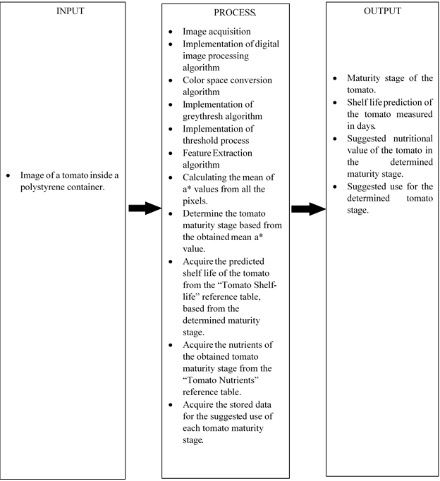

**Figure 9.1** Conceptual Framework of Methodology

The tomato’s maturity will be determined by capturing the image of the tomato itself then the system will start to acquisition the image then implementation of digital image processing to improve the clarity of the image and reduce the noise. The image will be converted into LAB color space then into grayscale image using graythresh algorithm in order to be easily convert it into binary image. Threshold process will now be executed to acquire the binary image of the photo to easily determine the object and the background. The feature extraction will be implemented so that the average a* value of the object will be acquired. The acquired a* value will be compared from the maturity table of the tomato to determine the state of maturity whether it is green, breaker, turning, pink, light red or red. The shelf life and the nutrients of the tomato will be based from the maturity level detected by the system. The system will now display what will be the level of maturity, the predicted shelf life that was referred from the Tomato Maturity Index, its nutrient content and the suggested use of the tomato from its current state.

## **3.2 Design**

### **3.2.1 Device Design Proposal**

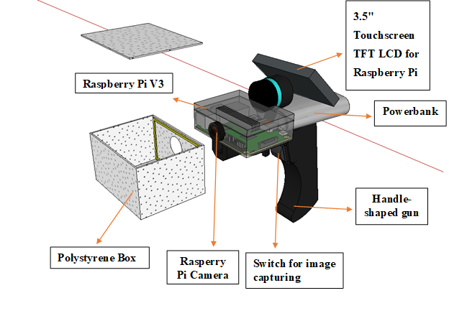

**Figure 10.1** Design Proposal

A Raspberry pi V3 will be used in this project that was configured using PYTHON along with a camera module, which is a Raspberry Pi camera V2 and a display module 3.5" Touchscreen TFT LCD for Raspberry Pi which will be connected to the rpi with the use of flexible flat cables. The Raspberry Pi camera V2 inserts into the Raspberry Pi V3 connector situated between the Ethernet and HDMI ports, with the silver connectors facing the HDMI port, it serves as the medium to capture images of the tomatoes that will be send and analyze into the raspberry Pi V3 that sends the information gathered to the LCD screen in order to communicate with the user. The Raspberry pi V3 connecting the four cables to the 5V, Ground, SCL and SDA connectors on the display board. The four jumper cables to the GPIO, matching 5V to 5V, Ground to Ground, etc. Then connect the ribbon cable to the Raspberry Pi, first unclipping the catch, and slotting it into place without twisting. Press the catch down when the ribbon is fully inserted to secure it. The button for capturing the image is installed on the handle of the device that looks like a handle-shaped gun. All of the external components connected to the RPi 3 will be powered using an external power bank with outputs of 5V 2.1A & 5V 2.4A connected by a usb cable.

### **3.2.2** **Setting Up Raspbian OS on the Raspberry Pi**

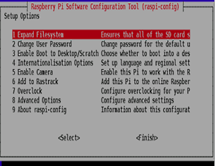

**Figure 11.1** Raspbian Setup Options Menu

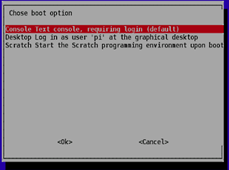

**Figure 11.2** Raspbian boot option

The first thing to do after buying a new Raspberry Pi is to install an operating system to navigate through its system. To do so an 8 GB micro SD card is required, format the SD card using the SD Formatter 4.0 application from the SD Association’s website. Download the RASPBIAN STRETCH WITH DESKTOP zip from the Raspberry Pi website. Using the “Etcher” application, select the downloaded RASPBIAN STRETCH WITH DESKTOP zip file and the SD card to be written on, then click “Flash”. Safely remove the SD card from the computer then insert into the Raspberry Pi. Boot up the Raspberry Pi, when credentials are asked, use “pi” as the username and “raspberry” as the password. In the “Setup Options” select “Expand Filesystem” to use all the space of the SD card to be used by the OS. Then select “Enable Boot To Desktop/Scratch” to proceed to the “choose boot option window” then select “Desktop Login” as user pi at the graphical desktop”. If the window doesn’t return to the “Setup Options” select the OK button at the bottom of the window then select finish. If the Raspberry Pi doesn’t reboot automatically, use the “sudo reboot” command on the terminal. After booting to the GUI update the firmware by using the “sudo rpi-update” on the terminal.

### **3.2.3** **Installing an LCD Display for the Raspberry Pi**

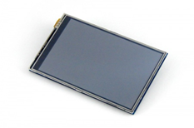

**Figure 11.3** Raspberry pi LCD

The device consists of a 3.5 inch touch screen TFT LCD display. To install the LCD on the Raspberry Pi, connect the display onto the board first then extract the image file with the pre-installed driver to the microSD card of the Raspberry Pi, insert the SD card to the Raspberry Pi then boot up and complete the installation.

### **3.2.4 Camera Installation**

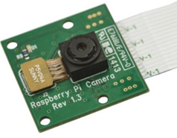

**Figure 11.4** Raspberry pi camera module

Connect the camera module using its ribbon cable, to the Raspberry Pi 3 then boot up your Raspberry Pi. In the prompt, run “sudo raspi-config”. If the “camera option is not listed, update your Raspberry Pi using the command sudo apt-get update" and "sudo apt-get upgrade”. Enter the command “sudo raspi-config” again and navigate through the “camera” option, enable it and finish, then reboot the Raspberry Pi.

### **3.2.5 Python Code**

The code to be used in determining the output of the device is Python code. This is used in order for the Raspberry Pi to be a standalone and portable device. The code will be made in such a way that it will display the stored information on the LCD attached to the Raspberry Pi. The information to be displayed is dependent on the mean values of RGB from the tomato image and the determine maturity stage.

### **3.2.6 Hardware Block Diagram**

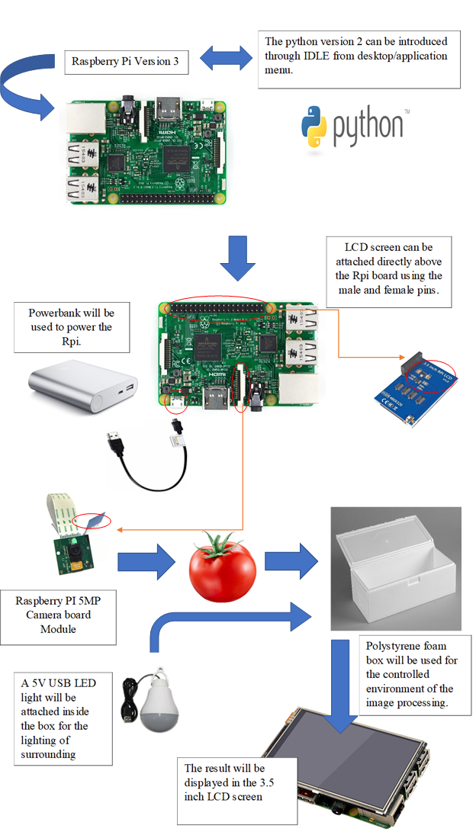

**Figure 11.5** Hardware block diagram

The Raspberry Pi Version 3 is programmed with the use of Python Version to analyze the Image Processing. The Raspberry Pi 5MP Camera Board Module is in charge of capturing the image of the tomato that is connected to the Raspberry Pi V3.The power bank with an output of 5 Volts 2.4 Amperes and 5V 2.1A is attached to the Raspberry Pi as the source of power for itself and the external components. The Raspberry Pi 5MP Camera Board Module will capture an image of the tomato that is placed in a Polystyrene foam box which will keep the tomato secure from uncontrolled light. The Polystyrene foam box is attached with a 5V USB LED light to lighten the foam box, it will also help maintain the resolution of the captured image. After a few seconds, the 3.5 inch LCD screen will display the result of the captured image that is directly attached above the Raspberry Pi v3 board using the male and female pins. The monitor then displays the maturity level of the tomato and its predicted shelf-life, it will also show the specific nutrient contents of the tomato and suggest where the tomato should be used. All devices are placed on top of a gunned shape holder that is specifically designed for its parts.

### **3.2.7 Algorithm Flow Chart**

**Figure 12.1** Algorithm Flow Chart Part 1

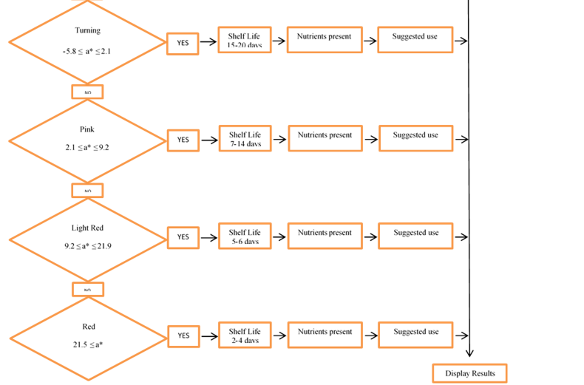

**Figure 12.2** Algorithm Flowchart Part 2

The first step will start with capturing the image of tomato. Image acquisition will take place then implementation of digital image processing will be executed to improve the clarity and remove the noise from the image. Conversion of RGB to LAB will be executed. Graythresh will be implemented so that it would be easier to convert it into a binary image. The grayscale image will go through threshold process so that it is easier to identify the object from the background image. The feature extraction will be executed so that the average value of a* will be determined. The device will decide now if the calculated mean value is qualified under the different a* of the gathered level of maturity stages (Green, Breakers, Turning, Pink, Light Red and Red). The device will be able to determine the ripeness level of the tomato and will now proceed to predicting its shelf-life. After predicting the shelf-life of tomato, the device will proceed in presenting the nutrient contents of the captured image of tomato, it will compare the data gathered data from the obtained nutrient chart from the research. After the device finished comparing, it will state a suggestion where the tomato should be used. Lastly the device will now display the results.

### **3.3 Tests and Calibration**

The tomato samples will be tested at room temperature with a tape over its stem scar to prevent bacteria and mold from entering and to prevent moisture from leaving. The tomatoes will be placed in individual storages to prevent additional Ethylene presence that will affect the ripening process of the tomato. The data that will be gathered will be compared with the existing reference values. If the values gathered falls under the correct maturity stage, then calibration may not be needed anymore. If the values gathered falls under the wrong maturity stage, then the device will be calibrated by changing either the light intensity for the image, the code, or image quality

**Table 1.1** a* Value Comparison with a Printed Image as Reference

|  |  |  |  |  |  |
| --- | --- | --- | --- | --- | --- |
| Stage | Sample | Trial | Print: Tomato | Print: Lab Space | Actual Tomato |
| Mature Green  R= 101.67 ± 21.95  G= 118.33 ± 26.67  B = 51.67 ± 11.66 | 1 | 1 |  |  |  |
| … |  |  |  |
| 30 |  |  |  |
| 2 | 1 |  |  |  |
| … |  |  |  |
| 30 |  |  |  |
| 3 | 1 |  |  |  |
| … |  |  |  |
| 30 |  |  |  |
| Breakers  R = 125 ± 25  G= 121.67 ± 18.33  B = 76.67 ± 23.33    a* < -5.8 | 1 | 1 |  |  |  |
| … |  |  |  |
| 30 |  |  |  |
| 2 | 1 |  |  |  |
| … |  |  |  |
| 30 |  |  |  |
| 3 | 1 |  |  |  |
| … |  |  |  |
| 30 |  |  |  |
| Turning  R= 138.33 ± 21.67  G= 128.33 ± 21.67  B= 65 ± 10    -5.8 ≤ a*<9.2 | 1 | 1 |  |  |  |
| … |  |  |  |
| 30 |  |  |  |
| 2 | 1 |  |  |  |
| … |  |  |  |
| 30 |  |  |  |
| 3 | 1 |  |  |  |
| … |  |  |  |
| 30 |  |  |  |
| Pink  R= 150 ± 32  G= 110 ± 27  B= 70 ± 18  2.1 ≤ a*<9.2 | 1 | 1 |  |  |  |
| … |  |  |  |
| 30 |  |  |  |
| 2 | 1 |  |  |  |
| … |  |  |  |
| 30 |  |  |  |
| 3 | 1 |  |  |  |
| … |  |  |  |
| 30 |  |  |  |
| Light Red  R= 152 ± 15  G= 78 ± 13  B= 54 ± 9    9.2 ≤ a*<21.5 | 1 | 1 |  |  |  |
| … |  |  |  |
| 30 |  |  |  |
| 2 | 1 |  |  |  |
| … |  |  |  |
| 30 |  |  |  |
| 3 | 1 |  |  |  |
| … |  |  |  |
| 30 |  |  |  |
| Red  R= 136.67 ± 26.66  G= 43.33 ± 15  B= 38.33 ± 10    21.5 ≤ a* | 1 | 1 |  |  |  |
| … |  |  |  |
| 30 |  |  |  |
| 2 | 1 |  |  |  |
| … |  |  |  |
| 30 |  |  |  |
| 3 | 1 |  |  |  |
| … |  |  |  |
| 30 |  |  |  |

For this table, the determined a* value for the actual tomato sample will be compared with the Lab-value reference, the determined Lab value for a printed tomato, and the Lab value for a printed Lab color space image created with the same values with the Lab-value reference. To properly calibrate the device, the variables affecting the a* value, such as the lighting, image, quality, or the code itself may require adjustments.

**Table 1.2** a* Value Comparison with Image Displayed on a Monitor as Reference

|  |  |  |  |  |  |
| --- | --- | --- | --- | --- | --- |
| Stage | Sample | Trial | LED Display: Tomato | LED Display: Lab Space | Actual Tomato |
| Mature Green  R= 101.67 ± 21.95  G= 118.33 ± 26.67  B = 51.67 ± 11.66 | 1 | 1 |  |  |  |
| … |  |  |  |
| 30 |  |  |  |
| 2 | 1 |  |  |  |
| … |  |  |  |
| 30 |  |  |  |
| 3 | 1 |  |  |  |
| … |  |  |  |
| 30 |  |  |  |
| Breakers  R = 125 ± 25  G= 121.67 ± 18.33  B = 76.67 ± 23.33    a* < -5.8 | 1 | 1 |  |  |  |
| … |  |  |  |
| 30 |  |  |  |
| 2 | 1 |  |  |  |
| … |  |  |  |
| 30 |  |  |  |
| 3 | 1 |  |  |  |
| … |  |  |  |
| 30 |  |  |  |
| Turning  R= 138.33 ± 21.67  G= 128.33 ± 21.67  B= 65 ± 10    -5.8 ≤ a*<9.2 | 1 | 1 |  |  |  |
| … |  |  |  |
| 30 |  |  |  |
| 2 | 1 |  |  |  |
| … |  |  |  |
| 30 |  |  |  |
| 3 | 1 |  |  |  |
| … |  |  |  |
| 30 |  |  |  |
| Pink  R= 150 ± 32  G= 110 ± 27  B= 70 ± 18  2.1 ≤ a*<9.2 | 1 | 1 |  |  |  |
| … |  |  |  |
| 30 |  |  |  |
| 2 | 1 |  |  |  |
| … |  |  |  |
| 30 |  |  |  |
| 3 | 1 |  |  |  |
| … |  |  |  |
| 30 |  |  |  |
| Light Red  R= 152 ± 15  G= 78 ± 13  B= 54 ± 9    9.2 ≤ a*<21.5 | 1 | 1 |  |  |  |
| … |  |  |  |
| 30 |  |  |  |
| 2 | 1 |  |  |  |
| … |  |  |  |
| 30 |  |  |  |
| 3 | 1 |  |  |  |
| … |  |  |  |
| 30 |  |  |  |
| Red  R= 136.67 ± 26.66  G= 43.33 ± 15  B= 38.33 ± 10  21.5 ≤ a* | 1 | 1 |  |  |  |
| … |  |  |  |
| 30 |  |  |  |
| 2 | 1 |  |  |  |
| … |  |  |  |
| 30 |  |  |  |
| 3 | 1 |  |  |  |
| … |  |  |  |
| 30 |  |  |  |

For this table, the image will be acquired by capturing the image of the tomato, and color space figure displayed on the monitor, the determined a* value for the actual tomato sample will be compared with the a*-value reference, the determined a* value for a tomato displayed on an LED monitor, and the a* value for the Lab color space image displayed on an LED monitor, created with the same values with the a*-value reference. To properly calibrate the device, the variables affecting the a* value, such as the lighting, image, quality, or the code itself may require adjustments.

**Table 1.3** Existing and Experimental Tomato Chemical Composition Comparison

|  |  |  |  |  |  |
| --- | --- | --- | --- | --- | --- |
| **Chemical Composition** | **Stage (Laboratory Result)** | | | | |
|  | **1** | **2** | **4** | **5** | **6** |
| Total Reducing Sugar (%) |  |  |  |  |  |
| Ascorbic Acid (Vitamin C) (mg%) |  |  |  |  |  |
| Potassium/100g (mg) |  |  |  |  |  |

The existing chemical composition of the tomato will be compared with the chemical composition from the conducted experiment in order to properly calibrate the basis of the device in projecting the chemical content of the tomato for each stage. The experiment will be conducted in a laboratory with at least 2 tests and the tomatoes will be tested by performing Lane&Eynon, Titrimetry, and AAS. This table will help to accurately determine the tomato’s maturity stage. This table is limited to only three (3) chemical composition due to financial restrictions.

**Table 1.4 Tomato Stage Transition at Room Temperature**

|  |  |  |  |
| --- | --- | --- | --- |
| Stage | Sample | Stage Duration | Observed Stage Duration |
| Mature Green | 1 | 2 |  |
| … | 2 |  |
| 30 | 2 |  |
| Breakers | 1 | 1 |  |
| … | 1 |  |
| 30 | 1 |  |
| Turning | 1 | 1 |  |
| … | 1 |  |
| 30 | 1 |  |
| Pink | 1 | 5 |  |
| … | 5 |  |
| 30 | 5 |  |
| Light Red | 1 | 5 |  |
| … | 5 |  |
| 30 | 5 |  |
| Red | 1 | 5 |  |
| … | 5 |  |
| 30 | 5 |  |

In this table the tomato’s duration in its maturity stage will be observed. The tomato will be stored at room temperature without direct sunlight. This table will be used to determine the tomato’s time line in transitioning to its succeeding stages, and will also be a reference in determining its shelf life.

**Table 1.5 Observation of Shelf life at Room Temperature**

|  |  |  |  |
| --- | --- | --- | --- |
| **Stage** | **Shelf life (Days)** | **Sample** | **Observed Shelf life (Days)** |
| Mature Green | 22 to 34 | 1 |  |
| … |  |
| 30 |  |
| Breakers | 21 to 28 | 1 |  |
| … |  |
| 30 |  |
| Turning | 15 to 20 | 1 |  |
| … |  |
| 30 |  |
| Pink | 7 to 14 | 1 |  |
| … |  |
| 30 |  |
| Light Red | 5 to 6 | 1 |  |
| … |  |
| 30 |  |
| Red | 2 to 4 | 1 |  |
| … |  |
| 30 |  |

In this table the shelf life of the tomato starting from its mature green stage until it rots will be observed. The tomato will be stored at room temperature without direct sunlight. The actual observation of the shelf life of the tomato will be compared to the estimated shelf life reference in order to determine the shelf life of our tomato.

**3.4 Statistics**

The t-test assesses whether the means of two groups are *statistically* different from each other. This analysis is used for comparing the means of the printed image and the displayed image from a monitor based from the researched reference on table 1.1 and table 1.2 respectively if there is any significant difference between the two groups.

Standard error of the difference between the means

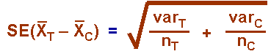

Formula for the t-test

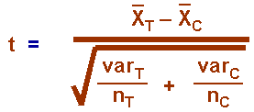

**REFERENCES**

[**https://sensing.konicaminolta.us/blog/identifying-color-differences-using-l-a-b-or-l-c-h-coordinates/**](https://sensing.konicaminolta.us/blog/identifying-color-differences-using-l-a-b-or-l-c-h-coordinates/)

* **Chroma and hue are calculated from the a* and b* coordinates in L*a*b\***
* **Δa* (a* sample minus a* standard) = difference in red and green (+ = redder, - = greener)**