Chapter 3

**METHODOLOGY**

**3.1 Introduction**

This section covers the proposed methods for achieving the desired output, testing procedures and statistical data analysis, and software implementation.

**3.2 Theoretical Framework**

This study aims to develop a system that determines the severity of the coffee leaf rust and the corresponding degree of infection in a coffee plant to identify the proper fungicide to be applied to the tree. The main process to achieve the detection is image processing which comprises of the tasks such as image acquisition, image background removal, image segmentation, and affected pixels’ percent calculation. The proper fungicide depends on the level of severity of the coffee plant. The result is flashed in an LCD. Moreover, the proponents used Python as the programming language for this project.

***Image Acquisition***

In this process, the image of the coffee leaf is captured using an 8 Megapixel Raspberry Pi camera module v2. It has a 3280x2464 resolution for high definition image and clarity. The image is in 10-bit RAW RGB (Red, Green and Blue) form and in JPEG format. The captured image of coffee leaf is fed in the microprocessor to undergo certain processes. The acquiring of image can be one or multiple times until the process button is pressed.

***Image Processing***

The image undergoes image enhancement like noise filtering and histogram equalization after the image is taken. It is useful in feature selection, image analysis and image segmentation. Image enhancement is done to the obtained images that lack contrast and brightness when capturing. Images have different types of noise so that the goal of the enhancement is to emphasize certain image features which are necessary for analysis.

***Image Segmentation***

An edge-based image segmentation is used to split the leaf and its background. A contour will be generated by finding the edges of the acquired image, and by creating a mask to fill the contours, the background can now be removed. After the background subtraction, the area of the region of interest can now be calculated by counting its pixels. Identifying the infected and uninfected regions is undertaken at the same time when the background is removed. The image undergoes threshold-based image segmentation to convert the image into binary and isolate the infected region for its area calculation. This method transforms the image into grayscale image in which the total leaf area and the lesion region area are segmented. Diseased regions and the region of interest are segmented to be able to measure the ratio of their area. This process will be done also for multiple image inputs.

1. **Threshold Based Image Segmentation**

Thresholding is the process of converting a grayscale image to a binary image using optimal threshold. This is used to extract the pixels of region of interest or the object of interest from the image itself. The pixels represent range of intensities even though the image is in binary mode. Therefore, the basic objective of this kind of segmentation is to mark the pixels that includes to the foreground with a single intensity and background regions with different intensities.

There are two types of thresholding algorithms, global thresholding algorithm and local or adaptive thresholding algorithm. In global, a single threshold is used for the entire pixels of the image used while in local or adaptive, different threshold values for different regions of the image or local areas are used.

1. **OTSU Threshold Based**

One of the types of thresholding algorithms is Otsu Algorithm. It is a global type thresholding algorithm. The total mean and variance is calculated by this kind of threshold to set each pixel to either 1 or zero. It stores the intensities of the pixels in an array. This kind of threshold is used to reduced graylevel image to a binary image and if the image contains bi-modal histogram or the foreground and background pixels, it will calculate the optimum threshold.

***Percent Calculation of Affected Pixels***

To obtain the result desired for knowing the severity of the coffee rust in the plant, the number of infected region pixels and the region of interest pixels are calculated to get their ratio. The system will calculate now the percent severity of the coffee rust of a coffee tree by getting the areas infected and leaf regions captured.

***Display Results***

After the calculation of the percentage of the severity of the coffee leaf rust, the system will flash this percentage using a Raspberry Pi LCD screen display including the fungicide to be used.

**3.3 Block Diagram**

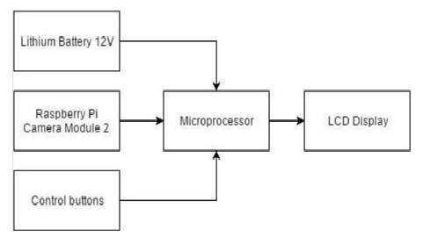

Figure 3.1 Block Diagram

The system block diagram represents the connection of each component of the system. The microprocessor is supplied by a lithium battery having a 12V capacity. This is also responsible for processing all the information coming from the inputs, specifically the camera module and the control buttons. After processing, the system will display the output in an LCD.

***Lithium Battery***

The battery in the device is rechargeable and has a life of 5200mAh.

***Raspberry Pi Camera Module***

The Raspberry Pi Camera Module v2 is responsible for the capturing of image. It has a Sony IMX219 8-megapixel sensor. Compared to sensor of the previous raspberry pi camera, which is a 5- megapixel Omnivision OV5647 sensor, this will obviously be used to take high- definition photographs. Moreover, this camera works with all models of Raspberry Pi. Also, there are libraries built for it and one of those is the Picamera Python library.

***Raspberry Pi 3 Microcontroller***

The Raspberry Pi 3 is responsible for almost all processes in the system including the image processing of the input image and the interpretation of the image analysis.

Raspberry Pi 3 has the following specifications:

* A 1.2GHz 64-bit quad-core ARMv8 CPU
* 802.11n Wireless LAN
* Bluetooth 4.1
* Bluetooth Low Energy (BLE)
* 1GB RAM
* 4 USB ports
* 40 GPIO pin
* Full HDMI port
* Ethernet port
* Combined 3.5mm audio jack and composite video
* Camera interface (CSI)
* Display interface (DSI)
* Micro SD card slot (now push-pull rather than push-push)
* Video Core IV 3D graphics core

***LCD***

LCD (Liquid Crystal Display) is responsible for displaying the output of the system.

***Control Buttons***

The control buttons serve as the mechanism to control the actions to be done in the device like the image capturing and the start of image processing.

**3.4 Schematic Diagram**

***Microprocessor (BCM2837)***

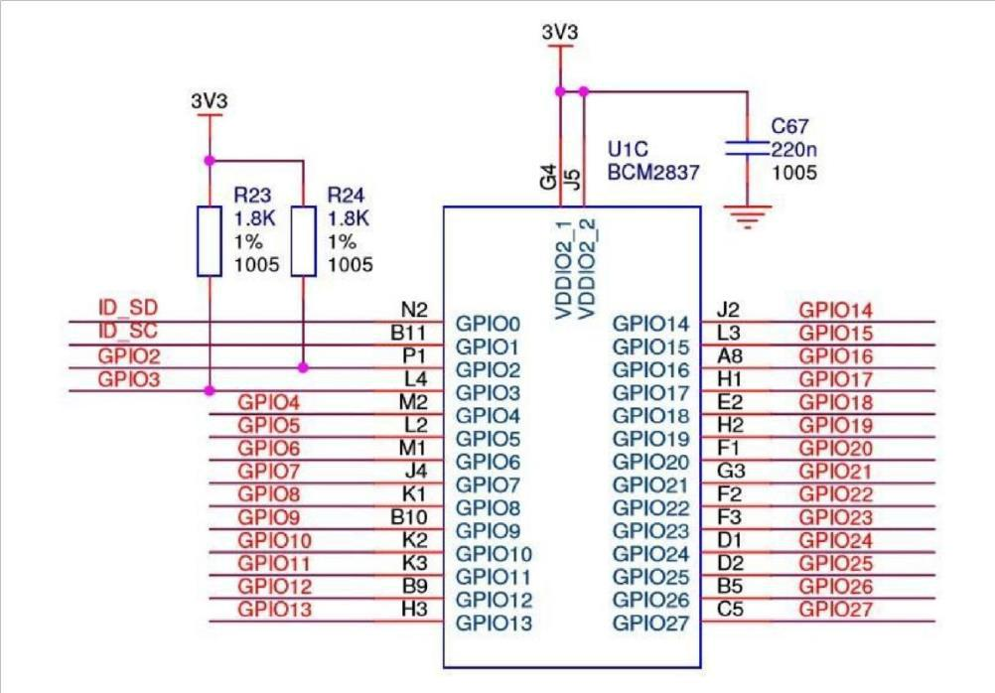

Figure 3.2 Schematic Diagram of BCM2837

***Camera port***

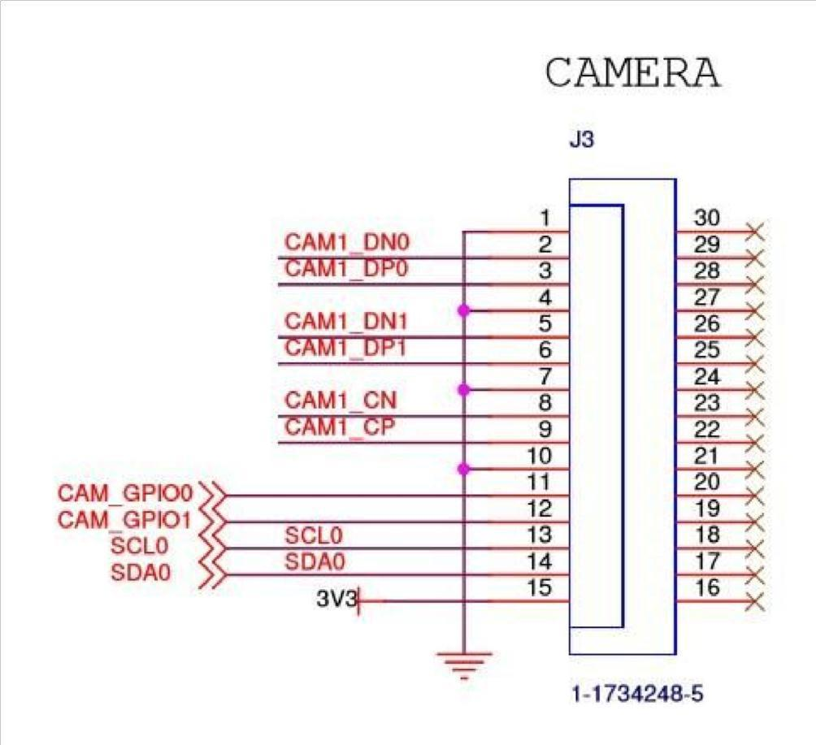

Figure 3.3 Camera Port of Raspberry Pi 3

***Display Port***

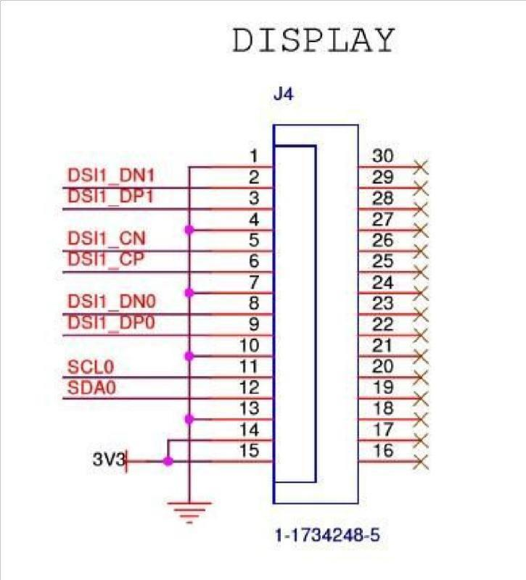

Figure 3.4 Display Port of Raspberry Pi 3 Model B

**3.5 PCB Layout**

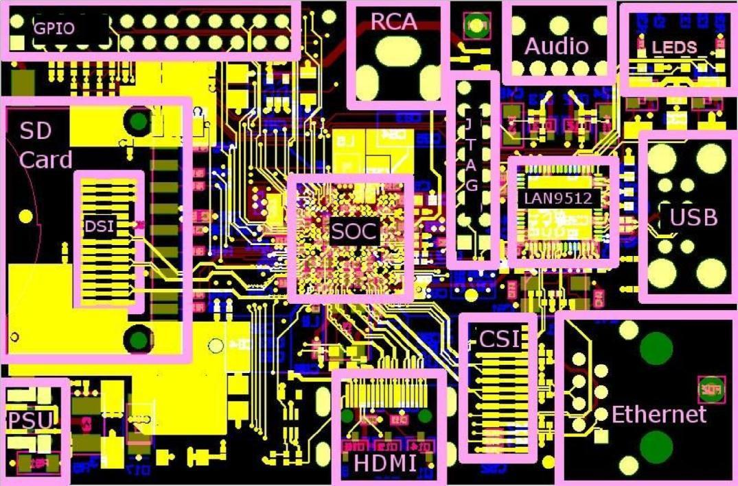

Figure 3.5 PCB Design of a Raspberry Pi

**3.6 System Flowchart**

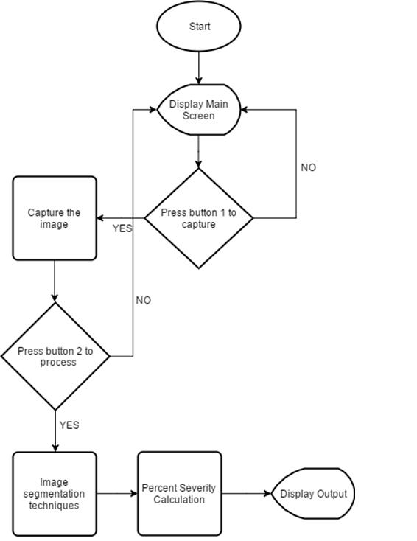

***System Process***

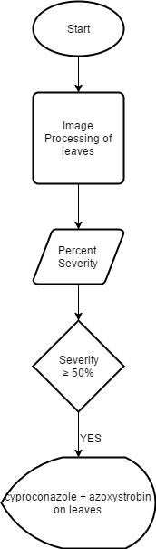

***Decision for fungicide recommendation***

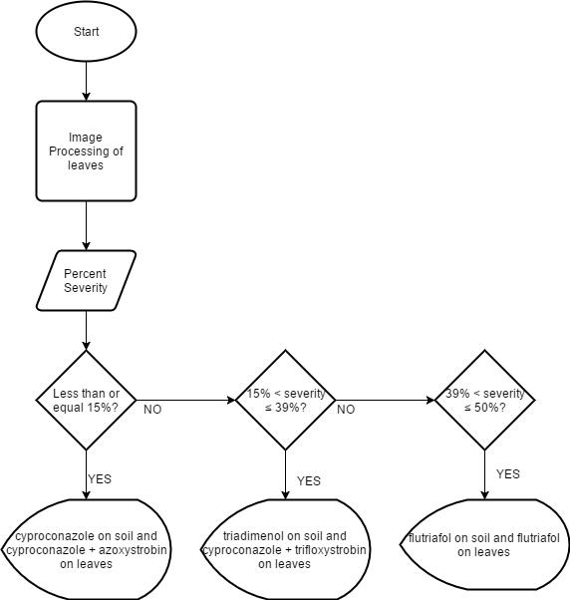

**3.7 Testing Population**

***Determining the sample size***

During the consultation with the experts, it was decided to have 30 coffee trees as the sample size. Moreover, based on the study entitled “Identification, Assessment, and Characterization of Pests and Diseases in Coffee Plants”, which was done in CVSU, it was stated that in each tree, leaf samples were chosen by picking three branches from the top, middle, and bottom part of the coffee tree. In line with this idea, the researchers follow the same sampling method for picking the leaf samples of the tree.

**3.8 Treatment of Data**

In order to conduct this project responsibly, proper treatment of data plays an important role in meeting the expected accuracy level.

***Severity of Coffee Rust***

1. **Counting Method**

According to Ms. Jacqueline Ramos, an entomologist and agriculturist, the current way that is being used in the Philippines for the determination of severity of coffee rust is the counting method. Severity depends on the number of leaves infected over the total number of leaves of the sample tree. In each tree, the expert must pick three branches coming from top, middle, and bottom part of the sample. After that, leaf with coffee rust infection must be counted and noted. Total number of leaves of the branches is noted as well. This is to be done until all the selected coffee trees were sampled. Using the gathered data, the computation for the percent severity of coffee rust is given by the equation below.

1. **Proposed Method**

The proposed method tested the same sample tree and leaves used in the previous process. This method used the area of infection and the total area of the leaves as the primary objects to measure for the percent severity. The leaves of the branches selected by the expert were captured and processed by the camera and program installed in the device, respectively. The area of infection on the leaf and the total area of the leaf were measured and saved in the device’s memory. This was done until all the leaves in the selected branches are captured. Individual area of infection and total area of each leaf were summed up. To determine the percent severity, the total area of the infection on the leaves is divided by the total area of the leaves. This is represented by the equation,

This was done until the selected coffee trees have done this process. The data from the counting and proposed method underwent statistical tests, regression analysis to determine the relationship between them.

With regards to validation of the proposed method, the proponents used MATLAB, specifically the Image Region Analyzer App with region props algorithm, which serves as a third-party software that determines the area of infection as well as the total leaf area.

Based on Sanjay B. Patil, an author of International Journal on Computer Science and Engineering (IJCSE) paper entitled “Betel Leaf Area Measurement Using Image Processing”, they used MATLAB as their software for image processing to calculate leaf area and found out that it has a 99% accuracy. In addition, according to the paper “Two new Methods for the Estimation of Leaf Area using Digital Photography”, a mean of 0.45% error for measuring the leaf area was found during the experimentation.

1. **Determining the Degree of Infection**

The CVSU had presented a study, under the leadership of Dr. Josephina Rint, showing the range of the coffee rust percentage severity and their corresponding degree of infection. Below table shows the parameters stated above.

Table 3.1 Degree of Infection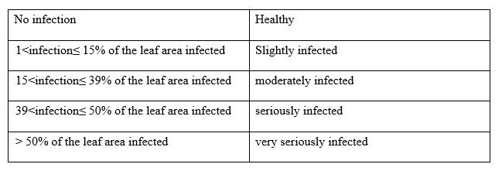

***Correlation of Data from Counting and Proposed Method***

As stated in the book of “Coffee Rust: Epidemiology, Resistance, and Management”, a high positive correlation was observed between the area damages per leaf and the percentage of leaves rusted. Due to these, correlation was not performed anymore, instead, the proponents directly proceeded to regression analysis.

***Regression Analysis***

In this part, the data obtained in the manual way of determining the severity of coffee rust was compared to the data from the automated way. Using regression analysis, the proponents intend to determine the relationship between the two sets of data. According to the book, Critical Reviews in Plant Sciences, which focuses on plant disease severity estimated visually, by digital photography and image analysis, and by hyperspectral imaging, regression analysis is a well-known tool that has been used to investigate various aspects of error in disease assessment and reliability, precision and accuracy of measured or estimated data. These founding ideas informed the proponents to use this in order to show that the manual and automated way have a relationship.

To elaborate more, using regression analysis, an equation was formed in which the independent variable inputs were the percentage severity attained in measuring the area while the dependent values were the percent severity obtained by counting. The values obtained from area measurement served as the input in the equation to obtain its corresponding values from the counting measurement. The result when an input is substituted to the equation was used as the reference value for identifying the degree of infection.

**3.9 Testing Procedure**

The proponents tested the device on leaves coming from three different branches of the sample tree. Data obtained from this test was used in the process of determining the severity of coffee rust. Instructions on how the testing was done and how to operate the device are given for the correct operation.

1. **Counting Method**

This step is composed of the following:

* Selection of a sample coffee tree;
* Selection of a branch from the top, middle, and bottom part of the tree;
* testing of the leaves of each branch by the counting method;
* recording the number of infected leaves and the total number of leaves of the three branches on the table given below; and
* computation for the percent severity using the formula of the counting method.

1. **Proposed Method**

Using the same samples on counting method, the proponents tested them using the proposed method. Thus, the following is observed.

* turn on the device;
* go to the capture mode;
* focus the camera on the leaf and press button 1 to capture;
* press button 2 to process image;
* wait for the device to say done;
* repeat previous steps until all leaves of the selected branches have been tested;
* press button 3 to calculate the percent severity, total area of infection, and total area of the leaves;
* record the results on the table below; and
* repeat all the previous steps until 30 coffee trees have been tested.

1. **Validation Method**

As what have been written on the related studies, NCRDEC was assigned by DA-BAR as the leader for coffee researches nationally. This also agrees to the interview with the Bureau of Plant Industry which they told that they only detect if a certain tree is infected or not but not the percentage severity. This has motivated the proponents to have small interview with the professionals in NCRDEC to confirm the studies that the proponents have accumulated which are: Development and validation of a standard area diagram set to estimate severity of leaf rust in Coffee Arabica and C. canephora; Leaf Area Measurement Using Image Processing and Two new Methods for the Estimation of Leaf Area using Digital Photography; Evaluation, Documentation, and Control Insect Pests and Diseases in Liberica and Excelsa.

The proponents now decided that together with a professional from a credible organization that deals with coffee rust these are the steps on validating:

* choosing a single branch from the top, middle, and bottom part of the tree;
* using the device capture all the leaves on the chosen branches;
* waiting for the device to display the percent severity and its corresponding fungicides; and
* utilizing MATLAB to validate the accuracy of getting the area obtained by the device;

The accuracy is calculated using the equation,

Where: Y = measured value = output value of the device

X = true value = MATLAB- based value

The proponents are expecting to meet an accuracy above 90%, because according to the rule of thumb of measurement system acceptability, a result having a less than 10% error is considered acceptable. Consequently, the following are observed:

* the percent severity obtained by area measurement and counting method will undergo regression analysis to create a working equation;
* the equation obtained from the regression analysis will be used to determine the corresponding values of severity from the counting method and use this values for the system output;
* the accuracy of the percent severity output of the system will be validated through the values obtained from the counting method in experimentation. The percent accuracy will be calculated using the equation in 4th step. and an accuracy above 90% is expected by the proponents; and

**3.10 Proposed Table for Test Results**

Table 3.2 Data Collection

|  |  |  |  |  |  |  |
| --- | --- | --- | --- | --- | --- | --- |
| Coffee Tree | Counting Method  (Number of infected leaves of the selected branches of the selected tree) | Counting Method  (Total number of leaves of the selected branches of the selected tree) | Percent Severity | Proposed Method  (total area of infection) | Proposed Method  (total area of the leaves) | Percent Severity |
| 1 |  |  |  |  |  |  |
| 2 |  |  |  |  |  |  |
| 3 |  |  |  |  |  |  |
| …. |  |  |  |  |  |  |
| 30 |  |  |  |  |  |  |

The data to be recorded in the second column is the number of infected leaves for each tree. On the third column is the total number of leaves per tree. On the fourth is the percent severity for the counting method. On the fifth is the total area of infection on the leaves of the branches of the selected coffee tree. On the sixth is the total area of the leaf samples and on the last is the percent severity of coffee rust using the proposed method.

Table 3.3 Percent Severity of Coffee Rust

|  |  |  |  |  |
| --- | --- | --- | --- | --- |
| Coffee Tree | Counting Method | Degree of Infection | Proposed Method | Degree of Infection |
| 1 |  |  |  |  |
| 2 |  |  |  |  |
| 3 |  |  |  |  |
| …. |  |  |  |  |
| 30 |  |  |  |  |

Data from this table is to be used for regression analysis. On the second column is the percent severity of rust per tree while on the fourth is the percent severity of rust using the proposed method. Columns 3 and 5 are the corresponding degree of infection (healthy, slightly infected, moderately infected, seriously infected with premature defoliation, and very seriously infected). Degree of infection is based on the series of study done by CVSU (Project leader: Josephina Rint). See table 1. Result from the statistical analyses will be the degree of agreement between the two methods and their relationship.

Table 3. Fungicides, Active Ingredients and Their Use

|  |  |  |
| --- | --- | --- |
| Active Ingredient | Commercial Name | Use |
| Copper Oxychloride | Copper Oxychlorua 30  BTN/WP | Prevention and in soils poor in copper some trace-element fertilization effect can be expected |
| Copper Hydrocide | Champion 77 WP  Funguran-OH 59 BHN (WP) |
| Benomyl 25% +  Copper Oxychloride 25% | Viben C 50 BTN |
| Kasugamycin 0.6% + Basic  Cupric Chloride 16% | New Kasuran BTN |
| Zineb 20% + Copper  Oxychloride 30% | Vizincop 50 BTN |
| Diniconazole | Sumi-Eight 12.5 WP | These fungicides should only be used when the disease has spread severely |
| Epiconazole | Opus 125 EC |
| Hexaconazole | Anvil 5 SC |
| Triadimenol | Bayfidan 25 EC  Samet 15 WP |
| Propiconazole | Tilt 250 EC |

Table 3.5 Accuracy Using Counting Method

|  |  |  |  |
| --- | --- | --- | --- |
|  | Counting Method | Proposed Method | Accuracy (%) |
| 1 |  |  |  |
| 2 |  |  |  |
| 3 |  |  |  |
| …. |  |  |  |
| 30 |  |  |  |

Table 3.6 Accuracy Using Area Estimation

|  |  |  |  |
| --- | --- | --- | --- |
|  | Counting Method | Proposed Method | Accuracy (%) |
| 1 |  |  |  |
| 2 |  |  |  |
| 3 |  |  |  |
| …. |  |  |  |
| 30 |  |  |  |

Data from this table is to be used to know the accuracy of the device in terms of determining the area of infection. A third-party software, specifically MATLAB Image Region Analyzer App with region props algorithm, is to be used to validate the area measurement of our device. Comparing the two measurements, the below equation is to be used for the computation of the accuracy.

Where: Y = measured value = output value of the device

X = true value = MATLAB- based value

Table 3.7 Treatment, description, and its health stage

|  |  |  |
| --- | --- | --- |
| Treatment no. | Description | Health Stage |
| T1 | cyproconazole on soil and cyproconazole + azoxystrobin on leaves | Slightly infected |
| T2 | triadimenol on soil and cyproconazole + trifloxystrobin on leaves | Moderately infected |
| T3 | flutriafol on soil and flutriafol on leaves | Seriously infected |
| T4 | cyproconazole + azoxystrobin on leaves | Very seriously infected |

The proponents followed this treatment to the study of Honorato Jr. et. al. regarding the fungicides application for the control of coffee leaf rust. Thus, if after application of the specific fungicide, the coffee rust disease will stop in growing in terms of severity in a specific tree.

**3.11 Statistical Analysis**

***T-Test***

T-Test is used when there is a need to compare the performance of two conditions. Among the two versions of the T-test, Dependent-means t-test was used. This version of the T-test is used when same subjects participate in two different conditions. In this study, the two conditions are the proposed method and the counting method. The subjects being mentioned are the sample trees.

***Dependent-means T-test Formula***

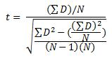

Where: D = difference

N = number of samples

***Regression Analysis***

Regression analysis is the most commonly used predictive analysis. Regression evaluations are used to explain data and relationship between one dependent variable and one or more independent variables.

**3.12 Software Algorithm**

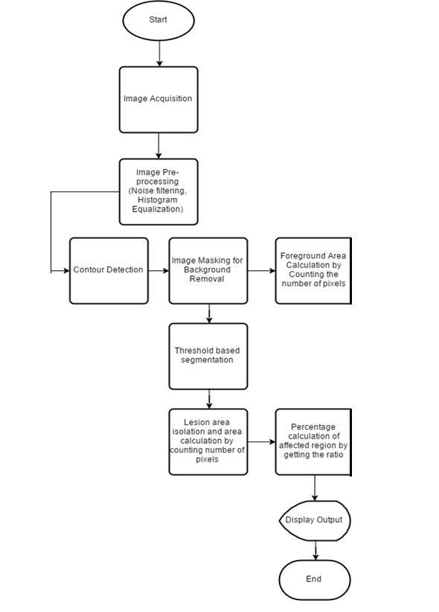

**3.13 Proposed Project**

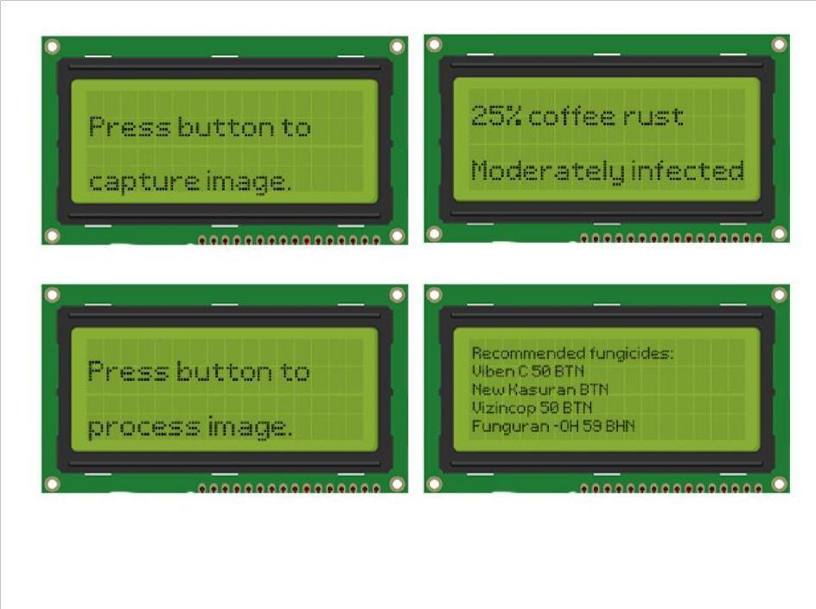

Figure 3.6 Sample Output Display

**Refer to the figure in the next pages**

Figure 3.7 Portable Device Sample Design

**3.14 Design Constraints**

This section covers the limitations and difficulties from the economic, environmental, and manufacturability aspects for designing the device.

The tools and equipment in the device, which are Raspberry Pi, camera, LCD and battery, are readily available in the market and are not too expensive. Thus, the device may be easily manufactured, and it is quick to troubleshoot. However, there are problems that may be encountered by the proponents in producing the device.

Since Python is the main programming language, the proponents are required to attain enough knowledge about its basics by asking some experts and studying tutorial videos which may consume a lot of time before embedding the codes in the device itself. OpenCV is an image processing library as part of the proposed algorithm which is purely image processing, so it is also necessary to be learned. In addition, the mounting of accessories like the LCD and camera so as their configurations require knowledge as well. Furthermore, the device is a bit bulky since the Raspberry Pi and the battery require some space. The casing is composed of materials which fits the device and are readily available.

Moreover, the coffee rust infection is seasonal in which it is most abundant in the months from November to January. It is expected that the trees to be tested in the area have less rust infection and the results that are arising from the training part produce less rust area percentage since the training and testing period is outside this range. The weather and sunlight can also have a significant effect in performing the calibration specifically in capturing. Therefore, a material with dark background is placed under the leaf during capturing.

