Detection of Measles using Raspberry Pi 3 with Support Vector Machine

Carlos IV C. Hortinela1, Jessie R. Balbin2, Ian Gabrielle T. Bautista3, Renz Denise B. Calangi4,

*School of Electrical, Electronics, and Computer Engineering  
Mapua University  
Intramuros, Manila, Philippines*

1[cchortinela@mapua.edu.ph](mailto:cchortinela@mapua.edu.ph)

2[jayebalbin@gmail.com](mailto:jayebalbin@gmail.com)

3[igtbautista@mymail.mapua.edu.ph](mailto:igtbautista@mymail.mapua.edu.ph)

4[rdbcalangi@mymail.mapua.edu.ph](mailto:rdbcalangi@mymail.mapua.edu.ph%20)

***Abstract —* The device is first to go under training using Support Vector Machine with the sample images to be converted to HSV color space image conversion to differentiate measles from different skin diseases. In detecting the measles, input images are used in SVM based feature detection algorithm that is developed from the feature map from the training process and to classify the severity based on area and color.**

***Index Terms — Support Vector Machine, HSV color space, algorithm, feature map***

1. INTRODUCTION

The device can detect measles rashes from the images captured using the Raspberry Pi camera. The device is trained using Support Vector Machine training, it needs sample images to train the machine. The sample images are composed of images of measles rashes and different rashes that is almost the same as measles. The sample images are images that is pre-classified by the doctors.

The device will use image processing techniques like: color detection using HSV color space, image masking, image binary, pixel count and the use of Support Vector Machine.

The first process for training is the color detection using HSV color space which detects the value of the color in the sample image. The device will get the red value of the rashes then convert the image into binary image. Binary image is a digital image that has only two possible values for each pixel. The binary image will separate the red rash pixels to the pixels from skin and background will make the image black and white. After separating the red rash pixels to the skin, the device uses image masking to segment the rash to the skin and background. The red rash part of the image and the background are now separated and will use feature extraction of the support vector machine to classify the measles severity based on color and area.

The previous studies detect different skin diseases which includes measles, it uses fuzzy inference system. The paper discussed the use of fuzzy interference system in children’s skin diseases diagnose application. Another study uses image processing with blood samples to determine the number of plaque compared to eye assessment.

The objective of the device is to detect measles and classify the severity of measles rashes based on its color and area covered in the skin using Support Vector Machine for training and different Image Processing Algorithms. The study shows the different input and output images from each image processing techniques to show the process happened on each step.

1. METHODOLOGY

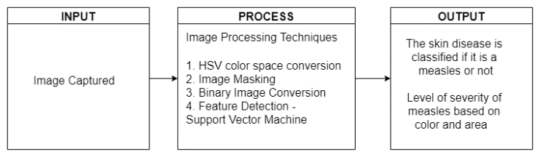

**Figure 2.1** Conceptual Framework

To check the skin of the subject, the camera will focus to acquire an image of the area of the affected area of the skin and process the image using image processing techniques and will output the result if the subject has measles. The captured image will be the input for the system. The system will use some image processing techniques to process the captured image and detect measles. The techniques used are HSV Color Space Conversion, Image Binary, Image Masking, and Support Vector Machine.

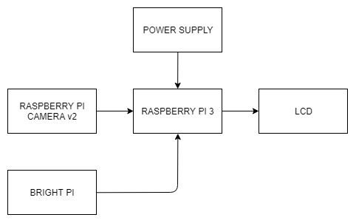

**Figure 2.2** Hardware Block Diagram

The figure shows the hardware block diagram and the hardware components that will be used on proposed system. It comprises of the Raspberry Pi 3, camera module, LCD, light source, and power supply. The Raspberry Pi 3 is the microcomputer that process the image captured and apply the image processing algorithm to obtain the results. The camera module will capture the image with the help of bright pi to enhance the image with light and the output will be displayed in the LCD. The power supply provides power for the Raspberry Pi, and the Raspberry Pi provides power to camera module, LCD, and bright pi.

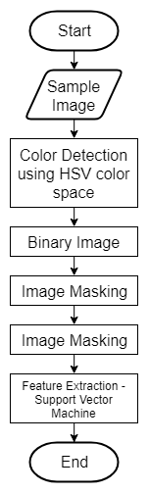

**Figure 2.1** Support Vector Machine Training Flowchart

The figure shows the process for the training of the machine using Support Vector Machine. At first the device will allow to take sample images with measles and other skin disease as an input for the machine to differentiate and know the characteristics of measles. The sample images is then converted to HSV color space image conversion to get the red value of the rashes, then the image is then converted to binary image and image masking for it to segment the rash to the skin and background.

**Table 2.1** Relationship of Severity based on area to the number of pixels

|  |  |
| --- | --- |
| **Severity of measles based on area** | **Ratio of measles pixels to skin pixels** |
| **Light** | 2.82% - 20.41% |
| **Moderate** | 20.41% - 35.03% |
| **Severe** | 35.03% above |

Table 2.1 will formulate the relationship of the severity based on area to the number of pixels. The table will show the range of the number of pixels for each level of severity based on area.

// Image of the device

1. RESULTS AND DISCUSSION

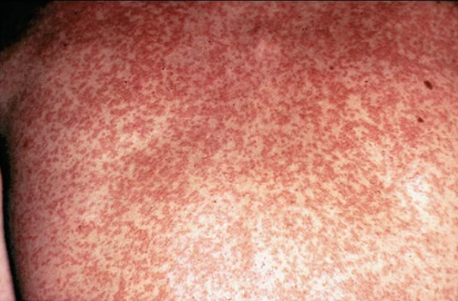

(a)

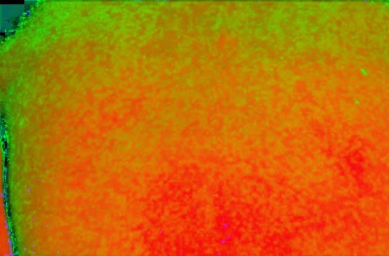

(b)

**Figure 3.1** HSV color space conversion (a) input and (b) output image comparison



(a)

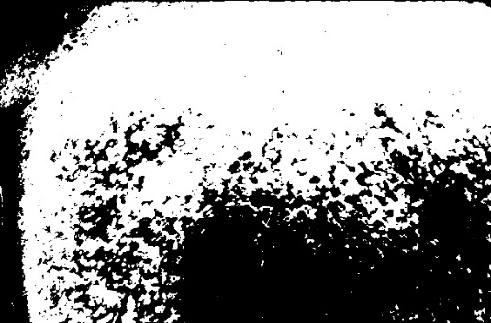

(b)

**Figure 3.2** Red Image masking (a) input and (b) output image comparison



(a)



(b)

**Figure 3.3** Brown Image masking (a) input and (b) output image comparison

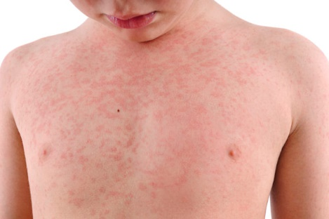

**Figure 3.4** The sample image for light severity measles

**Table 3.1** The ratio of rashes to skin of light severity measles

|  |  |
| --- | --- |
| **Total Number of Image Pixel** | 272000 |
| **Total Number of Measles Pixel** | 13219 |
| **Total Number of Skin Pixel** | 234453 |
| **Ratio of Measles over Skin Pixel** | 5.337300946% |

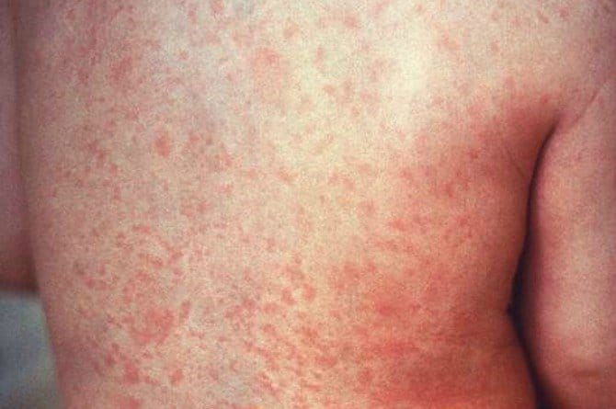

**Figure 3.5** Sample image for moderate severity measles

**Table 3.2** The ratio of rashes to skin of moderate severity measles

|  |  |
| --- | --- |
| **Total Number of Image Pixel** | 298150 |
| **Total Number of Measles Pixel** | 75424 |
| **Total Number of Skin Pixel** | 259607 |
| **Ratio of Measles over Skin Pixel** | 22.5124362% |

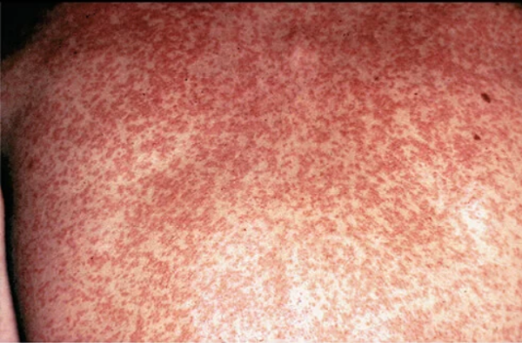

**Figure 3.6** The sample image for severe measles

**Table 3.3** The ratio of rashes to skin of severe measles

|  |  |
| --- | --- |
| **Total Number of Image Pixel** | 598400 |
| **Total Number of Measles Pixel** | 20398 |
| **Total Number of Skin Pixel** | 32406 |
| **Ratio of Measles over Skin Pixel** | 38.62964927% |

1. CONCLUSION

The researchers were able to construct a machine that determines measles rashes. The device uses different image processing techniques that is used in creating the device such as HSV color space conversion, Image Masking, Binary Image Conversion, Support Vector Machine. Percent errors

1. RECOMMENDATION

Furthermore, the researchers recommend using another feature extraction image processing techniques such as Deep Learning, Convolutional Neural Network, or Recurrent Neural Network, and if possible, find a better image processing technique and feature extraction that will produce a more accurate result. Further improvements on the hardware, the future researchers can use low-cost hardware to produce the device.

REFERENCES

[1] Hal B. Jenson MD, Charles T. Leach MD, “Measles”, 2012

[2] Centers for Disease Control and Prevention, “Measles (Rubeola) Signs and Symptoms”, *in Centers for disease control and prevention*, 2015

[3] World Health Organization, “Measles”, 2018

[4] Centers for Disease Control and Prevention, “Measles (Rubeola) Complications”, *in Centers for disease control and prevention,* 2018

[5] Aditya Agung Putra, Rinaldi Munir, “Implementation of fuzzy inference system in children skin disease diagnosis application”, *in 5th international conference on electrical engineering and informatics,* 2015

[6] M.M. Jordan, S. Hashmi, W.J. Perkins, “Automatic image analysis of antibody assays to measles virus”, *in Computer methods and programs in biomedicine journal volume 49 issue 1,* 1996

[7] Lenesha Warrener, et al, “A point-of-care test for measles diagnosis: detection of measles-specific IgM antibodies and viral nucleic acid”, *in World Health Organization Bulletin,* 2011

[8] Centers for disease control and prevention, “Serologic testing for measles in low prevalence setting”, *in Measles Serology Journal Centers for disease control and prevention,* 2018

[9] Joseph Aglibut, Luigi Alonzo, Monica Coching, Jumelyn Torres, Noel Linsangan, “Skin Disease Identification System using Gray Level Co-occurrence Matrix”, *in 9th International conference on computer and automation engineering*, 2017

[10] Centers for disease control and prevention, “Vaccines and Preventable Diseases: Routine Measles, Mumps, and Rubella Vaccination”, *in Vaccines and preventable disease journal Centers for disease control and prevention*, 2019

[11] Dr. Reddi Kiran Kumar, “Journal on image processing”, *Volume 3 Issue 1,* 2016

[12] Jeefri Moka, “Image Classification with HSV color model processing”, 2017

[13] Attila Stubendek, Kristof Karacs, “Shape recognition based on projected edges and global statistical features”, *in Mathematical problems in engineering journal*, 2017

[14] Paul A. Gastanaduy, et al, “VPD Surveillance Manual”, *in Bull World Health Program, Chapter 7.1 Serologic testing*, 2011

[15] Rahat Yasir, Md. Ashiqur Rahman, Nova Ahmed, “Dermatological disease detection using image processing and artificial neural network”, *in 8th International Conference on Electrical and Computer Engineering,* 2014

[16] Archana Ajith, Vrinda Goel, Priyanka Vazirani; M. Mani Roja, “Digital dermatology: Skin disease detection model using image processing”, *in International conference on intelligent computing and control systems*, 2017

[17] Nazrul Islam, Jaime Gallardo-Alvarado, Masyitah Abu, Nurfazlyna Aneem Salman, “Skin disease recognition using texture analysis”, *in IEEE 8th Control and system graduate research colloquium*, 2017

[18] Gavrilov, Melerzanov, Shchelkunov, Zakirov, “Use of Neural Network-Based Deep Learning Techniques for the Diagnostics of Skin Diseases”, *in Biomedical Engineering Journal*, 2019

[19] Jessie Balbin, Jennifer Dela Cruz, Clarisse Camba, Angelo Gozo, Sheena Jimenez, Aivje Tribiana, “Facial fluid synthesis for assessment of acne vulgaris using uminescent visualization system through optical imaging and integration of fluorescent imaging system”, *in 2nd International Workshop on pattern recognition,* 2017