Area and Color Severity Detection of Measles

Carlos IV C. Hortinela1, Jessie R. Balbin2, Ian Gabrielle T. Bautista3, Renz Denise B. Calangi4,

*School of Electrical, Electronics, and Computer Engineering  
Mapua University  
Intramuros, Manila, Philippines*

1[cchortinela@mapua.edu.ph](mailto:cchortinela@mapua.edu.ph)

2[jayebalbin@gmail.com](mailto:jayebalbin@gmail.com)

3[igtbautista@mymail.mapua.edu.ph](mailto:igtbautista@mymail.mapua.edu.ph)

4[rdbcalangi@mymail.mapua.edu.ph](mailto:rdbcalangi@mymail.mapua.edu.ph%20)

***Abstract —* This paper intends to detect Rubeola measles rash captured from humans via camera and will process the image using the algorithm in the Raspberry Pi. The algorithm uses image processing techniques such as color detection using HSV color space, image masking, bit operator, and pixel counter. The measles is classified by its severity as a result. The severity is based on area and color of the measles. The area and color severity are classified as light, moderate, and severe.**

***Index Terms —* Rubeola, Raspberry Pi, Algorithm, HSV Color Space, Image Masking, Bit Operator, Pixel Counter**

1. INTRODUCTION

Measles or also called as “Rubeola” is an infection in respiratory system caused by Rubeola virus. Measles is a very contagious disease that can be transmitted through coughing and sneezing, close personal contact or direct contact with infected nasal or throat secretion. It can be life-threatening complications and can be serious and even fatal for small children. Measles can be prevented with a vaccine, which is usually done at the age of nine months and twelve months. The Center for Disease Control and Prevention calls the very effective and can result to 97% immunity to Measles after the second dose. Measles outbreak can result in epidemics that cause many deaths, especially among young, malnourished children. In countries where measles has been largely eliminated, cases imported from other countries remain an important source of infection. The death rates have been falling worldwide because almost of the children receives the measles vaccines. Measles still kills more than 100,000 people a year worldwide, mostly under the age of 5. Measles is highly infectious illness caused by the virus called a paramyxovirus. It usually transferred between humans through tiny droplets when an infected person coughs, breathes, or sneezes. People can spread it 4 days before they first get the measles rash, and 4 days after the rash starts. Measles is an acute systemic viral infection with fever, respirator involvement and symptoms, and a rash. The virus remains active and contagious in the air or infected surfaces for up to 2 hours. Since measles affects immune system, it can start some severe diseases like Pneumonia, Brain swelling, Diarrhea, and Ear infections, which lead to hearing loss. The Centers for Disease Control and Prevention (CDC) estimates about 1 or 2 of every 1,000 children with measles dies.

There are previous studies that detects different skin diseases which includes measles. The study uses different technique in detecting measles using the fuzzy inference system. Another study uses image processing with blood samples to determine the number of plaque compared to eye assessment. The result from both methods are very similar. The automatic method is faster than the original method. The study did not use any machine learning. Point-of-care tests (POCTs) are increasingly used for the rapid diagnosis of infections. They can be performed in a single incubation step at ambient temperature without complex electrical equipment and their results can be read visually. By increasing diagnostic capacity and facilitating rapid diagnosis in resource-poor countries, they have the potential to improve measles surveillance and the response of health authorities to possible outbreaks. The serologic test is a blood test that look for antibodies in your blood. It is commonly used by the hospitals and laboratories to diagnose various disease conditions like measles. Diagnosis of the skin disease has always been in terms of a doctor's knowledgeable opinion, or by number of laboratory screenings. Diagnosis is made by looking for additional signs that make the doctor's statement accurate, however in some cases signs are indistinguishable that results to miss potential diagnosis.

Existing measles detection is based on the examination of the doctor on its symptoms, or by running some blood test. There are few studies that use image processing on skin image and Support Vector Machine for classification.

The general objective of this study is to detect the severity of measles based on the area and color using Image Processing Algorithms and Support Vector Machine. Specifically, the study aims: (1) To create a device that will detect measles through image processing using Raspberry Pi. (2) To determine the severity of Measles based on area and color using Support Vector Machine and image processing algorithms technique. (3) To verify if the detection and the phase of severity is correct compared to doctor’s evaluation.

This study will provide severity based on the area and color of measles. The primary beneficiary of this study is the people with measles who are not yet diagnosed with measles and the people with measles to diagnose the severity of the measles based on the area and color. This study will also be significant to hospitals, and laboratory clinics.

The device will not be able to classify or categorize other type of skin disease occured and what caused it. The study will use image processing techniques like: color detection using HSV color space, image masking, image binary, pixel count and the use of Support Vector Machine to detect the rash if it is measles. The study will be using Raspberry Pi 3 microcomputer for the implementation of the device and Support Vector machine learning technique for processing the detection of measles. The study will be using Python language.

1. METHODOLOGY

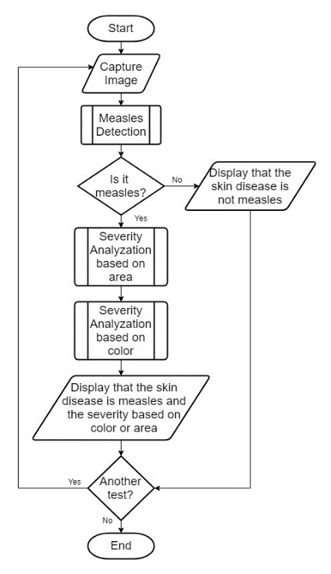

Fig. 4. Main System Flowchart

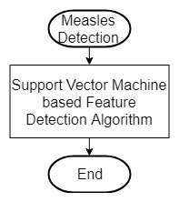

Fig. 5. Measles Detection Module Flowchart

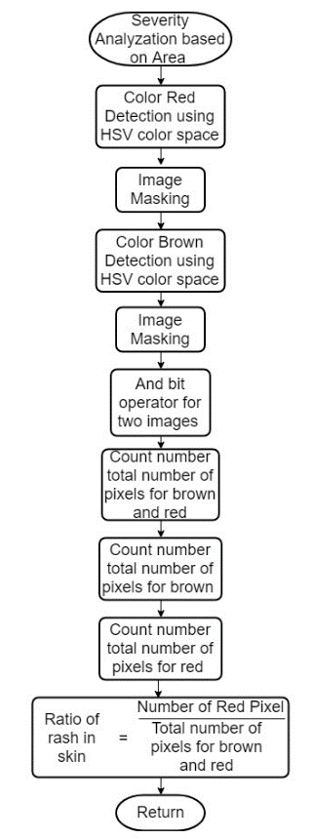

Fig. 6. Severity Analyzation Based on Area of the Rash Flowchart

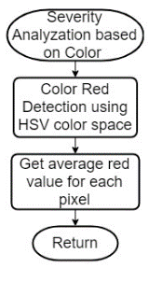

Fig. 7. Severity Analyzation Based on Color of the Rash

1. RESULTS AND DISCUSSION

Testing Table for Measles Detection

|  |  |  |  |
| --- | --- | --- | --- |
| **Samples** | **Doctor’s Evaluation** | **Device’s Evaluation** | **Remarks** |
| **Patient A** | Measles | Measles | True |
| **Patient B** | Measles | Measles | True |
| **Patient C** | Measles | Measles | True |
| **Patient D** | Measles | Measles | True |
| **Patient E** | Measles | Measles | True |
| **Patient F** | Not Measles | Not Measles | True |
| **Patient G** | Not Measles | Measles | False |
| **Patient H** | Not Measles | Measles | False |
| **Patient I** | Not Measles | Not Measles | True |
| **Patient J** | Not Measles | Not Measles | True |

Testing Table for Determination on Severity of Area of the Rash

|  |  |  |  |
| --- | --- | --- | --- |
|  | **Doctor’s Evaluation on severity on area** | **Device’s Evaluation on severity on area** | **Remarks** |
| **Patient A** | 3 doctors  severe | 39.61260522%  severe | True |
| **Patient B** | 3 doctors  severe | 40.05514649 %  severe | True |
| **Patient C** | 3 doctors  severe | 30.84310354%  severe | True |
| **Patient D** | 3 doctors  moderate | 21.81426012%  moderate | True |
| **Patient E** | 2 doctors  light | 5.702285244%  light | True |
| **Patient F** | Not measles | Not measles | True |
| **Patient G** | Not measles | 19.06162736%  light | False |
| **Patient H** | Not measles | 16.66990703%  light | False |
| **Patient I** | Not measles | Not measles | True |
| **Patient J** | Not measles | Not measles | True |

|  |  |  |  |
| --- | --- | --- | --- |
|  |  | **Doctor’s Evaluation** | |
| **Device’s Evaluation** |  | **Unknown skin disease** | **Measles** |
| **Unknown skin disease** |  |  |
| **Measles** |  |  |

1. CONCLUSION
2. FUTURE WORKS

REFERENCES

[1] Hal B. Jenson MD, Charles T. Leach MD, “Measles”, 2012

[2] Centers for Disease Control and Prevention, “Measles (Rubeola) Signs and Symptoms”, *in Centers for disease control and prevention*, 2015

[3] World Health Organization, “Measles”, 2018

[4] Centers for Disease Control and Prevention, “Measles (Rubeola) Complications”, *in Centers for disease control and prevention,* 2018

[5] Aditya Agung Putra, Rinaldi Munir, “Implementation of fuzzy inference system in children skin disease diagnosis application”, *in 5th international conference on electrical engineering and informatics,* 2015

[6] M.M. Jordan, S. Hashmi, W.J. Perkins, “Automatic image analysis of antibody assays to measles virus”, *in Computer methods and programs in biomedicine journal volume 49 issue 1,* 1996

[7] Lenesha Warrener, et al, “A point-of-care test for measles diagnosis: detection of measles-specific IgM antibodies and viral nucleic acid”, *in World Health Organization Bulletin,* 2011

[8] Centers for disease control and prevention, “Serologic testing for measles in low prevalence setting”, *in Measles Serology Journal Centers for disease control and prevention,* 2018

[9] Joseph Aglibut, Luigi Alonzo, Monica Coching, Jumelyn Torres, Noel Linsangan, “Skin Disease Identification System using Gray Level Co-occurrence Matrix”, *in 9th International conference on computer and automation engineering*, 2017

[10] Centers for disease control and prevention, “Vaccines and Preventable Diseases: Routine Measles, Mumps, and Rubella Vaccination”, *in Vaccines and preventable disease journal Centers for disease control and prevention*, 2019

[11] Dr. Reddi Kiran Kumar, “Journal on image processing”, *Volume 3 Issue 1,* 2016

[12] Jeefri Moka, “Image Classification with HSV color model processing”, 2017

[13] Attila Stubendek, Kristof Karacs, “Shape recognition based on projected edges and global statistical features”, *in Mathematical problems in engineering journal*, 2017

[14] Paul A. Gastanaduy, et al, “VPD Surveillance Manual”, *in Bull World Health Program, Chapter 7.1 Serologic testing*, 2011

[15] Rahat Yasir, Md. Ashiqur Rahman, Nova Ahmed, “Dermatological disease detection using image processing and artificial neural network”, *in 8th International Conference on Electrical and Computer Engineering,* 2014

[16] Archana Ajith, Vrinda Goel, Priyanka Vazirani; M. Mani Roja, “Digital dermatology: Skin disease detection model using image processing”, *in International conference on intelligent computing and control systems*, 2017

[17] Nazrul Islam, Jaime Gallardo-Alvarado, Masyitah Abu, Nurfazlyna Aneem Salman, “Skin disease recognition using texture analysis”, *in IEEE 8th Control and system graduate research colloquium*, 2017

[18] Gavrilov, Melerzanov, Shchelkunov, Zakirov, “Use of Neural Network-Based Deep Learning Techniques for the Diagnostics of Skin Diseases”, *in Biomedical Engineering Journal*, 2019

[19] Jessie Balbin, Jennifer Dela Cruz, Clarisse Camba, Angelo Gozo, Sheena Jimenez, Aivje Tribiana, “Facial fluid synthesis for assessment of acne vulgaris using uminescent visualization system through optical imaging and integration of fluorescent imaging system”, *in 2nd International Workshop on pattern recognition,* 2017