**Chapter 1**

**INTRODUCTION**

Measles or also called as “Rubeola” is an infection in respiratory system caused by Rubeola virus [1]. Measles is a very contagious disease that can be transmitted through coughing and sneezing, close personal contact or direct contact with infected nasal or throat secretion. It can be life-threatening complications and can be serious and even fatal for small children. Measles can be prevented with a vaccine, which is usually done at the age of nine months and twelve months. The Center for Disease Control and Prevention calls the very effective and can result to 97% immunity to Measles after the second dose [2]. Measles outbreak can result in epidemics that cause many deaths, especially among young, malnourished children. In countries where measles has been largely eliminated, cases imported from other countries remain an important source of infection. The death rates have been falling worldwide because almost of the children receives the measles vaccines [3]. Measles still kills more than 100,000 people a year worldwide, mostly under the age of 5 [4]. Measles is highly infectious illness caused by the virus called a paramyxovirus [1]. It usually transferred between humans through tiny droplets when an infected person coughs, breathes, or sneezes. People can spread it 4 days before they first get the measles rash, and 4 days after the rash starts. Measles is an acute systemic viral infection with fever, respirator involvement and symptoms, and a rash. The virus remains active and contagious in the air or infected surfaces for up to 2 hours [4]. Since measles affects immune system, it can start some severe diseases like Pneumonia, Brain swelling, Diarrhea, and Ear infections, which lead to hearing loss. The Centers for Disease Control and Prevention (CDC) estimates about 1 or 2 of every 1,000 children with measles dies [3].

There are previous studies that detects different skin diseases which includes measles. The study uses different technique in detecting measles using the fuzzy inference system [5]. Another study uses image processing with blood samples to determine the number of plaque compared to eye assessment [6]. The result from both methods are very similar. The automatic method is faster than the original method. The study did not use any machine learning. Point-of-care tests (POCTs) are increasingly used for the rapid diagnosis of infections [7]. They can be performed in a single incubation step at ambient temperature without complex electrical equipment and their results can be read visually. By increasing diagnostic capacity and facilitating rapid diagnosis in resource-poor countries, they have the potential to improve measles surveillance and the response of health authorities to possible outbreaks. The serologic test is a blood test that look for antibodies in your blood. It is commonly used by the hospitals and laboratories to diagnose various disease conditions like measles [8]. Diagnosis of the skin disease has always been in terms of a doctor's knowledgeable opinion, or by number of laboratory screenings. Diagnosis is made by looking for additional signs that make the doctor's statement accurate, however in some cases signs are indistinguishable that results to miss potential diagnosis [9].

Existing measles detection is based on the examination of the doctor on its symptoms, or by running some blood test. There are few studies that use image processing on skin image and Support Vector Machine for classification.

The general objective of this study is to detect the severity of measles based on the area and color using Image Processing Algorithms and Support Vector Machine. Specifically, the study aims: (1) To create a device that will detect measles through image processing using Raspberry Pi. (2) To determine the severity of Measles based on area and color using Support Vector Machine and image processing algorithms technique. (3) To verify if the detection and the phase of severity is correct compared to doctor’s evaluation.

This study will provide severity based on the area and color of measles. The primary beneficiary of this study is the people with measles who are not yet diagnosed with measles and the people with measles to diagnose the severity of the measles based on the area and color. This study will also be significant to hospitals, and laboratory clinics.

The device will not be able to classify or categorize other type of skin disease occured and what caused it. The study will use image processing techniques like: color detection using HSV color space, image masking, image binary, pixel count and the use of Support Vector Machine to detect the rash if it is measles. The study will be using Raspberry Pi 3 microcomputer for the implementation of the device and Support Vector machine learning technique for processing the detection of measles. The study will be using Python language.

**Chapter 2  
REVIEW OF RELATED LITERATURE**

**Measles**

The [measles](https://www.webmd.com/children/vaccines/measles-faq) virus lives in the [mucus](https://www.webmd.com/allergies/features/the-truth-about-mucus) of your nose and throat. It’s spread through the air and by coming into direct contact with someone who has it. The virus can stay active on surfaces and in the air for up to 2 hours. If you haven’t been vaccinated and are in a room with someone who has [measles](https://www.webmd.com/children/vaccines/video/measles-on-a-comeback), you have a 90% chance of getting it. Part of what makes measles so dangerous is that you can be contagious 4 days before you get the telltale [rash](https://www.webmd.com/skin-problems-and-treatments/guide/common-rashes). So, you could easily spread the virus without knowing you have it. You’ll continue to be contagious 4 days after the rash goes away [3].

**Phases of Measles**

Measles can be classified into four phases: 1) the incubation phase, 2) the prodromal (catarrhal) phase, 3) the rash phase, and 4) the recovery phase.

The incubation phase typically lasts 8 to 12 days after exposure to the virus and does not have any symptoms. The prodromal phase begins at the onset of the first symptoms, which begin gradually and include a fever, cough, runny nose, and red eyes. Usually, the fever is the first symptom noticed, and can rise steadily and may reach maximum temperature of 40˚C. The rash develops at the height of the fever and spread all over the body. After four to five days, the rash begins to subside, marking the beginning of the recovery phase. About 10 to 14 days after developing the rash, the child is back to a normal level of activity [1].

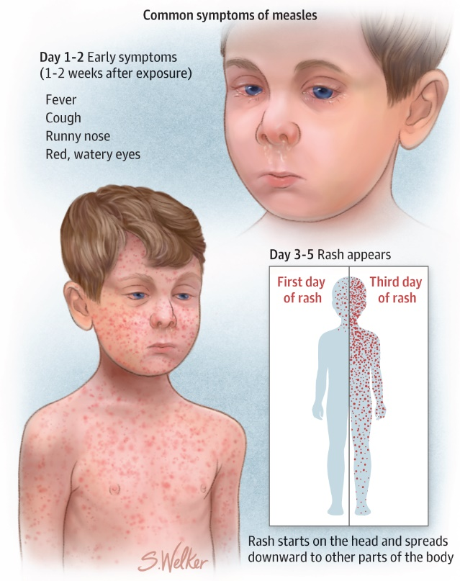

**Figure 2.1** Difference of measles rash on day 1 to 2 and day 3 to 5 [1]

As the measles become severe the distance of each rash to each other become very close as and the intensity of the color red becomes more intense.

**Paramyxovirus**

Paramyxovirus: One of a group of RNA viruses that are predominantly responsible for acute respiratory diseases and are usually transmitted by airborne droplets. The paramyxoviruses include the agents of [mumps](https://www.medicinenet.com/mumps/article.htm), [measles](https://www.medicinenet.com/measles_rubeola/article.htm) (rubeola), RSV ([respiratory syncytial virus](https://www.medicinenet.com/respiratory_syncytial_virus/article.htm)), Newcastle disease, and parainfluenza [1].

**Kopliks spot**

Little spots inside the mouth that are highly characteristic of the early phase of [measles](https://www.medicinenet.com/measles_rubeola/article.htm) (rubeola). The spots look like a tiny grain of white sand, each surrounded by a red ring. They are found especially on the inside of the cheek (the buccal mucosa) opposite the 1st and 2nd upper molars. Named for the New York pediatrician Henry Koplik who described them [2].

**Measles Vaccination**

Live attenuated measles virus vaccine is incorporated into combination MMR vaccine and combination measles, mumps, rubella, and varicella (MMRV) vaccines. Monovalent measles vaccine is not available in the United States. For prevention of measles, two doses of MMR vaccine are recommended routinely for children, with the first dose at age 12 through 15 months and the second dose at ages four through six years (school entry). For prevention of measles among adults, two doses of MMR vaccine are also recommended for adults at high risk, including international travelers, college and other post-high school students, and health care personnel born during or after 1957. All other adults, born during or after 1957, without other presumptive evidence of measles immunity, should be vaccinated with one dose of MMR vaccine [10].

**Image Processing**

Image Processing is the processing of an image given as an input by the use of signal processing to enhance and gather information from the image then the output of the image processing can either be another image or features depending from the input [11].

**A point-of-care test for measles diagnosis: detection of measles-specific IgM antibodies and viral nucleic acid**

Point-of-care tests (POCTs) are increasingly used for the rapid diagnosis of infections [7]. They can be performed in a single incubation step at ambient temperature without complex electrical equipment and their results can be read visually. By increasing diagnostic capacity and facilitating rapid diagnosis in resource-poor countries, they have the potential to improve measles surveillance and the response of health authorities to possible outbreaks.

POCT is capable of detecting measles-specific IgM antibodies in both serum and oral fluid specimens. In this paper we describe the diagnostic performance of this POCT for each specimen type. We also investigated whether viral RNA could be amplified from the used test strips, as that would enhance their use in measles surveillance [7].

Blood for serologic testing of adults is collected by venipuncture. Collect 7–10 ml of blood in a red-top or serum-separator tube (SST). The preferred volume for IgM and IgG testing at CDC is 0.5–1 ml of serum to allow for re–testing; however, testing can be done with as little as 0.1 ml (100 µl) if necessary.  Do not freeze tubes containing whole blood. Centrifuge blood collection tubes (10 min at 2200 – 2500 rpm) to separate serum from clot. Gel separation tubes should be centrifuged no later than 2 hours after collection. Aseptically transfer serum to a sterile tube that has an externally threaded cap with an o–ring seal. Store specimens at 4°C and ship on wet ice packs. Hemolyzed and lipemic serum and plasma are noted and tested, usually without apparent interferences [7].

Blood for serologic testing of infants or small children can be collected by finger/heel stick. Capillary tubes can be utilized for infants. Capillary tubes require the submitter to have access to a hematocrit centrifuge. Clinical laboratories should have 50 or 100 µl capillary tubes that are typically used for a variety of tests such as hematocrits or total lipids on newborns. At least 3 of the 50 µl hematocrit capillary tubes should be collected and spun in a hematocrit centrifuge [7].

**Edge Detection**

Edge detection is an image processing technique used to find the boundaries of object within images. It works by detecting discontinuities in brightness. Edge detection is used for an image segmentation and data extractions in image processing.

**Color Detection**

Hue-Saturation-Value (HSV) color space conversion is used to select colors from a color wheel or pallete. HSV color space is more often used in machine vision owing to its superior performance compared to RGB color space in varying illumination levels [12]. Often thresholding and masking is done in HSV color space. So it is very important to know the HSV value of the color which we wnat to filter out. Saturation is the grayness, so that the saturation value near 0 means it is dull or gray looking. The HSV color wheel is also used to generate high-quality graphics [12]. Selecting an HSV color begins with picking one of the available hues, which is how most humans relate to color and then adjusting the shade and brightness values.

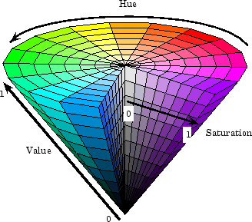

**Fig 2.2** HSV color space [12]

HSV Color wheel is some times depicted as a cone or cylinder, but always with these components:

Hue is the color portion of the color model, expressed as a number from 0 to 360 degrees:

**Table 2.1** Hue value of colors

|  |  |
| --- | --- |
| Color | Angle |
| Red | 0-60 |
| Yellow | 60-120 |
| Green | 120-180 |
| Cyan | 180-240 |
| Blue | 240-300 |
| Magenta | 300-360 |

Saturation is the amount of gray in the color, from 0 to 100 percent. Reducing the saturation toward zero to introduce more gray produces a faded effect. Sometimes, saturation is expressed in a range from just 0-1 where 0 is gray and 1 is a primary color [12].

Value (or brightness) works in conjuction with saturation and describes the brightness or intensity of the color from 0-100 percent, where 0 is completely black, and 100 is the brightest and reveals the most color.

**Binary Image Conversion**

Binary image is a digital image that has only two possible values for each pixel. Typically, the two colors used for binary image are black and white. The color used for a binary image are black and white. The color used for the objects in the image is the foreground color while the rest of the image is the background color. Binary images often arise in digital image processing as masks or as the result of certain operations such as segmentation, thresholding, and dithering. Some input and output devices, such as laser printers, fax machines, and bilevel computer displays, can only handle bilevel images. A binary image can be stored in memory as a bitmap, a packed array of bits. A 650x480 image requires 37.5 KiB of storage. Because of the small size of the image files, fax machine and document management solutions usually use this format.

**Image Segmentation**

Image Segmentation is the process of dividing an image into multiple parts to identify objects or other information in digital images. Edges are the organized point wherein the brightness of the image changes sharply into a set of curved line segments. Edges can be obtained through edge detectors and this can be segmented [13]. Binary images are produced from color images by segmentation. Segmentation is the process of assigning each pixel in the source image to two or more classes. If there are more than two classes then the usual result is several binary images.

**Image Masking**

Image masking it is used to segment the image and hide some portions from the segmentaiton of the image to reveal some portions. This process is a non-destructive process of image processing. It is used to hide the background of the image to emphasize the needed part of the image [13].

**Support Vector Machine**

Vector Machine (SVM) is a discriminative classifier formally defined by a separating hyperplane. In other words, given labeled training data (supervised learning), the algorithm outputs an optimal hyperplane which categorizes new examples. In two-dimensional space this hyperplane is a line dividing a plane in two parts where in each class lay in either side. The objective of the support vector machine algorithm is to find a hyperplane in an N-dimensional space (N — the number of features) that distinctly classifies the data points. To separate the two classes of data points, there are many possible hyperplanes that could be chosen. Our objective is to find a plane that has the maximum margin, like the maximum distance between data points of both classes. Maximizing the margin distance provides some reinforcement so that future data points can be classified with more confidence.

**Serologic testing**

The state health department can provide guidance regarding available laboratory services. At the direction of the state health department, health care providers and state and local health departments may send serum specimens from suspected measles cases to the CDC Measles Laboratory [11]. There is no single serologic laboratory test capable of confirming with 100% confidence every true case of measles. Public health laboratories that use commercial measles assay kits are encouraged to fully characterize and validate the kits in their laboratories using known test panels of positive and negative specimens [14]. Information regarding the performance characteristics of many of the commercially available enzyme immunoassays (EIA) kits is available by contacting the CDC Measles Laboratory. The reference laboratory at CDC uses an IgM assay developed at CDC for measles serologic testing of IgM [8]. The assay is a capture IgM format EIA that utilizes a recombinant measles nucleoprotein (NP) antigen and tends to have high sensitivity and specificity compared to some commercial EIAs.

**Dermatological disease detection using image processing and artificial neural network**

Skin diseases are among the most common health problems worldwide. The article proposed a method that uses computer vision-based techniques to detect various kinds of dermatological skin diseases. Different types of image processing algorithms were used for feature extraction and feed forward artificial neural network for training and testing purpose. The system works on two phases- first pre-process the colour skin images to extract significant features and later identifies the diseases. The system successfully detects 9 different types of dermatological skin diseases with an accuracy rate of 90% [15].

# **Digital dermatology: Skin disease detection model using image processing**

# This paper proposes a skin disease detection method based on image processing techniques. This method is mobile based and hence very accessible even in remote areas and it is completely noninvasive to patient's skin. The patient provides an image of the infected area of the skin as an input to the prototype. Image processing techniques are performed on this image and the detected disease is displayed at the output. The proposed system is highly beneficial in rural areas where access to dermatologists is limited [16].

# **Skin disease recognition using texture analysis**

This research describes skin disease recognition by using neural network which based on the texture analysis. There are many skin disease which have a lot of similarities in their symptoms, such as Measles (rubeola), German measles (rubella), and Chickenpox etc. In general, these diseases have similarities in pattern of infection and symptoms such as redness and rash. Diagnosis and recognition of skin disease take a very long term process because it require patient’s history, physical examination and proper laboratory diagnostic tests. Not only that, it also requires large number of features clinical as well as histopathological for analysis and to provide further treatment. The disease diagnosis and recognition becomes difficult as the complexity and number of features of the disease increases. Hence, a computer aided diagnosis and recognition system is introduced. Computer algorithm which contains few steps that involves image processing, image feature extraction and classification of data have been implemented with the help of classifier such as artificial neural network (ANN). The ANN can learn patterns of symptoms of particular diseases and provides faster diagnosis and recognition than a human physician. Thus, the patients can do the treatment for the skin disease faced immediately based on the symptoms detected [17].

## **Use of Neural Network-Based Deep Learning Techniques for the Diagnostics of Skin Diseases**

Melanoma is one of the most dangerous types of cancer. The accuracy of visual diagnosis of melanoma directly depends on the experience and specialty of the physician. Current development of image processing and machine learning technologies allows systems based on artificial neural convolutional networks to be created, these being better than humans in object classification tasks, including the diagnostics of malignant skin neoplasms. Presented is an algorithm for the early diagnostics of melanoma based on artificial deep convolutional neural networks. This algorithm can discriminate benign and malignant skin tumors with an accuracy of at least 91% by examination of dermatoscopy images [18].

[**Skin disease identification system using gray level co-occurrence matrix**](https://www.scopus.com/record/display.uri?eid=2-s2.0-85020893567&origin=resultslist&sort=plf-f&src=s&nlo=1&nlr=20&nls=afprfnm-t&affilName=mapua+institute+of+technology&sid=97c76bce8a3f20808e58475994a2cfc5&sot=afnl&sdt=sisr&sl=36&s=%28AF-ID%28%22Mapua+University%22+60104319%29%29&ref=%28skin+disease%29&relpos=1&citeCnt=1&searchTerm=)

Diagnosis of the skin disease has always been in terms of a doctor's knowledgeable opinion, or by number of laboratory screenings. Diagnosis is made by looking for additional signs that make the doctor's statement accurate, however in some cases signs are indistinguishable that results to miss potential diagnosis. With the use of this human skin diseases classification system, diagnosing existing skin disease will be accessible without undergoing laboratory screenings. The skin image is classified using the GLCM (Gray Level Co-Occurrence Matrix) features, wavelet decomposition for normalization, and k-NN (k-nearest neighbors) classifier. The skin disease that will be classified are Acne and Psoriasis. The device was proven to be effective for classifying the skin diseases. Acne have 100% accuracy while Psoriasis have 92% accuracy, with 25 trials per disease [9].

**Facial fluid synthesis for assessment of acne vulgaris using luminescent visualization system through optical imaging and integration of fluprescent imaging system**

Acne vulgaris, commonly called as acne, is a skin problem that occurs when oil and dead skin cells clog up in a person's pores. This is because hormones change which makes the skin oilier. The problem is people really do not know the real assessment of sensitivity of their skin in terms of fluid development on their faces that tends to develop acne vulgaris, thus having more complications. This research aims to assess Acne Vulgaris using luminescent visualization system through optical imaging and integration of image processing algorithms. Specifically, this research aims to design a prototype for facial fluid analysis using luminescent visualization system through optical imaging and integration of fluorescent imaging system, and to classify different facial fluids present in each person. Throughout the process, some structures and layers of the face will be excluded, leaving only a mapped facial structure with acne regions. Facial fluid regions are distinguished from the acne region as they are characterized differently [19].

**Automatic image analysis of antibody assays to measles virus**

A system for the automatic analysis of 24-well plates used in antibody assays to measles virus has been designed and developed based on digitizing the information on the plate through a CCD camera, displaying the image and then analyzing it using image processing methods. The system is being used in the analysis of sera from individuals vaccinated against measles and has been compared with the previous method where the plates were assessed by eye [6]. The results from both methods are very similar although the manual method consisted of counting numbers of plaques (clear areas in the cells of the plate) and the automatic method measured plaque area. The automatic method is much faster than the original method and prevents operator fatigue. It does not deal, at present, with anomalies such as partially filled wells but could be developed to do so by incorporating intelligence into the system.

**Implementation of fuzzy inference system in children skin disease diagnosis application**

This paper discussed the use of fuzzy inference system in children's skin disease diagnose application. The selected diseases to be diagnosed by the application are measles, German measles and chicken pox. These diseases were selected due to their similarities in pattern of infection and symptoms such as rash and fever. The built fuzzy inference system has input variables that represent the symptoms that may appear in each disease. The used fuzzy rules generated from experts' knowledge and literature. Additional features to modify the inference system also included in the application. The application diagnosed diseases from 19 of 25 data represent patients' condition correctly [12].

**Chapter 3  
METHODOLOGY**

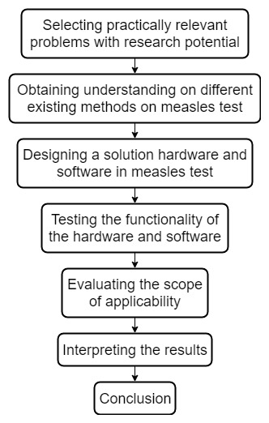

**Figure 3.1** Constructive Methodology

In figure 3.1 the constructive methodology, it shows the research method and the methodological approach in conducting this research with the help of practical problem solving and some scientific theories. This shows the constructive research process in the development of the study. The steps on constructive research include selecting practically relevant problem with research potential, obtaining pre-understanding on different methods on testing measles, designing a solution hardware and software in testing measles, testing the functionality of the hardware and software, evaluating the scope of the applicability, interpreting the results, and by formulating a conclusion from the results.

The researchers identified the statement of the problem that the existing method to detect measles is the manual process and a need of blood test to detect measles. Researchers will obtain pre-understanding of the topic by reading articles related to measles detection and look into previous works regarding detection of various skin diseases. Researchers then will think of different algorithms that can be used in the study to determine measles. After researching for solutions, image processing technique is applicable to solve the problem. Software development will be done to apply the process and algorithms to use in the system to acquire the desired results. Development of the hardware will be done once the system design is finished and the materials are gathered. After formulating the development of the software and hardware, the testing will be done next to make sure that the outputs obtained from the system is acceptable and correct values expected by the researchers. The results will then be interpreted to analyze before presenting the results obtained. Lastly, based from the results gathered, the researchers will make a conclusion.

**Conceptual Framework** 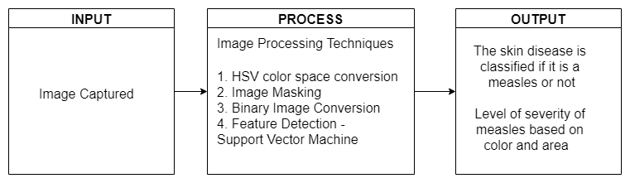

**Figure 3.2** Conceptual Framework

To check the skin of the subject, the camera will focus to acquire an image of the area of the affected area of the skin and process the image using image processing techniques and will output the result if the subject has measles. The captured image will be the input for the system. The system will use some image processing techniques to proess the captured image and detect measles. The techniques used are HSV color space conversion, Image Binary, Image Masking, and Support vector machine. The system will display if the rash is a measles or not and if it is measles, it displays its severity based on area and color.

**Software Development**

**Support Vector Machine Training**

**Table 3.1** Training for determination on severity of area of the rash table

|  |  |  |  |  |
| --- | --- | --- | --- | --- |
| **Samples** | **Doctor A** | **Doctor B** | **Doctor C** | **Remarks** |
| **1** |  |  |  |  |
| **2** |  |  |  |  |
| **3** |  |  |  |  |
| **4** |  |  |  |  |
| **5** |  |  |  |  |
| **…** |  |  |  |  |
| **500** |  |  |  |  |

The table 3.1 shows the table for the training for the basis for the severity of area. Each doctor will classify each sample whether the severity of measles of the sample images are light, moderate or severe. The samples is then classified based on area severity to be trained in the system using Support Vector Machine. The sample images that will be categorized by the three doctors on the same severity will be used on the training of the system.

**Table 3.2** Relationship of Severity based on area to the number of pixels

|  |  |
| --- | --- |
| **Severity of measles based on area** | **Ratio of measles pixels to skin pixels** |
| **Light** | 2.82% - 20.41% |
| **Moderate** | 20.41% - 35.03% |
| **Severe** | 35.03% above |

Table 3.2 will formulate the relationship of the severity based on area to the number of pixels. The table will show the range of the number of pixels for each level of severity based on area.

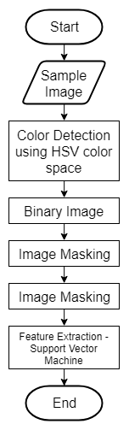

**Fig 3.3** Support Vector Machine Training Flowchart

The figure 3.3 shows the process for the training of the machine using Support Vector Machine. At first the device will allow to take sample images with measles and other skin disease as an input for the machine to differentiate and know the characteristics of measles. The sample images is then converted to HSV color space image conversion to get the red value of the rashes, then the image is then converted to binary image and image masking for it to segment the rash to the skin and background. The system will now process the Support Vector Machine based training to detect features of the measles and other skin diseases. The classification multiclass file will be formulated to have its file to be used for detecting measles using the system.

**System Flowchart**

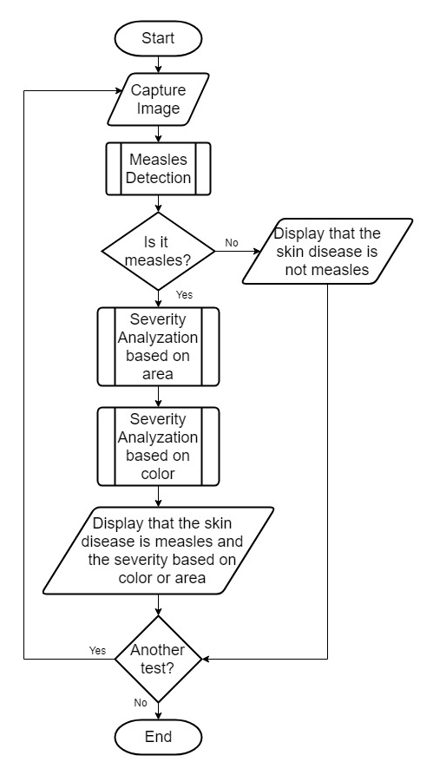

**Figure 3.4** Main System Flowchart

Figure 3.4 shows the main system flowchart. The system starts capturing image of the rash on the skin. The captured image will be processed using image processing techniques to detect if the rash is measles. The image is processed to detect if it is measles and if it is classified as measles the system will measure its severity in color and area. The results is then displayed in the LCD.

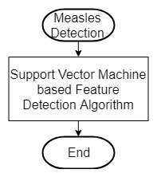

**Fig 3.5** Measles Detection Module Flowchart

Fig 3.5 shows the process on how to detect measles. The input image is used in SVM based feature detection algorithm that is developed from the feature map from the training process.

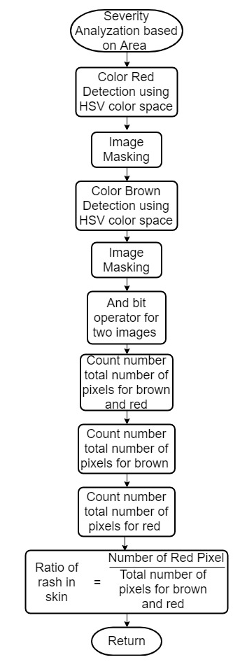

**Fig 3.6** Severity Analyzation based on area of the rash flowchart

Fig 3.6 shows the process on how the severity based on ratio area of the rash to the skin. The input image is converted to HSV color space and image masking to segment the red rash from the skin. The process is done again to segment the color of the skin from the rash. The ratio is computed after having the pixel count for the skin and the rash. To get the ratio of the area of the rash to the skin the formula below is used:

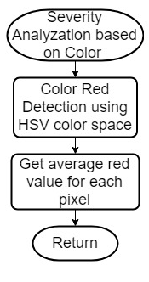

**Figure 3.7** Severity Analyzation based on color of the rash flowchart

Figure 3.7 shows on how the process on how the severity based on color of the rash in the skin. The input image is converted to HSV color space and compute for the average value of the HSV value of the rash.

**Image Processing**

**Edge Detection**

Hue, Saturation, and Value (HSV) color space conversion is used to detect the color value of the rash and the skin. The value is maped on the HSV color space to determine the color of the rash. It is used to classify the segment of the rash and the skin in the image.

Binary Image conversion is used to segment the rash to its background and the image will be black and white. The red color will be the black and the background will be the color white, it is used to easily segment the rash to the skin and get the area of the rash from the pixel count.

**Image Segmentation**

Image Masking is used to segment the image, the background is removed in the image so that the rash will be easily classified for determining its severity based on area and color.

**Severity based on area and color**

Step 1: Read the input image

Step 2: Convert the image to its HSV value

**Table 3.3** Comparison of input and output image after color variation table

|  |  |  |  |
| --- | --- | --- | --- |
| **Samples** | **Input Image** | **Output Image** | **Number of red pixels** |
| **Sample 1** |  |  | 147675 |
| **Sample 2** |  |  | 1715036 |
| **Sample 3** |  |  | 126090 |
| **Sample 4** |  |  | 35802 |
| **Sample 5** |  |  | 41883 |

Table 3.3 will compare the input and output image after the color variation algorithm and shows the red value of the rash.

Step3: Apply image masking for rash

**Table 3.4** Comparison of input and output image after segmenting the edges table

|  |  |  |  |
| --- | --- | --- | --- |
| **Sample** | **Input Image** | **Output Image** | **Remarks** |
| **Sample 1** |  |  |  |
| **Sample 2** |  |  |  |
| **Sample 3** |  |  |  |
| **Sample 4** |  |  |  |
| **Sample 5** |  |  |  |

The table 3.4 will compare the input and output image after the image segmentation algorithm and shows the remarks if the image segmentation from the edge detection is properly detected.

Step 4: Convert the image to its brown HSV value

**Table 3.5** Comparison of input and output image after color variation table

|  |  |  |  |
| --- | --- | --- | --- |
| **Sample** | **Input Image** | **Output Image** | **Number of brown pixels** |
| **Sample 1** |  |  | 225123 |
| **Sample 2** |  |  | 2566651 |
| **Sample 3** |  |  | 282721 |
| **Sample 4** |  |  | 128320 |
| **Sample 5** |  |  | 692612 |

Table 3.5 will compare the input and output image after the HSV color space conversion and count the pixels of the skin.

Step 5: Image masking for skin

**Table 3.6** Comparison of input and output image after image masking

|  |  |  |  |
| --- | --- | --- | --- |
| **Sample** | **Input Image** | **Output Image** | **Remarks** |
| **Sample 1** |  |  |  |
| **Sample 2** |  |  |  |
| **Sample 3** |  |  |  |
| **Sample 4** |  |  |  |
| **Sample 5** |  |  |  |

Table 3.6 will compare the input and output image after the image masking and shows the remarks if the edge of the rash is properly detected.

Step 6: Apply And bit operator (bitwise) to combine 2 images

**Table 3.7** Comparison of input and output image after and bit operator

|  |  |  |  |
| --- | --- | --- | --- |
| **Sample** | **Input Image (rash)** | **Input Image (skin)** | **Output Image** |
| **Sample 1** |  |  |  |
| **Sample 2** |  |  |  |
| **Sample 3** |  |  |  |
| **Sample 4** |  |  |  |
| **Sample 5** |  |  |  |

Table 3.7 will compare the input and output image after the image masking and shows the remarks if the edge of the rash is properly detected.

Step 7: Count the total number of pixels

**Table 3.8** Total number of pixels of the skin and rash

|  |  |  |
| --- | --- | --- |
| **Sample** | **Output Image** | **Total Number pixels** |
| **Sample 1** |  | 225218 |
| **Sample 2** |  | 2567521 |
| **Sample 3** |  | 282721 |
| **Sample 4** |  | 135575 |
| **Sample 5** |  | 696074 |

Table 3.8 will count the number of totatl pixels to be used in computing the ratio area of the rash to the skin.

Step 9: Compute for the ratio area using the formula

Step 8: Get the average value of red HSV value to get the average redness of the rash

Step 9: Compare the input image to CNN Feature map to detect if it is measles or not

Step 10: Display the ratio area of the rash to its skin and its severity by color.

**Feature Extraction**

Feature extraction is a process on machine learning in which it selects important characteristics of an image and then to compare on the input image. The phase of maturity will be classified using the machine learning support vector machine. After processing of the image, the data to be acquired will be compared to the data that is trained in the support vector machine. With this comparison, the support vector machine will classify the sample.

Process of Support Vector Machine Algorithm

Step 1: Set up the training data

**Table 3.9** Input image for training data for area severity

|  |  |  |  |
| --- | --- | --- | --- |
| **Samples** | **Input Image** | **Area** | **Remarks of severity** |
| **1** |  |  |  |
| **2** |  |  |  |
| **3** |  |  |  |
| **...** | **...** | **...** | **...** |
| **500** |  |  |  |

The table 3.9 is used to list the image used for training data for the area measured from the device with its remarks of severity based on area.

**Table 3.10** Input image for training data for red value severity

|  |  |  |  |
| --- | --- | --- | --- |
| **Samples** | **Input Image** | **Red Value** | **Remarks of severity** |
| **1** |  |  |  |
| **2** |  |  |  |
| **3** |  |  |  |
| **...** | **...** | **...** | **...** |
| **500** |  |  |  |

The table 3.10 is used to list the image used for training data for the color from the device with its remarks of severity based on its color.

Step 2: Set up the Support Vector Machine parameters

Step 3: Train the Support Vector Machine

Step 4: Classification of the Support Vector Machine

Step 5: Support vectors

**Hardware Development**

**Block Diagram**

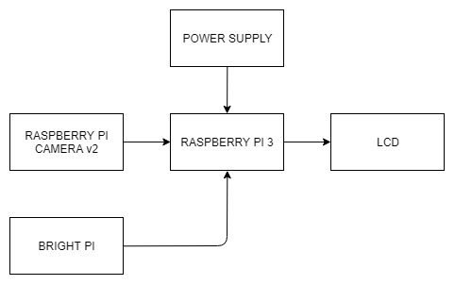

**Figure 3.8** Hardware Block Diagram

Figure 3.8 shows the hardware block diagram and the hardware components that will be used on proposed system. It comprises of the Raspberry Pi 3, camera module, LCD, light source, and power supply. The Raspberry Pi 3 is the microcomputer that process the image captured and apply the image processing algorithm to obtain the results. The camera module will capture the image with the help of bright pi to enhance the image with light and the output will be displayed in the LCD. The power supply provides power for the Raspberry Pi, and the Raspberry Pi provides power to camera module, LCD, and bright pi.

**Hardware Description**

* Raspberry Pi 3

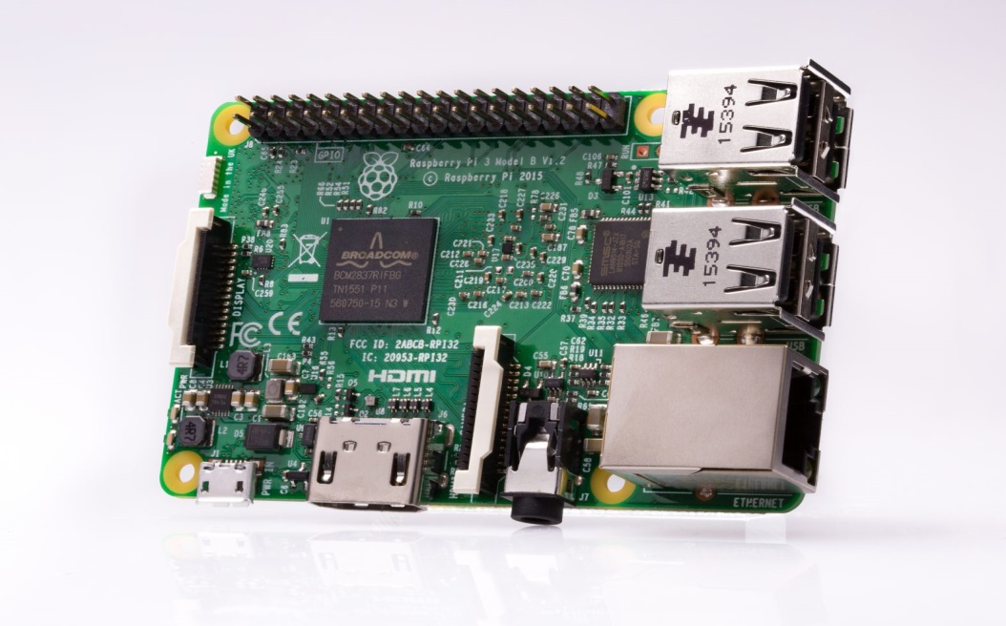

**Figure 3.9** Raspberry Pi 3

Raspberry Pi 3 microcomputer performs the algorithms and software programs that are loaded in the microcomputer.

Specifications:

* + Quad Core 1.2 GHz Broadcom BCM2837 CPU
  + Broadcom VideoCore IV GPU
  + 1GB LPDDR2 900MHz RAM
  + 10/100 Ethernet, 2.4GHz 802.11n wireless
  + Bluetooth 4.1 Classic
  + microSD port
  + 40-pin header extended GPIO
  + HDMI port
  + 3.5mm analogue audio-video jack
  + 4x USB 2.0
  + Ethernet port
  + Camera Serial Interface
  + Display Serial Interface
* Raspberry Pi Camera Module v2

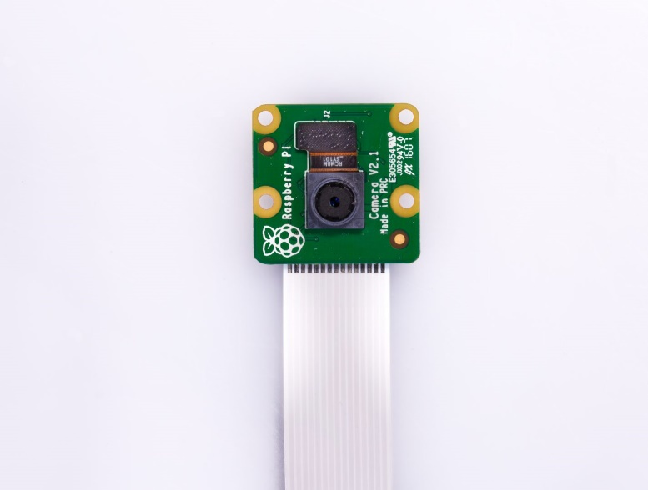

**Figure 3.10** Raspberry Pi Camera Module v2

Raspberry Pi Camera Module v2 is used to take high-definition photographs and video. The camera works with all models of Raspberry Pi, and there are various third party libraries built for it, including the Picamera Python library.

Specifications:

* + 8-megapixel resolution high quality Sony IMX219 image sensor
  + Captures static images at 3280 x 2464 pixel
  + Capture video at 1080p30, 720p60, and 640x480p90 resolutions
  + Optical size of 1/4"
* 16 x 2 LCD Module

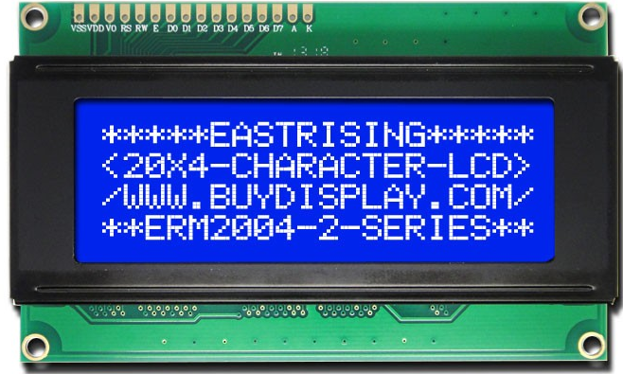

**Figure 3.11** 16x2 LCD Module

Liquid Crystal Display screen is an display module that is commonly used

Various devices and prototypes. LCDs are easily programmable and have no limitations of displaying special and even custom characters. It can display 16 characters per line and has 2 lines.

**Data Gathering Procedures**

1. The experiment will be conducted during the rash is visible in the patient.
2. The doctor will observe the rashes if it rubeola and identify its phase of maturity.
3. The components that will be used are the light source, camera module, LCD display, and the Raspberry Pi 3 microcomputer.
4. The area of the rash will be placed under the light source to make sure that the camera will have a clear image of the rash.
5. The camera will take a picture of the skin with rash and the image will be sent to the microcomputer for processing.
6. Edge detection technique will be applied to process the image and extract only the region of interest.
7. Determininig the phase of maturity of the measle rash will be measured and determined using support vector machine algorithm.
8. The LCD displays if the the rash is a measles and the phase of maturity of the measles.
9. The results of the device will be compared to the results obtained from the doctor’s examination to verify that the device yields an acceptable output.

**Testing Tables**

**Table 3.11** Testing table for measles detection

|  |  |  |  |
| --- | --- | --- | --- |
|  | **Doctor’s Evaluation** | **Device’s Evaluation** | **Remarks** |
| **Patient A** | Measles | Measles | True |
| **Patient B** | Measles | Measles | True |
| **Patient C** | Measles | Measles | True |
| **Patient D** | Measles | Measles | True |
| **Patient E** | Measles | Measles | True |
| **Patient F** | Not Measles | Not Measles | True |
| **Patient G** | Not Measles | Measles | False |
| **Patient H** | Not Measles | Measles | False |
| **Patient I** | Not Measles | Not Measles | True |
| **Patient J** | Not Measles | Not Measles | True |

Table 3.11 shows the measles test if the rash is measles and if it is evaluated as measles, its phases. The evaluation to 10 patients of doctor and the device using image processing is compared that must be in accordance to the objective of the study. Remarks will be placed if the device’s evaluation is predicted true positive, true negative, false positive, false negative.

**Table 3.12** Testing table for determination on severity of area of the rash

|  |  |  |  |
| --- | --- | --- | --- |
|  | **Doctor’s Evaluation on severity on area** | **Device’s Evaluation on severity on area** | **Remarks** |
| **Patient A** | 3 doctors  severe | 39.61260522%  severe | True |
| **Patient B** | 3 doctors  severe | 40.05514649 %  severe | True |
| **Patient C** | 3 doctors  severe | 30.84310354%  severe | True |
| **Patient D** | 3 doctors  moderate | 21.81426012%  moderate | True |
| **Patient E** | 2 doctors  light | 5.702285244%  light | True |
| **Patient F** | Not measles | Not measles | True |
| **Patient G** | Not measles | 19.06162736%  measles | False |
| **Patient H** | Not measles | 16.66990703%  measles | False |
| **Patient I** | Not measles | Not measles | True |
| **Patient J** | Not measles | Not measles | True |

Table 3.12 shows the severity of the measles based on the area of the rash in skin. The evaluation of the doctor is compared on the evaluation of the device on the severity of the measles based on area by light, moderate or severe measles.

**Confusion Matrix**

**Table 3.13** Confusion Matrix for measles detection

|  |  |  |  |
| --- | --- | --- | --- |
|  |  | **Doctor’s Evaluation** | |
| **Device’s Evaluation** |  | **Unknown skin disease** | **Measles** |
| **Unknown skin disease** |  |  |
| **Measles** |  |  |

Table 3.13 shows the confusion matrix. It is used to describe the performance of the classification of the support vector machine on determining the skin disease if it is measles. The table represents the condition of the measles evaluated by the doctor and the condition of the measles evaluated by the machine. It shows visualize performance of the algorithm. The data is represented as true and false. The performance of the classification is evaluated in accuracy and precision.

Accuracy is the ratio of total number of samples correctly classified to the total number of samples classified as given by the equation below:

Where:  
 TP (True Positive) = Number of positive samples classified as postive

TN (True Negative) = Number of negative samples classified as negative

FP (False Positive) = Number of negative samples classified as positive

FN (False Negative) = Number of positive samples classified as negative

Precision is the ratio of number of positive samples correctly classified to the total number of samples classified as given by the equation below:

**Table 3.14** Confusion Matrix for measles severity based on area

|  |  |  |  |  |
| --- | --- | --- | --- | --- |
|  | | **Doctor’s Evaluation** | | |
| **Device’s Evaluation** |  | **Light** | **Moderate** | **Severe** |
| **Light** |  |  |  |
| **Moderate** |  |  |  |
| **Severe** |  |  |  |

Table 3.14 shows the confusion matrix. It is used to describe the performance of the classification of the support vector machine on determining the area of the measles. The columns represent the severity of the measles based on area evaluated by the doctor and the severity of the measles evaluated by the machine. It shows visualize performance of the algorithm. The data is represented as true and false. The performance of the classification is evaluated in accuracy.

Accuracy is the ratio of total number of samples correctly classified to the total number of samples classified as given by the equation below:

Where:  
 TL (True Light) = Number of light severity samples classified as light severity

TM (True Moderately severe) = Number of moderately severe samples classified as moderately severe

TS (True Severe) = Number of severe samples classified as severe

FL (False Light Severity) = Number of samples wrongly classified as light severity

FM (False Moderately Severe) = Number of samples wrongly classified as moderately severe

FS (False Severe) = Number of samples wrongly classified as severe

**Chapter 4**

**CONCLUSION**

The researchers were able to construct a device that detects measles from the captured images. The device can classify the severity of the measles based on its area and color. The use of image processing techniques such as HSV color space conversion, Image masking, Image Binary conversion and the Support Vector Machine for the feature extraction of the images of the measles are reliable to use as detection of measles rash. The device has ________ percent errors from the measles detection of the device’s evaluation and doctor’s evaluation. The results yield an average percent error of ________. The results obtained helped the researchers to understand the device learning process

The device has ________ percent error in the determination of measles severity based of area of the rash.