**Detection and Counting of Red Blood Cells in Human Urine using Canny Edge Detection and Circular Hough Transform Algorithms**

by

**Arnold Janssen G. Hernandez**

**Gilbert P. Ombay**

A Thesis Submitted to the School of Electrical Engineering, Electronics Engineering, and Computer Engineering in Partial Fulfilment of the Requirements for the Degree

Bachelor of Science in Computer Engineering

Mapúa University

March 2018

**Chapter 1**

**Introduction**

Urinalysis test is done in order to detect and manage a wide range of disorders. Usually, a microscopic exam of urine is done to look for abnormalities.Red blood cells are blood cells that carry oxygen. When specific number of red blood cells are distinguished in urine, this is a medical condition is known as “hematuria”. A normal result is 4 red blood cells per high power field (RBC/HPF) which represents a 400-fold magnification when referenced in scientific papers. Blood in urine can come from the kidneys, where urine is made. Other source of it can come from other structures in urinary tract such as Ureters, Bladder and Urethra. Physical activities which involve using a lot of energy can also be a cause of this condition. There are two types of hematuria namely: Gross hematuria which can be seen by the naked eye in urine due to its color pigmentation which may be pink, red or dark brown. The other type is the Microscopic hematuria which is where the red blood cells can only be seen through the use of microscope. A high count of red blood cells in the urine can indicate infection, trauma, tumors or kidney stones. If red blood cells seen under microscopy look distorted, they suggest kidney as the possible source and may arise due to kidney inflammation also known as glomerulonephritis. With the advancement of technology nowadays, image processing is one of the most efficient method to use in detecting and count the amount of the RBCs in urine compared to the manual inspection of blood cells which is time consuming and requires more technical knowledge and experience.

The most well-known and traditional viable method in counting the red blood cell is by using the hemocytometer. It is made up of microscopic slide glass with a rectangular indention that creates a chamber. Grid of perpendicular lines are etched within this chamber. By placing it under the microscope, the cells can be counted manually by observation. Counting these samples manually takes time and may lead to unreliable cell counts with high standard deviation. There are also some expensive machines like the Analyzer, which are not affordable by every laboratory. With the use of image processing technology, the expected results may be more precise, highly efficient, better reliability and less time consuming. Image processing is a method to convert an image into digital form and perform the operations on it. The implementation of image processing is made possible by using the python language as the researcher’s main of source software computer technology.

The result of urinalysis may take some time or even days to be obtained. One part of this process is counting the amount of red blood cells present in the urine of the patient. There exist in previous studies about automatically detecting and counting the red blood cells but did not specify how long it will take for it to be done. Previous researches did not focused on the speed and time it will take for their device to process and count the amount of red blood cells.

The core objective of the study is to detect and determine the number of red blood cell count present in the urine sample of a person. Specifically, the researchers aim to: (1) create a device using raspberry pi that enables medical technicians to examine red blood cells in urine samples, (2) develop a software application that would display the processed image and count the total amount of red blood cells in human urine by implementing Canny Edge Detection and Circular Hough Transform algorithms, (3) to record the time it takes for the system to perform an RBC detection and counting, (4) to compare the accuracy of the system to the results produced by the existing studies.

Carrying this study enables us to better understand the effects of containing red blood cells in urine. This can help laboratories that are still conducting or using the traditional way of counting the number of RBCs. Early detection of RBCs can help many people change their unhealthy lifestyles and to also consult a medical expert. All cases of having RBCs in their urine should be evaluated by a doctor who can order tests to confirm or rule out an underlying cause. Although there are already other existing methods to detect the number of RBCs in human urine, this opens up ideas for the researchers to come up with their own approach based on what they have researched and understood.

The study covers the determination and counting the number of red blood cells in the urine sample of a person using a microscopic lens and image processing technology with an algorithm implementation to accurately acquire the number of RBCs. By obtaining the number of the red blood cells, certain results of it would be identified. The production of a processed image of the microscopic view of the red blood cells in the urine was coved by the research. The study limits its coverage on determining other medical test results such as presence of bacteria, Epithelial or flat cells, white blood cells and urine pH level or the acidity of urine. The study does not cover the identification of the specific diseases that causes the abnormality in the number of red blood cells.

**Chapter 2**

**REVIEW OF RELATED LITERATURE**

**Urinalysis**

A urinalysis is a test of the urine which is used to identify different types of disorders. Human urine contains different chemical substances discharged from living bodies. Because of these chemical substances, different conditions of kidneys and several significant systems can be identified by Ongkum et al [1].

|  |  |
| --- | --- |
| **Classification** | **Normal Value** |
| Color | Yellow (light/pale to dark/deep amber) |
| Clarity/turbidity | Clear or cloudy |
| pH | 4.5-8 |
| Specific gravity | 1.005-1.025 |
| Glucose | ≤130 mg/d |
| Ketones | None |
| Nitrites | Negative |
| Leukocyte esterase | Negative |
| Bilirubin | Negative |
| Urobilirubin | Small amount (0.5-1 mg/dL) |
| Blood | ≤3 RBCs |
| Protein | ≤150 mg/d |
| RBCs | ≤4 RBCs/hpf |
| WBCs | ≤2-5 WBCs/hpf |
| Squamous epithelial cells | - ≤15-20 squamous epithelial cells/hpf |
| Casts | 0-5 hyaline casts/lpf |
| Crystals | Occasionally |
| Bacteria | None |
| Yeast | None |

**Table 2.1 Reference range**

Urinalysis may be categorized to microscopic, chemical, and visual examinations in order to detect cells, cell fragments and other sediments. Table 2.1 shows the reference range for the normal values that should be followed based by Lerma et al [2].

Visual or physical examination I s the observation of the color and clarity of the urine. A normal color of the urine should be light to dark amber. Any different color or appearance of the urine may mean that the person has urinary tract infection. For chemical examination, strip test was performed wherein the strip is to be dipped into the urine. After the dipping, chemical reactions would change the colors of the pads within minutes. The laboratorian can determine the results by observing the changes in color and referring to the references. Chemical examination includes the observation on specific gravity, pH level, protein, and glucose. The normal results can be seen in the table above. Lastly, the main focus of the research, is the microscopic examination. Microscopic examination is the method in which the laboratorians use microscope to count cells and other sediments in the urine sample. Counting the cells include the use of low power field and high-power field. Above are the range for the normal count for RBCs, WBCs, bacteria, and other substances found in the urine test.

**Red Blood Cells**

Red blood cells which are also known as erythrocytes in medical field, constructs the main part of the immune system. Their main purpose is to distribute oxygen to the different body tissues by the means of blood flow through the circulatory system. They carry oxygen from lungs and release it into tissues by driving through the body’s capillaries. It contains a biomolecule termed as Hemoglobin which provides red color to it. Proteins and lipids in the cell membrane provide the physiological functions such as deformability and stability by Acharya et al [3].

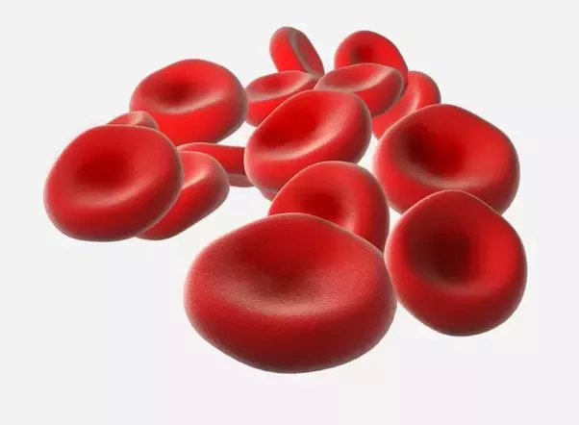

**Figure 2.1** An illustration of Red Blood Cells

RBCs are blood cells that transport and carry oxygen. Hemoglobin are contained within these red cells which permits them to transport oxygen and removes carbon dioxide in the body. Hemoglobin, aside from being a transport molecule, is a pigment. It gives the cells their red color.

*Classification of Red Blood Cells*

Red blood cells (RBCs) are the most abundant cells present in human body. Normal RBCs are biconcave and disk shaped. Any abnormality in the shape of RBC indicates presence of disease. The number of RBCs also plays an important role in detecting anemia. A decrease in the number of RBCs and an abnormality in RBC’s shape is a clear indicator of presence of blood related disorders. Presence of tear drop cells, echinocytes, elliptocytes, macrocytes indicate presence of diseases like myelofibrosis, severe iron deficiency, uremia hereditary elliptocytosis, haemolytic anaemia, etc. Dalvi et al [4].

Different diseases may be the cause of the abnormality in the number of red blood cell counts of a person. For men, the normal range for and RBC count is 4.7 to 6.1 million cells per microliter while for women is 4.2 to 5.4 million. Erythrocytosis is the phenomenon in which a person has a higher than normal count of RBC. The causes may be due to congenital heart disease, dehydration, pulmonary fibrosis, and many more. If the count of RBC is below than normal, this may be due to anemia, chronic kidney disease, leukemia and many more.

Red blood cell counts play a vital role in identifying the overall health of the patient by Acharya et al [3]. If a person’s RBCs are too high or too low, that person could experience symptoms and complications.

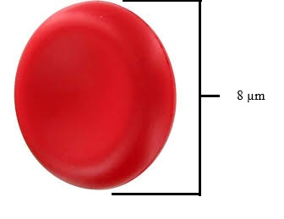

**Figure 2.2** An approximate diameter of a red blood cell

White blood cell’s radius is greater than red blood cell’s radius by Gatc et al [5]. A typical human red blood cell has a disk diameter of approximately 8 microns or micrometer. Obtaining the radius of a blood cell in the researcher’s experiment is very important because it will determine the difference between a red blood cell and a white blood cell since WBCs have larger radius than RBCs.

When viewed under high-power field magnification, specifically on 400x magnification, the radius of a red blood cell is approximately 3.5 mm while for the white blood cell, it is 6 mm by Strasinger & Di Lorenzo [6]. The 400x magnification of a high-power field microscope is composed of 40x objective lens of the eyepiece multiplied by 10x magnification.

**Red Blood Cells in Urine**

RBCs should not be seen in human urine because as much as possible, urine color should be transparent indicating an abnormal medical condition. A yellowish one indicates that it is still normal. A presence of RBC in urine indicates that a person has a hematuria or a blood in urine which is a sign of a serious disorder.

The appearance of crystals, casts, red blood cells, white blood cells and bacteria or yeast in urine is a major clinical significance. It provides important information for both diagnosis and prognosis by Maneesukasem et al [9]. In hematuria or blood in urine, the human body or other parts of urinary tract allow blood cells to leak into urine. Various problems can cause leakage, including:

* Urinary tract infections
* Kidney infections
* A bladder or kidney stone
* Enlarged prostate
* Cancer
* Inherited disorders
* Kidney injury
* Medications
* Strenuous exercise

**Traditional Way of Cell Counting**

Hemocytometer is a special plate apparatus used for cell counting that has straight lines (counting chambers) in certain size by Özkan et al [7]. It is a device invented by the 19th century by French anatomist Louis Charles Malassez to perform blood cell counts.

The presence of cells in the human body can be observed under the microscope with high power field magnification and is quantitively recorded manually by registered or licensed medical technologist by Navea et al [8]. The traditional or manual counting is important to be learned in medical field in order for them to familiarize with the long-established techniques and cell morphology.

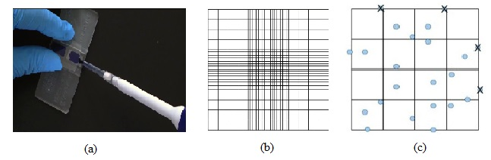

**Figure 2.3** The hemocytometer

Figure 2.3 illustrates the hemocytometer and its view under the microscope. Part (a) is where samples are placed. A simple amount or a droplet is enough for testing. Part (b) shows the gridlines in the apparatus where it has different measurements and sizes. Part (c) is illustrate samples in the apparatus which can only be seen using a microscope. The cells serve as guidelines in manually counting red blood cells.

**Image Processing**

Image processing is the examination and manipulation of an acquired image in its digital form which is yield to produce a more improved and qualitative result by Madhura et al [10]. Image processing is a technique used to perform some procedures on an image. This is done in order to obtain an enhanced quality of the image or to simply extract information about it. Nowadays, it is rapidly growing and widely used technology. It outlines significance research area within computer science and engineering.

Urine micrograph often degrades by noise, so in order to administer more accurate information about the image specially the edges, it is necessary to process the image by Cao et al [11]. There are different techniques or algorithms to be used in image processing.

*Canny Edge Detector vs Different Edge Detection Algorithms*

The Canny edge detector is an edge detection operator that uses a multi-stage algorithm to detect a wide range of edges in images. Edge detection is an important pre-processing step in image analysis to find object boundaries in images. The most known efficient property of Canny edge detector is the fact that it has lower error rate in terms of detecting edges by Maini et al [12]. Canny edge detector is a pre-process for Hough Transform which is broken down in to sub-processes. Edge detection is an important pre-processing step in image analysis by Matuska et al [13]. Canny edge detector is an algorithm used to detect a wide range of edges in an image. Edge detection is used to find object boundaries in images. Canny edge provides a low error rate, thus, it is accurate in catching many edges as possible in a given image.

Sobel operator is used in image processing and computer vision, particularly within edge detection algorithms where it creates an image emphasizing edges. The most known advantage of Sobel operator is its simplicity. This algorithm is simple in terms of the approximation of the gradient magnitude. But even though it is simple enough to apply, there exist a disadvantage for Sobel operator. This algorithm is sensitive to noise. Overall, the Sobel method cannot produce accurate edge detection with thin and smooth edge.

Prewitt operator is an edge detection algorithm similar to Sobel operator. It is used for detecting horizontal and vertical edges in the image. The Prewitt operator is based on convolving the image with a small, separable and integer valued filter in horizontal and vertical directions. The advantage of Prewitt operator is also similar with Sobel operator which lies on its simplicity.

Robert Cross operator is an edge detection algorithm which the main idea is to approximate the gradient of an image through discrete differentiation. This operator is one of the first edge detectors developed for image processing. The advantage of Robert Cross operator is also the simplicity due to the approximation of gradient magnitude.

A study on the performance of edge detection algorithms for image processing made by Selvakumar P et al [14], shows the Canny edge detector has the greatest advantage compared to other edge detection algorithms.

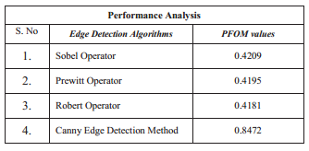

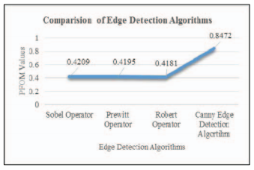

**Table 2.2** Performance analysis on different edge detection algorithms

Table 2.2 above shows the performance analysis of the four edge detection algorithms. Selvakumar and Hariganesh used the Pratt Figure of Merit Method (PFOM), which shows that the output results of Canny edge detection algorithm has more localized and detected edges than other edge detection methods.

Another research by Kutty et al [15], on the evaluation of Canny edge detector and Sobel operator, concludes that Sobel operator is more sensitive to noise. While for Canny edge detector, it keeps important and brings all image contains.

Generally, first order differential operators such as Sobel, Prewitt and Robert are known to have the advantage simple computation. But these operators are more sensitive to noise and their detection effect are not perfect for engineering application by Ballado et al [16]. Overall, Canny edge has the advantage in removing noise. Noise removal is very important in image processing. Noise reduction is the process of removing noise from a signal. All recording devices, both analog and digital, have traits that make them susceptible to noise. Canny edge is the recommended edge detection algorithm by most researchers.

**OpenCV vs Matlab for Image Processing**

OpenCv is an open source computer vision library containing more than 500 optimized algorithms for image and video analysis, including factory product inspection, medical imaging, security, user interface, camera calibration, stereo vision and robotics. OpenCv is faster than Matlab in some algorithm from 4 to 30 times and in case of Erosion algorithm up to 100 times according to Matuska et al [13]. OpenCV has more functions for computer vision than Matlab. In terms of CPU time consumption, OpenCv is faster and more efficient than Matlab. Matlab may be better in being user friendly, but it is not an open source language. Issues of Matlab include the license which when expired, certain packages needed cannot be installed.

# Chapter 3­­­­

## METHODOLOGY

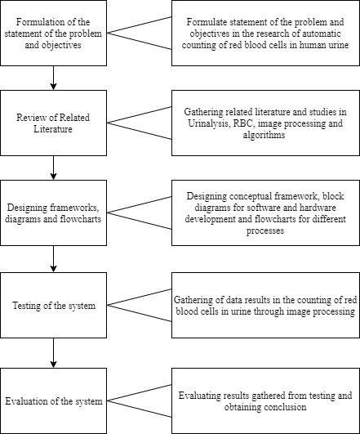

**Figure 3.1** Constructive Research Methodology

Figure 3.1 shows the constructive research methodology that aims to solve the problem in this research. The problem was first determined in order to know what study the researchers will conduct. The statement of the problem is that there exist researches about the detection and counting of red Blood cells in human urine, but these researches do not specify the time it takes to do it and lack automation, which made the researchers the need to construct a system that can automatically count RBCs through image processing in a faster time. Related literature and previous studies are reviewed to gain knowledge on the details concerning the problem which mainly focuses on urinalysis, red blood cells in urine and image processing. After understanding each literature, the solution design may be created which is acquiring the urine micrograph, processing the micrograph and evaluation of the system. For the software development, two algorithms will be used; one for edge detection and one for detecting circular objects in an image. For image processing, Python is the language to be used which will be implemented in Raspberry Pi 3. For hardware development, Raspberry Pi 3, Raspberry Pi Camera and an LCD monitor will be used in order to create the portable device. Testing of the system will involve comparison of the data gathered by the traditional manual way obtained by a medical technician and data gathered by the automatic way obtained by the image processing device. The efficiency of the device will be identified through percent error, standard deviation and standard error to prove the system’s functionality and reliability. Conclusion will be made based on the analyzed results and if the objectives are met.

**Conceptual Framework**

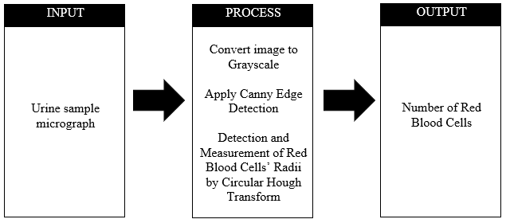

**Figure 3.2** Conceptual Framework of the system

Figure 3.2 illustrates the conceptual framework of the system. The input is the micrograph view of the urine sample. A micrograph is the image taken by means of microscope, where in the researcher’s inquest is not less than 400x high power. Typical red blood cells can only reach 6 – 8 micrometers in diameter which can be visible in a total magnification of around 400x. With the use of the raspberry pi camera which is projected to the microscope’s eyepiece lens, the input is passed through the raspberry pi.

For the process, as soon as the image is already received, it will be first converted to grayscale. The researchers want to grayscale it so that less information needs to be provided for each pixel. In RGB space, red, green and blue all have same magnitude because of the gray color. Next is to apply canny edge detection where it has four procedures to be performed. 1.) Image Filtering 2.) Finding Image Gradient 3.) Edge Thinning 4.) Double Threshold. The last step in the process is to detect and measure the red blood cells’ radii using the circular Hough transform algorithm. The purpose of CHT is to find circles in perfect or even imperfect inputs.

The number or total count of red blood cells are the output. The researchers need to identify it in order to tell the condition of a person whether he or she has a normal or abnormal number of RBCs per high power field. Not less than or equal to 4 RBC/HPF is a normal condition.

**System Flowchart**

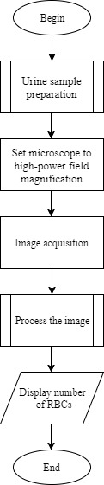

**Figure 3.3** System flowchart

The overall flow of the system is illustrated in figure 3.3. The first step is to prepare the urine sample. There are several procedures that needs to be taken into account during this phase. Next is to set up the digital microscope’s magnification to not less than a total 400x magnification. Then the sample can be captured using the raspberry pi camera which is to be processed by the program made by the researchers. Here, they will be using python open CV as their system’s software. Lastly, after processing the image, the number of RBCs are produced.

*Preparation in urine sampling*

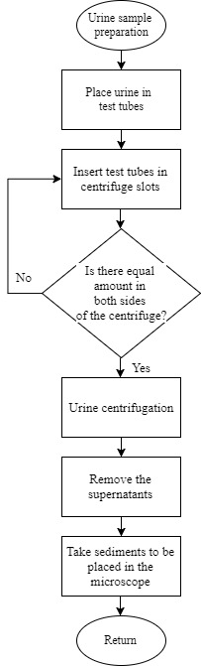

**Figure 3.4** Preparation for urine sampling

Figure 3.4 demonstrates how the supernatants and the sediments are being separated using the centrifuge. The test tubes will be first placed in a centrifuge and spin at a relative centrifugal force of 400 for 5 minutes. After that, the supernatants will lie above the sediments. In urinalysis, the supernatants are disregarded and only the sediments are extracted to be examined under the microscope.

**Hardware Development**

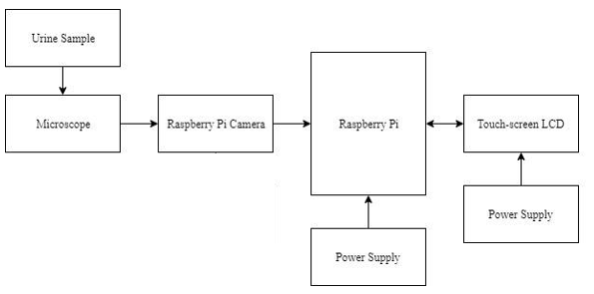

**Figure 3.5** Hardware Block Diagram

Figure 3.5 illustrates the block diagram of the hardware. The figure shows how the components are used in the design of the hardware. A microscope would be used to get the microscopic view of the urine sample. The Raspberry Pi camera is connected to the lens of the microscope which will capture the image that will be sent to the Raspberry Pi. The image processing techniques are loaded to the raspberry pi and the results can be seen through the touch-screen LCD. A power supply will power all the devices used.

**Proposed Hardware Setup**

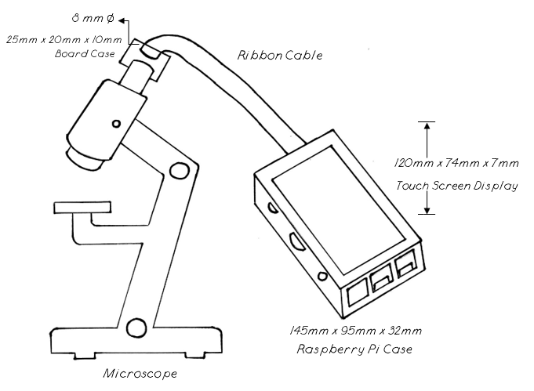

**Figure 3.6** Proposed Hardware Setup

In the researcher’s proposed hardware setup, the raspberry pi which is stored inside the customized case is being linked to the microscope by the ribbon cable of the raspberry pi camera. The ribbon cable is connected to the cable slot in the raspberry pi while the camera and the camera board at the other end is attached to a customized board case that can be inserted to the eyepiece of the microscope. The raspberry pi is capable of acquiring a 3280 x 2464 image pixel. A touchscreen display is inserted above the customized case where the created program or the graphical user interface will be seen. There are also slots for usb ports, lan cable, audio cable and for the power supply.

**Software Development**

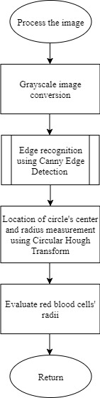

**Figure 3.7** Flowchart in processing the image

Figure 3.7 shows the flow on how the urine sample image is developed under image processing. It starts by implementing converting the image into grayscale which is simpler and easier to analyzed by a computer vision. It is needed so that less information needs to be provided for each pixel. Next is to recognize the edges of the image using canny edge detection. This technique requires four more process to be performed which are: 1.) Image Filtering 2.) Finding Image Gradient 3.) Edge Thinning 4.) Double Threshold. Lastly, using the circular hough transform algorithm, the center of the circle can be identified. When the center is located, a radius can be form for every circle which will be converted into pixels to evaluate whether if the circle is a white or red blood cell.

*Canny Edge Detector Process*

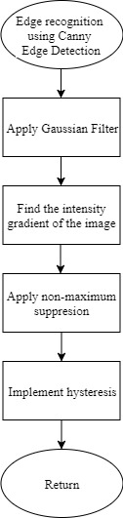

**Figure 3.8** Canny Edge Detector Flowchart

Figure 3.8 shows the flowchart for the process of edge detection using Canny edge detector. Canny edge detector is a pre-process for Hough Transform which is broken down in to sub-processes. For the first step, Gaussian filter is applied to remove the noise and smooth the image. Then, the intensity gradient of the image would be identified. The gradient of the image is also known as the edge strength. Image gradient is used to extract information from images. Next, the non-maximum suppression is applied in the image. Non-maximum suppression is an edge thinning technique to remove the unwanted false points on the edges of an image. Lastly, hysteresis is implemented in the image. Hysteresis is used to eliminate streaking or the breaking up of an edge contour.

*Implementation of Canny Edge Detector*

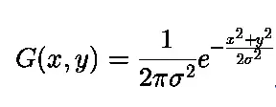The Canny edge detector is an edge detection operator that uses a multi-stage algorithm to detect a wide range of edges in images. Edge detection is an important pre-processing step in image analysis to find object boundaries in images. First thing to do is to perform the application of Gaussian filter.

(Eq. 3.1)

Sigma corresponds inversely to the amount of filtering. The higher the value of the sigma means less frequencies suppressed and vice versa. The size of the filter affects the amount of blurring in the image. Size of the kernel of convolution matrix affect the performance of the detector. The larger the size of the kernel, the lower the sensitivity of the detector to noise.

The second step would be the finding of intensity gradient in the image. Canny edge algorithm uses four filters to detect horizontal, vertical, and diagonal edges in the blurred image. The operation would return first derivative value in the horizontal direction (Gx) and vertical direction (Gy).

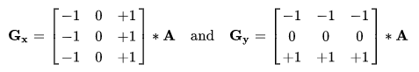

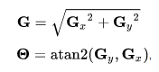As seen above, the operator used two 3x3 kernel which are convolved with the original image as denoted by the asterisk. Convolution was executed to calculate approximations of the derivatives.

(Eq. 3.2)

The formula above shows the formula for finding edge gradient for each pixel, where G can be computed by the square root of the derivatives in the horizontal and vertical directions. The gradient direction denoted by theta can be computed by the arctangent function of the two arguments.

The third step is the applying of non-maximum suppression, which removes the pixels that are not part of an edge. The process for edge thinning is by comparing the edge strength of the current pixel with the edge strength of the pixel in the positive and negative directions. If the edge strength of the current pixel is the largest compared to the other pixels in the mask with the same direction, the value will be preserved. Otherwise, the value will be suppressed. The result of this third step is a binary image with thin edges.

Last step would be the finalizing of edges detected by suppressing all the other edges that are weak and not connected to strong edges. Implementation of hysteresis requires double threshold. Any pixel which has a value above the higher threshold will be marked 1, and any pixel whose value lies between the higher and lower threshold but is connected to a pixel whose value is above the higher threshold will also be marked 1.

*Implementation of Circular Hough Transform*

Hough transform is a feature extraction technique which is widely used in image analysis, computer vision and digital image processing. One of its feature is the Circular Hough Transform (CHT) which is a technique for detecting circular objects. The purpose of the technique is to find circles in imperfect image inputs. In a two-dimensional space, a circle can be described by:

(x – a)2 + (y – b)2 = r2 (Eq. 3.3)

Where a and b coordinates are the center of the circle while r is the radius. The x and y are the change in the horizontal and vertical axis with respect to Pythagorean Theorem. If the circle(s) in an image are of known radius R, then the search can be reduced to two-dimensional. The idea is to find the a and b coordinates of the centers.

x = a + Rcos(θ)

y = b + Rsin(θ) (Eq. 3.4)

The locus of (a, b) points in the parameter space fall on a circle of radius R centered at (x, y). The true center point will be common to all parameter circles and can be found with a Hough accumulation in array.

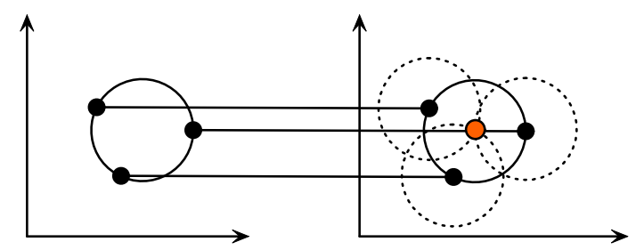

**Figure 3.9** Points in geometric space (left) and points in parametric space (right)

The illustration above shows that points in in geometric space generates a circle in a parameter space which serves as the radius of imaginary circles. These imaginary circles in the parameter space intersect at a and b coordinates which serves as the center of the circle in geometric space. The intersections are also termed as “voting” in the Hough parameter space.

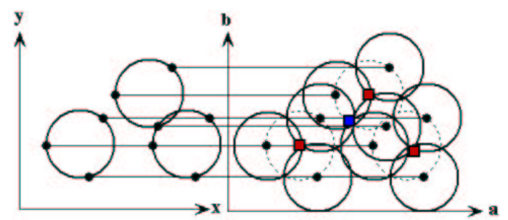

**Figure 3.10** Multiple circles in geometric space (left) and in parametric space (right)

Same procedure also goes with multiple circles with known R as shown on the illustration above. The center points are represented as red cells in the parameter drawing. Overlapped circles can cause spurious centers to also be found, such as at the blue cell. Multiple circles are the best sample in this research because if a person is having a medical condition in his or her urine, there might be an implication or presence of more than one red blood cells in the urine.

*Radius as the basis of determining the RBCs*

With the radius identified using the Hough Transform Algorithm, the researchers can differentiate a RBCs to WBCs using the pixels of the image. The diameter of a red blood cell is approximately 8 micrometers and based on experimental researches, its diameter, when viewed in 400x magnification, is approximately 7 mm. Its radius will be approximately 3.5 mm and when converted to pixel is equivalent to 13.23 pixels. Where 1 mm is equivalent to 3.78 pixels. White blood cells are much larger than red blood cells, with an approximation of about 12 mm in diameter when viewed in high power field magnification. WBC radius measures an average of about 22.68 pixels. The raspberry pi camera that the researchers will be using is capable of acquiring 3280 x 2464 image pixel.

This will be the researcher’s basis in classifying the RBCs. If the measured radius will be less than or equal to 13.5, it will be detected as red blood cell while if greater than that, it will be classified as a white blood cell which is not included in the counting.

*Multithreading*

Raspberry pi 3 Model B is a series of small single-board computers which has a specification of Quad Core 1.2GHz Broadcom BCM2837 64bit CPU. The Raspberry Pi runs Linux and can multitask. Having four processor ARM cores, researchers may be able to implement multithreading and measure speedup up to four times. The combination of multithreading on a multicore and interfacing to GPIO makes the RPi 3 a powerful embedded platform by Youssfi [17].

By default, any computer will try to use all of its cores when it can. However, it can only achieve this when an application is multi-threaded. Multithreading is a technique by which a single set of code can be used by several processors at different execution. On a multiprocessor system, multiple threads can execute in parallel, with every core executing a separate thread simultaneously. Raspberry pi supports this type of programming which can speed up the researcher’s system and be faster than other existing studies and methods. Meanwhile, for the programming language to be used, Python supports multithreading.

Due to the effects of multithreaded programming, the researchers aim to implement it into the system to have a faster time in the image processing execution. Aside from this, manually capturing of images from the microscope will be removed as per what in the related literatures have done. This is due to the researchers proposed device. Overall, the time it takes for every process will be reduced.

*Projected GUI*

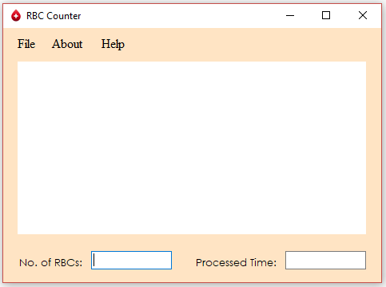

**Figure 3.11** Projected Graphical User Interface

The illustration above showcases the researcher’s simple projected graphical user interface. The File tab contains the load image and open image menu where the user can load the previous captured image and the open image is where the user can open images that are already saved. The About tab include the descriptions of the program and information about the creators. For the Help tab, it contains troubleshooting solutions if something went wrong with the program. There is also a plane rectangular field where the image will be loaded along with different types of buttons for processing the image. Once a sample image was already processed, the total count of RBCs will be displayed as well as the time it took to be processed.

**System Testing**

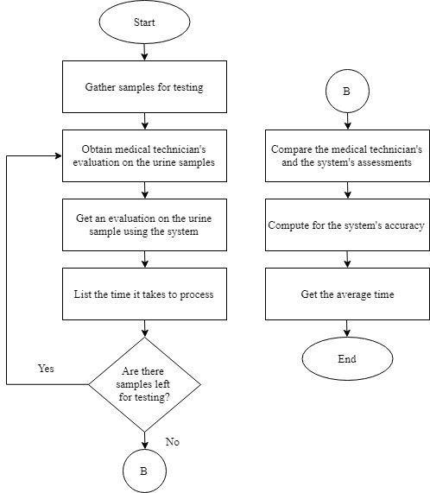

**Figure 3.12** System testing flowchart

The figure above shows the flowchart of the testing process of the system. First, the researchers will gather test subjects who would give urine samples to be first tested by the medical technician using the microscope. Afterwards, the researchers would also test the urine sample to get an evaluation using the image processing device. The average time for each sample taken will also be calculated. The device’s result will be compared to the evaluations of the medical technician. This process will be repeated until all test subjects are tested. Lastly, the device’s accuracy would be computed to know its efficiency and effectiveness.

**Testing Procedures**

For the testing of the device, 20 urine samples will be obtained from different test subjects. A medical technician will be the first to count the red blood cells present in the urine using the traditional manual counting through the microscope and hemocytometer. Afterwards, the urine sample will be analyzed by the image processing device for the automatic counting. The results for both counting will be recorded in the provided table for further comparison and evaluation.

|  |  |  |  |
| --- | --- | --- | --- |
| No. of sample | No. of RBCs for Manual Counting | No. of RBCs for Automatic Counting | Error (%) |
| 1  2  3  .  .  .  20  Standard Error |  |  |
|  |

**Table 3.1** Comparison of Manual and Automatic Counting

Table 3.1 shows the comparison of the medical technician’s assessment the device’s assessment. The assessment of the medical technician and the device would be the number of red blood cells present in the human urine. The percent error is needed to determine the precision of each calculations. The table above also serve as the researchers’ basis in determining the accuracy of the device which will depend on the Standard Error. The testing procedure for the system is as follows:

1. Place urine samples in test tubes and perform centrifugation.
2. Remove the supernatants and take the sediments to be placed in the microscope.
3. Allow the medical technician to perform his or her own evaluation on the samples.
4. Correctly place the raspberry pi camera over the eyepiece of the microscope with 400x magnification and capture the image.
5. Using Canny Edge Detection, noises will be remove and the blood cells will be acquired. The red blood cells will be identified and count using the Circular Hough Transform algorithm.
6. The processed image will be seen through the LCD as well as the number of red blood cells.
7. Comparison of the results produced between the manual and automatic counting will be performed to identify the reliability of the system.
8. If the results are not greater than or equal to 90% accuracy, return to step 4.

The testing also includes the determination of time it takes to finish the counting of red blood cells. For measuring the time it takes in manual counting, the researchers will use a stopwatch for every samples that the medical technician will evaluate. While the automatic counting will be based on the software that will be created. The results will be recorded for further comparison and evaluation.

|  |  |  |  |
| --- | --- | --- | --- |
| No. of sample | Manual Counting Time (in seconds) | Automatic Counting Time (in seconds) | Error (%) |
| 1  2  3  .  .  .  20  Standard Error  Average |  |  |
|  |

**Table 3.2** Comparison of the Processing Time for Manual and Automatic Counting

Table 3.2 shows the comparison of the processing time for manual and automatic counting. The results obtained are in the unit of seconds. The gathered data would then be averaged to know the average time it takes in counting the red blood cells. Obtaining the time is important for the researchers to be identified since this is one of their objectives and this is one of the way that they can contribute within this study.

% Error = | (Eq. 3.5)

Percent Error will be produced in every samples unless the technician’s calculation and the researcher’s system calculations are the same. Its formula is stated above where MC serves as the manual counting of the technician is the experimental value and AC serves as the automatic counting of the system. Percent error is a helpful method for identifying the precision of the researcher’s calculations.

Standard Deviation σ = $\sqrt{\frac{\sum{(x-\overline{x})^{2}}}{n-1}}$ (Eq. 3.6)

In order to obtain the standard error, the researchers first need to obtain the standard deviation which is the formula stated above. It is basically the variance’s square root which is the average of the squared difference from the Mean.

Standard Error = $\frac{σ}{\sqrt{n}}$ (Eq. 3.7)

With all the data provided, the standard error in the researcher’s system can be calculated. They need to know the standard error of their system because it will be their basis in identifying the system’s accuracy. With the results gathered, the researchers aim to expect a minimum of 90% accuracy. Obtaining such results, they can conclude that their system is functioning well otherwise, they need to reexamine it and figure out where the problem is.

**References**

[1] Ongkum C., et al (2016). Analysis System for Urine Strip Test Using Image Processing Technique. *The 2016 Biomedical Engineering International Conference*, 1-5

[2] Lerma E., et al (2015). Urinalysis. *Medscape*, Reference Range Section

[3] Acharya V., et al (2017). Identification and Red Blood Cell Classification using Computer Aided System to Diagnose Blood Disorders. *2017 International Conference on Advances in Computing, Communications and Informatics (ICACCI)*, 2098 – 2104

[4] Dalvi P., et al (2016). Computer Aided Detection of Abnormal Red Blood Cells. *2016 IEEE International Conference on Recent Trends in Electronics, Information & Communication Technology (RTEICT)*, 1741 - 1746

[5] Gatc J., et al (2016). Red Blood Cell and White Blood Cell Classification Using Double Thresholding and BLOB Analysis. *2016 4th International Conference on Information and Communication Technology (ICoICT)*, 1 – 5

[6] S.K. Strasinger & M.S. Di Lorenzo, *Urinalysis and Body Fluids*. 2014, p. 110 – 112

[7] Özkan A., et al (2016). Method Proposal for Distinction of Microscope Objectives on Hemocytometer Images. *2016 24th Signal Processing and Communication Application Conference (SIU)*, 1305 – 1308

[8] Navea R.F., et al (2015). Red Blood Cells and White Blood Cells Detection, Differentiation and Counting using Image Processing. *DLSU Research Congress 2015*, 1 – 7

[9] Maneesukasem W., et. al (2012). Urine Sediment Image Segmentation Based on Feedforward Backpropagation Neural Network. *The 5th 2012 Biomedical Engineering International Conference*, 1 – 4

[10] Madhura J., el al (2017). Methods of Impulsive Noise Reduction using Image Processing. *2017 International conference of Electronics, Communication and Aerospace*, 296 – 302

[11] Cao G., et. al (2009). Red Blood Cell in Urine Micrograph. *2009 3rd International*  *Conference in Bioinformatics and Biomedical Engineering*, 1 – 4

[12] Maini R., et al. (2011). Study and Comparison of Various Image Edge Detection Techniques. *International Journal of Image Processing (IJIP)*, 1 – 12

[13] Matuska S., et al (2012). The comparison of CPU Time Consumption for Image Processing Algorithm, 1-4

[14] Selvakumar P., et al (2016). The performance analysis of edge detection algorithms for image processing, *2016 International Conference on Computing Technologies and Intelligent Data Engineering (ICCTIDE’16)*, 1-5

[15] Kutty S., et al (2014). Evaluation of Canny and Sobel Operator for Logo Edge Detection*, 2014 International Symposium on Technology Management and Emerging Technologies (ISTMET 2014)*, 1-4

[16] Ballado A., et al (2015). Philippine Currency Paper Bill Counterfeit Detection through Image Processing using Canny Edge Technology, *8th IEEE International Conference Humanoid, Nanotechnology, Information Technology Communication and Control, Environment and Management (HNICEM),* 1-4

[17] Youssfi Z., (2017). Making operating system more appetizing with the raspberry Pi, *Frontiers in Education Conference (FIE),* 1-4