**Monitoring of Rice Weevil Reproduction on Controlled and Uncontrolled Environmental Parameters through Wireless Monitoring and Control System for NFA Rice Warehouse**

by

**Jim Alfred M. Dacanay**

**Chanel Anne B. Marquez**

**Robert Carlo T. Riego**

ECE/4

A Research Proposal Submitted to the School of EE-ECE-CoE

in Partial Fulfilment of the Requirements for the Degree

Bachelor of Science in Electronics and Communications Engineering

Mapúa University

January 2019

**Chapter 1**

**INTRODUCTION**

Rice weevils are a species of stored product pest that are are mainly found in places that have warmer climates. They are a serious stored product pest, and if left unchecked, they have the ability to compromise food supplies on a massive scale. In Subic Bay Freeport, Philippines, it was discovered that at least 133,000 sacks of rice imported from Thailand were infested with rice weevils that caused the delay of the unloading of the sacks last August 2, 2018 [1]. The same thing happened to 200,000 bags set to be unloaded in Tabaco City, Albay province. Due to the delay, the heat inside the ship became conducive to the hatching of the weevil eggs. After discovering the infestation, authorities had to fumigate all the sacks of rice in the ships [2]. The rice should be treated as soon as possible to prevent the insects from multiplying before being brought to the NFA warehouse.

Researches were done for rice weevils reproduction in relation with its environment temperature and humidity. A study on the temperature and relative humidity on development of rice weevils resulted to determining of certain temperature and relative humidity that can greatly affect the life stage of rice weevils [3]. A similar research in the oviposition preference and development of rice weevils shows the development of weevil eggs on rice grains under a controlled environment. [4]. Prevention of the rice weevils as soon as possible is important for all the consumers of rice and it is a great concern in the present. Thus, having a monitoring device for the environment of storage are of rice sacks presence of rice weevils is very beneficial for the for the importers and as well as the consumers.

A study proves the effect of temperature and relative humidity on rice weevil reproduction. The temperature and relative humidity has a great impact in the reproduction of rice weevils in stored grains [5]. The proposed study evaluates the effect of controlling the environmental parameters of NFA rice warehouse on the reproduction of rice weevils in stored NFA rice versus an uncontrolled NFA rice warehouse.

The main objective of the study is to examine the effect of wireless monitoring and control system for environmental parameters of NFA rice warehouse on the reproduction of rice weevils. Specifically, this study aims (1) to use wireless sensors as sensor nodes and Raspberry Pi for data receiving, control unit and communication with the user all through wireless internet connection, (2) to program the Raspberry Pi to summarize the data collected by each sensor nodes, transfer the data to the user and receive instructions for controlling environmental parameters, (3) and lastly, to enable the mobile phone of the user to display the temperature and humidity of the NFA rice warehouse, notify if it is in the unwanted range of values and give instructions to control the temperature and humidity or automatically set it off of the unwanted range of values.

Even though rice weevils won’t cause any direct harm on people because they don’t transmit any diseases, they are dangerous on grain and agriculture industries as they infect the rice or food sources [6]. The study will benefit the said companies and the customers. Also, it will improve the production and quality of the rice. In the study, the reproduction of the rice weevils will be compared based on two different environment; which is the controlled and uncontrolled environment. Certain parameters on the controlled environment will be adjusted based on the temperature in which the eggs of rice weevils are less likely to survive. By adjusting the temperatures on the warehouse, it will prevent them to further spoil the crops, specifically the rice, and also to prevent them from multiplying.

Rice weevils attacks a wide variety of grains that also includes barley and pasta, but the study only focuses on the rice. Other type of insects that will be present in the rice will not be observed. The study will only focus on preventing the hatching of the eggs of the rice weevils and not on eradicating the adult weevils. The sensor that will be used is a temperature and humidity sensor that will be responsible for adjusting the temperature, detecting the moisture and air temperature respectively. And also the subject regarding the monitoring or sending of data if the user is disconnected or having connectivity issues from the internet will not be taken into consideration.

**Chapter 2**

**Review of Related Literature**

**1. Rice Weevils**

Adult rice weevils live for four to five months and each female lays 300 to 400 eggs during this period. The female uses her strong mandibles to chew a hole in the grain kernel where she deposits a single egg and seals the hole with a gelatinous fluid. During hot weather, the development period for egg to adult may be as few as twenty-six days. This period is greatly prolonged during cool or cold weather. Rice weevils are capable of flight, and infestations may develop in the field prior to harvest [7].

These weevils are very destructive grain pests. Of the three, the rice weevil is probably the most insidious, owing largely to the ability of flight. All three weevils develop as larvae within the grain kernels. They frequently cause almost complete destruction of grain in elevators or bins, where conditions are favorable and the grain is undisturbed for some length of time. Infested grain will usually be found heating at the surface, and it may be damp, sometimes to such an extent that sprouting occurs. Wheat, corn, macaroni, oats, barley, sorghum, Kaffir seed, and buckwheat are just some of the grains and products on which these weevils feed [7].

The grain industries in developing countries use a range of methods to minimize insect infestation on stored grains, but generally rely on fumigants (Plimmer, 1982).

Adults and larvae feed on a wide variety of grains and a female can deposit up to 150 eggs. A single egg is laid in each grain after boring a hole inside. The egg stays in the grain until it becomes an adult, and this completely damages the grain. The life cycle takes approximately 35 days under good conditions such as 28 °C and 70% relative humidity [24].

**1.1 Measuring RF and Microwave Permittivities of Adult Rice Weevils**

The permittivities or dielectric properties of materials are of major significance in the consideration of any new high-frequency or microwave applications involving energy absorption. In considering the potential use of selective radiofrequency (RF) or microwave dielectric heating to control insects in cereal grains, the need has been evident for data on the permittivities of the insects as well as those of the grain [11].

**1.2 Effect of temperature and relative humidity on development of Rice weevils**  
**Table 1**: Mean values of egg laying (± S.E) of Sitophillus orzae after different days under different temperature (T=25, 30 and 35 °C) and different relative humidities (H= 55, 60 and 65%). Each column, mean value followed by same latter are not significant to each other; Tukey and HSD test ≤ 0.05; *= Significant, ** = Highly Significant, NS = Non-Significant

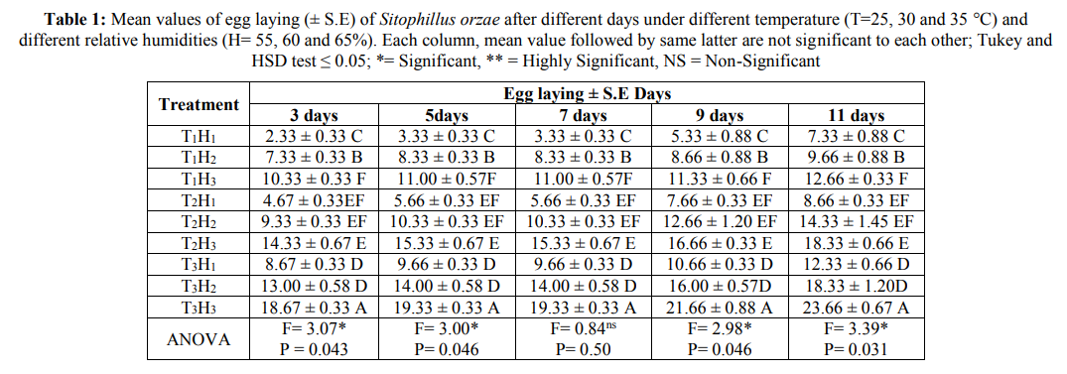

**Table 2**: Mean values of larvae emergence (± S.E) of Sitophillus orzae after different days under different temperature (T=25, 30 and 35 °C) and different relative humidities (H= 55, 60 and 65%). Each column, mean value followed by same latter are not significant to each other; Tukey and HSD test ≤ 0.05; * = Significant, ** = Highly Significant, NS = Non-Significant

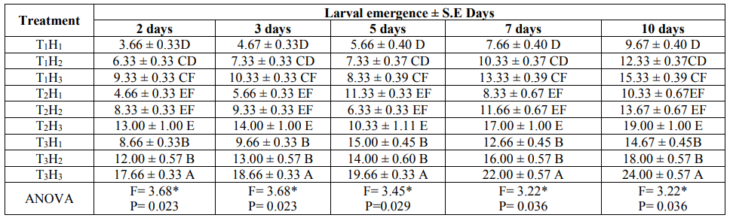  
  
**Table 3**: Mean values of pupae formation (± S.E) of Sitophillusorzae after different days under different temperature (T=25, 30 and 35 °C)and different relative humidities (H= 55, 60 and 65%).Each column, mean value followed by same latter are not significant to each other; Tukey and HSD test ≤ 0.05; * = Significant, ** = Highly Significant, NS = Non-Significant

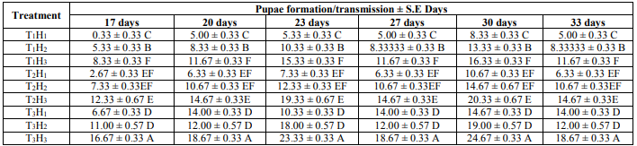



**Table 4**: Mean values of adult formation (± S.E) of Sitophillus orzae after different days under different temperature (T=25, 30 and 35 °C) and different relative humidities (H= 55, 60 and 65%). Each column, mean value followed by same latter are not significant to each other; Tukey and HSD test ≤ 0.05; Df= degree of freedom; * = Significant, ** = Highly Significant, NS = Non-Significant.  
 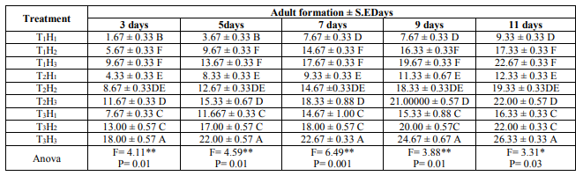

The tables above are the results, it shows that temperature and relative humidity have a great impact on the reproduction of rice weevil. In table 1, the egg laying of the rice weevils is maximum at 35 °C and 65% and minimum at 25°C and 55%, same goes for tables 2 and 3, pupae formation and adult formation [23].

**2. Temperature and Humidity Control System**

**2.1 On-Off Temperature Control System Implementation**

The technology in the field of measurement is advancing in a fast rate [8]. A recent study conducted an experiment of a system of the TS500 series, a temperature sensor, and a Pt100 resistance temperature detector which is programmed to be an On-Off temperature control system [9]. The intelligent temperature sensor acquires the temperature value accurately then sends the data to a programmable logic controller to control the supply voltage on the power resistor which also varies the output temperature of the cooler [9].

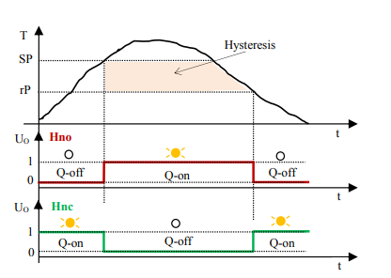

Fig. 1 System operating for Hysteresis switching function

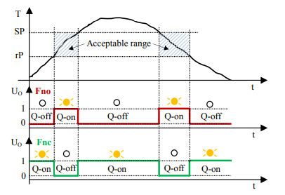

Fig. 2 System operating for Window switching function

**2.2 Temperature and Humidity Control System for Mushroom Nursery**

A recent study focused on a mushroom nursery with a length of 5 meters, width of 3 meters and height of 3.5 meters, in which a temperature and humidity sensor (DHT11) is placed around of the insides of the mushroom nursery, then the sensor sends the data to the Arduino Mega Uno R3 microcontroller which for automatic control system [10]. The mushroom nursery have 2 fans, mist sprayer with 8 heads and 3 lamps all being varied depending on the analyzation of the fuzzy logic for controlling the environment suitable for the growth mushrooms [10].

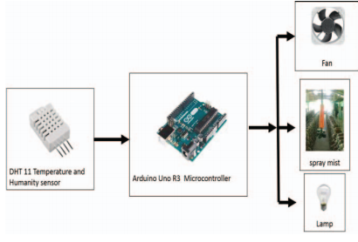

Fig. 3 Automatic Control System for Mushroom Nursery

**2.3 IMC-PID controller within air conditioning system**

A recent study solved the problem of multivariable coupling of A/C processes particularly the temperature and relative humidity. MATLAB simulation showed that IMC-PID controller on air conditioning system can control temperature and relative humidity with large hysteresis and the coupling of temperature and relative humidity [20].

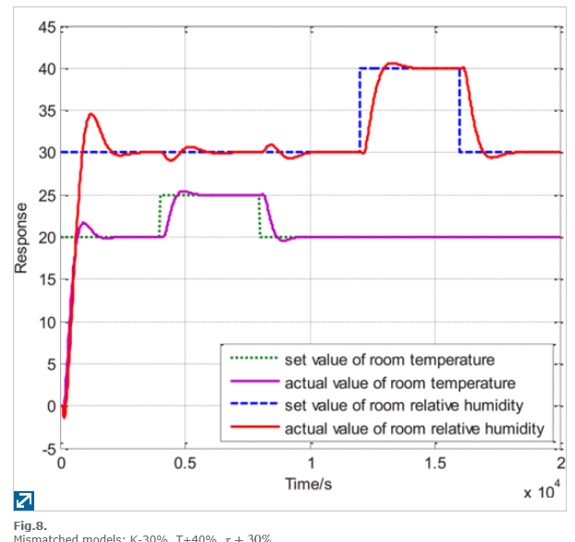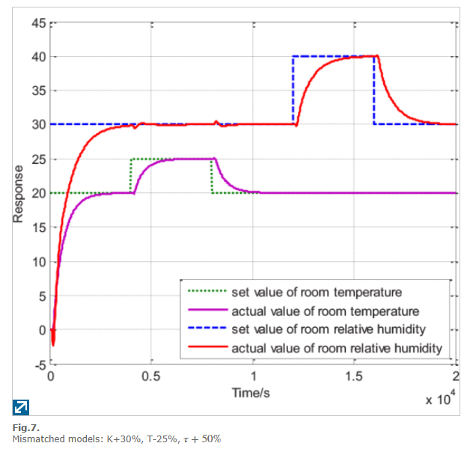

**2.3.1 Design of the IMC-PID controller**

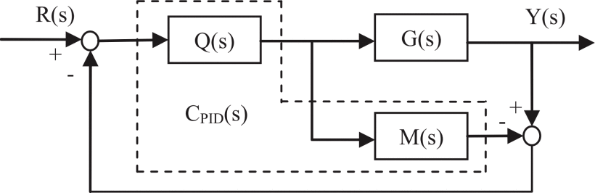

The system has two inputs and these are the refrigerant flow and the air flow. G(s) is the the actual control object and it controls the room temperature and the relative humidity. M(s) is the internal model and it correlates the inputs and the outputs of the system. Q(s) is the control and decoupling integration IMC controller. R(s) is the two inputs’ vector, it is the set value of room temperature and relative humidity while Y(s) is the actual value of the room temperature and relative humidity. Q(s) and M(s) is in a dashed box, meaning, it is integrated as an IMC-PID controller (CPID(s)) for conveniency purposes in practical projects [20].

**2.4 Air Conditioning Control Method for Peak Power Reduction Using Heat Capacity**

**2.4.1 Heat Capacity Modeling**

Thermal network method can be used for heat capacity modeling by creating a model of the relationship of the air conditioning operation data, room temperature change considering the entry of heat from the outside and the heat dissipated by the human body [14]. It should be taken into consideration that the said method may sometimes be inaccurate, in this case, the volume of the room may served as a basis for estimating the heat capacity [15].

**2.4.2 Duration Estimate for Heat Storage**

During an electrical power loss of a refrigeration system, the temperature of a compartment can only be in the acceptable range for a certain duration due to heat transfer [16]. The temperature change can be equated as given below.

Q = c Δ T (1)

where Q is the amount of heat, c is the estimation of the heat capacity by the heat capacity modeling and T is the temperature change. The duration of the air conditioner when it is turned off can be computed by using the allowed heat storage as a mark that the air conditioner should be turned on [15]. It is derived below.



**2.4.3 Air conditioner power reduction**

Using the computed duration for which the air conditioner is turned off, the reduction in power consumed by the air conditioner can also be computed, because while it is turned off, there is no consumption of electrical power for it [15].

**2.5 Temperature and Humidity Monitoring System for Storage Rooms of Industries**

This observing system is designed to come up with a solution for protecting dozens of pharmaceuticals or food products inside storage rooms of various industries. Multiple nodes help in reading the temperature in all the parts of the rooms. And these nodes constantly send data to the base station. After collection of data from the nodes, the base station with the help of GPRS uploads them to the sensor cloud. Here we will use a gateway for collection of data and sending them to the server as because if we allow each node to communicate with the remote server independently, then the cost will rise up. As given on the Figure 2 the application is made up of the controller system, the gateway, the server, and the ZigBee coordinator as part of the gateway [18].

**3. Fuzzy Logic**

Fuzzy logic which is a proper way to map an input space to output space. Fuzzy logic has many advantages that can control complex systems, non-linear, and systems that are difficult to be represented mathematically. Fuzzy logic is easy to understand, flexible, tolerant of improper data, able to build and apply expert experiences directly without training, can work with conventional control techniques, and based on natural language. Fuzzy logic based of microcontroller can be designed to control the air conditioner to control the temperature and use of dry mode to reduce the humidity of the room [17].

**3.1 Design of Server Room Temperature and Humidity Control System using Fuzzy Logic Based on Microcontroller**

Real time monitoring of the Server room is very important. One of important factors that are needed be monitored is the temperature and humidity of the room, because the computers and networks equipment is very susceptible to high temperatures and humidity [17].

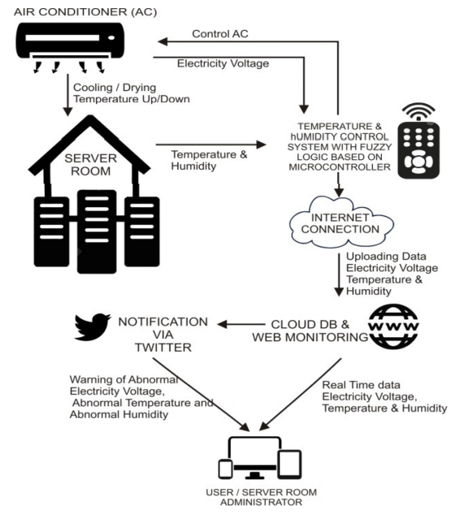

Fig. 4 Proposed system for server room control and monitoring

In this proposed system, we proposed server room temperature and humidity control system using fuzzy logic as the decision making to maintain server room temperature and humidity by control the setting of air conditioner based on the measurement of sensor data. In this system, we collected sensor data such as temperature, humidity, and electricity voltage from the sensor that implemented using microcontroller.

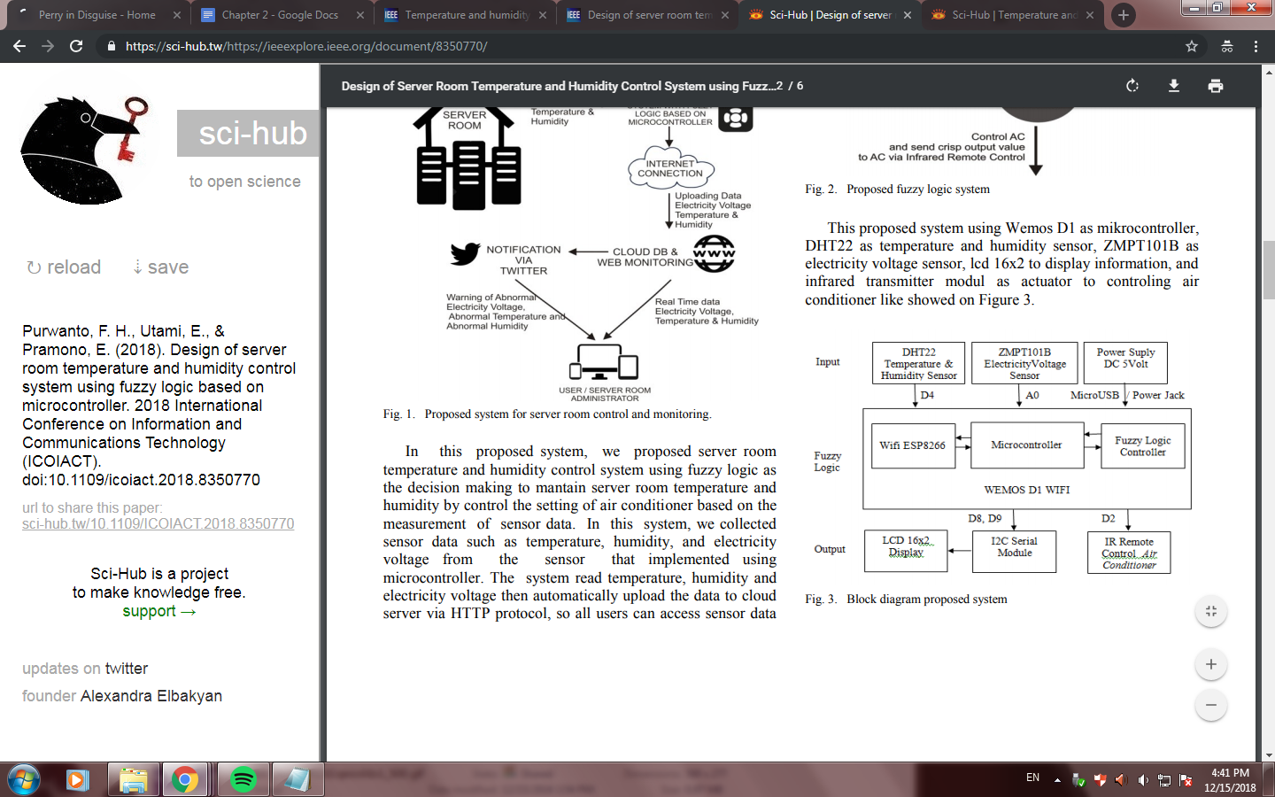

In order for this fuzzy logic to work to control the Air Conditioner, the hardware designed as in figure above to be inserted with fuzzy logic algorithm program code. Fuzzy algorithm implemented on microcontroller Wemos D1 using eFLL Library (Embedded Fuzzy Logic Library) v1.0.10 that support fuzzy mamdani type in C programming language through Arduino IDE application.

**3.1.1 Rule Based**

This system analysis using fuzzy input and fuzzy rules which have been determined earlier to produce fuzzy output. In this proposed inference system, we have 2 input variables and each comprise 3 fuzzy membership. Variable temperature comprise to fuzzy membership COOL, NORMAL, HOT. Variable humidity comprise to fuzzy membership DRY, NORMAL, WET. Total of 9 rules were used to make decisions to produce output AC Temperature in 3 membership degree i.e LOW, MIDDLE, HIGH, and AC Mode in 2 membership degree i.e COOL and DRY. In this case, we calculated 2 output at a time with 2 input. The used rules are as follows :

IF Temperature COOL AND Humidity DRY

THEN Temperature AC HIGH AND AC Mode COOL

IF Temperature COOL AND Humidity NORMAL

THEN Temperature AC HIGH AND AC Mode COOL

IF Temperature COOL AND Humidity WET

THEN Temperature AC HIGH AND AC Mode DRY

IF Temperature NORMAL AND Humidity DRY

THEN Temperature AC MIDDLE AND AC Mode COOL

IF Temperature NORMAL AND Humidity NORMAL

THEN Temperature AC MIDDLE AND AC Mode COOL

IF Temperature NORMAL AND Humidity WET

THEN Temperature AC MIDDLE AND AC Mode DRY

IF Temperature HOT AND Humidity DRY

THEN Temperature AC LOW AND AC Mode COOL

IF Temperature HOT AND Humidity NORMAL

THEN Temperature AC LOW AND AC Mode COOL

IF Temperature HOT AND Humidity WET

THEN Temperature AC LOW AND AC Mode DRY

**3.1.2 Result of Fuzzy Logic Controller Using Matlab FIS Editor with Variation of Temperature Input**

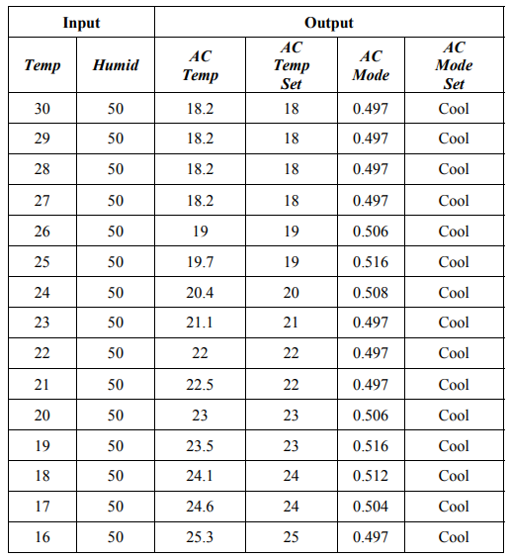

When temperature of the server room is above normal then the fuzzy logic controller will try to normalize the server room temperature by setting the temperature of Air Conditioner to a number below the normal temperature range, so that the air conditioner will produce more cold to reach the desired normal temperature. Similarly vice versa when the temperature of the server room is below the normal temperature, fuzzy logic controller will try for normalize the temperature by setting the temperature of the air conditioner to a number above the normal temperature range, so that the conditioner will reduce the cold produced to achieve the desired normal temperature. When the server room temperature is in normal condition then the fuzzy logic controller will return the air conditioner setting value to normal temperature range. To control the humidity, proposed system try to adjust the mode setting on air conditioner ie if the humidity is too high then the fuzzy logic controller will set air conditioner mode into DRY mode, so air conditioner will operated with fan on low speed and compressor is on short duration in large cycles just to remove extra humidity, so it can reduce humidity. When humidity is back to normal range then fuzzy logic controller will set the air conditioner back into COOL mode so that the air conditioner still dehumidifier and will keep humidity in normal range.

**3.1.3 RESULT OF FUZZY LOGIC CONTROLLER USING MATLAB FIS EDITOR VS FUZZY LOGIC IMPLEMENTED ON MICROCONTROLLER**

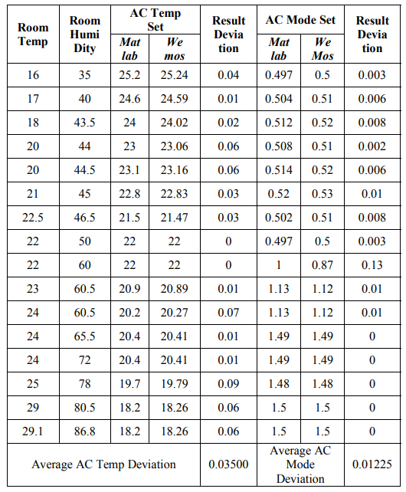

**4. Internet of Things**

The Internet of Things (IoT) is a collection of electronic, mechanical and non-electronic devices that have the ability to be self-configurable, operated and controlled remotely over communication networks. The user can control local and external devices and can also, for example, switch ON/OFF devices, switch trip circuits between several devices, access devices and remote controls, etc [8]. Internet of Thing (IoT) is a concept where an object that has the ability to transfer data over the network without requiring human to human interaction or human to computer interaction [17].

**4.1 Plantation Monitoring System Based on Internet of Things**

This study made use of IoT in monitoring the appropriate density of trees. The system combines wireless sensor network, embedded development, GPRS communication technology, web service, and Android mobile platform. In order to study the precise effects of density on plantation, ecologists need long-term monitoring on a variety of ecological indicators. However, it is difficult to collect automatically and reliably environmental monitoring data with traditional monitoring system. Internet of things provides the technical foundation for accomplishing this task [12].

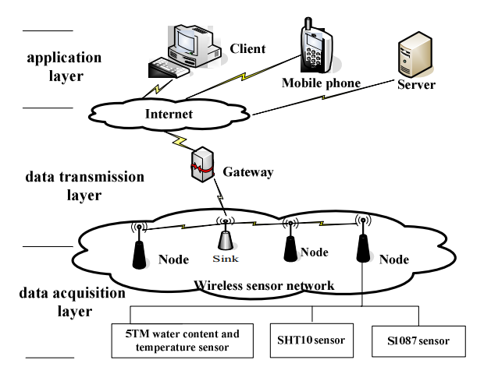

Fig. 4 System Architecture for Plantation Monitoring System

By using long distance wireless links, data can be monitored in real time, avoiding the need for manual data collection from remote stations [12].

**4.2 Approximation and Temperature Control System via an Actuator and a Cloud: An Application Based on the IoT for Smart Houses**

This study presents the use of the Internet of things (IoT) applied to a control of an actuator that works through temperature and approximation values. The main goal of this work is to develop a solution based on the IoT via a mechanical actuator ON/OFF control system within the parameters of temperature and position [13].

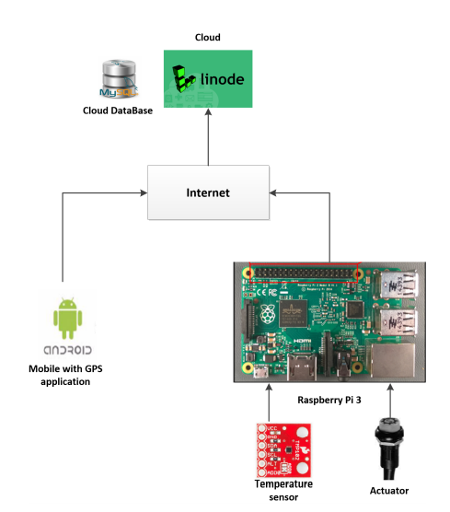

Fig. 5 Approximation and Temperature Control System via an Actuator and a Cloud

**4.3 Temperature Monitored IoT Based Smart Incubator**

This study made use of LM35 temperature sensor, ESP2866 Arduino for collecting the continuous readings of the sensor and sending it to a monitoring screen through a web server. If it was detected that the temperature need to warm the babies inside the incubator exceeded the normal, the doctor will be informed so that they will be able to take necessary precautions immediately [21].

**4.4 Embedded based Remote Monitoring Station for Live Streaming of Temperature and Humidity**

Weather monitoring involves different parameters, and for this study the parameters -----are measured using different sensors integrated to a single unit called the weather monitoring stations. The weather monitoring stations can be static or mobile. For mobile weather monitoring stations the wind speed data is collected from a particular location over a period of time and then the average is calculated. The static weather stations are generally installed at different geographical locations to monitor the required parameters and continuously send the collected data to ground stations. The mobile weather station is mounted on a movable vehicle which continuously collects the data from a particular region and then moves on to other location for the same task. The communication to the ground station can be wired or through wireless medium. If the monitoring station is situated at a far off location, then wired communication is not feasible. The ground monitoring stations continuously acquire data and transmit them accordingly to different receivers [19].

**4.5 A Smart Power Outlet for Electric Devices**

A recent technology for IoT devices is the Belkin WeMo Mini Smart Plug. It is a switched-outlet that can be controlled using IP networks. It can be controlled using its iOS/ Android App that can turn on/off the plug and any device that is connected to it remotely [33]. It can also be programmed using various library from different programming languages. One example is the wemo-client, it is a low-level client library that is used to control WeMo devices within Node.js applications [34]. Another example is the ouimeaux library for Python Language, it has the same feature with the wemo-client for Node.js which is also supports WeMo switch, can control and interact with the devices at a low level [35].

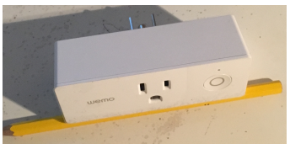

Fig. 6. The Belkin WeMo Mini Smart Plug (WeMo).

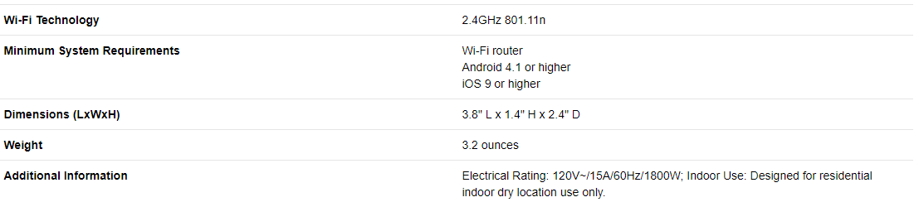

Fig. 7. The Belkin WeMo Mini Smart Plug (WeMo) Specifications.

**5. Web Page Monitoring**

**5.1 Temperature and Humidity Monitoring System for Storage Rooms of Industries**

Web-based monitoring applications are created using PHP, Bootstrap, JQuery and MySql as databases. This application can store and display the temperature, humidity and voltage data generated by the sensor in real time also and can provide early warning message through social media twitter using PHP TwitterOAuth library for use with Twitter API [17].

**5.2 Design of a Web-based Temperature and Humidity Monitoring System**

The system is consisted of local data acquisition hardware and remote database management software. The hardware is made up of temperature and humidity sensors arranged in the laboratory and a central control set, which is controlled by a MCU and takes charge of collecting data from sensors and transmitting them to remote data server. Application of the system shows that it operates reliably and stably and can help the administrative departments to monitor temperature and humidity real time and manage data of all laboratories efficiently

The monitor system was composed of two parts. One is the on-site supervision, and the other is remote database monitor system. The sensor, the transmitting apparatus and the on-site processor comprised the former one .The sensors which were placed in relevant positions in the laboratory, delivered data to the connected transmitting apparatus. After being handled, the data was transferred to the on-site treatment. Depending on the temperature and humidity data collected by certain sensors, the processor stored the data in the inside server. At the same time, the on-site displayer displayed the real-time temperature and humidity value and status messages of the sensors [22].

**6. Rice**

Rice is one of the leading food crops in the world. They directly supply more than 25% of calories consumed by the entire human population. 150 ha is the area harvested for rice crops. Human consumption sums upto 85% of total production for rice compared with other leading food crops. Rice accounts upto 21% of global human per capita energy and 15% of per capita protein. It is also the most important food crop for millions of small farmers who grow it on millions of hectares throughout the region [27].

Rice grain is hygroscopic and in open storage systems the grain moisture contentwill eventuallyequilibrate with the surrounding air. High relative humidityandhightemperaturescontribute to high equilibrium moisture content (EMC) or final moisture content [24].

**6.1 Equilibrium Moisture Content of paddy at different storage temperatures**

The following table shows the EMC of paddy under different storage conditions. The green colored areas represent the desirable environmental conditions for safe storage of paddy or rough rice in the tropics. The yellow areas represent conditions for safe seed storage. Grain needs to be stored at less than 14% moisture and seed at less than 12% [24].

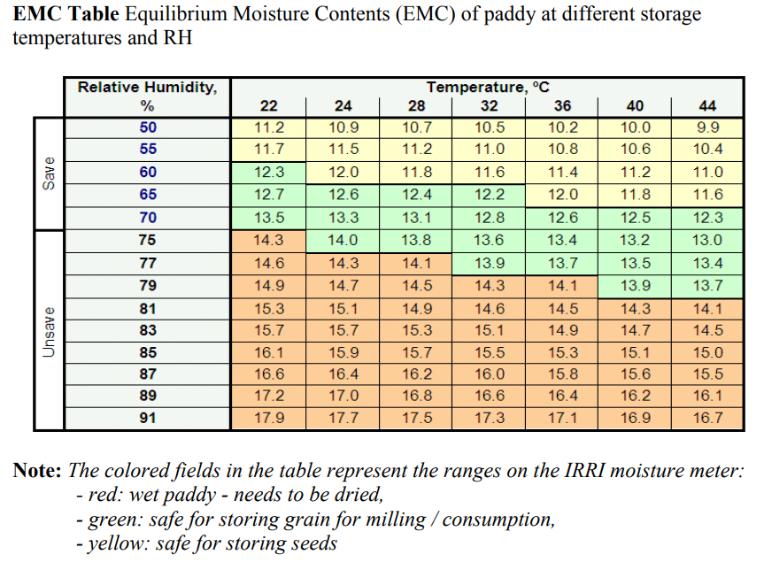

**6.2 Henderson’s Equation**

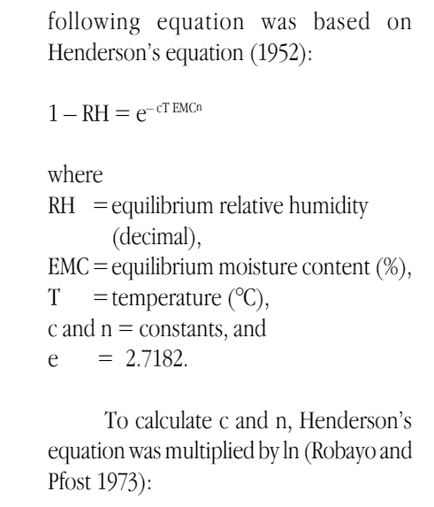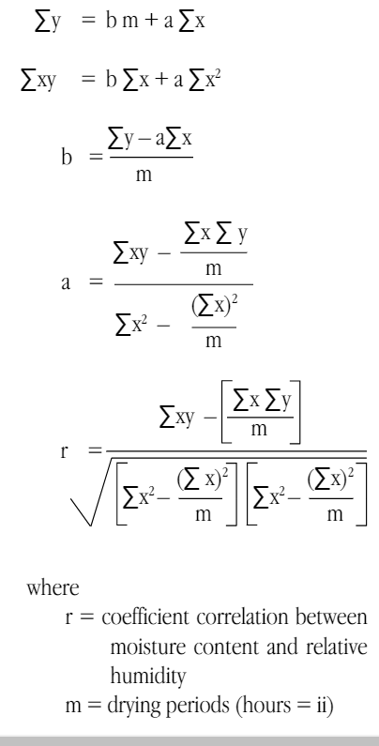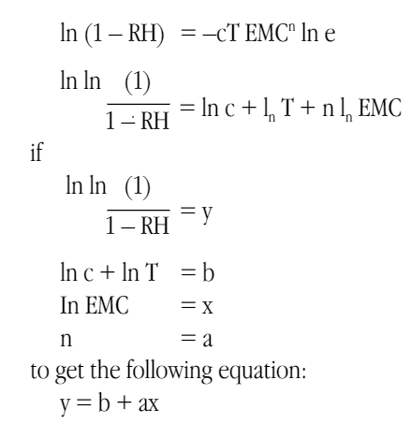

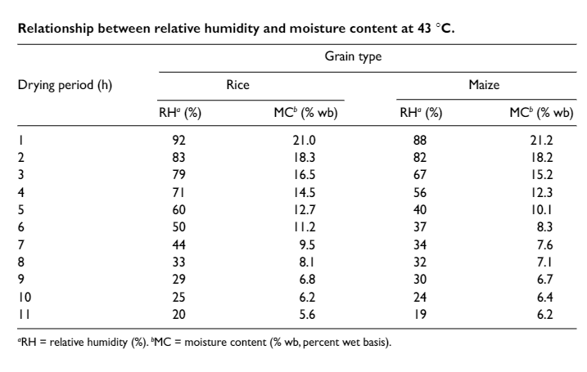

**7. Raspberry Pi**

The Raspberry Pi is a basic embedded system and being a low cost a single board computer used to reduce the complexity of systems in real time applications. The Raspberry Pi is based on the Broadcom BCM2835 system on a chip (SOC) which includes an ARM1176JZF-S Core (ARM V6K)700 MHz CPU processor, Broadcom Video Core IV GPU having 17 pins, 3. 5W of power, and 512 MB of RAM memory. [28]

The Raspberry Pi (R-pi) is a linux-based microcomputer with the size of an identification card that that can be directly used in electronics projects because it is programmable and flexible with the use of its general-purpose input/output (GPIO) pins right on the board. The GPIO connector has 26 pins where up to 17 GPIO pins (8 existing GPIO + 9 reconfigurable) are available for hardware interfacing. Common applications of this device is in integrating sensors or actuators into the Internet of Things. It is widely used in industrial automation, home automation, education, and in many commercial products like OTTO. The latest release of their product is the Raspberry Pi Zero W and the Raspberry Pi 3 Model B has Wi-Fi and Bluetooth functionality that can make data transfer as well as remote access of the device.

**8. DS18B20 temperature sensor**

The DS18B20 digital thermometer provides 9-bit to 12-bit Celsius temperature measurements and has an alarm function with nonvolatile user-programmable upper and lower trigger points. The DS18B20 communicates over a 1-Wire bus that by definition requires only one data line (and ground) for communication with a central microprocessor. In addition, the DS18B20 can derive power directly from the data line (“parasite power”), eliminating the need for an external power supply [32].

The DS18B20 communicates with the “One-Wire” communication protocol, a proprietary serial communication protocol that uses only one wire to transmit the temperature readings to the microcontroller. It’s other technical specifications are: -55°C to 125°C range, 3.0V to 5.0V operating voltage, and 750 ms sampling [32].

DS18B20, launched by DALLAS Semiconductor Company, is a smart temperature sensor. It has several main characteristics. (1) It has a unique way of single wire interface. It needs only a mouth line to connect microprocessors and to realize two’s two-way communication. (2) Any peripheral device is not needed in use. (3) The power supply could be available via the data line, and the relevant voltage has the range: +3.0V~+5.5V. (4) The temperature measurement has the range: ˉ 55°C ~+125°C ; the inherent resolution regarding temperature measuring is 0.5ć. (5) The digital reading pattern with 9~12 bits could be realized by programming. (6) Nonvolatile alarm’s upper and lower thresholds can be set up by users. (7) It supports the networking function with multicast groups. Thus, multiple DS18B20 could be parallel in only three lines to realize the multi-point temperature measurement [32].

**9. Humidity Sensor**

**9.1 RELATIVE HUMIDITY (RH) SENSORS**

This research used an integrated RH and temperature sensor, SHT75 (Sensirion AG, Zurich, Switzerland). Selection of this particular sensor was based on several factors: 1) accuracy is claimed to be as good or better than most commercial RH sensors; 2) it incorporates a temperature sensor; 3) a digital interface is used to retrieve data and thus eliminates some of the noise problems associated with other RH sensors; 4) its small size makes it suitable for a cabled monitoring system; 5) individual sensors are factory calibrated with calibration coefficients stored within the sensor; and 6) cost (estimated $15 USD in bulk) and interchangeability make it replaceable. Each sensor consisted of a capacitive polymer-sensing element for RH and a bandgap PTAT (proportional to absolute temperature) temperature sensor. RH and temperature outputs were internally coupled to a 14-bit analog to digital converter and a serial interface circuit on a singular chip. Rated absolute accuracy of the sensor was ±2.0% RH and ±0.4°C for most ambient conditions. Because sensors may be susceptible to grain dust and free moisture, individual sensors were enclosed in a porous plastic tube (Porex Corp., Fairbunn, Calif.) and sealed at each end with heat-shrink tubing and plastic electrical tape (fig. 1). Tube dimensions were 12.7-mm outside and 6.35-mm inside diameter. Pore size was 20 m [28].

**9.2 DHT11 & DHT22 Sensors**

The DHT22 is the more expensive version which obviously has better specifications. Its temperature measuring range is from -40 to +125 degrees Celsius with +-0.5 degrees accuracy, while the DHT11 temperature range is from 0 to 50 degrees Celsius with +-2 degrees accuracy. Also the DHT22 sensor has better humidity measuring range, from 0 to 100% with 2-5% accuracy, while the DHT11 humidity range is from 20 to 80% with 5% accuracy [31].

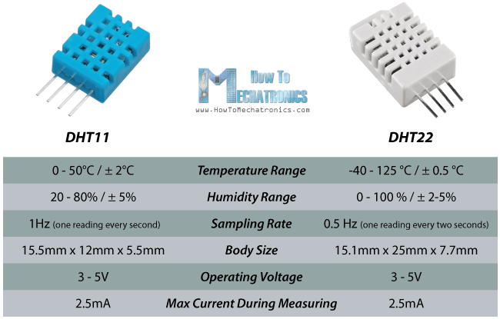

**10. Air Conditioning**

**10.1 AERATION SYSTEM**

Three test bins were equipped with a thermostatically controlled aeration controller that operated the fans when the ambient air conditions fell below preset conditions (table 1). The controllers were set to cool the rice in three cycles. Initially, the thermostat was set to aerate the rice when the ambient air was 23.9°C (75°F) or below. A humidistat prevented re–wetting of the rice [aeration at high relative humidity (RH)] by preventing fan operation above the preset level. Table 2 shows the effects of temperature and relative humidity on equilibrium moisture content (EMC) of rough rice calculated by the Modified Henderson Equation (ASAE Standards, 1997). For this study, the humidistat (in conjunction with the temperature settings) was set so that air with an EMC greater than 14% would not pass through the rice. When the grain temperature equilibrated at or below 23.9°C, the controller was set at 15.5°C (60°F) and 70% RH, and the process was repeated. Finally, the controllers were set at 7.2°C (45°F) and 65% RH. Mathematical simulation studies have shown the potential of using a three–cycle aeration system for stored corn (Arthur et al., 1998;Arthur and Flynn, 2000) and stored wheat (Flinn et al., 1997; Arthur and Flinn, 2000). Rice is significantly more susceptible to damage during storage than these grains, and its value is tied to intact kernels. If the grain were to be rewetted significantly, fissuring could occur, causing major reduction in its value. The control bins were aerated at the discretion of the farm manager, which is the standard practice in the rice industry and varies from manager to manager. Most managers make their decisions based on weather conditions and rice conditions, but lack predictable consistency. In this work, the rice was aerated when the ambient temperature was within 10°C of the rice temperature, and the fans were operated about 3 hours per week [26].

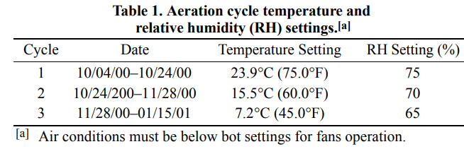

**11. Arduino**

It is an open source platform. It has 14 digital input/output pins (of which 6 can be used as PWM outputs), a 16 MHz ceramic Resonator, a USB connection, a power jack, an ICSP header and a reset button [6]. The input/output pin is used for developing the environment for writing programs for the board. This device creates a platform where according to the needs we can design our gateway with the help of this device’s functionality which is directly related to IoT [18].

**12. Humidity**

**12.1 Relative Humidity**

The relative humidity quantity is significant because of the relative humidity in the air makes the inventory deteriorates to are damaged fast , such as , iron , chemicals , way agriculture produce , electronics equipment , etc. Data from the Department of Meteorology in Thailand shows that the average temperatures and relative humidity are 30o C and 80% respectively. The high relative humidity will affect the deterioration of the inventory and all equipment such as , iron , pipe , the erosion erodes of iron skin will happen at 55% relative humidity and will severely go up when the relative humidity increases [29].

Many products manufactured and processed in a clean room environment are moisture-sensitive. For this reason, clean room specifications often include relative humidity (RH) control. These control points range from 35-65%RH for year-round operation. These RH levels generally are maintained in a narrow band ±2 percent RH at temperatures below 70°F. The effects of higher humidity levels in close tolerance environments can be detrimental to product quality and production schedules [29].

In atmosphere control systems, relative humidity is an important controlled parameter and is central to a wide range of applications in industrial manufacturing. The accuracy and precision of relative humidity control not only influences product quality but also the amount of energy and money expended in the processes that maintain the control set point [30].

**13. Dehumidifiers**

Dehumidifiers work by refrigeration or by absorption/adsroption. By refrigeration, the unit will suck the warm, moist air through a grill by using an electric fan, then the warm air will be cooled by freezing cold pipes which coolant circulates. As the warm air cools, the moisture it contains turn into liquid state and drips off the pipes. With the cool air now free of moisture, it will then pass to a heating fan to warm it back to its original temperature and it will be blown back to the room through a grille. The moisture that was in the air will drip down in a collecting tray [36]

.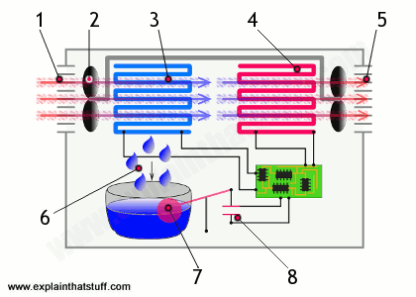

As for absorption/adsroption, moist air is drawn through a duct then it will move past a large rotating wheel made of water absorbing material which removes the humidity, then the dry air will be blown back to the room. Below is a air duct heated using an electric heating element. The large rotating fan made of water absorbing material will also pass through an air duct below that is heated using an electric heating element to dry the large fan. Then the hot, wet air will be blown out of through an exhaust duct [36].

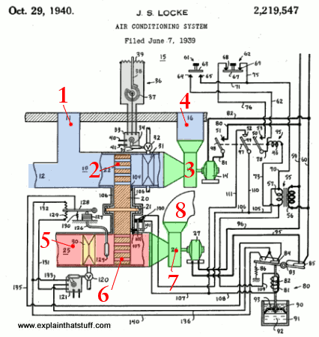

**14. The Internet**

Data travels across the internet in packet and a packet can carry up to 1500 bytes. The packets have wrappers with a header and a footer that tells the information to computer about the data, informations about what kind of data is it, how it relates with other data and the origin and final destination of the data. Different packets from the same message does not have to follow the same path and as the packet arrive, the computer will assemble the data to recreate the message [37].

In industrial cabling, the options are copper conductors or fiber optic technology. Copper cabling is a twisted pair of copper wires and fiber cables uses light. The two cabing are different in the length of the run they are able to sustain and the data size they are able to carry [38].

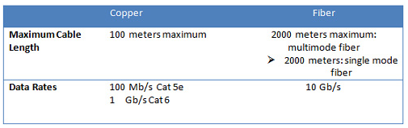

Figure 8. Comparison of cable runs and data rates between copper and fiber cable.

**15. Wi-Fi**

IEEE 802.11n is developed by the Institute of Electrical and Electronics Engineers, it is a wireless networking standard and its feature is that is works on 2.4GHz and 5GHz frequency, has a data transfer rate of 300 Mbps at its peak and can transfer data in 70 meters under open structure environment and 250 meters under open air environment. Another standard is the IEEE 802.11ac wireless networking standard. Its feature is that it has a transfer rate of 1.35 Gbps and has greater stability than IEEE 802.11n [39].

**Chapter 3**

**METHODOLOGY**

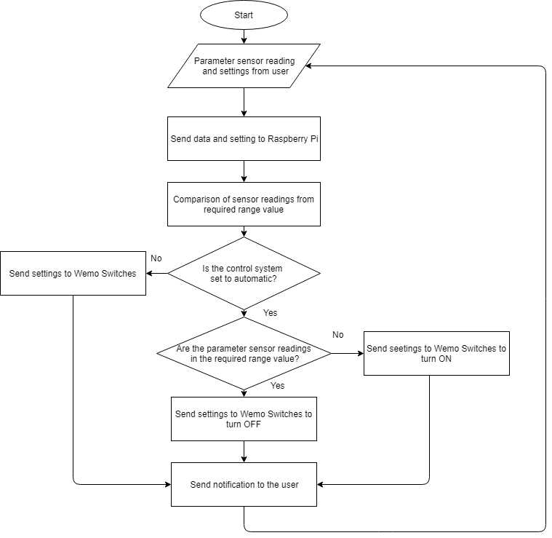

**Figure 3.1 System Flowchart**

The sensors will read the parameters and send it to the Raspberry Pi 3, the user will also send settings to the Raspberry Pi through the internet. If the setting is manual, the user will also set two Wemo switches to turn ON/OFF in which an air conditioner is connected to one of the switch and a dehumidifier to the other, Raspberry Pi 3 will send the sensor readings to the user through internet. If the setting is automatic, the Raspberry Pi 3 will automatically turn ON the Wemo switch for the parameter that is not in the desired range and turn OFF if it is in the desired range, Raspberry Pi 3 will still send the sensor readings and the state of the air conditioner and dehumidifier.

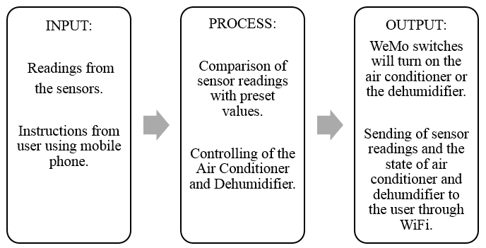

**Figure 3.2 Conceptual Framework**

In Figure 3.2, the conceptual framework of the research paper is shown. The sensors will measure its respective parameters then will send the readings to the Raspberry Pi, depending on the instruction of the user, the control system for the air conditioner and the dehumidifier may either be automatic or manual changing of the state. If the setting is automatic, the Raspberry Pi will compare the sensor readings with the preset values then automatically change the state of the air conditioner or the dehumidifier depending on the result of the comparison and will send data sensor readings and the state of air conditioner and dehumidifier to the user through WiFi. If the setting is manual, the Raspberry Pi will compare the sensor readings with the preset values then alert the user if the readings is not within the desired range and the Raspberry Pi will also receive instructions from the user if the air conditioner and the dehumidifier should be turned off or on and will give it to the WeMo switches of the air conditioner and the dehumidifier. Below are the list of materials that will be used for the prototype.

**Table 3.1 List of Materials**

|  |  |
| --- | --- |
|  | **Aircon**  This device will be responsible for removing the heat and humidity from the warehouse while blowing cool air into it. It’s core function is to cool the room. |
|  | **Dehumidifier**  A dehumidifier is an electrical appliance that reduces and maintains the level of humidity in the air. It removes moisture by pulling the air into the system, cools it, heats it, and dispels the moisture into a bucket or a drainage system. |
|  | **DHT22 Digital Temperature And Humidity Sensor Module**The DHT22 uses a capacitive humidity sensor and a thermistor to measure the surrounding air, and spits out a digital signal on the data pin (no analog input pins needed). Small size, low power consumption, signal transmission distance up to 20 meters, making it the best choice of all kinds of applications and even the most demanding applications. |
|  | **Raspberry Pi 3**  The Raspberry Pi 3 is the third-generation Raspberry Pi. It has 1GB of RAM and 40-pin extended GPIO. |
|  | **SD Card**  A 32GB microSD card is inserted on the Raspberry Pi. This is used for loading the operating system, as well as storing the data of the temperature and humidity readings. |
|  | **WeMo Switch**  The Wemo switch lets the user control their electronic devices right from their phone or tablet.  This switch will be plugged into an electrical outlet, and will be connected to the humidifier and air conditioner. The devices will be controlled through the free WeMo application. |

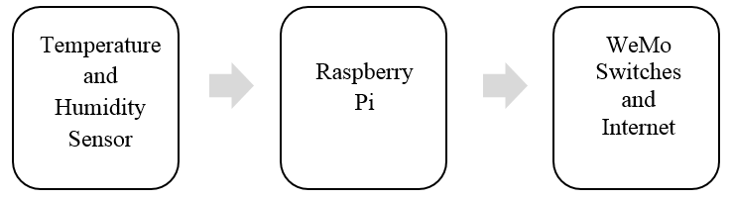

**Figure 3.3 Designed System Scheme**

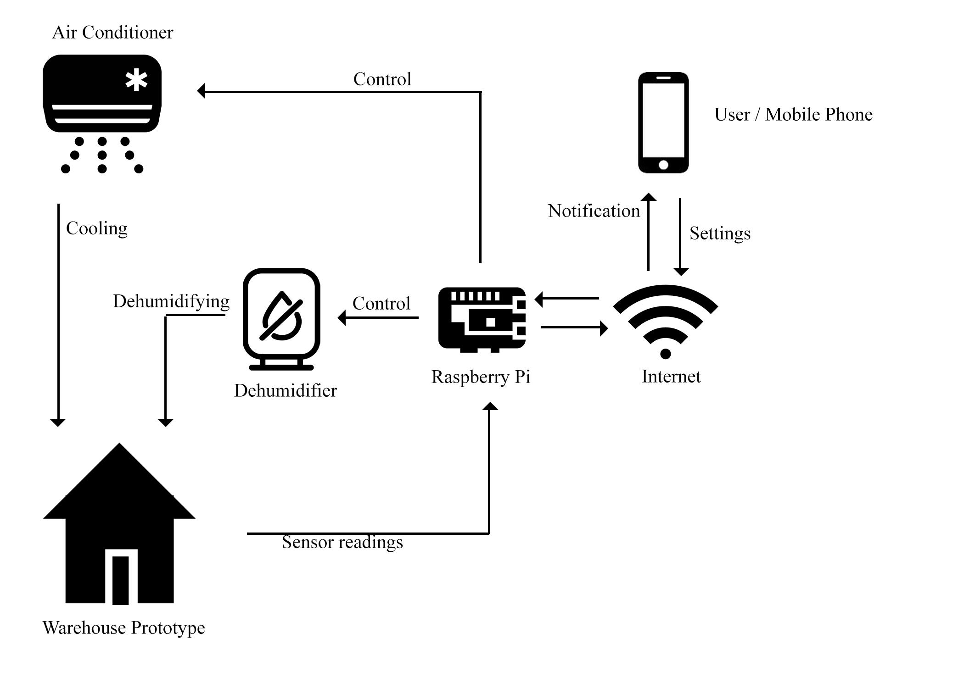

**Figure 3.4 Proposed System**

In the proposed system, we are to use a warehouse prototype then we will put a kilo of NFA rice with matured, ready for reproduction, rice weevils inside. First, we will observe the effect of an uncontrolled environment, NFA’s traditional storage, to the number of adults that will be formed in thirty days. We will then observe the effect of the proposed system to the number of adults that will be formed in thirty days.

**The Warehouse Prototype**

The warehouse prototype will be made using cement as the walls and a metal roofing. The inside part of the roofing will be covered with insulation sheets. The warehouse prototype will have an area of one square meter and a height of one meter.

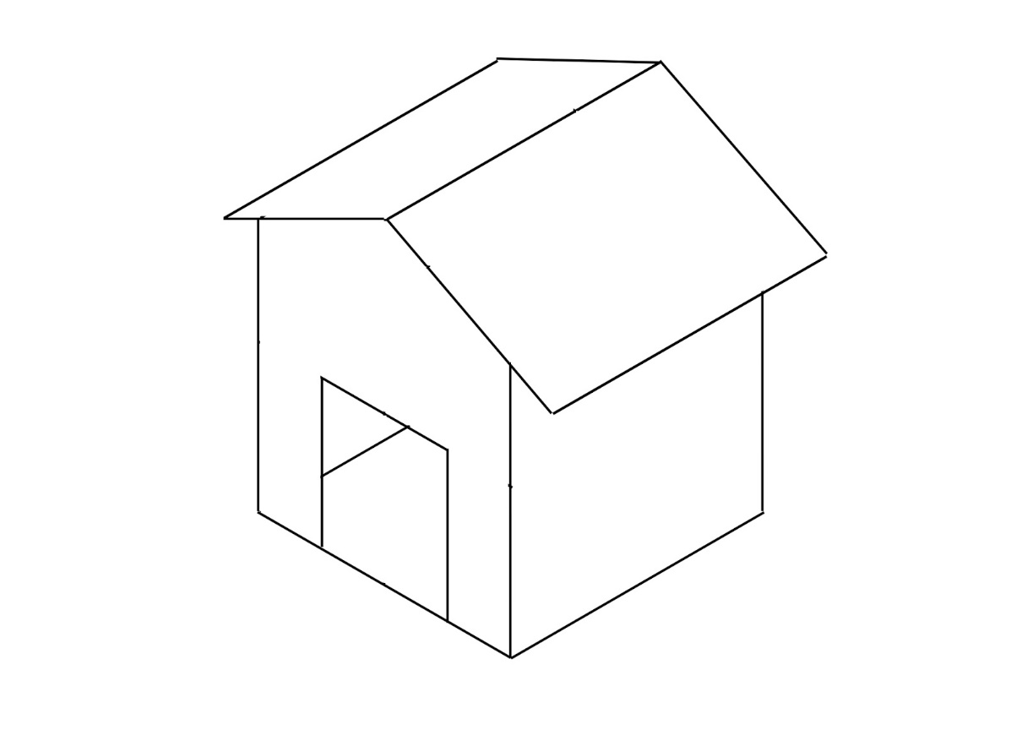

**Fig. 3.5 Warehouse Prototype**

**The Proposed User Interface**

The user will choose if the automatic mode is either enabled or disabled. Figure 3.6a shows the display when the automatic mode is enabled, the parameter sensor readings and the current state of the air conditioner and the dehumidifier are displayed. It also displays if the parameter sensor readings are within the desired range or not. While Figure 3.6b shows the display when the automatic mode is disabled, the only change is that the user manually set the air conditioner and the dehumidifier.

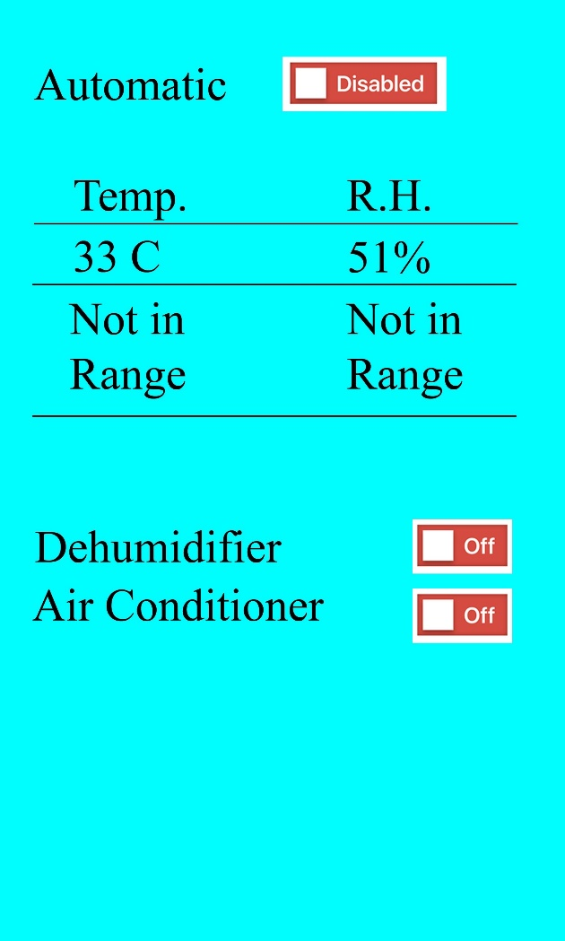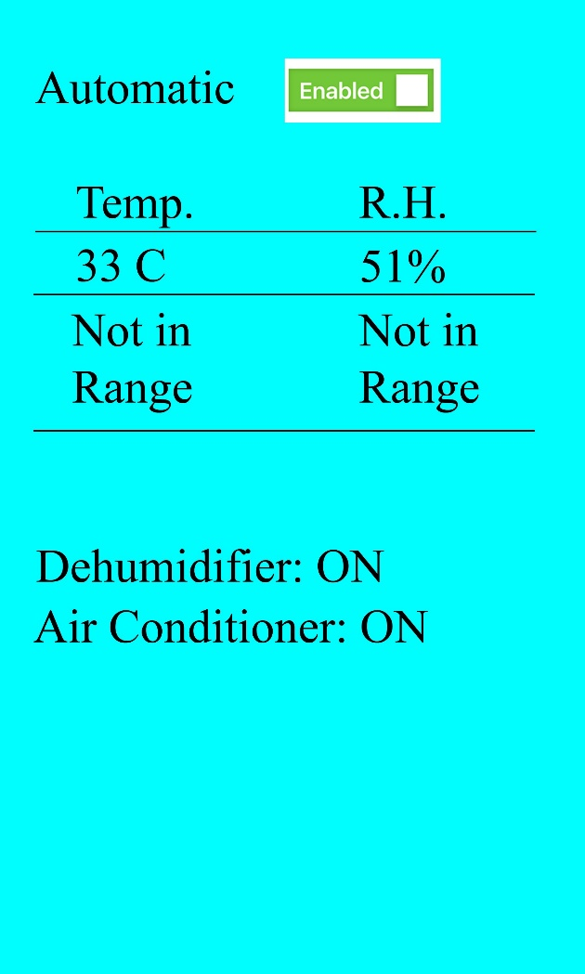

**(a) (b)**

**Fig. 3.6 Graphical User Interface**

**Testing and Calibration**

**Hardware**

**Table 3.2 Testing and Calibration**

|  |  |  |
| --- | --- | --- |
| **Action** | **Yes** | **No** |
|  |  |  |
|  |  |  |
|  |  |  |

**Software**

**Table 3.3 Testing and Calibration for Software**

|  |  |  |
| --- | --- | --- |
| **Action** | **Yes** | **No** |
|  |  |  |
|  |  |  |
|  |  |  |
|  |  |  |

**Data Gathering**

**Table 3.4 Temperature Detection Evaluation Table**

|  |  |  |
| --- | --- | --- |
| **Temperature reading** | **<= 25 C** | **Aircon Temperature Set** |
|  |  |  |
|  |  |  |

**Table 3.5 Relative Humidity Detection Evaluation Table**

|  |  |  |
| --- | --- | --- |
| **Relative Humidity Reading** | **<=55%** | **Humidifier Value Set** |
|  |  |  |
|  |  |  |

**Table 3.6 Number of Rice Weevils in Controlled and Uncontrolled environment**

|  |  |  |
| --- | --- | --- |
| **Number of Rice Weevils in Controlled and Uncontrolled environment** | | |
| **Days** | **Controlled** | **Uncontrolled** |
| **14** |  |  |
| **17** |  |  |
| **20** |  |  |
| **23** |  |  |
| **27** |  |  |
| **30** |  |  |

The T-test is to be used for statistical analysis.

Hypothesis:

Ho: there is a significant difference between the population of rice weevils in controlled and an uncontrolled environment. (u1 ≠ 5)

Ha: there is no significant difference between the population of rice weevils in controlled and an uncontrolled environment. (u1 = 5)

where X = number of rice weevils

The formula used in obtaining the t-values is:

**REFERENCES**

[1] Quintos, K., “100,000 sacks of rice in Subic infested with rice weevils”, 2018. Retrieved from https://news.abs-cbn.com/news/08/22/18/rotten-goods-100000-sacks-of-rice-in-subic-infested-with-rice-weevils

[2] Jaucian, M., Macatuno, A., “NFA: 330,000 bags of imported rice infested with weevils,” 2018. Retrieved from https://newsinfo.inquirer.net/1024529/nfa-330000-bags-of-imported-rice-infested-with-weevils#ixzz5ZvLEK4Ab

[3] Robotics. “Automated Remote Insect Surveillance at a Global Scale and the Internet of Things”, 2017

[4] Santiago, R. M. C., Rabano, S. L., Billones, R. K. D., Calilung, E. J., Sybingco, E., & Dadios, E. P., “Insect detection and monitoring in stored grains using MFCCs and artificial neural network. TENCON 2017 - 2017 IEEE Region 10 Conference”, 2017.

[5] Masuma A., Shanjida S., Tangin A. & Shefali B., (2017). “Oviposition Preference and Development of Rice Weevil, Sitophilus Oryze (Lin.)(Coleoptera:Curculionidae) in different stored Grains”

[6] Profile-Rice Weevils (n.d.). Retrieved from https://www.allamericanpestcontrol.com/pest-identification/profile/rice-weevils

[7] B. Lee, W. Choi, S. Lee, B. Park, “Fumigant toxicity of essential oils and their constituent compounds towards the rice weevil, Sitophilus oryzae (L.)” Crop Protection, Volume 20, Issue 4, Pages 317-320, 2001.

[8] J. Hu, X. Huang, Q. Zhou, D. Liu and W. Fu, "A novel design of voltage controlled temperature compensated crystal oscillator," *2017 Joint Conference of the European Frequency and Time Forum and IEEE International Frequency Control Symposium (EFTF/IFCS)*, Besancon, 2017, pp. 235-237.

[9] D. Purcaru, A. Purcaru and V. Rădulescu, "Temperature measurement and control system for engineering education," *2017 18th International Carpathian Control Conference (ICCC)*, Sinaia, 2017, pp. 258-262.

[10] T. Kaewwiset and P. Yodkhad, "Automatic temperature and humidity control system by using Fuzzy Logic algorithm for mushroom nursery," *2017 International Conference on Digital Arts, Media and Technology (ICDAMT)*, Chiang Mai, 2017, pp. 396-399.

[11] S. O. Nelson, P. G. Bartley and K. C. Lawrence, "Measuring RF and microwave permittivities of adult rice weevils," in *IEEE Transactions on Instrumentation and Measurement*, vol. 46, no. 4, pp. 941-946, Aug. 1997.

[12] Y. Wang, J. Song, X. Liu, S. Jiang and Y. Liu, "Plantation Monitoring System Based on Internet of Things," *2013 IEEE International Conference on Green Computing and Communications and IEEE Internet of Things and IEEE Cyber, Physical and Social Computing*, Beijing, 2013, pp. 366-369.

[13] P. Palacios and A. Córdova, "Approximation and Temperature Control System via an Actuator and a Cloud: An Application Based on the IoT for Smart Houses," *2018 International Conference on eDemocracy & eGovernment (ICEDEG)*, Ambato, 2018, pp. 241-245.

[14] C. Boo, J. Kim, H. Kim, M. Kang and K. Y. Lee, “Energy efficient temperature control for peak power reduction in building cooling systems,” International Journal of Control and Automation, vol. 6, no. 6, pp. 105-114, 2013

[15] F. Sato, H. Kawano, N. Kobayashi, Y. Kaneko and K. Miura, "An air conditioning control method for peak power reduction using heat capacity based room temperature constraints," *2015 IEEE International Telecommunications Energy Conference (INTELEC)*, Osaka, 2015, pp. 1-4.

[16] M.M. Joybari, F. Haghighata, J. Moffat and P. Sra, “ Heat and cold storage using phase change materials in domestic refrigeration systems: The state-of-the-art review.” Energy and Build.vol 106, pp. 111–124, November 2015.

[17] F. H. Purwanto, E. Utami and E. Pramono, "Design of server room temperature and humidity control system using fuzzy logic based on microcontroller," *2018 International Conference on Information and Communications Technology (ICOIACT)*, Yogyakarta, 2018, pp. 390-395.

[18] A. Roy, P. Das and R. Das, "Temperature and humidity monitoring system for storage rooms of industries," *2017 International Conference on Computing and Communication Technologies for Smart Nation (IC3TSN)*, Gurgaon, 2017, pp. 99-103.

[19] S. Halder and G. Sivakumar, "Embedded based remote monitoring station for live streaming of temperature and humidity," *2017 International Conference on Electrical, Electronics, Communication, Computer, and Optimization Techniques (ICEECCOT)*, Mysuru, 2017, pp. 284-287.

[20] X. Zeng and C. Yu, "Multivariable IMC-PID within air-conditioned room temperature and relative humidity control system," *Proceedings of the 33rd Chinese Control Conference*, Nanjing, 2014, pp. 3609-3613.

[21] B. Ashish, "Temperature monitored IoT based smart incubator," *2017 International Conference on I-SMAC (IoT in Social, Mobile, Analytics and Cloud) (I-SMAC)*, Palladam, 2017, pp. 497-501.

[22] Ding Libo and Wang Xuehui, "Design of a web-based temperature and humidity monitoring system," *2011 2nd International Conference on Artificial Intelligence, Management Science and Electronic Commerce (AIMSEC)*, Dengleng, 2011, pp. 2028-2030.

[23] Aslam, Asad & Jafir, Muhammad & Javed, Muhammad & Shehzad, Muhammad & Zubair Chaudhary, Muhammad & Aftab, Muhammad. (2017). Effect of temperature and relative humidity on development of Sitophilus oryzae L. (coleoptera: curculionidae). 85. 85-90.

[24] C. Chavapradit, “Grain Storage”,Manhattan Klongluang Hotel, Pathum Thani, Thailand, December 2010

[25] R. Arief and T. M. Lando, “Equilibrium Moisture Content of Rice and Maize upon Drying”, South Sulawesi, Indonesia, April 2001

[26] R. P. Ranalli, T. A. Howell Jr., F. H. Arthur, D. R. Gardisser, “CONTROLLED AMBIENT AERATION DURING RICE STORAGE FOR TEMPERATURE AND INSECT CONTROL ”

2002 American Society of Agricultural Engineers, Vol. 18(4): 485–490.

[27] N. G. K. K. Reddy, K. Anand, R. Priyadharshini and K. Rajeshwari, "Estimation of durability of rice grains using sensors and mobile technology," *2016 IEEE Technological Innovations in ICT for Agriculture and Rural Development (TIAR)*, Chennai, 2016, pp. 33-35.

[28] M. S. Uddin, P. R. Armstrong, N. Zhang, “ACCURACY OF GRAIN MOISTURE CONTENT PREDICTION USING TEMPERATURE AND RELATIVE HUMIDITY SENSORS ” 2006 American Society of Agricultural and Biological Engineers, Vol. 22(2): 267-273

[29] S. Wangnipparnto and T. Suksri, "The relative humidity control," *2009 ICCAS-SICE*, Fukuoka, 2009, pp. 5216-5219.

[30] Wei Zhang and S. X. Yang, "A fuzzy based approach to effective relative humidity tracking in industrial systems," *2010 8th World Congress on Intelligent Control and Automation*, Jinan, 2010, pp. 2148-2153.

[31] J. Courbat, Y. B. Kim, D. Briand and N. F. de Rooij, "Inkjet printing on paper for the realization of humidity and temperature sensors," *2011 16th International Solid-State Sensors, Actuators and Microsystems Conference*, Beijing, 2011, pp. 1356-1359.

[32] Li Ping, Z. Yucai, X. Zeng and Y. Ting-fang, "A Design of the Temperature Test System Based on Grouping DS18B20," *2007 2nd IEEE Conference on Industrial Electronics and Applications*, Harbin, 2007, pp. 188-191.

[33] Ramavarapu, V. P., Sowers, R., & Sreenivas, R. S. (2017). A smart power outlet for electric devices that can benefit from Real-Time Pricing. 2017 International Conference on Control, Electronics, Renewable Energy and Communications

[34] R. K. Kodali and A. Sahu, "An IoT based weather information prototype using WeMos," *2016 2nd International Conference on Contemporary Computing and Informatics (IC3I)*, Noida, 2016, pp. 612-616.

[35] A. Imteaj, T. Rahman, H. A. Begum and M. S. Alam, "IoT based energy and gas economic home automation system using Raspberry Pi 3," *2017 4th International Conference on Advances in Electrical Engineering (ICAEE)*, Dhaka, 2017, pp. 647-652.

[36] H. Faten, M. Abdelkader and B. M. Slah, "Experimental study of the influence of using a dehumidifier on the moisture content of stored wheat," *2016 7th International Renewable Energy Congress (IREC)*, Hammamet, 2016, pp. 1-5.

[37] B. Bae, Y. Song, H. Seo and J. Kim, "IP based convergence service for Terrestrial DMB," *2012 IEEE 16th International Symposium on Consumer Electronics*, Harrisburg, PA, 2012, pp. 1-2.

[38] A. Enteshari and M. Kavehrad, "Transmission strategies for high-speed access over Category-7A copper wiring," *2008 Canadian Conference on Electrical and Computer Engineering*, Niagara Falls, ON, 2008, pp. 001065-001068.

[39] T. Kaewkiriya, "Performance comparison of Wi-Fi IEEE 802.11ac and Wi-Fi IEEE 802.11n," *2017 2nd International Conference on Communication Systems, Computing and IT Applications (CSCITA)*, Mumbai, 2017, pp. 235-240.