Top View

|  |  |  |  |  |
| --- | --- | --- | --- | --- |
| Weight | Area | B | A | Parameters Added |
| 30 | 12 | 13.28984 | 496.9137 | 142.9096 |
| 9 | 7 | 9.026823 | 392.3692 | 128.8465 |
| 12 | 11 | 7.008333 | 331.3399 | 107.4838 |

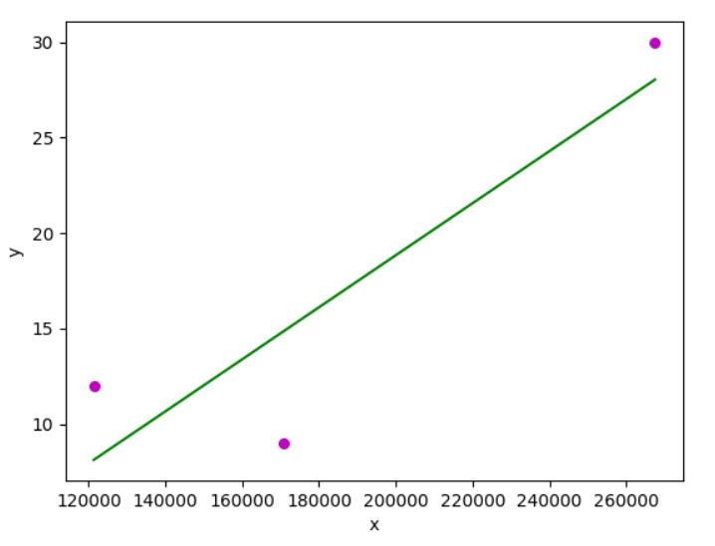

Linear Regression: Weight and Parameters Added

Parameters Added = Area^2 + B^2 + A^2

bo = -8.4026

b1 = 0.0001

weight = bo+b1*parameters_added

Side

|  |  |  |  |  |
| --- | --- | --- | --- | --- |
| Weight | Area | B | A | Parameters Added |
| 30 | 12 | 30.9375 | 594.9399 | 320.9782 |
| 9 | 7 | 10.68333 | 349.47 | 212.9798 |
| 12 | 11 | 10.6862 | 352.9139 | 211.7251 |

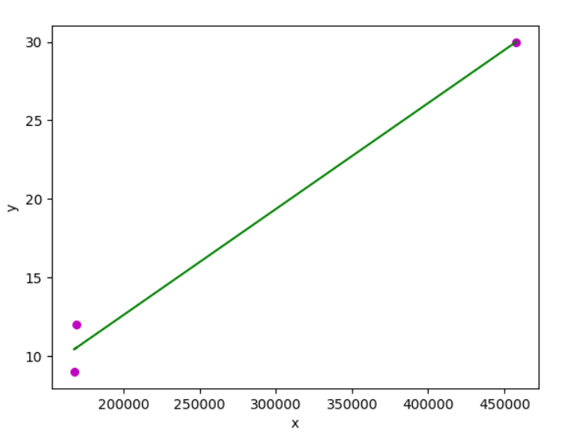

Linear Regression: Weight and Parameters Added

Parameters Added = Area^2 + B^2 + A^2

weight = bo+b1*parameters_added

bo = -0.87

b1 = 0.00006