**Gmail Account**

thesisvitalsignsmapua@gmail.com

thesisvitalsignsmapua01

Note: Wag galawin yung Google Sheets sa Gmail Account, ayun ginamit na database. Pwede iexport, wag lang iedit.

**000 WebHost Account**

thesisvitalsignsmapua@gmail.com

thesisvitalsignsmapua01

**Website Link:** : (Hosted in 000 webhostapp free hosting, not available between 2 AM – 3 AM for free version)

<https://vitalsignsmonitormapua.000webhostapp.com>

**Program Files Link:**

Website (For PC view only):

* <https://github.com/romnegrillo/THESIS_VITALIOTWEBB>

Device Programs (In RPi and Arduino):

* <https://github.com/romnegrillo/THESIS_VITALIOT>

**Manual**

* First register sa website.
* Mga registered users lang makakagamit sa device.
* May guest mode pero di masasave sa website.
* Follow niyo na lang instruction sa device.

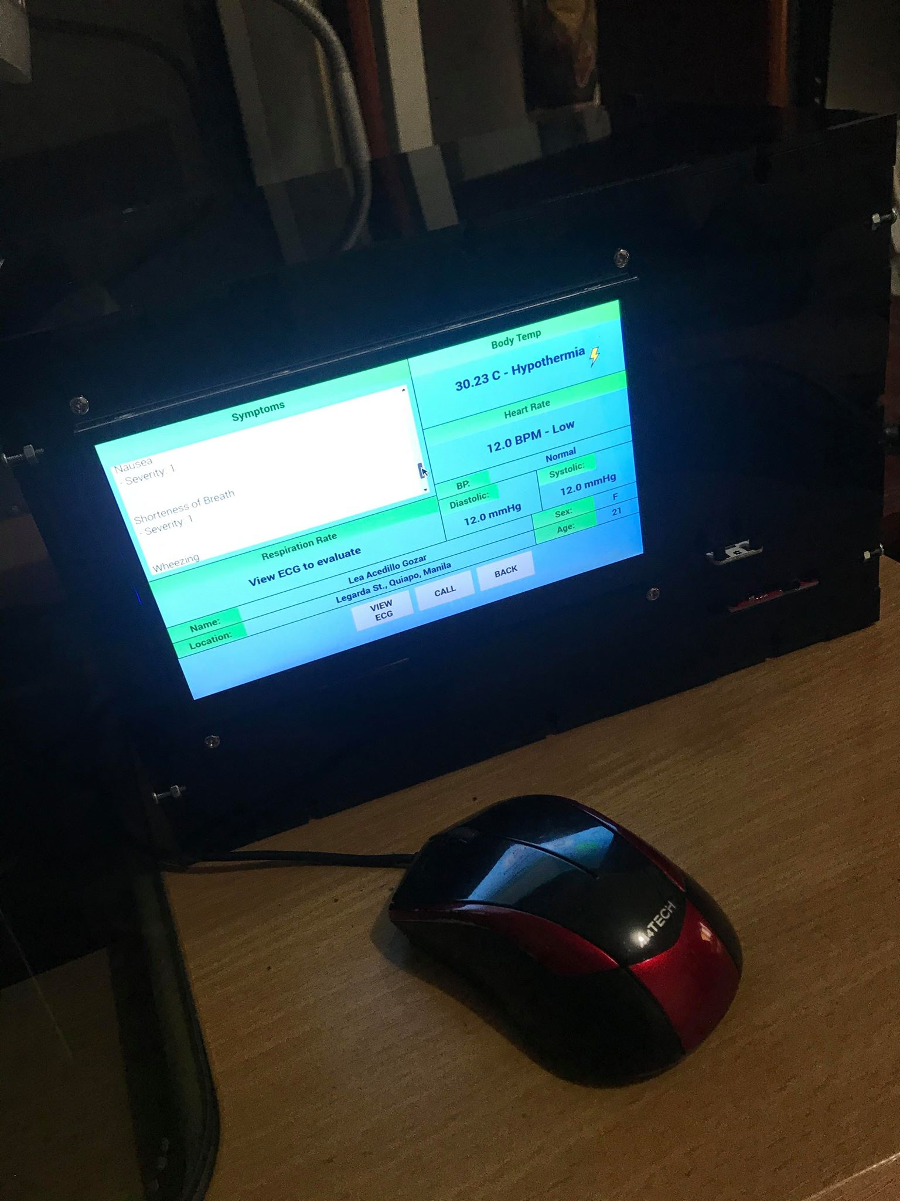

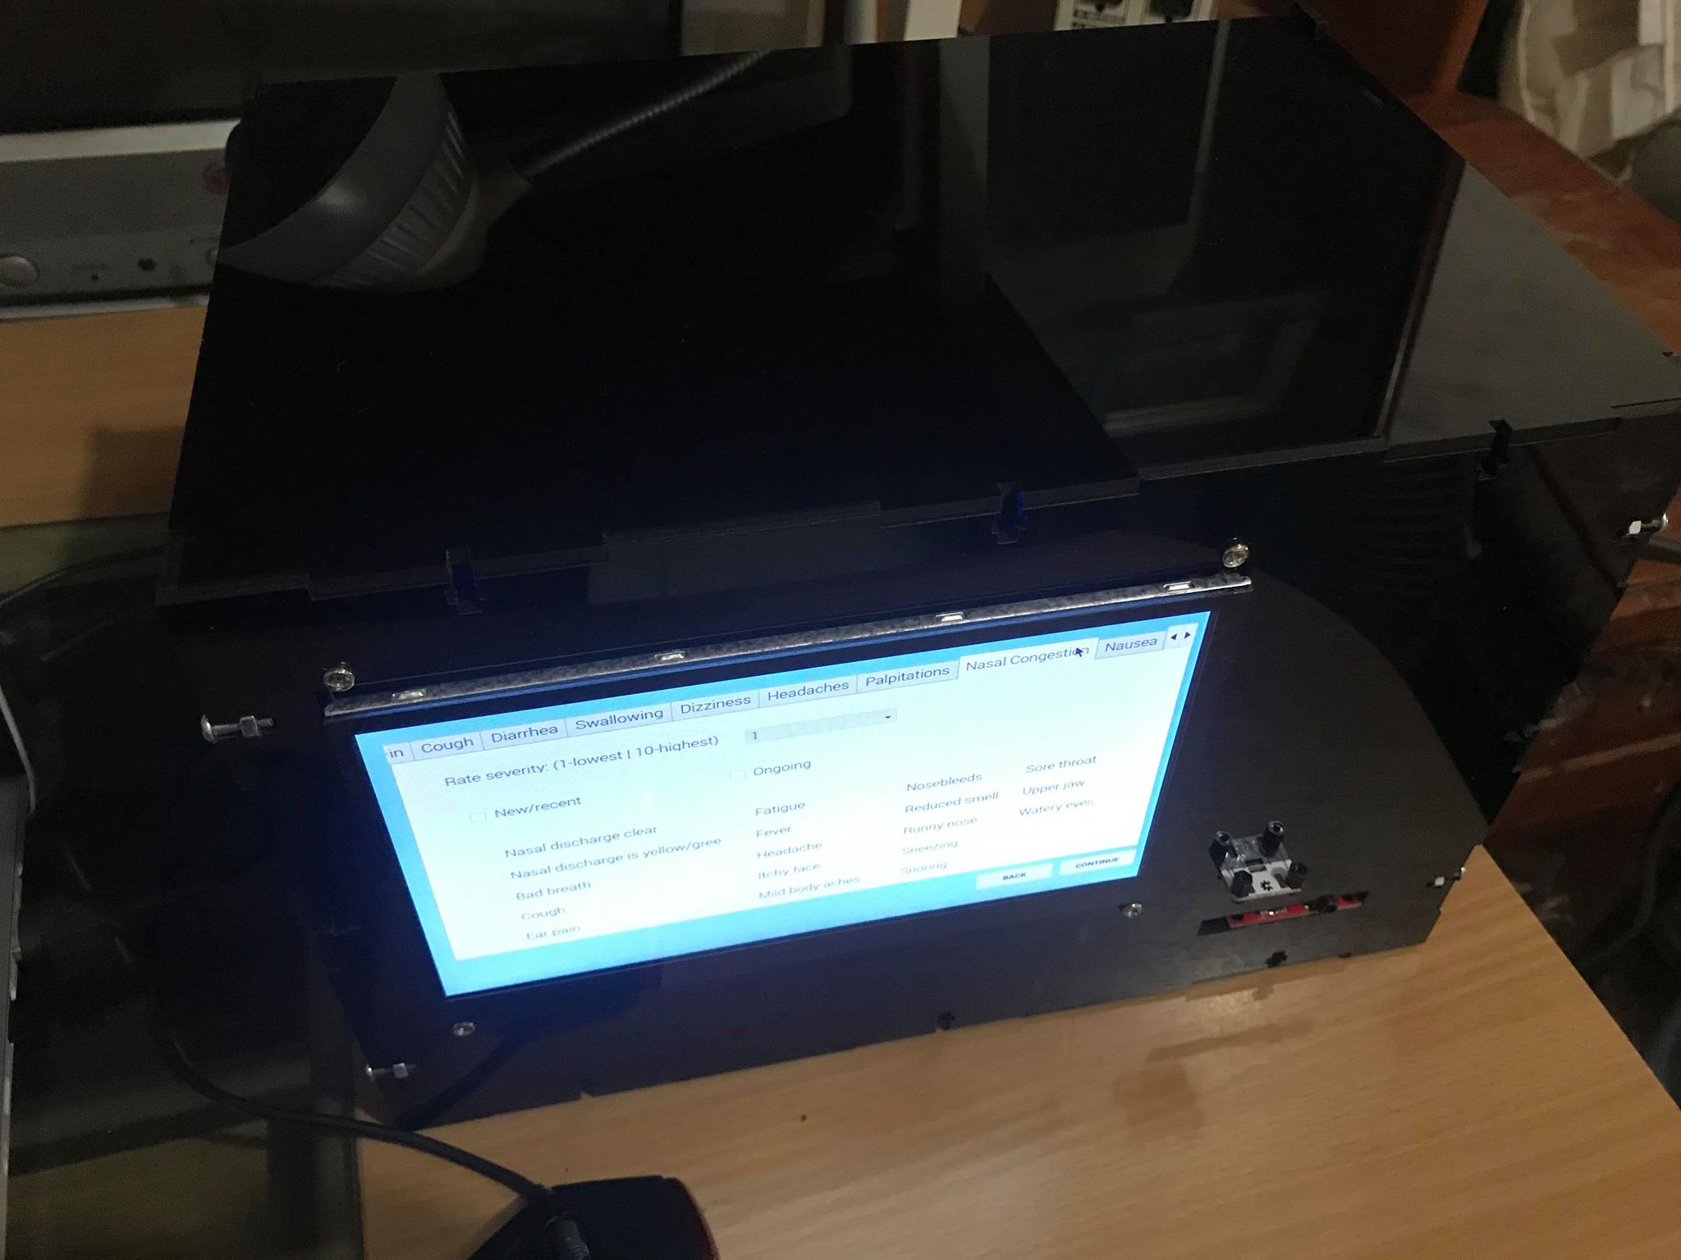

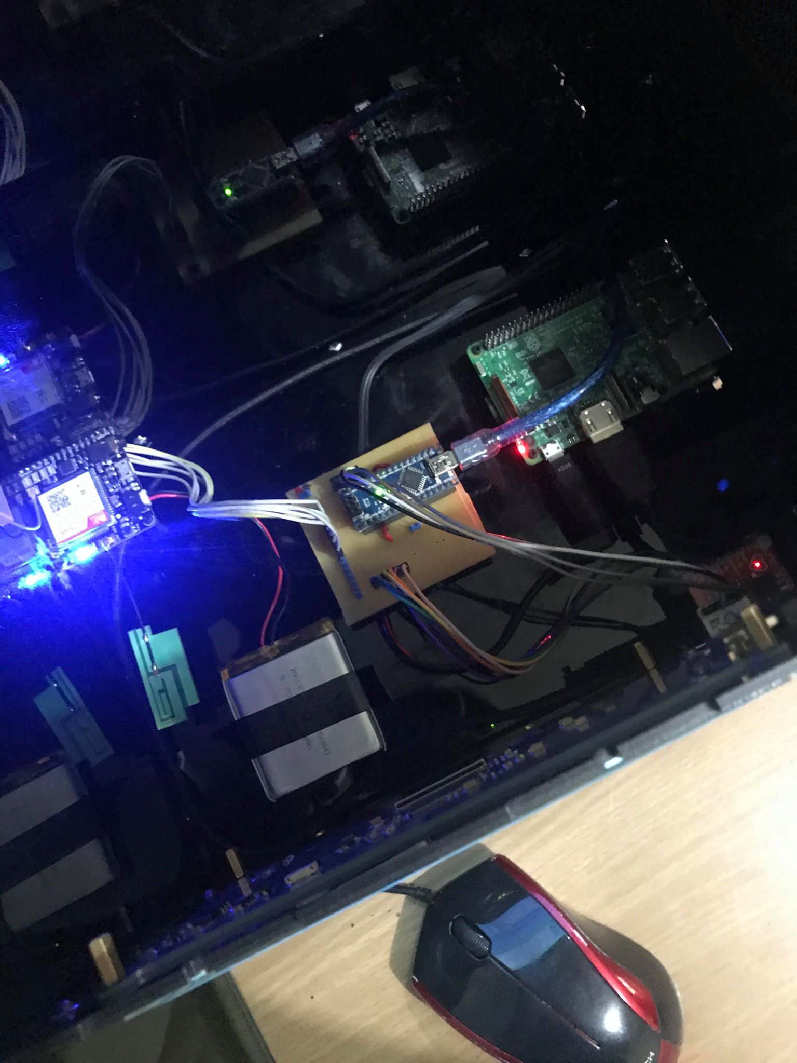

**Website Manual**

Pag admin, kaya niya maaccess lahat ng data ng user.

* View user vital signs.
* View user symptoms
* Search specific vital signs for specific date.
* View/edit user personal data.
* Delete user.

Username: admin

Password: admin

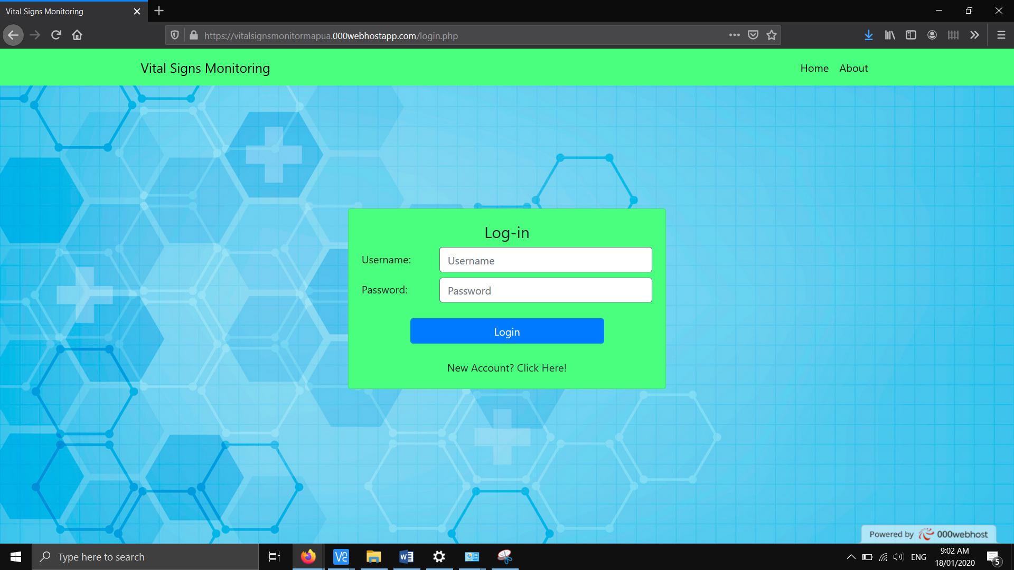

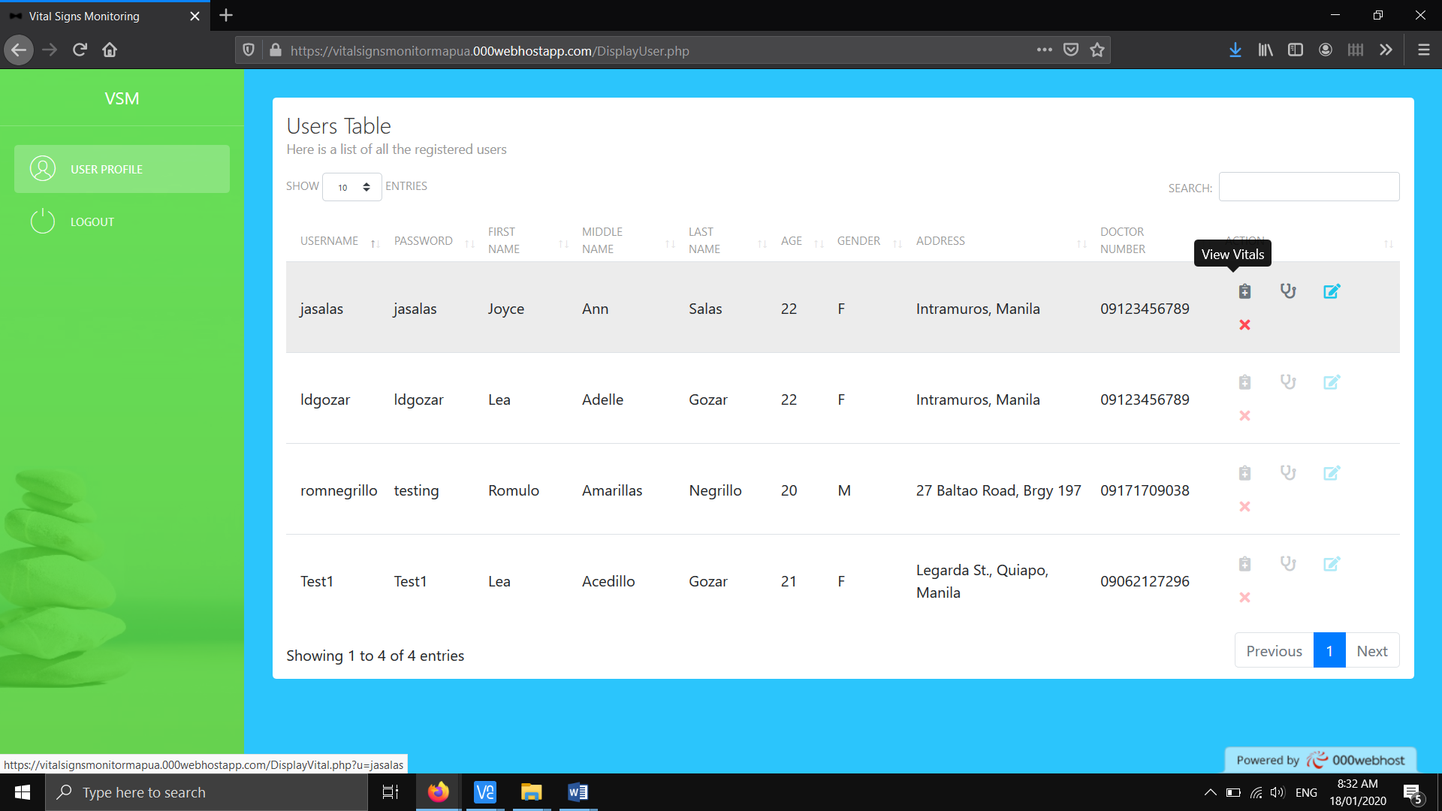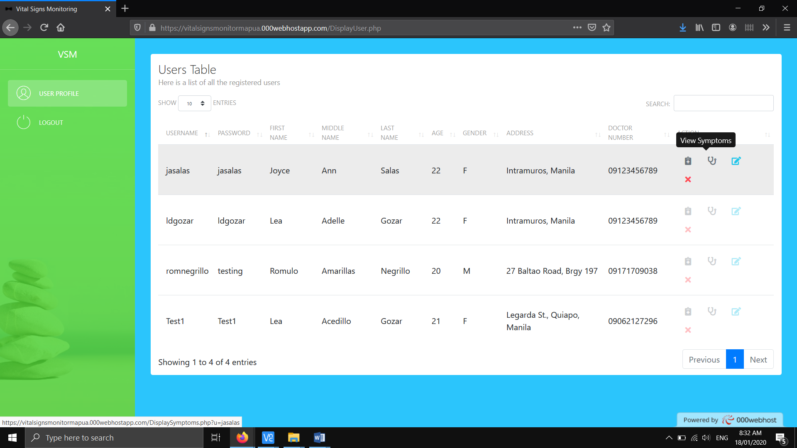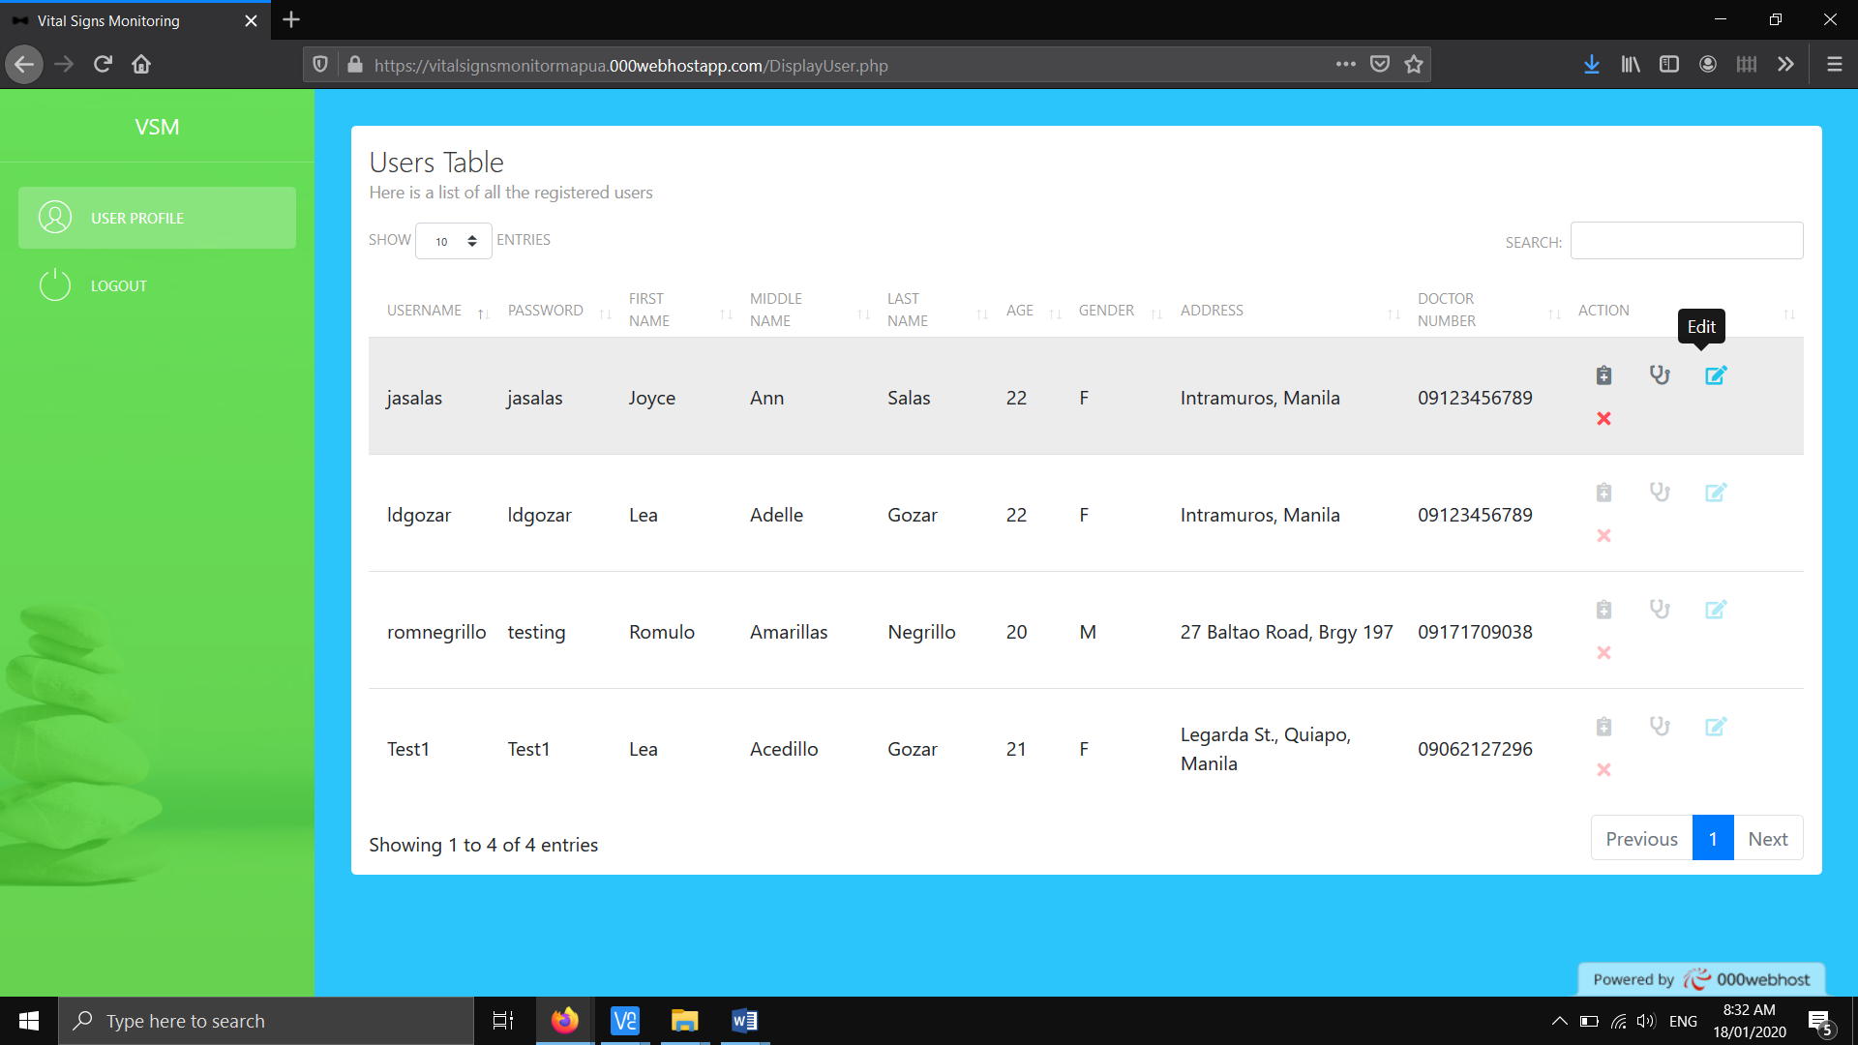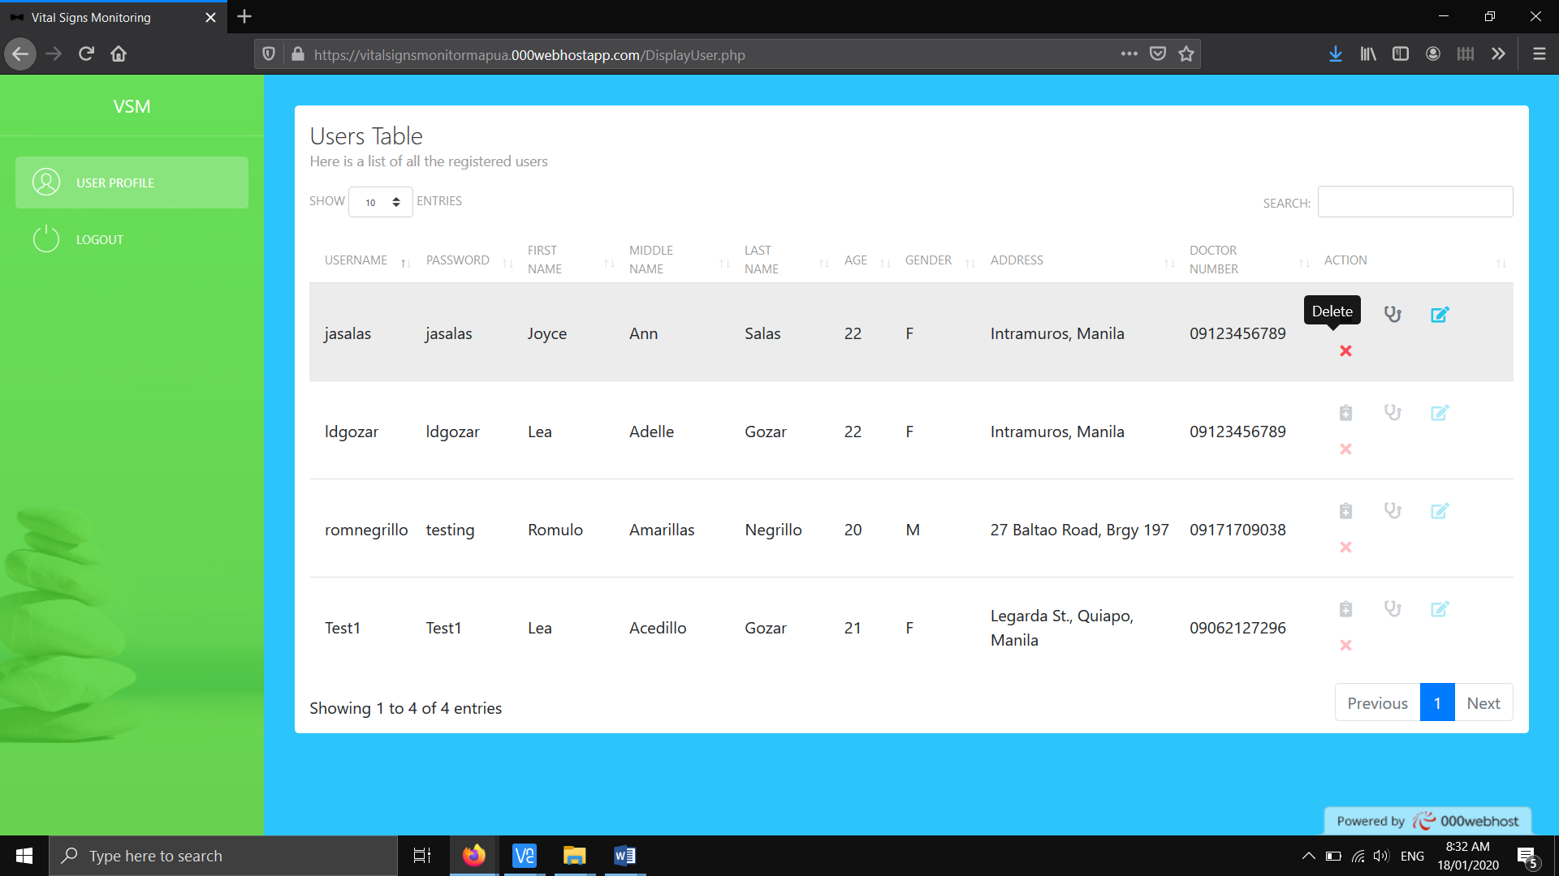

Pag user:

* View symptoms
* View vital signs

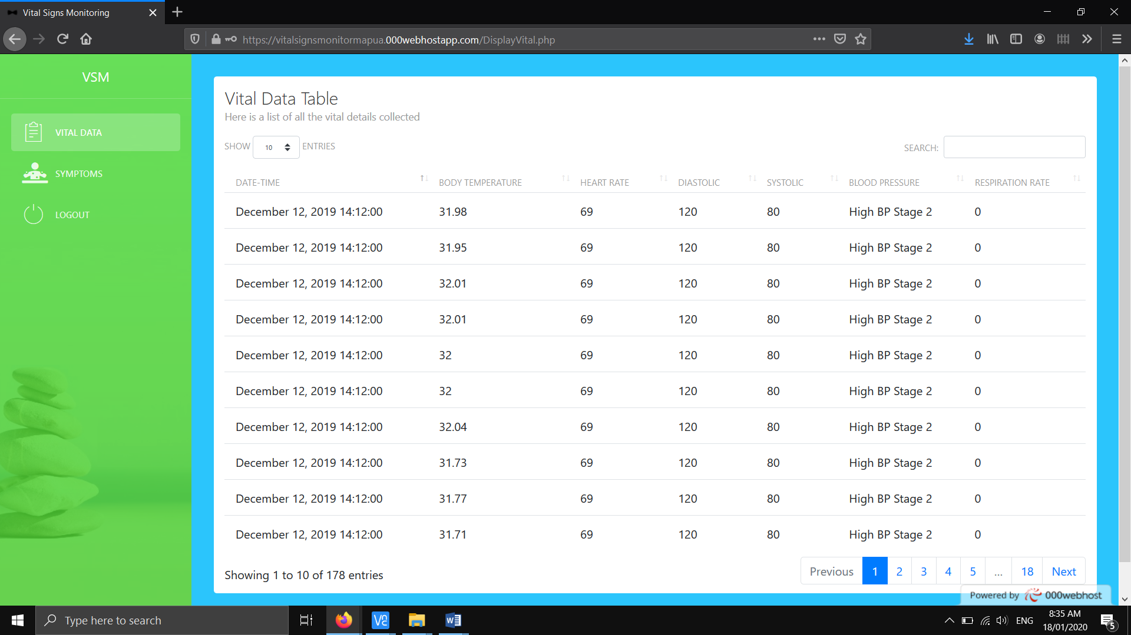

**Starting the device**

* Pag may keyboard mouse kayo, rekta run niyo na lang program. Nasa folder na THESIS_VITALIOT/Programs/vitalsigns_main.py
* Check niyo muna kung may internet kayo, bago irun program kasi magsstuck lang yung sa isang windows since aattempt attempt niyo magconnect.
* Open niyo cmd sa RPi tas ping lang kayo kahit anong website.